Online Appendix: Closer look at Game IP differentiation
If a new innovative game is one of the few to become a hit, it is an economically rational response from game companies to develop it to an IP with sequels that builds upon successful formula. Individual franchises have the potential to become a source of revenues and profits for an extended period of time. Some of the most successful game IP’s from the major Japanese game companies involve over a dozen of titles, many with a history ranging back to the 1980s and total sales in excess of 10+ million units.

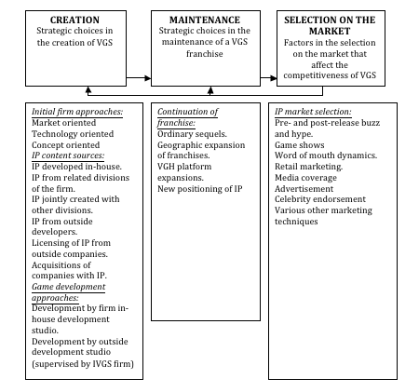
Game IP development process
Source: Author’s elaboration based on company interviews, CESA (various years), industry reports and company annual reports.

The management process of a video game IP is illustrated in figure 1, describing the main strategies involved in the creation, maintenance and selection of game IP.
In creation of game IP’s, a number of (non-exclusive) strategic approaches to differentiation are used by VGS firms. What could be characterized as technology driven, market driven and concept driven approaches stand out as the most common. With a technology driven approach, specific technological skills that can provide a unique game experience are the points of departure. In market driven approaches, the primary focus is on closely studying the characteristics and preferences of existing and potential users and developing games with this in mind. Concept driven approaches involve focusing on the creation of innovative game design concepts (e.g., a specific game play feature or a developed story line) that could form the basis for the creation of the games.
This dynamics of IP differentiation has also been evident in the extensive effort of video game platform holders in trying to gain game developers unique IP through a range of strategies such as financial incentives, acquisitions, publishing and marketing terms and contractual arrangements (Lee, 2013). Consistent with existing literature on buyer-supplier relationships in Japan (Gerlach, 1992), game platforms in Japanese has focused on long-term relationships with game developers. For example, a study of Japanese games published during the period 2000-2008 found that 76% of all video game firms only had a publishing relationship with one platform firm (Inoue & Nagayama, 2011).
IP content sources could be firm-internal or external. The first category refers to in-house developed original IP’s and IP’s developed from related divisions of the firms (e.g., arcade games, PC games, toys, anime, comics, manga). The second category involves game developers pitching a game IP to game publishers, licensing or acquisition of IP content from external firms. During the subsequent video game development process (currently around 1-3 years) the game is developed either by an in-house or firm external development studio under supervision from the publisher’s producer. Technological, creative and managerial skills are all important part of the development process (Tschang, 2005; Cohendet and Simon, 2007; Aoyama and Izushi, 2003). The development process includes a diverse skillset of artists, programmers, game designers, quality assurance personnel, producers and managers
If a new game gains market acceptance, the maintenance phase follow various strategies for the continuous differentiation of a new game IP: new video game sequels, porting the IP to other game platforms and expansion to new regional market territories. The differentiation strategies also involve reposition the game IP itself to sustain differentiation, e.g. by releasing the game IP in a new genre.

