**SUPPLIMENTAL MATERIALS**

**Arsenic immobilization in anaerobic soils by the application of by-product iron materials obtained from the casting industry**

Aomi Suda1), Tomoyuki Makino1), Noriko Yamaguchi1), Hayato Taniguchi2)

1. *Institute for Agro-Environmental Sciences, NARO, 3-1-3, Kannondai, Tsukuba, Ibaraki 305-8604, Japan*
2. *Shintokogyo, Ltd., 3-28-12, Mei-eki, Nakamura-ku, Nagoya, Aichi 450-6424, Japan*

*Corresponding author

Aomi Suda

suda_aomi@affrc.go.jp

***Table of Contents***

Figure S1. X-ray Diffraction Patterns of the Fe Materials

Figure S2. Particle-size Distribution of the Fe Materials

Table S1. Time Course of Dissolved Fe in Incubated Soils

Table S2. Time Courses of the Ratios of Dissolved Si and P to As in the Control Soils

Fig. S1 X-ray diffraction patterns of (a) spent steel shot (whole), (b) spent steel shot (<212 μm), (c) fine spent casting sand (<212 μm), (d) fine spent casting sand (<212 μm, magnetically separated), (e) residual iron material-1 (<212 μm), (f) residual iron material-2 (<212 μm), (g) commercial ferrihydrite (212 μm) and (h) commercial zero-valent iron (<212 μm). The relative intensities of (f) and (g) are quintupled to show small peaks. F, ferrihydrite; H, hematite; M, magnetite and/or maghemite; Q, quartz; W, wüstite; Z, zero-valent iron

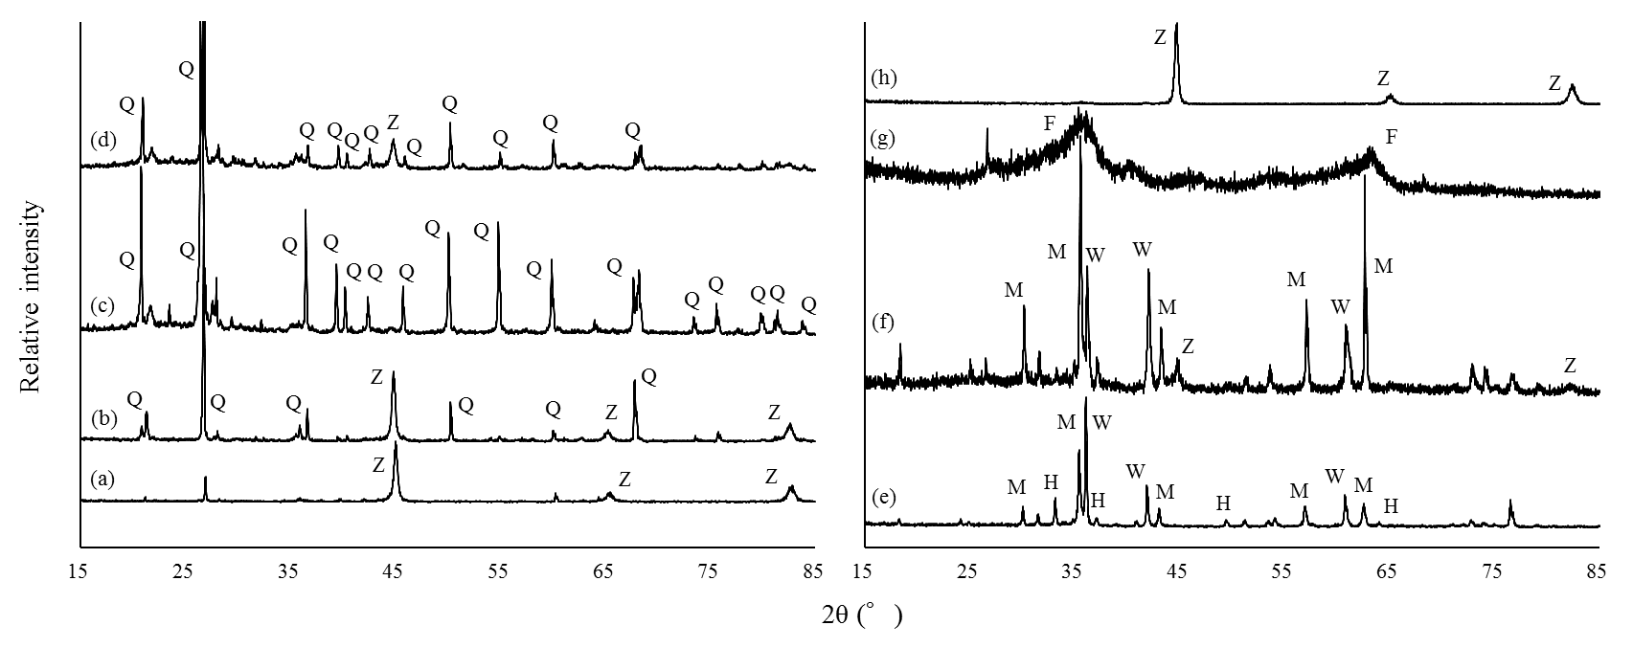

Fig. S2. Cumulative weight of passed particles in the Fe materials. SSS, SCS, RIM, cZVI and cFH denote spent steel shot, fine spent casting sand, residual iron material of steel shot production, commercial zero-valent iron and commercial ferrihydrite, respectively.

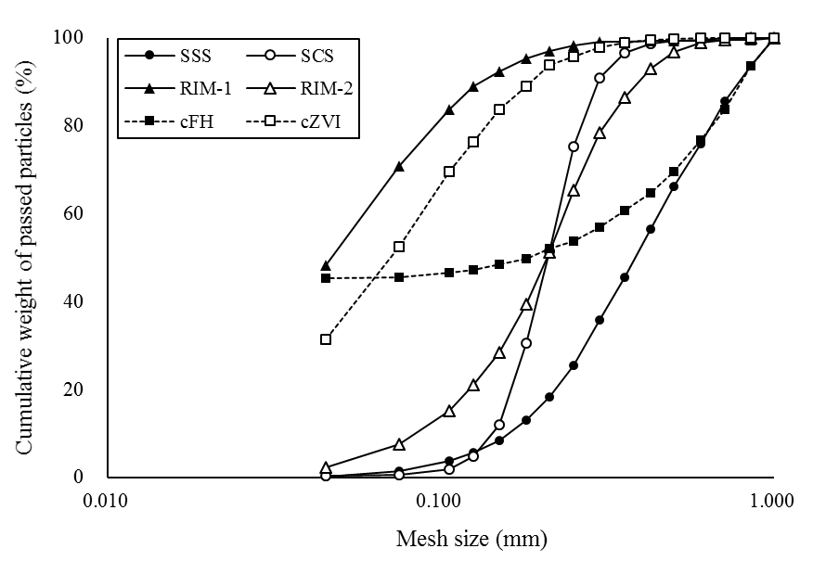

Table S1 Time course of the concentrations of iron (Fe) in soil solution and two-way analysis of variance (ANOVA).

SSS, spent steel shot; SCS, fine spent casting sand; RIM, residual iron material of steel shot production; cFH, commercial ferrihydrite; cZVI, commercial zero-valent iron. Values followed by the same letter within a column are not significant (*P* = 0.05, Tukey’s test).

Table S2 Time courses of the ratios of dissolved silica (Si) and phosphorus (P) to arsenic (As) in control soils

