**Supplementary materials**

**Supplementary figure 1**

**a**

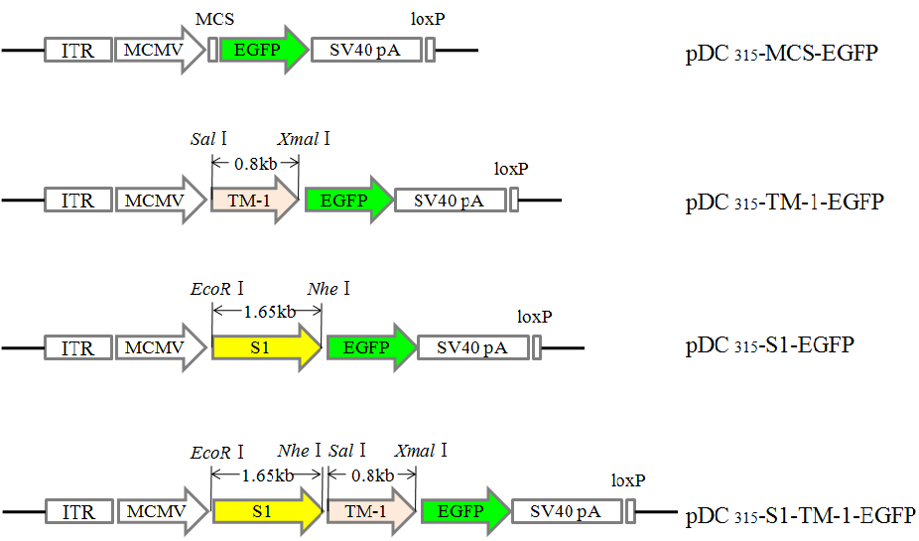

**b**

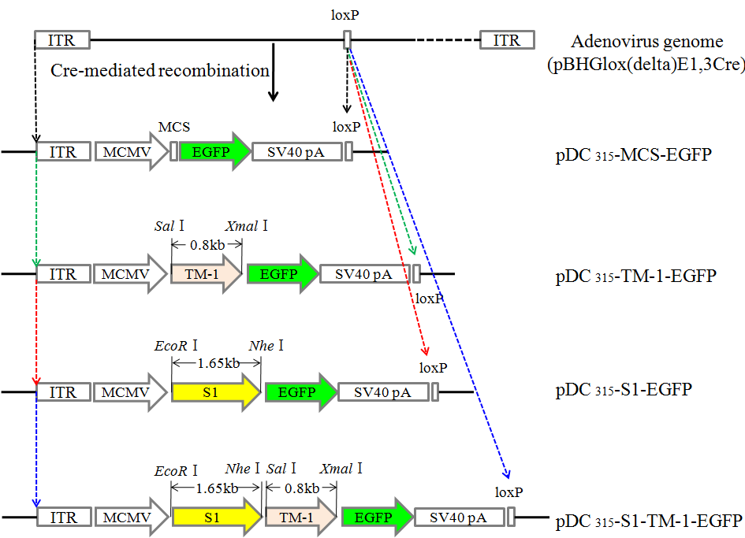

**c**

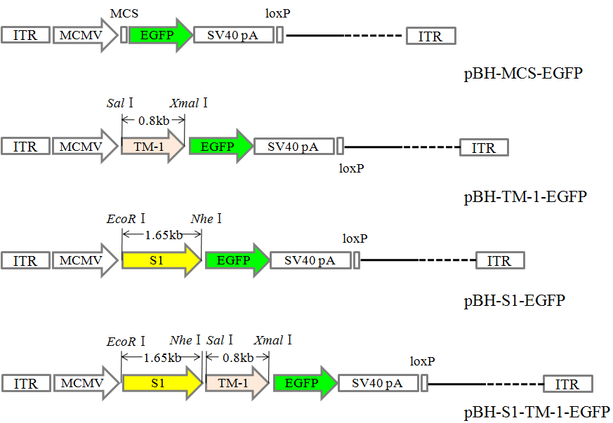

**Supplementary figure 2**

**a b**

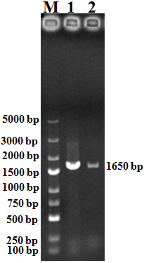 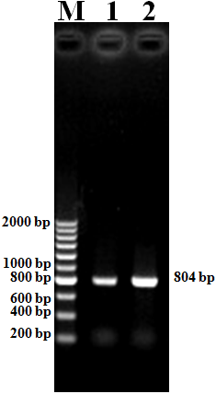

**c d**

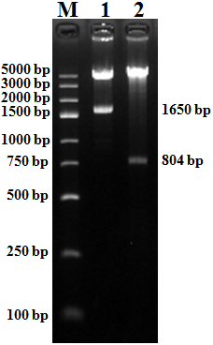 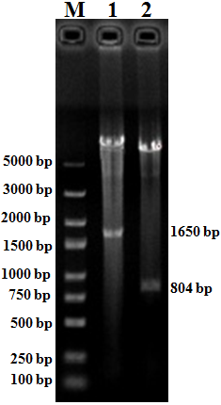

**Supplementary figure 3**

|  |  |  |
| --- | --- | --- |
|  | Phase-contrast microscopy | Fluorescence microscopy |
| Control | **图片1**  **100 μm** | **图片2** |
| pBH-S1-TM-1-EGFP | **图片3** | **图片4** |
| pBH-S1-EGFP | **图片5** | **图片6** |
| pBH-TM-1-EGFP | **图片7** | **图片8** |

**Supplementary figure 4**

**a**

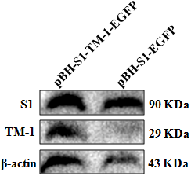

**b**

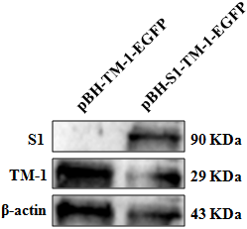

**Supplementary figure 5**

**a**



**b c**

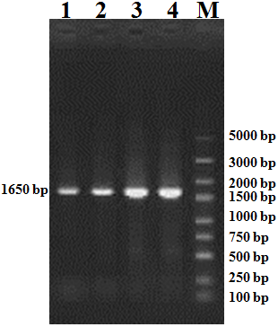 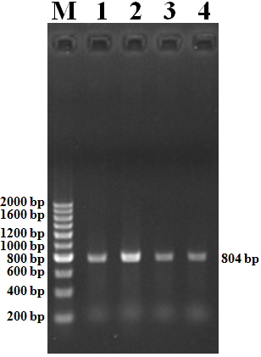

**Supplementary figure 6**

|  |  |  |  |
| --- | --- | --- | --- |
| **a** | Kidney | Lung | Trachea |
| IBV group | A | B | C |

|  |  |  |  |
| --- | --- | --- | --- |
| **b** | Air sac | Lung | Trachea |
| MG group | D | E | F |

**Supplementary figure 7**

|  |  |  |  |
| --- | --- | --- | --- |
|  | Trachea | Lung | Kidney |
| Control | **7**  a | 1  b | 7  c |
| pBH-EGFP | **8**  d | 2  e | 8  f |
|  | Trachea | Lung | Kidney |
| pBH-S1-EGFP | **9**  g | 44  h | 10  i |
| pBH-S1-TM-1-EGFP | **11**  j | 5  k | 11  l |

|  |  |  |  |
| --- | --- | --- | --- |
|  | Trachea | Lung | Kidney |
| IB attenuated vaccine | **10**  m | 13  n | 12  o |

**Supplementary figure 8**

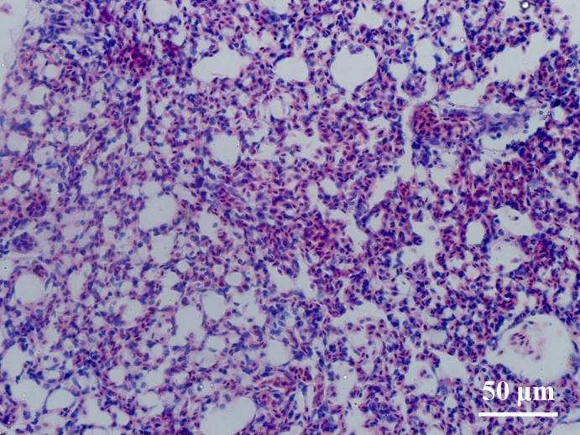 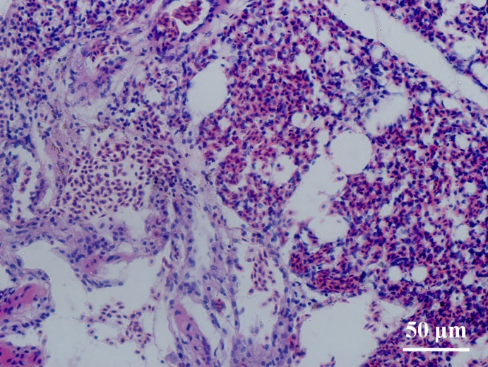

b

a

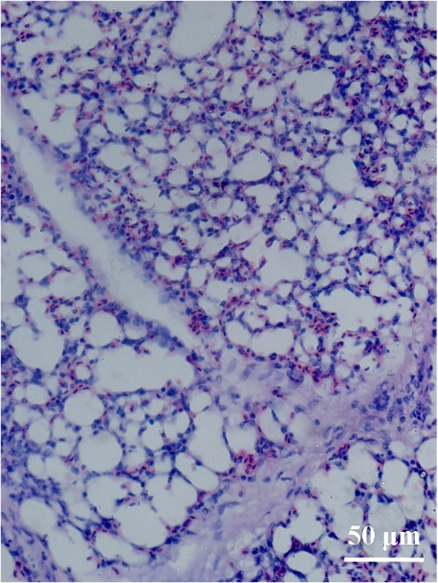 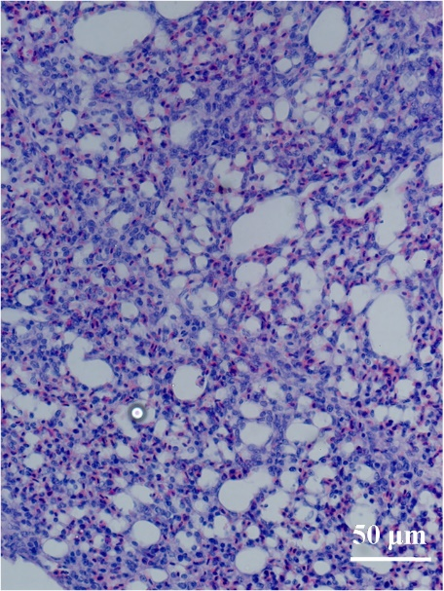

e

c

d