Experimental and Theoretical Investigation of Antioxidant Activity and
Capacities of Thiosemicarbazones Based on Isatin Derivatives
Temelkan Bakır ^{a)*}, Hakan Sezgin SAYINER ^{b)},Fatma Kandemirli ^{c)}
^{a)}Kastamonu University, Faculty of Science and Letters, Department of Chemistry,Kastamonu, Turkey
^{b)}Infectious Diseases, Medicine Department, Adiyaman University, Adıyaman, Turkey
^{c)}Kastamonu University, Faculty of Engineering, Department of biomedical engineering, Kastamonu, Turkey
Email: temelkan@kastamonu.edu.tr

Supplemental Materials
The optimized HOMO, LUMO, and electron density of H₂5MI3PT and H₂5MI3ClPT for neutral, anionic, cationic, and radical forms are given in Fig. S 1. The HOMO mainly consists of an isatin group and a S atom for H₂5MI3PT, but for H₂5MI3ClPT, the HOMO is distributed over the whole of the molecule. The LUMO mainly consists of an isatin group for the neutral form. The optimized HOMO, LUMO, and electron density of DPPH for neutral, radical, anionic, and cationic forms are shown in Fig. S2.

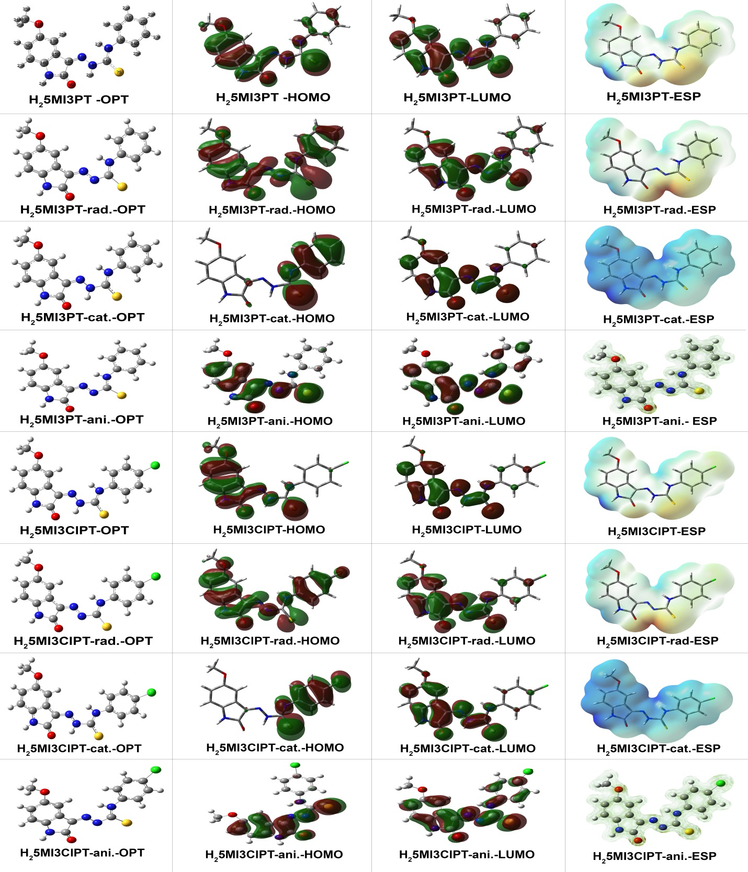
Figure S 1: Optimized form, HOMO, LUMO and Electron density of H₂5MI3ClPT and H₂5MI3PT molecules for neutral radical anionic and cationic form
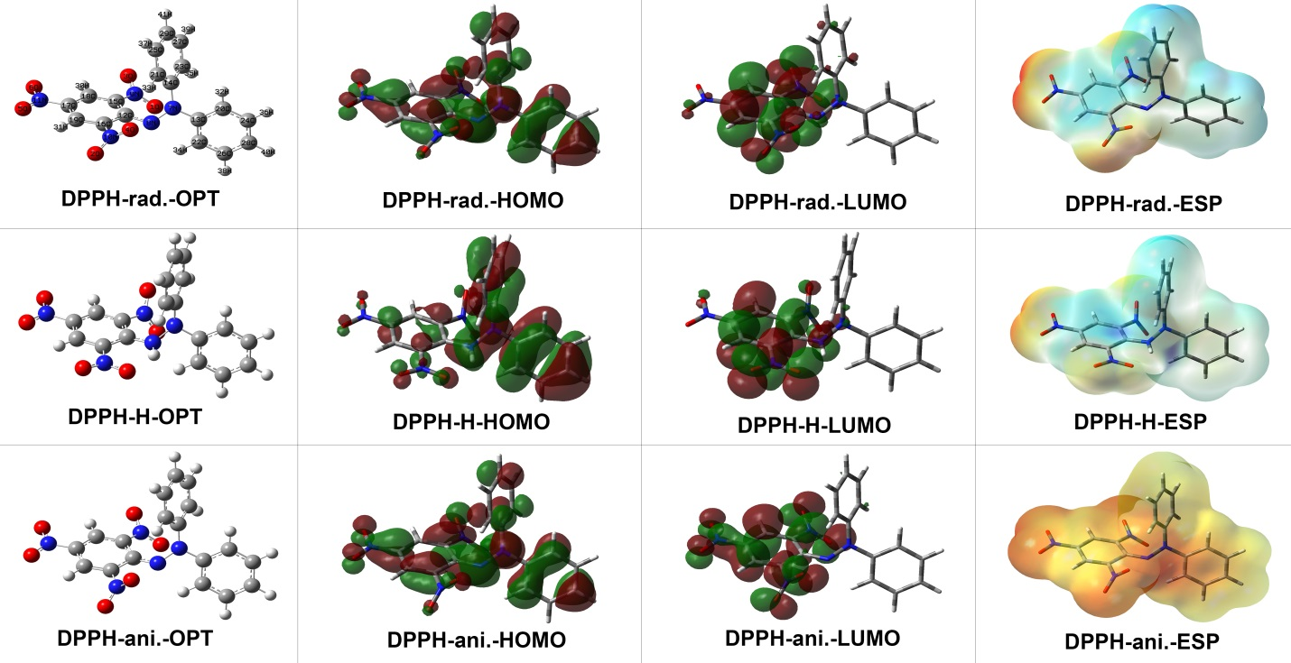
Figure S 2: Optimized form, HOMO, LUMO and Electron density of DPPH molecule for neutral radical anionic and cationic form

