Supporting Information

A fluorescent Cd(II) based 2D coordination polymer for highly selective detection of nitroaromatics and Hg²⁺

YU WU*, RUI WANG, YING-LE LIU, YU-LONG LI, YONG-XIANG HE, YI-WEN LIANG, JIAN-HUI MAN and ABHINAV KUMAR*

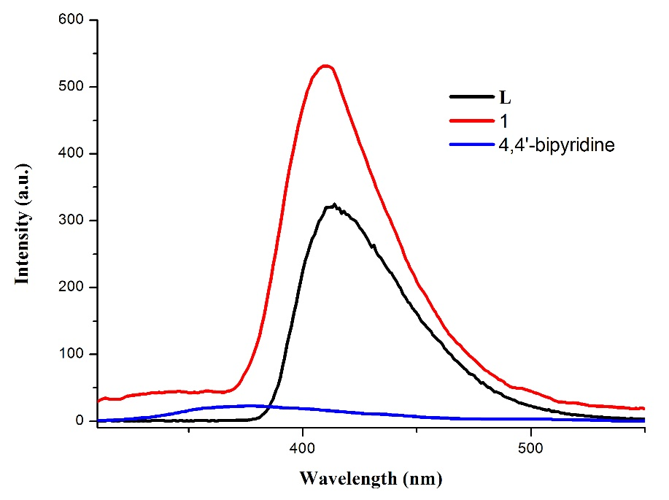
Figure S1. View of luminescent spectra for H₂L, 4,4’-bipy and 1 at room temperature.
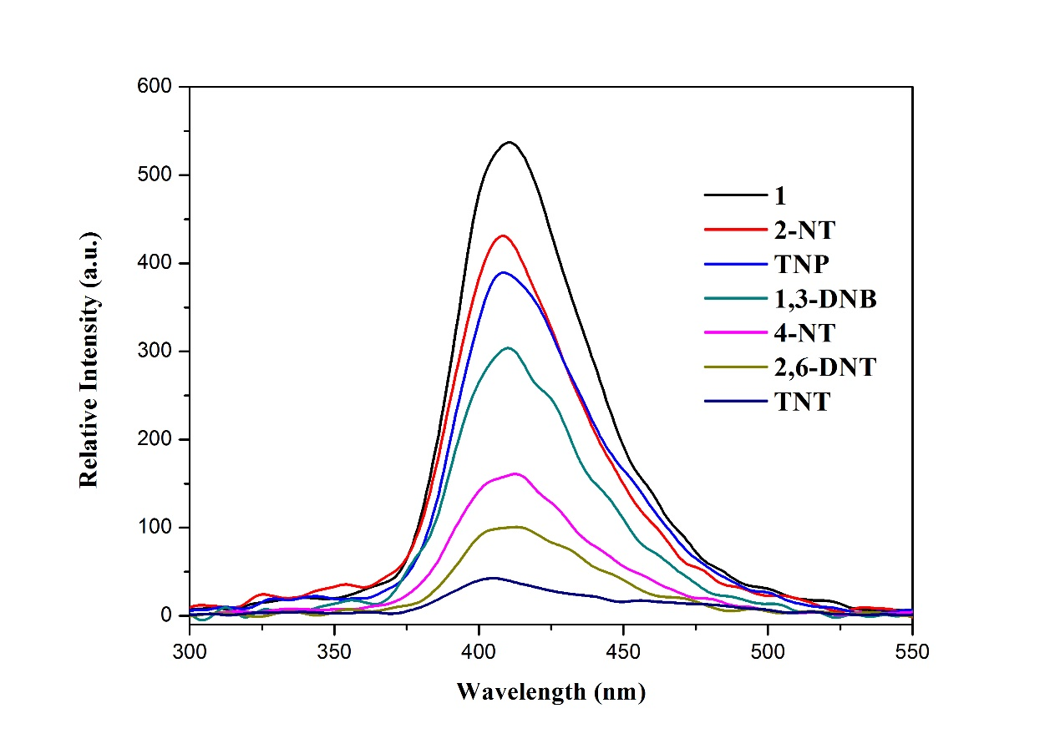
Figure S2. View of luminescent spectra for different NACs in 1 (λ_{ex} = 290 nm).
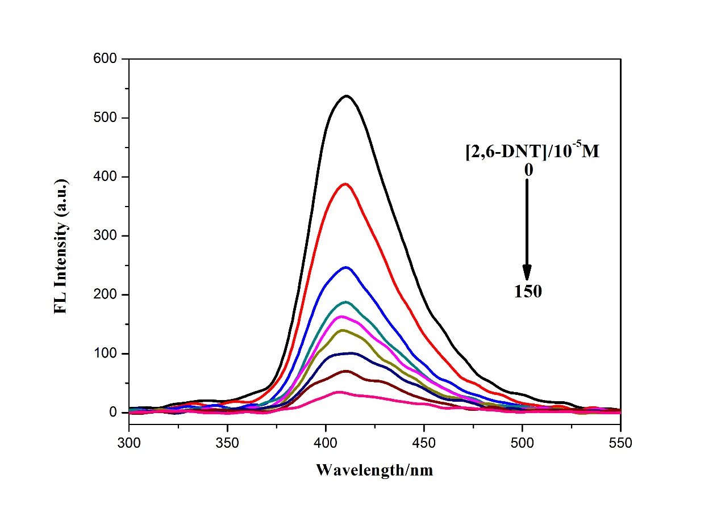
Figure S3. Fluorescence response of 1 to 2,6-DNT in DMF (λ_{ex} = 290 nm).
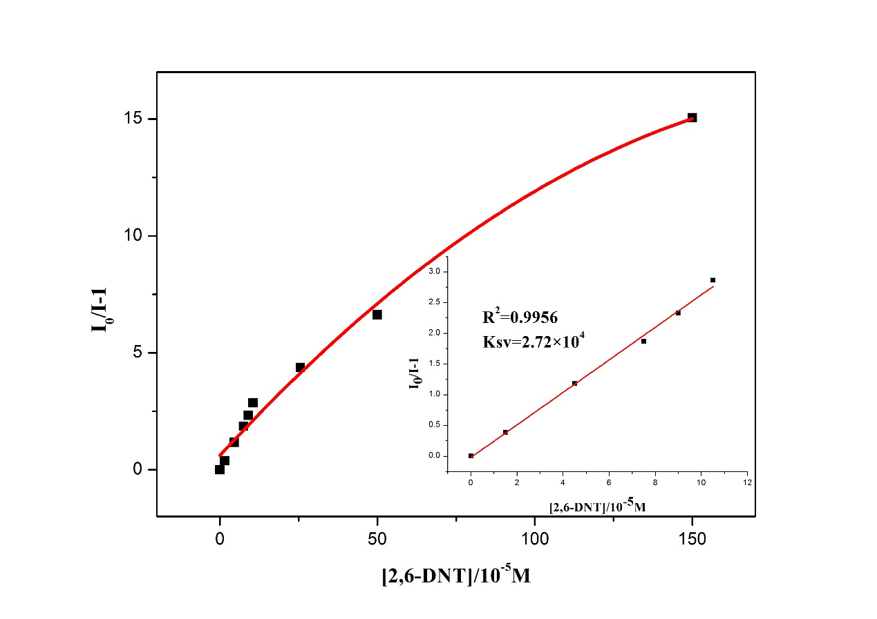
Figure S4. Views of Stern–Volmer plots for 2,6-DNT.
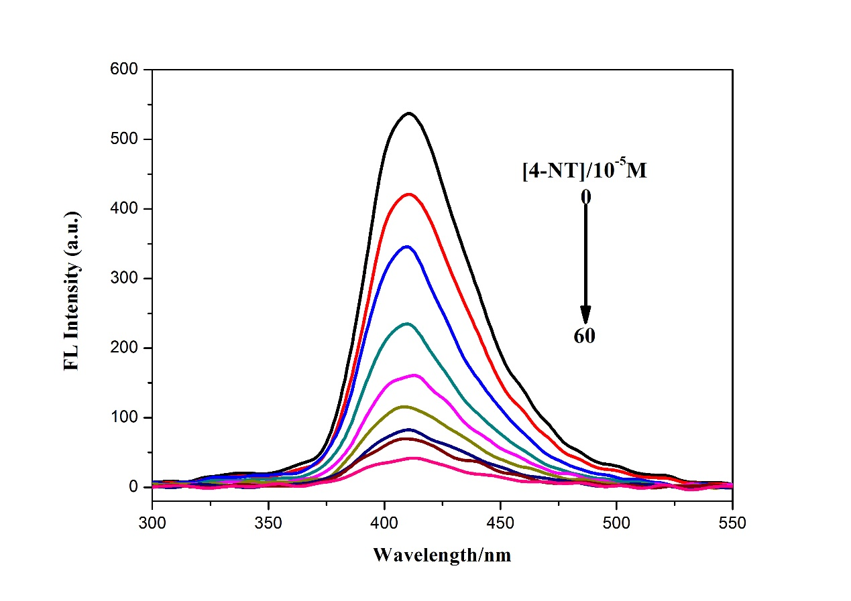
Figure S5. Fluorescence response of 1 to 4-NT in DMF (λ_{ex} = 290 nm).
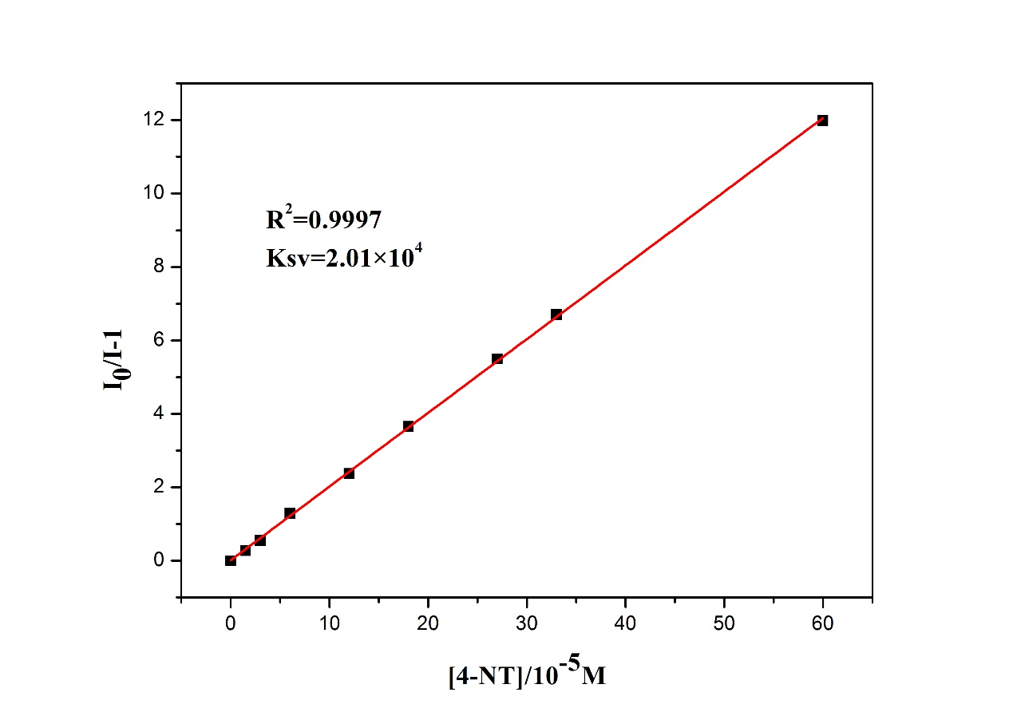
Figure S6. Views of Stern–Volmer plots for 4-NT.
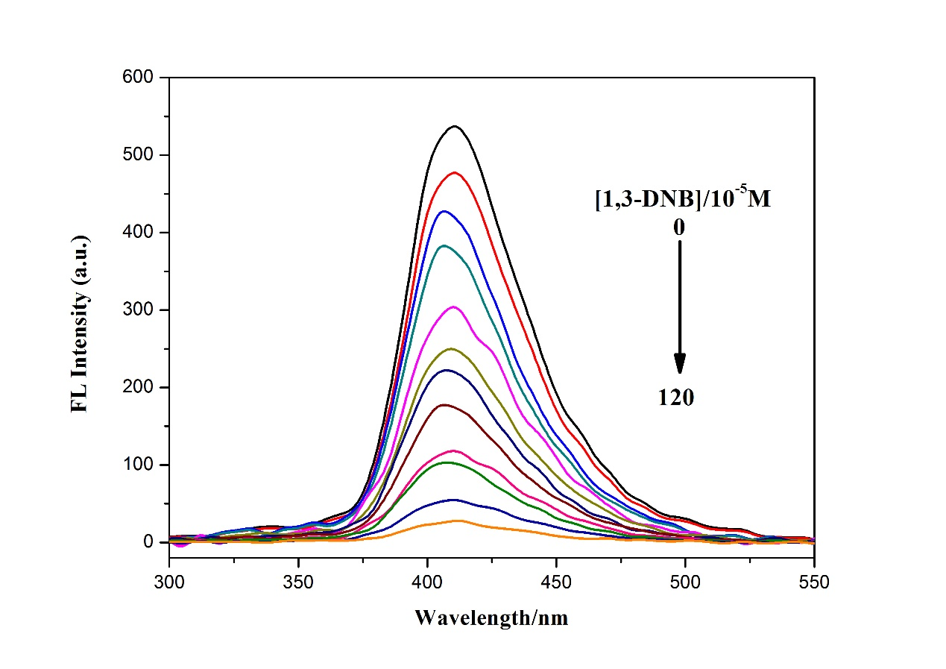
Figure S7. Fluorescence response of 1 to 1,3-DNB in DMF (λ_{ex} = 290 nm).
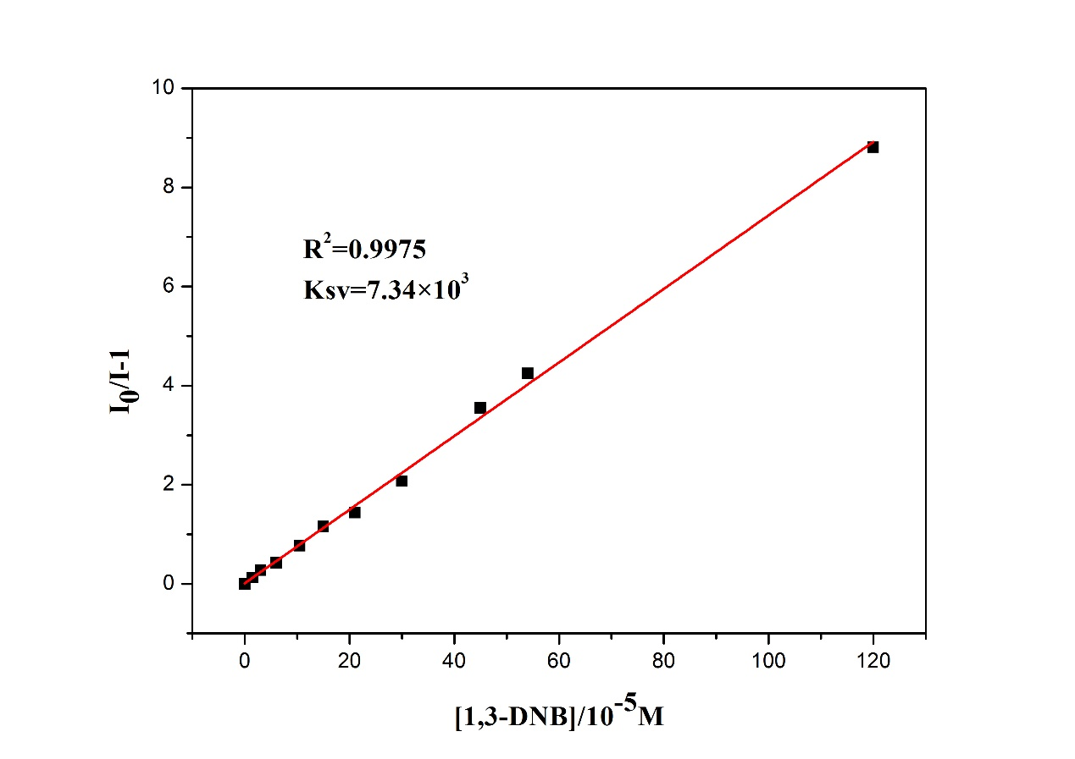
Figure S8. Views of Stern–Volmer plots for 1,3-DNB.
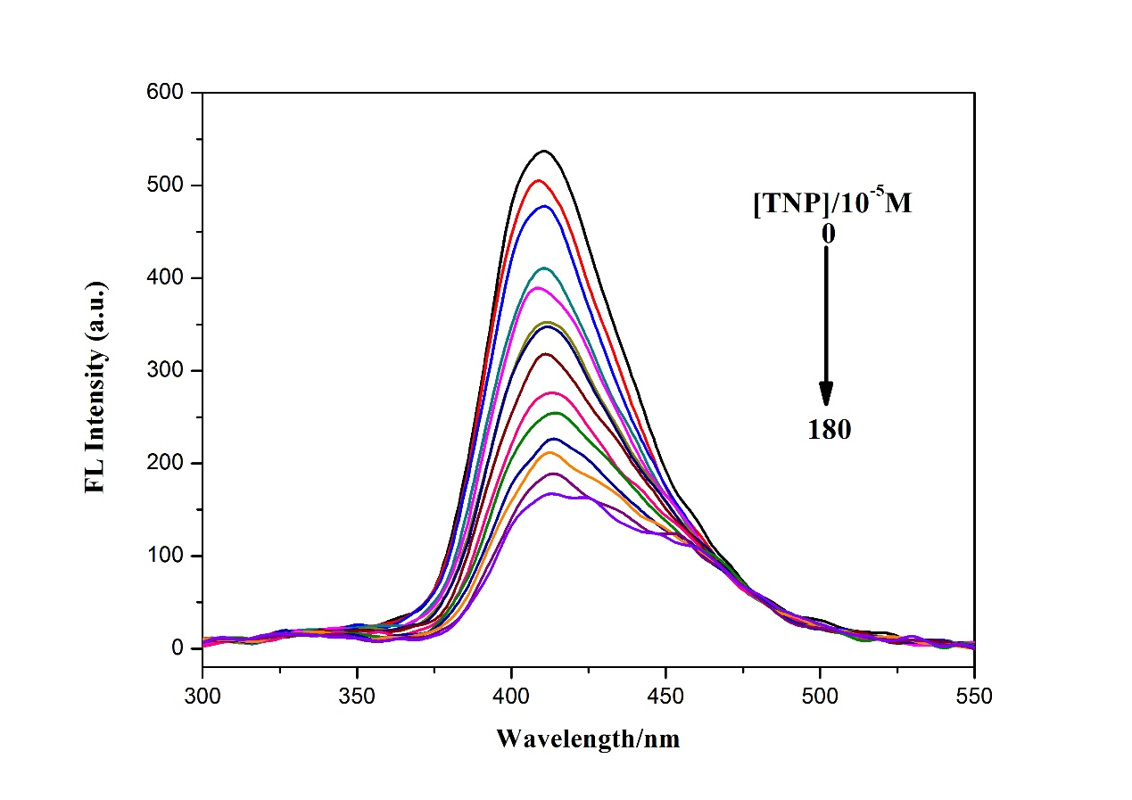
Figure S9. Fluorescence response of 1 to TNP in DMF (λ_{ex} = 290 nm).
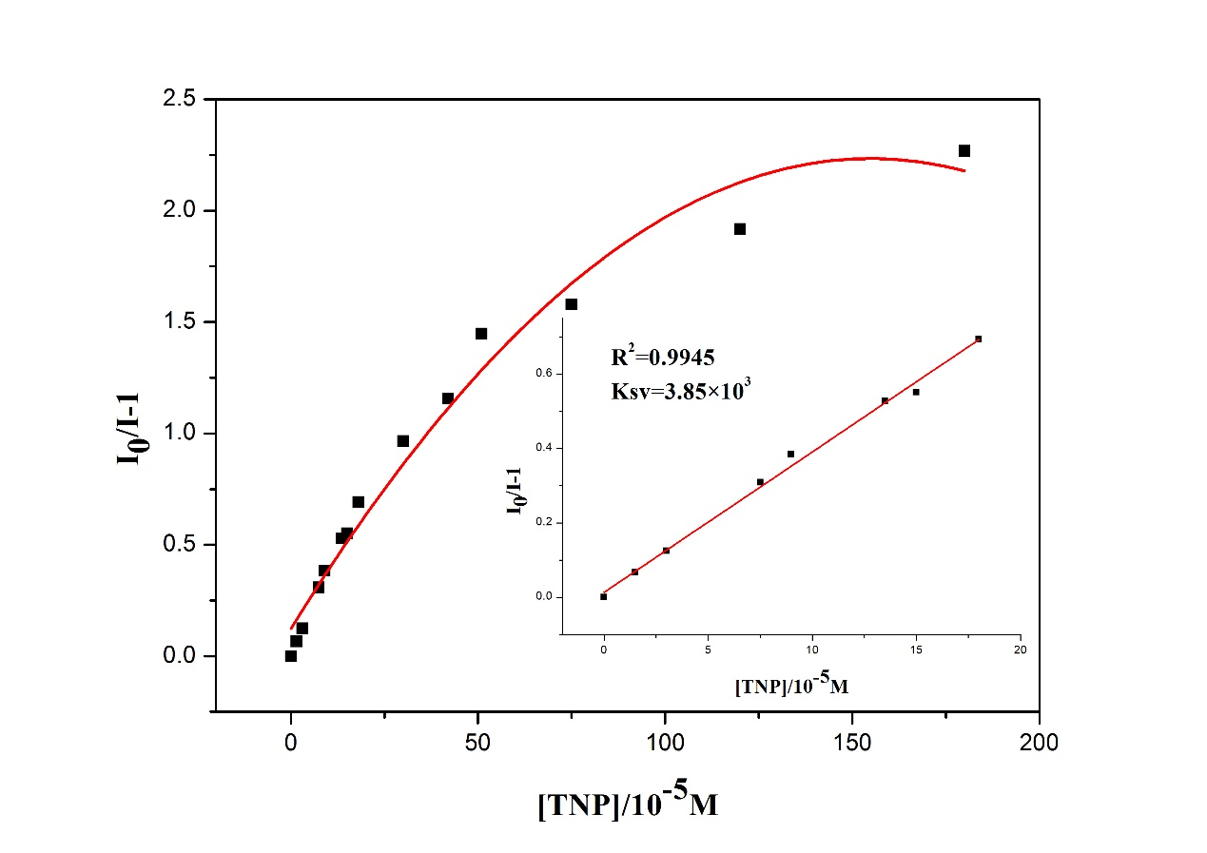
Figure S10. Views of Stern–Volmer plots for TNP.
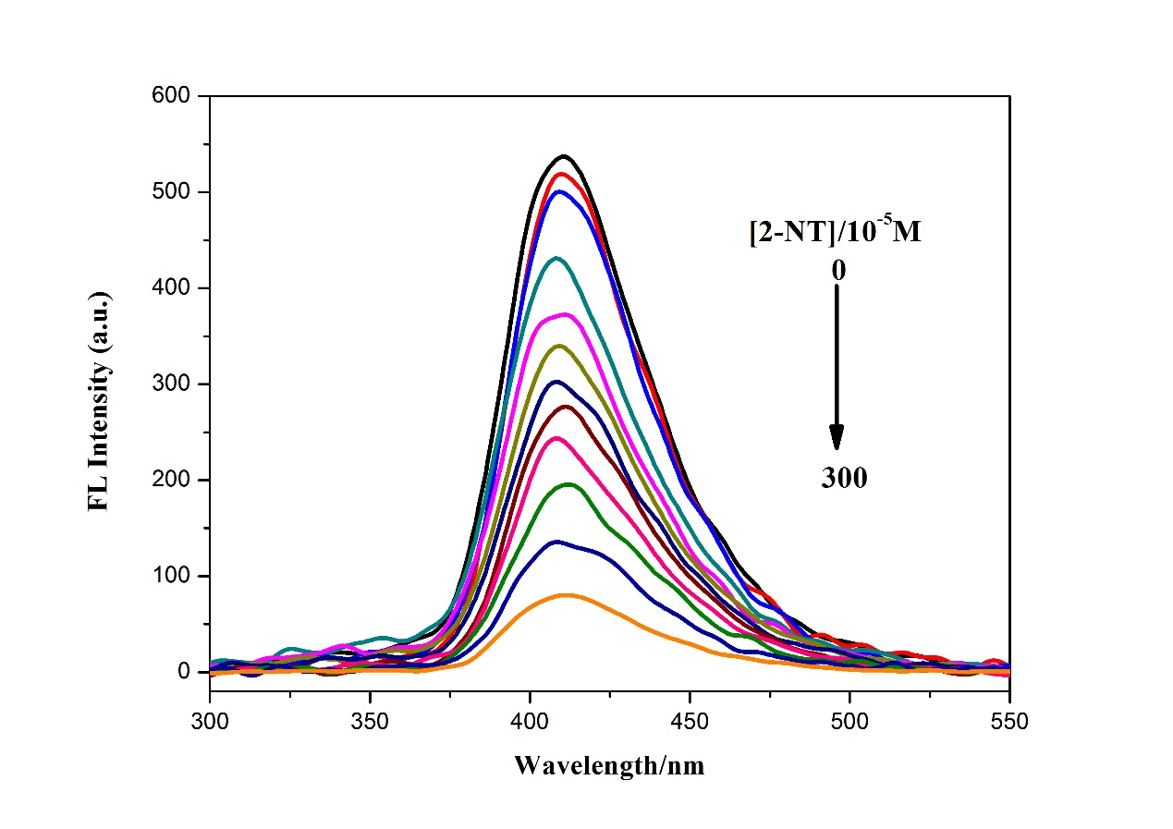
Figure S11. Fluorescence response of 1 to 2-NT in DMF (λ_{ex} = 290 nm).
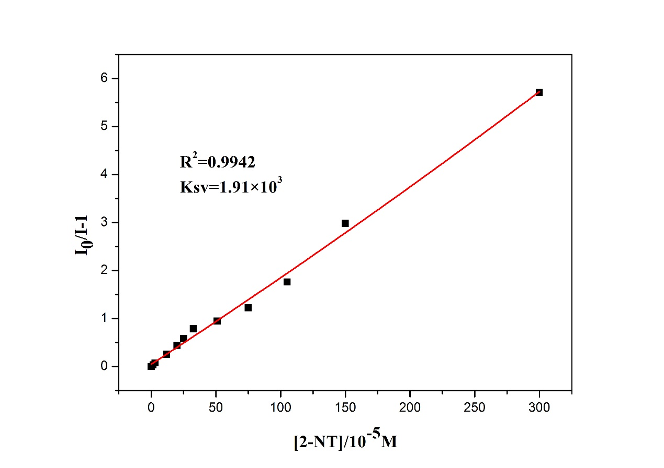
Figure S12. Views of Stern–Volmer plots for 2-NT.
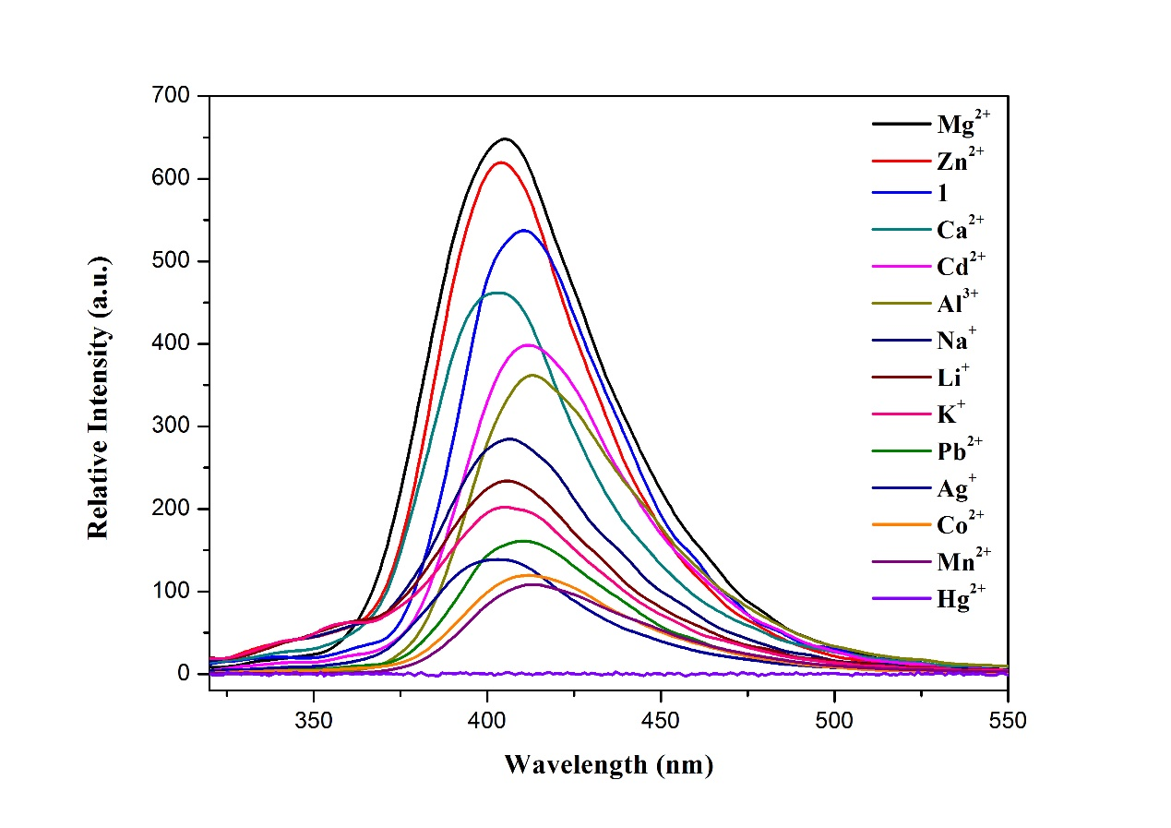
Figure S13. View of luminescent spectra for different metal ions in 1 (λ_{ex} = 290 nm).

Thermal analysis
The thermal stabilities of crystalline samples of 1 were measured under a nitrogen atmosphere. 1 has a two-step weight-loss process. The weight loss of 14.1% (calcd 13.7%) in the first step from 35 to 255 °C corresponds to the removal of one coordinated water and seven free water molecules. The second weight loss occurred in a temperature range from 305 to 575 °C, respectively, corresponding to the decomposition of the organic ligands (obsd: 64.8%; calcd: 65.1%). The remaining residue is attributed to the generation of CdO (obsd 22.8%, calcd 24.3%).
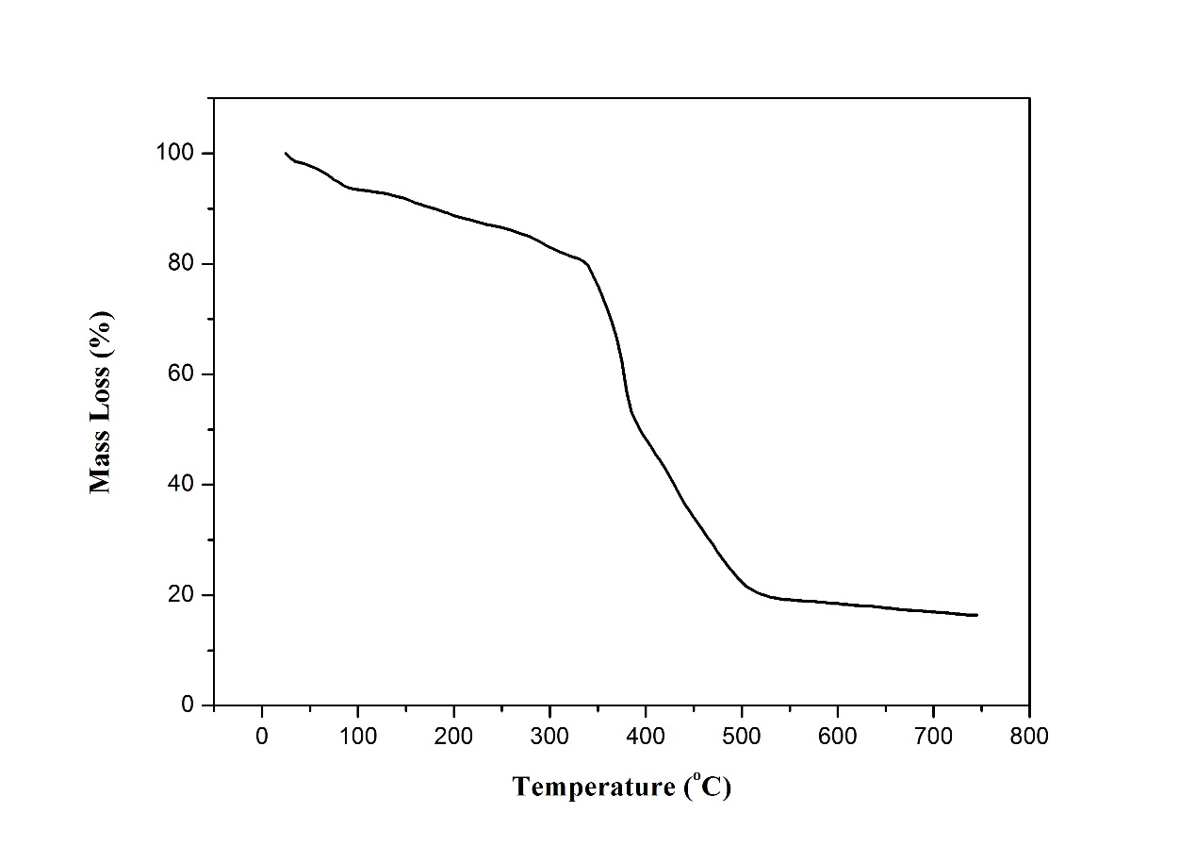
Figure S14. View of TGA in 1.

HOMO 1 | LUMO 1
HOMO 1,3-DNB | LUMO 1,3-DNB
HOMO NB | LUMO NB
HOMO 2,6-DNT | LUMO 2,6-DNT
HOMO 2-NT | LUMO 2-NT
HOMO 2,4-DNT | LUMO 2,4-DNT
HOMO 4-NT | LUMO 4-NT
HOMO TNP | LUMO TNP
HOMO TNT | LUMO TNT
Figure S15. HOMO–LUMO energies of the NACs along with 1.

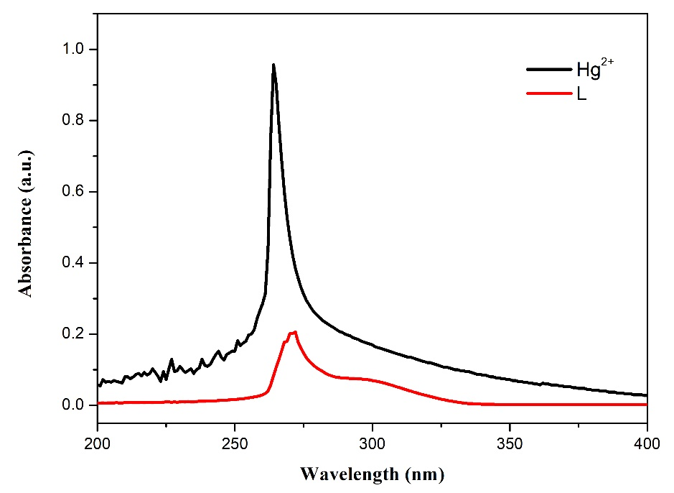
Figure S16. View of UV-vis spectra of H₂L and Hg²⁺.

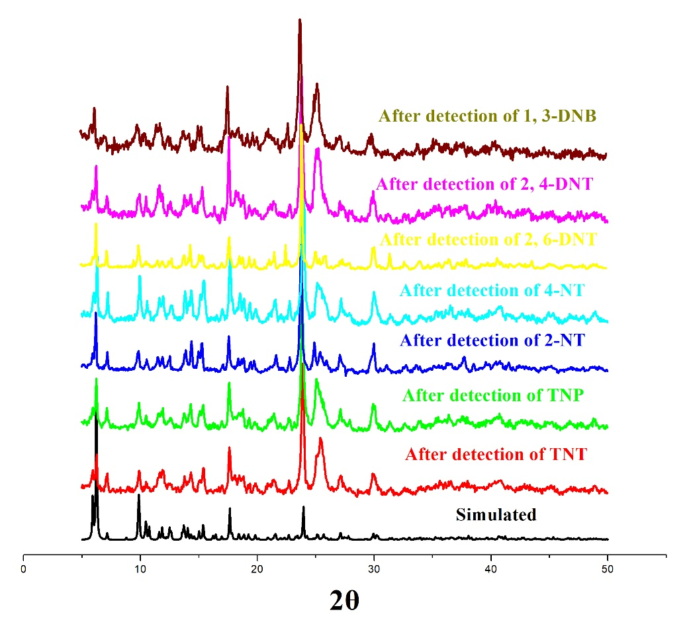
Figure S17. View of the PXRD pattern of 1 after detection of different explosives.

Table S1. LOD and K_{sv} values of 1 for analytes.
Analytes | LOD | Ksv(M⁻¹)
Hg²⁺ | 6.16×10⁻⁸ mol/L | 8.19×10⁵
TNT | 5.68×10⁻⁷ mol/L | 8.89×10⁴
TNP | 1.31×10⁻⁵ mol/L | 3.85×10³
4-NT | 2.40×10⁻⁶ mol/L | 2.01×10⁴
2-NT | 2.64×10⁻⁵ mol/L | 1.91×10³
2,6-DNT | 1.86×10⁻⁶ mol/L | 2.72×10⁴
1,3-DNB | 6.88×10⁻⁶ mol/L | 7.34×10³

Table S2. Comparison of the detective sensitivity in various Hg²⁺ sensors.
Material | Sensitivity | Reference
Et₄N[Co(L)₂] | 1×10⁻⁵ M | 1
Zn₂(dbtdcO₂)₂(tppe) | 3.33×10⁻⁹ M | 2
PCN-224 | 6×10⁻⁹ M | 3
{[Cd_{1.5}(C₁₈H₁₀O₁₀)]·(H₃O)(H₂O)₃}_{n} | 2×10⁻⁹ M | 4
COF-LZU8 | 25×10⁻⁹ M | 5
[Cd(₂NH₂bdc)(tib)·4H₂O·0.5DMA]_{n} | 4×10⁻⁸ M | 6
ZIF-60 | 3×10⁻⁹ M | 7
2,9-DMP | 40×10⁻⁹ M | 8
1 | 6.16×10⁻⁸ M | This work

References
[1] A. Mishra, J.H. Jo, H. Kim, S. Woo, K.W. Chi. ChemPlusChem, 79, 925 (2014).
[2] N.D. Rudd, H. Wang, E.M.A. Fuentes-Fernandez, S.J. Teat, F. Chen, G. Hall, Y.J. Chabal, J. Li. ACS Appl. Mater. Interfaces, 8, 30294 (2016).
[3] J. Yang, Z. Wang, Y. Li, Q. Zhuang, W. Zhao, J. Gu. RSC Adv., 6, 69807 (2016).
[4] P.Y. Wu, Y.H. Liu, Y. Liu, J.R. Wang, Y. Li, W. Liu, J. Wang. Inorg. Chem., 54, 11046 (2015).
[5] S.Y. Ding, M. Dong, Y.W. Wang, Y.T. Chen, H.Z. Wang, C.Y. Su, W. Wang. J. Am. Chem. Soc., 138, 3031 (2016).
[6] L.L. Wen, X.F. Zheng, K.L. Lv, C.G. Wang, X.Y. Xu. Inorg. Chem., 54, 7133 (2015).
[7] F. Xu, L. Kou, J. Jia, X. Hou, Z. Long, S. Wang. Anal. Chim. Acta, 804, 240 (2013).
[8] F.S. Shan, J.P. Lai, H. Sun, P. Zhang, C. Luo, Y.H. He, H.R. Feng. RSC Adv., 6, 66215 (2016).

