**Online Supplemental Material**

Evaluating the impacts of land use and land cover changes on surface air temperature using the WRF-mosaic approach

ZHAO De-Ming a and WU Jian b

aCAS Key Laboratory of Regional Climate-Environment for Temperate East Asia, Institute of Atmospheric Physics, Chinese Academy of Sciences, Beijing 100029, China; 2Department of Atmospheric Science, Yunnan University, Kunming 650091, China

**This file includes:**

**Supplementary Figures S1**–**S3 and Table S1**–**S2**

**1. Data and experimental design**

The data and experimental design described in Zhao and Wu (2017a) are repeated here with minor modifications, for the readers' convenience.

**1.1 Satellite-based LULC data**

Based on AVHRR and MODIS satellite data from the long-term land data record covering the last 30 years (Pedelty et al. 2007), two new types of LULC data from 1980 and 2010 were retrieved. Meanwhile, the Defense Meteorological Satellite Program–Operational Linescan System nighttime light data were used to extract the distribution of urban areas. Then the two images, which have a resolution of 30 km based on the IGBP-Modified MODIS 20-category land use categories and which can display the LULC distributions in 1980 and 2010 and be directly adopted in the WRF model, were produced from an annual LULC dataset with a resolution of 5 km (Xiao et al. 2013; Li et al. 2017). This was done due to the limitations of the available computing resources. These two images are hereafter abbreviated as LU80 and LU10. The methods and solutions used for processing this satellite-derived LULC data were discussed in Wang et al. (2014), Xiao et al. (2014) and Li et al. (2017).

**1.2 Experimental design**

Two numerical experiments using the WRF model were continuously integrated from 1 January 1979 to 31 December 2014 (36 years) based on the new LULC data (LU80 and LU10, which were kept unchanged for the individual integration) in place of the default LULC data in the WRF model. The first two years were used to ‘spin-up’ the model in the experiment, and only the results for the subsequent 34 years were analyzed. The central latitude and longitude of the simulated domain were 35°N and 108.5°E, respectively. The horizontal mesh consisted of 289 grid points in the longitudinal direction and 229 grid points in the latitudinal direction, including a 10-grid-point-wide buffer zone not used in the analysis (Figure S1a). The horizontal resolution was 30 km, and the pressure at the top of the model was 10 hPa. The model domain contained 51 levels in the vertical direction. The main physical parameterization schemes for the experiment included the WRF Single-Moment 6-class graupel microphysics scheme (Hong and Lim 2006), the RRTMG shortwave and longwave radiation schemes (Mlawer et al. 1997) with a flexible approach for reading the annual greenhouse gas concentrations [WRF modifications for regional climate simulation, CLWRF; *Fita et al.*, http://meteo.unican.es/files/pdfs/WRFusers_clwrf.pdf], the unified Noah land-surface model (Chen and Dudhia 2001), the single-layer Urban Canopy Model (Chen et al. 2006), the Yonsei University boundary-layer scheme (Hong et al. 2006), and the Kain-Fritsch (new Eta) cumulus scheme (Kain 2004).

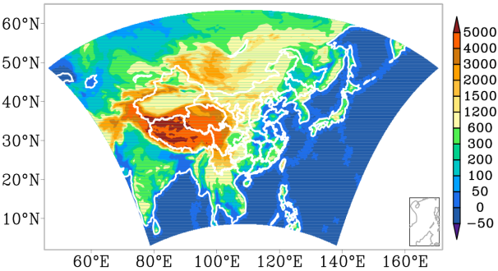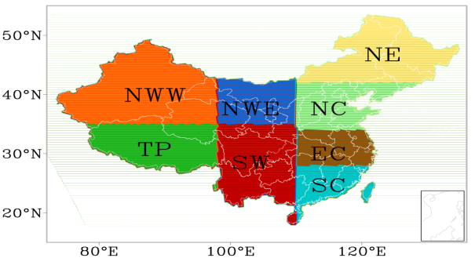

**b**

**a**

**Figure S1.** (a) Model domain and elevation distribution (unit: m) and (b) the eight subregions of China (NE: northeastern China; NC: northern China; EC: eastern China; SC: southern China; SW: southwestern China; NWE: eastern part of northwestern China; NWW: western part of northwestern China; TP: Tibetan Plateau).

**1.3 Forcing data**

The initial conditions and time-varying boundary conditions (updated every 6 hours) were taken from the NCEP - Department of Energy (DOE) Atmospheric Model Intercomparison Project (AMIP-II) reanalysis dataset for 1979 and 2014 (R-2, Kanamitsu et al. 2002) with a resolution of 2.5° × 2.5°.

**1.4 Observed surface air temperatures**

The observed SATs from 2400 China meteorological observation stations with a resolution of 0.25°×0.25 derived across the whole of China (CN05.1, Wu and Gao 2013) and the University of Delaware (UDEL) with a resolution of 0.5° × 0.5°(version 4.01) out of China (Matsuura and Willmott2015) were used for comparison with the simulated results. The observed data have been shown to perform well in terms of SAT simulations (Zhao et al. 2009; Zhao 2013). To compare the observed data and the simulated results, the data were remapped onto the model grid, which has a resolution of 30 km.

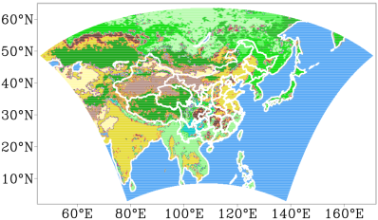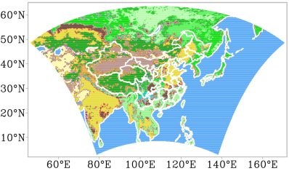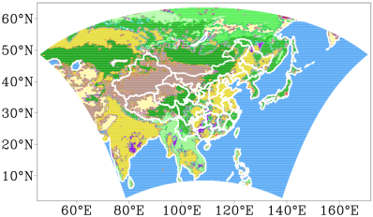

**a**

**b**

**c**

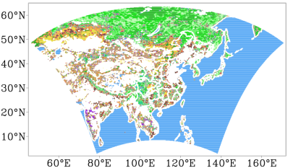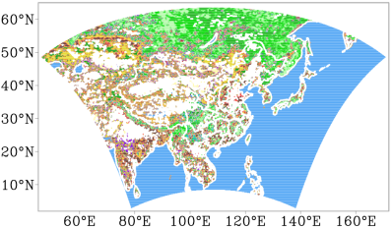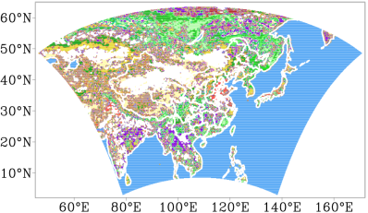

**f**

**e**

**d**

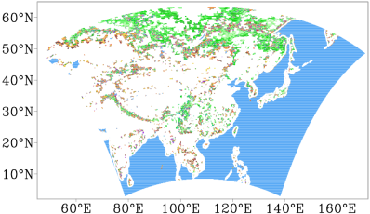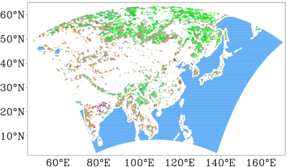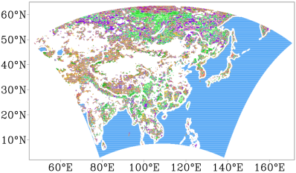

**g**

**h**

**it**

**Figure S2.** Spatial distributions of land use categories for the three dominant tiles within each grid cell for (a, d, g) LU80, (b, e, h) LU10, and (c, f, i) LU01 (a, b, c: the first tiles; d, e, f: the second tiles; g, h, i: the third tiles). Blue areas in (c-i) indicate water category, and white areas in (c-f) indicate that there are no second or third tiles. Land use categories: (1) evergreen needleleaf forest, (2) evergreen broadleaf forest, (3) deciduous needleleaf forest, (4) deciduous broadleaf forest, (5) mixed forests, (6) closed shrublands, (7) open shrublands, (8) woody savannas, (9) savannas, (10) grasslands, (11) permanent wetlands, (12) croplands, (13) urban and built-up areas, (14) cropland/natural vegetation mosaic, (15) snow and ice, (16) barren or sparsely vegetated, (17) water, (18) wooded tundra, (19) mixed tundra, (20) barren tundra.

**2. LULC changes using the mosaic approach**

To evaluate the impacts of LULC changes on the regional climate, comparisons of the land use categories between LU80 and LU10, as well as for LU01 for the three dominant tiles were performed. The sum of mean areal land use fractions for the three dominant tiles over the terrestrial areas were 97.9%, 97.7%, and 96.3% for LU80, LU10 and LU01, respectively. The corresponding values were 92.7%, 92.2%, and 90.9% for the two dominant tiles and 75.9%, 74.0% and 75.4% for the most dominant tile. The most dominant tiles (Figures S2a-S2c) revealed the main changes of each of the land use categories; however, the second (Figures S2d-S2f) and third (Figures S2g-S2i) dominant tiles also expressed substantial coverage and changes. Meanwhile, there were differences between the new and default LULC data. The number of changed model grid cells was 7084 for LU10-LU80 for the first dominant tiles across the simulated domain, which was approximately 21.7% of the total number of analyzed land grid cells.

In the different land use categories, greater spatial distributions and more intense changes were observed for forests, open shrublands, grasslands, croplands, cropland/natural vegetation mosaics, and barren or sparsely vegetated areas. Although the changes and distributions were lower in urban and built-up areas, they were not negligible in the LULC studies.

In the northern part of the simulated domain, the changes predominantly involved conversions in forests, permanent wetlands, and tundra. On the Indian subcontinent, these changes primarily occurred in croplands, cropland/natural vegetation mosaics, and savannas. On the Indo-China peninsula, the conversions in croplands, cropland/natural vegetation mosaics, and forests were the main contributors to the observed changes. In eastern China, the changes mainly occurred in forests, croplands, cropland/natural vegetation mosaics, and urban and built-up areas. The conversions in shrublands, grasslands, barren or sparsely vegetated areas, croplands, cropland/natural vegetation mosaics, and areas of snow and ice contributed to the changes observed in western China and central Asia. LULC changes induced conversions between different land use categories contributed to the increased albedo over the simulated domain with the exception of decreased values in southeastern part of China.

**3. Model performance in terms of SAT simulations**

Three regional monsoon systems make up the Asia–Pacific summer monsoon: the Indian Summer Monsoon (ISM), the western North Pacific summer monsoon (WNPSM), and the East Asian Summer Monsoon (EASM). The subregion between the ISM and WNPSM is a broad transitional zone over the Indo-China Peninsula and the Yun-Gui Plateau (Wang and Lin 2002). To reveal the influences of LULC changes, latitude–month cross sections of SAT in the three subregions are displayed, in which the following three subregions are defined: a subregion between 110°E and 125°E that covers East Asia (SREA); a subregion to the west of 98° E (SRINDIA) that includes the Indian subcontinent; and a subregion between 98° E and 110° E that includes the Indo-China Peninsula (SRINDO).

The model shows good performance in terms of simulated SAT for the three subregions (SREA, SRINDO and SRINDIA), where the annual variations were reproduced (Figures S3a-S3f). Analysis of the new LULC data adopted in the RCM showed that the SAT bias could be decreased (Zhao and Wu 2017b).



**a**

**b**

**c**



**e**

**d**

**f**



**h**

**g**

**io**

**Figure S3.** Latitude–month cross sections of monthly mean SAT from (a-c) UDEL and (d-f) LU80, as well as the corresponding differences from (g-i) LU10-LU80 in (a, d) SREA, (b, e) SRINDO, and (c, f) SRINDIA (units: °C).

**Table S1.** Changes in the annual, JJA and SON mean values for climatic variables [SAT (units: °C), the radiative forcings at the surface (RFB) and in the upper atmosphere (RFT) (units: W m-2)] in subregions of China, China as a whole and the land areas of East Asia, based on LU10-LU80.

|  |  |  |  |  |  |  |  |  |  |
| --- | --- | --- | --- | --- | --- | --- | --- | --- | --- |
|  | SAT | | | RFB | | | RFT | | |
|  | Annual | JJA | SON | Annual | JJA | SON | Annual | JJA | SON |
| NE | –0.13 | –0.049 | –0.092 | –1.07 | –1.33 | –0.88 | –0.76 | –0.68 | –0.72 |
| NC | –0.013 | 0.081 | 0.061 | 0.55 | 0.72 | 0.33 | 0.86 | 1.07 | 0.52 |
| EC | 0.14 | 0.15 | 0.25 | 1.50 | 2.76 | 0.83 | 1.28 | 1.69 | 0.60 |
| SC | 0.13 | 0.13 | 0.18 | 1.29 | 1.48 | 0.99 | 1.53 | 1.90 | 1.15 |
| SW | –0.0016 | –0.059 | 0.058 | 1.43 | 2.29 | 1.27 | 0.78 | 1.16 | 0.38 |
| NWE | –0.10 | –0.13 | 0.00065 | 0.46 | 0.51 | 0.52 | 0.19 | –0.13 | 0.16 |
| NWW | –0.14 | –0.22 | –0.097 | –0.99 | –2.20 | –1.02 | –1.16 | –2.45 | –1.29 |
| TP | –0.16 | –0.26 | –0.13 | –4.02 | –5.36 | –3.83 | –4.18 | –5.78 | –4.21 |
| CN | –0.062 | –0.087 | –0.0038 | –0.44 | –0.66 | –0.51 | –0.56 | –0.95 | –0.77 |
| EAL | –0.061 | –0.061 | –0.034 | –0.47 | –0.77 | –0.47 | –0.50 | –0.83 | –0.58 |

**Table S2.** JJA mean values from LU80 and the corresponding changes from LU10-LU80 for cloud fractions at different levels (low, middle and high) in southeastern (including EC, and SC) and northwestern (including NWE and NWW) China, China as a whole and the land areas of East Asia.

|  |  |  |  |  |  |  |  |  |
| --- | --- | --- | --- | --- | --- | --- | --- | --- |
|  | Low cloud | | Middle cloud | | High cloud | | Total cloud | |
|  | LU80 | Change | LU80 | Change | LU80 | Change | LU80 | Change |
| EC | 0.43 | −0.011 | 0.31 | −0.00085 | 0.26 | −0.014 | 0.33 | −0.0087 |
| SC | 0.64 | −0.0061 | 0.31 | 0.0056 | 0.23 | −0.0009 | 0.40 | −0.00046 |
| Southeastern China | 0.54 | −0.0085 | 0.31 | 0.0025 | 0.25 | −0.0075 | 0.37 | −0.0045 |
| NWE | 0.089 | 0.0043 | 0.27 | 0.0036 | 0.26 | −0.0041 | 0.21 | 0.0013 |
| NWW | 0.023 | 0.0018 | 0.16 | 0.0035 | 0.21 | −0.0015 | 0.13 | 0.0013 |
| Northwestern China | 0.045 | 0.0026 | 0.20 | 0.0035 | 0.22 | −0.0023 | 0.16 | 0.0013 |

**References**

Chen, F., J. Dudhia. 2001. "Coupling an advanced land-surface/hydrology model with the Penn State/NCAR MM5 modeling system. Part I: Model description and implementation." *Monthly Weather Review* 129: 569–585.

Chen, F., M. Tewari, H. Kusaka, et al.. 2006. "Current status of urban modeling in the community Weather Research and Forecast (WRF) model. Joint with Sixth Symposium on the Urban Environment and AMS forum: Managing our Physics and Natural Resources: Successes and Challeges." Atlanta, GA, USA, *American Meteorological Society* CD-ROM. J1.4.

Fita, L., J. Fernandez, M. Garcia-Diez. "CLWRF: WRF modifications for regional climate simulation under future scenarios." http://meteo.unican.es/files/pdfs/WRFusers_clwrf.pdf.

Hong, S.-Y., J.-O. Lim. 2006. "The WRF Single-Moment 6-Class Microphysics Scheme (WSM6)." *Journal of Korean Meteorological Society* 42: 129–151.

Hong, S.-Y., Y. Noh, J. Dudhia. 2006. "A new vertical diffusion package with an explicit treatment of entrainment processes" *Monthly Weather Review* 134: 2318–2341.

Kain, J. S.. 2004. "The Kain-Fritsch convective parameterization: An update." *Journal of Applied Meteorology* 43: 170–181.

Kanamitsu, M., W. Ebisuzaki, J. Woollen, et al.. 2002. "NCEP-DOE AMIP-II Reanalysis (R-2)." *Bulletin of American Meteorological Society* 83: 1631–1643, doi: 10.1175/BAMS-83-11-1631.

Li, H. X., P. F. Xiao, X. Z. Feng, et al.. 2017. "Using land long-term data records to map land cover changes in China over 1981–2010." *IEEE Journal of Selected Topics in Applied Earth Observation and Remote Sensing*10: 1372–1389.

Mlawer, E. J., S. J. Taubman, P. D. Brown, et al.. 1997. "Radiative transfer for inhomogeneous atmosphere: RRTM, a validated correlated-k model for the longwave" *Journal of Geophysical Research-Atmosphere* 102(D14): 16663–16682.

Matsuura, K., C. J. Willmott. 2015. "Terrestrial Air Temperature:  1900-2014 Gridded Monthly Time Series (Version 4.01)." Available at http://climate.geog.udel.edu/~climate/html_pages/Global2014/README.GlobalTsT2014.html.

Pedelty, J., S. Devadiga, E. Masuoka, et al.. 2007. "Generating a long-term land data record from the AVHRR and MODIS Instruments" *IEEE International Geoscience and Remote Sensing Symposium* 1021–1025.

Wang, B., H. Lin. 2002. "Rainy season of the Asian–Pacific summer monsoon." *Journal of Climate* 15: 386–398.

Wang, L. X., P. F. Xiao, X. Z. Feng, et al.. 2014. "Effective compositing method to produce cloud-free AVHRR image." *IEEE Geoscience and Remote Sensing Letters* 11: 328–332.

Wu, J., X. J. Gao. 2013. "A gridded daily observation dataset over China region and comparison with the other datasets (in Chinese)." *Chinese Journal of Geophysics* 56: 1102–1111. doi: 10.6038g20130406.

Xiao, P. F., H. X. Li, L. X. Wang, et al.. 2013. "Large-scale land cover change in China over the past 30 years." *Beijing Symposium on Global Change* 179pp.

Xiao, P. F., X. H. Wang, X. Z. Feng, et al.. 2014. "Detecting China’s urban expansion over the past three decades using nighttime light data" *IEEE Journal of Selected Topics in Applied Earth Obscation sand Remote Sensing* 7: 4095–4106.

Zhao, D. M.. 2013. "Performance of Regional Integrated Environment Modeling System (RIEMS) in precipitation simulations over East Asia." *Climatic Dynamics* 40: 1767–1787, doi: 10.1007/s00382-012-1660-1.

Zhao, D. M., C. B. Fu, X. D. Yan. 2009. "Testing the ability of RIEMS2.0 (Regional Integrated Environment Modeling System) to simulate multi-year precipitation and air temperature in China." *Chinese Science Bulletin* 54: 3101–3111, doi: 10.1007/s11434-009-0178-3.

Zhao, D. M., J. Wu. 2017a. "The impact of land use and land cover changes on East Asian summer monsoon precipitation using the WRF-mosaic approach." *Atmospheric Science Letters* doi: 10.1002/asl.788

Zhao, D. M., J. Wu. 2017b. "Inclusion of land use changes in long-term regional climate simulations over East Asia." *Atmospheric Science Letters* doi: 10.1002/asl.744.