Montmorillonite K-10 catalyzed Mannich reaction - Synthesis of aminonaphthoquinone derivatives from Lawsone
Sankaranarayanan Jayashree and Kalegowda Shivashankar*
P.G. Department of Chemistry, Central College Campus, Bangalore University,
Bangalore - 560 001, Karnataka, India.
*Corresponding author: E-mail address: shivashankark@gmail.comTel: +91-80-22961249, (K. Shivashankar)

Synthetic Procedure for various aminonaphthoquinones
Synthetic procedure for the preparation of 2-hydroxy-3-(phenyl(phenylamino)methyl)naphthalene-1,4-dione (4a)
A mixture of benzaldehyde (1 mmol), aniline (1 mmol), 2-hydroxynaphthalene-1,4-dione (1 mmol) and montmorillonite K-10 (10 mol%) was stirred in ethanol (3 mL). After the completion of the reaction, as indicated by TLC, the mixture was diluted with CH₂Cl₂ and the catalyst was separated by filtration. The solvent was evaporated under reduced pressure to get the crude product that was recrystallized from ethanol to get 2-hydroxy-3-(phenyl(phenylamino)methyl)naphthalene-1,4-dione.

Synthetic procedure for the preparation of 2-hydroxy-3-(phenyl(p-tolylamino)methyl)naphthalene-1,4-dione (4b)
A mixture of benzaldehyde (1 mmol), 4-methylaniline (1 mmol), 2-hydroxynaphthalene-1,4-dione (1 mmol) and montmorillonite K-10 (10 mol%) was stirred in ethanol (3 mL). After the completion of the reaction, as indicated by TLC, the mixture was diluted with CH₂Cl₂ and the catalyst was separated by filtration. The solvent was evaporated under reduced pressure to get the crude product that was recrystallized from ethanol to get 2-hydroxy-3-(phenyl(p-tolylamino)methyl)naphthalene-1,4-dione.

Synthetic procedure for the preparation of 2-hydroxy-3-(p-tolyl(p-tolylamino)methyl)naphthalene-1,4-dione (4c)
A mixture of 4-methylbenzaldehyde (1 mmol), 4-methylaniline (1 mmol), 2-hydroxynaphthalene-1,4-dione (1 mmol) and montmorillonite K-10 (10 mol%) was stirred in ethanol (3 mL). After the completion of the reaction, as indicated by TLC, the mixture was diluted with CH₂Cl₂ and the catalyst was separated by filtration. The solvent was evaporated under reduced pressure to get the crude product that was recrystallized from ethanol to get 2-hydroxy-3-(p-tolyl(p-tolylamino)methyl)naphthalene-1,4-dione.

Synthetic procedure for the preparation of 2-((4-chlorophenyl)(p-tolylamino)methyl-3-hydroxy)naphthalene-1,4-dione (4d):
A mixture of 4-chlorobenzaldehyde (1 mmol), 4-methylaniline (1 mmol), 2-hydroxynaphthalene-1,4-dione (1 mmol) and montmorillonite K-10 (10 mol%) was stirred in ethanol (3 mL). After the completion of the reaction, as indicated by TLC, the mixture was diluted with CH₂Cl₂ and the catalyst was separated by filtration. The solvent was evaporated under reduced pressure to get the crude product that was recrystallized from ethanol to get 2-((4-chlorophenyl)(p-tolylamino)methyl-3-hydroxy)naphthalene-1,4-dione.

Synthetic procedure for the preparation of 2-hydroxy-3-(4-bromophenyl(p-tolylamino)methyl)naphthalene-1,4-dione (4e)
A mixture of 4-bromobenzaldehyde (1 mmol), 4-methylaniline (1 mmol), 2-hydroxynaphthalene-1,4-dione (1 mmol) and montmorillonite K-10 (10 mol%) was stirred in ethanol (3 mL). After the completion of the reaction, as indicated by TLC, the mixture was diluted with CH₂Cl₂ and the catalyst was separated by filtration. The solvent was evaporated under reduced pressure to get the crude product that was recrystallized from ethanol to get 2-hydroxy-3-(4-bromophenyl(p-tolylamino)methyl)naphthalene-1,4-dione.

Synthetic procedure for the preparation of 2-hydroxy-3-(((4-nitrophenyl)(p-tolyl)amino)methyl)naphthalene-1,4-dione (4f)
A mixture of 4-methylbenzaldehyde (1 mmol), 4-nitroaniline (1 mmol), 2-hydroxynaphthalene-1,4-dione (1 mmol) and montmorillonite K-10 (10 mol%) was stirred in ethanol (3 mL). After the completion of the reaction, as indicated by TLC, the mixture was diluted with CH₂Cl₂ and the catalyst was separated by filtration. The solvent was evaporated under reduced pressure to get the crude product that was recrystallized from ethanol to get 2-hydroxy-3-(((4-nitrophenyl)(p-tolyl)amino)methyl)naphthalene-1,4-dione.
Synthetic procedure for the preparation of 2-hydroxy-3-((4-nitrophenyl)(4-nitrophenyl)amino)methyl)naphthalene-1,4-dione (4g)
A mixture of 4-nitrobenzaldehyde (1 mmol), 4-nitroaniline (1 mmol), 2-hydroxynaphthalene-1,4-dione (1 mmol) and montmorillonite K-10 (10 mol%) was stirred in ethanol (3 mL). After the completion of the reaction, as indicated by TLC, the mixture was diluted with CH₂Cl₂ and the catalyst was separated by filtration. The solvent was evaporated under reduced pressure to get the crude product that was recrystallized from ethanol to get 2-hydroxy-3-((4-nitrophenyl)(4-nitrophenyl)amino)methyl)naphthalene-1,4-dione.

Synthetic procedure for the preparation of 2-hydroxy-3-((4-chlorophenyl)(4-nitrophenyl)amino)methyl)naphthalene-1,4-dione (4h)
A mixture of 4-chlorobenzaldehyde (1 mmol), 4-nitroaniline (1 mmol), 2-hydroxynaphthalene-1,4-dione (1 mmol) and montmorillonite K-10 (10 mol%) was stirred in ethanol (3 mL). After the completion of the reaction, as indicated by TLC, the mixture was diluted with CH₂Cl₂ and the catalyst was separated by filtration. The solvent was evaporated under reduced pressure to get the crude product that was recrystallized from ethanol to get 2-hydroxy-3-((4-chlorophenyl)(4-nitrophenyl)amino)methyl)naphthalene-1,4-dione.

Synthetic procedure for the preparation of 2-hydroxy-3-((4-chlorophenyl)((4-methoxyphenyl)amino)methyl)naphthalene-1,4-dione (4i)
A mixture of 4-chlorobenzaldehyde (1 mmol), 4-methoxyaniline (1 mmol), 2-hydroxynaphthalene-1,4-dione (1 mmol) and montmorillonite K-10 (10 mol%) was stirred in ethanol (3 mL). After the completion of the reaction, as indicated by TLC, the mixture was diluted with CH₂Cl₂ and the catalyst was separated by filtration. The solvent was evaporated under reduced pressure to get the crude product that was recrystallized from ethanol to get 2-hydroxy-3-((4-chlorophenyl)((4-methoxyphenyl)amino)methyl)naphthalene-1,4-dione.

Synthetic procedure for the preparation of 2-hydroxy-3-((4-methoxyphenyl)amino((4-nitrophenyl)methyl)naphthalene-1,4-dione (4j)
A mixture of 4-nitrobenzaldehyde (1 mmol), 4-methoxyaniline (1 mmol), 2-hydroxynaphthalene-1,4-dione (1 mmol) and montmorillonite K-10 (10 mol%) was stirred in ethanol (3 mL). After the completion of the reaction, as indicated by TLC, the mixture was diluted with CH₂Cl₂ and the catalyst was separated by filtration. The solvent was evaporated under reduced pressure to get the crude product that was recrystallized from ethanol to get 2-hydroxy-3-((4-methoxyphenyl)amino((4-nitrophenyl)methyl)naphthalene-1,4-dione.

Synthetic procedure for the preparation of 2-hydroxy-3-((2-nitrophenyl(phenylamino)methyl)naphthalene-1,4-dione (4k)
A mixture of 2-nitrobenzaldehyde (1 mmol), aniline (1 mmol), 2-hydroxynaphthalene-1,4-dione (1 mmol) and montmorillonite K-10 (10 mol%) was stirred in ethanol (3 mL). After the completion of the reaction, as indicated by TLC, the mixture was diluted with CH₂Cl₂ and the catalyst was separated by filtration. The solvent was evaporated under reduced pressure to get the crude product that was recrystallized from ethanol to get 2-hydroxy-3-((2-nitrophenyl(phenylamino)methyl)naphthalene-1,4-dione.

Synthetic procedure for the preparation of 2-((2,6-dimethylphenyl)(phenylamino)methyl)-3-hydroxynaphthalene-1,4-dione (4l)
A mixture of 2,6-dimethylbenzaldehyde (1 mmol), aniline (1 mmol), 2-hydroxynaphthalene-1,4-dione (1 mmol) and montmorillonite K-10 (10 mol%) was stirred in ethanol (3 mL). After the completion of the reaction, as indicated by TLC, the mixture was diluted with CH₂Cl₂ and the catalyst was separated by filtration. The solvent was evaporated under reduced pressure to get the crude product that was recrystallized from ethanol to get 2-((2,6-dimethylphenyl)(phenylamino)methyl)-3-hydroxynaphthalene-1,4-dione.
.
Synthetic procedure for the preparation of 2-hydroxy-3-((phenylamino)(3,4,5-trimethoxyphenyl)methyl)naphthalene-1,4-dione (4m)
A mixture of 3,4,5-trimethoxybenzaldehyde (1 mmol), aniline (1 mmol), 2-hydroxynaphthalene-1,4-dione (1 mmol) and montmorillonite K-10 (10 mol%) was stirred in ethanol (3 mL). After the completion of the reaction, as indicated by TLC, the mixture was diluted with CH₂Cl₂ and the catalyst was separated by filtration. The solvent was evaporated under reduced pressure to get the crude product that was recrystallized from ethanol to get 2-hydroxy-3-(phenylamino)(3,4,5-trimethoxyphenyl)methyl)naphthalene-1,4-dione.

Synthetic procedure for the preparation of 2-hydroxy-3-((4-nitrophenyl)pyridin-2-ylamino)methyl)naphthalene-1,4-dione (4n)
A mixture of 4-nitrobenzaldehyde (1 mmol), 2-aminopyridine (1 mmol), 2-hydroxynaphthalene-1,4-dione (1 mmol) and montmorillonite K-10 (10 mol%) was stirred in ethanol (3 mL). After the completion of the reaction, as indicated by TLC, the mixture was diluted with CH₂Cl₂ and the catalyst was separated by filtration. The solvent was evaporated under reduced pressure to get the crude product that was recrystallized from ethanol to get 2-hydroxy-3-((4-nitrophenyl)pyridin-2-ylamino)methyl)naphthalene-1,4-dione.

Synthetic procedure for the preparation of 2-(((1H-benzo[d]imidazol-2-yl)amino(4-nitrophenyl)methyl)-3-hydroxynaphthalene-1,4-dione (4o)
A mixture of 4-nitrobenzaldehyde (1 mmol), 2-aminobenzimidazole (1 mmol), 2-hydroxynaphthalene-1,4-dione (1 mmol) and montmorillonite K-10 (10 mol%) was stirred in ethanol (3 mL). After the completion of the reaction, as indicated by TLC, the mixture was diluted with CH₂Cl₂ and the catalyst was separated by filtration. The solvent was evaporated under reduced pressure to get the crude product that was recrystallized from ethanol to get 2-(((1H-benzo[d]imidazol-2-yl)amino(4-nitrophenyl)methyl)-3-hydroxynaphthalene-1,4-dione.

Synthetic procedure for the preparation of 2-((benzo[d]thiazol-2-yl)amino(phenyl)methyl)-3-hydroxynaphthalene-1,4-dione (4p)
A mixture of benzaldehyde (1 mmol), 2-aminobenzothiazole (1 mmol), 2-hydroxynaphthalene-1,4-dione (1 mmol) and montmorillonite K-10 (10 mol%) was stirred in ethanol (3 mL). After the completion of the reaction, as indicated by TLC, the mixture was diluted with CH₂Cl₂ and the catalyst was separated by filtration. The solvent was evaporated under reduced pressure to get the crude product that was recrystallized from ethanol to get 2-((benzo[d]thiazol-2-yl)amino(phenyl)methyl)-3-hydroxynaphthalene-1,4-dione.

Synthetic procedure for the preparation of 2-((benzo[d]thiazol-2-yl)amino(4-nitrophenyl)methyl)-3-hydroxynaphthalene-1,4-dione (4q)
A mixture of 4-nitrobenzaldehyde (1 mmol), 2-aminobenzothiazole (1 mmol), 2-hydroxynaphthalene-1,4-dione (1 mmol) and montmorillonite K-10 (10 mol%) was stirred in ethanol (3 mL). After the completion of the reaction, as indicated by TLC, the mixture was diluted with CH₂Cl₂ and the catalyst was separated by filtration. The solvent was evaporated under reduced pressure to get the crude product that was recrystallized from ethanol to get 2-((benzo[d]thiazol-2-yl)amino(4-nitrophenyl)methyl)-3-hydroxynaphthalene-1,4-dione.

Synthetic procedure for the preparation of 2-((benzo[d]thiazol-2-ylamino)(4-hydroxyphenyl)methyl)-3-hydroxynaphthalene-1,4-dione (4r)
A mixture of 4-hydroxybenzaldehyde (1 mmol), 2-aminobenzothiazole (1 mmol), 2-hydroxynaphthalene-1,4-dione (1 mmol) and montmorillonite K-10 (10 mol%) was stirred in ethanol (3 mL). After the completion of the reaction, as indicated by TLC, the mixture was diluted with CH₂Cl₂ and the catalyst was separated by filtration. The solvent was evaporated under reduced pressure to get the crude product that was recrystallized from ethanol to get 2-((benzo[d]thiazol-2-ylamino)(4-hydroxyphenyl)methyl)-3-hydroxynaphthalene-1,4-dione.

Synthetic procedure for the preparation of 2-((benzo[d]thiazol-2-ylamino)(4-bromophenyl)methyl)-3-hydroxynaphthalene-1,4-dione (4s)
A mixture of 4-bromobenzaldehyde (1 mmol), 2-aminobenzothiazole (1 mmol), 2-hydroxynaphthalene-1,4-dione (1 mmol) and montmorillonite K-10 (10 mol%) was stirred in ethanol (3 mL). After the completion of the reaction, as indicated by TLC, the mixture was diluted with CH₂Cl₂ and the catalyst was separated by filtration. The solvent was evaporated under reduced pressure to get the crude product that was recrystallized from ethanol to get 2-((benzo[d]thiazol-2-ylamino)(4-bromophenyl)methyl)-3-hydroxynaphthalene-1,4-dione.

Synthetic procedure for the preparation of 2-((benzo[d]thiazol-2-ylamino)(p-tolyl)methyl)-3-hydroxynaphthalene-1,4-dione (4t)
A mixture of 4-methylbenzaldehyde (1 mmol), 2-aminobenzothiazole (1 mmol), 2-hydroxynaphthalene-1,4-dione (1 mmol) and montmorillonite K-10 (10 mol%) was stirred in ethanol (3 mL). After the completion of the reaction, as indicated by TLC, the mixture was diluted with CH₂Cl₂ and the catalyst was separated by filtration. The solvent was evaporated under reduced pressure to get the crude product that was recrystallized from ethanol to get 2-((benzo[d]thiazol-2-ylamino)(p-tolyl)methyl)-3-hydroxynaphthalene-1,4-dione.

SPECTRAL DETAILS
2-Hydroxy-3-(phenyl(phenylamino)methyl)naphthalene-1,4-dione (4a) (Lit. ²⁸)
Yield 93%; An orange solid; mp: 143-145 ºC; IR (ATR cm⁻¹): 3420 (OH), 3321 (NH), 1660 (C=O), 1636 (C=O); ¹H NMR (400 MHz, DMSO-d₆): δ 11.18 (s, 1H, OH), 10.12 (s, 1H, NH), 7.94-6.82 (m, 14H, Ar-H), 6.01 (s, 1H, CH) ppm; ¹³C NMR (100 MHz, DMSO-d₆): δ 182.4, 180.6, 153.1, 145.2, 143.8, 135.7 (2C), 131.2, 130.9, 129.4 (2C), 128.8 (2C), 127.7, 126.9 (2C), 125.7 (2C), 120.1, 117.3, 113.2 (2C), 52.3 ppm.

2-Hydroxy-3-(phenyl(p-tolylamino)methyl)naphthalene-1,4-dione (4b) (Lit. ²⁸)
Yield 85%; A yellow solid; mp: 147-149 ºC; IR (ATR cm⁻¹): 3391 (OH), 3324 (NH), 1665 (C=O), 1634 (C=O); ¹H NMR (400 MHz, DMSO-d₆): δ 11.08 (s, 1H, OH), 10.04 (s, 1H, NH), 7.9-6.51 (m, 13H, Ar-H), 6.13 (s, 1H, CH), 2.37 (s, 3H, CH₃) ppm; ¹³C NMR (100 MHz, DMSO-d₆): δ 183.9, 181.8, 153.8, 144.5, 142.2, 135.8 (2C), 131.1, 130.2, 129.9 (2C), 128.4, 127.2 (2C), 126.5 (2C), 125.7, 124.7 (2C), 116.0, 113.0 (2C), 52.1, 21.8 ppm.

2-Hydroxy-3-(p-tolyl(p-tolylamino)methyl)naphthalene-1,4-dione (4c) (Lit. ²⁸)
Yield 88%; A dark red solid; mp: 146-148 ºC; IR (ATR cm⁻¹): 3427 (OH), 3332 (NH), 1675 (C=O), 1645 (C=O); ¹H NMR (400 MHz, DMSO-d₆): δ 11.21 (s, 1H, OH), 9.92 (s, 1H, NH), 7.94-6.47 (m, 12H, Ar-H), 6.18 (s, 1H, CH), 2.35 (s, 6H, two CH₃ gps) ppm; ¹³C NMR (100 MHz, DMSO-d₆): δ 183.1, 181.5, 153.1, 142.2, 140.4, 136.2, 135.5 (2C), 131.7, 130.4, 129.8 (2C), 129.1, 128.2 (2C), 126.9 (4C), 117.8, 113.8 (2C), 52.7, 21.6 (2C) ppm.

2- ((4-Chlorophenyl)(p-tolylamino)methyl-3-hydroxy)naphthalene-1,4-dione (4d): (Lit. ³³)
Yield 83%; An orange solid; mp: 151-153 ºC; IR (ATR cm⁻¹): 3397 (OH), 3325 (NH), 1681 (C=O), 1653 (C=O); ¹H NMR (400 MHz, DMSO-d₆): δ 11.17 (s, 1H, OH), 10.18 (s, 1H, NH), 7.93-6.47 (m, 12H, Ar-H), 6.12 (s, 1H, CH), 2.34 (s, 3H, CH₃) ppm; ¹³C NMR (100 MHz, DMSO-d₆): δ 183.4, 181.1, 152.4, 143.6, 142.6, 135.3 (2C), 132.8, 131.5, 130.0, 129.8 (2C), 129.3, 128.0 (2C), 126.6 (2C), 126.3 (2C), 117.5, 113.4 (2C), 52.0, 21.8 ppm.

2-Hydroxy-3-(4-bromophenyl(p-tolylamino)methyl)naphthalene-1,4-dione (4e) (Lit. ²⁸)
Yield 90%; An orange solid; mp: 148-150 ºC. IR (ATR cm⁻¹): 3393 (OH), 3318 (NH), 1672 (C=O), 1649 (C=O); ¹H NMR (400 MHz, DMSO-d₆): δ 11.31 (s, 1H, OH), 9.97 (s, 1H, NH), 7.98-6.45 (m, 12H, Ar-H), 6.13 (s, 1H, CH), 2.24 (s, 3H, CH₃) ppm; ¹³C NMR (100 MHz, DMSO-d₆): δ 183.4, 181.8, 153.4, 143.0, 142.9, 135.8 (2C), 132.8 (2C), 131.6, 130.1, 129.8 (2C), 129.2, 128.8 (2C), 126.5 (2C), 121.5, 117.8, 113.6 (2C), 52.2, 21.9 ppm.

2-Hydroxy-3-(((4-nitrophenyl)(p-tolyl)amino)methyl)naphthalene-1,4-dione (4f) (Lit. ³³)
Yield 81%; An orange solid; mp: 145-147 ºC. IR (ATR cm⁻¹): 3419 (OH), 3321 (NH), 1679 (C=O), 1650 (C=O); ¹H NMR (400 MHz, DMSO-d₆): δ 11.31 (s, 1H, OH), 10.07 (s, 1H, NH), 8.05-6.76 (m, 12H, Ar-H), 6.18 (s, 1H, CH), 2.39 (s, 3H, CH₃) ppm; ¹³C NMR (100 MHz, DMSO-d₆): δ 183.3, 181.1, 153.6, 151.9, 140.3, 137.2, 136.1, 135.7 (2C), 131.2, 130.8, 128.7 (2C), 127.3 (2C), 126.6 (4C), 117.9, 114.8 (2C), 52.4, 21.6 ppm.

2-Hydroxy-3-((4-nitrophenyl)(4-nitrophenyl)amino)methyl)naphthalene-1,4-dione (4g)
(Lit. ³³)
Yield 93%; A yellow solid; mp: 134-136 ºC. IR (ATR cm⁻¹): 3408 (OH), 3334 (NH), 1685 (C=O), 1656 (C=O); ¹H NMR (400 MHz, DMSO-d₆): δ 11.23 (s, 1H, OH), 10.13 (s, 1H, NH), 8.15-6.79 (m, 12H, Ar-H), 6.08 (s, 1H, CH) ppm; ¹³C NMR (100 MHz, DMSO-d₆): δ 183.1, 181.3, 153.4, 151.2, 149.2, 146.7, 136.2, 135.0 (2C), 131.4, 130.2, 128.4 (2C), 127.0 (2C), 126.7 (2C), 125.2 (2C), 117.1, 114.5 (2C), 52.3 ppm.

2-Hydroxy-3-((4-chlorophenyl)(4-nitrophenyl)amino)methyl)naphthalene-1,4-dione (4h) (Lit. ³³)
Yield 90%; An orange solid; mp: 132-134 ºC. IR (ATR cm⁻¹): 3429 (OH), 3317 (NH), 1673 (C=O), 1643 (C=O); ¹H NMR (400 MHz, DMSO-d₆): δ 10.21 (s, 1H, OH), 9.24 (s, 1H, NH), 8.04-6.77 (m, 12H, Ar-H), 6.11 (s, 1H, CH) ppm; ¹³C NMR (100 MHz, DMSO-d₆): δ 183.9, 181.0, 153.7, 152.2, 149.6, 136.4, 135.9 (2C), 132.1, 131.0, 130.4, 128.1 (2C), 127.8 (2C), 126.6 (2C), 125.1 (2C), 117.8, 114.1 (2C), 52.1 ppm.

2-Hydroxy-3-((4-chlorophenyl)((4-methoxyphenyl)amino)methyl)naphthalene-1,4-dione (4i) (Lit. ³³)
Yield 85%; A yellow solid; mp: 127-128 ºC. IR (ATR cm⁻¹): 3433 (OH), 3319 (NH), 1677 (C=O), 1647 (C=O); ¹H NMR (400 MHz, DMSO-d₆): δ 10.04 (s, 1H, OH), 9.33 (s, 1H, NH), 7.94-6.76 (m, 12H, Ar-H), 6.10 (s, 1H, CH), 3.84 (s, 3H, OCH₃) ppm; ¹³C NMR (100 MHz, DMSO-d₆): δ 183.3, 181.1, 153.0, 151.7, 149.7, 138.0, 135.0 (2C), 132.5, 131.4, 130.2, 128.8 (2C), 126.6 (2C), 125.2 (2C), 117.0, 115.6 (2C), 115.1 (2C), 56.2, 52.1 ppm.

2-Hydroxy-3-((4-methoxyphenyl)amino((4-nitrophenyl)methyl)naphthalene-1,4-dione (4j) (Lit. ³³)
Yield 83%; A yellow solid; mp: 139-140 ºC. IR (ATR cm⁻¹): 3421 (OH), 3338 (NH), 1680 (C=O), 1651 (C=O); ¹H NMR (400 MHz, DMSO-d₆): δ 11.34 (s, 1H, OH), 9.97 (s, 1H, NH), 8.15-6.74 (m, 12H, Ar-H), 6.08 (s, 1H, CH), 3.85 (s, 3H, OCH₃) ppm; ¹³C NMR (100 MHz, DMSO-d₆): δ 183.3, 181.5, 153.4, 152.0, 149.5, 145.2, 138.0, 135.5 (2C), 131.6, 130.1, 128.0 (2C), 126.1 (2C), 125.4 (2C), 117.0, 115.8 (2C), 115.1 (2C), 55.0, 52.2 ppm.

2-Hydroxy-3-((2-nitrophenyl(phenylamino)methyl)naphthalene-1,4-dione (4k)
Yield 90%; An orange solid; mp: 143-145 ºC; IR (ATR cm⁻¹): 3425 (OH), 3317 (NH), 1672 (C=O), 1647 (C=O); ¹H NMR (400 MHz, DMSO-d₆): δ 11.02 (s, 1H, OH), 9.92 (s, 1H, NH), 8.15-6.29 (m, 13H, Ar-H), 6.09 (s, 1H, CH) ppm; ¹³C NMR (100 MHz, DMSO-d₆): δ 183.7, 181.0, 154.9, 148.1, 145.2, 140.4, 135.2 (2C), 132.1, 131.5, 130.7, 129.4 (2C), 128.1, 126.8, 125.7 (2C), 124.1, 120.9, 117.8, 112.5 (2C), 48.7 ppm. HRMS: m/z Calculated: 401.1137, Found: 401.1135 [M + H] ⁺

2-((2,6-Dimethylphenyl)(phenylamino)methyl)-3-hydroxynaphthalene-1,4-dione (4l)
Yield 81%; A red solid; mp: 145-147 ºC. IR (ATR cm⁻¹): 3431 (OH), 3331 (NH), 1678 (C=O), 1651 (C=O); ¹H NMR (400 MHz, DMSO-d₆): δ 11.69 (s, 1H, OH), 9.83 (s, 1H, NH), 7.98-6.69 (m, 12H, Ar-H), 6.45 (s, 1H, CH), 2.76 (s, 6H, two CH₃ gps) ppm; ¹³C NMR (100 MHz, DMSO-d₆): δ 182.2, 180.5, 153.1, 145.6, 143.4, 136.3 (2C), 134.2 (2C), 131.1, 130.8, 129.2 (2C), 128.7 (2C), 127.4 (2C), 126.8, 120.6, 117.7, 112.2 (2C), 49.6, 20.9 (2C) ppm; HRMS: m/z Calculated: 384.1599, Found: 384.1596 [M + H] ⁺
2-Hydroxy-3-((phenylamino)(3,4,5-trimethoxyphenyl)methyl)naphthalene-1,4-dione (4m)
Yield 83%; A red solid; mp: 160-162 ºC. IR (ATR cm⁻¹): 3427 (OH), 3326 (NH), 1675 (C=O), 1649 (C=O); ¹H NMR (400 MHz, DMSO-d₆): δ 11.01 (s, 1H, OH), 10.57 (s, 1H, NH), 7.92-6.19 (m, 11H, Ar-H), 6.06 (s, 1H, CH), 3.84 (s, 9H, OCH₃ ) ppm; ¹³C NMR (100 MHz, DMSO-d₆): δ 182.7, 181.6, 154.0, 152.2 (2C), 146.9, 137.3, 136.6, 135.1 (2C), 131.3, 130.4, 129.9 (2C), 127.0 (2C), 120.2, 118.1, 113.9 (2C), 103.3 (2C), 60.1, 55.9 (2C), 53.6 ppm; HRMS: m/z Calculated: 445.1603, Found: 446.1605 [M + H]⁺

2-Hydroxy-3-((4-nitrophenyl)pyridin-2-ylamino)methyl)naphthalene-1,4-dione (4n) (Lit. ³³)
Yield 91%; An orange solid; mp: 150-152 ºC. IR (ATR cm⁻¹): 3431 (OH), 3327 (NH), 1681 (C=O), 1654 (C=O); ¹H NMR (400 MHz, DMSO-d₆): δ 11.27 (s, 1H, OH), 9.82 (s, 1H, NH), 8.27-6.64 (m, 12H, Ar-H), 6.11 (s, 1H, CH) ppm; ¹³C NMR (100 MHz, DMSO-d₆): δ 182.8, 181.5, 154.2, 153.8, 149.5, 148.1, 145.8, 138.5, 135.8 (2C), 131.5, 130.4, 128.1 (2C), 126.3 (2C), 125.8 (2C), 118.4, 117.9, 106.5, 52.7 ppm.

2-(((1H-Benzo[d]imidazol-2-yl)amino(4-nitrophenyl)methyl)-3-hydroxynaphthalene-1,4-dione (4o) (Lit. ³³)
Yield 93%; An orange solid; mp: 151-153 ºC. IR (ATR cm⁻¹): 3435 (OH), 3332 (NH), 3327 (NH), 1682 (C=O); 1663 (C=O); ¹H NMR (400 MHz, DMSO-d₆): δ 11.18 (s, 1H, OH), 10.25 (s, 1H, NH), 9.87 (s, 1H, NH), 8.19-7.17 (m, 12H, Ar-H), 6.10 (s, 1H, CH) ppm; ¹³C NMR (100 MHz, DMSO-d₆,): δ 183.7, 181.2, 153.7, 149.1, 145.7, 141.0, 136.7 (2C), 135.7 (2C), 131.1, 130.3, 128.3 (2C), 126.3 (2C), 125.7 (2C), 123.4 (2C), 117.1, 115.4 (2C), 51.8 ppm.

2-((Benzo[d]thiazol-2-yl)amino(phenyl)methyl)-3-hydroxynaphthalene-1,4-dione (4p)
Yield 89%; An orange solid; mp: 151-153 ºC; IR (ATR cm⁻¹): 3421 (OH), 3339 (NH), 1672 (C=O), 1647 (C=O); ¹H NMR (400 MHz, DMSO-d₆): δ 11.74 (s, 1H, OH), 10.08 (s, 1H, NH), 8.24-7.16 (m, 13H, Ar-H), 6.04 (s, 1H, CH) ppm; ¹³C NMR (100 MHz, DMSO-d₆): δ 183.8, 181.0, 173.1, 155.3 153.3, 148.6, 135.5 (2C), 131.4, 130.8, 129.5, 128.8 (2C), 127.1 (2C), 126.7, 125.2, 124.6, 123.0 (2C), 121.0, 117.4, 116.6, 50.8 ppm; HRMS: m/z Calculated: 413.0960, Found: 413.0963 [M + H] ⁺

2-((Benzo[d]thiazol-2-yl)amino(4-nitrophenyl)methyl)-3-hydroxynaphthalene-1,4-dione (4q)
Yield 92%; A red solid; mp: 149-151 ºC; IR (ATR cm⁻¹): 3410 (OH), 3314 (NH), 1670 (C=O), 1645 (C=O); ¹H NMR (400 MHz, DMSO-d₆): δ 11.04 (s, 1H, OH), 10.03 (s, 1H, NH), 8.54-7.49 (m, 12H, Ar-H), 6.08 (s, 1H, CH) ppm; ¹³C NMR (100 MHz, DMSO-d₆): δ 181.0, 180.1, 170.8, 165.5, 152.9, 149.3, 148.2, 135.0 (2C), 131.2, 130.5 (2C), 129.2, 128.2 (2C), 125.9 (2C), 125.6 (2C), 123.4, 120.2, 112.5, 111.9, 49.2 ppm; HRMS: m/z Calculated: 458.0810, Found: 458.0812 [M + H] ⁺

2-((Benzo[d]thiazol-2-ylamino)(4-hydroxyphenyl)methyl)-3-hydroxynaphthalene-1,4-dione (4r)
Yield 90%; A red solid; mp: 150-152 ºC; IR (ATR cm⁻¹): 3392 (OH), 3325 (NH), 1680 (C=O), 1653 (C=O); ¹H NMR (400 MHz, DMSO-d₆): δ 10.15 (s, 1H, OH), 9.48 (s, 1H, NH), 8.15-6.66 (m, 12H, Ar-H), 6.07 (s, 1H, CH), 5.07 (s, 1H, OH) ppm; ¹³C NMR (100 MHz, DMSO-d₆): δ 183.1, 181.6, 175.4, 156.5, 153.9, 152.1, 136.4, 135.0 (2C), 132.8, 130.6 (2C), 127.3 (2C), 126.3 (2C), 125.5, 124.9, 121.8, 117.4, 116.1, 115.8 (2C), 52.0 ppm; HRMS: m/z Calculated: 429.0909, Found: 429.0912 [M + H] ⁺

2-((Benzo[d]thiazol-2-ylamino)(4-bromophenyl)methyl)-3-hydroxynaphthalene-1,4-dione (4s)
Yield 93%; A red solid; mp: 152-154 ºC; IR (ATR cm⁻¹): 3423 (OH), 3318 (NH), 1673 (C=O), 1649 (C=O); ¹H NMR (400 MHz, DMSO-d₆): δ 11.28 (s, 1H, OH), 10.58 (s, 1H, NH), 8.25-7.20 (m, 12H, Ar-H), 6.01 (s, 1H, CH) ppm; ¹³C NMR (100 MHz, DMSO-d₆): δ 181.7, 180.8, 172.2, 156.2, 154.2, 141.1, 135.7 (2C), 132.4 (2C), 131.1, 130.4 (2C), 128.7 (2C), 126.8, 125.4 (2C), 123.0, 121.9, 120.5, 118.5, 116.0, 51.1 ppm; HRMS: m/z Calculated: 491.0065, Found: 491.0061 [M + H]⁺

2-((Benzo[d]thiazol-2-ylamino)(p-tolyl)methyl)-3-hydroxynaphthalene-1,4-dione (4t)
Yield 87%; An orange solid; mp: 157-159 ºC; IR (ATR cm⁻¹): 3419 (OH), 3324 (NH), 1683 (C=O), 1650 (C=O); ¹H NMR (400 MHz, DMSO-d₆): δ 11.07 (s, 1H, OH), 10.18 (s, 1H, NH), 8.22-7.23 (m, 12H, Ar-H), 5.97 (s, 1H, CH), 2.38 (s, 3H, CH₃) ppm; ¹³C NMR (100 MHz, DMSO-d₆): δ 182.7, 181.8, 173.2, 154.8, 152.2, 141.9, 137.7, 136.8 (2C), 132.4, 131.8 (2C), 129.9 (2C), 126.6 (2C), 125.5 (2C), 125.0, 123.9, 120.7, 119.8, 117.0, 50.8, 22.3 ppm; HRMS: m/z Calculated: 427.1116, Found: 427.1119 [M + H] ⁺

Supporting Information:
Contents
¹H NMR and ¹³C NMR spectra of 4a……………….......................................S14 - S15
¹H NMR and ¹³C NMR spectra of 4b………………......................................S16 - S17
¹H NMR and ¹³C NMR spectra of 4c………………...................................... S18 – S19
¹H NMR and ¹³C NMR spectra of 4d……………………………………….. S20 – S21
¹H NMR and ¹³C NMR spectra of 4e……………………………………….. S22 – S23
¹H NMR and ¹³C NMR spectra of 4f………………………………………... S24 – S25
¹H NMR and ¹³C NMR spectra of 4g……………………………………….. S26 – S27
¹H NMR and ¹³C NMR spectra of 4h………………………………………... S28 – S29
¹H NMR and ¹³C NMR spectra of 4i………………………………………… S30 – S31
¹H NMR and ¹³C NMR spectra of 4j………………………………………… S32 – S33
¹H NMR and ¹³C NMR spectra of 4k………………………………………… S34 – S35
HRMS spectra of 4k……………………………………………………………...S35
¹H NMR and ¹³C NMR spectra of 4l…………………………………………. S36 – S37
HRMS spectra of 4l……………………………………………………………...S37
¹H NMR and ¹³C NMR spectra of 4m………………………………………… S38 – S39
HRMS spectra of 4m……………………………………………………………...S39
¹H NMR and ¹³C NMR spectra of 4n……………………………………………. S40 – S41
¹H NMR and ¹³C NMR spectra of 4o…………………………………………… S42 – S43
¹H NMR and ¹³C NMR spectra of 4p…………………………………………… S44 – S45
HRMS spectra of 4p……………………………………………………………...S45
¹H NMR and ¹³C NMR spectra of 4q……………………………………………. S46 – S47
HRMS spectra of 4q……………………………………………………………...S47
¹H NMR and ¹³C NMR spectra of 4r…………………………………………….. S48 – S49
HRMS spectra of 4r……………………………………………………………...S49
¹H NMR and ¹³C NMR spectra of 4s………………………………………………S50 – S51
HRMS spectra of 4s……………………………………………………………...S51
¹H NMR and ¹³C NMR spectra of 4t……………………………………………….S52 – S53
HRMS spectra of 4t……………………………………………………………...S53

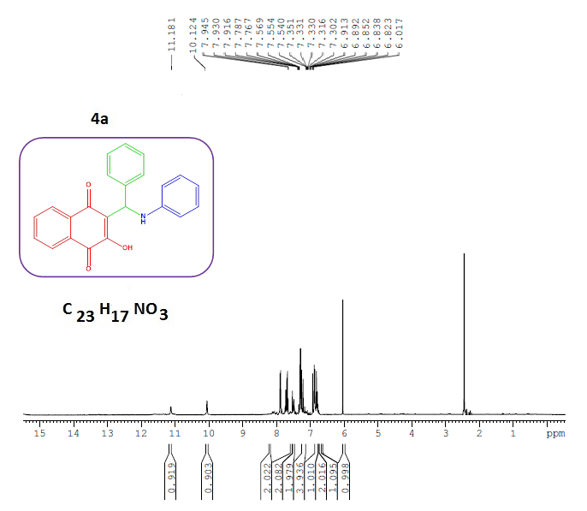
¹H NMR of 4a

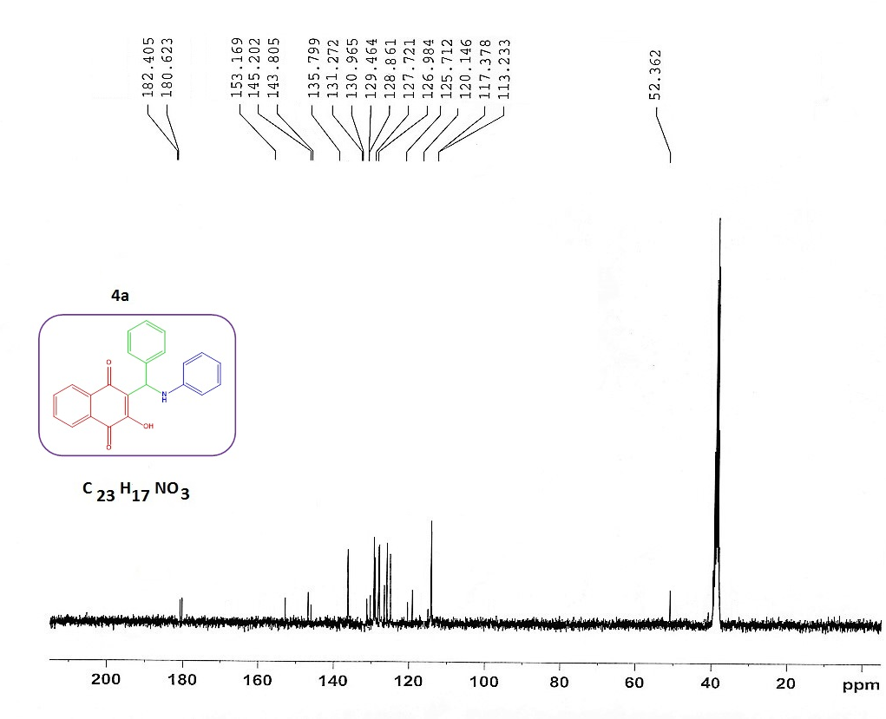
¹³C NMR of 4a

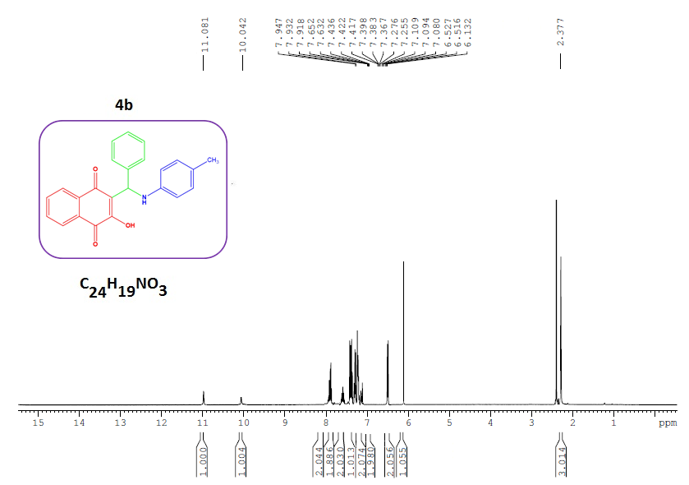
¹H NMR of 4b

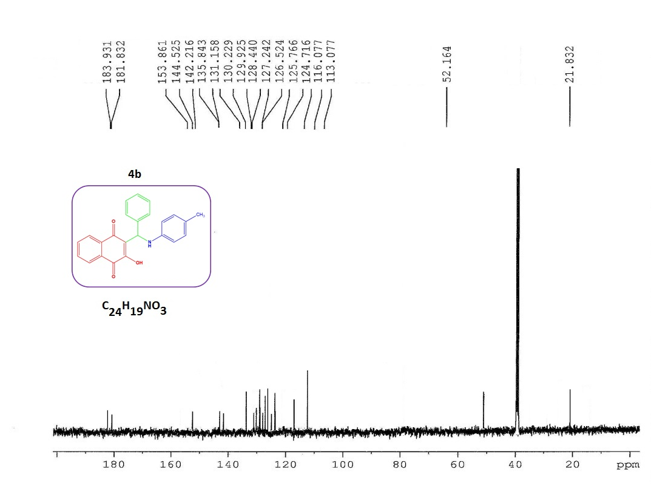
¹³C NMR of 4b

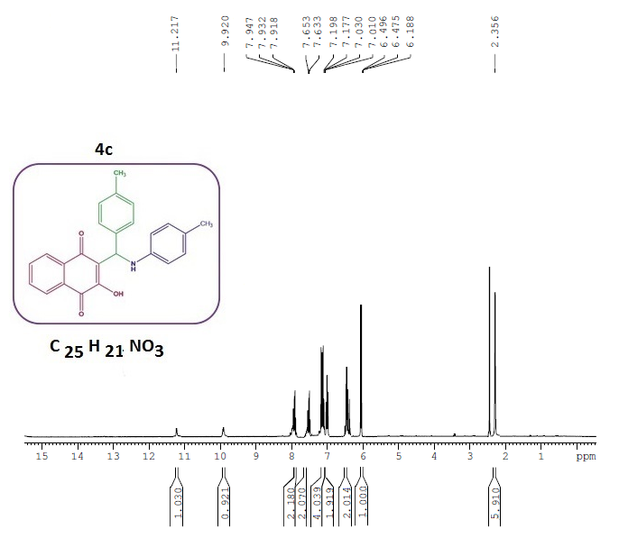
¹H NMR of 4c

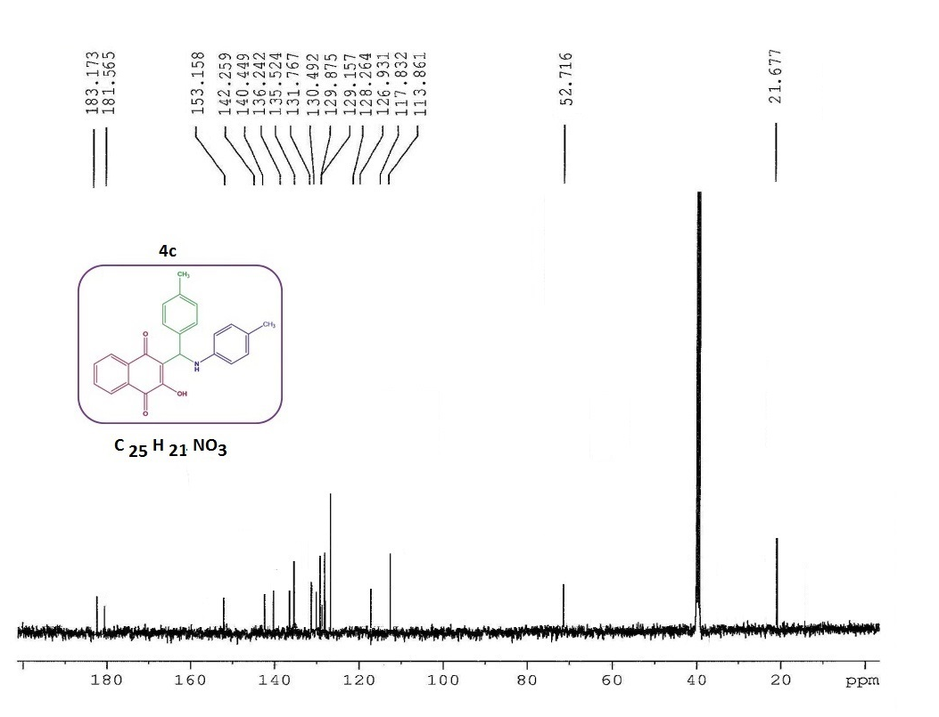
¹³C NMR of 4c

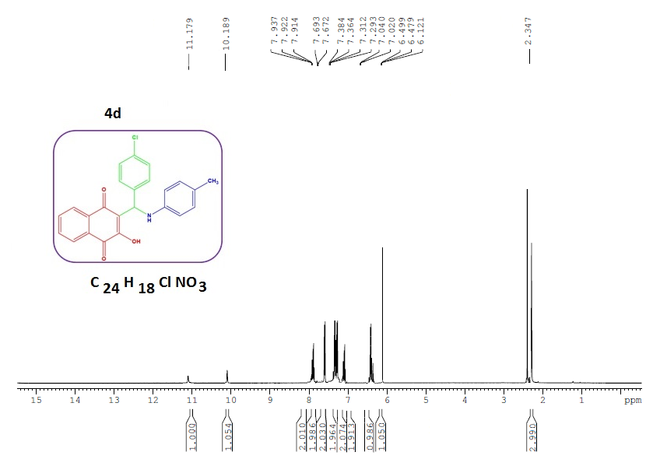
¹H NMR of 4d

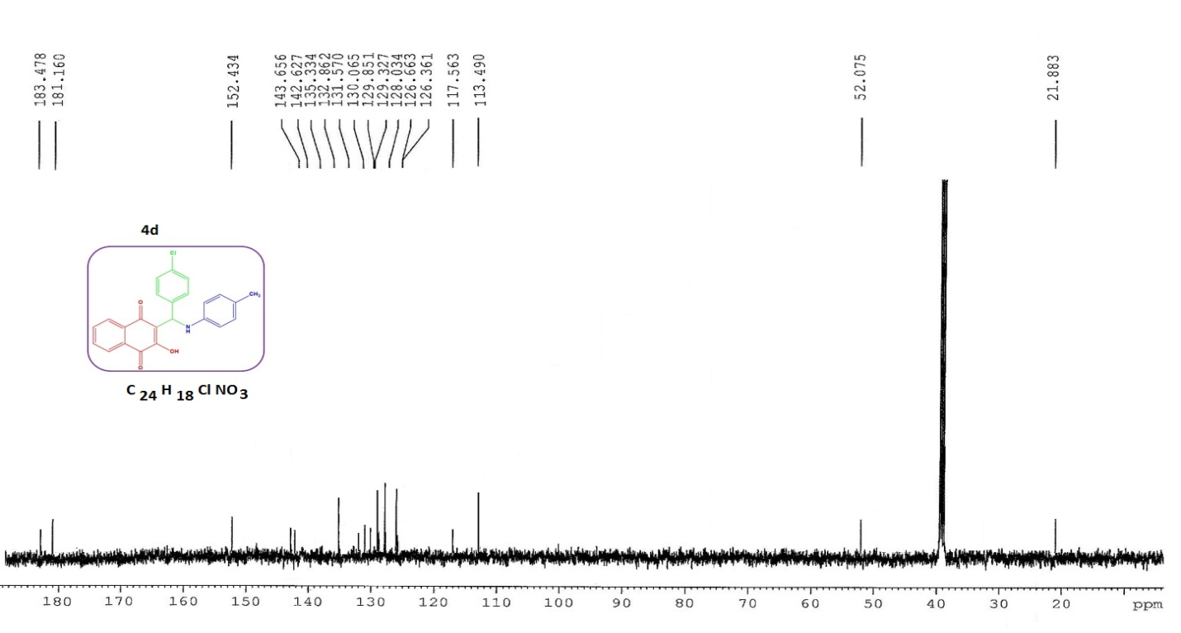
¹³C NMR of 4d

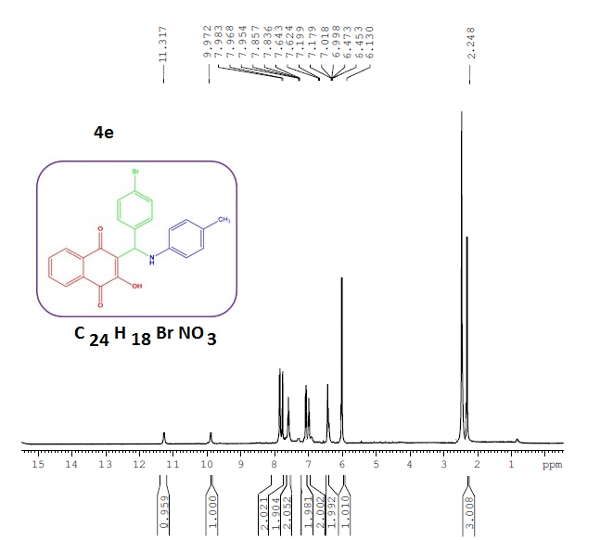
¹H NMR of 4e

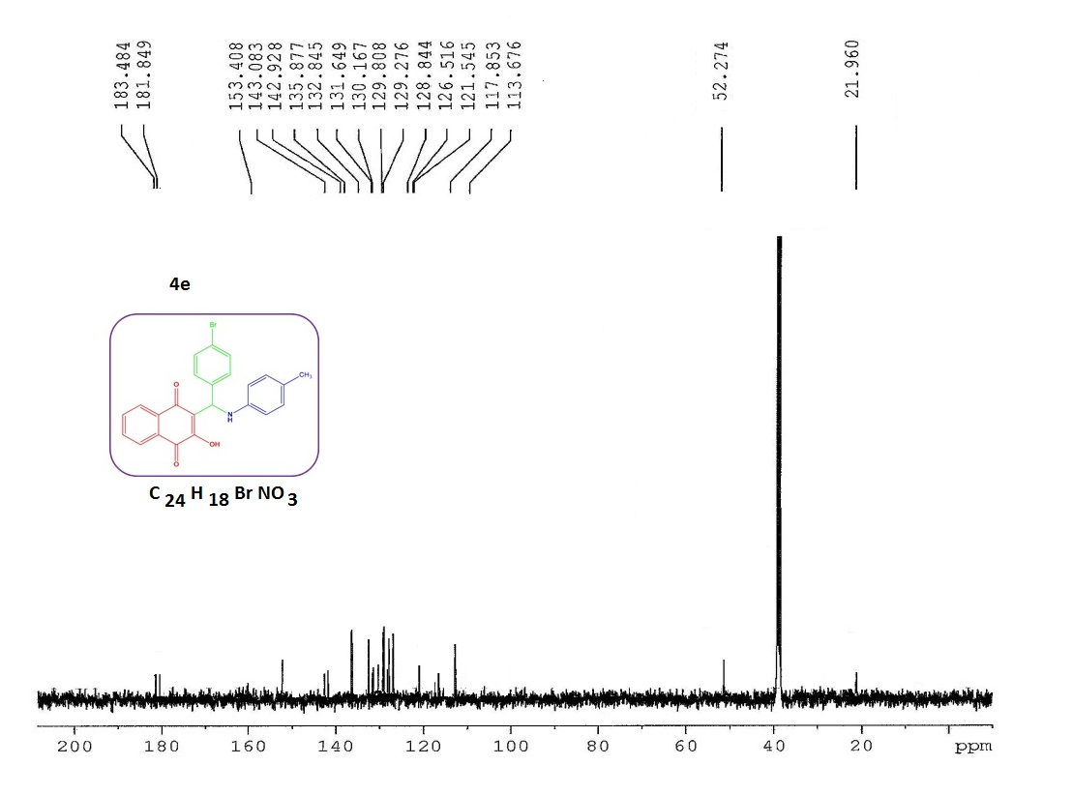
¹³C NMR of 4e

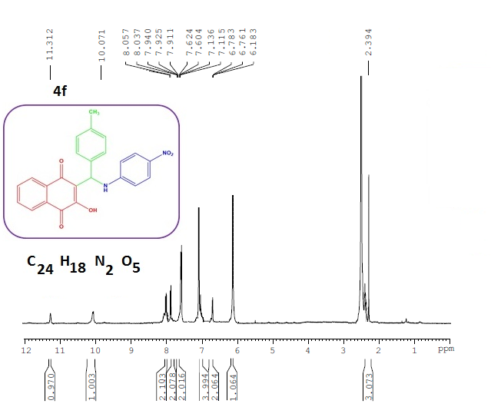
¹H NMR of 4f

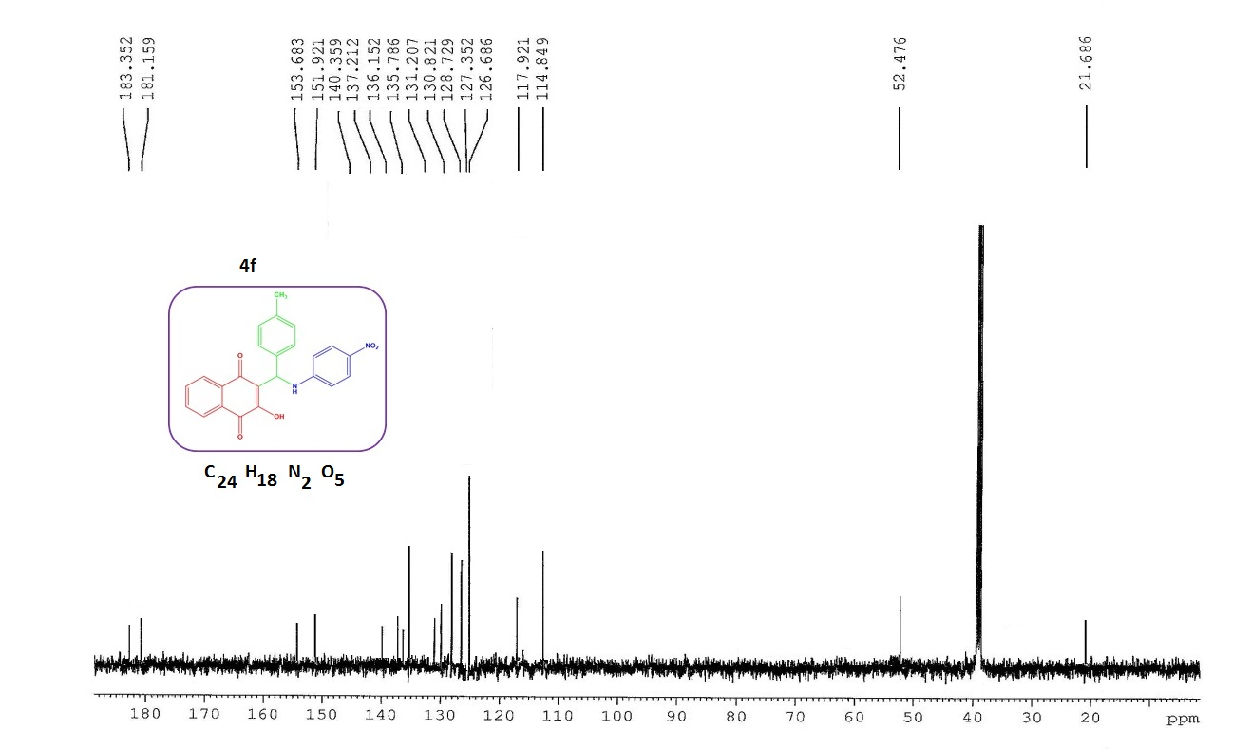
¹³C NMR of 4f

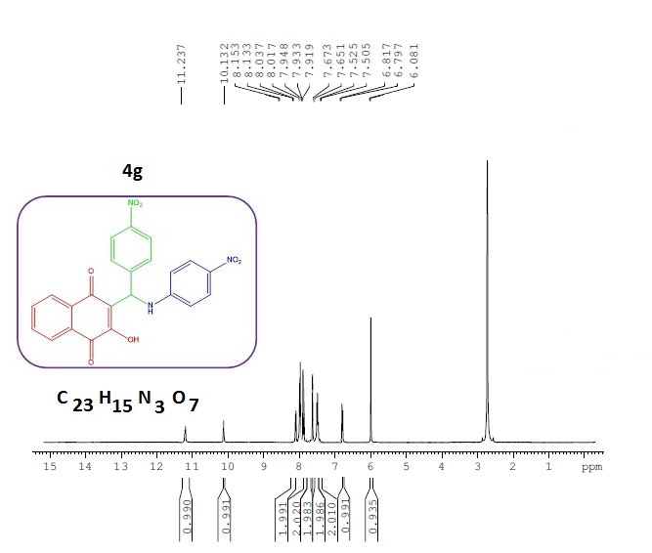
¹H NMR of 4g

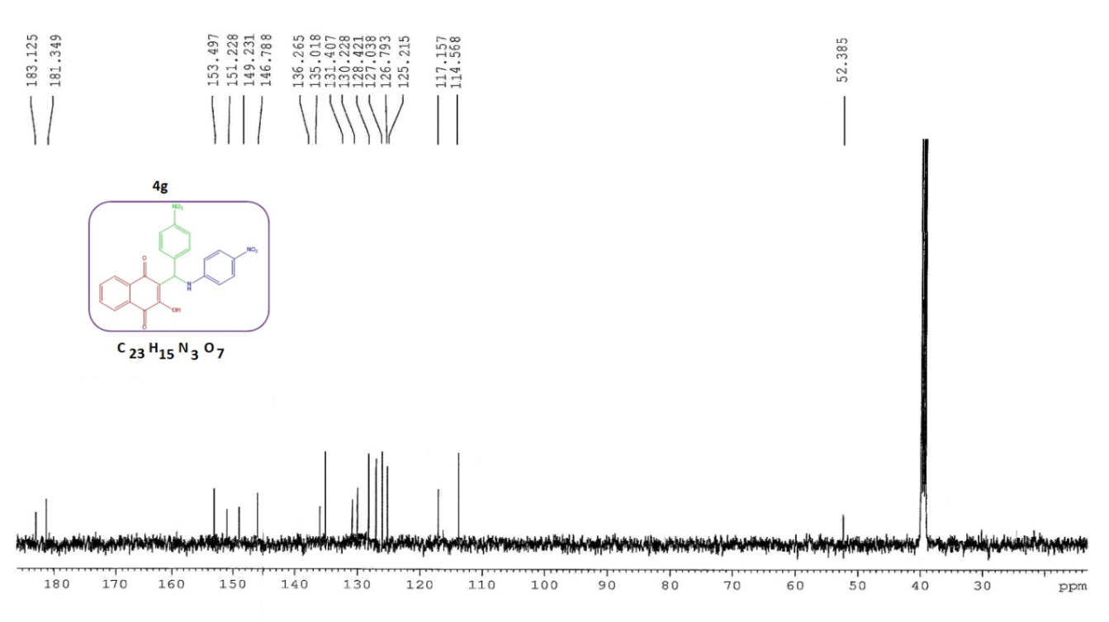
¹³C NMR of 4g

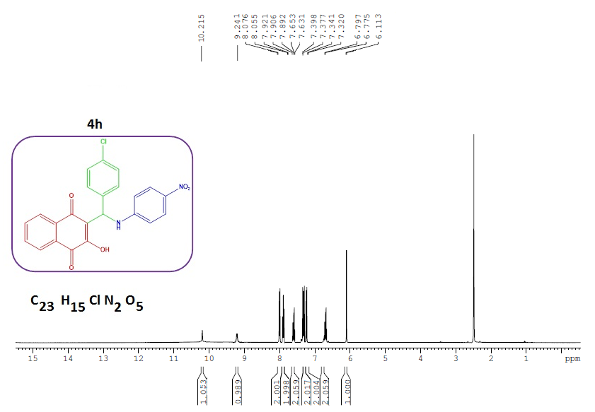
¹H NMR of 4h

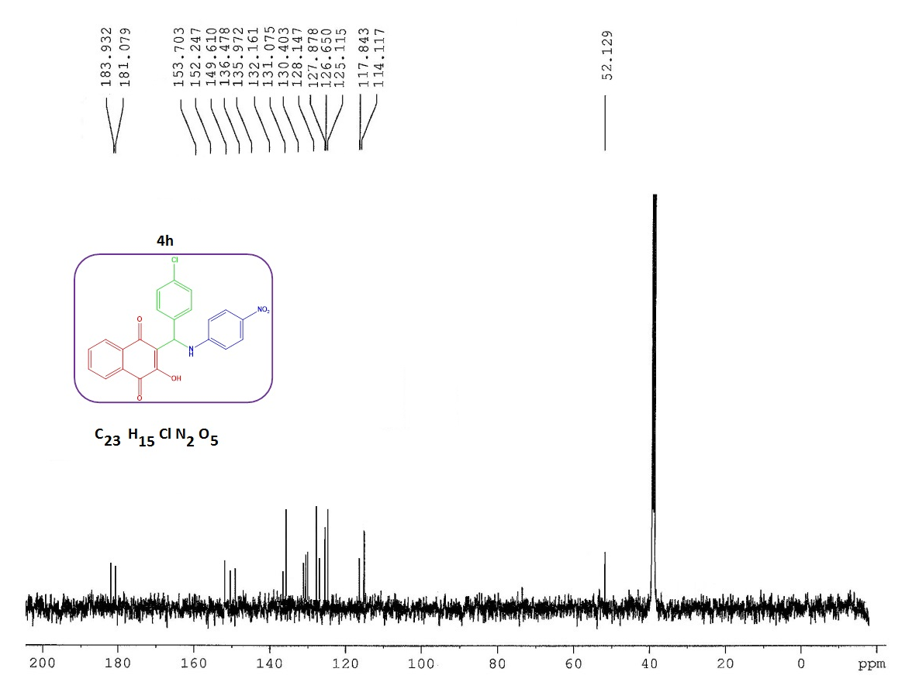
¹³C NMR of 4h

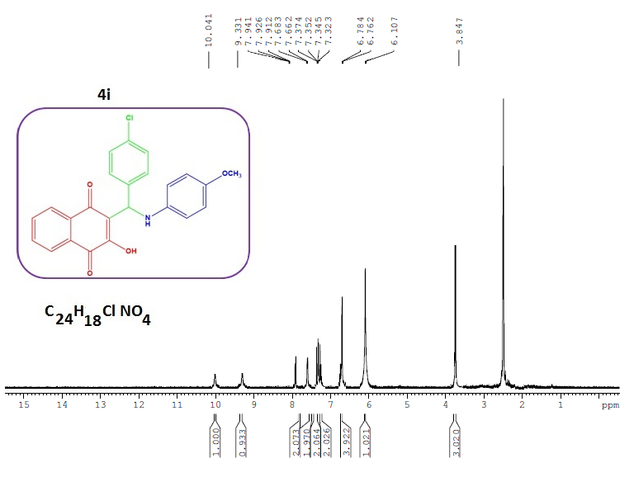
¹H NMR of 4i

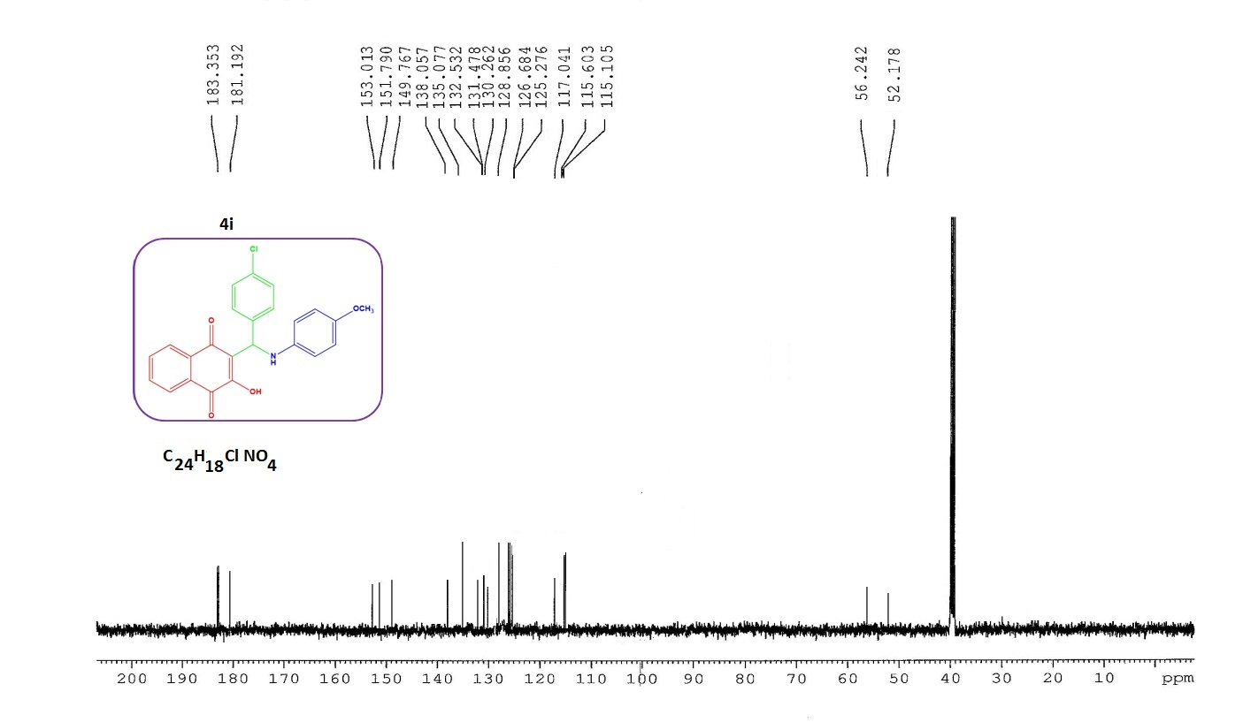
¹³C NMR of 4i

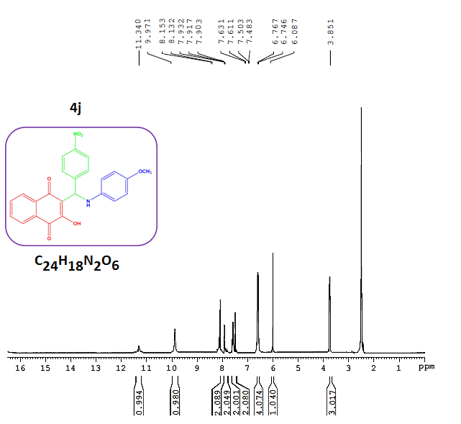
¹H NMR of 4j

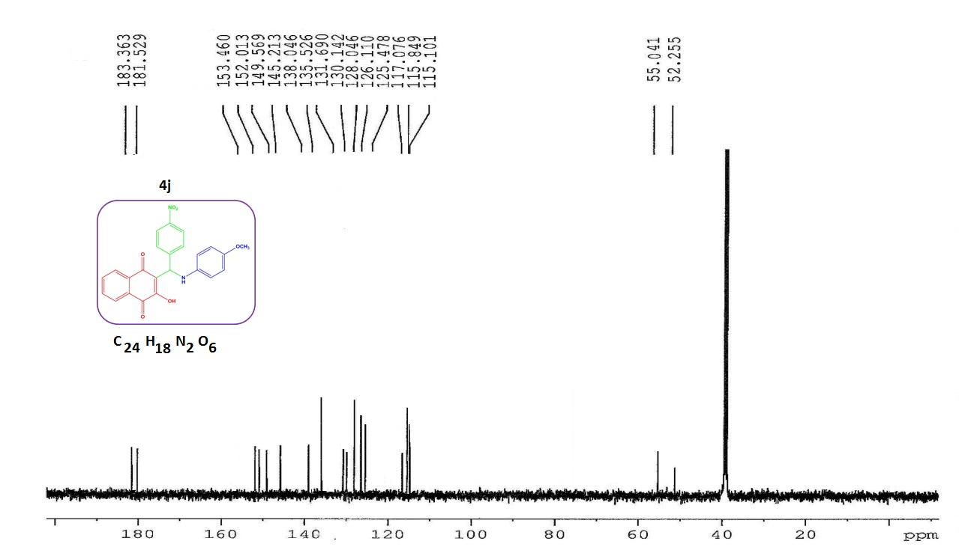
¹³C NMR of 4j

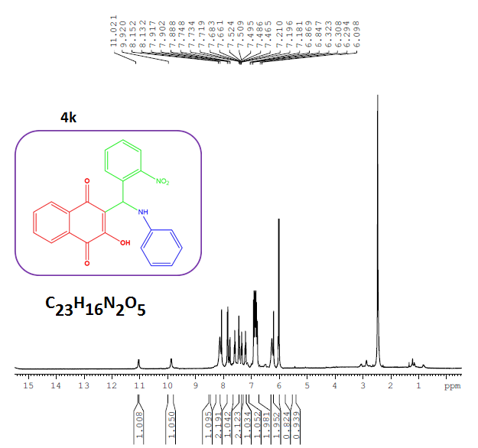
¹H NMR of 4k

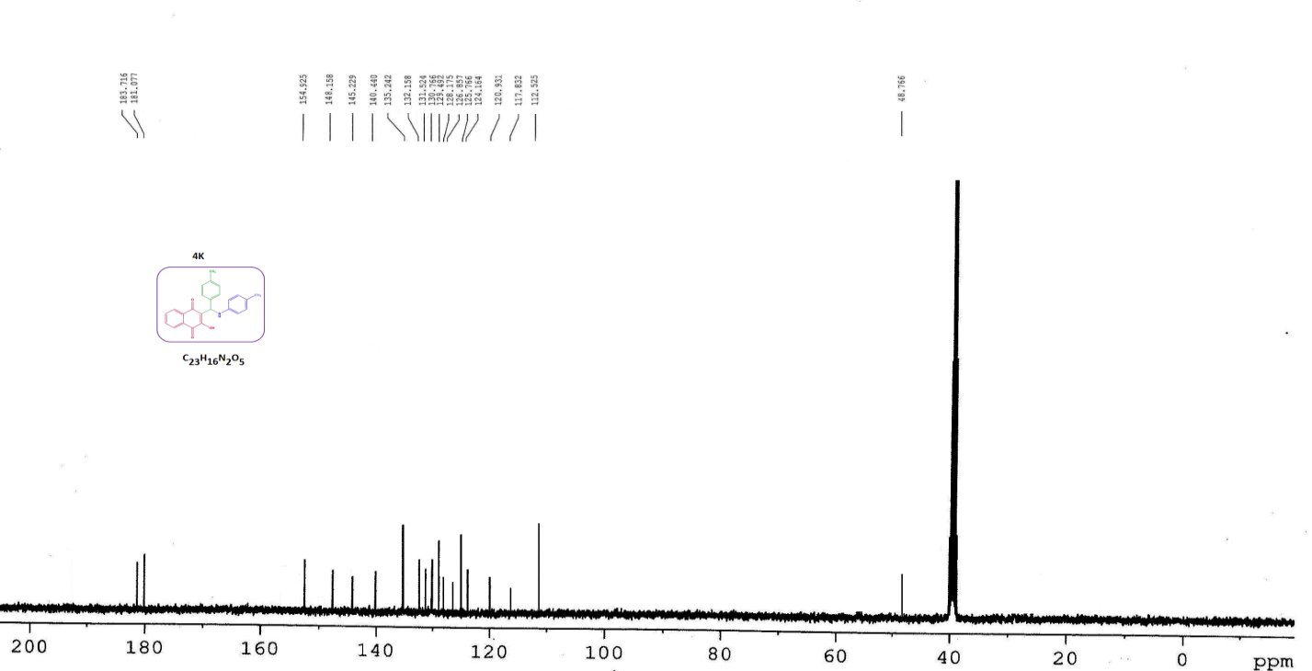
¹³C NMR of 4k
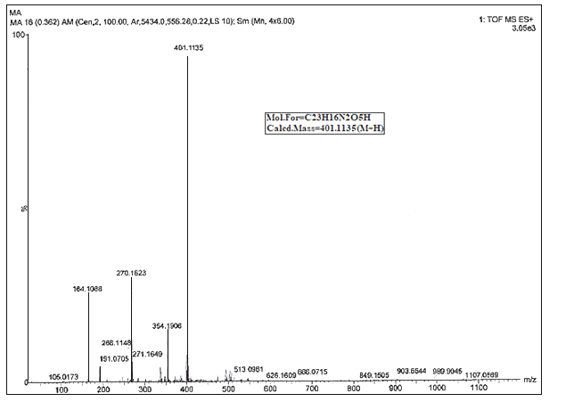
HRMS of 4k

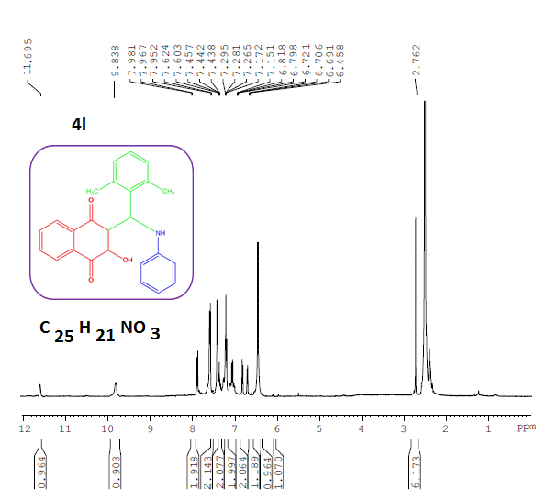
¹H NMR of 4l

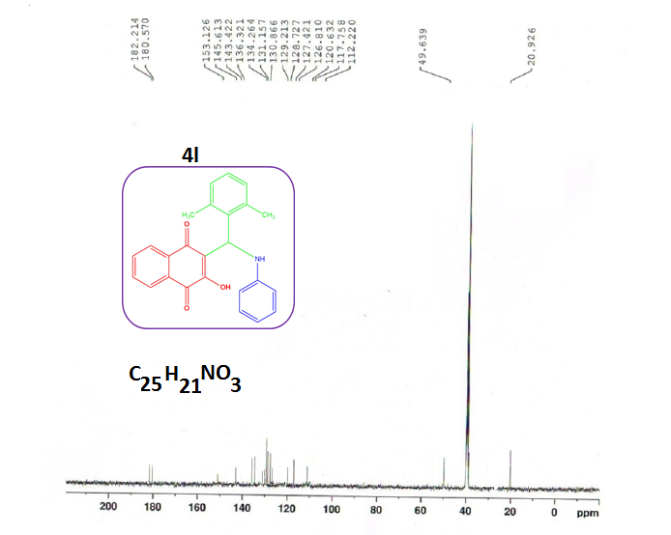
¹³C NMR of 4l
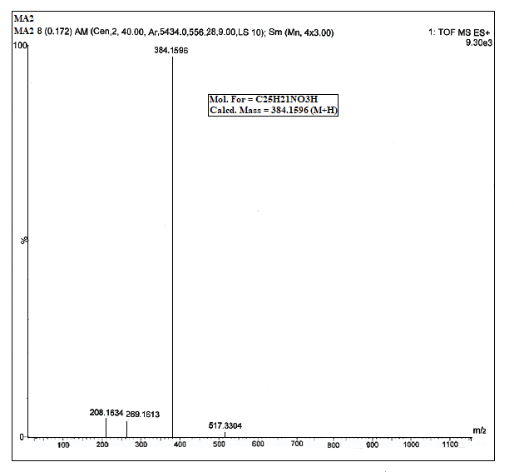
HRMS of 4l

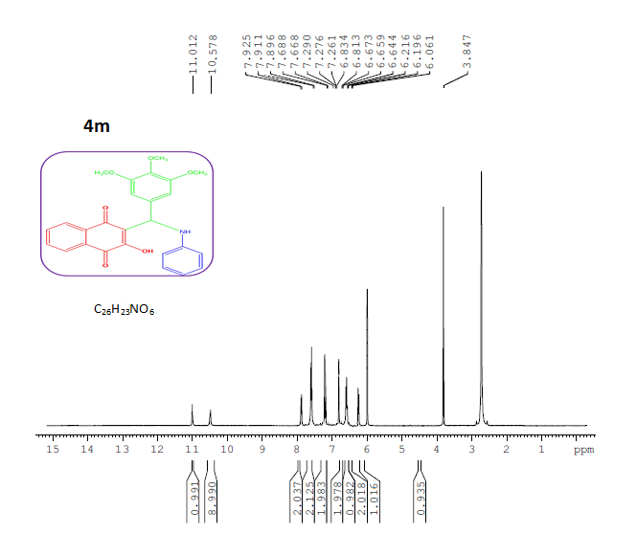
¹H NMR of 4m

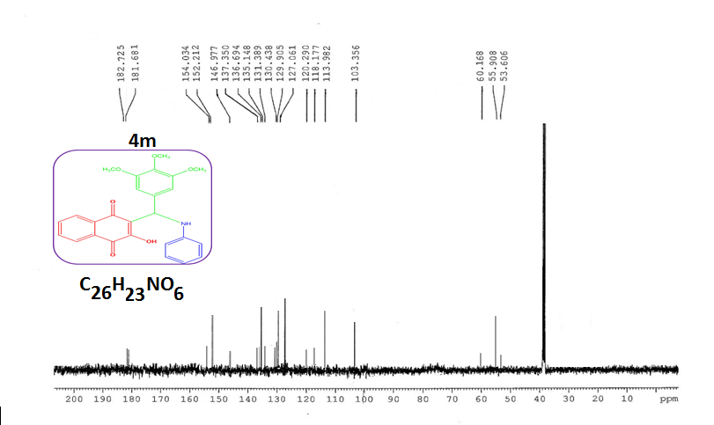¹³C NMR of 4m
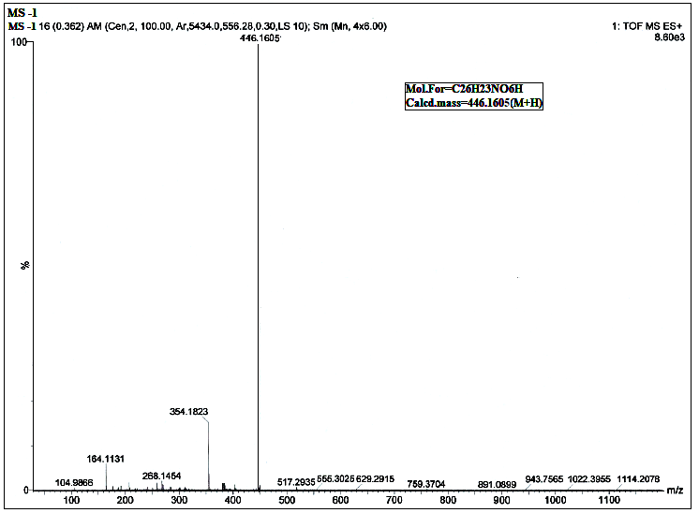
HRMS of 4m

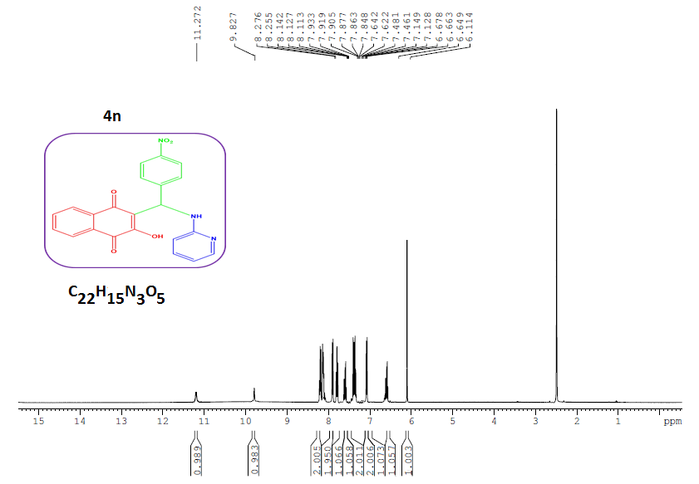
¹H NMR of 4n

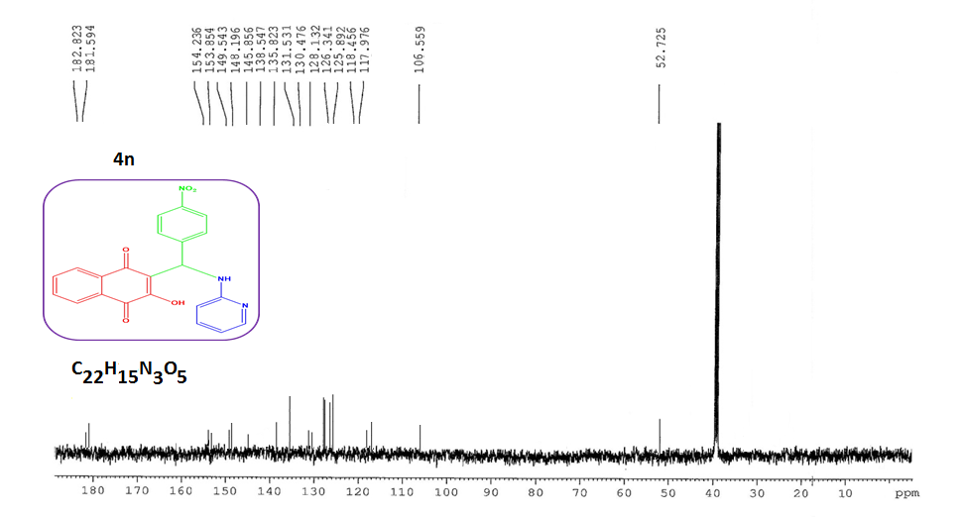
¹³C NMR of 4n

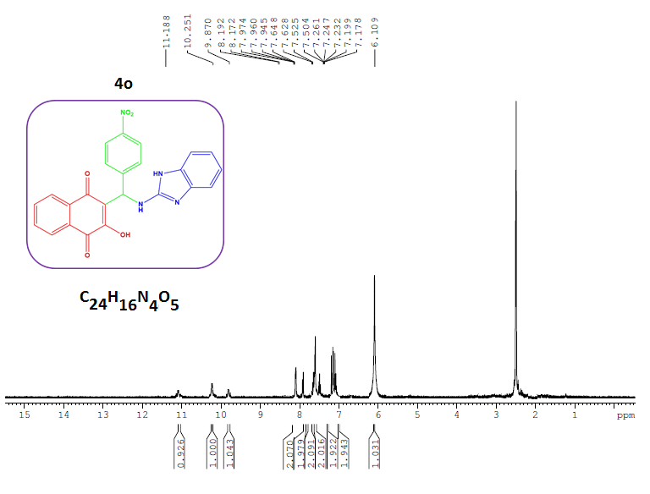
¹H NMR of 4o

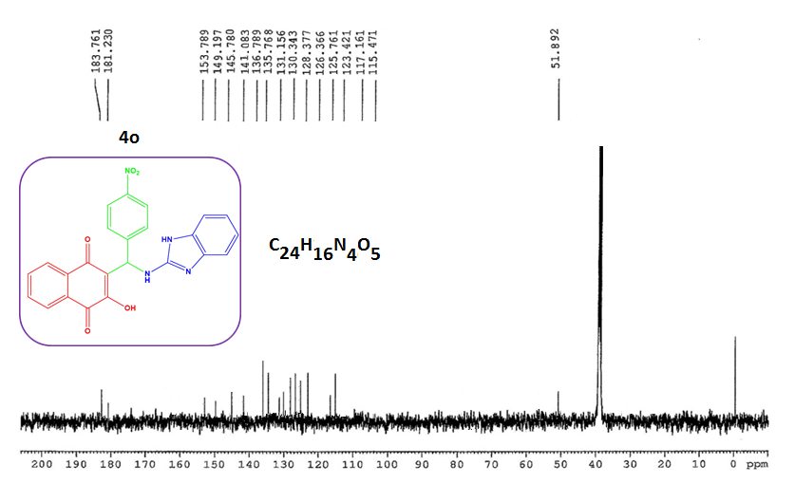
¹³C NMR of 4o

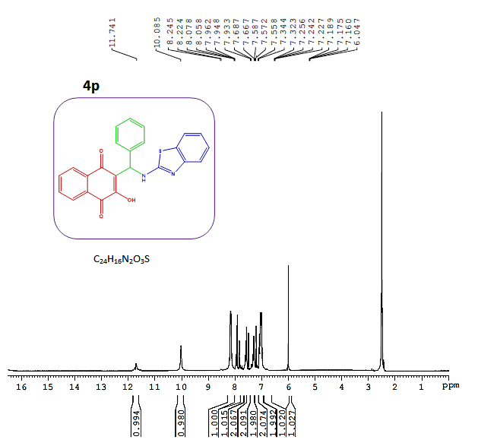
¹H NMR of 4p

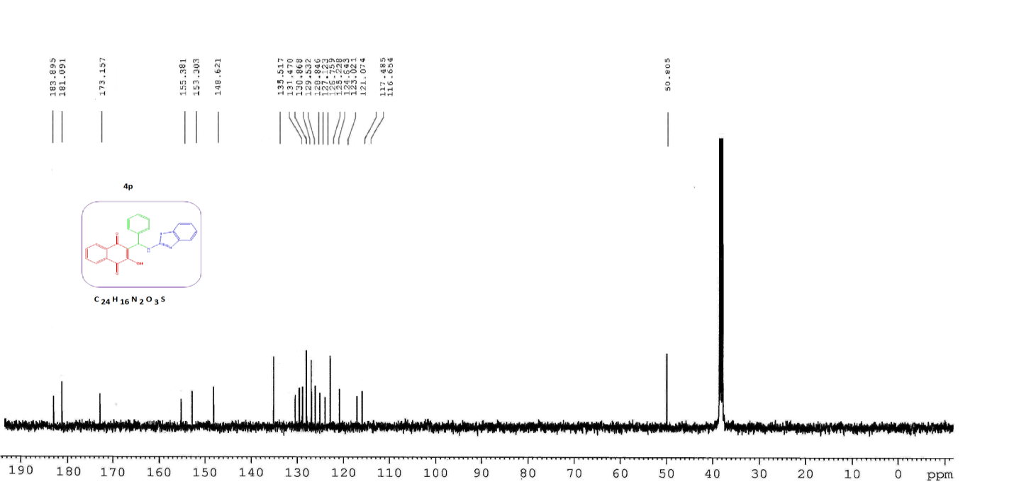
¹³C NMR of 4p
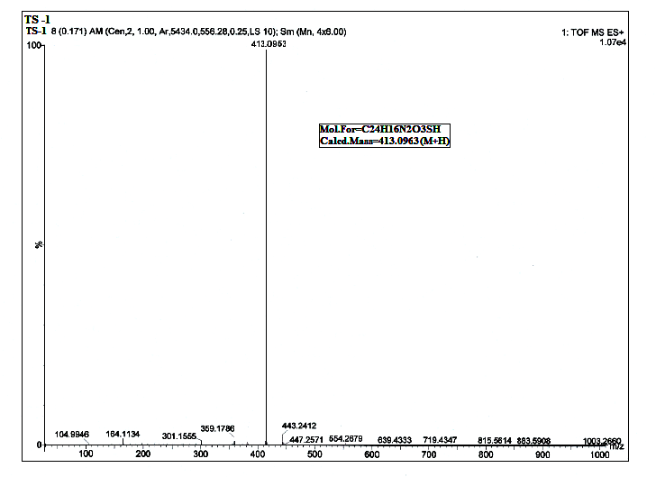
HRMS of 4p

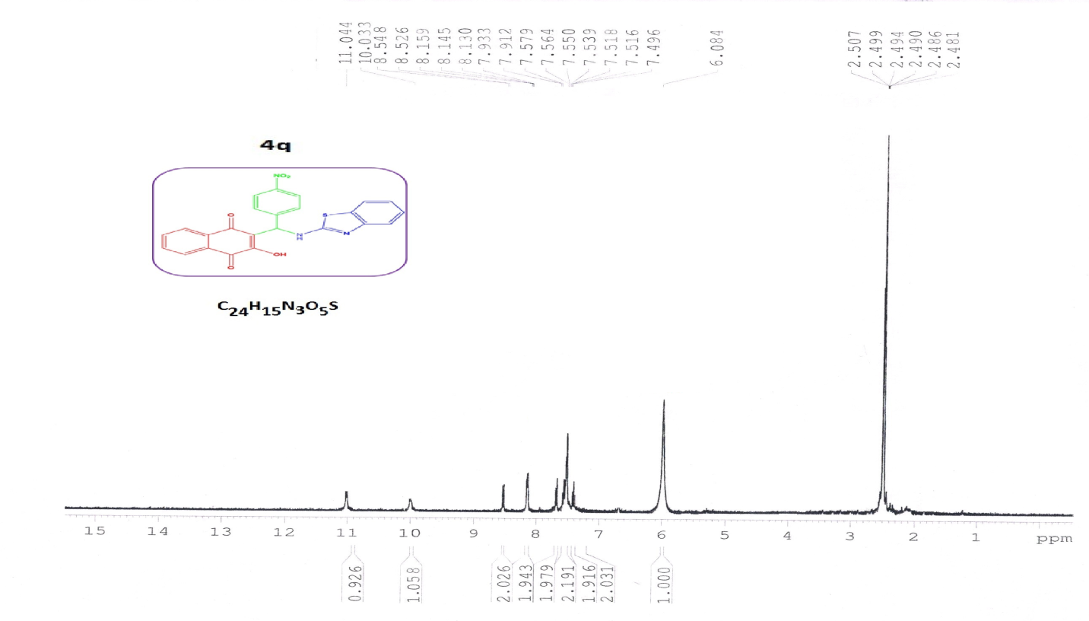
¹H NMR of 4q

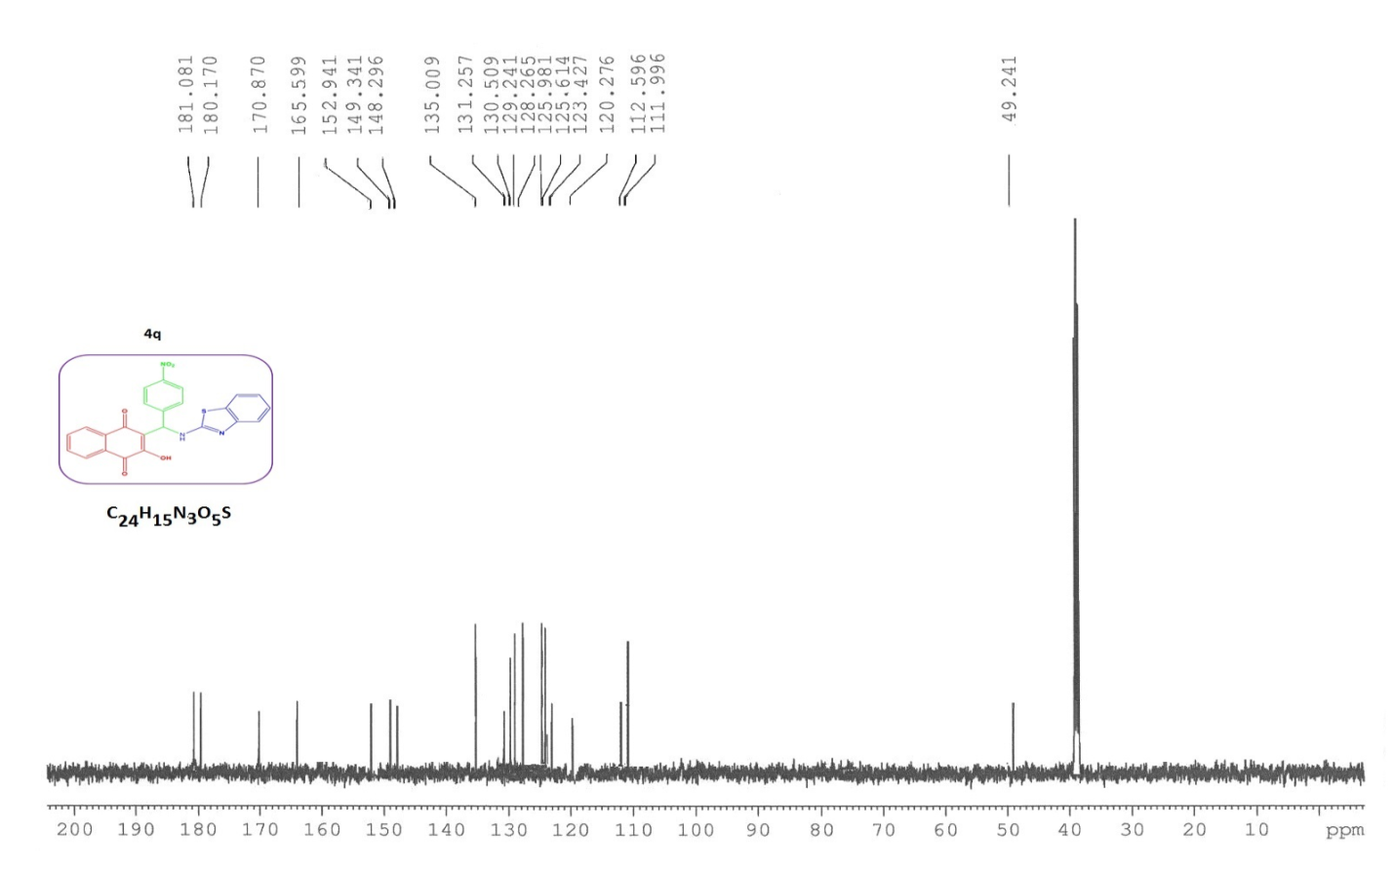
¹³C NMR of 4q
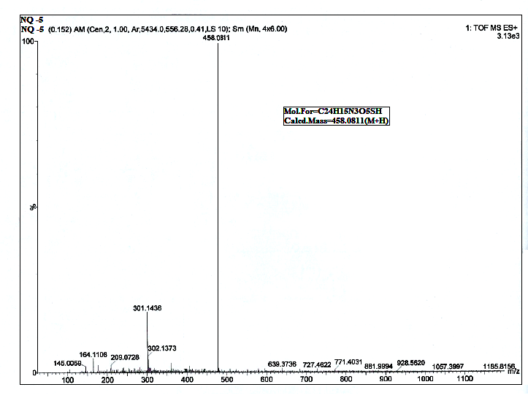
HRMS of 4q

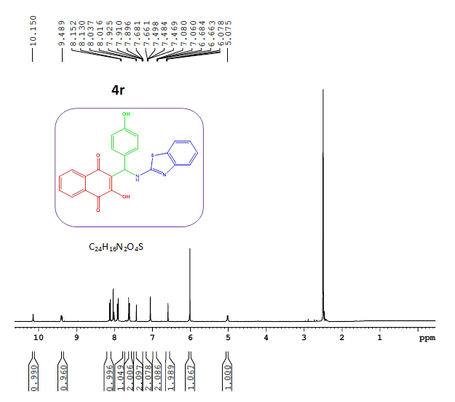
¹H NMR of 4r

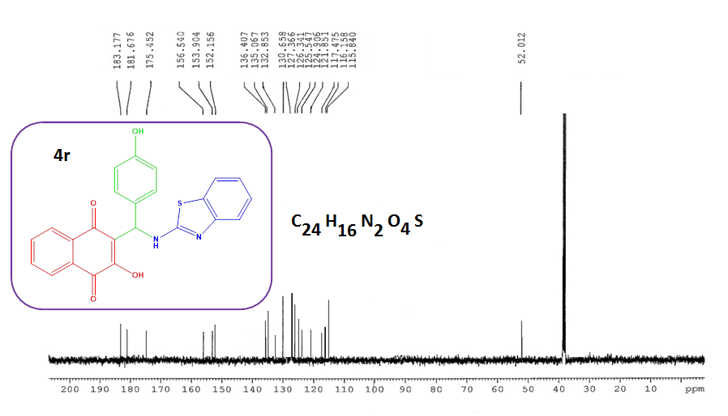
¹³C NMR of 4r
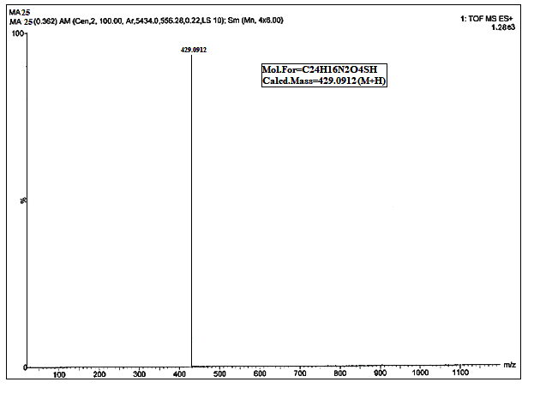
HRMS of 4r

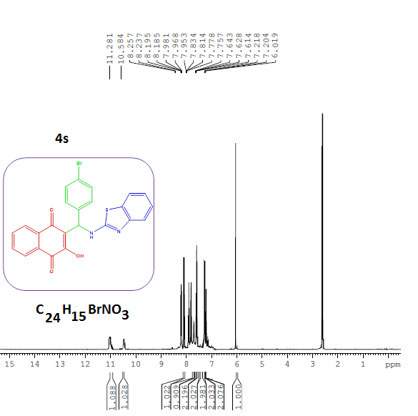
¹H NMR of 4s

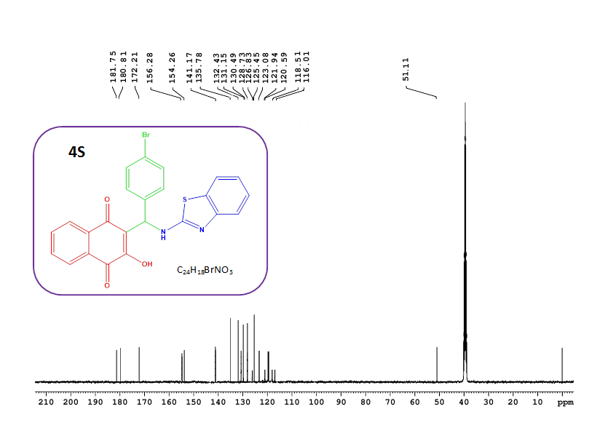
¹³C NMR of 4s
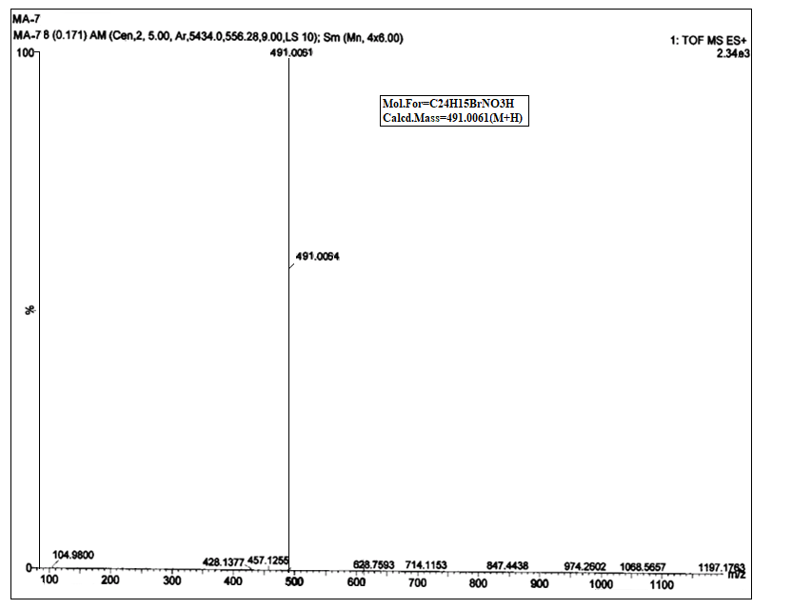
HRMS of 4s
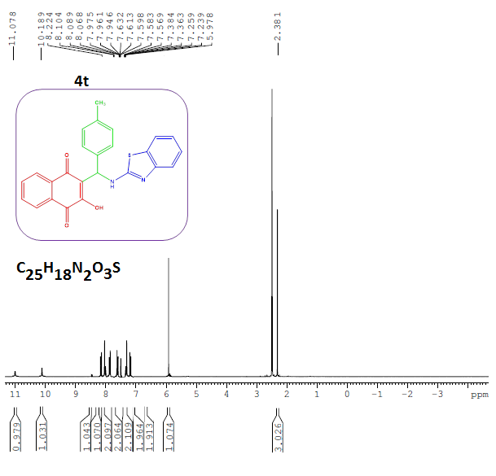
¹H NMR of 4t

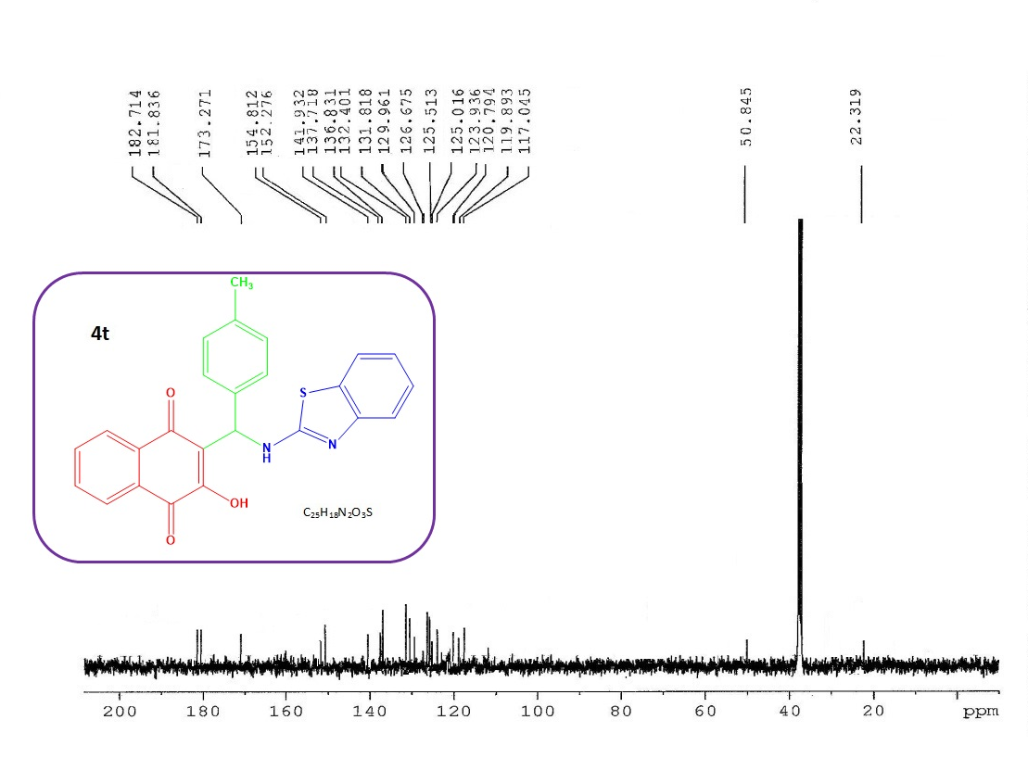
¹³C NMR of 4t
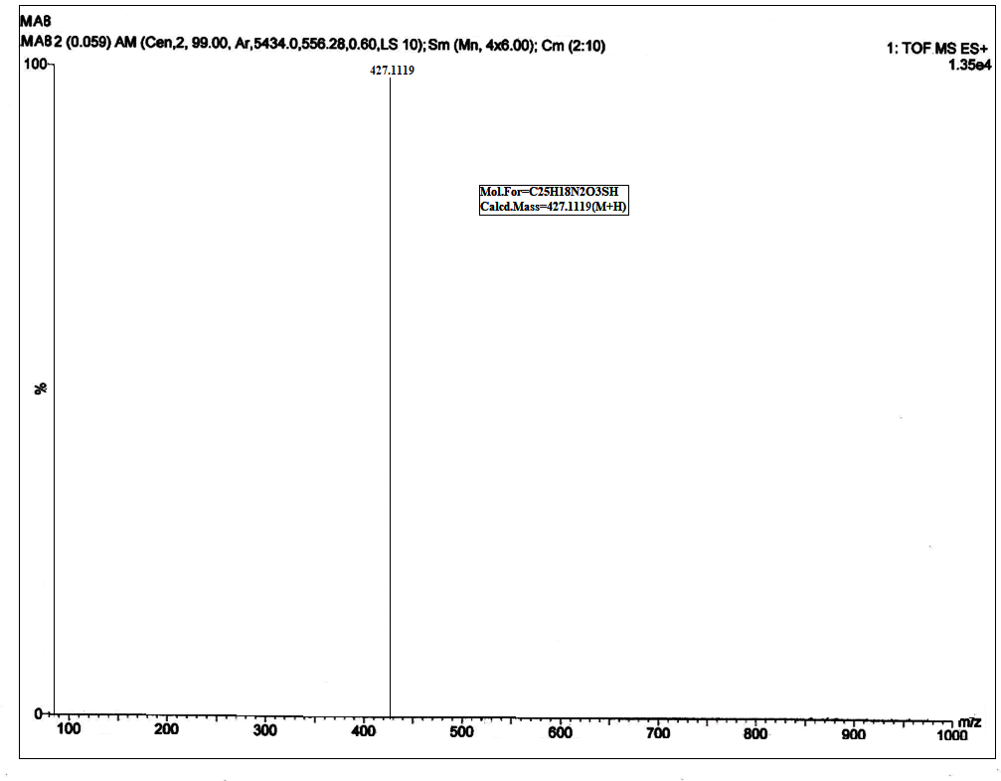
HRMS of 4t

