A simple and low-cost portable paper-based ABO blood typing device for point-of-care testing

Temsiri Songjaroen, Vitsarut Primpray, Thawintra Manosarn, Witsanuwat Khumchanta, Tasanee Sakuldamrongpanich, Suntree Kulkeratiyut, Wanida Laiwattanapaisal

Supplementary data
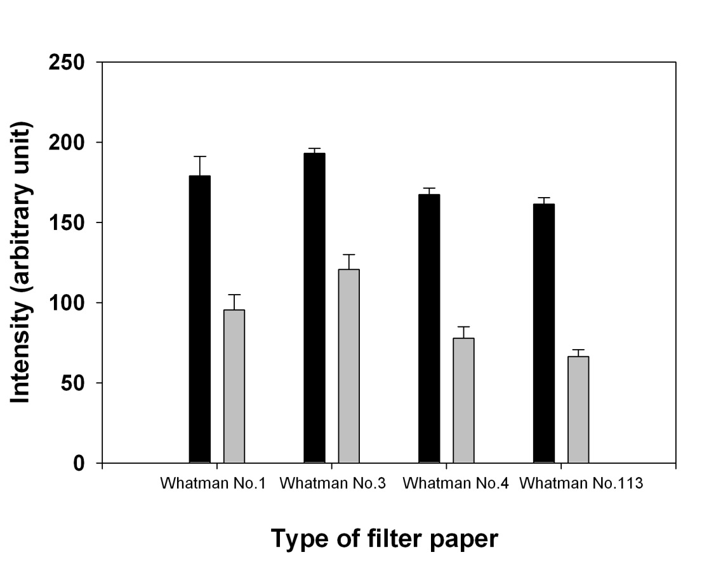
Fig. S1 Type of filter paper for fabrication of PADs; ■ agglutinated RBCs (positive result); ■ non-agglutinated RBCs (negative result)

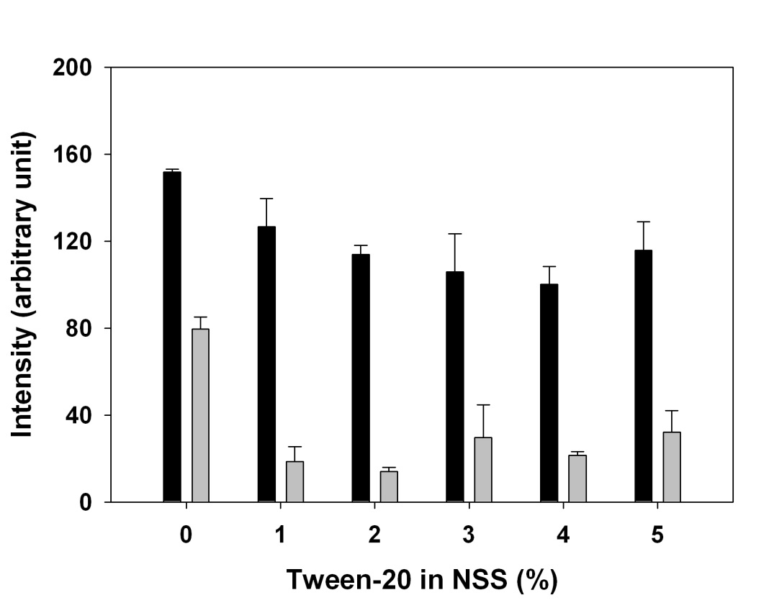
Fig. S2 Effect of Tween-20 in elution solution; ■ agglutinated RBCs (positive result); ■ non-agglutinated RBCs (negative result)

TABLE S1 Effect of hematocrit on blood typing by the ABO blood typing device
Blood sample | Number of samples (n) | Hematocrit range tested (%) | Interpretation
 |  |  | False negative hematocrit range (%) | Valid hematocrit range (%) | False positive hematocrit range (%)
Group A | 24 | 23–60 | - | 23–45 | ≥ 46
Group B | 22 | 23–54 | - | 23–45 | ≥ 46
Group AB | 18 | 21–59 | ≤ 23 | 24–59 | -
Group O | 25 | 21–52 | - | 21–43 | ≥ 44

TABLE S2 Precision of blood typing by the portable paper-based ABO blood typing device
Pooled blood sample | Blood typing result by PAD |  |  |  | Precision (%)
 | Group A | Group B | Group AB | Group O
Group A | 20 | 0 | 0 | 0 | 100
Group B | 0 | 20 | 0 | 0 | 100
Group AB | 0 | 0 | 20 | 0 | 100
Group O | 0 | 0 | 0 | 20 | 100

