Supplementary Information
Breakdown of Fractal Dimension Invariance in High Monomer-Volume-Fraction Aerosol Gels
William R. Heinson, Yuli W. Heinson, Pai Liu, Rajan K. Chakrabarty*

Experimental Setup
Figure S1 shows the schematic diagram of the static light scattering (SLS) apparatus. The forward scattering detection contains angles from ${\text{1}}^{\text{°}}$ to ${\text{10.0}}^{\text{°}}$ and is based on a design by Ferri (Ferri 1997). A beam stop was placed at the focal point of a Fourier lens to block the laser beam (CW 532nm). For the side scattering, a custom elliptical mirror (Optiforms) collects light from ${\text{12.1}}^{\text{°}}$ to ${\text{168}}^{\text{°}}$. To verify the experiment was under the single scattering limit, a power meter was placed after the aerosol to detect the power before and after the aerosol was turned on (Wang et al. 2015). The power for the aerosol on was 96% of the power for the aerosol off, which means the average number of scattering events was 0.04. This low value indicates the experiment was under the single scattering limit. Our SLS apparatus was calibrated with water droplets produced from a Collison 6-jet nebulizer (CH Technologies Inc., NJ, USA). From the size distribution of water droplets generated at 137.9 kPa (20 psi) (Wang et al. 2012) we calculated the theoretical scattered intensity and compared with the experimental data where the scattered intensity is plotted vs. scattering angle θ and q, as shown in Fig. S2A and B, respectively. Correction factors were applied to angle range ${\text{12.1}}^{\text{°}}$ – ${\text{45.0}}^{\text{°}}$. Previous work (Heffernan et al. 2016) has shown that the back scattering is extremely sensitive to particle size, shape, and refractive index, therefore no correction factor is applied to the ${\text{14}\text{0}}^{\text{°}}$ to ${\text{168}}^{\text{°}}$, regardless of the discrepancy between the experiment and theory. Note that our detection limit is q=0.3 µm⁻¹ (${\text{1}}^{\text{°}}$) since the intensity starts to curve down when q<0.3 µm⁻¹. Figure S3A shows the schematic diagram of the buoyancy-opposed flame (BoF) reactor along with the flow arrangement for fuel and oxidizer. The BoF reactor consists of a Burke-Schumann type diffusion burner operated in a down-fired configuration and enables continuous aerogelation in a millisecond time scale (Chakrabarty et al. 2014). Ethylene fuel (C₂H₄) was delivered through the center burner nozzle at a volumetric flow rate of 1 lpm. The fuel stream was diluted with 1 lpm nitrogen (N₂) prior to reaching the combustion chamber. Oxygen (O₂) was delivered through the annular burner nozzle at 20 lpm and diluted with 30 lpm N₂. This flow arrangement minimized the flame flickering and facilitated continuous production of gels through the aerosol gelation process that took place in the recirculation zone of the flame (Chakrabarty et al. 2014; Liu et al. 2015). The gel sample (1g) was collected in a flask placed underneath the combustion chamber. Then the flask, as shown in Fig. S3B, functioned as a suspension chamber, with one copper tube blowing in N₂ to aerosolize the gels and the other copper tube introduce the gels to the scattering volume of the SLS apparatus. Figure S4 is a picture of the BoF reactor flame. The particle growth primarily happens in the zones where the particle flow comes to a stop and reverses direction. In these flow reversal zones, particles are concentrated into spaces of high volume fraction which facilitates the growth of carbon gels. Figure S5 presents the carbon gel particles at various length scales. Figure S5A shows the SEM image of the sample collect directly from the scattering volume indicating the particles range in size 10-200 μm. Figure S5B is a typical gel particle taken from the scattering volume and C is the large gel particle collected directly from BoF flame. Comparison of the particles in B and C highlight the scale invariant nature of the fractal gels.

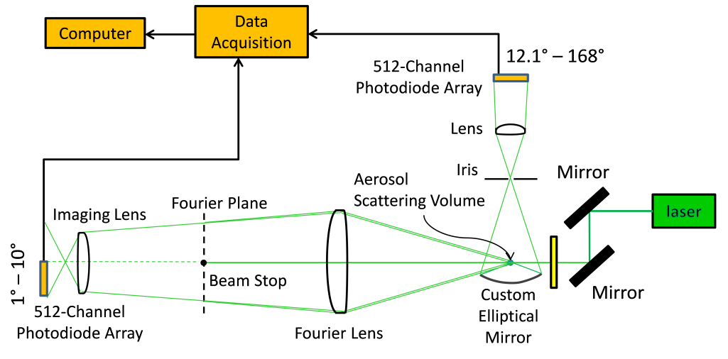
Figure S1. Schematic diagram of the static light scattering (SLS) apparatus. The design is similar to (Wang et al. 2015) except for two 512 channel photodiode arrays. The forward scattering is based on a design by Ferri (Ferri 1997). For the side scattering, a custom elliptical mirror (Optiforms) collects light from ${\text{12.1}}^{\text{°}}$ to ${\text{168}}^{\text{°}}$.

Figure S2. The SLS apparatus was calibrated with water droplets generated from a 6-jet nebulizer (Collison) with known size distribution. The scattered intensity is plotted vs. scattering angle θ and q in (A) and (B) respectively. Correction factors were applied to ${\text{12.1}}^{\text{°}}$ – ${\text{45.0}}^{\text{°}}$. Note that the detection limit is q=0.3 µm⁻¹.

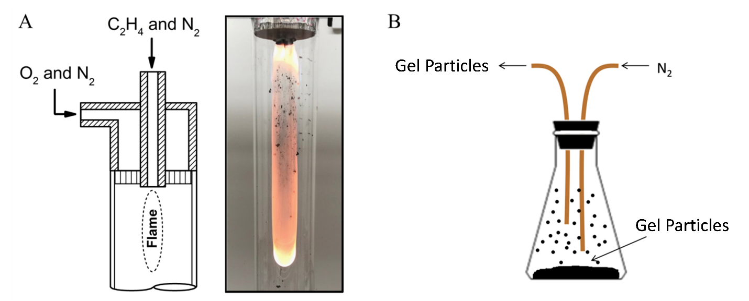
Figure S3. (A) Schematic diagram of the buoyancy-opposed flame (BoF) aerosol reactor and a photograph of the flame body. (B) Suspension chamber. Nitrogen (N₂) blows in from one copper tubing to aerosolize the gels. The aerosolized gels come out from the other copper tubing.

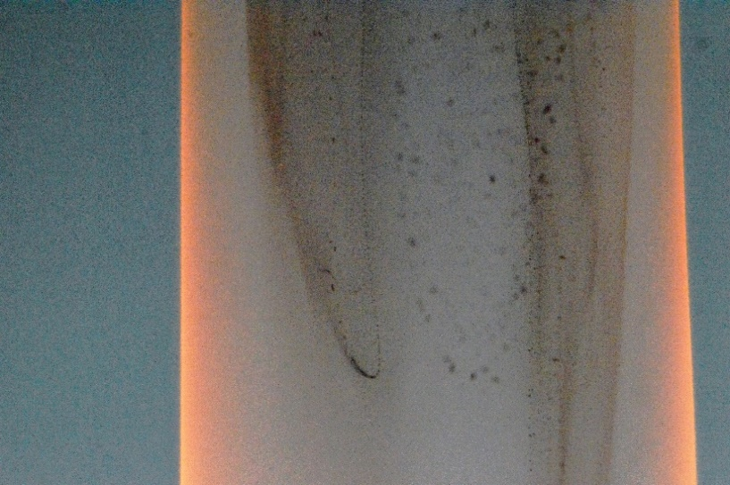
Figure S4. In the BoF reactor particle growth primarily happens in the zones where the particle flow comes to a stop and reverses direction. In these reversal zones, particles are concentrated into regions of high volume fraction which facilitates the growth of carbon gels.
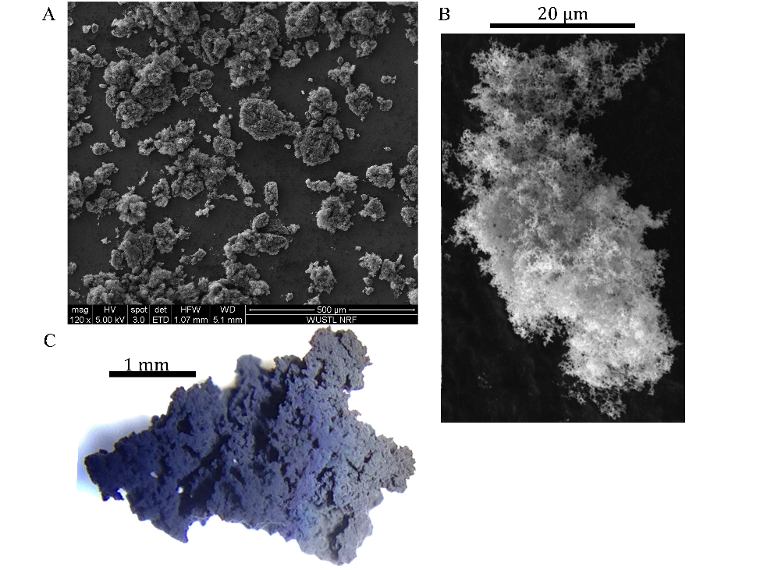
Figure S5. (A) Carbon gel particles sampled from the scattering volume range in size 10-200 μm. (B) Image of a typical gel particle taken from the scattering volume. (C) Large carbon gel sampled directly from BoF flame. Comparison of the particles in (B) and (C) highlight the scale invariant nature of the fractal gels.

DLCA simulation:
The DLCA simulations started with 10⁷ spherical monomers of radius a, randomly placed in a three-dimensional box of a given length, L. The system monomer volume fraction f_{v} is determined by the simulation box size L by the following
$$f_{v}={10}^{7}∙\frac{4}{3}{π\left(\frac{a}{L}\right)}^{3}$$
At the beginning of each iteration, the number of aggregates N_{c}, including lone monomers, was counted. A random aggregate was chosen and the simulation time was incremented by 1/N_{c}. Next, the probability that the selected aggregate would move was calculated by assuming that its drag force was in the Stokes–Einstein regime; hence, the probability of movement was inversely proportional to the radius of gyration R_{g} of the aggregate. If the aggregate moved, it would be a distance of one monomer diameter in a random direction. When two aggregates collided, they irreversibly stuck together and N_{c} was decremented by 1.

Figure S6. (A) For the DLCA aggregate (f_{v}=0.001) both g(r) and surface g(r) follow a D_{m}=D_{s}=1.8 trend. (B) S(q) scales with a power-law of -1.8.
References:
Chakrabarty, Rajan K., Igor V. Novosselov, Nicholas D. Beres, Hans Moosmüller, Christopher M. Sorensen, and Christopher B. Stipe. 2014. “Trapping and Aerogelation of Nanoparticles in Negative Gravity Hydrocarbon Flames.” Applied Physics Letters 104 (24): 243103. https://doi.org/10.1063/1.4884057.
Ferri, F. 1997. “Use of a Charge Coupled Device Camera for Low-Angle Elastic Light Scattering.” Review of Scientific Instruments 68 (6): 2265–74. https://doi.org/10.1063/1.1148135.
Heffernan, Brendan M., Yuli W. Heinson, Justin B. Maughan, Amitabha Chakrabarti, and Christopher M. Sorensen. 2016. “Backscattering Measurements of Micron-Sized Spherical Particles.” Applied Optics 55 (12): 3214–18. https://doi.org/10.1364/AO.55.003214.
Liu, Pai, Ian J. Arnold, Yang Wang, Yang Yu, Jiaxi Fang, Pratim Biswas, and Rajan K. Chakrabarty. 2015. “Synthesis of Titanium Dioxide Aerosol Gels in a Buoyancy-Opposed Flame Reactor.” Aerosol Science and Technology 49 (12): 1232–41. https://doi.org/10.1080/02786826.2015.1112356.
Wang, Wei-Ning, Yi Jiang, and Pratim Biswas. 2012. “Evaporation-Induced Crumpling of Graphene Oxide Nanosheets in Aerosolized Droplets: Confinement Force Relationship.” The Journal of Physical Chemistry Letters 3 (21): 3228–33. https://doi.org/10.1021/jz3015869.
Wang, Yuli, Amitabha Chakrabarti, and Christopher M. Sorensen. 2015. “A Light-Scattering Study of the Scattering Matrix Elements of Arizona Road Dust.” Journal of Quantitative Spectroscopy and Radiative Transfer 163 (September): 72–79. https://doi.org/10.1016/j.jqsrt.2015.05.002.

