SUPPLEMENTARY

Supplementary Table 1: GagΔp6 and Pr55^{Gag} binding to the Psi truncated RNAs. On the left side, binding parameters derived from the single binding site model⁸² and from the stoichiometry analysis¹⁴ (see Methods) for GagΔp6 in interaction with RNA fragments corresponding to the Psi truncation mutants used in this study. On the right side, binding parameters determined for Pr55^{Gag} in interaction with the same RNA fragments¹⁴. K_{di} (i=1, 2) correspond to the two different classes of binding affinity. Mean ± SD of at least three independent experiments.

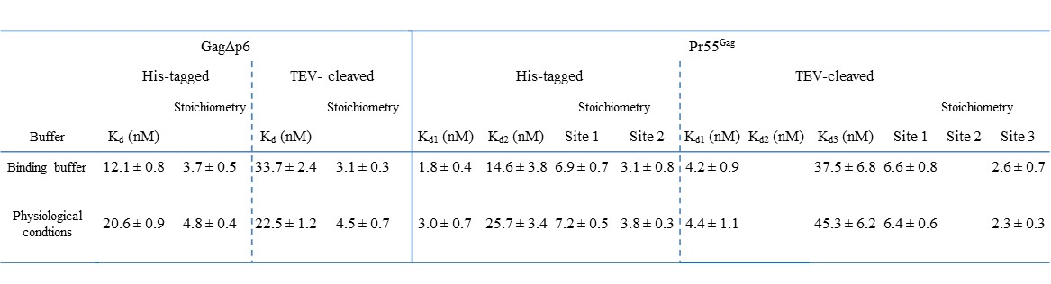
Supplementary Table 2: His-tagged and TEV-cleaved GagΔp6 and Pr55^{Gag} binding to the first 600 nts of the gRNA under different buffer conditions. On the left side, binding parameters derived from the single binding site model⁸² and from the stoichiometry analysis¹⁴ (see Methods) for GagΔp6 in interaction with the first 600 nts of the gRNA in our binding buffer conditions (30 mM Tris-HCl pH 7.5, 200 mM NaCl, 10 mM MgCl₂), and in more physiological conditions (30 mM Tris-HCl pH 7.5, 1 mM MgCl and 150 mM NaCl, and 4.8 mM spermidine). On the right side, binding parameters determined for Pr55^{Gag} in interaction with the same RNA fragment¹⁴ under the same experimental conditions. K_{di} (i=1, 2) correspond to the two different classes of binding affinity. Mean ± SD of at least three independent experiments.

Supplementary Figure 1: Representative experiments of GagΔp6 and Pr55^{Gag} interaction with Psi truncated RNAs. (A) Schematic representation of the Psi truncated RNA fragments used in this study. Increasing concentrations of RNA were added to 50 nM of proteins and the resulting binding curves were fitted. (B) On the left side, the binding curves corresponding to GagΔp6 interaction with N1-600 WT RNA (black squares), M1-SL1 WT (red triangles) and M305-615 WT (blue circles) were fitted with the single binding site model⁸². On the right side, the data corresponding to Pr55^{Gag} binding to N1-600 WT (black squares) were best fitted with a two-binding sites model as previously described¹⁴, while the data corresponding to Pr55^{Gag} binding to M1-SL1 WT (red triangles) and M305-615 WT (blue circles) were fitted with the single binding site model. (C) The corresponding residual plots for each curve fitted in B are represented. (D) Scatchard plots for each RNA species are represented. On the left, we observed for GagΔp6 interaction with N1-600 WT (black squares), M1-SL1 WT (red triangles) and M305-615 WT (blue circles) RNAs, single linear patterns. On the right side, the Scatchard plots of Pr55^{Gag} interaction with N1-600 WT RNA yielded two linear patterns (black squares), while only single linear patterns were observed for M1-SL1 WT (red triangles) and M305-615 WT (blue circles) RNAs.

Supplementary Figure2: Representative experiments of GagΔp6 binding to the Psi individual stem-loops. (A) Increasing concentrations of RNA were added to 100 nM of protein and the resulting binding curves corresponding to GagΔp6 interaction with NSL1 (black squares), NSL2 (red rounds), NSL3 (blue triangles), and NSL4 (cyan squares) RNAs were fitted according to the single binding site model⁸². (B) The residual plots for each curve fitted in A are represented. (C) The Scatchard plots of GagΔp6 in interaction with NSL1, NSL2, NSL3 and NSL4 yielded single linear patterns thus confirming the presence of one class of GagΔp6 binding sites for those RNAs.
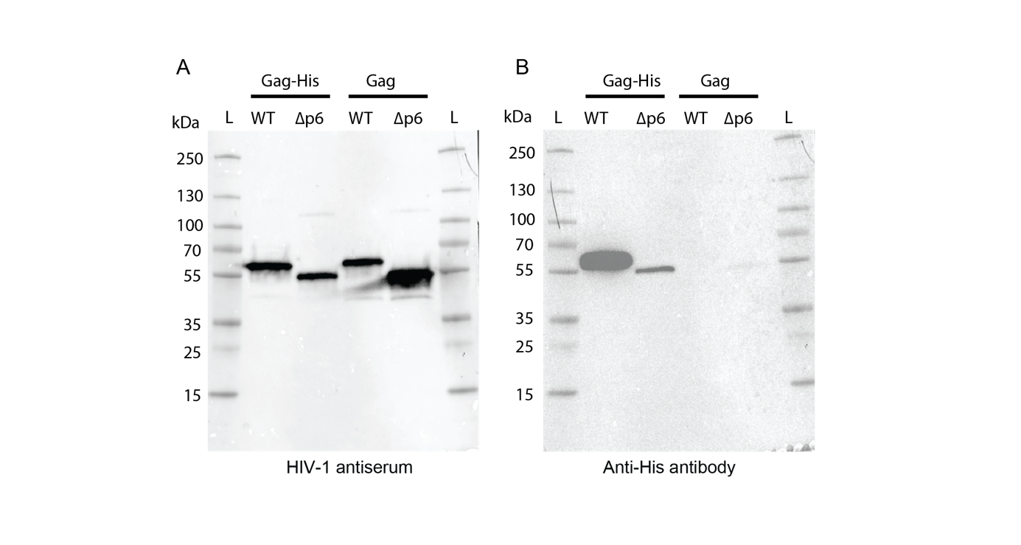

Supplementary Figure 3: Western Blot analysis of Pr55^{Gag} proteins. His-tag and TEV-cleaved Pr55^{Gag} and Gag∆p6 proteins were loaded on a 4-12% denaturing polyacrylamide gel and analyzed by western blot with specific antibodies against Pr55^{Gag} and His-tag (see Material and Methods). (L): Ladder (Page Ruler Plus Prestained Protein Ladder” - Thermo Scientific).

Supplementary Figure 4: Deconvoluted electrospray mass spectrum of the TEV-cleaved (A) GagΔp6 and (B) Pr55^{Gag} showing that the His-tag was successfully removed, and of the His-tagged (C) GagΔp6 and (D) Pr55^{Gag} similarly to what previously observed in⁷⁶ .

