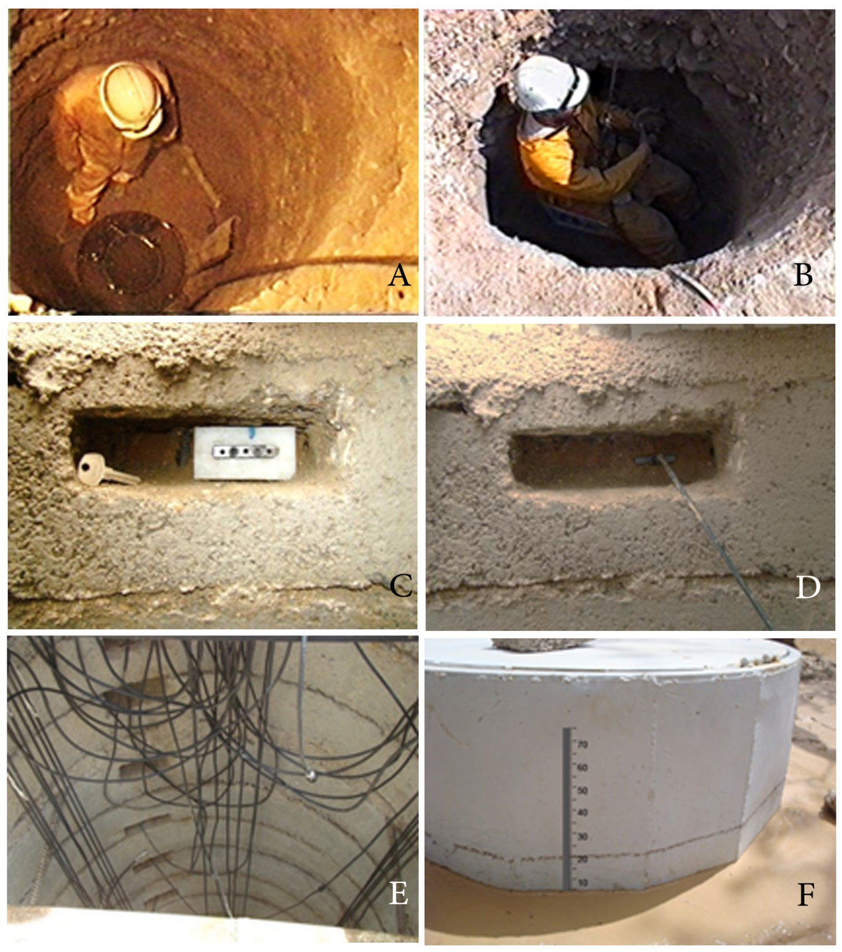

Figure S1. (A) Measuring the hydraulic conductivity, (B) identifying the layers, (C) the inserted polystyrene template, (D) the place for inserting the TDR probe, (E) the successive places for the TDR probes and (F) overall view of the experimental well. Photos: Mojtaba Pakparvar

