Autophagic Reliance Promotes Metabolic Reprogramming in Oncogenic KRAS-driven Tumorigenesis

H. Helen Lin, Yiyin Chung, Chun-Ting Cheng, Ching Ouyang, Yong Fu, Ching-Ying Kuo,
Kevin K. Chi, Maryam Sadeghi, Peiguo Chu, Hsing-Jien Kung, Chien-Feng Li,

Kirsten H. Limesand and David K. Ann

Supplementary Information

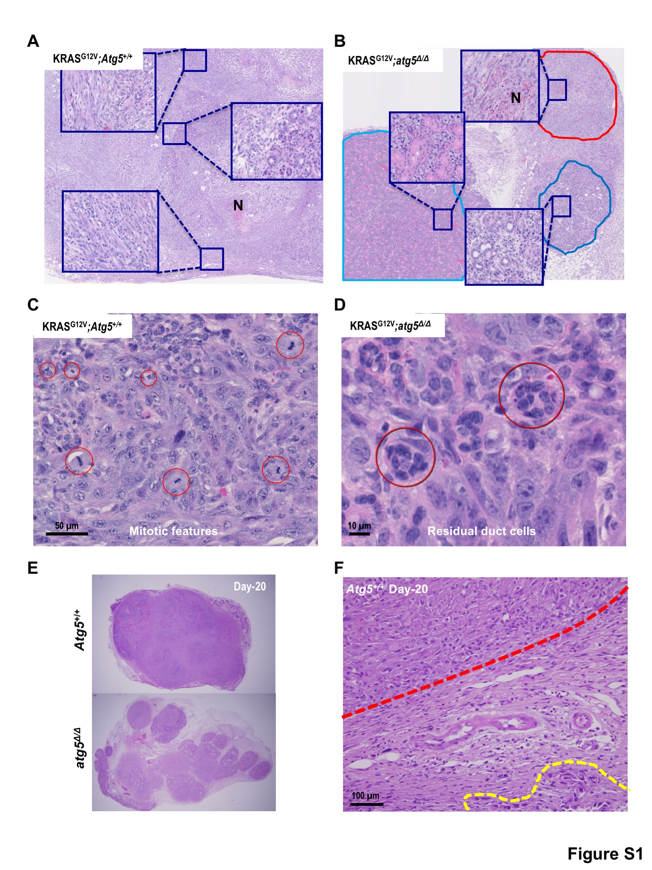
Figure S1. Compromised autophagy reduces the tumor burden in the Ela-CreERT;LGL-KRAS^{G12V} model. (A and B) Representative histological analyses (hematoxylin and eosin staining) of submandibular glands of KRAS^{G12V};Atg5^{+/+} (A) and KRAS^{G12V};atg5^{Δ/Δ} (B) mice at day 24 post-tumor induction. Tumors in Atg5^{+/+} mice (A) appear more aggressive than in atg5^{Δ/Δ} mice (B). N, necrotic area. (C) Mitotic figures (red circles) and apoptotic changes (cell shrinking, chromatin condensation, and nuclear fragmentation) were seen in tumor cells from KRAS^{G12V};Atg5^{+/+} mice. Scale bar: 50 μm. (D) Residual ducts (red circles) are visible in the tumor areas in KRAS^{G12V};atg5^{Δ/Δ} mice. Scale Bar: 10 μm (E) Representative tiling images from histological analyses (hematoxylin and eosin staining) of submandibular glands of KRAS^{G12V};Atg5^{+/+} (upper panel) and KRAS^{G12V};atg5^{Δ/Δ} (lower panel) mice at day 20 post-tumor induction showing that the tumor diffusely invaded into the peri-salivary gland fat in Atg5^{+/+} mice (fullness of tumor) than in atg5^{Δ/Δ} mice (presence of fibro-adipose tissue between tumor nodules). (F) Extra-salivary gland invasion in KRAS^{G12V};Atg5^{+/+} mice at day 20. Note the infiltrating edge of the tumor (red dotted line) and scattered nests of tumor cells (yellow dotted line). Scale bar: 100 μm.

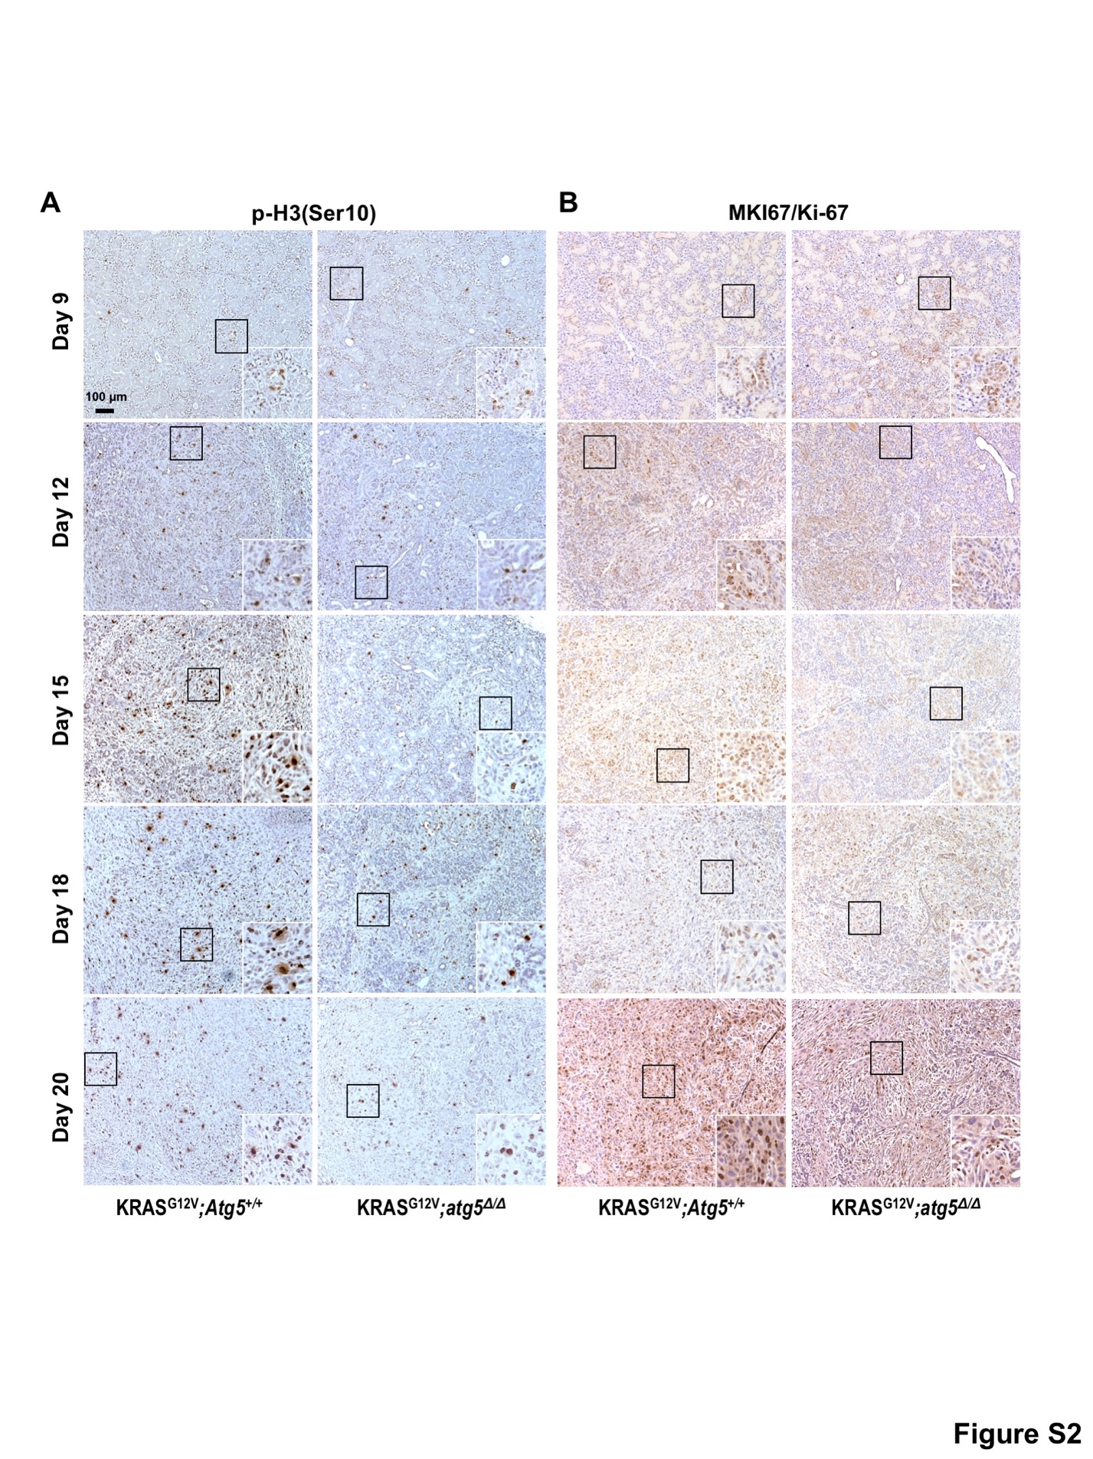
Figure S2. SDC tumors of KRAS^{G12V};Atg5^{+/+} mice grow more aggressively starting at day 15 post-tumor induction. Representative IHC of phosphorylated serine 10 of histone H3 (p-H3[Ser10])-stained (A) and MKI67/Ki-67-stained (B) SDC tumors from KRAS^{G12V};Atg5^{+/+} and KRAS^{G12V};atg5^{Δ/Δ} mice at day 9, 12, 15, 18 and 20 after tumor induction. Quantification of number of p-H3(Ser10)-positive and MKI67/Ki-67-positive cells was shown on Figs. 2F and 2H, respectively. Three random images were taken from each mouse tumor sample. At least 4 mice were included in each group. Scale bar: 100 μm.

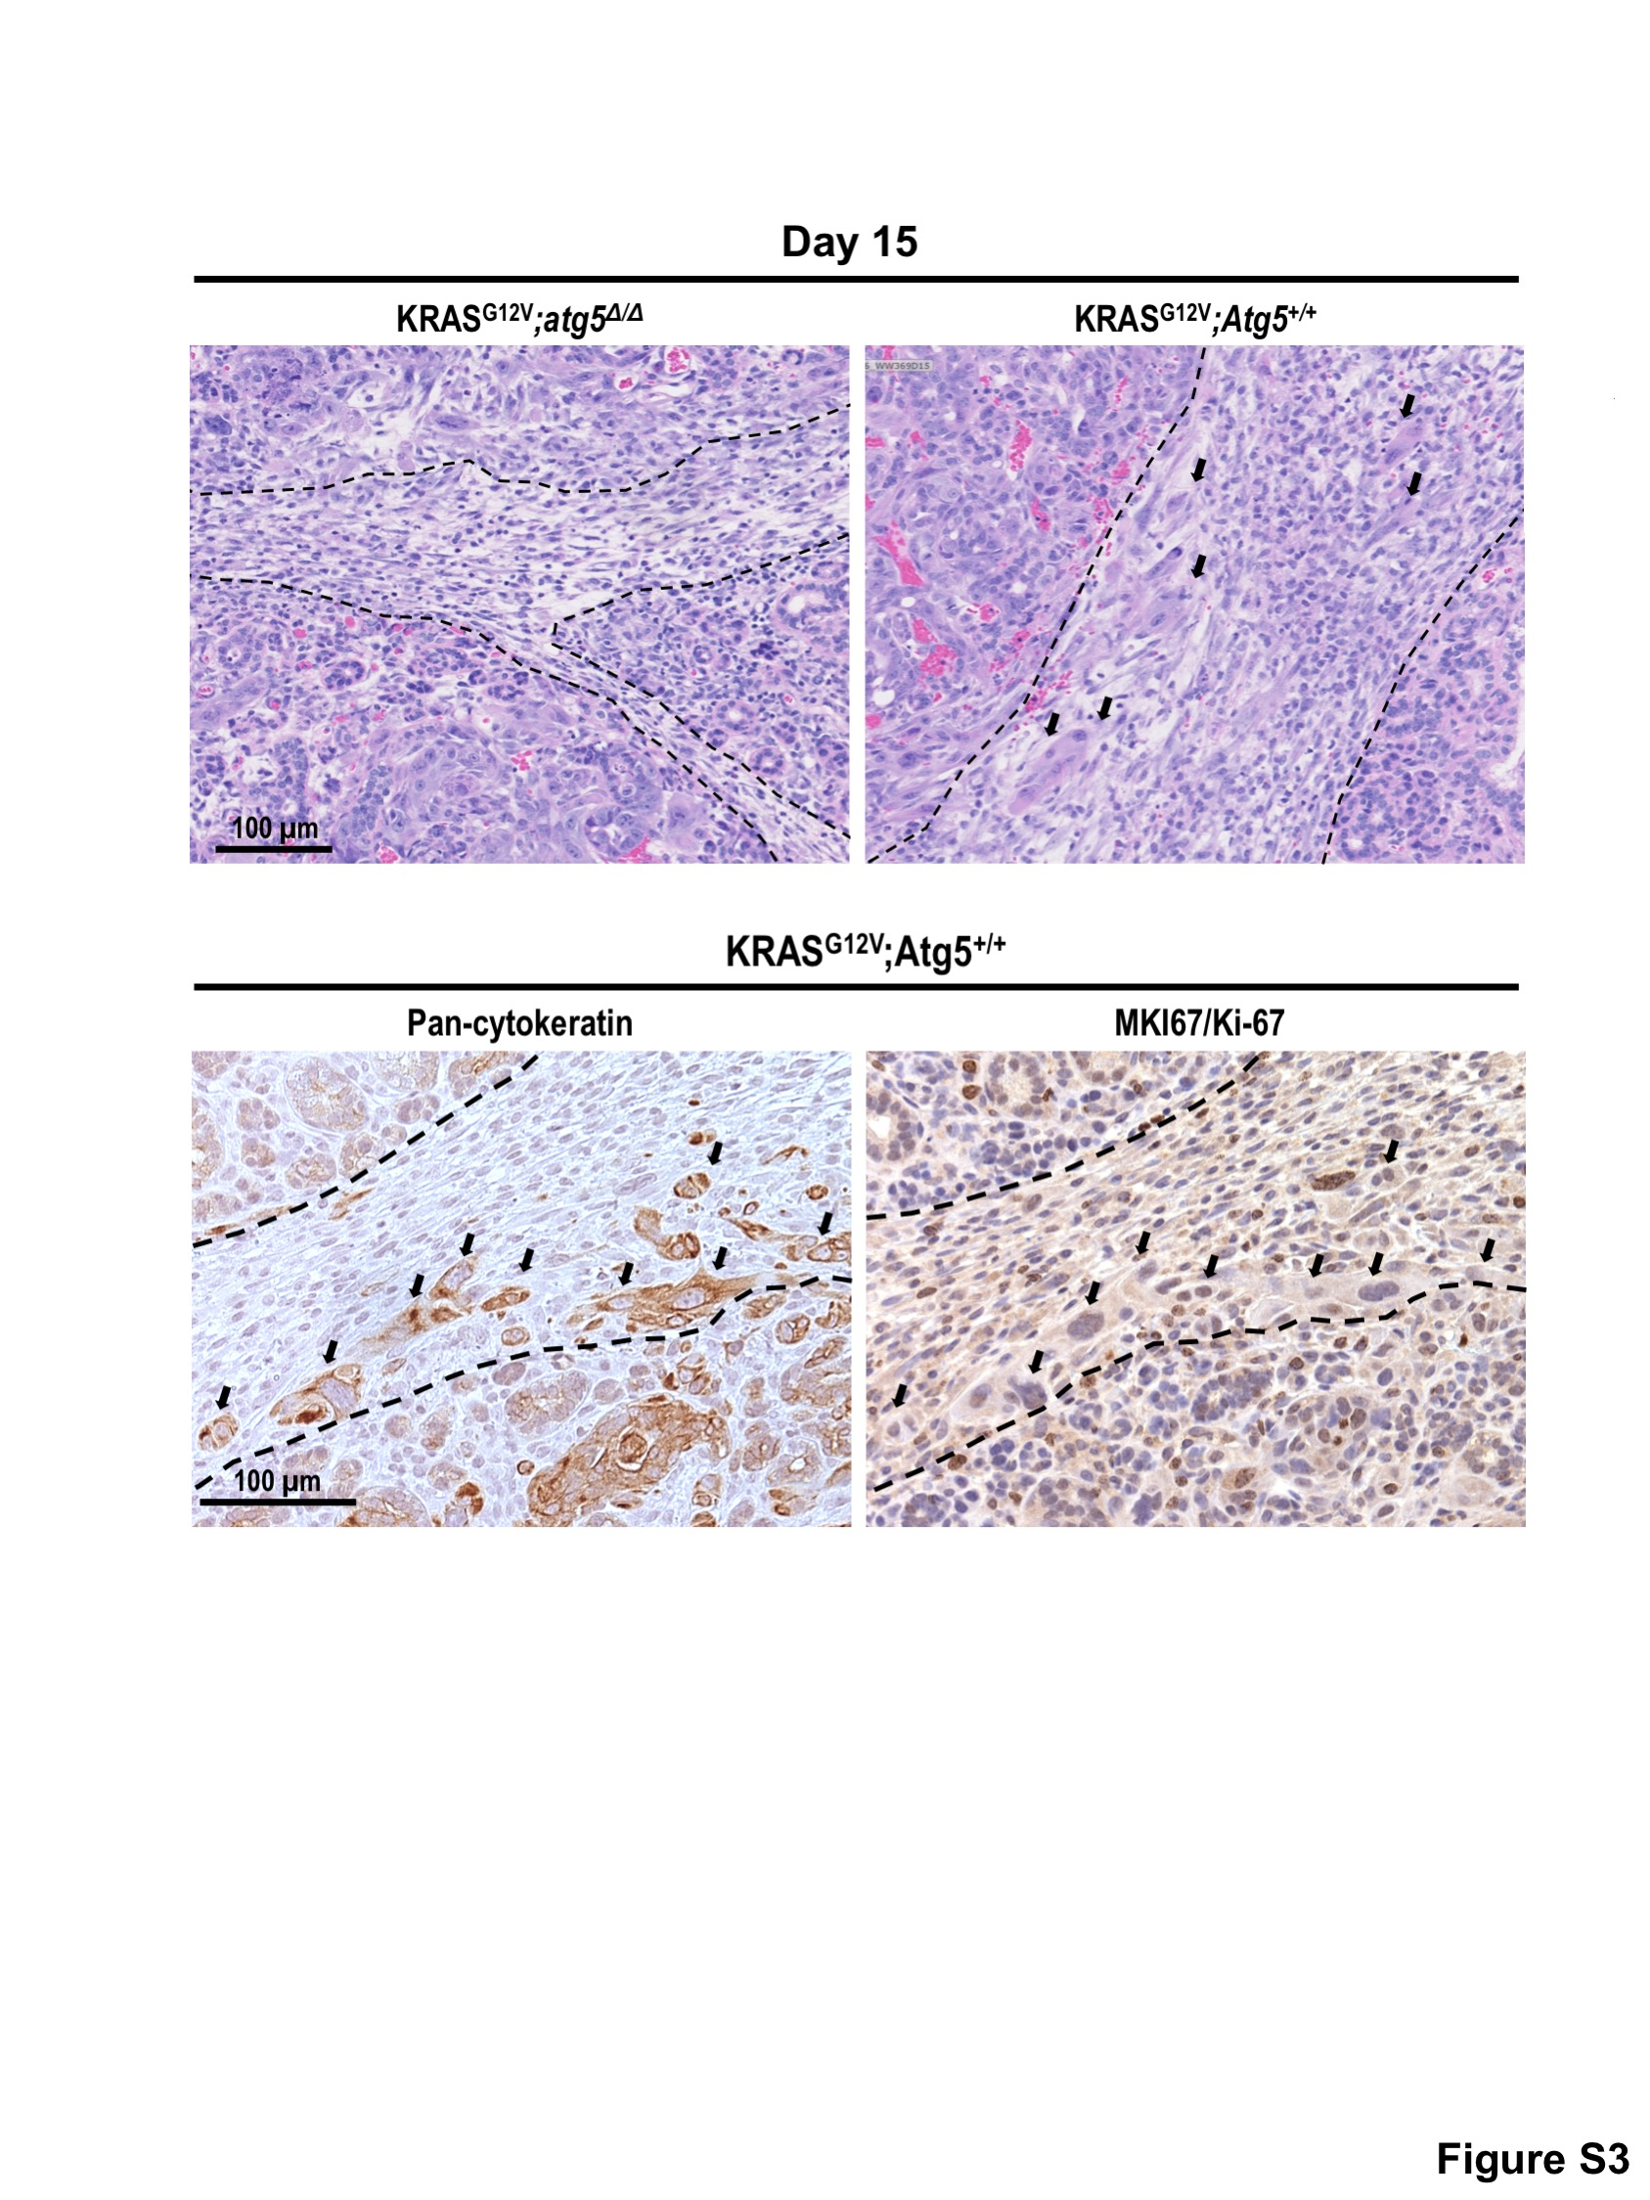
Figure S3. Stromal invasion. Representative histological analyses (hematoxylin and eosin staining) of the submandibular glands from KRAS^{G12V};atg5^{Δ/Δ} (upper left panel) and KRAS^{G12V};Atg5^{+/+} (upper right panel) mice at day 15 post-tumor induction. Tumor cells invading into peri-lobular stroma were observed in KRAS^{G12V};Atg5^{+/+} mice (black arrows). Representative IHC of pan-cytokeratin (lower left panel) highlights tumor cells and MKI67/Ki-67 (lower right panel), shows that invading tumor cells are not proliferating, using consecutive sections. Black arrow, invading tumor cell; black dotted line, margin of tumor regions. Scale bar: 100 μm.

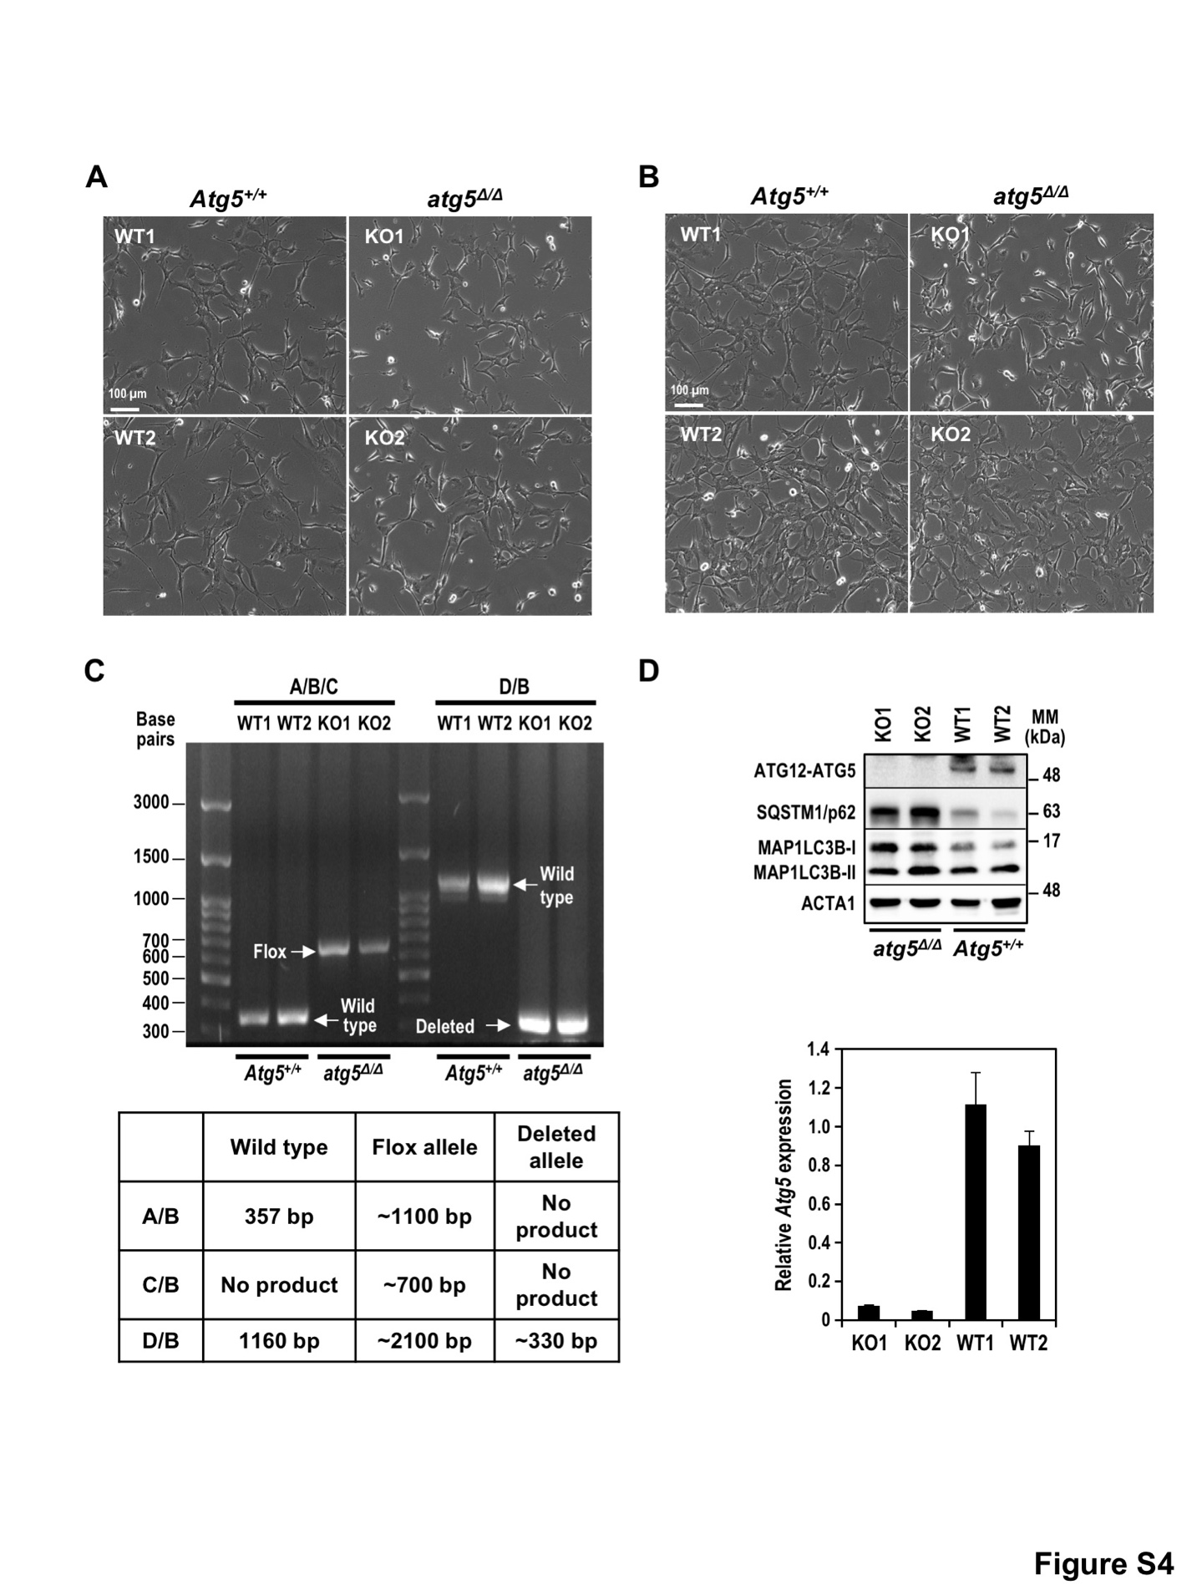
Figure S4. Characterization of KRAS^{G12V};Atg5^{+/+} and KRAS^{G12V};atg5^{Δ/Δ} SDC tumor cells. (A and B) Live-cell images of SDC cells isolated from 2 mice in each genotype group at low density (A) and high density (B). All 4 cells demonstrated similar sarcomatoid morphology. (C) Genotyping analyses confirmed the disruption of the Atg5 gene in isolated KRAS^{G12V};atg5∆/∆ tumor cells. Knockout of Atg5 in KRAS^{G12V};Atg5^{+/+} and KRAS^{G12V};atg5^{Δ/Δ} cells is validated by PCR. Primer sets A, B, C, and D were designed for genotyping Atg5. Genomic DNA isolated from 2 KRAS^{G12V};Atg5^{+/+} and 2 KRAS^{G12V};atg5^{Δ/Δ} cells were used as PCR templates. Specific PCR product sizes for individual Atg5 genotypes are summarized in the table. WT: KRAS^{G12V};Atg5^{+/+} cells; KO: KRAS^{G12V};atg5^{Δ/Δ} cells. (D) Western and qRT-PCR analyses confirming Atg5 genetic disruption in KRAS^{G12V};atg5^{Δ/Δ} tumor cells. Equal amounts of whole cell lysates from isolated KRAS^{G12V};Atg5^{+/+} and KRAS^{G12V};atg5^{Δ/Δ} cells were subjected to western blot analysis, and a representative image is shown (n = 3) (upper panel). Undetectable ATG12–ATG5, accumulation of SQSTM1 and abundant LC3B-I with a lower LC3B-II to LC3B-I ratio, a hallmark of compromised autophagy, were observed in KRAS^{G12V};atg5^{Δ/Δ} tumor cells. ACTA1 is shown as a loading control. Relative Atg5 mRNA abundance was calculated by designating the average ΔCt of WT1 and WT2 as 1 after normalizing to Rn18s rRNA (lower panel).

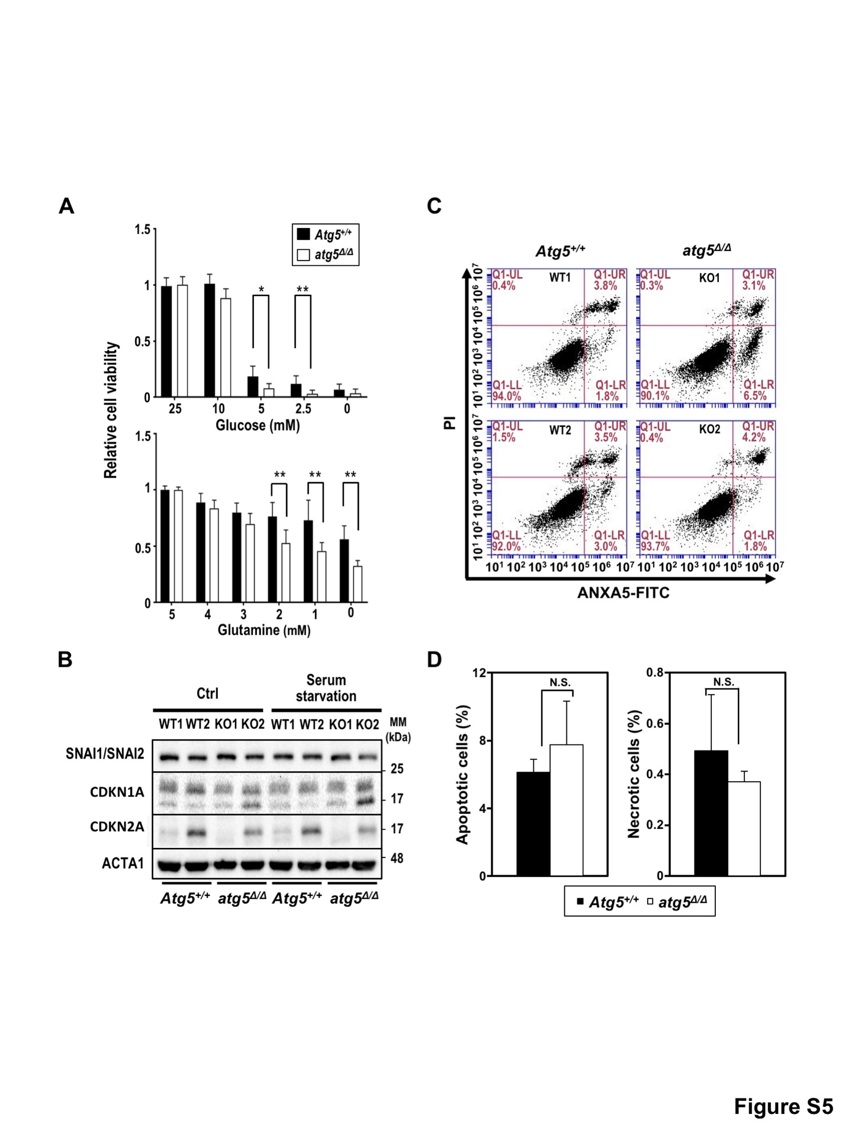
Figure S5. Compromised autophagy affects the response to metabolic stress, but not the senescence markers and the apoptotic cell population between autophagy-competent and -deficient SDC-tumor cells. (A) KRAS^{G12V};atg5^{Δ/Δ} cells are more sensitive than KRAS^{G12V};Atg5^{+/+} cells to the deprivation of glucose (upper panel) and glutamine (lower panel). Cells were incubated in the indicated concentrations of glucose and glutamine for 48 h, prior to acid phosphatase (ACP) cell viability assays. (B) Equal amounts of whole cell lysates from 2 KRAS^{G12V};Atg5^{+/+} and 2 KRAS^{G12V};atg5^{Δ/Δ} tumor cells were subjected to western blot analysis. The protein levels of senescence markers CDKN1A and CDKN2A varied among individual cells, but no overall differences between autophagy-competent and -compromised cells were observed. EMT was also examined by probing with an antibody recognizing both SNAI1 and SNAI2. The protein level of SNAI1 and SNAI2 was not affected by autophagy competency. ACTA1 is shown as a loading control. (C and D) KRAS^{G12V};Atg5^{+/+} and KRAS^{G12V};atg5^{Δ/Δ} cells were harvested and stained with ANXA5-FITC and PI for 20 min at room temperature and then subjected to flow cytometry analysis. (C) Representative flow cytometry data showing both ANXA5 binding and PI uptake of the cells. The percentages of cells that were ANXA5-positive, PI-positive, or double positive for both ANXA5 and PI were as indicated. (D) Percent of ANXA5-positive cells (left panel) and PI-positive (ANXA5-negative) cells (right panel) were not different based on autophagy competency. N.S.: not significant.

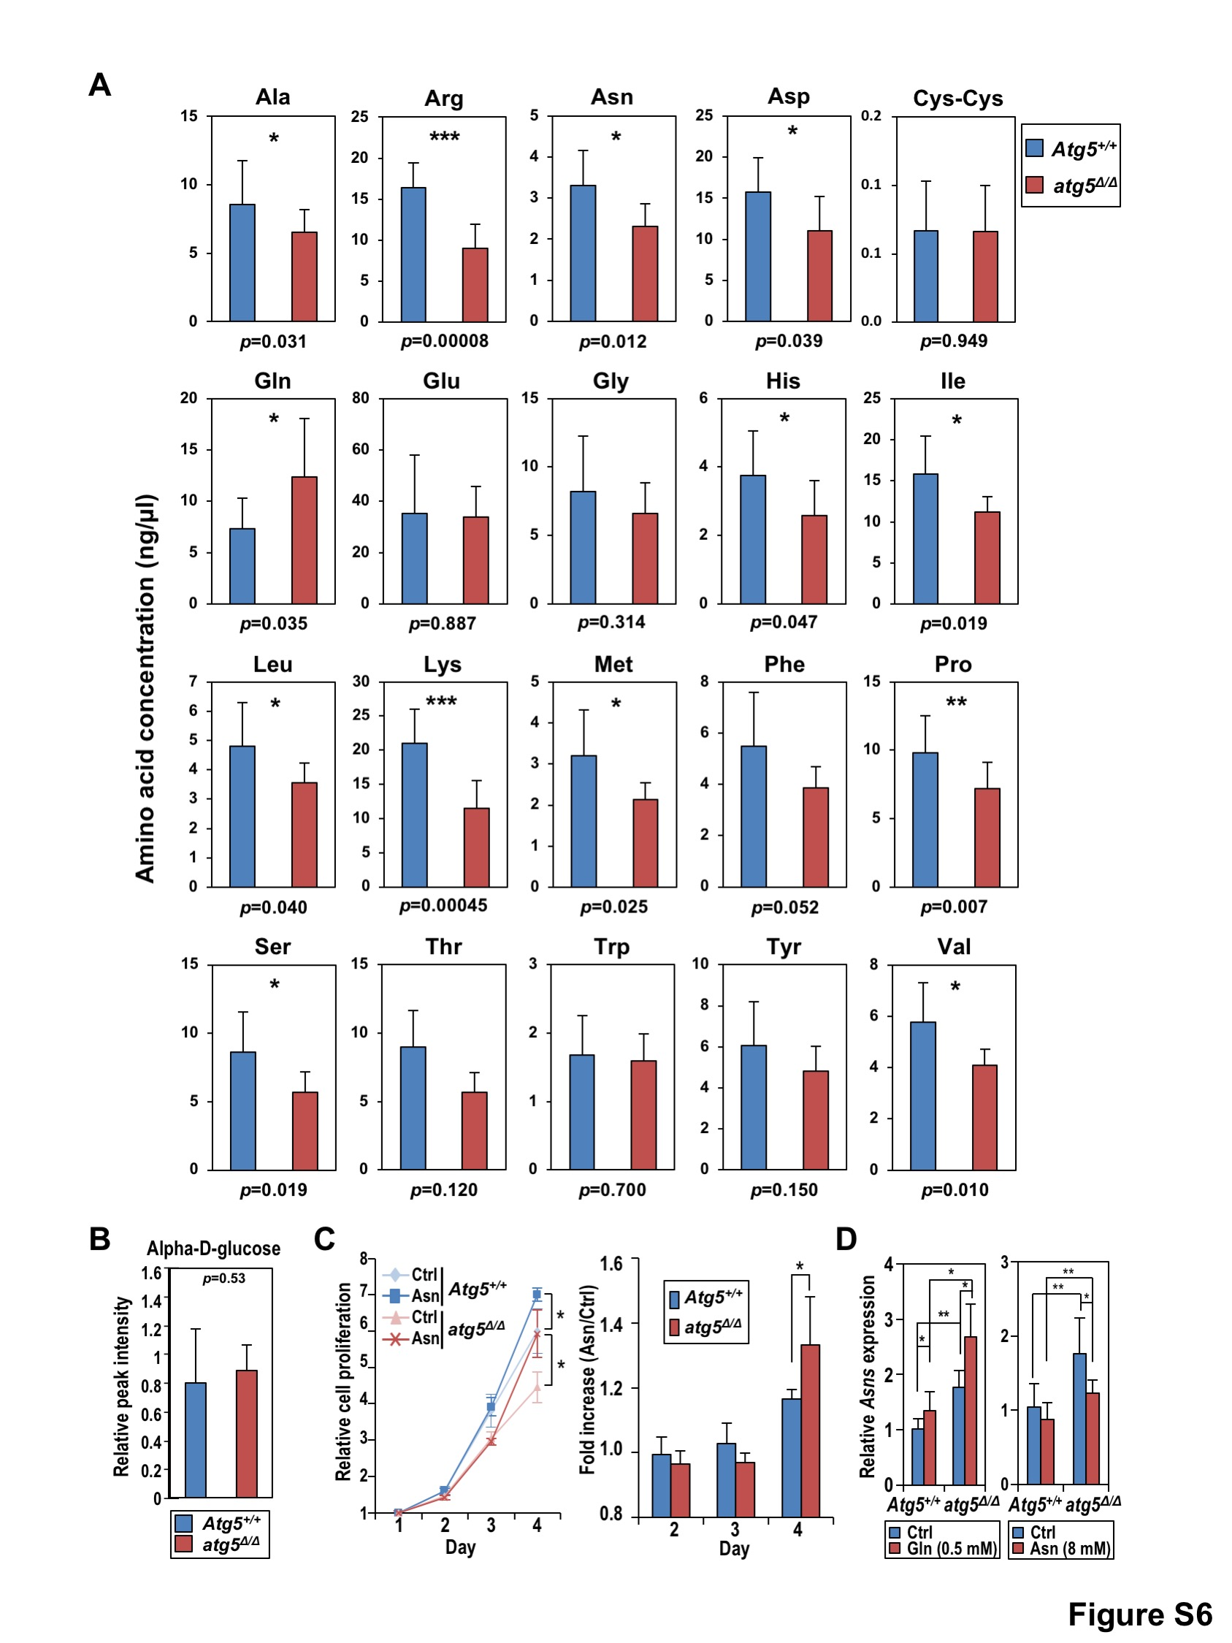
Figure S6. Twelve of 20 intracellular amino acid levels are reduced in autophagy-deficient SDC-tumor cells. (A) Amino acid profiles were determined by HPLC/MS as described in Methods. Data are shown as mean ± SD; n = 5. *: p < 0.05; **: p < 0.01; ***: p < 0.001 (Student’s t-test, two-tailed, unpaired). (B) Intracellular glucose level was not affected by autophagy capacity. Intracellular α-D-glucose level was determined by LC-MS followed by searching for matches in METLIN database (https://metlin.scripps.edu/). Data is shown as mean ± SD; n = 7. (C) Asparagine supplementation promotes cell proliferation. Cells were seeded at 20% confluency in full media with or without asparagine (Asn, 8 mM). Cell viability was measured daily by ACP assays for 4 consecutive days. Growth curve (left panel) and fold increase in cell proliferation (Asn over control; right panel) are shown. Data are shown as mean ± S.D.; n = 3. *: p < 0.05 (ANOVA with Bonferroni multiple comparisons test). (D) Nutrient-regulated endogenous Asns (asparagine synthetase) expression. Total RNAs were isolated from cells of both genotypes cultured in glutamine-depleted medium (Gln, 0.5 mM), control medium (Gln, 5 mM), or asparagine supplemented control medium (Gln, 5 mM; Asn, 8 mM) for 24 h. Asns mRNA abundance was measured by qRT-PCR and normalized to Rn18s RNA. Data were analyzed using 2^{ΔΔCt} method and the Asns mRNA level in KRAS^{G12V};Atg5^{+/+} cells grown in control medium is designated as 1. Data are shown as mean ± S.D.; n = 3. *: p < 0.05; **: p < 0.01 (Student’s t-test, two-tailed, unpaired).

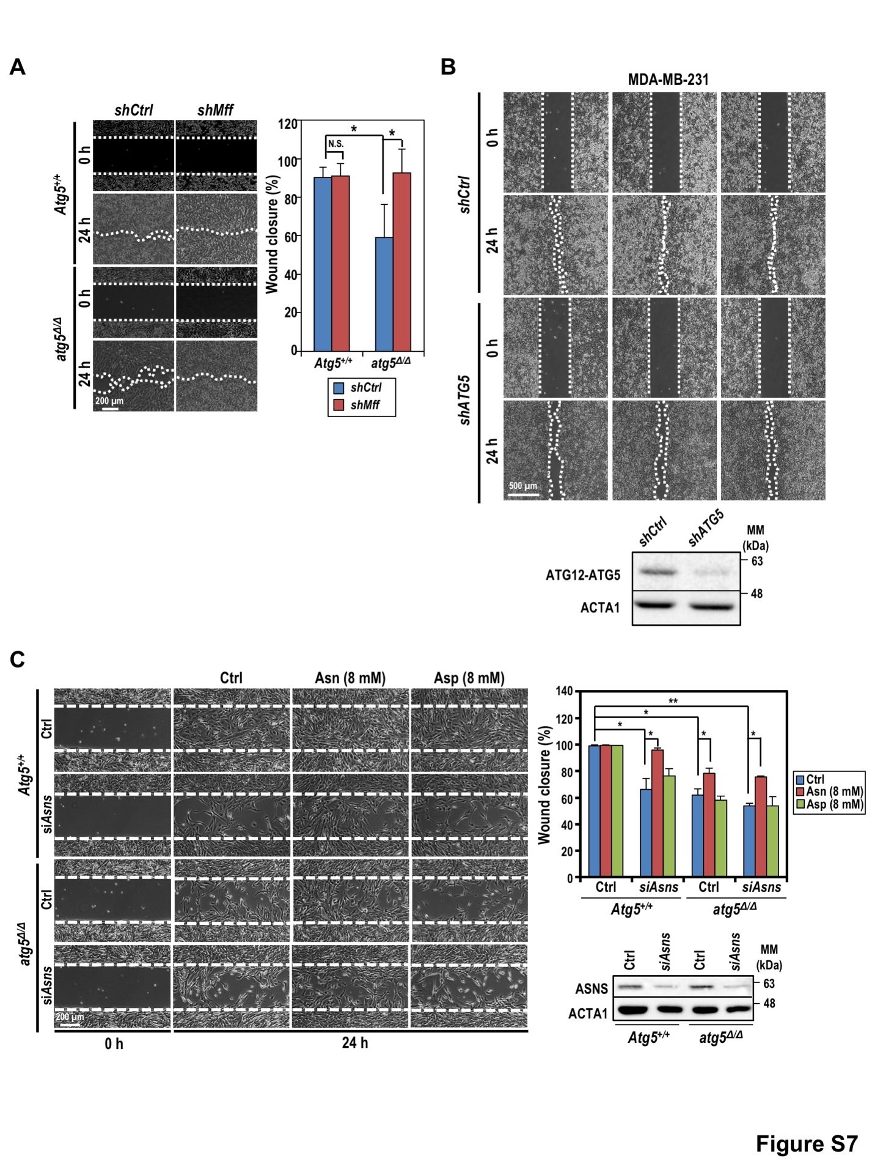
Figure S7. Knockdown of MFF, ATG5, or ASNS differentially affected the motility in oncogenic KRAS-driven tumor cells. (A) Wound healing assays show that knockdown of MFF restored cell migration in KRAS^{G12V};atg5^{Δ/Δ} cells. A set of representative images and quantification of wound closure are shown. *: p < 0.05; N.S.: not significant (Student’s t-test, two-tailed, unpaired). (B) Wound healing assay of control MDA-MB-231 (shCtrl) and ATG5-knockdown MDA-MB-231 (shATG5) cells. Images were taken immediate after the wounds were created (0 h) and at 24 h post-wounding. Images from 3 independent experiments are shown. Knockdown of ATG5 is confirmed by western blot analysis with ACTA1 as a loading control (bottom panel). (C) Knockdown of ASNS reduced KRAS^{G12V};Atg5^{+/+} cell motility while that of KRAS^{G12V};atg5^{Δ/Δ} cells was not affected. The effect of ASNS-KD can be reversed by supplementation of Asn (8 mM) but not Asp (8 mM). Cells were transfected with siRNA against mouse Asns (siAsns) or control siRNA (ctrl) and incubated for 48 h before wound healing assay. Representative images were shown (left panel). Quantification of percent of wound closure is shown (upper right panel). Data was shown as mean ± S.D.; n=3. Knockdown of ASNS was confirmed by western blot analysis (lower right panel). ACTA1 serves as a loading control. *: p < 0.05; **: p < 0.01 (Student’s t-test, two-tailed, un-paired).

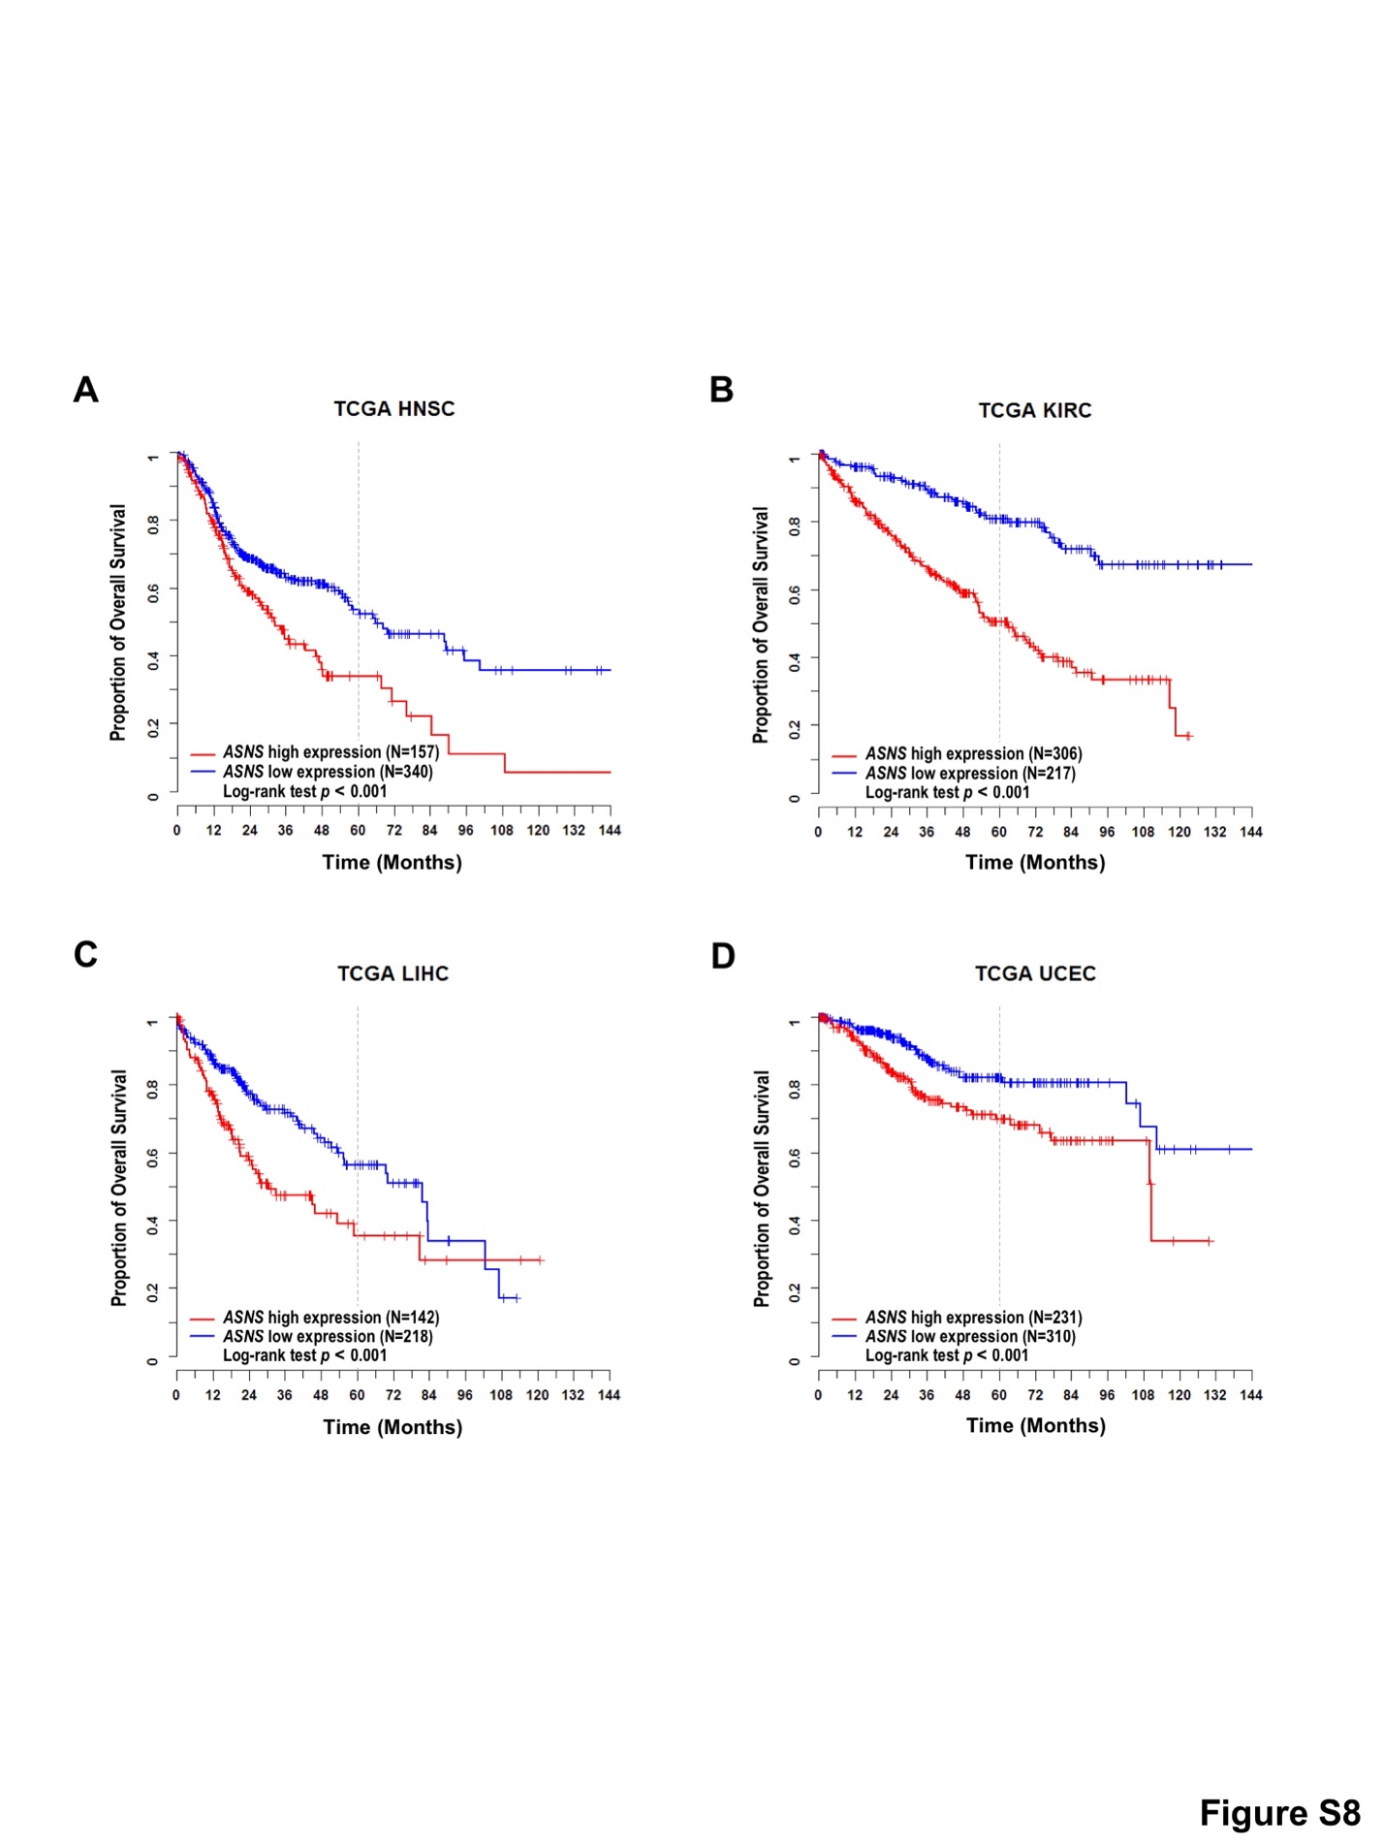
Figure S8. Kaplan–Meier survival analyses based on ASNS expression across multiple TCGA cancer types. Survival curves were analyzed for the following human cancers; (A) head and neck squamous cell carcinoma (HNSC), (B) kidney renal clear cell carcinoma (KIRC), (C) liver hepatocellular carcinoma (LIHC), and (D) uterine corpus endometrial carcinoma (UCEC).

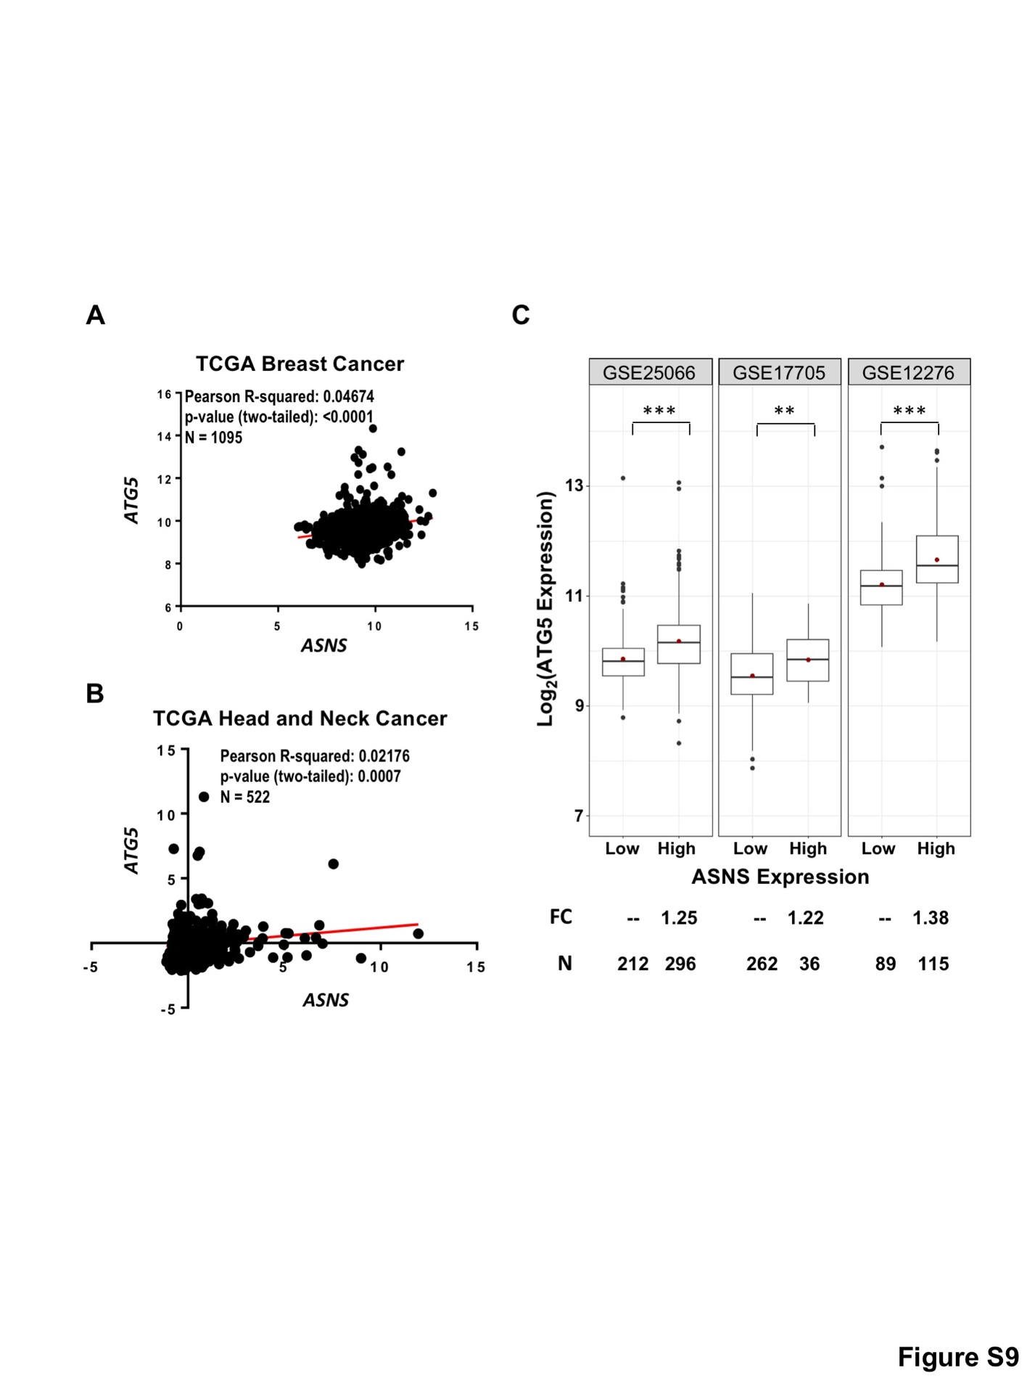
Figure S9. A positive correlation between expression levels of ATG5 and ASNS in human cancer. Scatter plots show positive correlation between ATG5 and ASNS gene expression in (A) Breast Cancer (p < 0.0001) and (B) Head and Neck Cancer (p < 0.001) in TCGA datasets. Pearson correlation and p-value were calculated using GraphPad Prism 7. (C) ATG5 expression levels were compared between the high and low ASNS expression groups that exhibited differential distal metastasis-free survival, as shown in Figs. 7E, 7F and 7G. Fold change (FC) of normalized expression values and the number (N) of samples are labeled at the bottom. Statistical p-values between groups were determined using Welch’s t-test (**: p <0.01; ***: p <0.001).

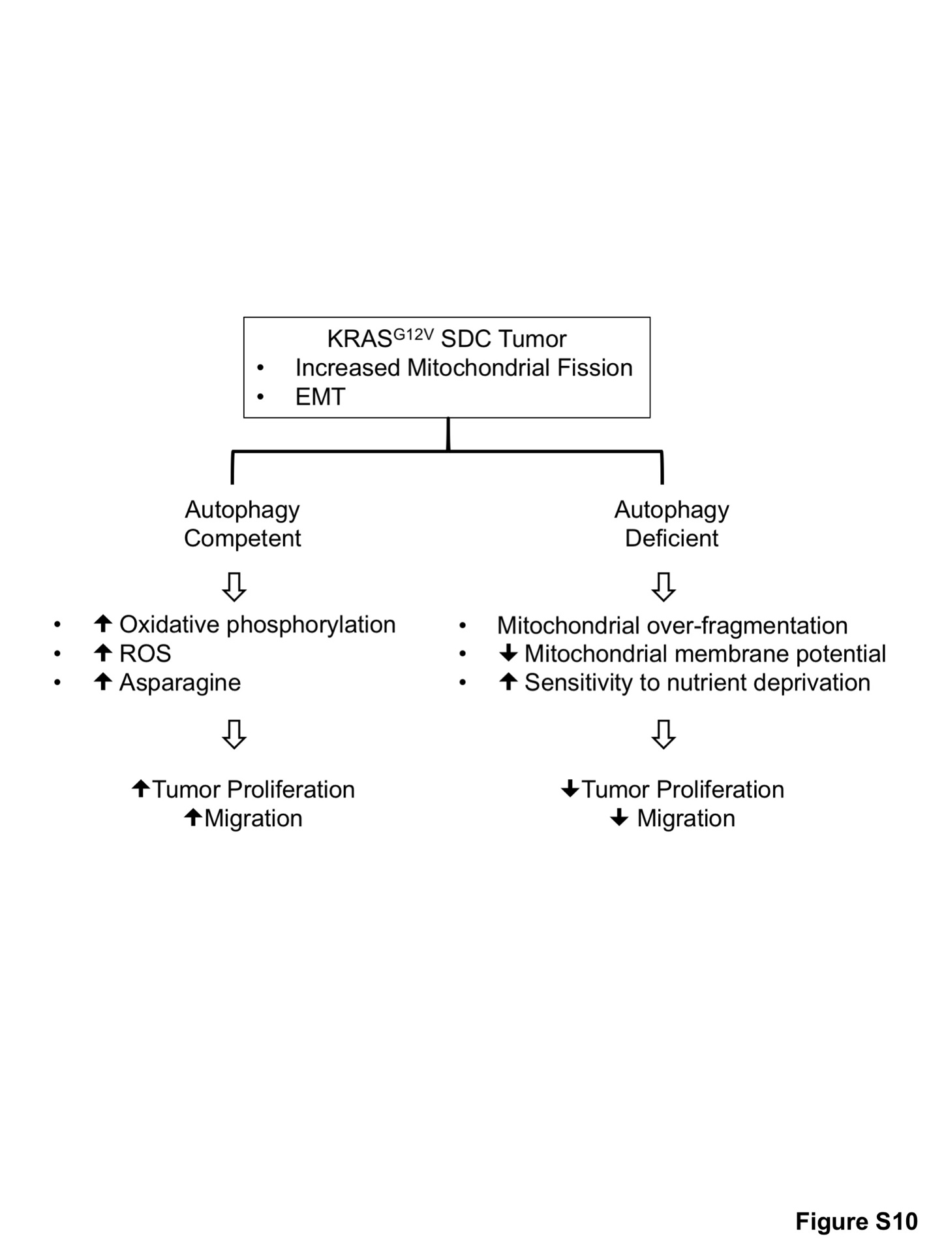
Figure S10. Summary of key characteristics of autophagy-competent and autophagy-deficient oncogenic KRAS-induced salivary duct carcinoma. The diagram summarizes our findings on differential mitochondrial biogenesis, nutrient dependency, and epithelial-to-mesenchymal transition (EMT) progression based on autophagy capacity. These factors converge to render reduced tumor proliferation and migration during autophagy-impaired tumorigenesis and extended survival of the respective tumor-bearing mice.

