Electronic Supporting Information
Application of Ni(II) complexes of air stable Schiff base functionalized N-heterocyclic carbene ligands as catalysts for the transfer hydrogenation of aliphatic ketones

SAMAILA ABUBAKAR and MUHAMMAD D. BALA*

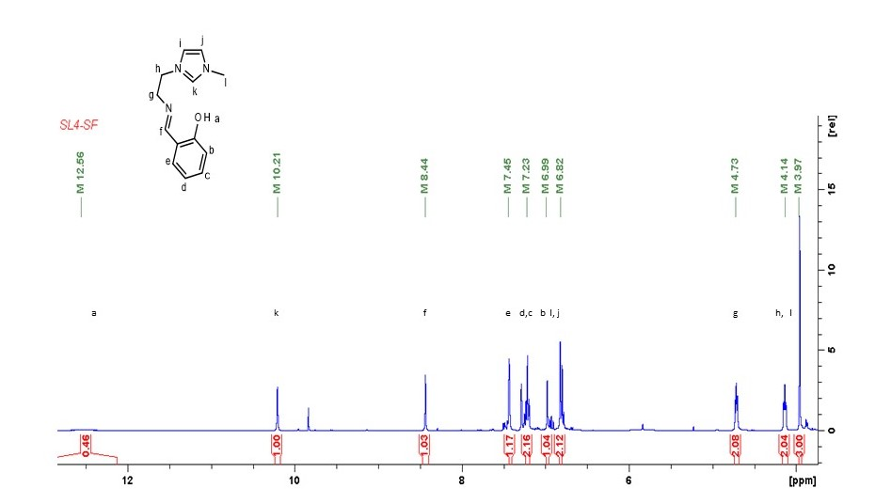
Figure S1. ¹H NMR Spectrum of compound 2 in CDCl₃.
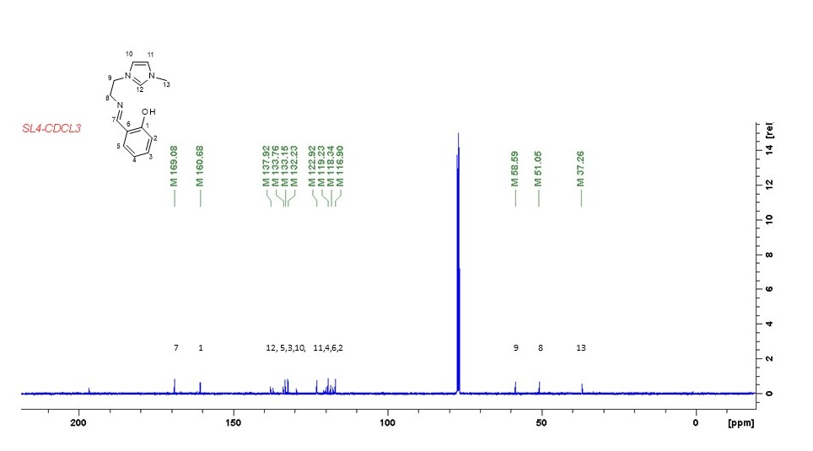
Figure S2. ¹³C NMR Spectrum of compound 2 in CDCl₃.

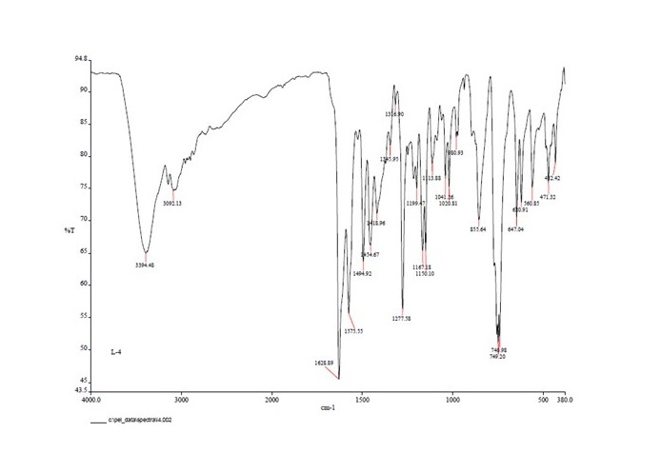
Figure S3. IR Spectrum of 2.

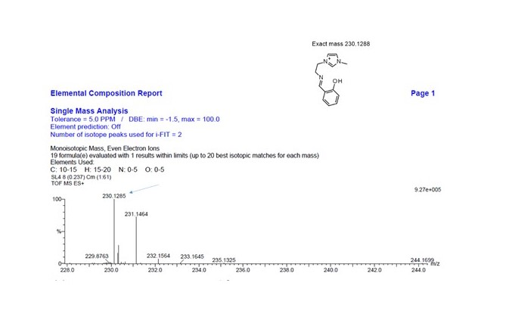
Figure S4. TOF MS ES⁺ of 2.

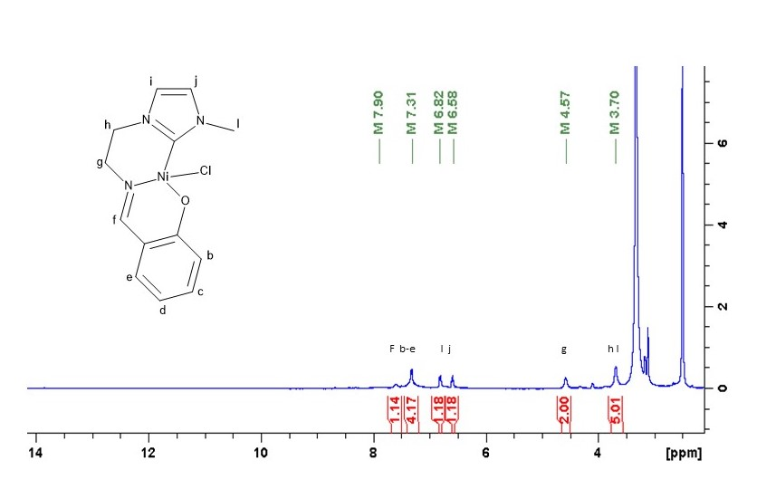
Figure S5. ¹H NMR Spectrum of 5 in DMSO-d₆.
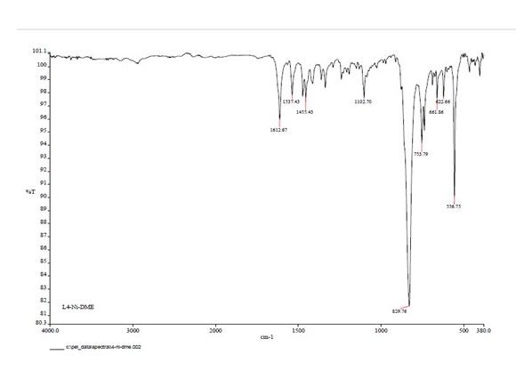
Figure S6. ¹H IR Spectrum of 5.

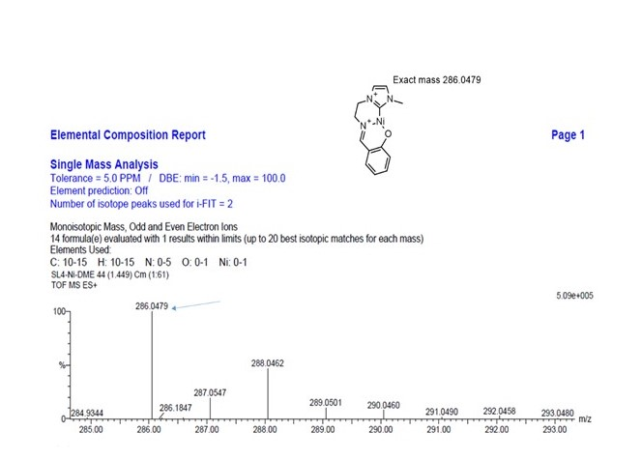
Figure S7. TOF MS ES⁺ of 5.
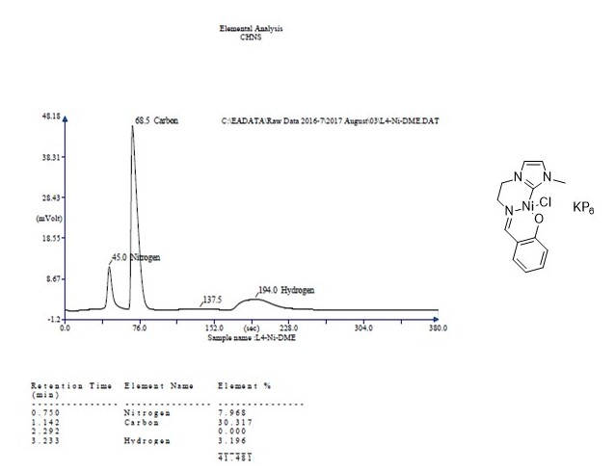
Figure S8. Elemental analysis of 5.
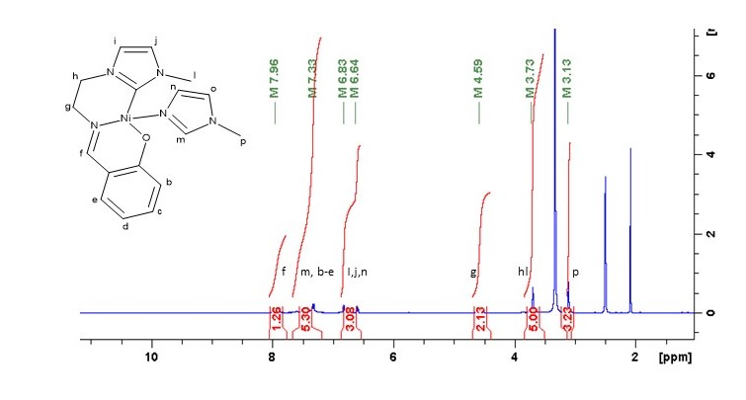
Figure S9. ¹H NMR spectrum of 6 in DMSO-d₆.
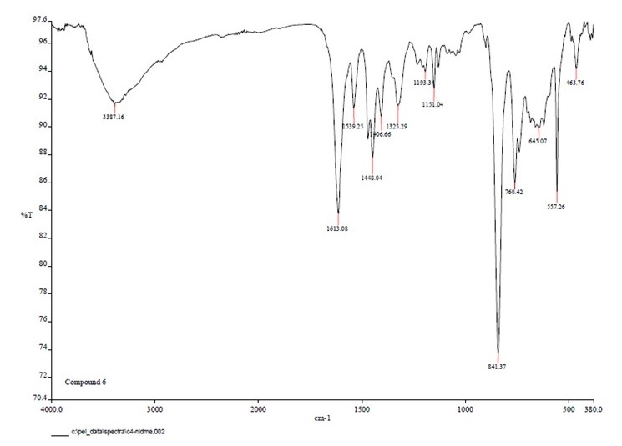
Figure 10. IR Spectrum of 6.

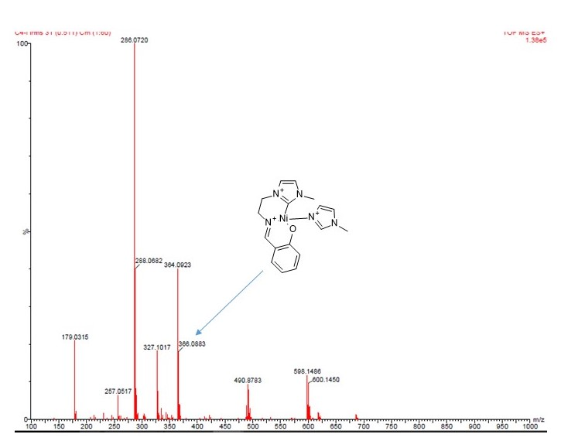
Figure S11. TOF MS ES⁺ of 6.

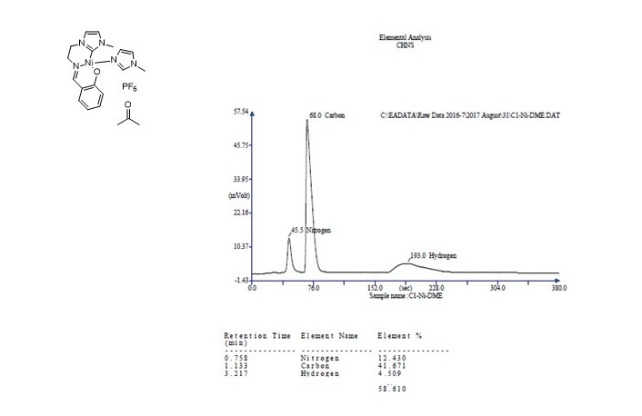
Figure S12. Elemental analysis results of 6.

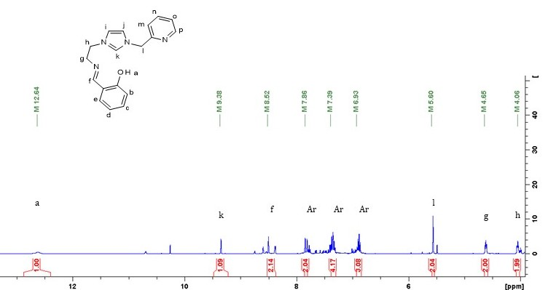
Figure S13. ¹H NMR Spectrum of 3 in DMSO-d₆.

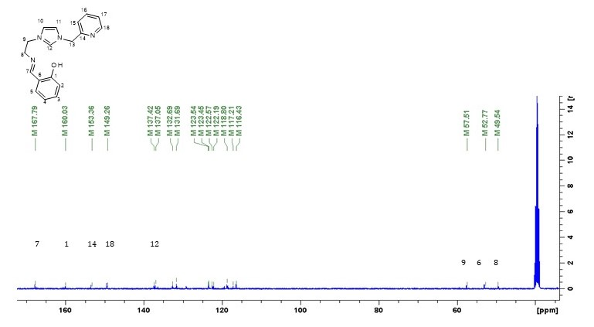
Figure S14. ¹³C NMR Spectrum of 3 in DMSO-d₆.

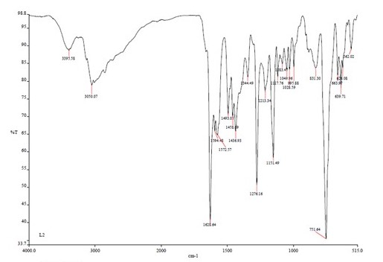
Figure S15. IR Spectrum of 3.

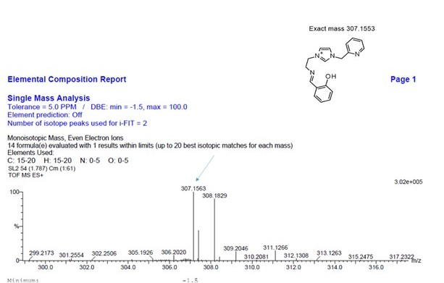
Figure S16. TOF MS ES⁺ of 3.

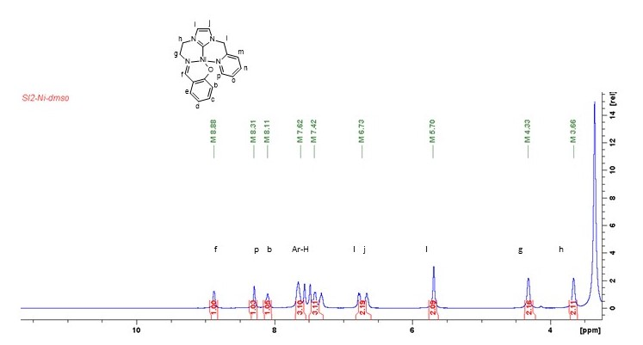
Figure S17. ¹H NMR Spectrum of 4 in DMSO-d₆.

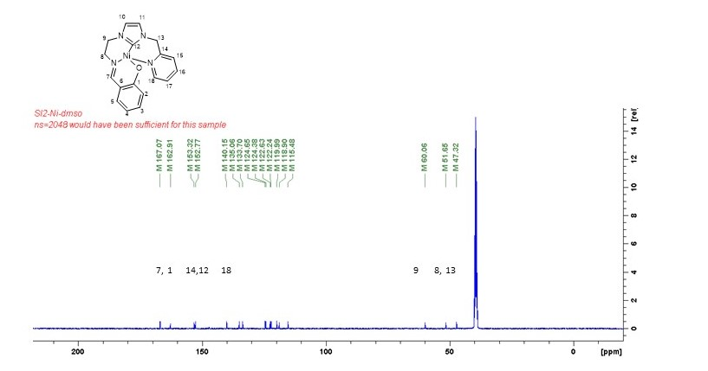
Figure S18. ¹³C NMR Spectrum of 4 in DMSO-d₆.

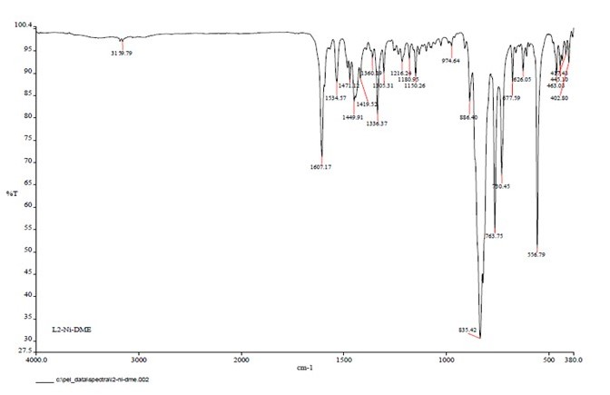
Figure S19. ATR IR Spectrum of 4.

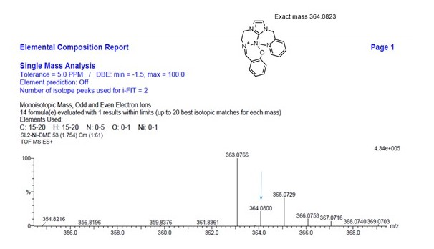
Figure S20. TOF MS ES⁺ of 4.
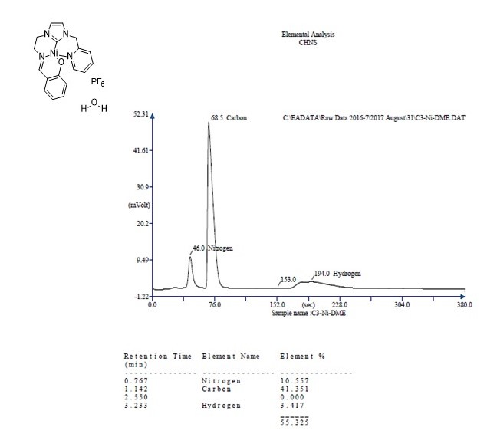
Figure S21. Elemental analysis results of 4.

