**Supporting information**

Lone pair···π interactions on the stabilization of intra and intermolecular arrangements of coordination compounds with 2-methyl imidazole and benzimidazole derivatives

GUILLERMO DURÁN-SOLARES, WALTER FUGAROLAS-GOMEZ, NAYTZÉ ORTÍZ-PASTRANA, HORACIO LÓPEZ-SANDOVAL, TAYDE OSVALDO VILLASEÑOR-GRANADOS, ANGELINA FLORES‑PARRA, PHILIPP J. ALTMANN and NORAH BARBA-BEHRENS\*



**4**

**5**

**1**

6

**7 d**

**8**

**3**

**2**

**2**

**1**

**3**

**4**

**5**

**MeCN**

**7 d**

**6 ds**

**8**

**H2O**

Figure S1. 1H-NMR spectrum of 2-mfsiz, 400 MHz (MeCN-d3).



**10**

**9**

**8**

**7**

**6**

**5**

**2**

**1**

**10**

**9**

**8**

**7**

**6**

**5**

**4**

**3**

**MeCN**

**2**

**1**

**3**

**4**

Figure S2. 13C-NMR spectrum of 2-mfsiz, 400 MHz (MeCN-d3).

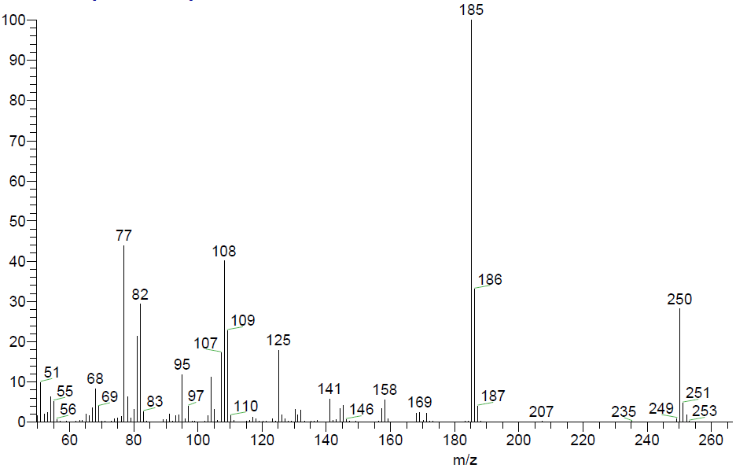

Figure S3. Mass spectrum of 2-mfsiz, electronic impact (EI).

**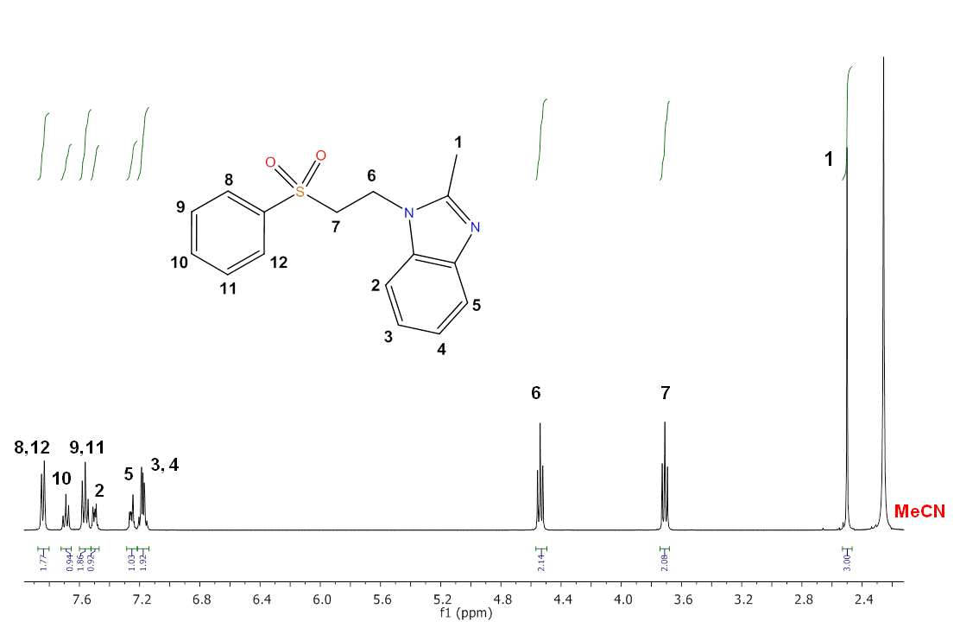**

Figure S4. 1H-NMR spectrum of 2-mfsbz, 400 MHz (MeCN-d3).

Table S1. Crystal data and structural refinement parameters of 2-mfsiz **1** and 2-mfbz **2**, and 2-mfsiz compounds **3**, **4** and **6**.

|  |  |  |  |  |  |
| --- | --- | --- | --- | --- | --- |
|  | **1** | **2** | **3** | **4** | **6** |
| Empirical formula | C12H14N2O2S | C16H16N2O2S | C24H28Cl2CoN4O4S2 | C24H28Br2CoN4O4S2 | C24H28Cl2NiN4O4S2 |
| M/gmol-1 | 250.31 | 300.37 | 630.45 | 719.37 | 630.23 |
| Crystal system | Monoclinic | Monoclinic | Monoclinic | Monoclinic | Monoclinic |
| Space group | P21/n | P21/c | P21 | P21 | P21 |
| a/Å | 5.7975(6) | 5.3621(5) | 8.6471(17) | 8.9230(3) | 8.5813(6) |
| b/Å | 10.5346(12) | 16.6165(16) | 9.3080(19) | 9.2263(4) | 9.3315(7) |
| c/Å | 19.1127(18) | 15.8493(15) | 17.076(3) | 17.1578(7) | 16.9298(11) |
| α/° | 90 | 90 | 90 | 90 | 90 |
| β/° | 95.092(7) | 91.609(2) | 96.75(3) | 93.225(2) | 97.672(3) |
| γ/° | 90 | 90 | 90 | 90 | 90 |
| V/Å3 | 1162.7(2) | 1411.6(2) | 1364.9(5) | 1410.30(10) | 1343.54(16) |
| Z | 4 | 4 | 2 | 2 | 2 |
| dcalcd./gcm-3 | 1.430 | 1.413 | 1.534 | 1.694 | 1.558 |
| F(000) | 528 | 632 | 650 | 722 | 652 |
| Collected reflections | 11906 | 18169 | 11556 | 28723 | 25694 |
| Independent reflections | 2681 | 3232 | 4986 | 4942 | 4726 |
| Rint | 0.0888 | 0.0572 | 0.0699 | 0.0295 | 0.0466 |
| GOF[c] on F2 | 1.031 | 1.094 | 1.053 | 1.031 | 1.037 |
| R1[a] [I>2σ(l)] | 0.0505 | 0.0463 | 0.0594 | 0.0149 | 0.0262 |
| wR2[b] (all data) | 0.1292 | 0.0985 | 0.1134 | 0.0362 | 0.0589 |

[a] *R*1 = Σ||*F*o| – |*F*c||/Σ|*F*o|. [b] *wR*2 = [Σ*w*(*F*o2 – *F*c2)2/Σ*w*(*F*o2)2]1/2; *w* = 1/σ2(|*F*o|). [c] Goodness of fit: GOF = [Σ*w*(*F*o2 – *F*c2)2/(*n* – *p*)]1/2, *n* is the number of reflections, and *p* is the number of parameters.

Table S2. Crystal data and structural refinement parameters of 2-mfsiz compounds **10** and **14** and of 2‑mfsbz compounds **16** and **17**.

|  |  |  |  |  |
| --- | --- | --- | --- | --- |
|  | **10** | **14** | **16** | **17** |
| Empirical formula | C32H40Cu2N4O12S2 | C24H28Cl2PdN4O4S2 | C32H32Br2CoN4O4S2 | C32H32CoN6O10S2 |
| M/gmol-1 | 863.88 | 677.92 | 819.48 | 783.68 |
| Crystal system | Monoclinic | Monoclinic | Monoclinic | Monoclinic |
| Space group | P21/n | P21/c | I2/a | C2/c |
| a/Å | 9.128(3) | 9.4632(13) | 19.689(4) | 29.244(5) |
| b/Å | 9.727(3) | 8.1015(10) | 7.3000(15) | 7.6696(6) |
| c/Å | 21.141(8) | 18.170(2) | 23.000(5) | 19.937(3) |
| α/° | 90 | 90 | 90 | 90 |
| β/° | 102.006(12) | 99.468(10) | 90.08(3) | 130.51(3) |
| γ/° | 90 | 90 | 90 | 90 |
| V/Å3 | 1835.9(11) | 1374.0(3) | 3305.7(11) | 3399.6(14) |
| Z | 2 | 2 | 4 | 4 |
| dcalcd./gcm-3 | 1.563 | 1.639 | 1.647 | 1.531 |
| F(000) | 892 | 688 | 1652 | 1620 |
| Collected reflections | 45375 | 10359 | 21228 | 9214 |
| Independent reflections | 4547 | 3652 | 4158 | 4034 |
| Rint | 0.0725 | 0.1030 | 0.0351 | 0.0373 |
| GOF[c] on F2 | 1.056 | 0.998 | 1.042 | 1.050 |
| R1[a] [I>2σ(l)] | 0.0349 | 0.0621 | 0.0288 | 0.0443 |
| wR2[b] (all data) | 0.0811 | 0.1661 | 0.0672 | 0.1013 |

[a] *R*1 = Σ||*F*o| – |*F*c||/Σ|*F*o|. [b] *wR*2 = [Σ*w*(*F*o2 – *F*c2)2/Σ*w*(*F*o2)2]1/2; *w* = 1/σ2(|*F*o|). [c] Goodness of fit: GOF = [Σ*w*(*F*o2 – *F*c2)2/(*n* – *p*)]1/2, *n* is the number of reflections, and *p* is the number of parameters.

Table S3. Crystal data and structural refinement parameters of 2-mfsbz compounds **20**-**23**.

|  |  |  |  |  |
| --- | --- | --- | --- | --- |
|  | **20** | **21** | **22** | **23** |
| Empirical formula | C32H32Cl2N4O4S2Zn | C32H32Br2N4O4S2Zn | C32H32N6O10S2Zn | C40H44N4O12S2Zn2 |
| M/gmol-1 | 737.00 | 825.92 | 790.12 | 967.65 |
| Crystal system | Monoclinic | Monoclinic | Monoclinic | Triclinic |
| Space group | C2/c | C2/c | C2/c | P-1 |
| a/Å | 30.2386(7) | 30.498(6) | 29.484(5) | 9.7533(7) |
| b/Å | 7.3807(2) | 7.3696(5) | 7.7620(4) | 11.2162(7) |
| c/Å | 19.3300(4) | 14.737(3) | 19.820(3) | 11.7887(7) |
| α**/°** | 90 | 90 | 90 | 114.198(6) |
| β**/°** | 129.6040(10) | 130.75(3) | 130.11(3) | 98.503(5) |
| γ**/°** | 90 | 90 | 90 | 108.919(6) |
| V/Å3 | 3323.88(14) | 3360.5(14) | 3469.0(13) | 1052.21(13) |
| Z | 4 | 4 | 4 | 1 |
| dcalcd./gcm-3 | 1.473 | 1.632 | 1.513 | 1.527 |
| F(000) | 1520 | 1664 | 1632 | 500 |
| Collected reflections | 24829 | 9560 | 10113 | 9226 |
| Independent reflections | 4668 | 4025 | 4159 | 4913 |
| Rint | 0.0452 | 0.0507 | 0.0316 | 0.0272 |
| GOF[c] on F2 | 1.022 | 1.035 | 1.045 | 1.077 |
| R1[a] [I>2σ (l)] | 0.0373 | 0.0478 | 0.0419 | 0.0412 |
| wR2[b] (all data) | 0.0925 | 0.0954 | 0.1042 | 0.0965 |

[a] *R*1 = Σ||*F*o| – |*F*c||/Σ|*F*o|. [b] *wR*2 = [Σ*w*(*F*o2 – *F*c2)2/Σ*w*(*F*o2)2]1/2; *w* = 1/σ2(|*F*o|). [c] Goodness of fit: GOF = [Σ*w*(*F*o2 – *F*c2)2/(*n* – *p*)]1/2, *n* is the number of reflections, and *p* is the number of parameters.

C:\Users\alfax\AppData\Local\Microsoft\Windows\INetCache\Content.Word\Td_Ni_supra.tif

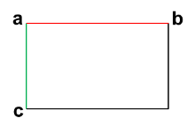

Figure S5. 3D supramolecular structure of [Ni(2-mfsiz)2Cl2] **6**, a axis.

C:\Users\alfax\AppData\Local\Microsoft\Windows\INetCache\Content.Word\supra_PdCl2.tif



Figure S6. 3D supramolecular structure of *trans*-[Pd(2-mfsiz)2Cl2] **14**, a axis.

C:\Users\alfax\AppData\Local\Microsoft\Windows\INetCache\Content.Word\areglo_cuAcO_.tif

Figure S7. 3D supramolecular structure of [Cu2(2-mfsiz)2(µ2-AcO)4] **10**, a axis.

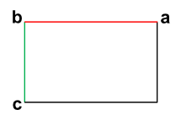C:\Users\alfax\AppData\Local\Microsoft\Windows\INetCache\Content.Word\supra_ZnAcO.TIF

Figure S8. 3D supramolecular structure of [Zn2(2-mfsbz)2(µ2-AcO)4] **23**, b axis.

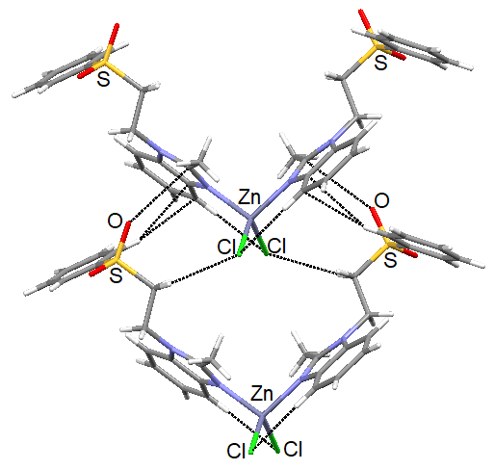

Figure S9. Map of the reduced gradient of the electron density[Zn(2-mfsbz)2Cl2] **20**. V conformation stacking of the complexes trough intermolecular lone pair S=O⋅⋅⋅π(iz).