Azurin interaction with the lipid raft components ganglioside GM-1 and caveolin-1 increases membrane fluidity and sensitivity to anti-cancer drugs
Nuno Bernardes¹, Ana Rita Garizo¹, Sandra N Pinto², Bernardo Caniço¹, Catarina Perdigão¹, Fábio Fernandes^{2,3}, Arsenio M Fialho^{1,4}
¹ iBB-Institute for Bioengineering and Biosciences, Biological Sciences Research Group, Av. Rovisco Pais 1, 1049-001 Lisbon, Portugal
²Centro de Química-Física Molecular and Institute of Nanoscience and Nanotechnology, Instituto Superior Técnico, Av. Rovisco Pais, 1049-001 Lisbon, Portugal
³UCIBIO, REQUIMTE, Departamento de Química, Faculdade de Ciências e Tecnologia, Universidade Nova de Lisboa, Campus da Caparica, Caparica, Portugal
⁴Department of Bioengineering, Instituto Superior Técnico, University of Lisbon, Lisbon, Portugal

HeLa
Azurin
F114A
100µM
MCF-7
Untreated
WT
100µM
WB: Caveolin-1
WB: GAPDH
F114A
100µM
Untreated
WT
100µM
F114A
100µM
Untreated
WT
100µM
HT-29
WB: Azurin
Supplementary Figure 1

Supplementary Figure 1: Entry of azurin WT and F114A mutant in MCF-7 and HeLa cells. Cells were exposed to 50-100µM of both proteins for 48h, after which cells were lysed and protein entry inside cells was determined by Western blot (top panel). Endogenous levels of caveolin-1 in each cell line (middle panel).

A)
B)

Supplementary Figure 2: Fluorescence spectra of the donors Atto390-WT (A) or Atto390-F114A (B) acquired with 390 nm excitation and measured over the emission wavelength range of 400 to 470 nm, since no acceptor (FITC-labeled CSD peptide) emits there. The FITC-labeled CSD peptide was titrated from 0 to 14μM. Fluorescence measurements were carried out with a SLMAminco 8100 Series 2 spectrofluorimeter (Rochester) with double excitation and emission monochromators (MC-400), in a right angle geometry. The light source was a 450-W Xe arc lamp and the reference a Rhodamine B quantum counter solution. Quartz cuvettes (1×1cm) from Hellma Analytics were used.

Supplementary information: Full-lenght Western blot images. Images are referred to the same conditions and Figure number as indicated in the main text.
MCF-7
Figure 1C
WB: Azurin
(15 kDa)
WB: GAPDH
(37 kDa)
F114A
100µM
WT
100µM
F114A
50µM
WT
50µM
Untreated
Untreated
2 hours
WB: Azurin
(15 kDa)
Azurin
30 min
WB: GAPDH
(37 kDa)
F114A
25µM
WT
25µM
WT
50µM
F114A
50µM
WT
100µM
F114A
100µM
HeLa
30 min
F114A
100µM
WB: Azurin
(15 kDa)
Azurin
WT
100µM
F114A
50µM
WT
50µM
Untreated
Figure 1C
WB: Azurin
(15 kDa)
WB: GAPDH
(37 kDa)
WB: GAPDH
(37 kDa)
2 hours
Figure 1C
WB: GAPDH
(37 kDa)
WB: Azurin
(15 kDa)
2 hours
HT-29
Untreated
WT
50µM
F114A
50µM
WT
100µM
F114A
100µM
WB: GAPDH
(37 kDa)
Azurin
30 min
WB: Azurin
(15 kDa)
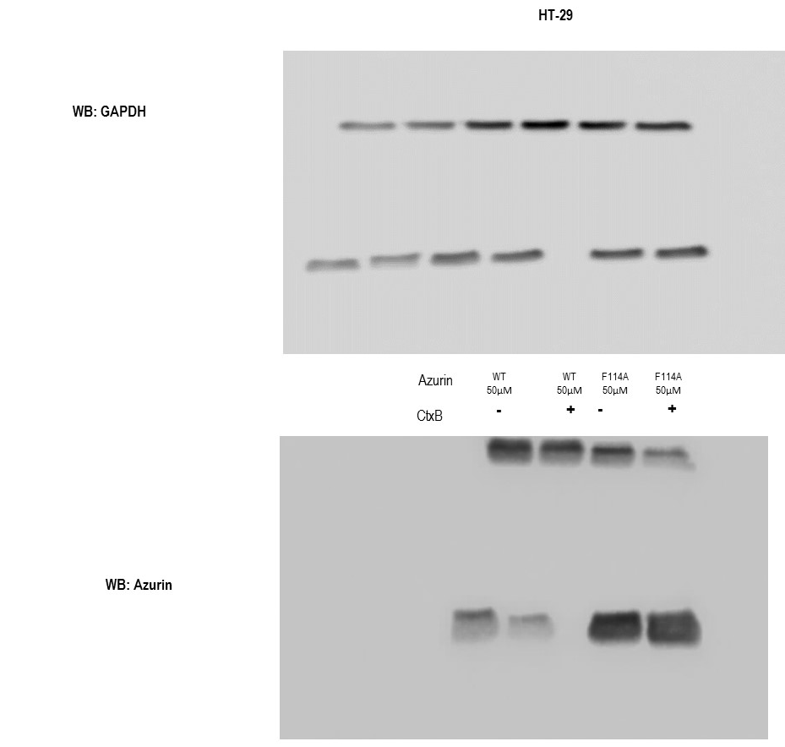
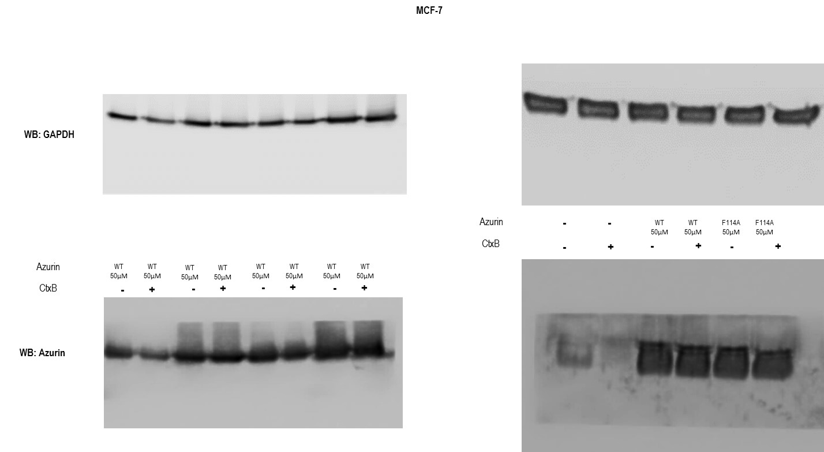
Figure 2A
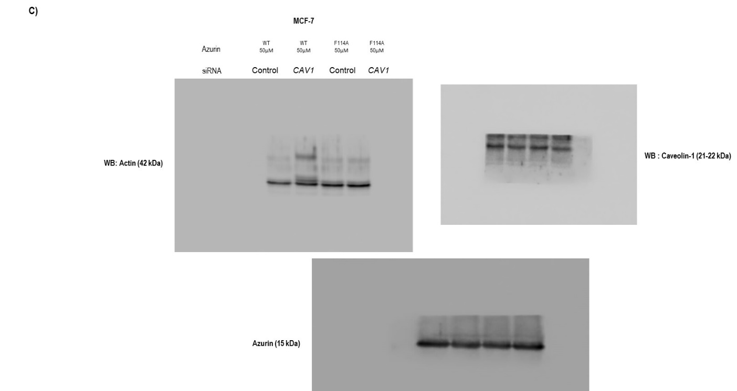
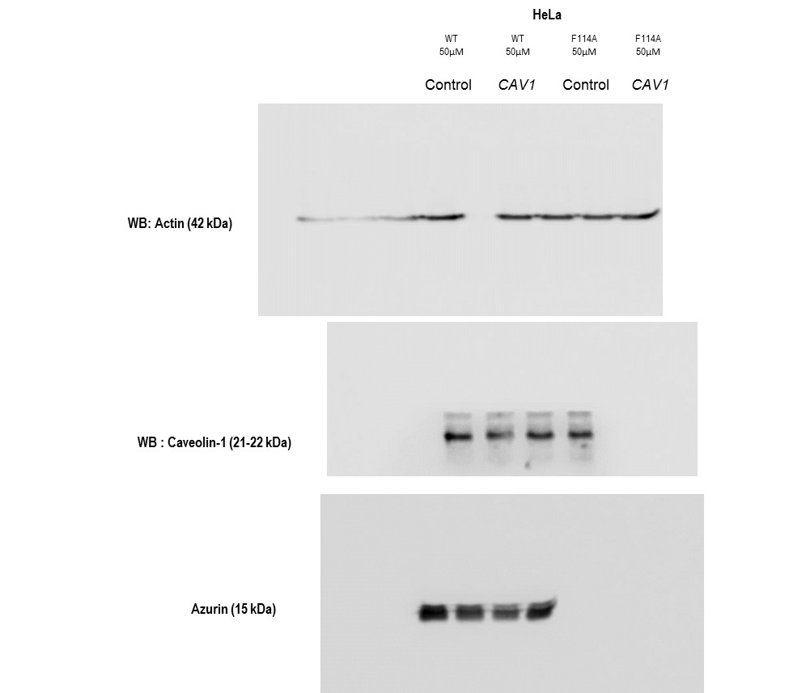
Figure 3A
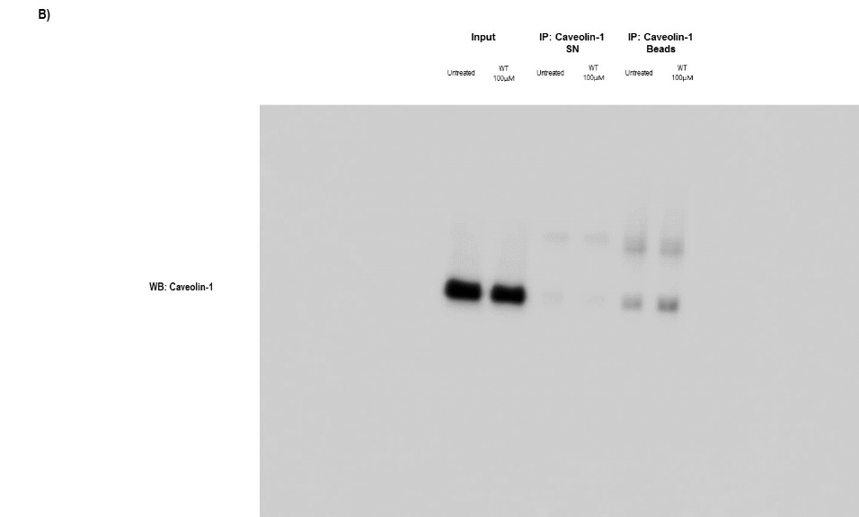

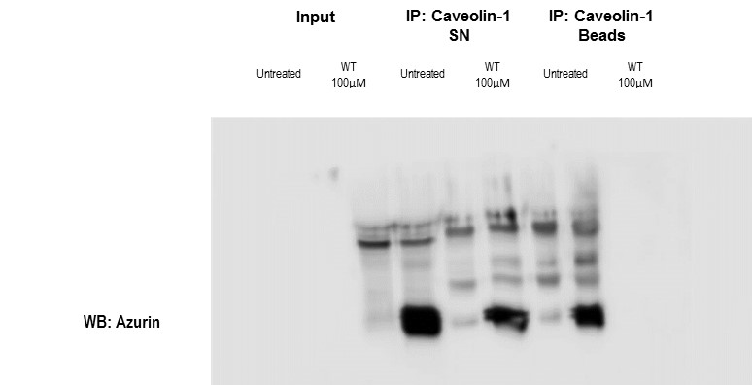

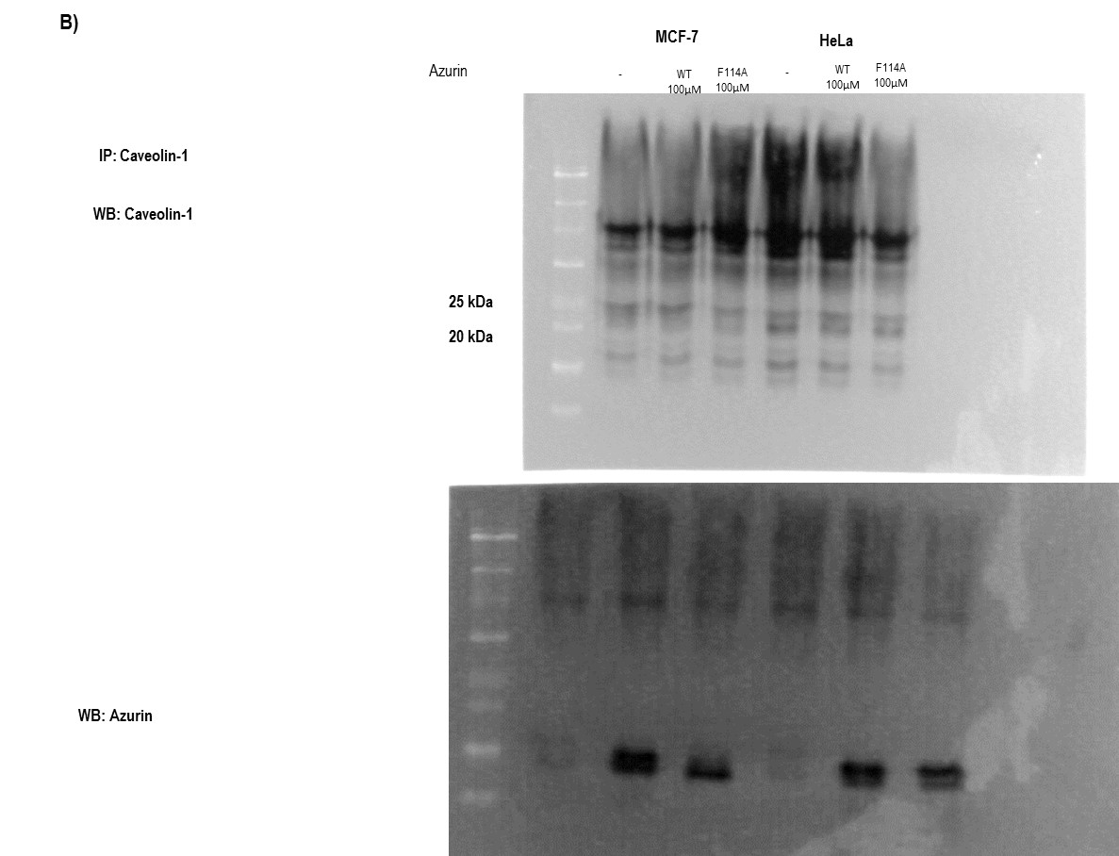

Figure 3C
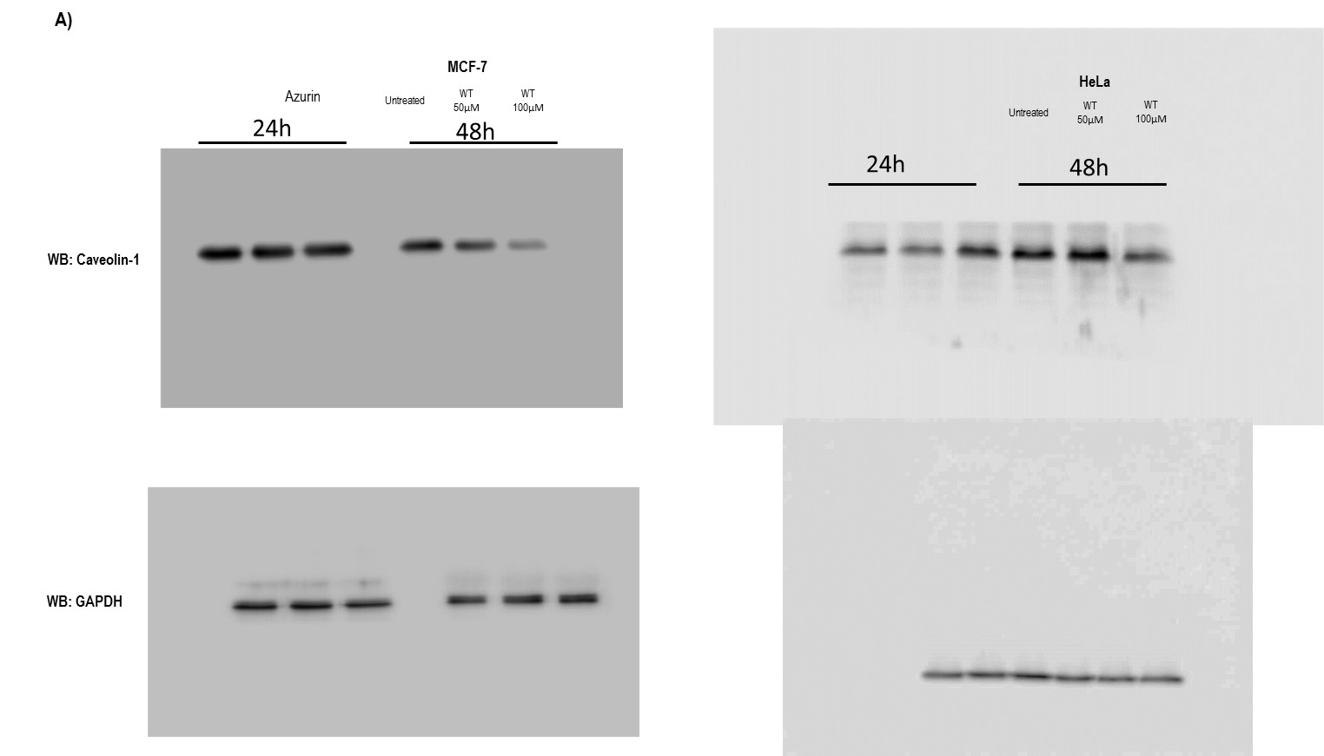

Figure 3D

