Supplementary Figures and Figure Legends
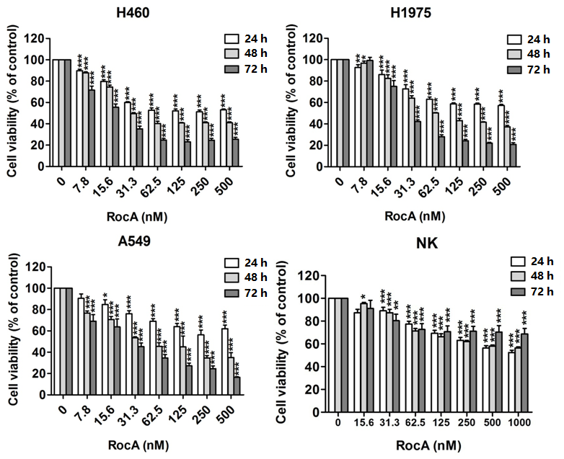

Figure S1. The inhibitory effect of Roc A on NSCLC cells and NK cells. H460, H1975, A549 or NK cells were treated with Roc A at different concentrations (0, 7.8, 15.6, 31.3, 62.5, 125, 250 and 500 nM) for 24, 48 and 72 h, and then cell viability was evaluated by MTT or CKK8 assay. Data were pooled from 3 independent experiments. *, p<0.05; **, p<0.01; ***, p<0.001.

Figure S2. Roc A inhibits GFP-MAP1LC3 fusion protein aggregation in the absence or presence of CQ. GFP-MAP1LC3⁺ HeLa cells were incubated with NK cells (A), 800 nM rapamycin (B) or EBSS medium (C) in the absence or presence of Roc A or 50 μM CQ for 24 h, then observed and photographed under laser confocal microscopy (63×). Data are a representation of 3 independent experiments.

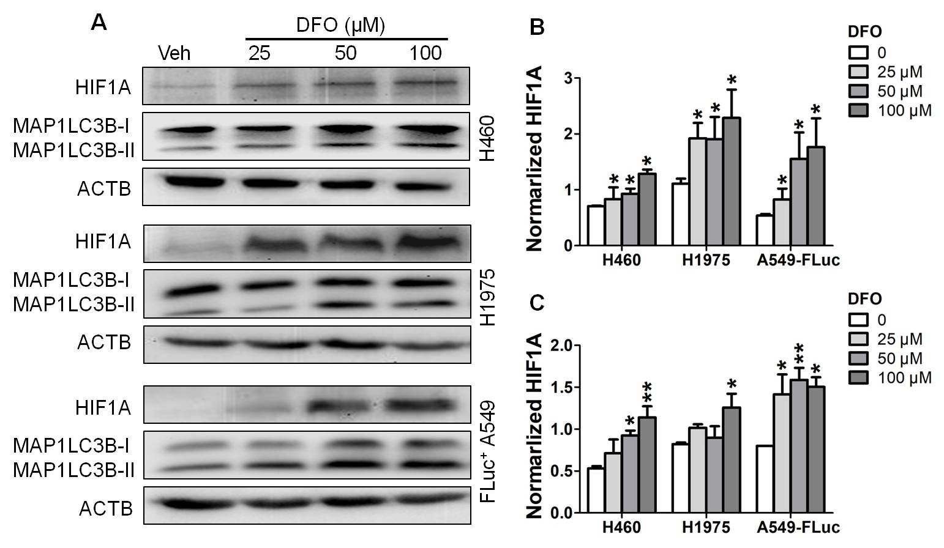

Figure S3. DFO increased HIF1A protein expression and activated autophagy in NSCLC cells. H460, H1975 and Ffluc+ A549 cells were treated with different concentrations (25, 50 and 100 μM) of DFO for 24 h. (A) cells were lysed and analyzed to detect expression of HIF1A and LC3B; (B) the quantified analysis of HIF1A protein; (C) the quantified analysis of MAP1LC3B-II protein. *, p<0.05; **, p<0.01.

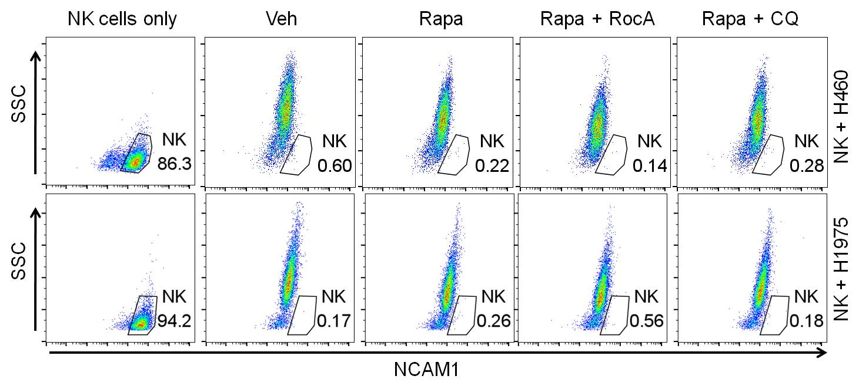

Figure S4. Percentages of NK cells in NSCLC cells after co-culture. H460 or H1975 cells were incubated with NK cells in the absence or presence of 800 nM rapamycin, 250 nM Roc A or 50 μM CQ for 24 h, and then NK cells were removed by anti-NCAM1/CD56 magnetic microbeads. The percentages of NK cells in NSCLC cells were assessed by flow cytometry. Data are a representation of 3 independent experiments.

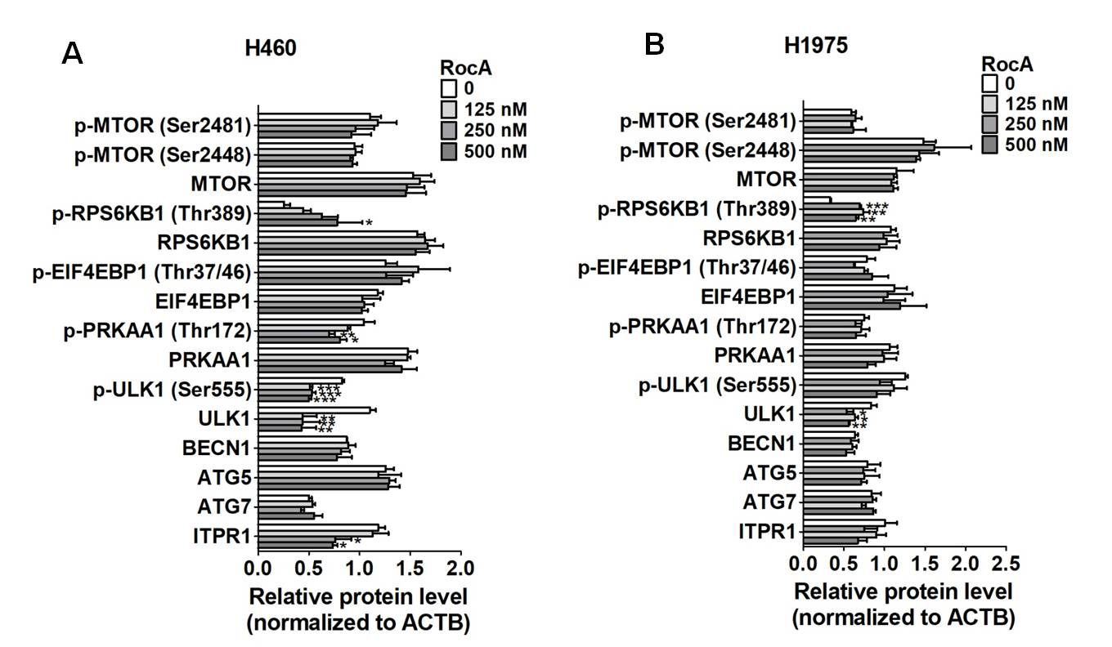

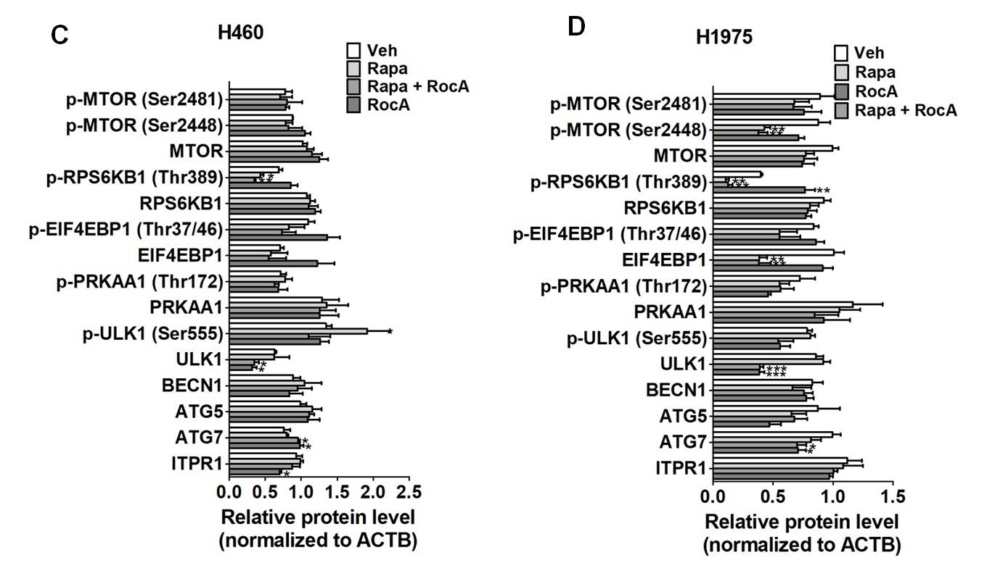

Figure S5. Roc A inhibits ULK1 protein expression in NSCLC cells. (A and B) the quantified analysis of protein expressions in Figure 7A. (C and D) the quantified analysis of protein expressions in Figure 7B. *, p<0.05; **, p<0.01; ***, p<0.001.

