## Supplemental data

## MULTIGRAM SCALE SYNTHESIS OF 3,4- AND 3,6-DIHYDRO-2*H*-THIOPYRAN 1,1-DIOXIDES

## AND FEATURES OF THEIR NMR SPECTRAL BEHAVIOR

**Roman M. Chabanenko, Svitlana Yu. Mykolenko, Eugene K. Kozirev and Vitalii A. Palchykov\***

*Oles Honchar Dnipro National University, 72 Gagarin Av., Dnipro, 49010, Ukraine*

*Dnipro State University of Agriculture and Economics, S. Efremov St., 25, Dnipro, 49600, Ukraine*

## *Corresponding author e-mail: palchikoff82@gmail.com

## Contents:

## Full experimental part

## Fig. 1. 1H NMR spectra of 3,4- and 3,6-dihydro-2*H*-thiopyran-1,1-dioxides 1, 2 (СDCl3, 400 МHz)

Fig. 2. 13C NMR spectra of 3,4- and 3,6-dihydro-2*H*-thiopyran-1,1-dioxides **1**, **2** (СDCl3 for **1**, DMSO-*d*6 for **2**, 100 МHz)

Fig. 3. COSY and HSQC spectra of 3,4-dihydro-2*H*-thiopyran-1,1-dioxide **1** (СDCl3, 400/100 МHz)

Fig. 4. COSY and HSQC spectra of 3,6-dihydro-2*H*-thiopyran 1,1-dioxide **2** (DMSO-*d*6, 400/100 МHz)

Fig. 5. Mass spectra of 3,4- and 3,6-dihydro-2*H*-thiopyran 1,1-dioxides **1, 2** (EI, 70eV)

## Fig. 6. 1H NMR spectrum of ketosulfone 12 (СDCl3, 500 МHz)

## Fig. 7. 1H NMR spectrum of ketosulfone 12 (DMSO-*d*6, 500 МHz)

## Fig. 8. 1H NMR spectrum of alcohol 13 (DMSO-*d*6, 500 МHz)

## Fig. 9. 1H NMR spectrum of alcohol 13 (СDCl3, 500 МHz)

## Fig. 10. 13C NMR spectrum of alcohol 13 (СDCl3, 125 МHz)

## Fig. 11. 1H NMR spectrum of mesylate 14 (СDCl3, 500 МHz)

## Fig. 12. 13C NMR spectrum of mesylate 14 (СDCl3, 125 МHz)

Fig. 13. 1H NMR spectrum of compound **18** (СDCl3, 500 МHz)

Fig. 14. 13C NMR spectrum of compound **18** (СDCl3, 125 МHz)

Fig. 15. 1H NMR spectrum of compound **15** (СDCl3, 500 МHz)

Fig. 16. 13C NMR spectrum of compound **15** (СDCl3, 125 МHz)

## Fig. 17. 1H NMR spectrum of ketosulfone 9 (DMSO-*d*6, 500 МHz)

## Fig. 18. 1H NMR spectrum of ketosulfone 9 (DMSO-*d*6, 125 МHz)

**Full experimental part**

Solvents were dried and distilled immediately prior to use. Melting points were determined in open capillary tubes and reported uncorrected. 1H, 13C, COSY and HSQC spectra were measured using Bruker spectrometers (400 and 500 MHz for 1Н nuclei) at room temperature (r.t.) in appropriate solvents. Chemical shifts (δ) are reported in parts per million (ppm) with respect to the solvent residual signal (CDCl3 1H: *δ* = 7.26 ppm, 13C: *δ* = 77.16 ppm; DMSO-*d6* 1H: *δ* = 2.50 ppm, 13C: *δ* = 39.52 ppm). Coupling constants (*J*) are reported in Hertz (Hz), multiplicities are given as s (singlet), d (doublet), t (triplet), dd (doublet of doublets) and m (multiplet). Purity of the synthesized compounds was checked by the gas chromatography mass-spectrometry using Shimadzu GCMS-QP2010 instrument: column Restek Rxi-5ms (Crossbond® 5% diphenyl / 95% dimethyl polysiloxane), length 30 m, diameter 0.25 mm, thickness 0.25µm, carrier gas helium, flow rate 1 ml/min, injection mode split, injection temperature 250 oC, column temperature from 50 to 300 oC with gradient 15 oC/min then isothermally at 300 oC for 5 min. Low resolution mass-spectra of compounds **1**, **2** were recorded in electron impact ionization mode (EI) at the energy of 70 eV in the range of *m/z* 25-400. Thin layer chromatography (TLC) was performed on Silufol UV-254 plates in ethyl acetate and its mixtures with hexane. The plates were visualized with potassium permanganate stain. The elemental analysis (C, H, S) was performed using Carlo Erba analyzer. The analytical results were within ± 0.4% of the theoretical values. Starting dihydro-2*H*-thiopyran-3(4*H*)-one **8** was synthesized from methyl thioglycolate and methyl-4-chlorobutyrate as published,[1] ketone **16** was purchased from Enamine Ltd.

**Dihydro-2*H*-thiopyran-3(4*H*)-one-1,1-dioxide 12. Method A.** To a solution of dihydro-2*H*-thiopyran-3(4*H*)-one **8** (71.30 g, 0.614 mol) in the mixture of acetic acid and acetic anhydride (250 mL, 6:1) 30% aqueous solution of hydrogen peroxide (156.41 g, 1.380 mol) was slowly added dropwise with the cooling in ice bath for 6 hours (the temperature of reaction mixture should not exceed 20 оС!). Stirring was continued in the ice bath for 1 day, and then at 20 оС for 6 days. The solvent was evaporated *in vacuo* (bath temperature of max. 30-35 оС!) to viscous oil. Crude product was purified by recrystallization from ethanol at overcooling to minus 30 oC. Yield: 81.90 g (90%), mp 140-142 оС (mp 140-140.5 оС[1]), R*f* 0.21 (ethyl acetate : hexane, 1:1). 1Н NMR (400 MHz, DMSO-*d6*) δ 4.28 (2Н, s, H-2), 3.47-3.41 (2Н, m, H-6), 2.57-2.51 (2H, m, H-4), 2.03-1.97 (2Н, m, H-5). 13С NMR (100 MHz, DMSO-*d6*) δ 221.03 (C=O), 76.51 (C-2), 57.09 (C-6), 46.87 (C-4), 26.11 (C-5). 1Н NMR (500 MHz, CDCl3) δ 3.99 (2Н, s, H-2), 3.29 (2H, t, *J =* 5.3 Hz, H-6), 2.60 (2H, t, *J =* 6.5 Hz, H-4), 2.27-2.21 (2Н, m, H*5*). Physical and chemical properties, parameters of some NMR and IR spectra, peculiar features for the crystal structure of ketosulfone **12** (XRD method) were previously reported by Shishkin.[2]

**Method B.** To a solution of dihydro-2*H*-thiopyran-3(4*H*)-one **8** (30.00 g, 0.258 mol) in 1 L of dichloromethane *m*-CPBA (124.77 g, 0.542 mol, 75% purity) was slowly added with the cooling in ice bath for 4 hours (the temperature of reaction mixture should not exceed 20 оС!). Stirring was continued in the ice bath for 1 day, and then at 20 оС for 1 day. Solid *m*-CBA was filtered and washed with dichloromethane (200 mL). The obtained filtrate was washed with 10% aqueous sodium sulfite (3×100 mL), dried over sodium sulfate and evaporated *in vacuo* to solid residue. Crude product was twice recrystallized from ethanol (target ketosulfone **12** and *m*-CBA has significantly different solubility). Yield: 27.14 g (71%), mp 144-145 оС (can contain up to 5% of *m*-CBA by 1H NMR).

**3-Hydroxytetrahydro-2*H*-thiopyran-1,1-dioxide 13**. To a mixture of ketosulfone **12** (40.10 g, 0.271 mol) in methanol (700 mL) was added sodium borohydride (15.36 g, 0.406 mol) of portionwise with stirring and cooling in ice bath during 1 hour (strongly exothermic reaction!). The reaction mixture was then stirred during 2 hours at 20 оС, evaporated *in vacuo* to solid residue, and mixture of saturated aqueous solution of sodium hydrogen carbonate (150 mL) and ethyl acetate (250 mL) was added (caution: product is soluble in water!). After intensive shaking the layers were separated, and water layer was additionally extracted with ethyl acetate (4×250 mL). The combined organic layers were dried over sodium sulfate and solvent was evaporated *in vacuo* to solid residue. Yield: 39.89 g (98%), mp 85-88 оС (82-86 оС[3]), R*f* 0.50 (ethyl acetate). 1Н NMR (500 MHz, DMSO-*d*6) δ 5.34 (1H, d, *J =* 4.4 Hz, ОН), 3.80 (1H, d, *J =* 4.4 Hz*,* H-3), 3.17 (1H, d, *J =* 13.1 Hz, H-2b), 3.05-2.86 (3H, m, H-6a,b,2a), 2.01-1.95 (1H, m, H-5b), 1.90 (1H, d, *J =* 12.9 Hz, H-5a), 1.65 (1H, dd, *J =* 25.6, 12.9 Hz, H-4b), 1.41-1.35 (1H, m, H-4a). 1Н NMR (500 MHz, CDCl3) δ 4.33-4.27 (1Н, m, H-3), 3.30 (1Н, d, *J =* 8.9 Hz, H-2b), 3.06-2.92 (3Н, m, OH+H-6b,2a), 2.82 (1Н, d, *J =* 6.8 Hz*,* H-6a), 2.31-2.25 (1Н, m, H-5b), 2.08-2.02 (1Н, m, H-5a), 1.93-1.87 (1H, m, H-4b), 1.74-1.68 (1Н, m, H-4a). 13С NMR (125 MHz, CDCl3) δ 66.53 (С-3), 57.89 (С-2), 50.73 (С-6), 32.37 (С-4), 19.32 (С-5). The 1H, 13С NMR (CDCl3) and13С NMR (CD2Cl2, acetone-*d*6, CD3OD) spectra of this compound were previously reported by Brunet.[3]

**Tetrahydro-2*H*-thiopyran-4-ol 17** was synthesized as described above from ketone **16 (**45.35 g, 0.390 mol) andsodium borohydride (16.24 g, 0.429 mol) in methanol (400 mL). Yield: 46.00 g (99%), obtained as a liquid which solidified at r.t., mp 48-50 оС, R*f* (ethyl acetate : hexane, 1 : 1) 0.47. NMR spectra of the alcohol **17** were identical to those described.[4]

**1,1-Dioxidotetrahydro-2*H*-thiopyran-3-yl methanesulfonate 14**. To a solution of 3-hydroxythiopyran dioxide **13** (39.80 g, 0.265 mol) and triethylamine (29.50 g, 0.291 mol) in dry dichloromethane (400 mL) mesyl chloride (33.40 g, 0.291 mol) was added at 0 оС. The reaction mixture was stirred for 8 hours at room temperature following by washing with brine (2×100 mL). Organic layer was dried over sodium sulfate and concentrated *in vacuo*. Yield: 54.10 g (89%), mp 102-103 оС, R*f* 0.70 (ethyl acetate). 1Н NMR (500 MHz, CDCl3) δ 5.08-5.02 (1Н, m, Н-3), 3.54 (1Н, d, 2*J2а,2b =* 13.6 Hz, H-2b), 3.21-3.15 (1Н, m, H-2a), 3.08 (3Н, s, СН3), 3.06-3.04 (1Н, m, H-6b), 2.95-2.89 (1Н, m, H-6a), 2.32 (1Н, d, 2*J5а,5b =* 8.0 Hz, H-5b), 2.28-2.22 (1Н, m, H-5a), 2.08-2.02 (1H, m, H-4b), 1.79-1.73 (1Н, m, H-4a). 13C NMR (125 MHz, CDCl3) δ 74.24 (C-3), 56.42 (C-2), 50.68 (C-6), 38.87 (СН3), 31.11 (C-4), 19.21 (C-5). Elemental analysis calculated for C6H12O5S2, C, 31.57; H, 5.30; S, 28.09; found C, 31.81; H, 5.05; S, 27.90%.

**Tetrahydro-2*H*-thiopyran-4-yl 4-methylbenzenesulfonate 18.** To a solution of tetrahydro-2*H*-thiopyran-4-ol **17** (46.00 g, 0.390 mol),DMAP(0.48 g, 1 mol%) and pyridine (33.93 g, 0.429 mol) in dry dichloromethane (500 mL) tosyl chloride (81.70 g, 0.429 mol) was added at 0 оС. The reaction mixture was stirred for 8 hours at room temperature following by washing with 5% HCl (2×200 mL) and brine (100 mL). Organic layer was dried over sodium sulfate and concentrated *in vacuo*. Yield: 92.00 g (87%), mp 92-94 оС, R*f* 0.67 (ethyl acetate : hexane, 1 : 1). 1Н NMR (500 MHz, CDCl3) δ 7.79 (1Н, d, *J =* 8.1 Hz, H-Ar), 7.34 (1Н, d, *J =* 8.1 Hz, H-Ar), 4.62-4.56 (1Н, m, H-4), 2.84-2.78 (2Н, m, H-3b,5b), 2.52-2.46 (2Н, m, H-3a,5a), 2.45 (3Н, s, СН3), 2.06-2.00 (2H, m, H-2b,6b), 1.97-1.91 (2Н, m, H-2a,6a). 13C NMR (125 MHz, CDCl3) δ 144.87 (С-Ar), 130.16 (С-Ar), 130.02 (С-Ar), 127.74 (С-Ar), 45.18 (С-4), 33.22 (С-3,5), 25.13 (С-2,6), 21.79 (СН3). Elemental analysis calculated for C12H16O3S2, C, 52.92; H, 5.92; S, 23.54; found C, 53.11; H, 5.78; S, 23.29%.

**1,1-Dioxidotetrahydro-2*H*-thiopyran-4-yl 4-methylbenzenesulfonate 15.** To a solution of tetrahydro-2*H*-thiopyran-4-yl 4-methylbenzenesulfonate **18** (91.00 g, 0.334 mol) in acetic acid (400 mL) 30% aqueous solution of hydrogen peroxide (113.62 g, 1.002 mol) was slowly added dropwise with the cooling in ice bath for 6 hours (the temperature of reaction mixture should not exceed 20 оС!). Stirring was continued in the ice bath for 1 day, and then at 20 оС for 6 days. The solvent was evaporated *in vacuo* and the crude product was titurated with water (400 mL), filtered and dried on air. Yield: 68.00 g (67%), mp 118-120 оС, R*f* 0.48 (ethyl acetate : hexane, 1:1). 1Н NMR (500 MHz, CDCl3) δ 7.81 (1Н, d, *J =* 7.9 Hz, H-Ar), 7.38 (1Н, d, *J =* 7.9 Hz, H-Ar), 4.84-4.78 (1Н, m, H-4), 3.30-3.24 (2Н, m, H-2b,6b), 2.95-2.89 (2Н, m, H-2a,6a), 2.47 (3Н, s, СН3), 2.35-2.29 (4Н, m, H-3,5). 13C NMR (125 MHz, CDCl3) δ 145.69 (С-Ar), 133.51 (С-Ar), 130.33 (С-Ar), 127.81 (С-Ar), 73.30 (С-4), 46.58 (С-2,6), 29.81 (С-3,5), 21.84 (СН3). Elemental analysis calculated for C12H16O5S2, C, 47.35; H, 5.30; S, 21.07; found C, 47.19; H, 5.53; S, 21.30%. Transformation **9** to **15** was also achieved as a simple combination of the reduction by NaBH4 and tosylation by TsCl as described above (61% yield over two steps).

**Dihydro-2*H*-thiopyran-4(3*H*)-one 1,1-dioxide** **9**. To a solution of ketone **16** (0.50 g, 4.304 mmol) in methanol (40 mL) 30% aqueous solution of hydrogen peroxide (1.67 g, 17.21 mmol) was slowly added dropwise with the cooling in ice bath for 1 hour (the temperature of reaction mixture should not exceed 20 оС!). Stirring was continued in the ice bath for 8 hours and then 1 day at r.t. The solid of unknown by-products was filtered off. The filtrate was evaporated *in vacuo* to obtain of pure ketosulfone **9**. Yield: 0.35 g (55%), mp 172-175 оС (163-170 оС[5]), R*f* 0.50 (ethyl acetate). 1Н NMR (500 MHz, DMSO-*d*6) δ 3.51 (4Н, t, *J =* 6.5 Hz, H-2,6), 2.76 (4Н, t, *J =* 6.5 Hz, H-3,5). 13C NMR (125 MHz, DMSO-*d*6) δ 203.24 (С=O), 48.20 (С-2,6), 37.89 (С-3,5). NMR spectra of the ketosulfone **9** were identical to those described.[5]

**3,4-Dihydro-2*Н*-thiopyran-1,1-dioxide 1.** The solution of mesylate **14** (27.00 g, 0.118 mol) in dry pyridine (100 mL) wasstirred at 120 оС in oil bath for 24 hours. After cooling to r.t., water (200 mL) was slowly added to the reaction mixture with cooling in the ice bath and then concentrated HCl (~95 mL) to the рН~2. The product was extracted with dichloromethane (4×200 mL). Water layer was saturated with crystalline sodium chloride, and product was additionally extracted with ethyl acetate (3×100 mL). Combined organic layers were dried over sodium sulfate and concentrated *in vacuo* to oily residue which was distilled under vacuum at 123-126 оС (1.5 mm Hg). Yield of the crude product 12.80 g (82%, purity by GCMS 89.3%). The product was further purified by recrystallization from 400 ml mixture of heptane-ethyl acetate (~3:1) at overcooling to minus 30 оС. Yield: 11.03 g (long transparent needles, purity by GCMS 98.0%), mp 46-46.5 оС (44-46 оС[1]), R*f* 0.21 (ethyl acetate : hexane, 1:1). 1Н NMR (500 MHz, CDCl3) δ 6.43 (1Н, d, *3J2,3 =* 11.2 Hz, H-2), 6.38 (1Н, d, 3*J2,3 =* 11.2 Hz, H-3), 3.20-3.14 (2H, m, H-6), 2.36-2.30 (4Н, m, H-4,5). 13C NMR (100 MHz, CDCl3) δ 138.71 (С-2), 130.10 (С-3), 50.69 (С-6), 24.81 (С-4), 20.72 (С-5). Mass spectrum (EI, 70еV), *m/z* (Irel., %): 132 (М*, 18), 103.0 (88), 87.0 (78), 83.1 (71), 67.1 (56), 55.1 (56), 41.1 (65), 39.1 (100). The same method was used for the synthesis of sulfone **2** from tosylate **15** (66.0 g, 0.217 mol) in dry pyridine (200 mL). Yield 11.0 g of the crude product (purity by GCMS 82.9%), after recrystallization 9.10 g (purity by GCMS 96.7%, 32% yield).

**3,6-Dihydro-2*Н*-thiopyran-1,1-dioxide 2.** Toan5% aqueous solution of sodium hydroxide (200 mL) mesylate **14** (27.00 g, 0.118 mol) was added and the reaction mixture stirred at 20 оС for 8 hours. The product was extracted with dichloromethane (4×200 mL). The combined organic layers were dried over sodium sulfate and concentrated *in vacuo* to oily residue which was recrystallized from methyl *tert*-butyl ether (500 mL). Yield: 14.81 g (95%, purity by GCMS 94.5%), mp 67-69 оС (68-72 оС (cyclohexane)[6], 65-69 оС[1]), R*f* 0.29 (ethyl acetate : hexane, 1:1). The product should be stored at 4 °C! 1Н NMR (500 MHz, CDCl3) δ 5.88 (1Н, d, 3*J*3,4 = 10.7 Hz, H-4), 5.65 (1Н, d, 3*J*3,4 = 10.7 Hz, H-3), 3.66-3.60 (2H, m, H-2), 3.11-3.05 (2H, m, H-6), 2.80-2.74 (2Н, m, H-5). 13C NMR (75 MHz, CDCl3) δ 126.83 (С-4), 119.42 (С-3), 50.79 (С-2), 47.43 (С-6), 25.80 (С-5).[7] 1Н NMR (400 MHz, DMSO-*d*6) δ 5.80 (1Н, d, 3*J*3,4 = 10.7 Hz, H-4), 5.61 (1Н, d, 3*J*3,4 = 10.7 Hz, H-3), 3.71-3.65 (2H, m, H-2), 3.18-3.12 (2H, m, H-6), 2.63-2.57 (2Н, m, H-5). 13C NMR (100 MHz, DMSO-*d*6) δ 126.21 (С-4), 119.96 (С-3), 49.95 (С-2), 46.46 (С-6), 25.62 (С-5). Mass spectrum (EI, 70еV), *m/z* (Irel., %): 131.9 (М*, 1), 68.0 (22), 67.1 (100), 53.0 (24), 39.0 (21), 41.0 (14).

The elimination of TsOH from **15** and MsOH from **14** under DBU conditions was tested only on the NMR scale (0.016-0.022 mmol) and gave 83% and 80% yield of sulfone **2** respectively.

**References to Supplemental data**

[1] Fehnel, E. A. *J. Am. Chem. Soc.* **1952**, *74*, 1569–1574.

[2] Shishkin, O. V.; Medvediev, V. V.; Shyshkina, O. O.; Kovalenko, N. V.; Volovenko, J. M. *Cryst. Eng. Comm.* **2012**, *14*, 8698–8707.

[3] Brunet, E.; Eliel, E.; Kenan, W. *J. Org. Chem.* **1986**, *51*, 677–686.

[4] Ramalingam, K.; Berlin, K.; Satyamurthy, N.; Sivakumar, R. *J. Org. Chem*. **1979**, *44*, 471–477.

[5] (a) Casy, G.; Sutherland, A.G.; Taylor, R. J. K.; Urben, P. G. *Synthesis* **1989**, 767–769; (b) Hirsch, J. A.; Havinga, E. *J. Org. Chem*. **1976**, *41*, 455–462.

[6] Fehnel, E. A.; Lackey, P. A. *J. Am. Chem. Soc.* **1951**, *73*, 2473–2479.

[7] (a) Culshaw, P. N.; Walton, J. C*. J. Chem. Soc., Perkin Trans. 2,* **1991**, 1201–1208; (b) Culshaw, P. N.; Walton, J. C. *Tetrahedron Lett.* **1990**, *31*, 6433–6436.

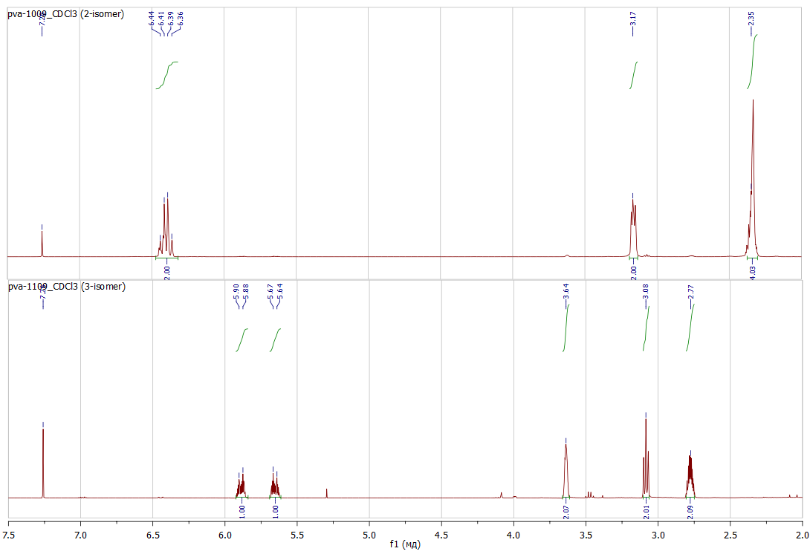



## Fig. 1. 1H NMR spectra of 3,4- and 3,6-dihydro-2*H*-thiopyran-1,1-dioxides 1, 2 (СDCl3, 400 МHz)

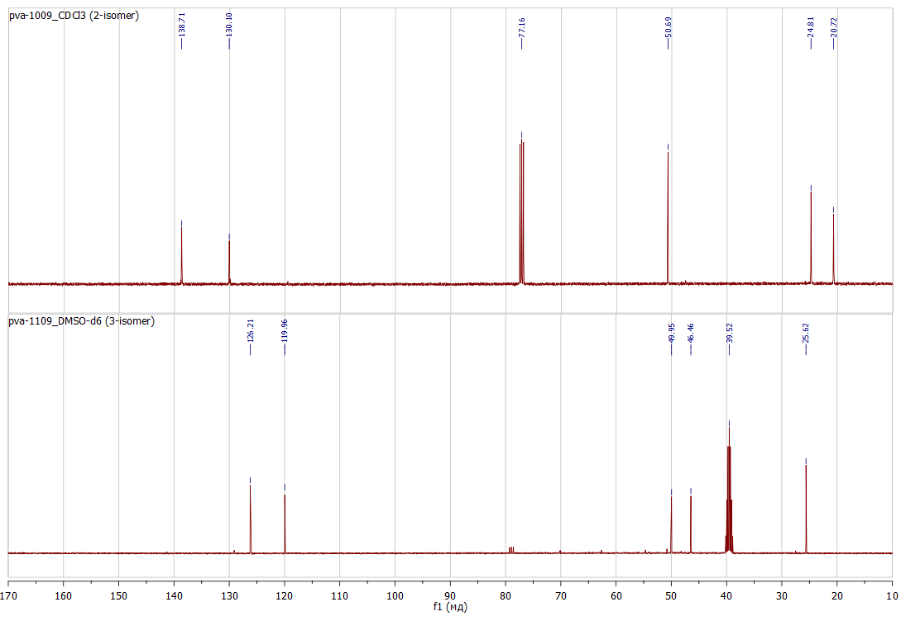



Fig. 2. 13C NMR spectra of 3,4- and 3,6-dihydro-2*H*-thiopyran-1,1-dioxides **1**, **2** (СDCl3 for **1**, DMSO-*d*6 for **2**, 100 МHz)

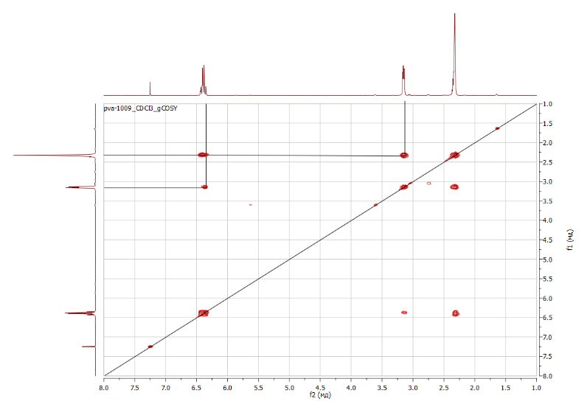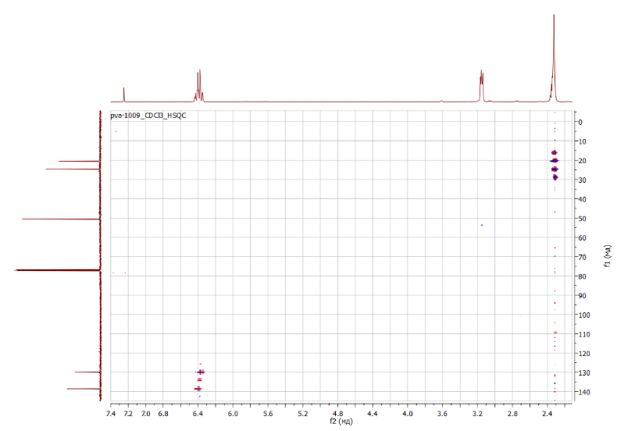



Fig. 3. COSY and HSQC spectra of 3,4-dihydro-2*H*-thiopyran-1,1-dioxide **1** (СDCl3, 400/100 МHz)

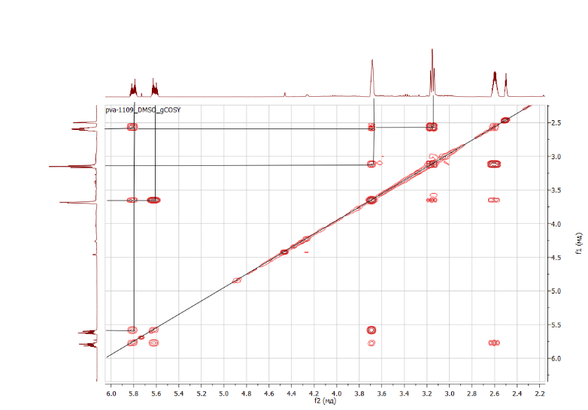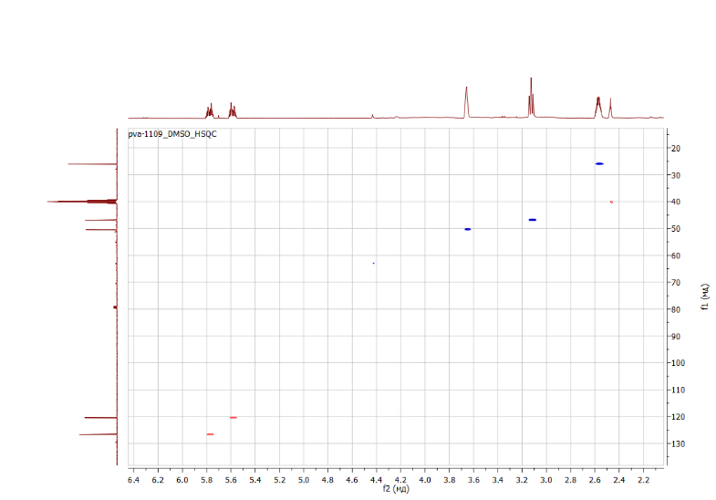



Fig. 4. COSY and HSQC spectra of 3,6-dihydro-2*H*-thiopyran 1,1-dioxide **2** (DMSO-*d*6, 400/100 МHz)







Fig. 5. Mass spectra of 3,4- and 3,6-dihydro-2*H*-thiopyran 1,1-dioxides **1**, **2** (EI, 70eV)

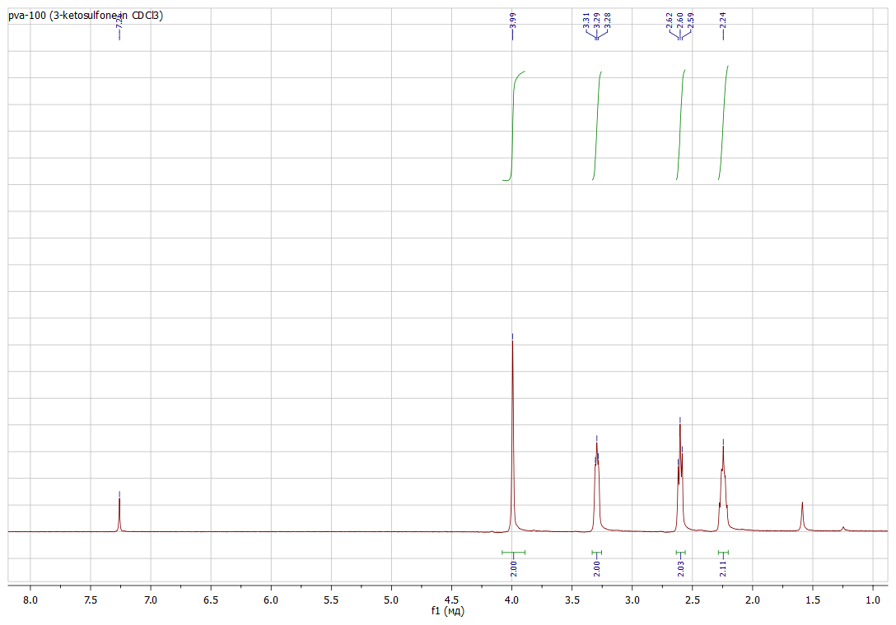



## Fig. 6. 1H NMR spectrum of ketosulfone 12 (СDCl3, 500 МHz)

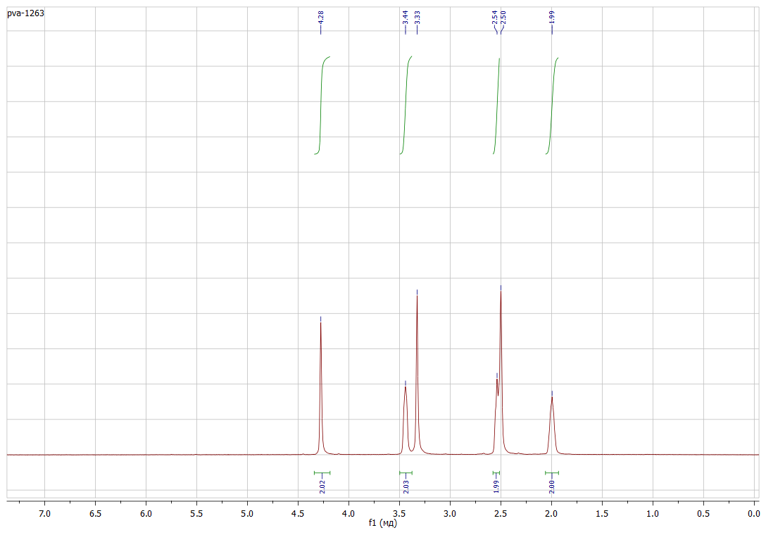



## Fig. 7. 1H NMR spectrum of ketosulfone 12 (DMSO-*d*6, 500 МHz)

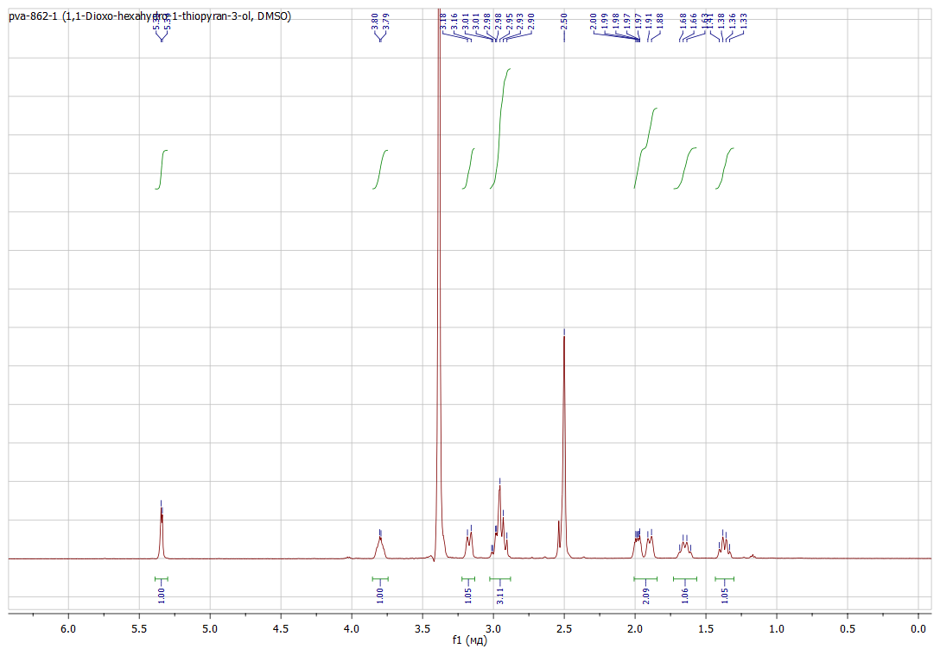



## Fig. 8. 1H NMR spectrum of alcohol 13 (DMSO-*d*6, 500 МHz)

## C:\Users\Vitalii Palchykov\Desktop\pva-862-3 1H.bmp

## Fig. 9. 1H NMR spectrum of alcohol 13 (СDCl3, 500 МHz)



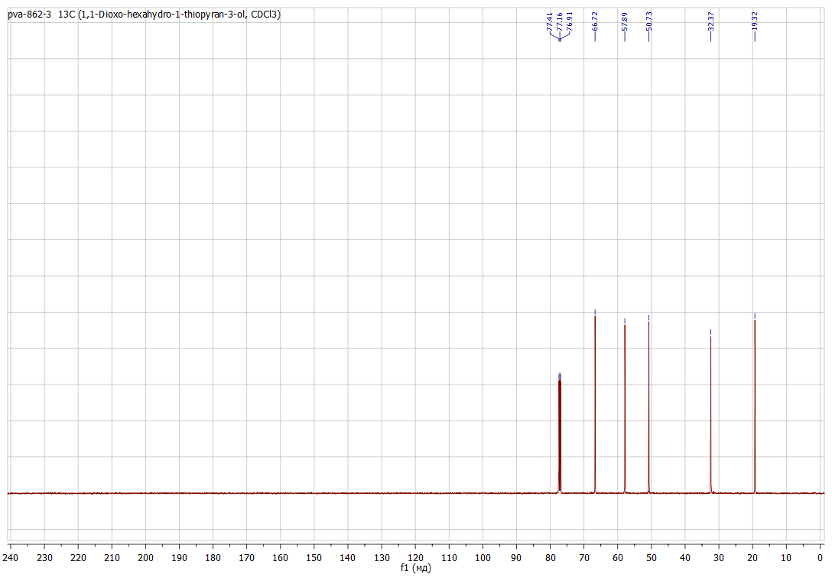

## Fig. 10. 13C NMR spectrum of alcohol 13 (СDCl3, 125 МHz)



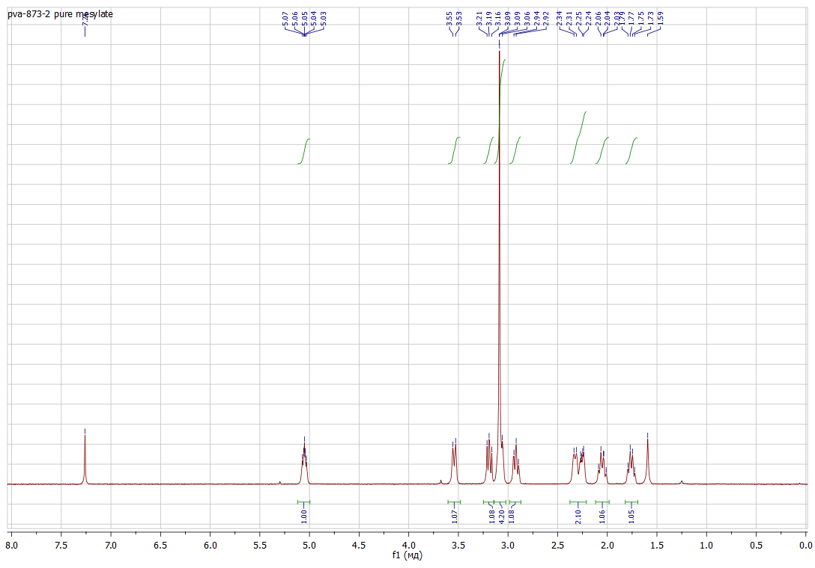

## Fig. 11. 1H NMR spectrum of mesylate 14 (СDCl3, 500 МHz)



## 

## C:\Users\Vitalii Palchykov\Desktop\pva-873-1.bmp

## Fig. 12. 13C NMR spectrum of mesylate 14 (СDCl3, 125 МHz)



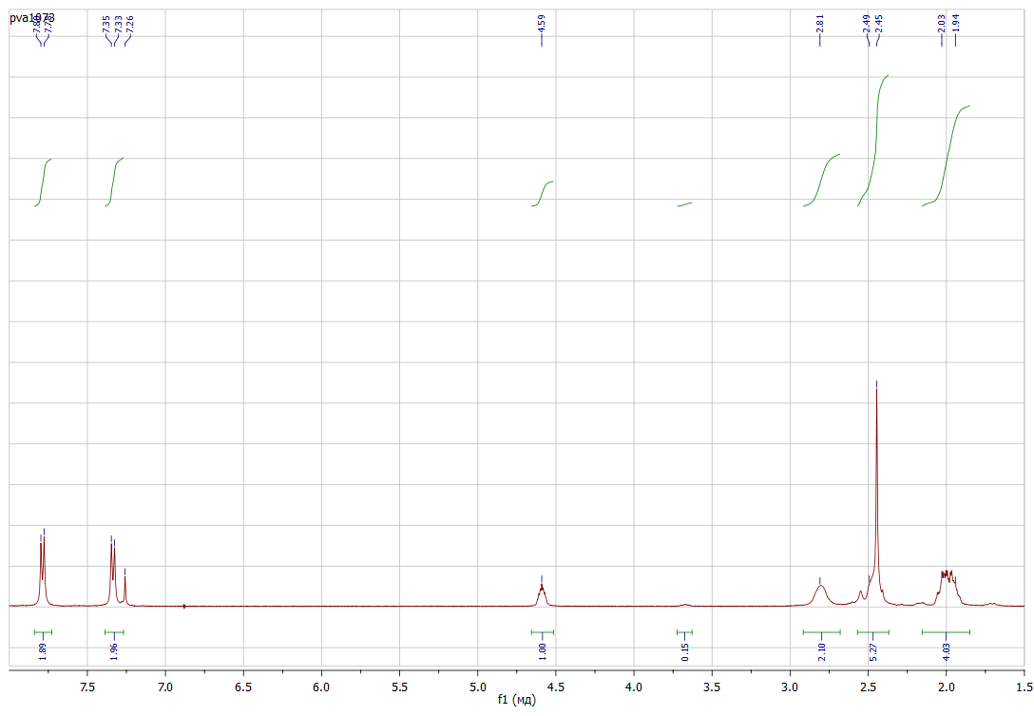



Fig. 13. 1H NMR spectrum of compound **18** (СDCl3, 500 МHz)

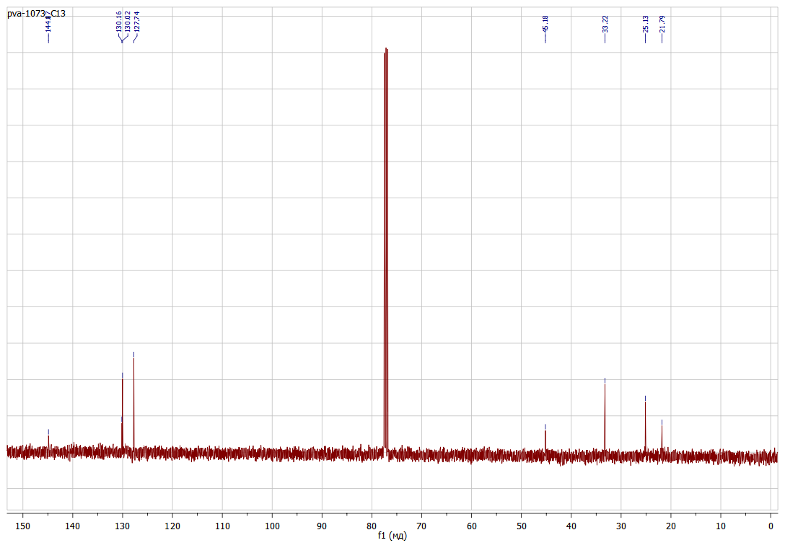



Fig. 14. 13С NMR spectrum of compound **18** (СDCl3, 125 МHz)

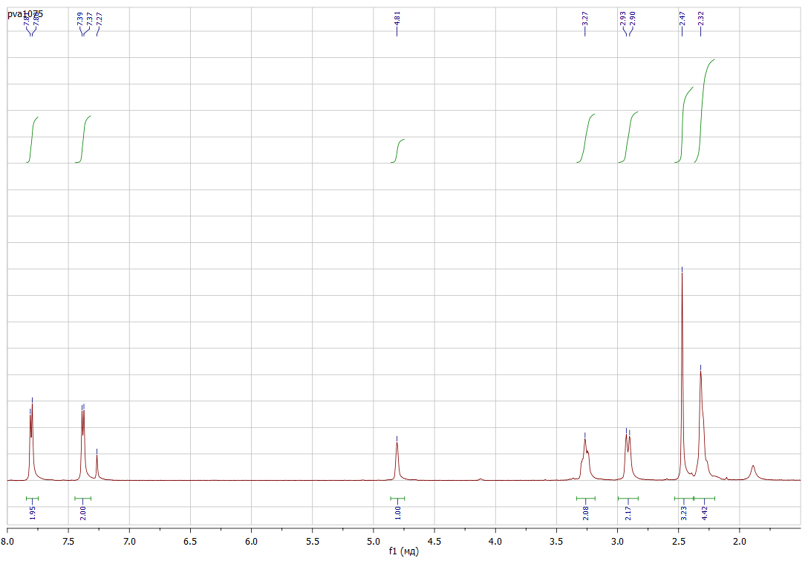



Fig. 15. 1H NMR spectrum of compound **15** (СDCl3, 500 МHz)

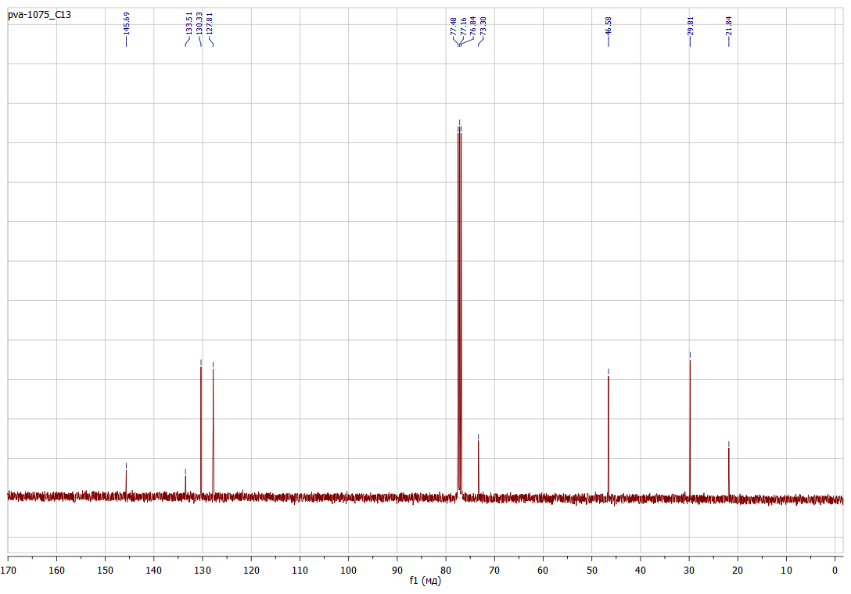



Fig. 16. 13С NMR spectrum of compound **15** (СDCl3, 125 МHz)

## D:\My Documents\ПУБЛИКАЦИИ\СТАТЬИ в работе\СТАТЬЯ 70 (Synth Commun 2018, 6-чл сульфолены)\Рисунки\pva-1066-2.bmp



## Fig. 17. 1H NMR spectrum of ketosulfone 9 (DMSO-*d*6, 500 МHz)

## D:\My Documents\ПУБЛИКАЦИИ\СТАТЬИ в работе\СТАТЬЯ 70 (Synth Commun 2018, 6-чл сульфолены)\Рисунки\pva-1066-2 C13.bmp



## Fig. 18. 1H NMR spectrum of ketosulfone 9 (DMSO-*d*6, 125 МHz)