DETAILED SOLUTIONS FOR THE EXAMPLES
Case 1: Numerical Example for $A_{2}$ Uniform
$Let A_{0}=\$1,600, { A}_{1}=\$10,000 and A_{2}∼uniform \left(a_{2}=\$8,000,{ b}_{2}=\$12,000\right).$ Here $2.32×{10}^{7}≤{A_{1}}^{2}-4 A_{0}A_{2}≤4.88×{10}^{7}$ indicating there are two real roots with probability one.
The IRR/First Root: Using Table 1, the valid range is $3.6302≤i≤4.3080$. The PDF and the CDF expressions are $f\left(i\right)=0.8(i-2.125)$ and $F\left(i\right)=0.4{(i-2.125)}^{2}-0.91$.
The IRR/Second Root: The valid range is $-0.0580≤i≤0.6198$. The PDF and the CDF expressions are $f\left(i\right)=-0.8(i-2.125)$ and $F\left(i\right)=-0.4{\left(i-2.125\right)}^{2}+1.90625$.

If the MARR is 3.95 or 395%, $F_{2}(3.95)-F_{1}(3.95)$ = P($i_{2}$) ≤ 3.95) – P($i_{1}$) ≤ 3.95) =
1-(1-P($i_{1}$) > 3.95) = 1 - $F_{1}(3.95)$ = 1 – (0.4(3.95 – 2.125)² – 0.91) = 0.578. Unlike the IRR, the ERR solution requires a MARR value as an input. Using the applicable ERR CDF formula for a MARR of 3.95 in Table 3, $F\left(ERR\right)=12.801-\frac{303.22}{{\left(ERR+1\right)}^{2}}$ in a valid range of 3.867 ≤ ERR ≤ 4.069 and P(ERR > 3.95) = 1 – F(3.95) = 0.574. Both the IRR and the ERR CDF expressions result in the same probability of project being acceptable.
If MARR is 0.25, $F_{2}(0.25)-F_{1}(0.25)$ = P($i_{2}$) ≤ 0.25) – P($i_{1}$≤ 0.25) = P($i_{2}$ ≤ 0.25) - 0
= $F_{2}$(0.25) =$\left(-0.4{\left(0.25-2.125\right)}^{2}+1.90625\right)=0.50$. The decision maker can use this information to make a decision for the project for accepting, rejecting, or further study.
Using$MARR=0.25 for the ERR,$the valid range is $0.1606≤ERR≤0.3639$. The PDF and the CDF expressions are: $f\left(ERR\right)=\frac{9.7656}{{(ERR+1)}^{3}} and F\left(ERR\right)=3.625-\frac{4.8828}{{\left(ERR+1\right)}^{2}} .$
Using the CDF above we can also compute the probability the project is desirable, $P\left(ERR>MARR\right)=1-F\left(0.25\right)=1-\left(3.625-\frac{4.8828}{{\left(0.25+1\right)}^{2}}\right)=0.50$. This confirms the answer found above using the IRR approach.
Case 2: Numerical Example for $A_{1}$ Uniform
$$Let A_{0}=\$1,600 , A_{1}∼uniform \left(a_{1}=\$8,000,b_{1}=\$12,000\right), and { A}_{2}=\$10,000.$$
The term ${A_{1}}^{2}-4 A_{0}A_{2}$ ranges in [0, 80000000] indicating two real roots.
The IRR/First Root: Using Table 1, the valid range is $1.5≤i≤5.5451$. The PDF and the CDF expressions are: $f\left(i\right)=\frac{-2.5}{{(i+1)}^{2}}+0.4 and F\left(i\right)=\frac{2.5}{i+1}+0.4\left(i+1\right)-2.$
The IRR/Second Root: The valid range is $-0.0451≤i≤1.5$. The PDF and the CDF expressions are $f\left(i\right)=\frac{2.5}{{(i+1)}^{2}}-0.4 and F\left(i\right)=\frac{-2.5}{i+1}-0.4\left(i+1\right)+3.$

If the MARR is 2.00, $F_{2}$(2.00)- $F_{1}$(2.00) = P ($i_{2}≤$2.00) – P($i_{1}≤$ 2.00) = 1 – $F_{1}$(2.00) = 0.966. The applicable ERR CDF for a MARR of 2.00 is 0.226*(ERR + 1)² – 2 in 1.975 $≤$ ERR $≤$ 2.644 range. P (ERR > MARR) = 1 – F(2.00) = 0.966.
Using a MARR of 0.25, $F_{2}$ (0.25)- $F_{1}$ (0.25) = P($i_{2}$ $≤$ 0.25) – 0 = $F_{2}$ (0.25) = 0.50.
$For the$ ERR, $let MARR=0.25$. Using Table 3, the valid range is $0.1180≤ERR≤0.3693$. The PDF and the CDF expressions are: $f\left(ERR\right)=3.2\left(ERR+1\right) and F\left(ERR\right)=1.6{(ERR+1)}^{2}-2.$
Here, $P\left(ERR>MARR\right)=1-F\left(MARR\right)=1-\left(1.6{\left(MARR+1\right)}^{2}-2\right)=.50$, which is the same as the value found using the IRR CDF above.

Case 3: Numerical Example for $A_{2}$ Exponential
$Let A_{0}=\$1,600, { A}_{1}=\$10,000 and A_{2} ∼Exponential \left(λ=1/\$10,000\right)$.
The term ${A_{1}}^{2}-4 A_{0}A_{2}$ ranges in [- ∞ , 100000000] indicating there are not always roots. The roots that exist happen when A₂ $≤$ $15,625 which happens with a probability of 0.7904.
The IRR/First Root: Using Table 2, the valid range is $2.125≤i≤5.250$. The conditional PDF and the CDF expressions are:
$$f\left(i\right)=0.32\left(i-2.125\right)\frac{e^{0.16{\left(i-2.125\right)}^{2}-1.5625}}{1-e^{-1.5625}} and F\left(i\right)=1-\frac{1-e^{0.16{\left(i-2.125\right)}^{2}-1.5625}}{1-e^{-1.5625}}.$$
The IRR/Second Root: The valid range is $-1≤i≤2.125$. The PDF and the CDF expressions are: $f\left(i\right)=-0.32\left(i-2.125\right)\frac{e^{0.16{\left(i-2.125\right)}^{2}-1.5625}}{1-e^{-1.5625}} and F\left(i\right)=\frac{1-e^{0.16{\left(i-2.125\right)}^{2}-1.5625}}{1-e^{-1.5625}}.$

If the MARR = 4.5, for the project to be favorable, the MARR must be between the roots.
$F_{2}$(4.5) – $F_{1}$(4.5) = 1 – $F_{1}$(4.5) = 0.611. Since ${{P(A}_{1}}^{2}-4A_{0}A_{2}≥0)=P({10}^{8}≥6400A_{2})$= ${1-e}^{-1.5625}=0.7904,$ the actual probability the project is desirable is (0.611 * 0.7904) = 0.483. Using Table 4, the applicable ERR CDF for a MARR of 4.5 is $F\left(ERR\right)=e^{-\frac{166.375}{{\left(ERR+1\right)}^{2}}+4.84}$ in
-1 $≤$ ERR $≤$ 4.86 range. Then, P (ERR > MARR) = 1-$F(4.5)$ = 0.483 which is the same as the IRR solution. Using a MARR of 0.25, $F_{2}$(0.25) – $F_{1}$(0.25) = P($i_{2}$ $≤$ 0.25) – 0 = $F_{2}\left(0.25\right)$. $F_{2}\left(MARR\right)=\frac{1-e^{0.16{\left(MARR-2.125\right)}^{2}-1.5625}}{1-e^{-1.5625}} =0.7998$. As noted earlier, this is a conditional probability. Since ${{P(A}_{1}}^{2}-4A_{0}A_{2}≥0)=P({10}^{8}≥6400A_{2})$= ${1-e}^{-1.5625}=0.7904.$ The actual probability the project is acceptable is (0.7998 * 0.7904) = 0.6321. Letting $MARR=0.25$ and using Table 4, the valid range for the ERR is $-1≤ERR≤$ $1.7951$. The PDF and the CDF expressions are: $f\left(ERR\right)=\frac{3.9062}{{(ERR+1)}^{3}}e^{-\frac{1.9531}{{\left(ERR+1\right)}^{2}}+0.25} and F\left(ERR\right)=e^{-\frac{1.9531}{{\left(ERR+1\right)}^{2}}+0.25}.$
Figure 1 shows that simulated PDF of the ERR resembles to the analytical one shown in Figure 8
in the article. Figure 2 shows the analytical CDF of the ERR for this case.
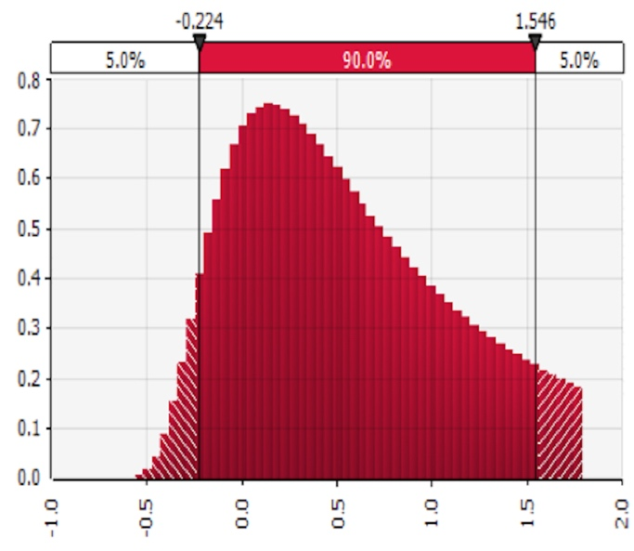
Figure 1. Simulated PDF of the ERR for $A_{2} Exponential$ (MARR = 0.25)
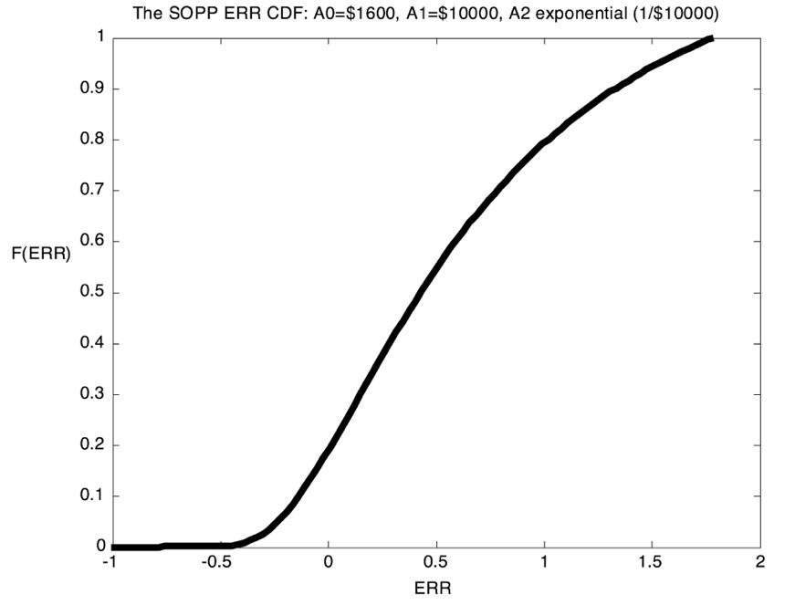
Figure 2. The CDF of the ERR for $A_{2} Exponential$ (MARR = 0.25)

Again, the decision maker would accept the project if the probability of the ERR exceeding a given MARR is high enough. $P\left(ERR>MARR\right)=1-F\left(MARR\right)=1-e^{-\frac{1.9531}{{\left(MARR+1\right)}^{2}}+0.25}.$ $Let MARR=0.25$, then $P\left(ERR>MARR\right)=1-F\left(MARR\right)=0.6321$ which is the same as the result found with the IRR approach.

Case 4: Numerical Example for $A_{1}$ Exponential
$Let A_{0}=\$1,600, A_{1} ∼Exponential \left(λ=1/{\$10,000}\right), and { A}_{2}=\$10,000.$
The term ${A_{1}}^{2}-4 A_{0}A_{2}$ ranges in [-64000000, ∞] indicating there are not real always roots. The real roots happen when A₁ ≥ $8,000 which happens with a probability of 0.4493.
The IRR/First Root: Using Table 2, the valid range is $1.5≤i≤∞$. The PDF and the CDF are$f\left(i\right)=\left(0.16-\frac{1}{{\left(i+1\right)}^{2}}\right)\left(e^{-0.16\left(i+1\right)-\frac{1}{\left(i+1\right)}+0.8}\right)$ , and$F\left(i\right)=1-e^{-0.16\left(i+1\right)-\frac{1}{\left(i+1\right)}+0.8}$.
Figure 3 shows the simulated conditional PDF of the first IRR root which resembles to Figure 9 in the article.
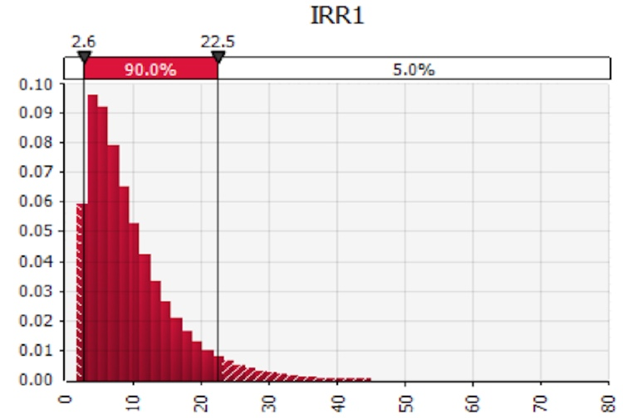
Figure 3. Simulated Conditional PDF of the IRR – First Root for $A_{1} Exponential$
The IRR/Second Root: The valid range is $-1≤i≤1.5$. The PDF and the CDF expressions are:
$f\left(i\right)=\left(-0.16+\frac{1}{{\left(i+1\right)}^{2}}\right)\left(e^{-0.16\left(i+1\right)-\frac{1}{\left(i+1\right)}+0.8}\right)and F\left(i\right)=e^{-0.16\left(i+1\right)-\frac{1}{\left(i+1\right)}+0.8}.$
Using MARR = 2.45, $F_{2}$(2.45) – $F_{1}$(2.45) = 1 – $F_{1}$(2.45) = 0.959. The actual probability that the project is desirable is (0.959 * 0.4493) = 0.430. The applicable ERR CDF is $1 – e^{-0.07073 {\left(ERR + 1\right)}^{2}}$ and P (ERR > MARR) = 1 – F(2.45) = 0.4309. .
Using a MARR of 0.25, $F_{1}\left(0.25\right)=0$and Equation 10 becomes $F_{2}\left(0.25\right) only$. $F_{2}\left(MARR\right)=e^{-0.16\left(MARR+1\right)-\frac{1}{\left(MARR+1\right)}+0.8}$ = 0.8187. Again, this is a conditional probability. Here the IRR only exists if $A_{1}≥8000$, which has a probability of 0.4493 so the actual probability that the project is desirable is (0.8187)*(0.4493) = 0.3679. The analytical IRR PDF and CDF graphs for the second root are shown in Figures 4 and 5. Simulated conditional PDF plot for the second IRR is shown in Figure 6.
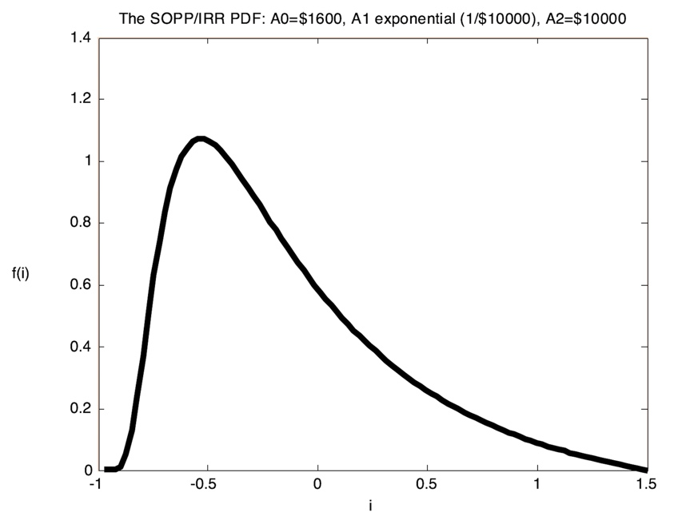
Figure 4. The Conditional PDF of the IRR – Second Root for $A_{1} Exponential$
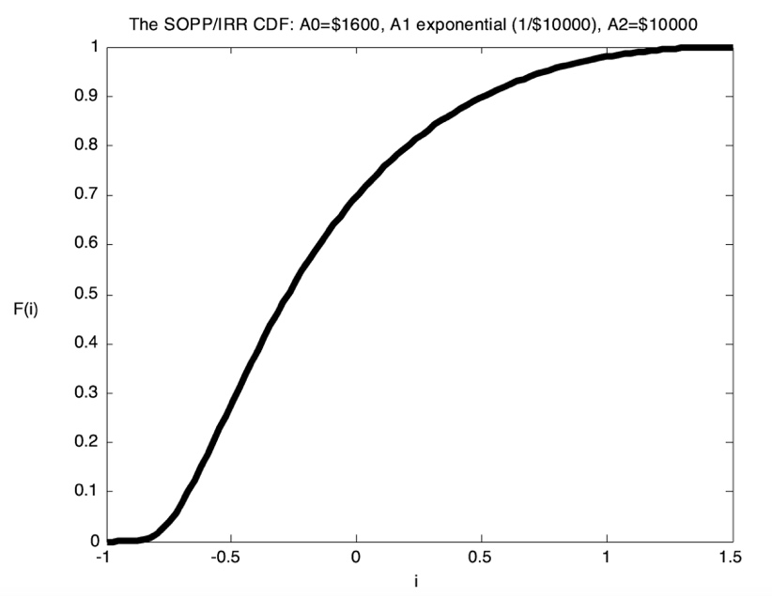
Figure 5. The Conditional CDF of the IRR - Second Root for $A_{1} Exponential$
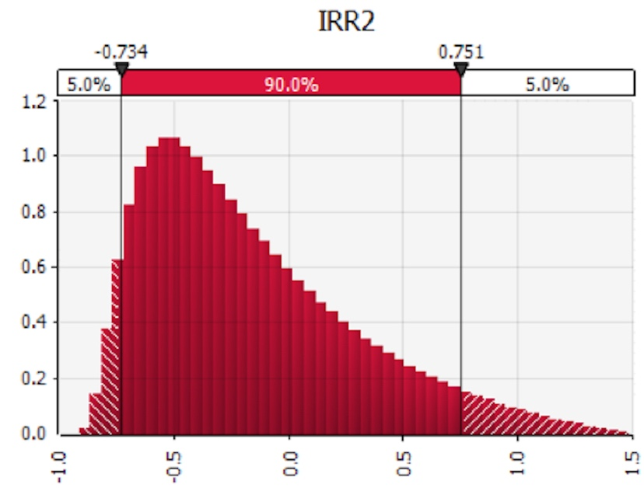
Figure 6. Simulated Conditional PDF of the IRR - Second Root for $A_{1} Exponential$

For the ERR, $let MARR=0.25.$Using Table 4, the valid range is $-1≤i≤∞$. The PDF and the CDF expressions are: $f\left(ERR\right)=1.28\left(ERR+1\right)e^{-0.64{\left(ERR+1\right)}^{2}}$ $and F\left(ERR\right)=1-e^{-0.64{\left(ERR+1\right)}^{2}}.$
$P\left(ERR>MARR\right)=1-F\left(MARR\right)=1-(1-e^{-0.64{\left(MARR+1\right)}^{2}})$. $Let MARR=0.25$, then $P\left(ERR>MARR\right)=0.3679$ and is the same as the value found above using the IRR CDF.

