Supporting Information
for
Rh^{III}-Catalyzed Annulation of N-Methoxyindozamides with Heterobicyclic Alkenes toward Indolo[3,2-c]heteroarenes
Ping Li, Jiancheng Wang, Wanrong Dong*, Zhihong Peng* and Delie An*
State Key Laboratory of Chemo/Biosensing and Chemometrics, College of Chemistry and Chemical Engineering, Hunan University, Lushan South Rd.2, Changsha, 410082, P.R. China.
wanrongdong@hnu.edu.cn; pzh7251@hnu.edu.cn; deliean@hnu.edu.cn

Table of Contents | Page No.
General information | S1
General procedure for the synthesis of 3 | S2
Referenece | S2
Data | S2
Spectra | S11

General information
All product mixtures were analyzed by thin layer chromatography using aluminum foil backed silica TLC plates with a fluorescent indicator from Merck. UV-active compounds were detected with a UV lamp (λ = 254 nm). For flash column chromatography, silica gel (200-300 mesh) was used as stationary phase. ¹H NMR and ¹³C NMR spectra were recorded on Varian INOVA-400 instrument using residue solvent peaks as internal standards (CHCl₃: δ = 7.26 ppm for ¹H and CDCl₃: δ = 77.16 ppm for ¹³C). Mass and High-resolution mass spectra (HRMS) were performed on a ThermoFinnigan MAT95XP microspectrometer. Melting points were recorded on a national standard melting point (Taike XT-4) apparatus and are uncorrected.
All solvents were dried prior to use, and all other reagents were purchased from commercial companies and used without further purification.
Data
9-Ethyl-1,1a,2,7,7a-5H-2,7-epoxy-indolo[3,2-c]-1-aza-anthracen-15-one (3ba)
White solid (143.7 mg, 87% yield), m.p. 207 - 209 ºC. ¹H NMR (DMSO-d⁶, 400 MHz) δ = 8.01 (d, J = 7.7 Hz, NH), 7.58 (d, J = 7.9 Hz, 2H), 7.43 (d, J = 8.0 Hz, 2H), 7.35 - 7.25 (m, 2H), 7.22 (t, J = 7.5 Hz, 1H), 7.15 (t, J = 7.4 Hz, 1H), 5.52 (s, 1H), 5.38 (s, 1H), 4.43 (dd, J = 14.8, 7.3 Hz, 1H), 4.27 (dd, J = 14.8, 7.3 Hz, 1H), 3.98 (d, J = 8.6 Hz, 1H), 3.55 (d, J = 8.6 Hz, 1H), 1.38 (t, J = 7.1 Hz, 3H) (ppm). ¹³C NMR (DMSO-d⁶, 100 MHz) δ = 162.9, 145.6, 142.3, 141.2, 136.1, 127.5, 127.3, 124.9, 122.0, 121.0, 120.5, 120.2, 119.6, 110.3, 103.7, 87.0, 83.3, 56.9, 38.4, 37.5, 14.9 (ppm). IR (KBr): ν = 3472, 2346, 1635, 1509, 1392, 1311, 1230, 1174, 1128, 1108, 1001, 981, 910, 859, 757, 641, 514 cm⁻¹. MS (EI): m/z (%) = 213.0, 274.1, 330.8. HRMS (ESI) (m/z) [M + H]⁺: Calcd. 331.1441, Found 331.1436.
9-(n-Propyl)-1,1a,2,7,7a-5H-2,7-epoxy-indolo[3,2-c]-1-aza-anthracen-15-one (3ca)
White solid (154.9 mg, 90% yield), m.p. 215 - 217 ºC. ¹H NMR (DMSO-d⁶, 400 MHz) δ = 8.00 (d, J = 7.7 Hz, NH), 7.57 (dd, J = 11.5, 7.6 Hz, 2H), 7.47 - 7.41 (m, 2H), 7.30 (dd, J = 13.2, 7.0 Hz, 2H), 7.21 (t, J = 7.5 Hz, 1H), 7.14 (t, J = 7.4 Hz, 1H), 5.54 (s, 1H), 5.38 (s, 1H), 4.42 - 4.33 (m, 1H), 4.18 - 4.11 (m, 1H), 3.99 (d, J = 8.4 Hz, 1H), 3.51 (d, J = 8.6 Hz, 1H), 1.85 - 1.73 (m, 2H), 0.91 (t, J = 7.3 Hz, 3H) (ppm). ¹³C NMR (DMSO-d⁶, 100 MHz) δ = 162.9, 145.7, 142.2, 141.4, 136.6, 127.6, 127.3, 124.7, 122.0, 121.0, 120.6, 120.2, 119.4, 110.5, 103.7, 87.0, 83.3, 56.8, 45.1, 37.6, 22.7, 11.3 (ppm). IR (KBr): ν = 3424, 2346, 1646, 1562, 1482, 1374, 1303, 1219, 1161, 983, 900 cm⁻¹. MS (EI): m/z (%) = 142.0, 213.0, 227.0, 344.8. HRMS (ESI) (m/z) [M + H]⁺: Calcd. 345.1598, Found 345.1605.
9-(n-Butyl)-1,1a,2,7,7a-5H-2,7-epoxy-indolo[3,2-c]-1-aza-anthracen-15-one (3da)
White solid (154.1 mg, 86% yield), m.p. 199 - 201 ºC. ¹H NMR (DMSO-d⁶, 400 MHz) δ = 8.01 (d, J = 7.7 Hz, NH), 7.58 (d, J = 8.1 Hz, 1H), 7.54 (d, J = 6.7 Hz, 1H), 7.44 (d, J = 7.2 Hz, 2H), 7.33 - 7.26 (m, 2H), 7.21 (t, J = 7.5 Hz, 1H), 7.15 (t, J = 7.4 Hz, 1H), 5.56 (s, 1H), 5.38 (s, 1H), 4.44 - 4.35 (m, 1H), 4.24 - 4.15 (m, 1H), 4.00 (d, J = 8.5 Hz, 1H), 3.50 (d, J = 8.6 Hz, 1H), 1.79 -1.70 (m, 2H), 1.42 - 1.31 (m, 2H), 0.92 (t, J = 7.3 Hz, 3H) (ppm). ¹³C NMR (DMSO-d⁶, 100 MHz) δ = 162.8, 145.6, 142.2, 141.2, 136.5, 127.5, 127.3, 124.7, 122.0, 121.0, 120.5, 120.2, 119.3, 110.4, 103.7, 87.0, 83.2, 56.8, 43.3, 37.6, 31.3, 19.7, 13.5 (ppm). IR (KBr): ν = 3472, 2340, 1646, 1504, 1457, 1374, 1314, 1173, 1090, 983 cm⁻¹. MS (EI): m/z (%) = 89.1 (22), 90.1 (16), 118.1 (36), 179.1 (18), 197.1 (100), 198.1 (16), 240.1 (93), 241.1 (17). HRMS (ESI) (m/z) [M + H]⁺: Calcd. 359.1754, Found 359.1768.
9-(Benzyl)-1,1a,2,7,7a-5H-2,7-epoxy-indolo[3,2-c]-1-aza-anthracen-15-one (3ea)
White solid (168.7 mg, 86% yield), m.p. 204 - 206 ºC. ¹H NMR (DMSO-d⁶, 400 MHz) δ = 8.08 (d, J = 7.3 Hz, NH), 7.61 (d, J = 7.7 Hz, 1H), 7.52 (s, 1H), 7.44 (d, J = 6.3 Hz, 1H), 7.38 (s, 1H), 7.34 (d, J = 7.4 Hz, 2H), 7.29 - 7.22 (m, 4H), 7.19 (d, J = 7.5 Hz, 1H), 7.14 (d, J = 7.4 Hz, 2H), 5.73 - 5.61 (m, 2H), 5.36 (s, 1H), 5.22 (s, 1H), 3.95 (d, J = 8.5 Hz, 1H), 3.36 (s, 1H) (ppm). ¹³C NMR (DMSO-d⁶, 100 MHz) δ = 162.8, 145.3, 142.2, 141.4, 137.5, 137.4, 129.0, 127.6, 127.4, 127.3, 126.5, 124.6, 122.4, 121.3, 120.4, 120.3, 119.4, 110.5, 104.5, 86.9, 82.8, 56.8, 46.5, 37.6 (ppm). IR (KBr): ν = 3475, 2350, 1660, 1500, 1457, 1374, 1314, 1173, 1078, 985 cm⁻¹. MS (EI): m/z (%) = 229.9, 274.2, 330.2, 374.3, 392.8. HRMS (ESI) (m/z) [M + H]⁺: Calcd. 393.1598, Found 393.1610.
9-(4-Methylbenzyl)-1,1a,2,7,7a-5H-2,7-epoxy-indolo[3,2-c]-1-azaanthracen-15-one (3fa)
White solid (182.9 mg, 90% yield), m.p. 206 - 208 ºC. ¹H NMR (DMSO-d⁶, 400 MHz) δ = 8.06 (d, J = 7.4 Hz, NH), 7.59 (d, J = 7.8 Hz, 1H), 7.49 (s, 1H), 7.45 (d, J = 6.5 Hz, 1H), 7.39 (d, J = 6.4 Hz, 1H), 7.27 – 7.23 (m, 2H), 7.23 – 7.17 (m, 2H), 7.14 (d, J = 8.0 Hz, 2H), 7.03 (d, J = 7.7 Hz, 2H), 5.61 (q, J = 16.9 Hz, 2H), 5.36 (s, 1H), 5.24 (s, 1H), 3.95 (d, J = 8.5 Hz, 1H), 3.35 (s, 1H), 2.23 (s, 3H) (ppm). ¹³C NMR (DMSO-d⁶, 100 MHz) δ = 162.8, 145.3, 142.2, 141.4, 137.4, 136.9, 134.4, 129.5, 127.4, 127.3, 126.4, 124.6, 122.4, 121.2, 120.4, 120.3, 119.4, 110.5, 104.4, 86.9, 82.8, 56.8, 46.3, 37.6, 20.6 (ppm). IR (KBr): ν = 3495, 2336, 1658, 1552, 1504, 1409, 1303, 1205, 1101 cm⁻¹. MS (EI): m/z (%) = 63.1 (19), 89.1 (54), 90.1 (48), 91.1 (25), 118.1 (78), 169.0 (80), 183.1 (14), 274.1 (17), 352.0 (100), 354.0 (96), 355.0 (18). HRMS (ESI) (m/z) [M + H]⁺: Calcd. 407.1754, Found 407.1764.
9-(3-Methylbenzyl)-1,1a,2,7,7a-5H-2,7-epoxy-indolo[3,2-c]-1-azaanthracen-15-one (3ga)
White solid (178.9 mg, 88% yield), m.p. 210 - 212 ºC. ¹H NMR (DMSO-d⁶, 400 MHz) δ = 8.05 (d, J = 6.6 Hz, NH), 7.60 (d, J = 7.8 Hz, 1H), 7.48 (s, 1H), 7.43 (d, J = 6.5 Hz, 1H), 7.39 (d, J = 6.4 Hz, 1H), 7.28 - 7.16 (m, 5H), 7.08 (d, J = 7.4 Hz, 1H), 7.01 (s, 1H), 6.90 (d, J = 7.4 Hz, 1H), 5.62 (q, J = 17.0 Hz, 2H), 5.35 (s, 1H), 5.24 (s, 1H), 3.94 (d, J = 8.3 Hz, 1H), 3.36 (s, 1H), 2.24 (s, 3H) (ppm). ¹³C NMR (DMSO-d⁶, 100 MHz) δ = 162.7, 145.4, 142.2, 141.4, 138.2, 137.41, 137.38, 128.9, 128.3, 127.4, 127.3, 127.1, 124.5, 123.6, 122.4, 121.2, 120.4, 120.2, 119.4, 110.5, 104.4, 86.9, 82.8, 56.8, 46.5, 37.6, 21.0 (ppm). IR (KBr): ν = 3471, 2358, 1646, 1552, 1495, 1469, 1397, 1314, 1173, 769, 662, 591, 521 cm⁻¹. MS (EI): m/z (%) = 63.1(9), 79.1(10), 89.1(24), 90.1(18), 105.1(100), 118.1(37), 288.1(99), 289.1(19). HRMS (ESI) (m/z) [M + H]⁺: Calcd. 407.1754, Found 407.1768.
9-(4-Chlorobenzyl)-1,1a,2,7,7a-5H-2,7-epoxy-indolo[3,2-c]-1-azaanthracen-15-one (3ha)
White solid (189.9 mg, 89% yield), m.p. 194 - 196 ºC. ¹H NMR (DMSO-d⁶, 400 MHz) δ = 8.06 (d, J = 7.6 Hz, NH), 7.58 (d, J = 7.6 Hz, 1H), 7.54 (s, 1H), 7.48 (d, J = 6.3 Hz, 1H), 7.40 (t, J = 7.5 Hz, 3H), 7.28 - 7.23 (m, 2H), 7.20 (t, J = 7.8 Hz, 2H), 7.14 (d, J = 8.3 Hz, 2H), 5.75 - 5.58 (m, 2H), 5.36 (s, 1H), 5.28 (s, 1H), 3.96 (d, J = 8.6 Hz, 1H), 3.35 (d, J = 8.6 Hz, 1H) (ppm). ¹³C NMR (DMSO-d⁶, 100 MHz) δ = 162.7, 145.3, 142.2, 141.4, 137.2, 136.5, 132.2, 128.9, 128.4, 127.4, 127.3, 124.6, 122.5, 121.4, 120.4, 120.3, 119.6, 110.5, 104.6, 86.9, 82.8, 56.9, 45.9, 37.6 (ppm). IR (KBr): ν = 3472, 2346, 1658, 1516, 1457, 1421, 1386, 1326, 1123, 769, 662, 604, 521 cm⁻¹. MS (EI): m/z (%) = 63.1 (10), 89.1 (38), 90.1 (24), 118.1 (39), 125.1 (100), 127.1 (36), 308.1 (74), 310.1 (24). HRMS (ESI) (m/z) [M + H]⁺: Calcd. 427.1208, Found 427.1210.
9-(4-Bromobenzyl)-1,1a,2,7,7a-5H-2,7-epoxy-indolo[3,2-c]-1-azaanthracen-15-one (3ia)
White solid (214.5 mg, 91% yield), m.p. 210 - 212 ºC. ¹H NMR (DMSO-d⁶, 400 MHz) δ = 8.05 (d, J = 7.3 Hz, NH), 7.58 -7.52 (m, 3H), 7.51 - 7.46 (m, 2H), 7.39 (d, J = 5.9 Hz, 1H), 7.27 - 7.23 (m, 2H), 7.19 (dd, J = 14.9, 7.3 Hz, 2H), 7.07 (d, J = 8.2 Hz, 2H), 5.73 - 5.56 (m, 2H), 5.35 (s, 1H), 5.28 (s, 1H), 3.96 (d, J = 8.5 Hz, 1H), 3.34 (s, 1H) (ppm). ¹³C NMR (DMSO-d⁶, 100 MHz) δ = 162.7, 145.2, 142.2, 141.3, 137.2, 136.9, 137.0, 131.8, 128.7, 127.4, 124.6, 122.4, 121.4, 120.7, 120.4, 120.3, 119.5, 110.5, 104.6, 86.9, 82.8, 56.9, 45.9, 37.6 (ppm). IR (KBr): ν = 3472, 2346, 1658, 1563, 1504, 1457, 1397, 1326, 1196, 1006 cm⁻¹. MS (EI): m/z (%) = 63.1 (33), 89.1 (84), 90.1 (73), 118.1 (100), 169.0 (39), 207.1 (29), 281.1 (10), 354.0 (26). HRMS (ESI) (m/z) [M + H]⁺: Calcd. 471.0703, Found 471.0707.
9-(2-Bromobenzyl)-1,1a,2,7,7a-5H-2,7-epoxy-indolo[3,2-c]-1-azaanthracen-15-one (3ja)
White solid (212.1 mg, 90% yield), m.p. 283 - 285 ºC (decomp.). ¹H NMR (DMSO-d⁶, 400 MHz) δ = 8.11 – 8.06 (m, NH), 7.75 (dd, J = 5.7, 3.5 Hz, 1H), 7.52 (d, J = 9.0 Hz, 2H), 7.39 (d, J = 7.5 Hz, 1H), 7.34 (d, J = 6.1 Hz, 1H), 7.26 - 7.22 (m, 3H), 7.22 - 7.16 (m, 3H), 6.41 (dd, J = 5.6, 3.7 Hz, 1H), 5.76 - 5.59 (m, 2H), 5.36 (s, 1H), 5.27 (s, 1H), 3.96 (dd, J = 8.6, 1.3 Hz, 1H), 3.29 (d, J = 8.6 Hz, 1H) (ppm). ¹³C NMR (DMSO-d⁶, 100 MHz) δ = 162.6, 145.2, 142.2, 141.4, 137.3, 136.0, 132.9, 129.7, 128.4, 127.44, 127.35, 127.31, 124.6, 122.6, 121.48, 121.45, 120.6,120.4, 119.1, 110.4, 104.8, 86.87 (s), 82.8, 56.8, 46.9, 37.6 (ppm). IR (KBr): ν = 3495, 2358, 1646, 1554, 1504, 1457, 1386, 1303, 1208, 1173, 1113 cm⁻¹. MS (EI): m/z (%) = 63.1 (23), 89.1 (58), 90.1 (52), 118.1 (48), 128.1 (17), 155.1 (15), 169.0 (45), 183.1 (18), 271.1 (26), 273.1 (48), 274.1 (11), 351.9 (97), 353.9 (100), 354.9 (22). HRMS (ESI) (m/z) [M + H]⁺: Calcd. 471.0703, Found 471.0698.
9-(4-Trifluoromethylbenzyl)-1,1a,2,7,7a-5H-2,7-epoxy-indolo[3,2-c]-1-azaanthracen-15-one (3ka)
White solid (195.7 mg, 85% yield), m.p. 208 - 209 ºC. ¹H NMR (DMSO-d⁶, 400 MHz) δ = 8.09 (d, J = 7.6 Hz, NH), 7.72 (d, J = 7.9 Hz, 2H), 7.57 (s, 2H), 7.48 (d, J = 6.0 Hz, 1H), 7.39 (d, J = 6.5 Hz, 1H), 7.32 (d, J = 7.9 Hz, 2H), 7.27 - 7.13 (m, 4H), 5.89 - 5.71 (m, 2H), 5.38 (s, 1H), 5.32 (s, 1H), 3.98 (d, J = 8.5 Hz, 1H), 3.37 (d, J = 8.6 Hz, 1H) (ppm). ¹³C NMR (DMSO-d⁶, 100 MHz) δ = 162.7, 145.2, 142.22 (d, J = 4.9 Hz), 141.4, 137.2, 128.4 128.2 (d, J = 31.6 Hz), 128.1, 127.4, 127.3, 127.2, 125.8 (J_{C-F} = 3.5 Hz), 124.7, 124.1 (J_{C-F} = 270.5 Hz), 122.5, 121.5, 120.42, 120.36, 119.6, 110.5, 104.8, 87.0, 82.9, 56.9, 46.2, 37.6 (ppm). IR (KBr): ν = 3851, 3744, 3685, 3626, 3567, 3519, 2927, 2358, 1741, 1682, 1646, 1552, 1504, 1457, 1374, 1040 cm⁻¹. MS (EI): m/z (%) = 63.1 (8), 89.1 (18), 90.1 (14), 118.1 (28), 155.1 (11), 159.1 (18), 183.1 (32), 342.1 (100), 343.1 (25). HRMS (ESI) (m/z) [M + H]⁺: Calcd. 461.1471, Found 461.1465.
9-(3-Trifluoromethylbenzyl)-1,1a,2,7,7a-5H-2,7-epoxy-indolo[3,2-c]-1-azaanthracen-15-one (3la)
White solid (191.1 mg, 83% yield), m.p. 198 - 200 ºC. ¹H NMR (DMSO-d⁶, 400 MHz) δ = 8.06 (d, J = 7.0 Hz, NH), 7.65 (s, 2H), 7.59 - 7.50 (m, 3H), 7.46 (d, J = 2.5 Hz, 1H), 7.38 (s, 1H), 7.28 - 7.17 (m, 5H), 5.88- 5.69 (m, 2H), 5.35 (s, 1H), 5.29 (s, 1H), 3.95 (d, J = 8.5 Hz, 1H), 3.34 (d, J = 2.7 Hz, 1H) (ppm). ¹³C NMR (DMSO-d⁶, 100 MHz) δ = 162.7, 145.2, 142.2, 141.4, 139.0, 137.2, 130.4, 130.2, 127.3, 124.6, 123.3, 122.6, 121.5, 120.44, 120.35, 119.5, 110.5, 104.8, 86.9, 82.8, 56.9, 46.1, 37.6 (ppm). IR (KBr): ν = 3872, 3733, 3670, 3626, 3567, 2938, 2348, 1741, 1682, 1658, 1552, 1516, 1457, 1018 cm⁻¹. MS (EI): m/z (%) = 63.1 (21), 89.1 (49), 90.1 (38), 105.1 (30), 118.1 (69), 128.1 (16), 155.1 (26), 159.1 (47), 183.1 (59), 184.1 (12), 288.1 (18), 342.1 (100), 343.1 (26). HRMS (ESI) (m/z) [M + H]⁺: Calcd. 461.1471, Found 461.1475.
9-(2-Naphthylmethyl)-1,1a,2,7,7a-5H-2,7-epoxy-indolo [3,2-c]-1-azaanthracen-15-one (3ma)
White solid (179.2 mg, 81% yield), m.p. 195 - 197 ºC. ¹H NMR (DMSO-d⁶, 400 MHz) δ = 8.08 (d, J = 6.9 Hz, NH), 7.87 (dd, J = 21.1, 9.1 Hz, 3H), 7.70 (s, 1H), 7.66 (d, J = 7.6 Hz, 1H), 7.51 - 7.43 (m, 4H), 7.36 (d, J = 6.3 Hz, 1H), 7.28 (d, J = 8.5 Hz, 1H), 7.25 - 7.15 (m, 4H), 5.91 -5.76 (m, 2H), 5.34 (s, 1H), 5.30 (s, 1H), 3.94 (d, J = 8.5 Hz, 1H), 3.37 (s, 1H) (ppm). δ = 162.8, 145.3, 142.2, 141.5, 137.5, 135.0, 132.8, 132.3, 128.8, 127.68, 127.64, 127.4, 127.3, 126.6, 126.2, 125.1, 124.7, 124.6, 122.5, 121.4, 120.4, 120.3, 119.4, 110.6, 104.6, 86.9, 82.8, 56.9, 46.8, 37.7 (ppm). IR (KBr): ν = 3874, 3756, 3661, 3626, 2936, 2370, 2334, 1848, 1789, 1741, 1682, 1646, 1563, 1552, 1516, 1465, 1421, 1374 cm⁻¹. MS (EI): m/z (%) = 63.1 (13), 89.1 (26), 90.1 (19), 118.1 (29), 141.1 (100), 142.1 (14), 324.1 (40), 325.1 (10). HRMS (ESI) (m/z) [M + H]⁺: Calcd. 443.1754, Found 443.1756.
9-(4-Chlorobenzyl)-12-methoxy-1,1a,2,7,7a-5H-2,7-epox -y-indolo[3,2-c]-1-azaanthracen-15-one (3na)
White solid (203.3 mg, 89% yield), m.p. 210 - 212 ºC. ¹H NMR (DMSO-d⁶, 400 MHz) δ = 7.54 (br, NH), 7.46 (d, J = 8.5 Hz, 3H), 7.40 (d, J = 8.0 Hz, 3H), 7.25 (d, J = 2.8 Hz, 2H), 7.12 (d, J = 8.0 Hz, 2H), 6.84 (d, J = 8.7 Hz, 1H), 5.72 - 5.52 (m, 2H), 5.35 (s, 1H), 5.26 (s, 1H), 3.94 (d, J = 8.4 Hz, 1H), 3.78 (s, 3H), 3.32 (d, J = 8.6 Hz, 1H) (ppm). ¹³C NMR (DMSO-d⁶, 100 MHz) δ = 162.8, 155.1, 145.3, 142.2, 141.5, 136.5, 132.2, 128.9, 128.4, 127.4, 127.3, 125.3, 120.4, 119.5, 112.1, 111.3, 104.3, 102.1, 86.9, 82.9, 56.8, 55.4, 46.0, 37.6 (ppm). IR (KBr): ν = 3874, 3744, 3685, 3614, 2998, 2915, 2358, 1741, 1682, 1646, 1552, 1516, 1457, 1256, 1054 cm⁻¹. MS (EI): m/z (%) = 63.1 (13), 89.1 (39), 90.1 (30), 118.1 (49), 125.1 (37), 127.1 (13), 170.1 (12), 198.1 (11), 213.1 (100), 214.1 (16), 338.2 (82), 340.2 (28). HRMS (ESI) (m/z) [M + H]⁺: Calcd.457.1313, Found 457.1325.
9-(4-Chlorobenzyl)-12-chloro-1,1a,2,7,7a-5H-2,7-epoxy-indolo[3,2-c]-1-azaanthracen-15-one (3oa)
White solid (212.1 mg, 92% yield), m.p. 204 - 206 ºC. ¹H NMR (DMSO-d⁶, 400 MHz) δ = 8.01 (s, 1H), 7.63 (d, J = 8.4 Hz, 2H), 7.48 (d, J = 6.4 Hz, 1H), 7.41 (d, J = 8.1 Hz, 3H), 7.24 (d, J = 8.8 Hz, 3H), 7.13 (d, J = 8.2 Hz, 2H), 5.74 - 5.59 (m, 2H), 5.36 (s, 1H), 5.30 (s, 1H), 3.96 (d, J = 8.5 Hz, 1H), 3.35 (d, J = 8.6 Hz, 1H). ¹³C NMR (DMSO-d⁶, 100 MHz) δ = 162.3, 145.2, 142.9, 142.2, 136.1, 135.8, 132.3, 129.0, 128.4, 127.5, 127.4, 126.2, 125.7, 122.4, 120.5, 119.6, 119.3, 112.4, 104.4, 86.9, 82.8, 57.0, 46.2, 37.7 (ppm). IR (KBr): ν = 3863, 3733, 3685, 3650, 3614, 2974, 2927, 2370, 1848, 1753, 1694, 1646, 1552, 1516, 1457, 1386, 1256, 1054 cm⁻¹. MS (EI): m/z (%) = 63.1 (24), 89.1 (63), 90.1 (42), 118.1 (76), 125.1 (100), 162.1 (7), 189.1 (8), 217.1 (12), 342.1 (68). HRMS (ESI) (m/z) [M + H]⁺: Calcd. 461.0818, Found 461.0822.
9-(4-Chlorobenzyl)-12-bromo-1,1a,2,7,7a-5H-2,7-epoxy-indolo[3,2-c]-1-azaanthracen-15-one (3pa)
White solid (217.5 mg, 86% yield), m.p. 198 - 200 ºC. ¹H NMR (DMSO-d⁶, 400 MHz) δ = 8.16 (br. s, NH), 7.64 (s, 1H), 7.58 (d, J = 8.7 Hz, 1H), 7.48 (d, J = 5.8 Hz, 1H), 7.41 (d, J = 7.7 Hz, 3H), 7.35 (d, J = 8.7 Hz, 1H), 7.25 (d, J = 3.5 Hz, 2H), 7.13 (d, J = 7.9 Hz, 2H), 5.76 - 5.59 (m, 2H), 5.35 (s, 1H), 5.29 (s, 1H), 3.96 (d, J = 8.4 Hz, 1H), 3.35 (d, J = 8.9 Hz, 1H) (ppm). ¹³C NMR (DMSO-d⁶, 100 MHz) δ = 162.3, 145.2, 142.8, 142.2, 136.1, 132.3, 129.0, 128.4, 127.5, 127.4, 126.3, 125.0, 122.3, 120.5, 119.6, 114.2, 112.8, 104.2, 86.9, 82.7, 57.0, 46.1, 37.7 (ppm). IR (KBr): ν = 3863, 3744, 3673, 3614, 2986, 2915, 2358, 1741, 1694, 1646, 1516, 1457, 1386, 1256, 1054, 888 cm⁻¹. MS (EI): m/z (%) = 63.1 (21), 89.1 (60), 90.1 (43), 118.1 (74), 125.1 (100), 127.1 (37), 189.1 (8), 217.1 (8), 342.1 (68), 344.1 (42). HRMS (ESI) (m/z) [M + H]⁺: Calcd. 505.0313, Found 505.0310.
9-(4-Chlorobenzyl)-11-chloro-1,1a,2,7,7a-5H-2,7-epoxy-indolo[3,2-c]-1-azaanthracen-15-one (3qa)
White solid (196.1 mg, 85% yield), m.p. 218 - 220 ºC. ¹H NMR (DMSO-d⁶, 400 MHz) δ = 8.02 (d, J = 8.4 Hz, NH), 7.78 (s, 1H), 7.60 (s, 1H), 7.48 (d, J = 6.2 Hz, 1H), 7.40 (t, J = 9.3 Hz, 3H), 7.26 – 7.19 (m, 3H), 7.13 (d, J = 8.0 Hz, 2H), 5.77 - 5.60(m, 2H), 5.35 (s, 1H), 5.28 (s, 1H), 3.96 (d, J = 8.5 Hz, 1H), 3.31 (d, J = 8.5 Hz, 1H) (ppm). ¹³C NMR (DMSO-d⁶, 100 MHz) δ = 162.4, 145.2, 142.4, 142.2, 137.9, 136.2, 132.3, 129.0, 128.4, 127.5, 127.40, 127.36, 123.3, 121.8, 121.6, 120.5, 119.6, 110.6, 104.9, 86.9, 82.8, 57.0, 46.0, 37.7 (ppm). IR (KBr): ν = 3863, 3744, 3673, 3650, 3614, 2915, 2832, 2358, 2322, 1741, 1706, 1658, 1540, 1516, 1457, 1256, 1066 cm⁻¹. MS (EI): m/z (%) = 89.1 (11), 125.0 (55), 127.0 (22), 189.1 (10), 218.1 (12), 342.1 (100), 344.1 (72), 345.1 (15). HRMS (ESI) (m/z) [M + H]⁺: Calcd. 461.0818, 461.0822.
9-Benzyl-4,5-dimethyl-1,1a,2,7,7a-5H-2,7-epoxy-indolo [3,2-c]-1-azaanthracen-15-one (3eb)
White solid (185.1 mg, 88% yield), m.p. 194 - 196 ºC. ¹H NMR (DMSO-d⁶, 400 MHz) δ = 8.04 (d, J = 7.4 Hz, NH), 7.57 (d, J = 7.6 Hz, 1H), 7.50 (s, 1H), 7.35 (t, J = 7.3 Hz, 2H), 7.29 - 7.25 (m, 1H), 7.20 (t, J = 7.0 Hz, 3H), 7.14 (d, J = 7.1 Hz, 3H), 5.64 (q, J = 17.0 Hz, 2H), 5.27 (s, 1H), 5.15 (s, 1H), 3.89 (d, J = 8.6 Hz, 1H), 3.32 (d, J = 8.6 Hz, 1H), 2.22 (d, J = 8.4 Hz, 6H) (ppm). ¹³C NMR (DMSO-d⁶, 100 MHz) δ = 162.8, 143.1, 141.6, 139.9, 137.4, 137.3, 135.2, 135.0, 129.0, 127.7, 126.5, 124.6, 122.4, 121.5, 121.3, 120.6, 120.2, 110.6, 104.4, 86.8, 82.8, 57.1, 46.6, 38.0, 19.68, 19.57 (ppm). IR (KBr): ν = 3851, 3744, 3685, 3626, 2915, 2370, 1741, 1694, 1658, 1552, 1516, 1469, 1054, cm⁻¹. MS (EI): m/z (%) = 65.1 (12), 91.1 (100), 92.1 (10), 128.1 (10), 155.1 (10), 184.1 (11), 274.2 (80), 275.2 (17). HRMS (ESI) (m/z) [M + H]⁺: Calcd. 421.1911, Found 421.1916.
9-Benzyl-4,5-dimethoxy-1,1a,2,7,7a-5H-2,7-epoxy-indolo [3,2-c]-1-azaanthracen-15-one (3ec)
White solid (371.5 mg, 82% yield), m.p. 256 - 258 ºC. ¹H NMR (DMSO-d⁶, 400 MHz) δ = 8.04 (d, J = 7.4 Hz, NH), 7.59 (d, J = 7.8 Hz, 1H), 7.49 (s, 1H), 7.34 (t, J = 7.3 Hz, 2H), 7.30 - 7.25 (m, 1H), 7.23 - 7.09 (m, 5H), 7.03 (s, 1H), 5.73 - 5.58 (m, 2H), 5.26 (s, 1H), 5.18 (s, 1H), 3.86 (d, J = 8.5 Hz, 1H), 3.80 (s, 3H), 3.75 (s, 3H), 3.24 (d, J = 8.5 Hz, 1H) (ppm). ¹³C NMR (DMSO-d⁶, 100 MHz) δ = 162.8, 148.2, 148.0, 141.7, 137.5, 137.4, 137.3, 134.1, 128.9, 127.7, 126.7, 124.6, 122.3, 121.2, 120.2, 110.6, 105.4, 104.6, 104.3, 87.1, 83.2, 57.1, 55.92, 55.87, 46.6, 38.1 (ppm). IR (KBr): ν = 3872, 3756, 3697, 3626, 3565, 2963, 2915, 2358, 1741, 1684, 1552, 1504, 1457, 1421, 1386, 1260, 1054 cm⁻¹. MS (EI): m/z (%) = 63.1 (12), 77.1 (14), 91.1 (100), 92.1 (14), 107.1 (11), 135.1 (17), 178.1 (55), 274.1 (75), 275.1 (15). HRMS (ESI) (m/z) [M + H]⁺: Calcd. 453.1809, Found 453.1815.
9-Benzyl-4,5-dioxole-1,1a,2,7,7a-5H-2,7-epoxy-indolo [3,2-c]-1-azaanthracen-15-one (3ed)
White solid (187.7 mg, 86% yield), m.p. 201 - 203 ºC. ¹H NMR (DMSO-d⁶, 400 MHz) δ = 8.05 (d, J = 7.1 Hz, NH), 7.57 (d, J = 7.6 Hz, 1H), 7.45 (s, 1H), 7.34 (t, J = 7.3 Hz, 2H), 7.29 - 7.24 (m, 1H), 7.19 (dd, J = 14.6, 7.1 Hz, 2H), 7.12 (d, J = 7.4 Hz, 2H), 7.09 (s, 1H), 6.98 (s, 1H), 6.05 (s, 1H), 5.99 (s, 1H), 5.65 (q, J = 17.1 Hz, 2H), 5.25 (s, 1H), 5.17 (s, 1H), 3.89 (d, J = 8.5 Hz, 1H), 3.28 (d, J = 8.6 Hz, 1H) (ppm). ¹³C NMR (DMSO-d⁶, 100 MHz) δ = 162.7, 146.56, 146.46, 141.4, 139.0, 137.5, 137.3, 135.74, 128.9, 127.6, 126.5, 124.6, 122.4, 121.3, 120.2, 110.6, 104.4, 102.5, 101.8, 101.3, 87.0, 83.0, 57.0, 46.5, 37.8 (ppm). IR (KBr): ν = 3683, 3756, 3685, 3614, 3555, 2927, 2358, 1753, 1694, 1646, 1540, 1504, 1469, 1374, 1030 cm⁻¹. MS (EI): m/z (%) = 50.0 (17), 76.1 (22), 91.1 (64), 104.1 (20), 134.1 (14), 162.1 (65), 274.1 (100), 275.1 (18). HRMS (ESI) (m/z) [M + H]⁺: Calcd. 437.1496, Found 437.1500.
9-Benzyl-4,5-dibromo-1,1a,2,7,7a-5H-2,7-epoxy-indolo [3,2-c]-1-azaanthracen-15-one (3ee)
White solid (239.3 mg, 87% yield), m.p. 198 - 200 ºC. ¹H NMR (DMSO-d⁶, 400 MHz) δ = 8.04 (d, J = 6.9 Hz, NH), 7.94 (s, 1H), 7.77 (s, 1H), 7.53 (d, J = 9.7 Hz, 2H), 7.32 (t, J = 7.2 Hz, 2H), 7.28 - 7.24 (m, 1H), 7.20 - 7.10 (m, 4H), 5.67 (q, J = 17.0 Hz, 2H), 5.36 (d, J = 7.1 Hz, 2H), 4.04 (d, J = 8.5 Hz, 1H), 3.48 (d, J = 8.6 Hz, 1H) (ppm). ¹³C NMR (DMSO-d⁶, 100 MHz) δ = 162.6, 146.6, 143.9, 140.8, 137.4, 137.2, 128.8, 127.6, 126.6, 125.9, 125.4, 124.6, 122.5, 122.40, 122.37, 121.3, 120.2, 110.8, 104.6, 86.5, 82.4, 56.4, 46.6, 37.1 (ppm). IR (KBr): ν = 3911, 3851, 3744, 3661, 3626, 3578, 3353, 3187, 2927, 2843, 2370, 1860, 1790, 1741, 1706, 1648, 1504, 1457, 1421, 1362, 1078 cm⁻¹. MS (EI): m/z (%) = 87.1 (10), 91.1 (40), 169.0 (14), 274.1 (100), 275.9 (56), 277.9 (26). HRMS (ESI) (m/z) [M + H]⁺: Calcd. 548.9808, Found 548.9815.
9-Methyl-indolo[3,2-c]-1-azaanthracen-15(1H)-one (4a)
White solid (128.3 mg, 86% yield), m.p. 299 - 301 ºC (decomp.). ¹H NMR (DMSO-d⁶, 400 MHz) δ = 11.55 (br, NH), 9.06 (s, 1H), 8.33 (d, J = 7.7 Hz, 1H), 8.18 (d, J = 8.1 Hz, 1H), 7.90 - 7.82 (m, 3H), 7.54 (t, J = 7.3 Hz, 1H), 7.46 (dd, J = 12.1, 7.2 Hz, 2H), 7.32 (t, J = 7.4 Hz, 1H), 4.47 (s, 3H) (ppm). ¹³C NMR (DMSO-d⁶, 100 MHz) δ = 160.0, 139.5, 139.2, 136.3, 132.5, 128.9, 128.3, 127.3, 126.4, 124.3, 124.2, 123.5, 122.8, 121.6, 120.9, 114.1, 111.2, 110.4, 107.0, 33.6 (ppm). IR (KBr): ν = 3863, 3733, 3685, 3626, 2927, 2358, 1741, 1694, 1646, 1552, 1504, 1457, 1279 cm⁻¹. MS (EI): m/z (%) = 149.1 (8), 255.2 (14), 297.2 (14), 298.2 (100), 299.2 (26). HRMS (ESI) (m/z) [M + H]⁺: Calcd. 299.1179, Found 299.1182.
9-(n-Propyl)-indolo[3,2-c]-1-azaanthracen-15(1H)-one (4c)
White solid (143.6 mg, 88% yield), m.p. 255 - 257 ºC. ¹H NMR (DMSO-d⁶, 400 MHz) δ = 11.59 (br, NH), 8.78 (s, 1H), 8.36 (d, J = 7.8 Hz, 1H), 8.14 (d, J = 8.2 Hz, 1H), 7.91 - 7.81 (m, 3H), 7.53 (t, J = 7.4 Hz, 1H), 7.44 (dd, J = 13.9, 7.0 Hz, 2H), 7.32 (t, J = 7.4 Hz, 1H), 4.89 (t, J = 7.2 Hz, 2H), 1.97 (dd, J = 14.4, 7.3 Hz, 2H), 1.03 (t, J = 7.3 Hz, 3H) (ppm). ¹³C NMR (DMSO-d⁶, 100 MHz) δ = 160.0, 139.4, 138.1, 136.2, 132.4, 128.9, 128.3, 127.3, 126.3, 124.3, 123.5, 122.3, 121.6, 121.0, 113.7, 111.4, 110.5, 107.6, 46.2, 23.0, 10.9 (ppm). IR (KBr): ν = 3851, 3744, 3650, 3614, 3353, 2915, 2843, 2370, 2320, 1741, 1682, 1658, 1540, 1516, 1457, 1256, 1040 cm⁻¹. MS (EI): m/z (%) = 197.1 (13), 226.2 (12), 255.2 (20), 284.1 (12), 297.2 (70), 298.2 (16), 326.2 (100), 327.2 (27). HRMS (ESI) (m/z) [M + H]⁺: Calcd. 327.1492, Found 327.1496.
9-(n-Butyl)-indolo[3,2-c]-1-azaanthracen-15(1H)-one (4d)
White solid (153.2 mg, 90% yield), m.p. 269 - 271 ºC. ¹H NMR (DMSO-d⁶, 400 MHz) δ = 11.61 (br, NH), 8.82 (s, 1H), 8.35 (d, J = 6.9 Hz, 1H), 8.13 (d, J = 7.3 Hz, 1H), 7.96 - 7.78 (m, 3H), 7.59 - 7.41 (m, 3H), 7.33 (s, 1H), 4.94 (s, 2H), 1.93 (s, 2H), 1.49 (d, J = 6.1 Hz, 2H), 0.96 (s, 3H) (ppm). ¹³C NMR (DMSO-d⁶, 100 MHz) δ = 160.0, 139.3, 138.1, 136.3, 132.5, 128.8, 128.3, 127.4, 126.4, 124.43, 124.37, 123.6, 122.4, 121.7, 121.0, 113.7, 111.4, 110.5, 107.6, 44.7, 31.7, 19.5, 13.8 (ppm). IR (KBr): ν = 3851, 3744, 3650, 3614, 2915, 2370, 2310, 1836, 1741, 1694, 1650, 1516, 1457, 1397, 1054 cm⁻¹. MS (EI): m/z (%) = 77.1 (12), 127.1 (16), 128.1 (12), 207.1 (7), 227.1 (8), 255.1 (24), 279.1 (13), 284.1 (18), 297.2 (76), 298.2 (21), 340.2 (100), 341.2 (26). HRMS (ESI) (m/z) [M + H]⁺: Calcd. 341.1648, Found 341.1658.
9-(4-Bromobenzyl)-indolo[3,2-c]-1-azaanthracen-15(1H)-one (4i)
White solid (208.5 mg, 92% yield), m.p. 309 ºC (decomp.). ¹H NMR (DMSO-d⁶, 400 MHz) δ = 11.66 (br, NH), 8.67 (s, 1H), 8.41 (d, J = 7.7 Hz, 1H), 7.90 - 7.83 (m, 4H), 7.50 (d, J = 8.3 Hz, 4H), 7.42 – 7.36 (m, 2H), 7.13 (d, J = 8.2 Hz, 2H), 6.26 (s, 2H) (ppm). ¹³C NMR (DMSO-d⁶, 100 MHz) δ = 160.0, 139.8, 138.6, 136.9, 136.2, 132.4, 131.8, 128.6, 128.3, 128.1, 127.5, 126.4, 124.8, 124.4, 123.7, 122.7, 122.2, 121.2, 120.5, 113.2, 111.3, 110.5, 108.1, 47.7 (ppm). IR (KBr): ν = 3864, 3735, 3657, 2930, 2358, 1748, 1695, 1644, 1552, 1513, 1448 cm⁻¹. MS (EI): m/z (%) = 89.1 (14), 90.1 (23), 127.1 (12), 169.0 (71), 171.0 (68), 227.1 (14), 255.2 (62), 256.2 (16), 283.1 (20), 284.1 (28), 373.2 (8), 454.1 (100), 455.1 (30). HRMS (ESI) (m/z) [M + H]⁺: Calcd. 453.0597, Found 453.0601.
9-(4-Trifluoromethylbenzyl)-indolo[3,2-c]-1-azaanthracen -15(1H)-one (4k)
White solid (201.3 mg, 91% yield), m.p. 311 ºC (decomp.). ¹H NMR (DMSO-d⁶, 400 MHz) δ = 11.67 (s, 1H), 8.66 (s, 1H), 8.43 (d, J = 7.7 Hz, 1H), 7.90 - 7.83 (m, 4H), 7.68 (d, J = 8.0 Hz, 2H), 7.48 (dd, J = 18.7, 7.7 Hz, 2H), 7.39 (t, J = 6.4 Hz, 4H), 6.40 (s, 2H) (ppm). ¹³C NMR (DMSO-d⁶, 100 MHz) δ = 160.0, 142.3, 139.8, 138.6, 136.2, 132.5, 128.6, 128.1, 127.5, 126.9, 126.4, 125.9 (J_{C-F} = 4.0 Hz), 125.5, 124.9, 124.4, 124.1(J_{C-F} = 270.6 Hz), 123.7, 122.5, 122.3, 121.2, 121.2, 113.2, 111.4, 110.5, 108.2, 48.0 (ppm). IR (KBr): ν = 3864, 3748, 3643, 3619, 2916, 2852, 2358, 2319, 1748, 1695, 1644, 1540, 1501, 1448, 1397 cm⁻¹. MS (EI): m/z (%) = 127.1 (9), 159.1 (15), 207.1 (7), 227.1 (8), 255.1 (66), 256.2 (16), 283.1 (30), 284.1 (10), 442.2 (100), 443.2 (32). HRMS (ESI) (m/z) [M + H]⁺: Calcd. 443.1366, Found 443.1365.
5-Methyl-2,3-Dihydro-1H-pyrido[3,2-c]indol-11-one (5a)
White solid (71.3 mg, 72% yield), m.p. 139 - 141 ºC. ¹H NMR (DMSO-d⁶, 400 MHz) δ = 11.22 (br, NH), 8.15 (d, J = 7.6 Hz, 1H), 7.57 (d, J = 8.0 Hz, 1H), 7.36 (dd, J = 17.5, 7.5 Hz, 2H), 7.24 (t, J = 7.3 Hz, 1H), 6.69 (d, J = 7.0 Hz, 1H), 3.83 (s, 3H) (ppm). ¹³C NMR (DMSO-d⁶, 100 MHz) δ = 159.7, 145.8, 138.5, 132.2, 123.7, 123.6, 120.8, 120.4, 109.6, 106.3, 92.6, 29.5 (ppm). IR (KBr): ν = 3852, 3742, 3643, 2981, 2916, 2358, 2319, 1734, 1695, 1644, 1540, 1513, 1448, 1423, 1254, 1059 cm⁻¹. MS (EI): m/z (%) = 99.1 (6), 115.1 (8), 169.1 (15), 182.1 (12), 198.1 (100), 199.1 (16). HRMS (ESI) (m/z) [M + H]⁺: Calcd. 199.0866, Found 199.0870.
5-(n-Propyl)-2,3-Dihydro-1H-pyrido[3,2-c]indol-11-one (5c)
White solid (79.2 mg, 70% yield), m.p. 180 - 182 ºC. ¹H NMR (DMSO-d⁶, 400 MHz) δ = 11.21 (br, NH), 8.16 (d, J = 6.8 Hz, 1H), 7.60 (d, J = 7.4 Hz, 1H), 7.45 – 7.29 (m, 2H), 7.23 (d, J = 6.5 Hz, 1H), 6.70 (d, J = 6.3 Hz, 1H), 4.29 (s, 2H), 1.75 (d, J = 6.3 Hz, 2H), 0.83 (s, 3H) (ppm). ¹³C NMR (DMSO-d⁶, 100 MHz) δ = 159.7, 145.4, 137.8, 132.2, 123.8, 123.6, 120.7, 120.5, 109.8, 106.4, 92.8, 44.2, 22.4, 11.1 (ppm). IR (KBr): ν = 3864, 3748, 3670, 3619, 2981, 2905, 2358, 2319, 1748, 1695, 1644, 1552, 1505, 1462, 1384, 1254, 1059 cm⁻¹. MS (EI): m/z (%) = 115.1 (10), 128.1 (12), 155.1 (11), 179.1 (25), 197.1 (100), 198.1 (24), 226.1 (65), 227.1 (13). HRMS (ESI) (m/z) [M + H]⁺: Calcd. 227.1179, Found 227.1190.
5-(n-Butyl)-2,3-Dihydro-1H-pyrido[3,2-c]indol-11-one (5d)
White solid (82.9 mg, 69% yield), m.p. 147 - 149 ºC. ¹H NMR (DMSO-d⁶, 400 MHz) δ = 11.22 (br, NH), 8.16 (d, J = 7.6 Hz, 1H), 7.58 (d, J = 8.1 Hz, 1H), 7.35 (dd, J = 18.8, 7.4 Hz, 2H), 7.23 (t, J = 7.3 Hz, 1H), 6.68 (d, J = 7.1 Hz, 1H), 4.31 (t, J = 6.7 Hz, 2H), 1.73 - 1.65 (m, 2H), 1.28 - 1.19 (m, 2H), 0.84 (t, J = 7.2 Hz, 3H) (ppm). ¹³C NMR (DMSO-d⁶, 100 MHz) δ = 159.8, 145.4, 137.8, 132.2, 123.8, 123.6, 120.7, 120.6, 109.8, 106.4, 92.8, 42.6, 31.3, 19.6, 13.7 (ppm). IR (KBr): ν = 3864, 3748, 3643, 3605, 3384, 2916, 2838, 2358, 2319, 1748, 1683, 1644, 1513, 1448, 1423, 1331, 1266, 1059 cm⁻¹. MS (EI): m/z (%) = 115.1 (7), 128.1 (8), 155.1 (10), 179.1 (16), 197.1 (100), 198.1 (17), 240.2 (84), 241.2 (15). HRMS (ESI) (m/z) [M + H]⁺: Calcd. 241.1335, Found 241.1343.
5-Benzyl-2,3-Dihydro-1H-pyrido[3,2-c]indol-11-one (5e)
White solid (109.7 mg, 80% yield), m.p. 159 - 161 ºC. ¹H NMR (DMSO-d⁶, 400 MHz) δ = 11.29 (br. s, NH), 8.18 (d, J = 7.6 Hz, 1H), 7.59 (d, J = 8.1 Hz, 1H), 7.39 (d, J = 7.0 Hz, 1H), 7.33 - 7.20 (m, 5H), 7.15 (d, J = 7.2 Hz, 2H), 6.77 (d, J = 7.1 Hz, 1H), 5.62 (s, 2H) (ppm). ¹³C NMR (DMSO-d⁶, 100 MHz) δ = 159.8, 145.7, 138.0, 137.4, 132.6, 128.7, 127.5, 126.8, 124.0, 123.8, 121.1, 120.6, 110.1, 106.8, 93.0, 46.1 (ppm). IR (KBr): ν = 3863, 3756, 3673, 3614, 2986, 2915, 2370, 1741, 1694, 1646, 1552, 1516, 1457, 1256, 1066 cm⁻¹. MS (EI): m/z (%) = 65.1 (8), 91.1 (94), 128.1 (10), 155.1 (12), 198.1 (12), 274.2 (100), 275.2 (25). HRMS (ESI) (m/z) [M + H]⁺: Calcd. 275.1179, Found 275.1188.
5-(4-Bromobenzyl)-2,3-Dihydro-1H-pyrido[3,2-c]indol-11-one (5i)
White solid (127.2 mg, 72% yield), m.p. 271 - 273 ºC. ¹H NMR (DMSO-d⁶, 400 MHz) δ =δ = 11.30 (br. s, NH), 8.16 (d, J = 7.6 Hz, 1H), 7.58 (d, J = 8.1 Hz, 1H), 7.48 (d, J = 8.1 Hz, 2H), 7.39 (d, J = 6.9 Hz, 1H), 7.31 (t, J = 7.6 Hz, 1H), 7.24 (t, J = 7.4 Hz, 1H), 7.09 (d, J = 8.1 Hz, 2H), 6.75 (d, J = 7.2 Hz, 1H), 5.62 (s, 2H) (ppm). ¹³C NMR (DMSO-d⁶, 100 MHz) δ =δ = 159.7, 145.6, 137.8, 136.9, 132.7, 131.6, 128.9, 124.0, 123.8, 121.1, 120.6, 120.5, 110.0, 106.8, 92.8, 45.41 (ppm). IR (KBr): ν = 3903, 3852, 3735, 3643, 3619, 3566, 2916, 2852, 2358, 2319, 1695, 1644, 1513, 1448, 1397, 1331, 1045 cm⁻¹. MS (EI): m/z (%) = 89.1 (16), 90.1 (27), 101.1 (10), 128.1 (15), 155.1 (17), 169.0 (92), 171.0 (86), 183.1 (18), 184.1 (14), 273.2 (8), 352.1 (100). HRMS (ESI) (m/z) [M + H]⁺: Calcd. 353.0284, Found 353.0287.
5-(4-Trifluoromethylbenzyl)-2,3-Dihydro-1H-pyrido[3,2-c]indol-11-one (5k)
White solid (128.4 mg, 75% yield), m.p. 212 - 214 ºC. ¹H NMR (DMSO-d⁶, 400 MHz) δ = 11.32 (br, 1H), 8.19 (s, 1H), 7.62 (d, J = 34.7 Hz, 4H), 7.35 (d, J = 33.6 Hz, 4H), 6.75 (s, 1H), 5.76 (s, 2H) (ppm). ¹³C NMR (DMSO-d⁶, 100 MHz) δ = 159.7, 145.7, 142.2, 137.9, 132.8, 127.3, 125.6, 124.0, 123.9, 121.2, 120.7, 109.9, 106.9, 92.7, 45.6 (ppm). IR (KBr): ν = 3864, 3748, 3657, 2981, 2916, 2358, 1748, 1695, 1644, 1552, 1513, 1448, 1319, 1254, 1072, cm⁻¹. MS (EI): m/z (%) = 109.1 (7), 128.1 (12), 155.1 (22), 159.1 (26), 183.1 (44), 342.2 (100), 343.2 (24). HRMS (ESI) (m/z) [M + H]⁺: Calcd. 343.1053, Found 343.1061.

NMR Spectra:
¹H, ¹³C-NMR spectra of 3aa
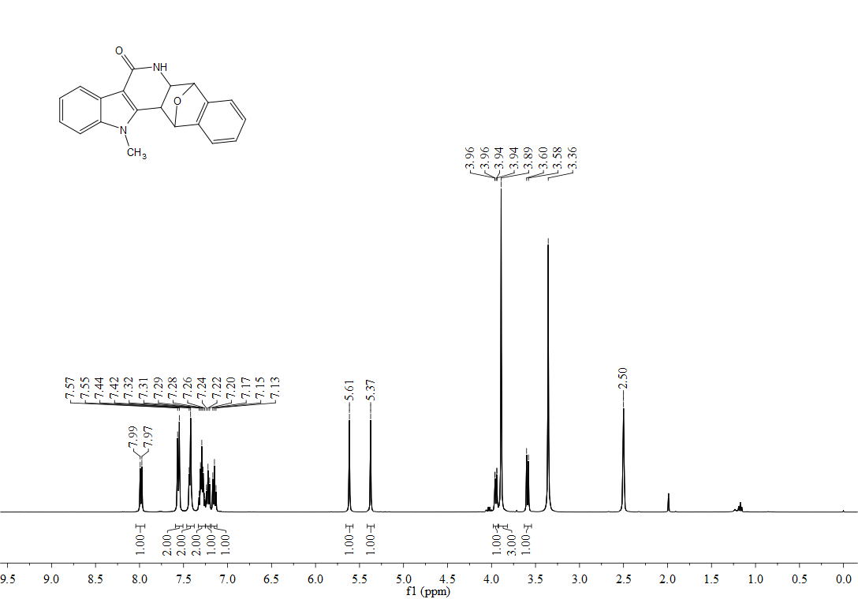
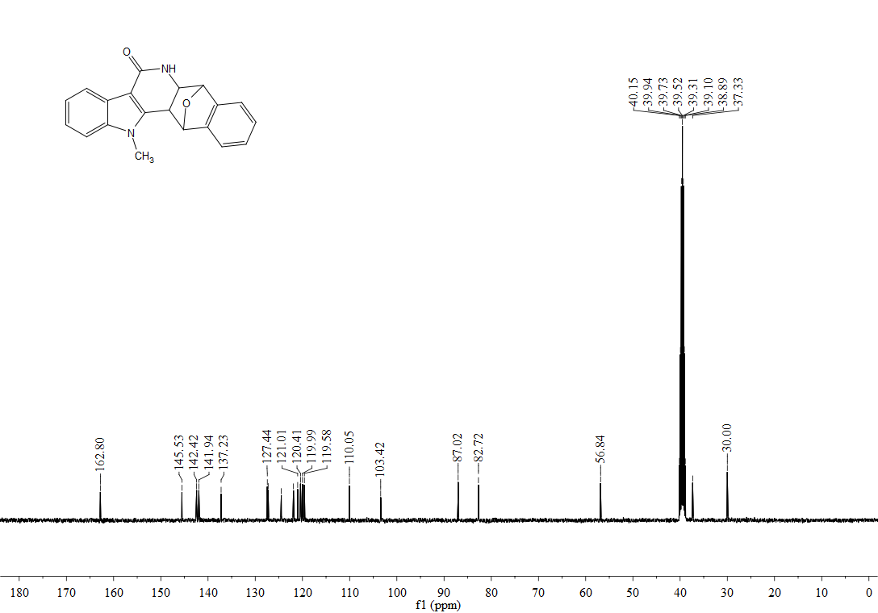
¹H, ¹³C-NMR spectra of 3ba
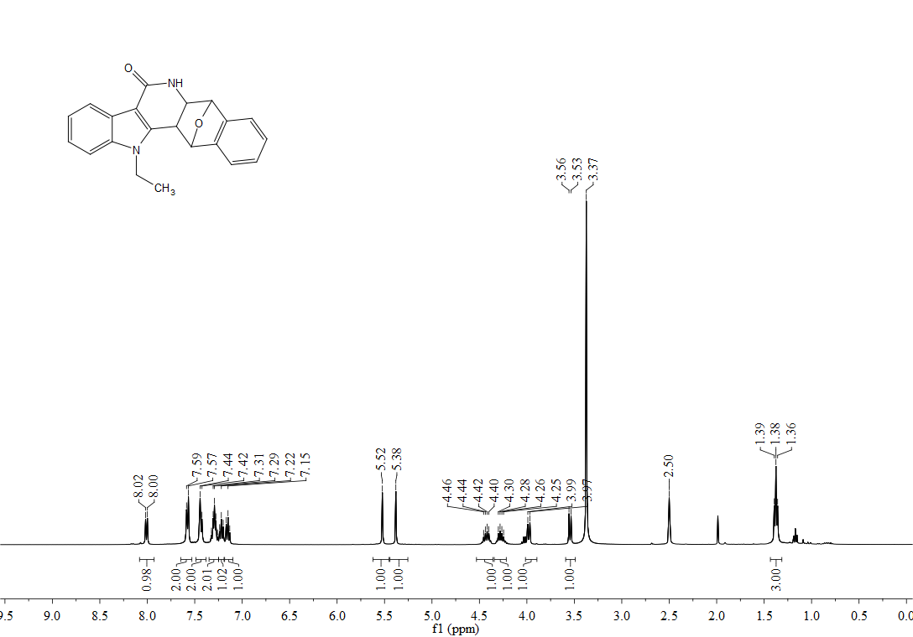

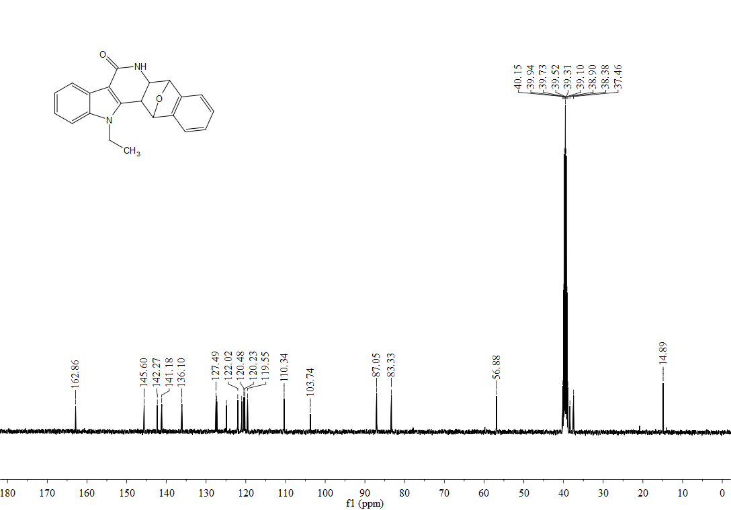
¹H, ¹³C-NMR spectra of 3ca
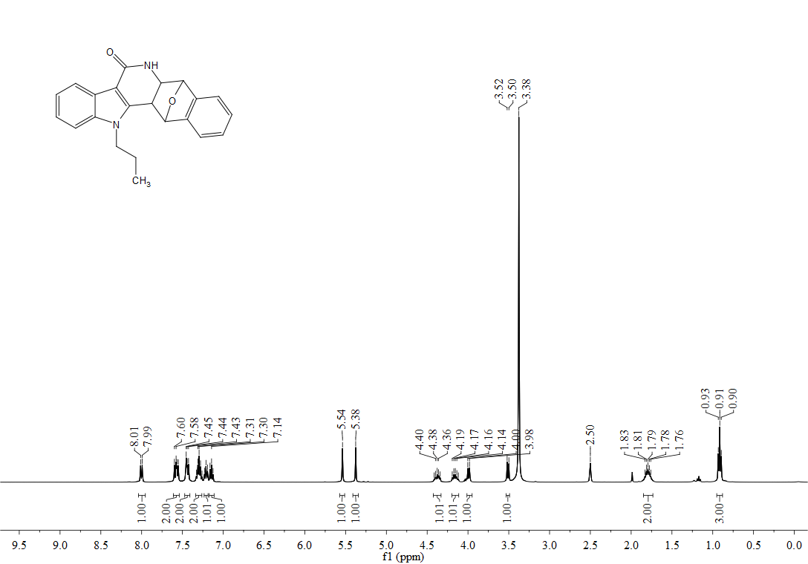
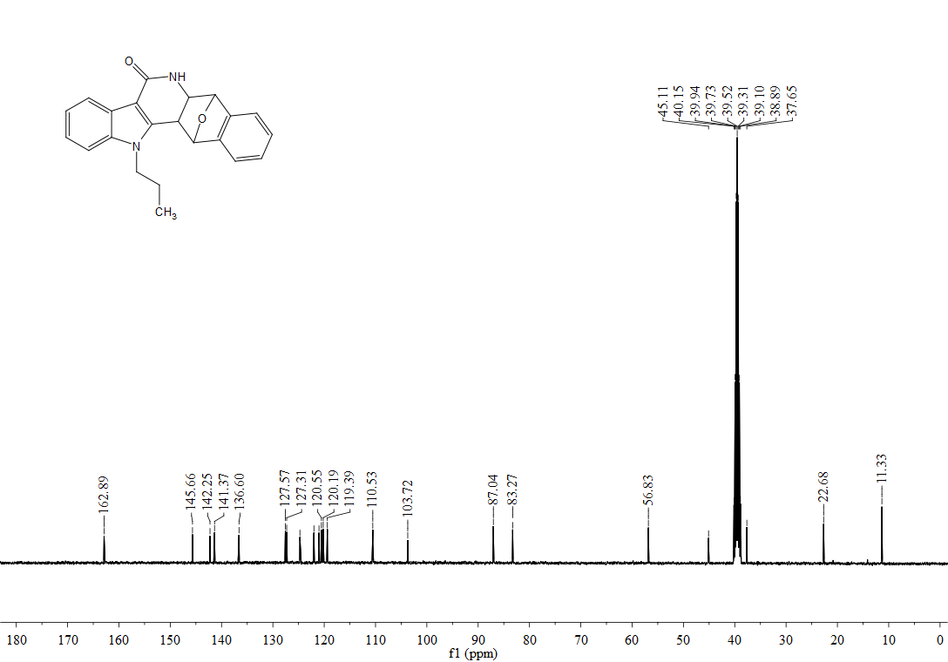

¹H, ¹³C-NMR spectra of 3da
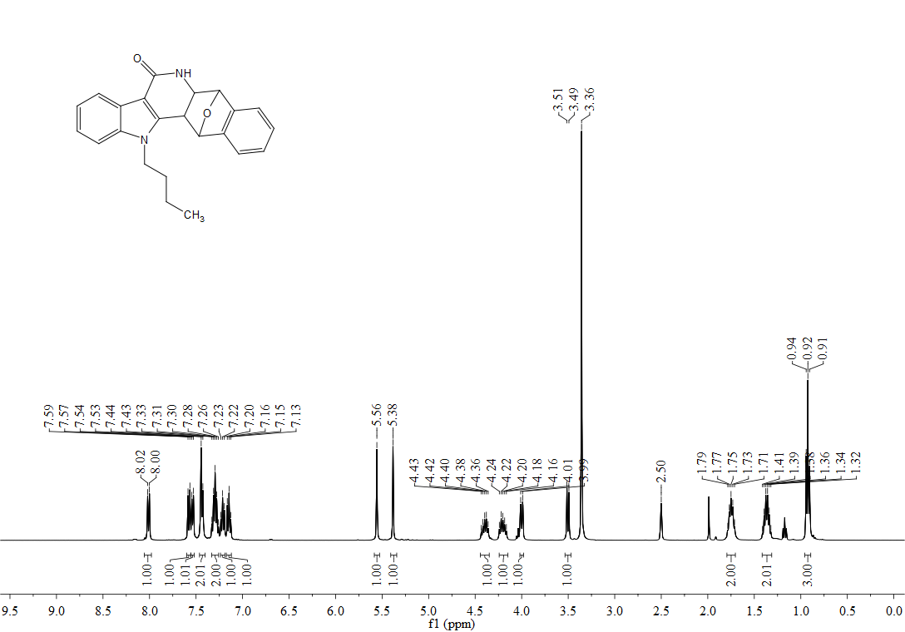
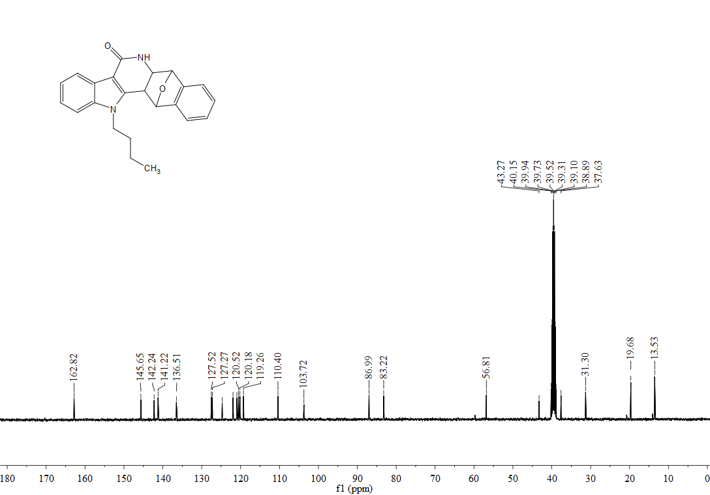

¹H, ¹³C-NMR spectra of 3ea
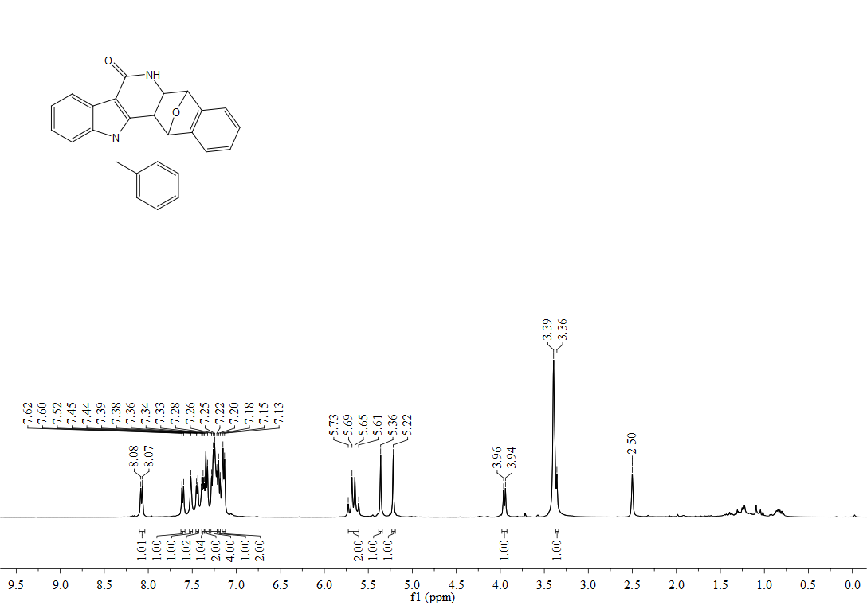
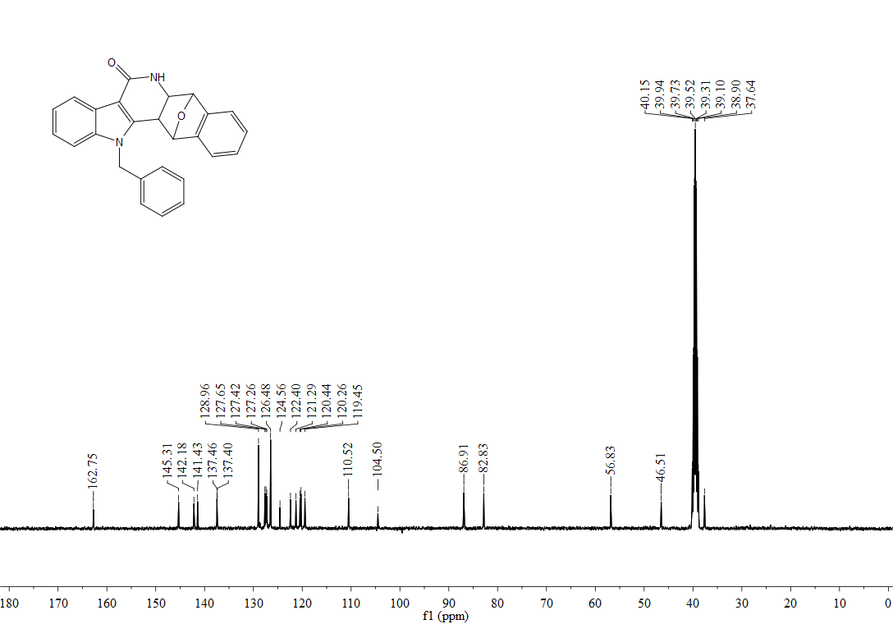

¹H, ¹³C-NMR spectra of 3fa
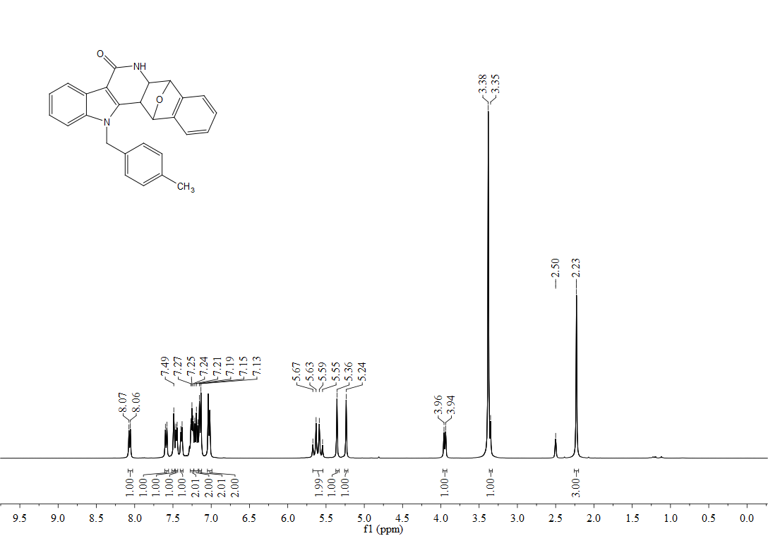
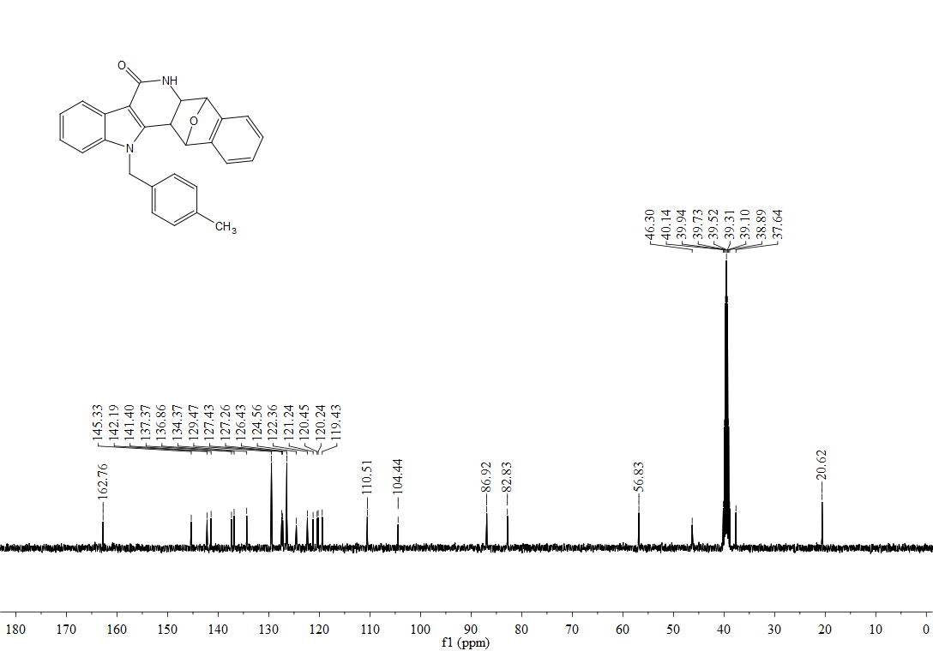

¹H, ¹³C-NMR spectra of 3ga
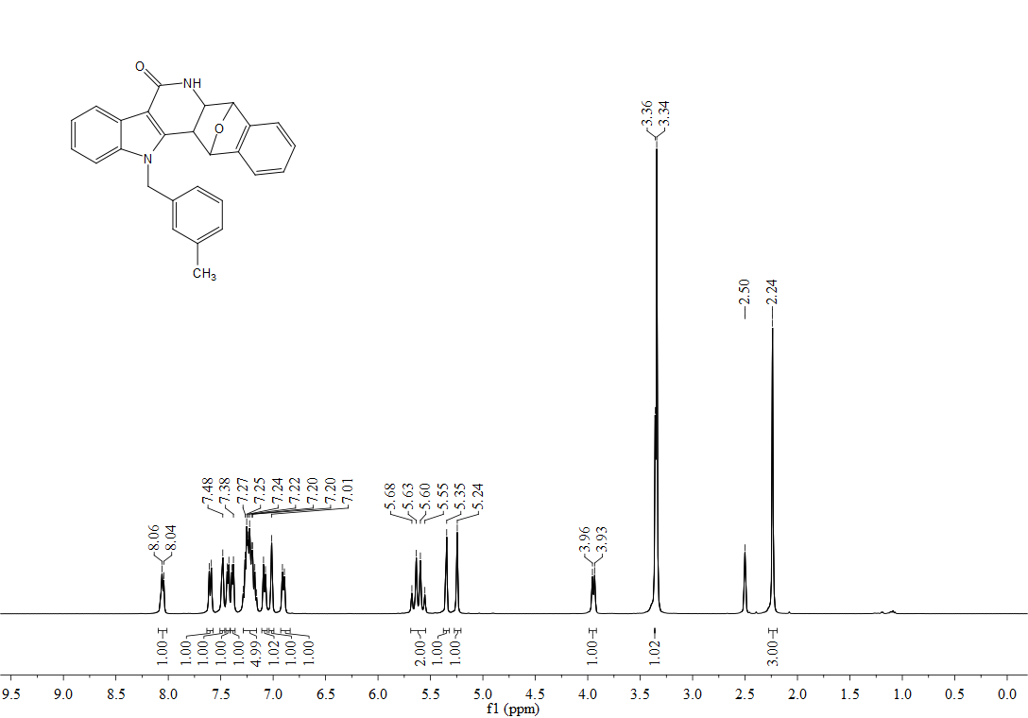
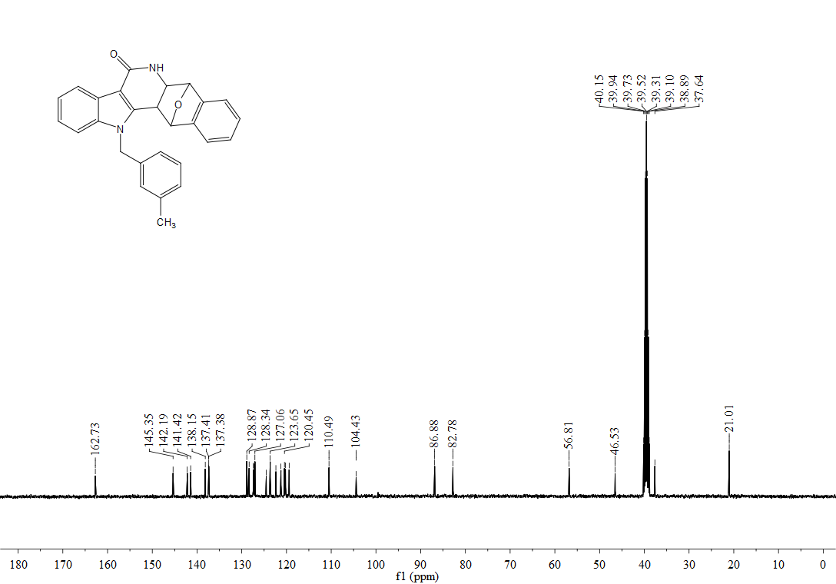

¹H, ¹³C-NMR spectra of 3ha

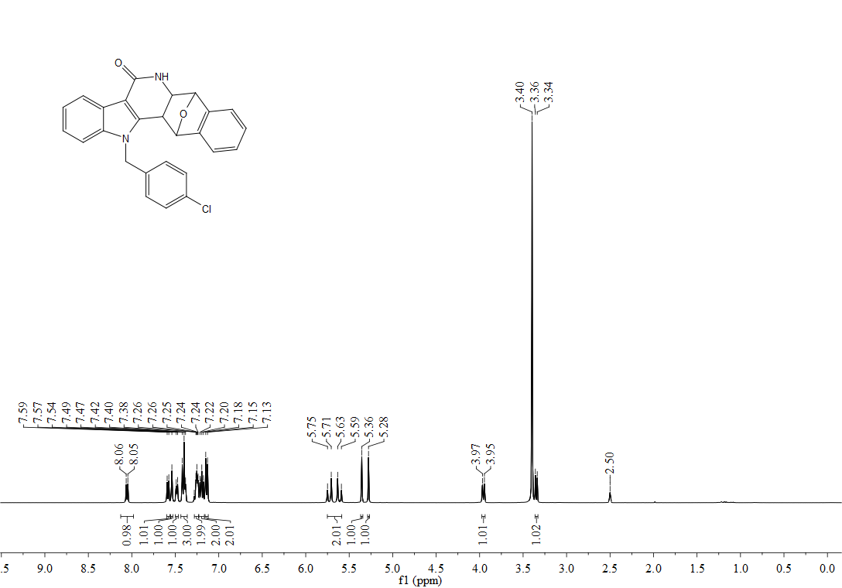
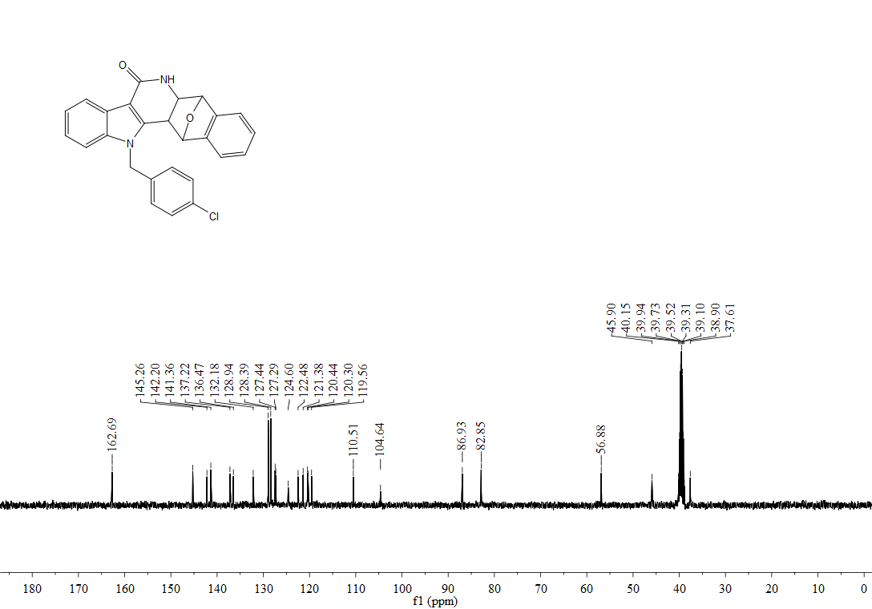
¹H, ¹³C-NMR spectra of 3ia
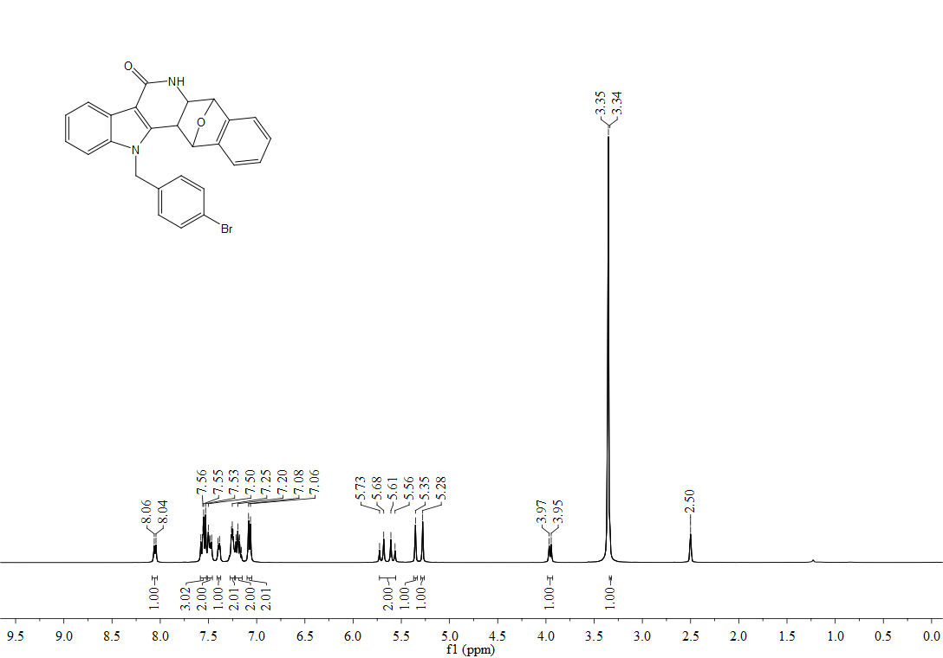
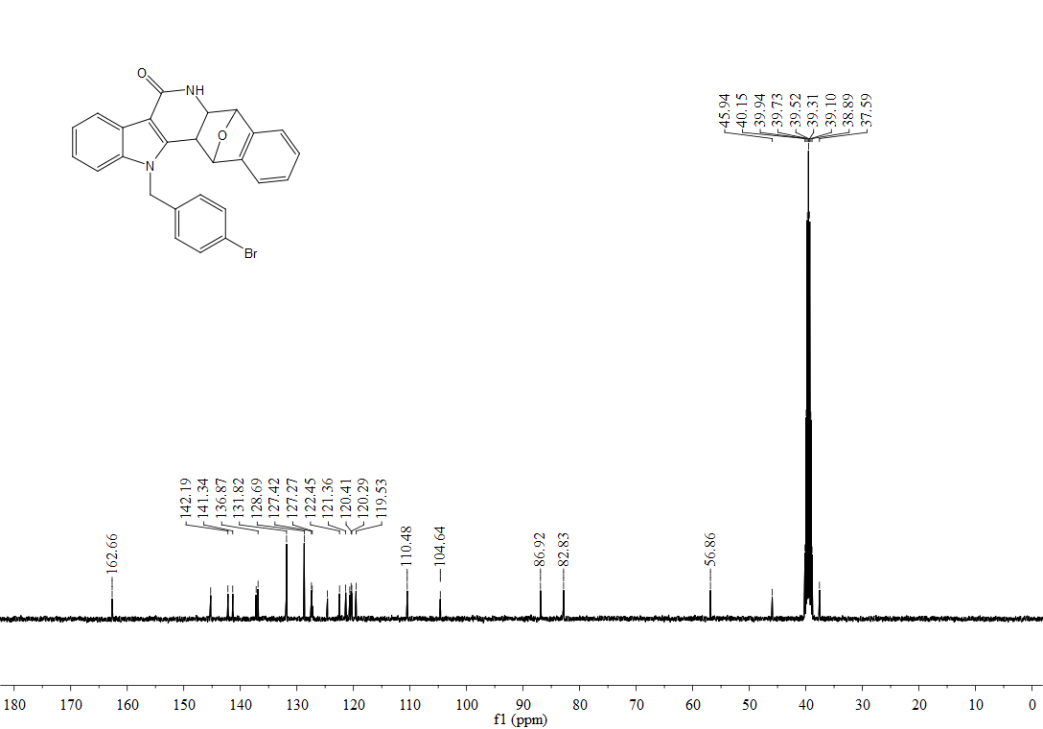

¹H, ¹³C-NMR spectra of 3ja

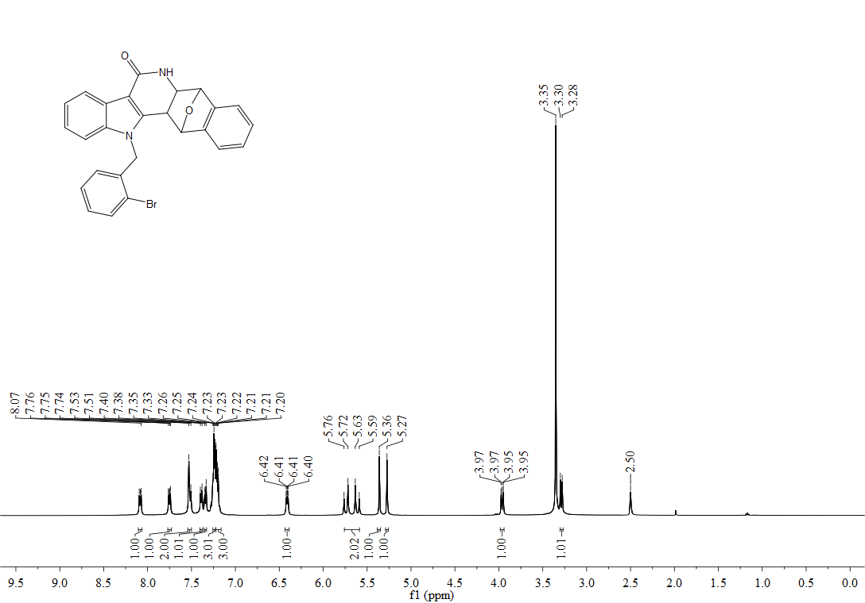
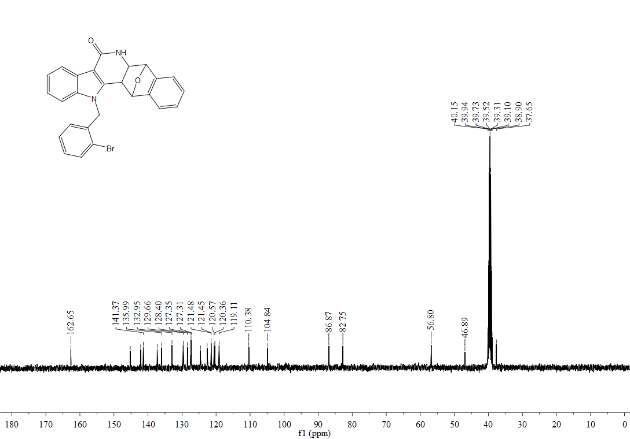
¹H, ¹³C-NMR spectra of 3ka
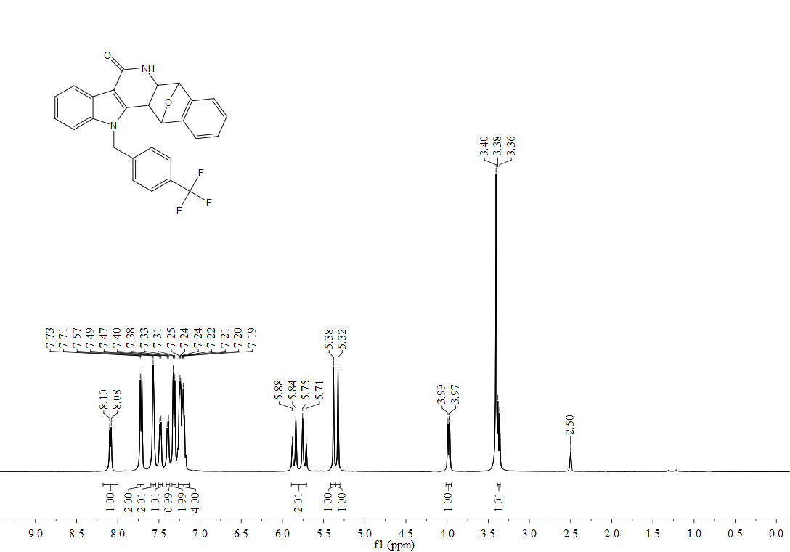
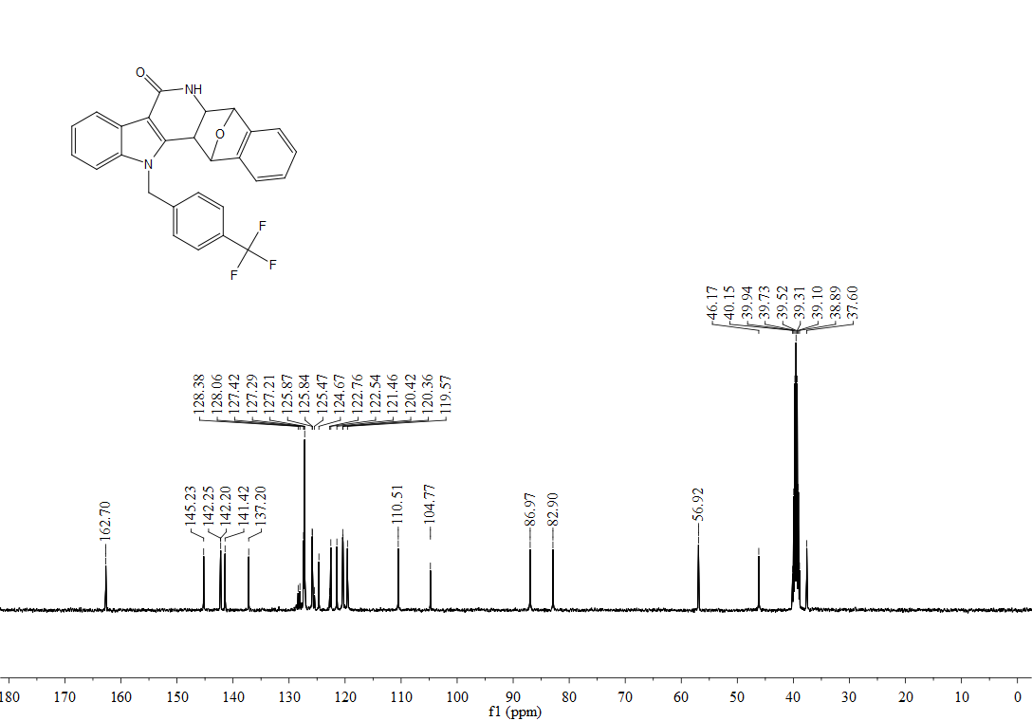

¹H, ¹³C-NMR spectra of 3la
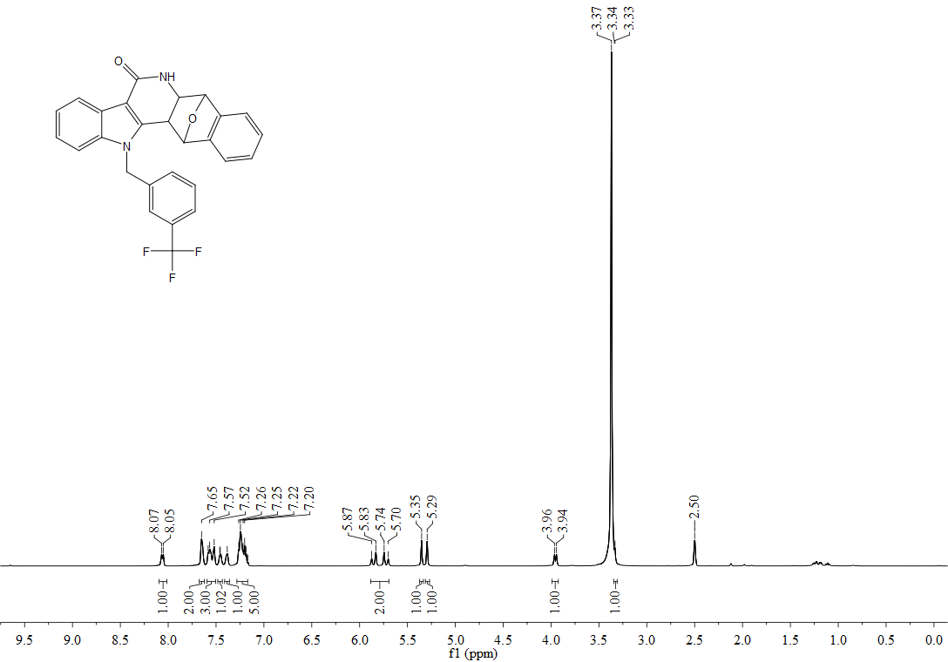
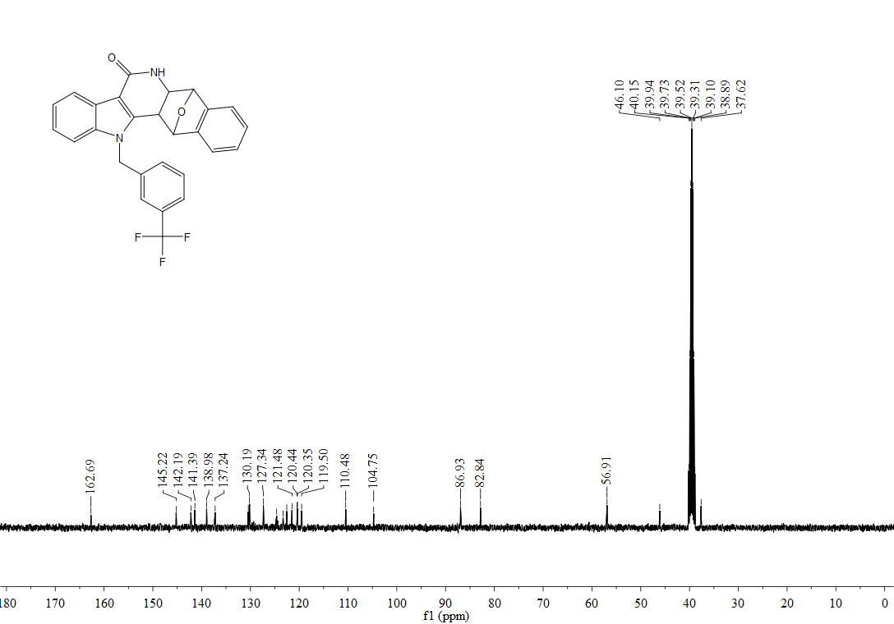

¹H, ¹³C-NMR spectra of 3ma
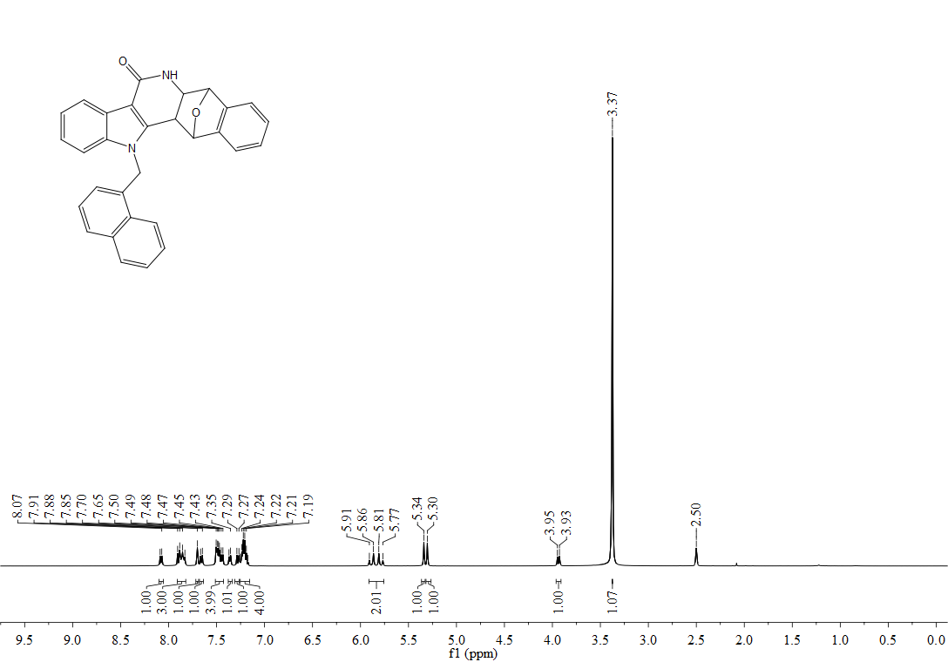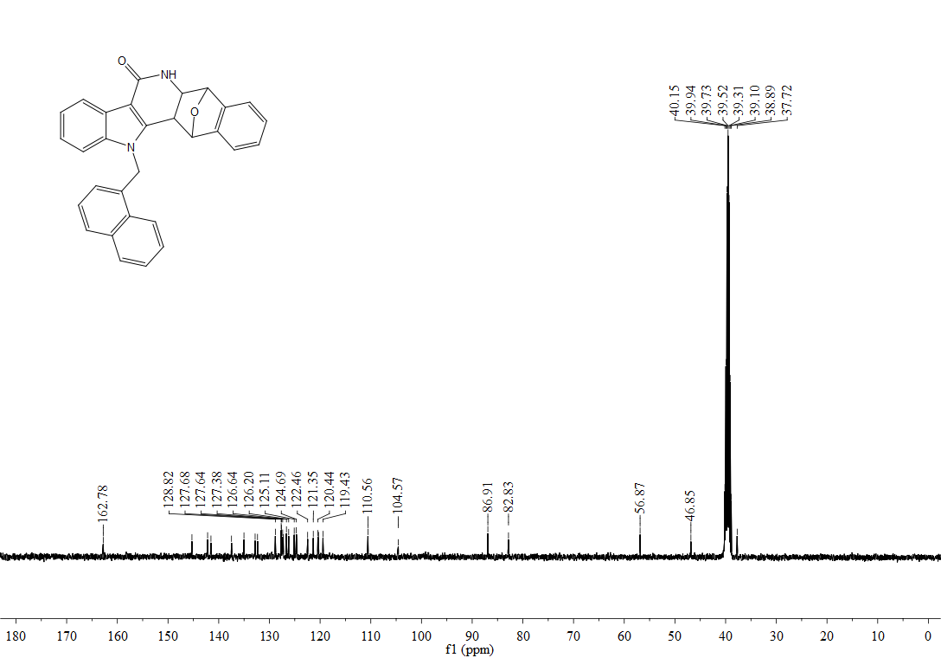

¹H, ¹³C-NMR spectra of 3na
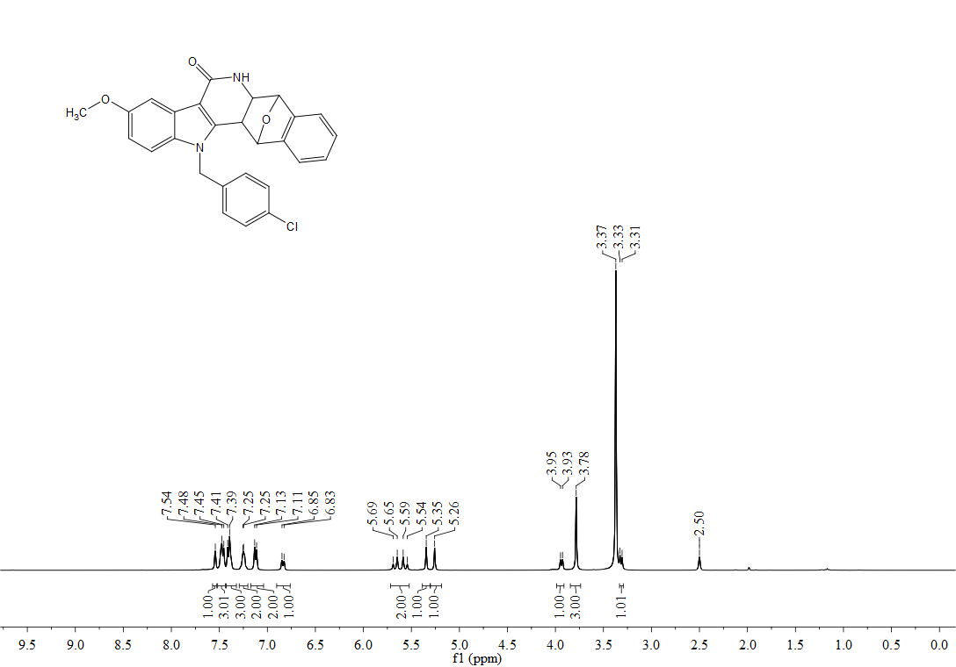
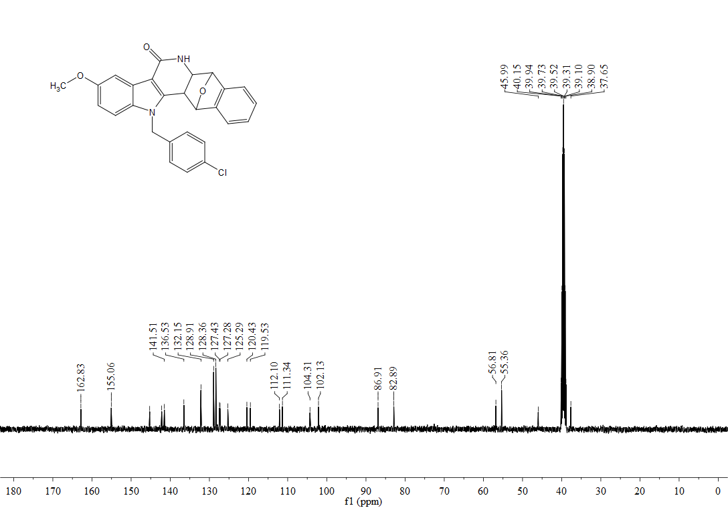

¹H, ¹³C-NMR spectra of 3oa

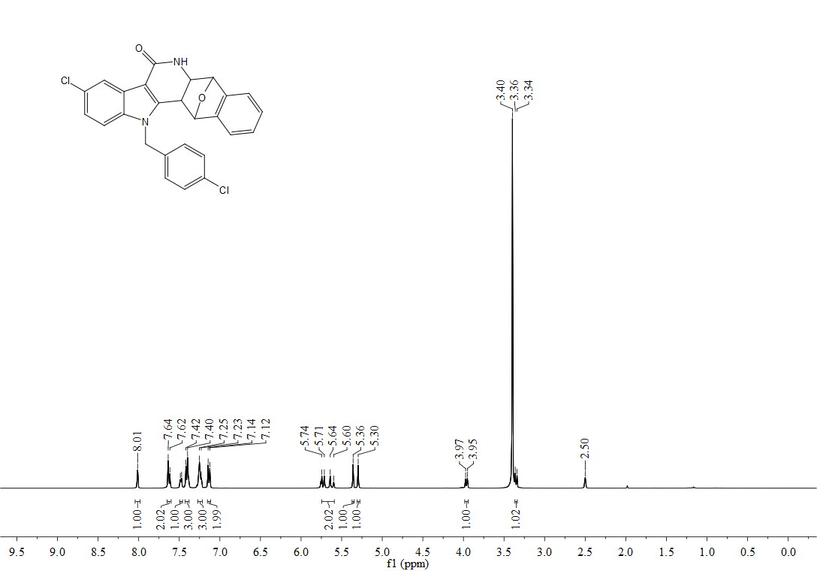
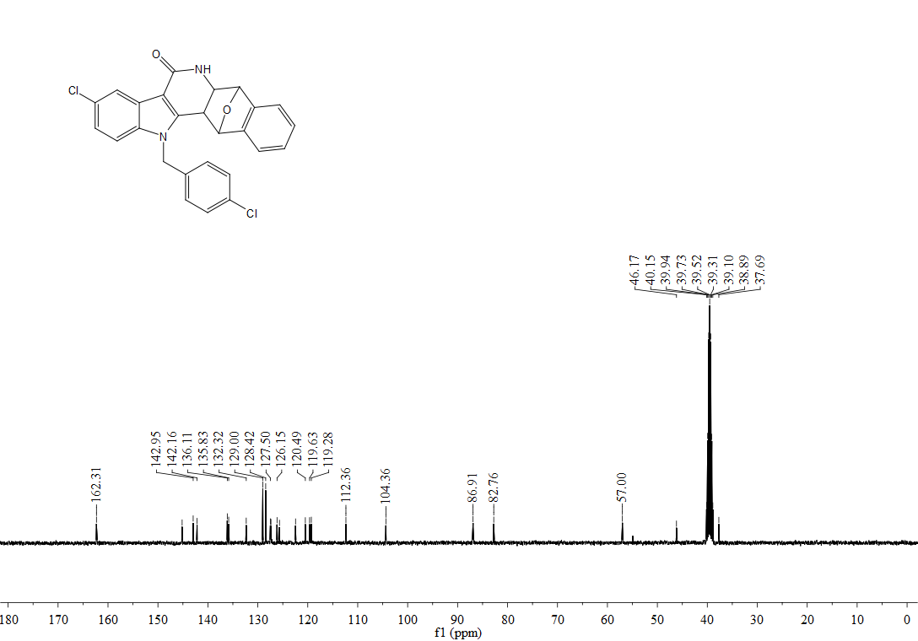
¹H, ¹³C-NMR spectra of 3pa
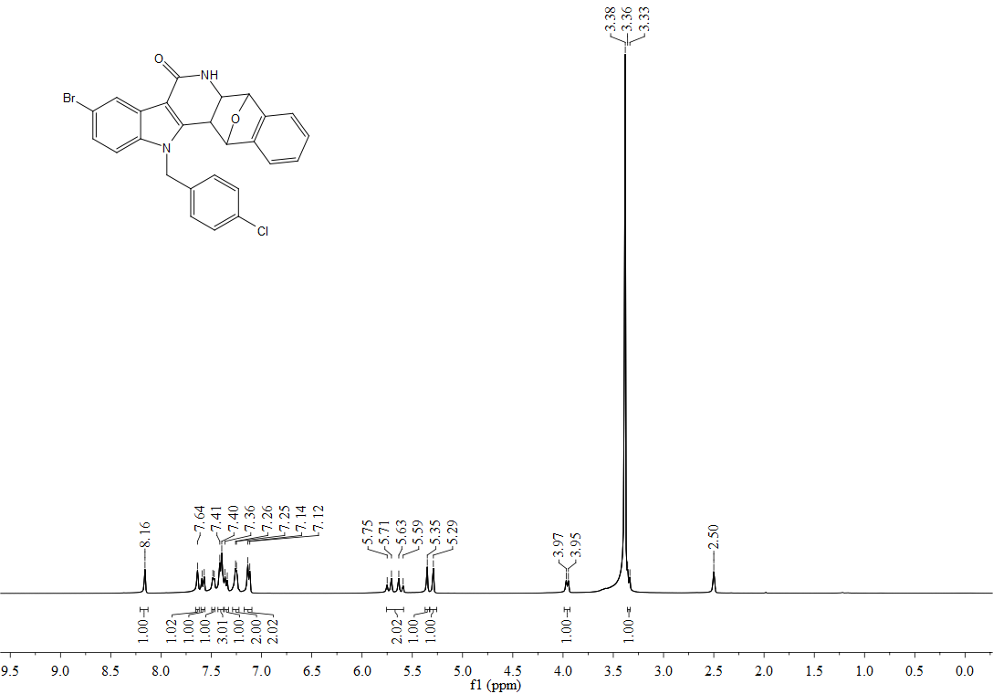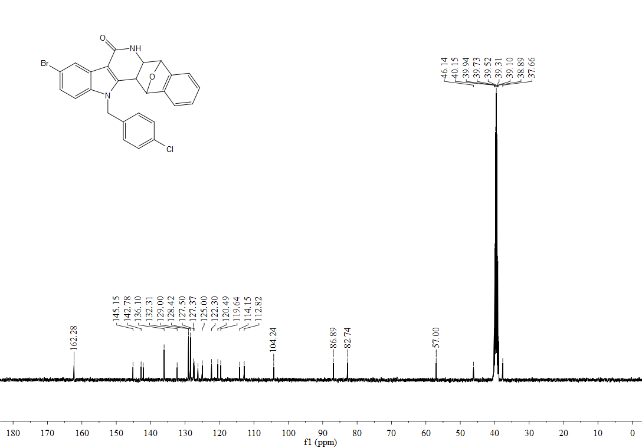

¹H, ¹³C-NMR spectra of 3qa
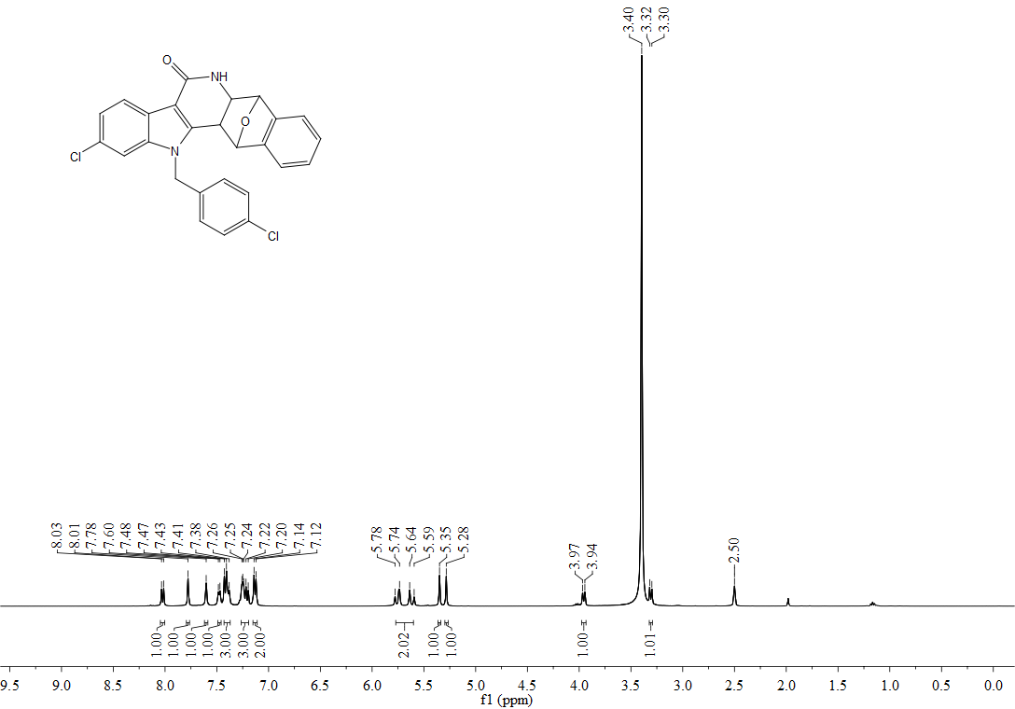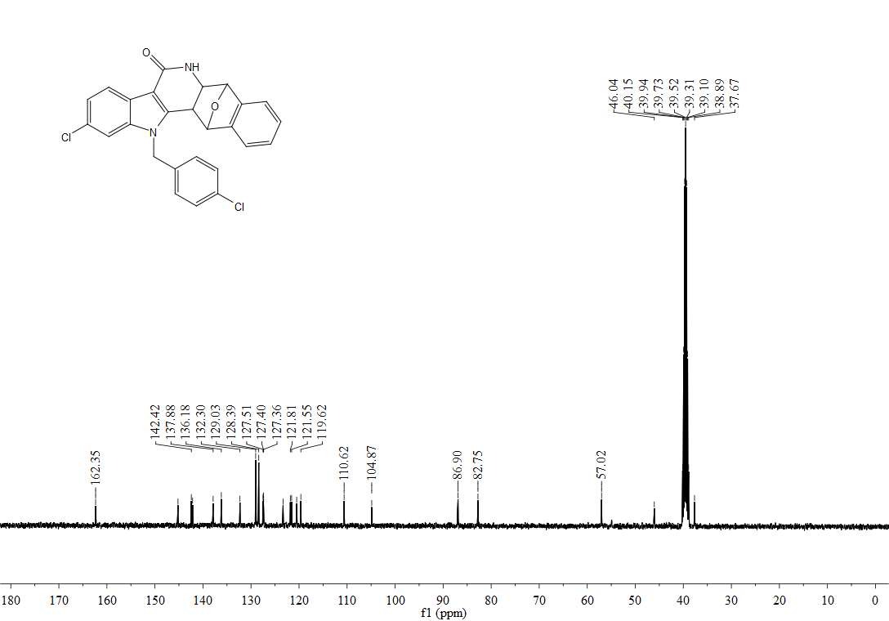

¹H, ¹³C-NMR spectra of 3eb
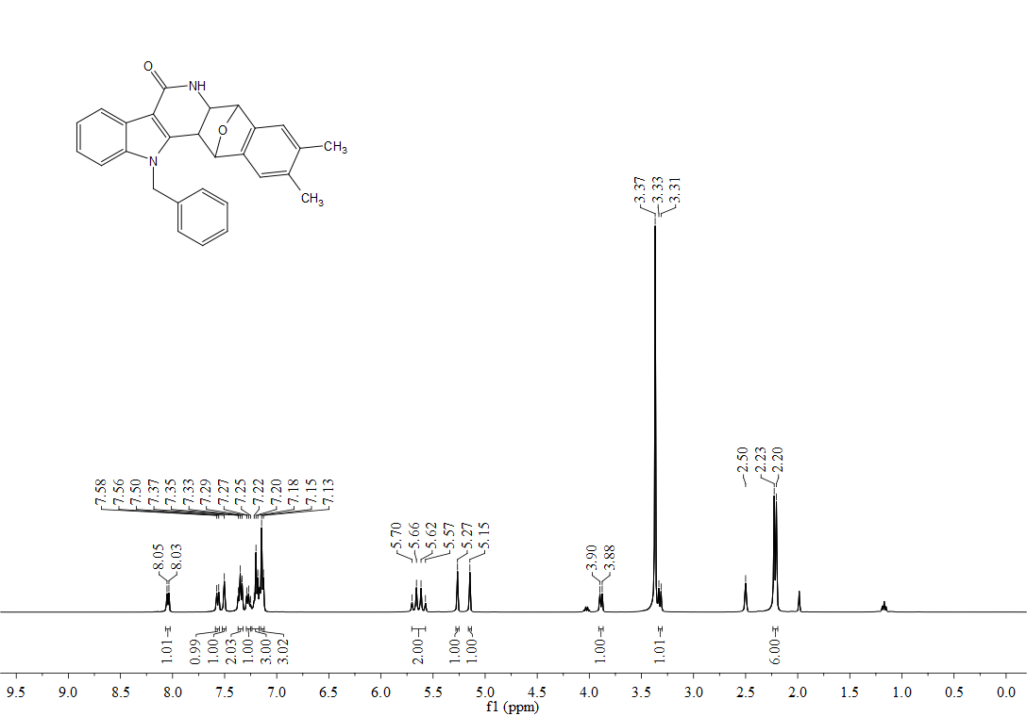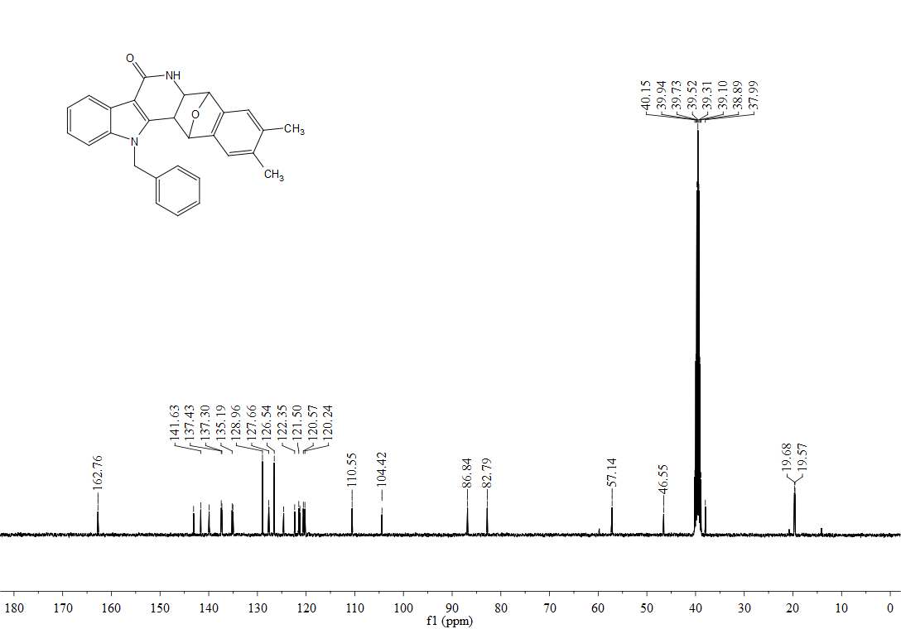

¹H, ¹³C-NMR spectra of 3ec
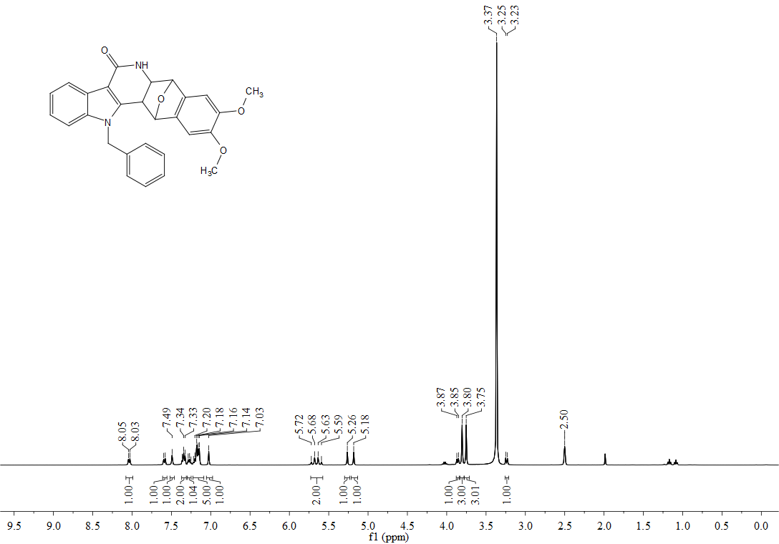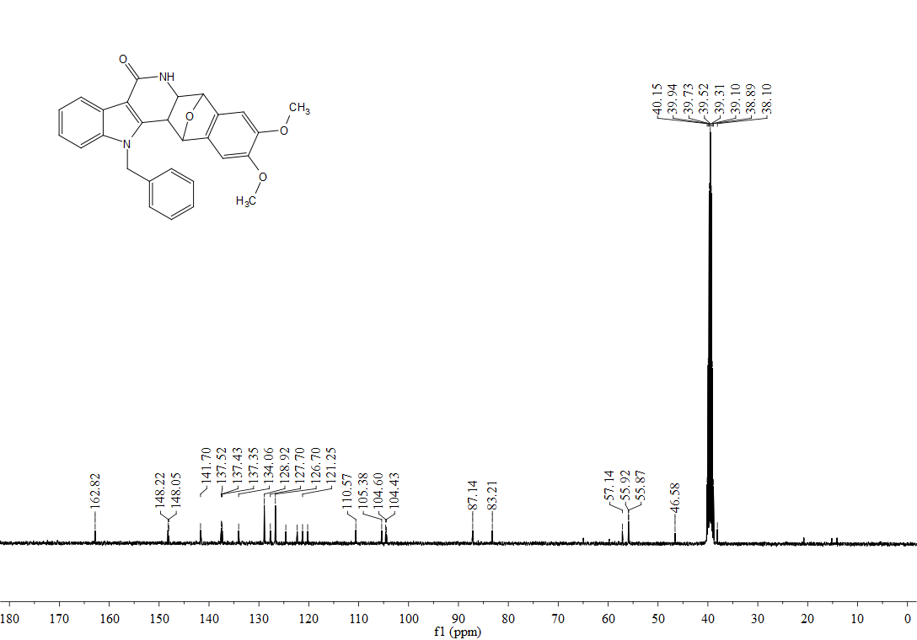

¹H, ¹³C-NMR spectra of 3ed
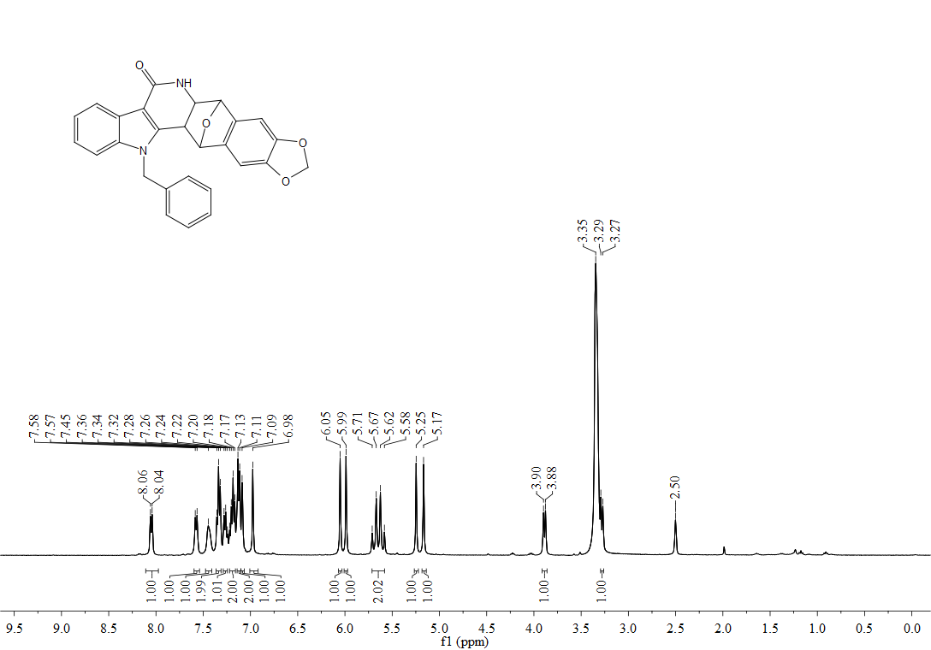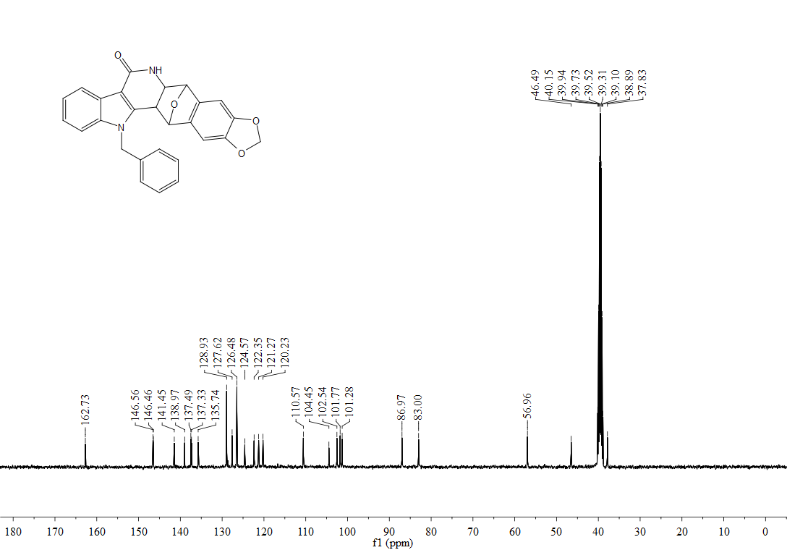

¹H, ¹³C-NMR spectra of 3ee
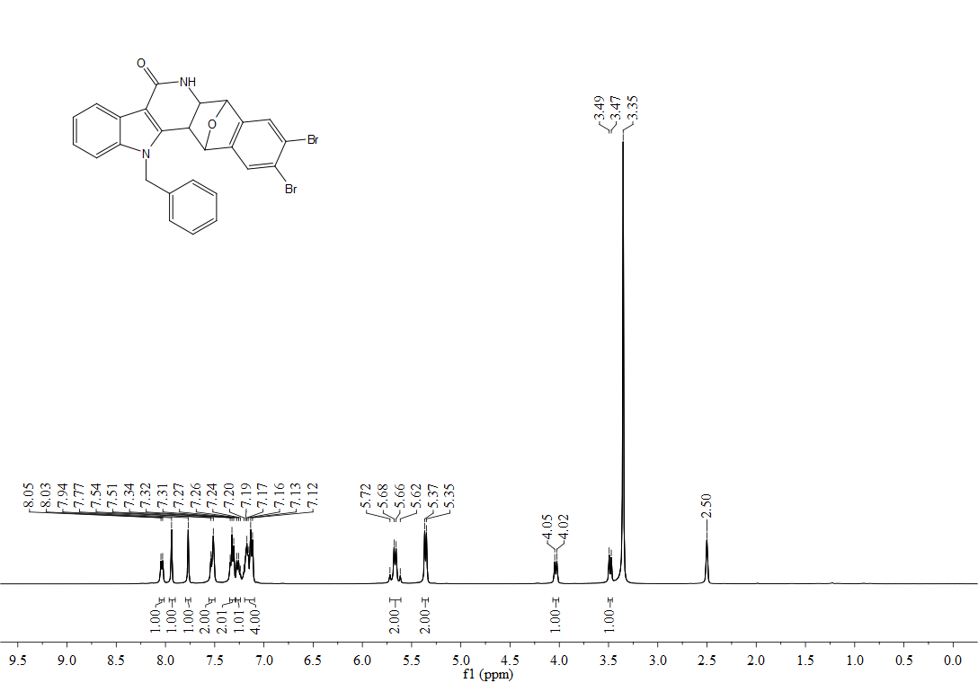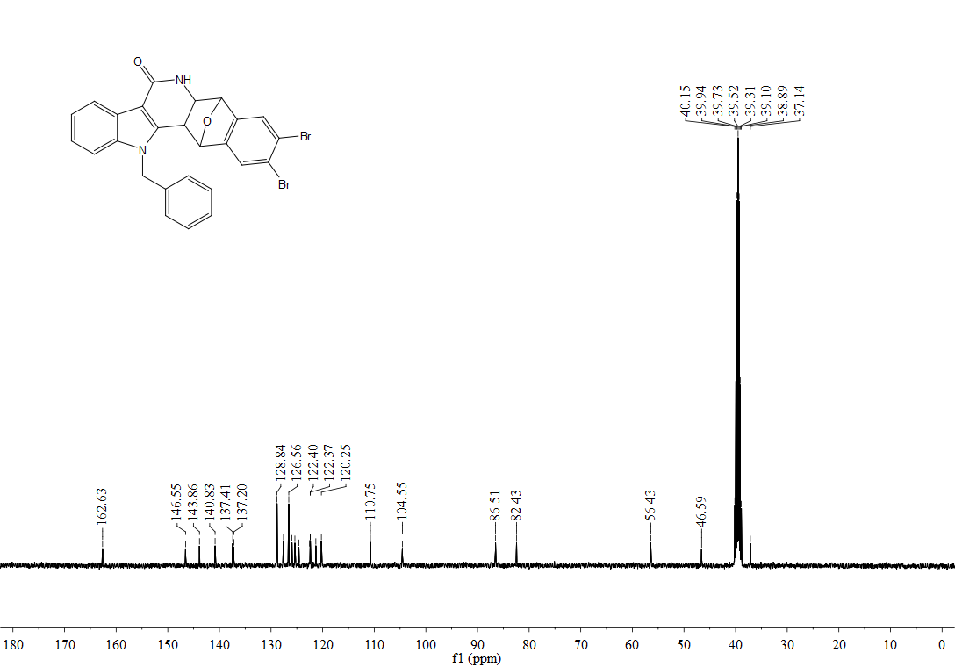

¹H, ¹³C-NMR spectra of 4a
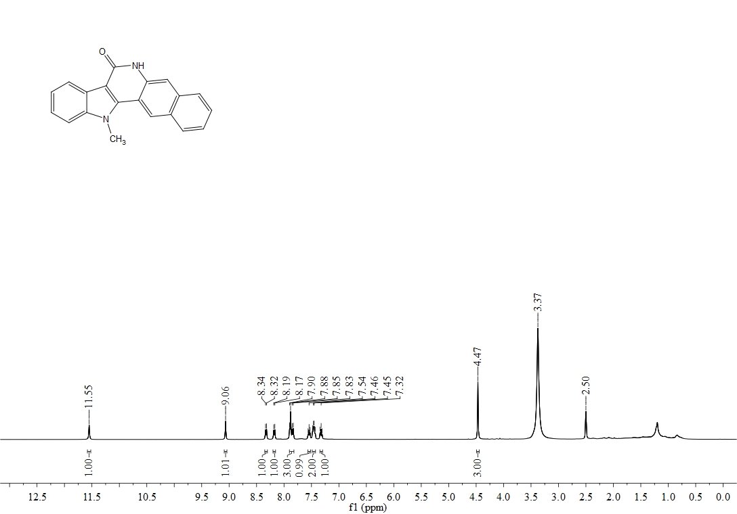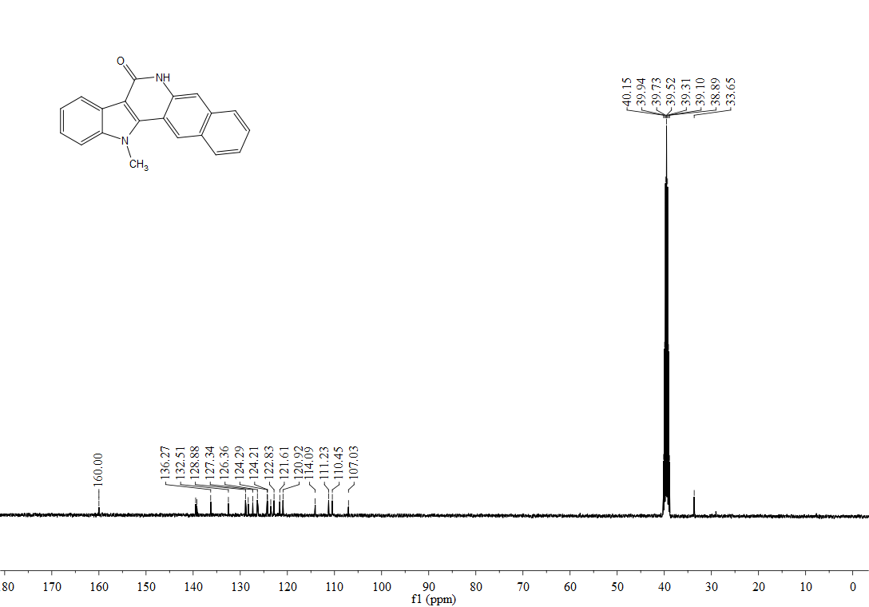

¹H, ¹³C-NMR spectra of 4c
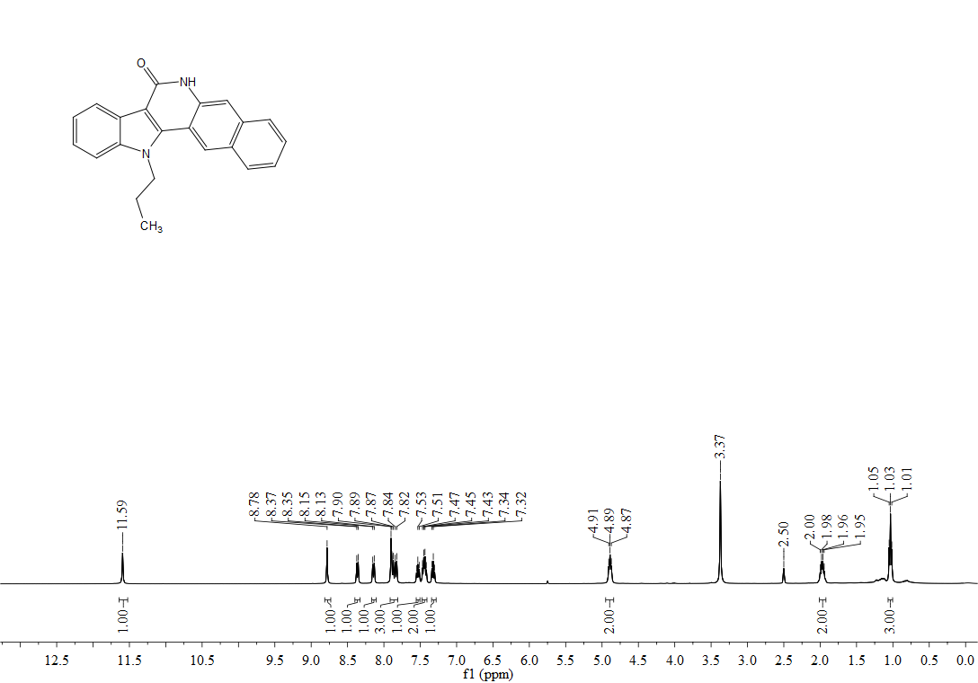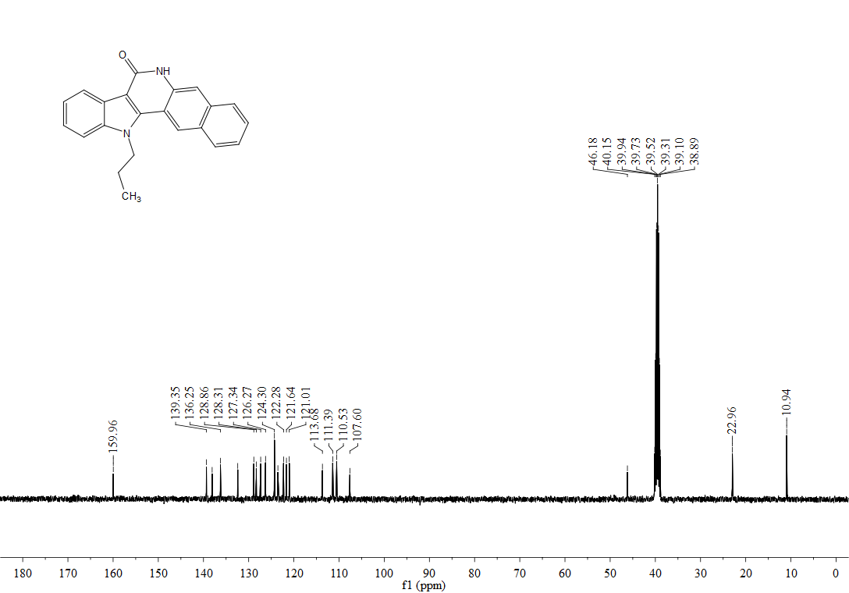

¹H, ¹³C-NMR spectra of 4d
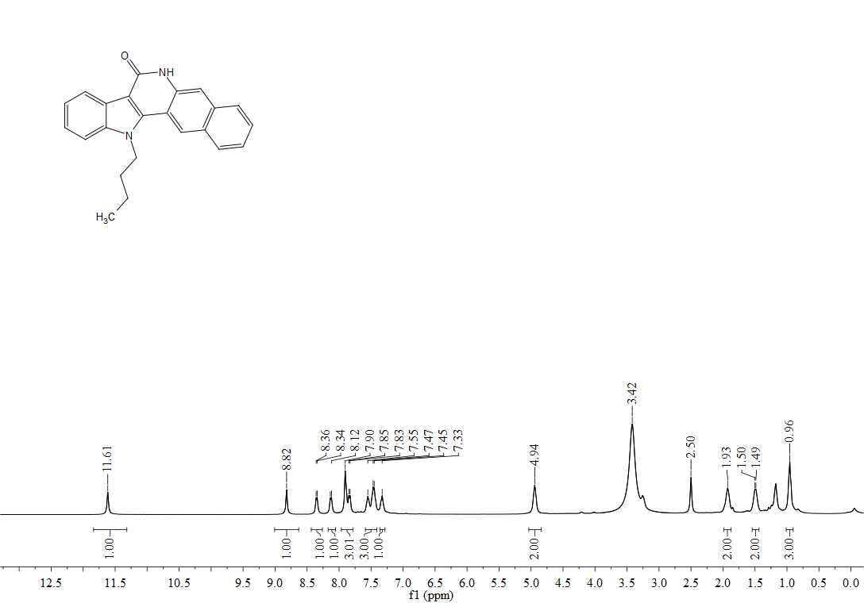
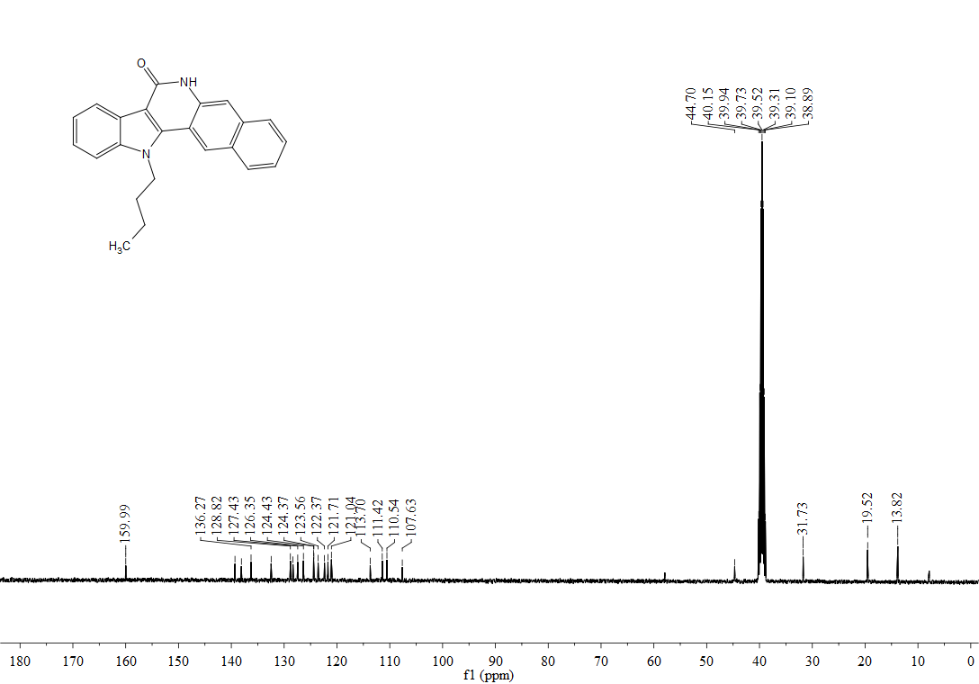

¹H, ¹³C-NMR spectra of 4i

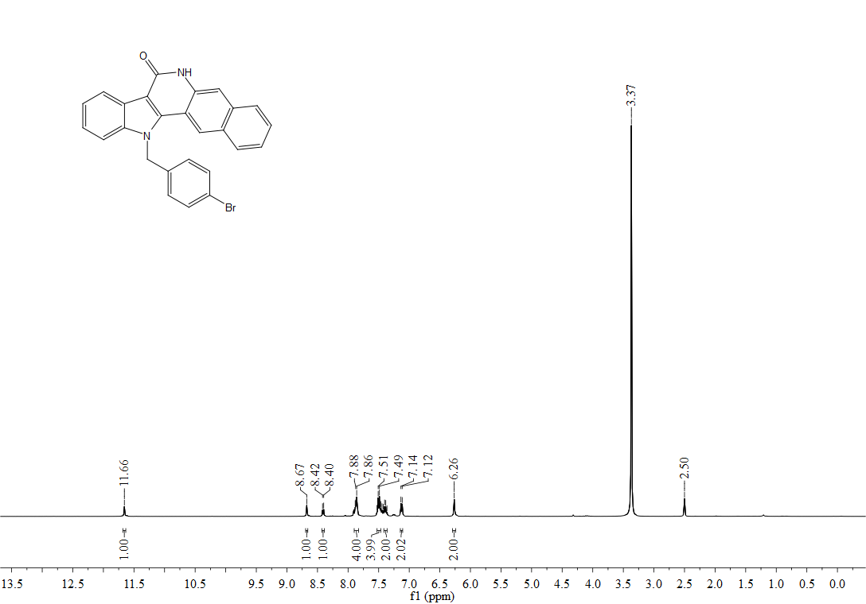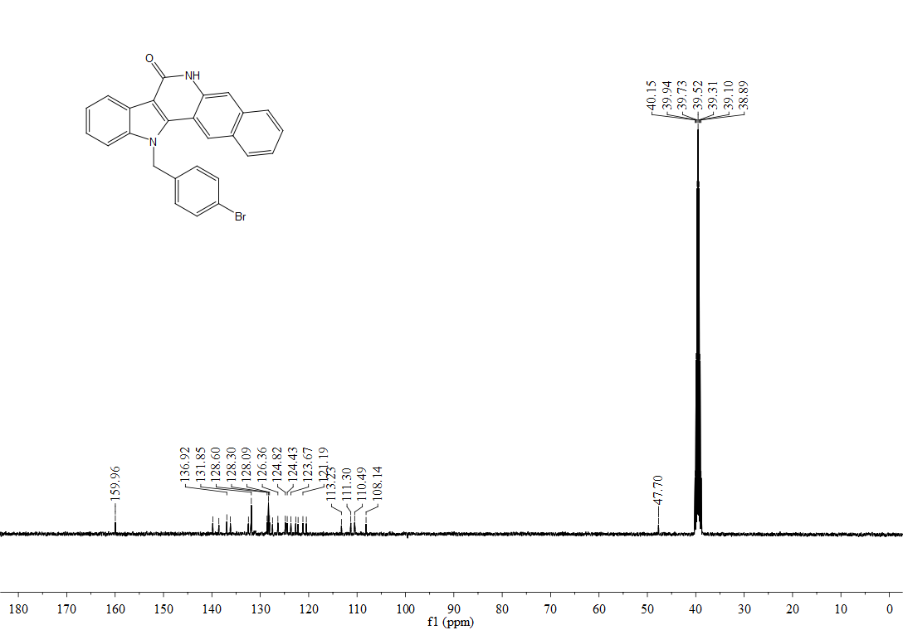
¹H, ¹³C-NMR spectra of 4k
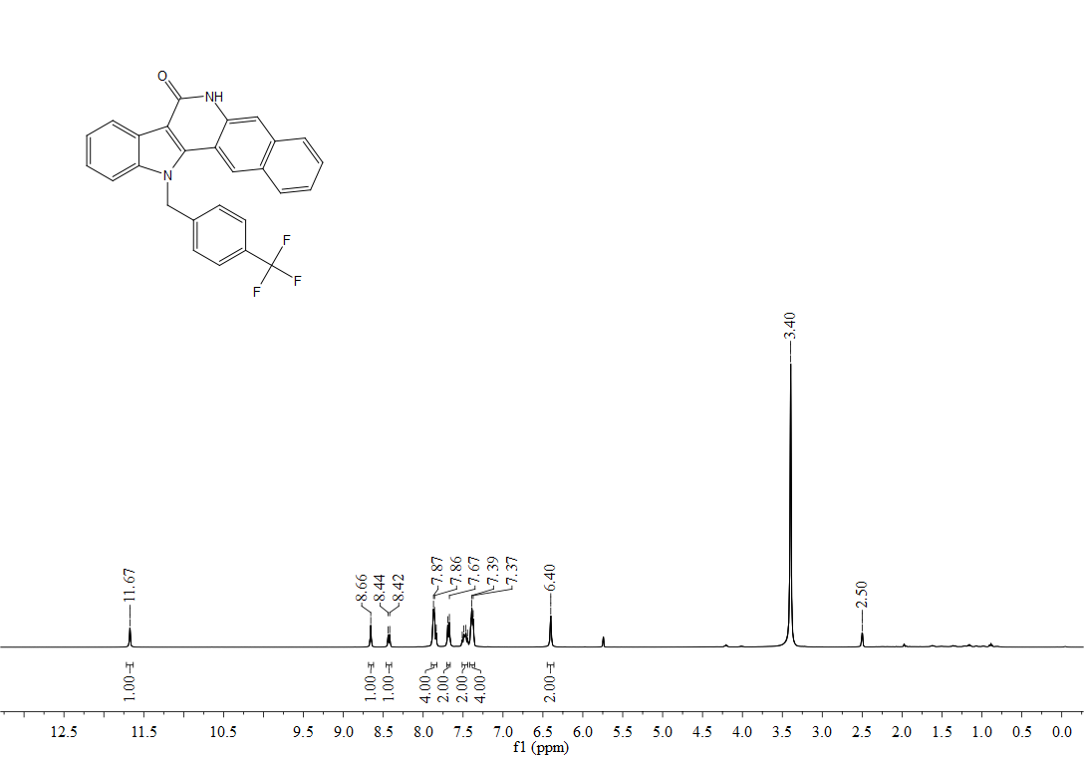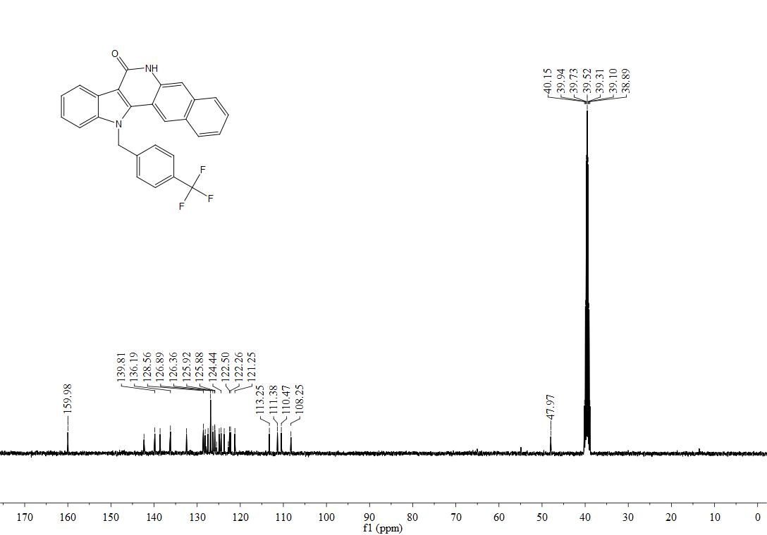

¹H, ¹³C-NMR spectra of 5a
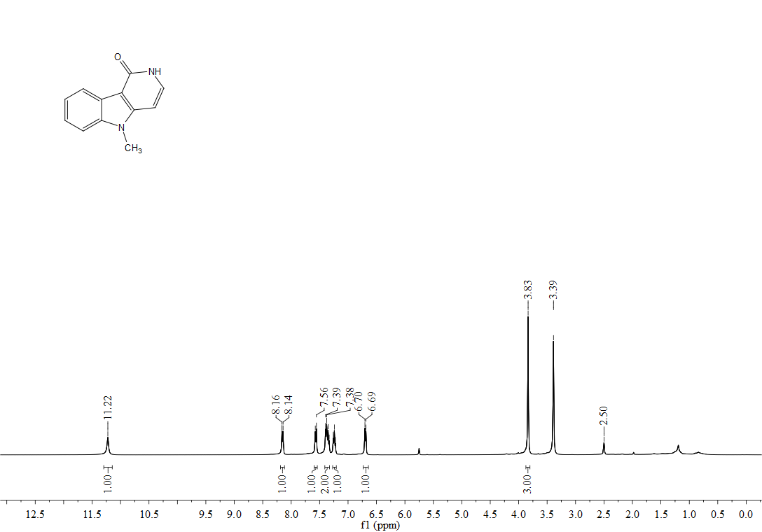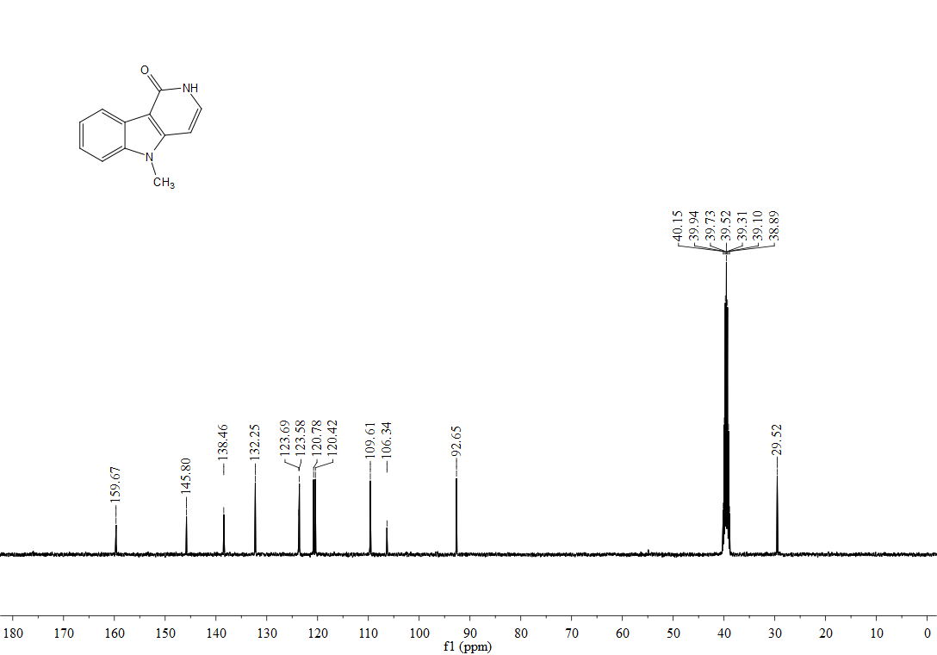

¹H, ¹³C-NMR spectra of 5c
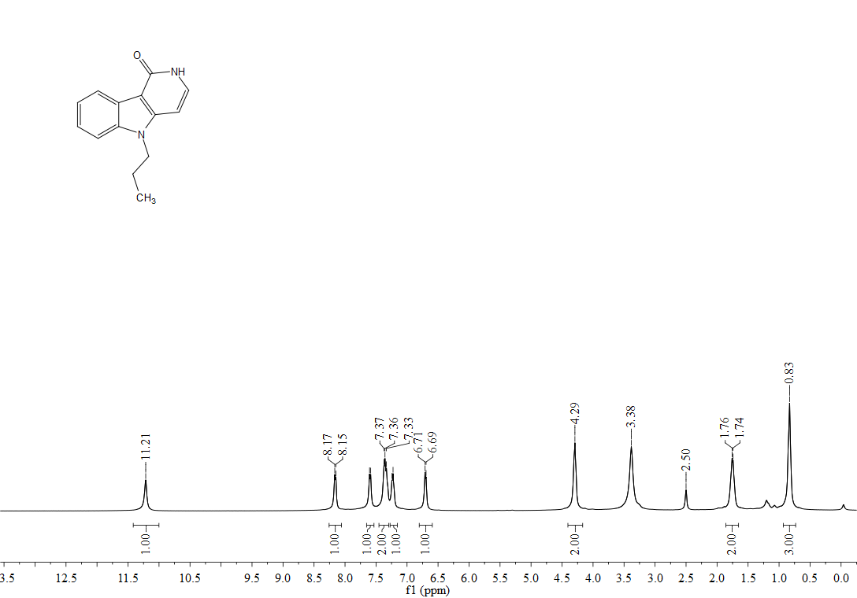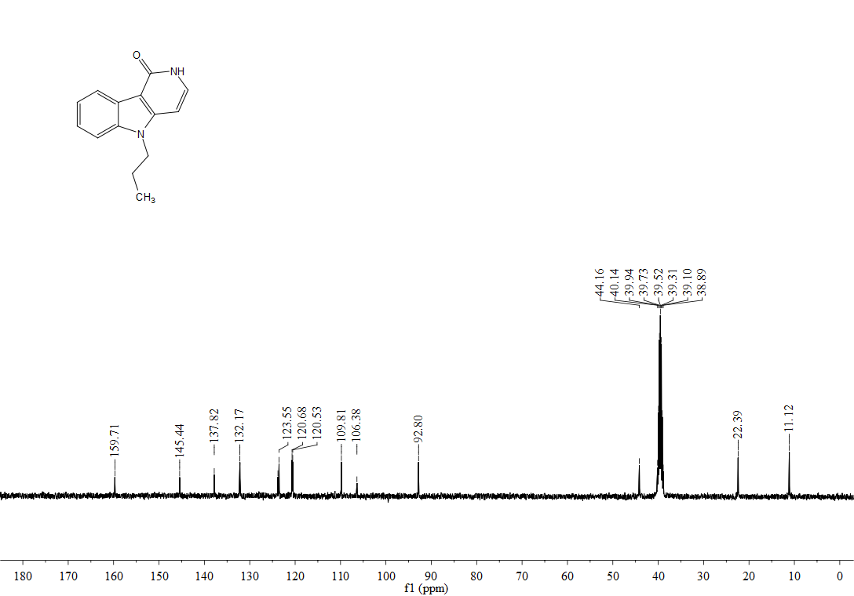

¹H, ¹³C-NMR spectra of 5d
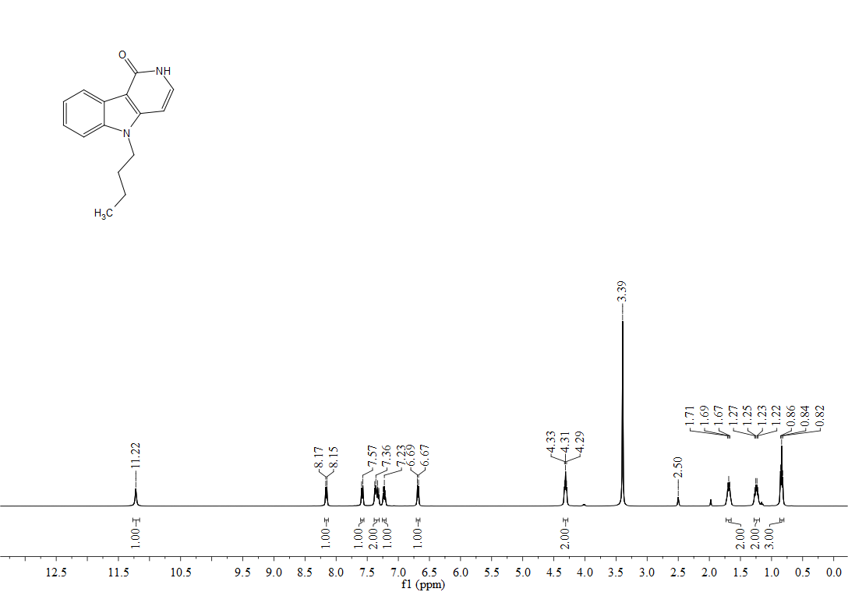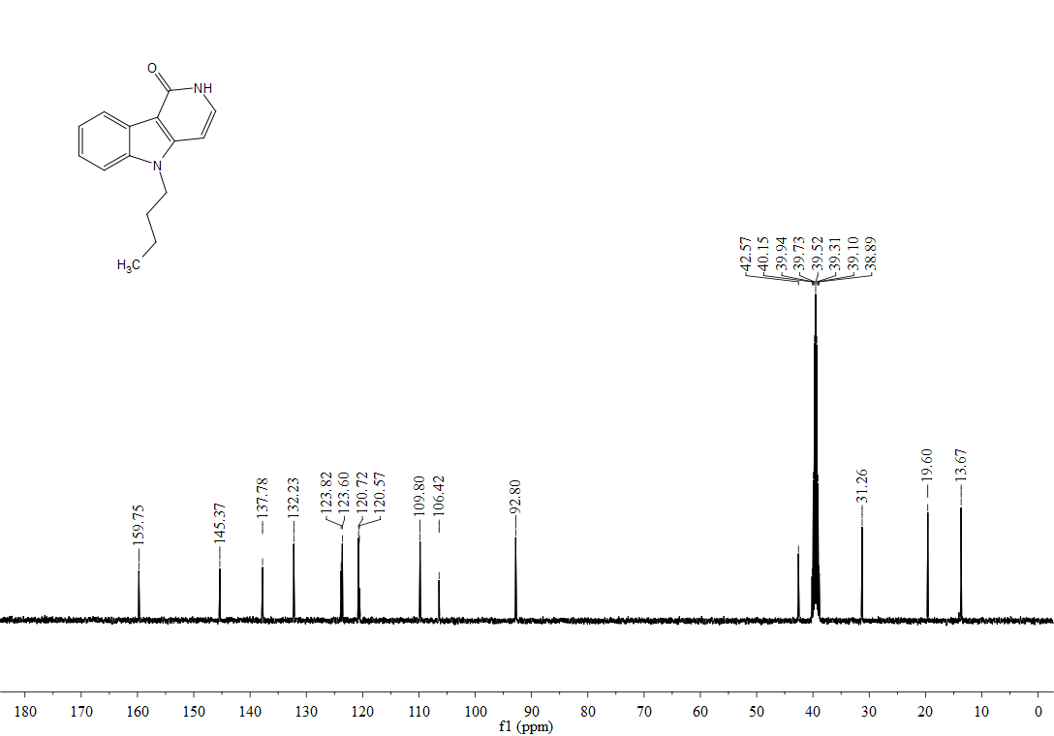

¹H, ¹³C-NMR spectra of 5e
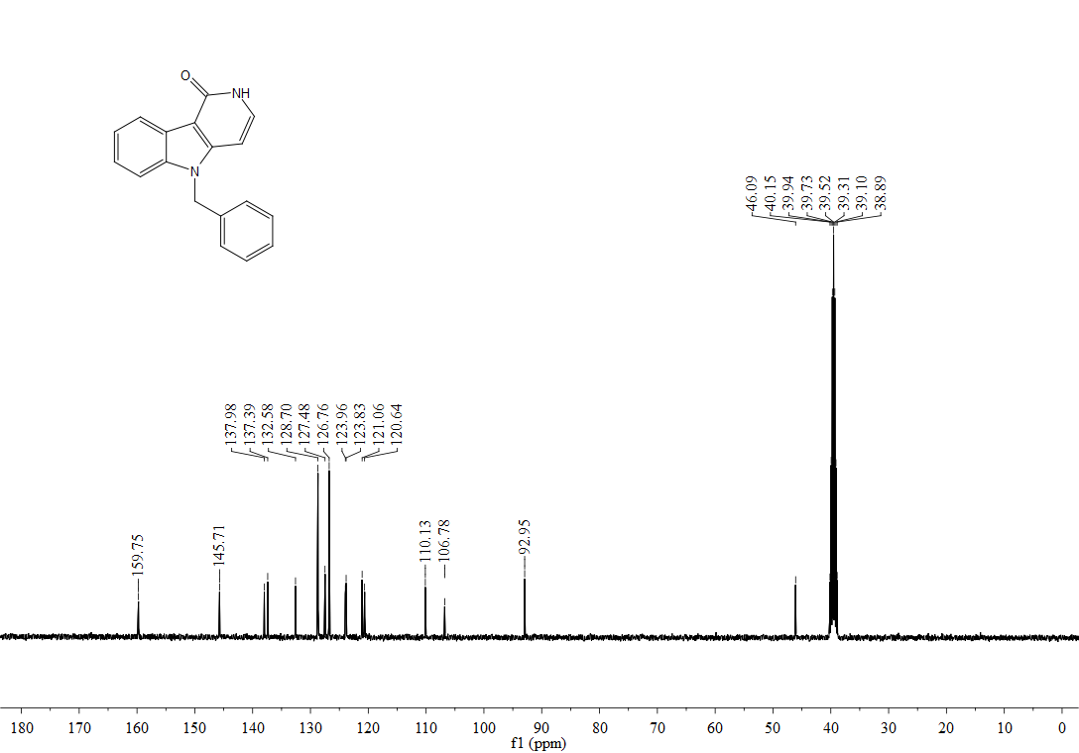
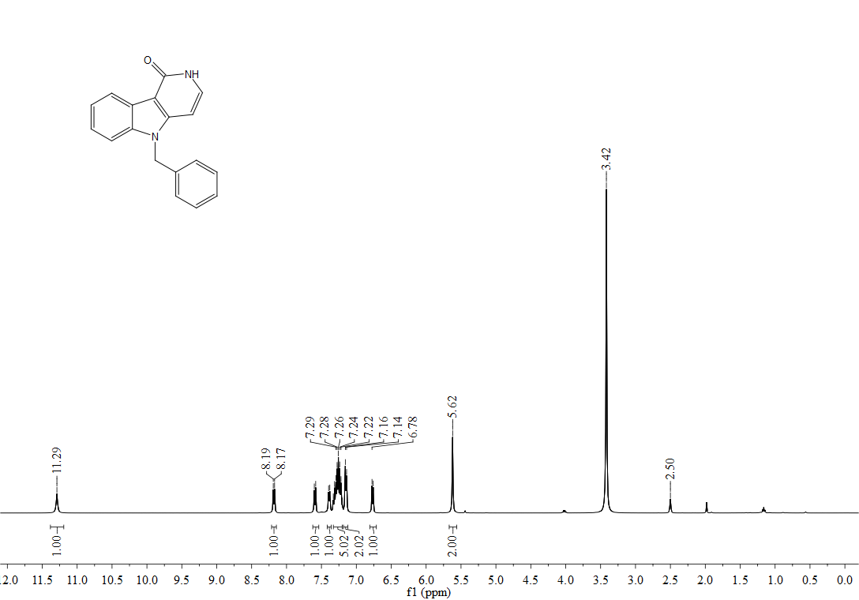

¹H, ¹³C-NMR spectra of 5i
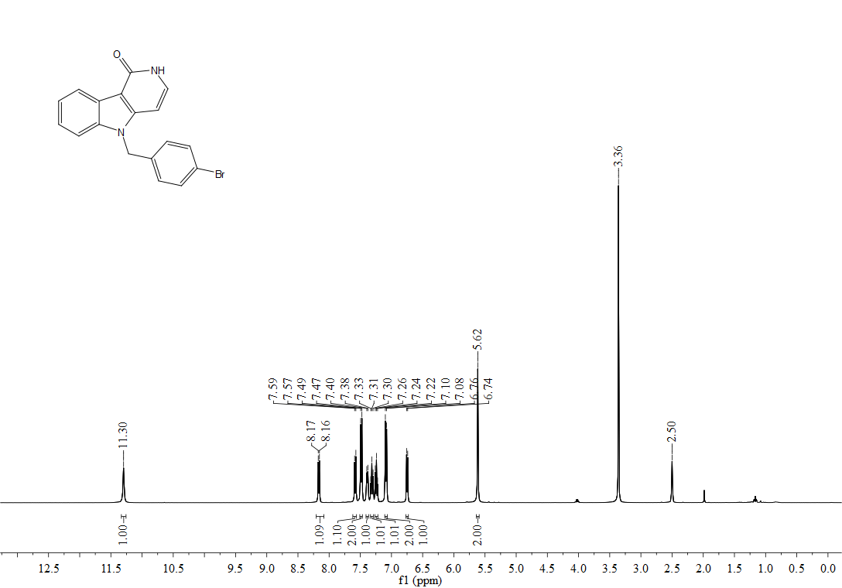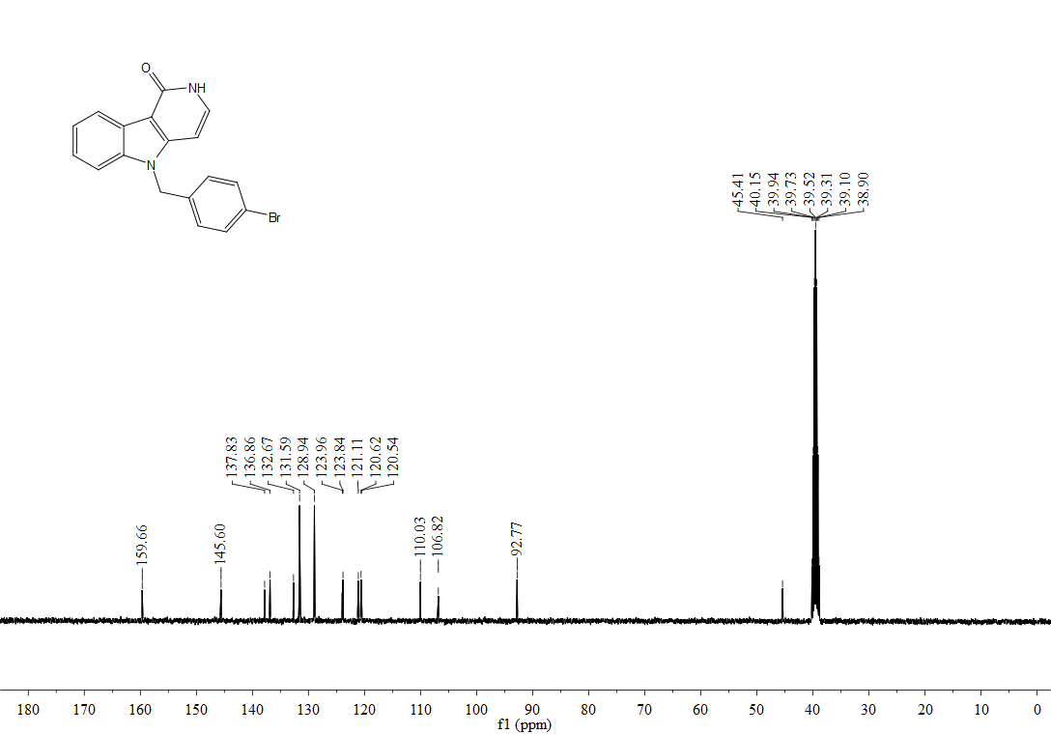

¹H, ¹³C-NMR spectra of 5k
