Supporting Information for
Multicomponent synthesis and anticancer activity studies of novel 6-(trifluoromethyl)-1, 2, 3, 4-tetrahydropyrimidine-5-carboxylate derivatives
Anil Valeru,ª Zhi-Bin Luo,^{a *}Imran Khan,ª Bin Liu,ª Bhavanarushi Sngepu,ªNarender Reddy Godumagadda,^{b} Yin Xu,ªJimin Xie, ^{a *}
ªSchool of Chemistry and Chemical Engineering, Jiangsu University, Zhenjiang, 212013,P.R.China.
^{b} Medicinal Chemistry and Pharmacology Division, CSIR-Indian Institute of Chemical Technology, Tarnaka, Hyderabad–500007, India.
(E-mail: luozb@ujs.edu.cn, xiejm@ujs.edu.cn)
General information:
Melting points were recorded on Casia-Siamia (VMP-AM) melting point apparatus and are uncorrected. ¹H NMR spectra were recorded on Bruker AV 300MHz in CDCl₃ & DMSO-d₆ using TMS as internal standard. ESI spectra were recorded on Micro mass, Quattro LC using ESI+ software with capillary voltage 3.98 kV and ESI mode positive ion trap detector. All high-resolution spectra were recorded on QSTARXL hybrid MS/MS system (Applied Biosystems, USA) under Electrospray ionization. All the reactions were monitored by thin layer chromatography (TLC) on precoated silica gel 60 F₂₅₄; spots were visualized with UV light. Merck silica gel (60-120 mesh) was used for column chromatography.
General Procedure:
A mixture of aryl aldehyde (0.1 mol), urea (0.1 mol) and trifluoromethyl 1,3-dicarbonyl compound (0.1 mol) in aq HF (40%) were charged in polypropelene bottle and stirred at ambient temperature for a period of 60 min. The reaction progress was monitored by thin-layer chromatography (TLC). After completion of the reaction, the reaction mixture was poured into crushed ice, and the resulted solid was filtered. The solid was washed with water and then sodium bicarbonate solution and dried to afford the product.

Ethyl-2-oxo-4-phenyl-6-(trifluoromethyl)-1,2,3,4-tetrahydro-5-pyrimidine carboxylate (4a):
Yield: 90%. m.p. 203-205 ºC; ¹H NMR (300 MHz, CDCl₃+ DMSO-d₆): δ 1.21 (3H, t, J = 7.2 Hz, OCH₂CH₃), 4.12 (2H, q, J = 7.2 Hz, CH₂), 5.13 (1H, d, J = 3.1), 7.21-7.29 (5H, m), 9.44 (1H, bs, N-H), 9.29 (1H, bs, N-H); ¹³C NMR (75 MHz, CDCl₃+ DMSO-d₆): δ 171.5, 168.1, 156.0, 152.2, 143.6, 138.6, 131.8, 126.2, 125.8, 124.7, 112.1, 70.8, 58.4, 15.2; MS (ESI): m/z [(M+H)⁺]: 315. HRMS m/z Calcd. for C₁₄H₁₃F₃N₂O₃ [(M+H)⁺]: 315.0878, Found 315.0876.
Ethyl 2-oxo-4-(p-tolyl)-6-(trifluoromethyl)-1,2,3,4-tetrahydropyrimidine-5-carboxylate (4b):
Yield: 87%. m.p. 223-225 ºC; ¹H NMR (300 MHz, CDCl₃+ DMSO-d₆): δ 1.25 (3H, t, J = 7.2 Hz, OCH₂CH₃), 2.34 (3H, s, ArCH₃), 4.11 (2H, q, J = 7.2 Hz, CH₂), 5.31 (1H, s, CH), 5.50 (1H, bs, NH),7.28 (2H, d, J = 8.4 Hz, ArH), 7.41 (2H, d, J = 8.4 Hz, ArH), 7.59 (1H, bs, NH); ¹³C NMR (75 MHz, CDCl₃+ DMSO-d₆): δ 170.4, 165.2, 153.4, 151.0, 144.5, 138.1, 132.6, 128.4, 126.8, 124.1, 120.5, 75.3, 60.4, 22.5, 16.2; MS (ESI): m/z [(M+H)⁺]: 329. HRMS m/z Calcd. for C₁₅H₁₅F₃N₂O₃ [(M+H)⁺]: 329.1068, Found 329.1066.
Ethyl 4-(4-chlorophenyl)-2-oxo-6-(trifluoromethyl)-1,2,3,4-tetrahydropyrimidine-5-carboxylate (4c):
Yield: 91%. m.p. 201-203 ºC; ¹H NMR (300 MHz, CDCl₃+ DMSO-d₆): δ 1.23 (3 H, t, J = 7.2 Hz, OCH₂CH₃), 4.12 (2H, q, J = 7.2 Hz, CH₂), 5.29 (1H, s, CH), 5.53 (1H, bs, NH), 7.29 (2H, d, J = 8.4 Hz, ArH), 7.51 (2H, d, J = 8.4 Hz, ArH), 7.62 (1H, bs, NH); ¹³C NMR (75 MHz, CDCl₃+DMSO-d₆): δ 172.3, 166.2, 154.4, 152.5, 144.8, 136.2, 132.5, 128.6, 125.6, 123.7, 119.1, 72.8, 59.2, 16.2; MS (ESI): m/z [(M+H)⁺]: 349. HRMS m/z Calcd. for C₁₄H₁₂ClF₃N₂O₃ [(M+H)⁺]: 349.0489, Found 349.0491.
Ethyl 4-(4-bromophenyl)-2-oxo-6-(trifluoromethyl)-1,2,3,4-tetrahydropyrimidine-5-carboxylate (4d):
Yield: 92%. m.p. 241-243 ºC; ¹H NMR (300 MHz, CDCl₃+ DMSO-d₆): δ 1.21 (3 H, t, J = 7.2 Hz, OCH₂CH₃), 4.11 (2H, q, J = 7.2 Hz, CH₂), 5.31 (1H, s, CH), 5.52 (1H, bs, NH), 7.31 (2H, d, J = 8.4 Hz, ArH), 7.54 (2H, d, J = 8.4 Hz, ArH), 7.65 (1H, bs, NH); ¹³C NMR (75 MHz, CDCl₃+DMSO-d₆): δ 171.2, 165.7, 152.1, 149.5, 143.4, 136.1, 133.5, 126.1, 124.4, 122.7, 120.1, 68.2, 56.1, 16.8; MS (ESI): m/z [(M+H)⁺]: 394. HRMS m/z Calcd. for C₁₄H₁₂BrF₃N₂O₃ [(M+H)⁺]: 394.1559, Found 394.1560.
Ethyl 4-(4-methoxyphenyl)-2-oxo-6-(trifluoromethyl)-1,2,3,4-tetrahydropyrimidine-5-carboxylate (4e):
Yield: 86%. m.p. 209-212 ºC; ¹H NMR (300 MHz, CDCl₃+ DMSO-d₆): δ 1.22 (3H, t, J = 7.2 Hz, OCH₂CH₃), 3.84 (3H, s, ArOCH₃), 4.12 (2H, q, J = 7.2 Hz, CH₂), 5.28 (1H, s, CH), 5.52 (1H, bs, NH), 7.29 (2H, d, J = 8.4 Hz, ArH), 7.65 (2H, d, J = 8.4 Hz, ArH), 7.71 (1H, bs, NH); ¹³C NMR (75 MHz, CDCl₃+DMSO-d₆): δ 169.1, 164.6, 156.1, 150.4, 143.2, 138.6, 132.7, 128.1, 124.6, 122.3, 120.8, 73.6, 55.4, 59.2, 16.2; MS (ESI): m/z [(M+H)⁺]: 345. HRMS m/z Calcd. for C₁₅H₁₅F₃N₂O₄ [(M+H)⁺]: 345.0984, Found 345.0982.
Ethyl 2-oxo-4-(o-tolyl)-6-(trifluoromethyl)-1,2,3,4-tetrahydropyrimidine-5-carboxylate (4f):
Yield: 86%. m.p. 215-217 ºC; ¹H NMR (300 MHz, CDCl₃+DMSO-d₆): δ 1.26 (3H, t, J = 7.2 Hz, OCH₂CH₃), 2.34 (3H, s, ArCH₃), 4.15 (2H, q, J = 7.2 Hz, CH₂), 5.32 (1H, s, CH), 5.53 (1H, bs, NH), 7.16-7.28 (4H, m, ArH), 7.61 (1H, bs, NH); ¹³C NMR (75 MHz, CDCl₃+ DMSO-d₆): δ 171.3, 166.1, 158.9, 152.5, 146.5, 138.4, 135.2, 127.3, 123.3, 124.7, 121.7, 76.6, 61.7, 21.6, 16.8; MS (ESI): m/z [(M+H)⁺]: 329. HRMS m/z Calcd. for C₁₅H₁₅F₃N₂O₃ [(M+H)⁺]: 329.1035, Found 329.1032.
Ethyl 4-(4-fluorophenyl)-2-oxo-6-(trifluoromethyl)-1,2,3,4-tetrahydropyrimidine-5-carboxylate (4g):
Yield: 89%. m.p. 189-192 ºC; δ ¹H NMR (300 MHz, CDCl₃): δ 1.21 (3H, t, J = 7.2 Hz, OCH₂CH₃), 4.18 (2H, q, J = 7.2 Hz, CH₂), 5.32 (1H, s, CH), 5.51 (1H, bs, NH), 7.26 (2H, d, J = 8.4 Hz, ArH), 7.58 (2H, d, J = 8.4 Hz, ArH), 7.69 (1H, bs, NH); ¹³C NMR (75 MHz, CDCl₃+DMSO-d₆): δ 170.3, 166.8, 155.2, 148.3, 144.1, 138.3, 132.7, 128.6, 124.9, 121.3, 119.1, 70.2, 57.2, 16.7; MS (ESI): m/z [(M+H)⁺]: 333. HRMS m/z Calcd. for C₁₄H₁₂F₄N₂O₃ [(M+H)⁺]: 333.0784, Found 333.0782.
Ethyl 4-(4-nitrophenyl)-2-oxo-6-(trifluoromethyl)-1,2,3,4-tetrahydropyrimidine-5-carboxylate (4h):
Yield: 85%. m.p. 210-212 ºC; ¹H NMR (300 MHz, CDCl₃+ DMSO-d₆): δ 1.18 (3 H, t, J = 7.2 Hz, OCH₂CH₃), 4.11 (2H, q, J = 7.2 Hz, CH₂), 5.25 (1H, s, CH), 5.62 (1H, bs, NH), 7.25 (2H, d, J = 8.4 Hz, ArH), 7.58 (2H, d, J = 8.4 Hz, ArH), 7.68 (1H, bs, NH); ¹³C NMR (75 MHz, CDCl₃+DMSO-d₆): δ 171.2, 168.5, 156.3, 151.8, 145.7, 135.9, 131.4, 127.5, 124.7, 122.8, 120.3, 73.9, 59.2, 15.8; MS (ESI): m/z [(M+H)⁺]: 360. HRMS m/z Calcd. for C₁₄H₁₂F₃N₃O₅ [(M+H)⁺]: 360.0729, Found 360.0726.
Ethyl 2-oxo-6-(trifluoromethyl)-4-(3-(trifluoromethyl)phenyl)-1,2,3,4-tetrahydropyrimidine-5-carboxylate (4i):
Yield: 82%. m.p. 231-233 ºC; ¹H NMR (300 MHz, CDCl₃+DMSO-d₆): δ 1.25 (3H, t, J = 7.2 Hz, OCH₂CH₃), 4.15 (2H, q, J = 7.2 Hz, CH₂), 5.34 (1H, s, CH), 5.51 (1H, bs, NH), 7.29 (1H, s, ArH), 7.42-7.48 (3H, m, ArH), 7.68 (1H, bs, NH); ¹³C NMR (75 MHz, CDCl₃+DMSO-d₆): δ 168.3, 162.3, 156.7, 151.4, 145.8, 137.1, 136.1, 128.1, 126.4, 123.2, 121.1, 120.3, 71.6, 60.2, 15.8; MS (ESI): m/z [(M+H)⁺]: 383. HRMS m/z Calcd. for C₁₅H₁₂F₆N₂O₃ [(M+H)⁺]: 383.0752, Found 383.0755.
Ethyl 4-(4-cyanophenyl)-2-oxo-6-(trifluoromethyl)-1,2,3,4-tetrahydropyrimidine-5-carboxylate (4j):
Yield: 82%. m.p. 210-212 ºC; ¹H NMR (300 MHz, CDCl₃+DMSO-d₆): δ 1.23 (3H, t, J = 7.2 Hz, OCH₂CH₃), 4.12 (2H, q, J = 7.2 Hz, CH₂), 5.31 (1H, s, CH), 5.51 (1H, bs, NH), 7.28 (2H, d, J = 8.4 Hz, ArH), 7.56 (2H, d, J = 8.4 Hz, ArH), 7.69 (1H, bs, NH); ¹³C NMR (75 MHz, CDCl₃+DMSO-d₆): δ 171.6, 165.1, 158.5, 152.6, 148.8, 136.5, 132.4, 129.4, 124.6, 122.7, 121.3, 118.2, 71.8, 58.3, 17.1; MS (ESI): m/z [(M+H)⁺]: 340. HRMS m/z Calcd. for C₁₅H₁₂F₃N₃O₃ [(M+H)⁺]: 340.0831, Found 340.0833.
Ethyl 4-(furan-2-yl)-2-oxo-6-(trifluoromethyl)-1,2,3,4-tetrahydropyrimidine-5-carboxylate (4k):
Yield: 85%. m.p. 184-186 ºC; ¹H NMR (300 MHz, CDCl₃+DMSO-d₆): δ 1.20 (3H, t, J = 7.2 Hz, OCH₂CH₃), 4.10 (2H, q, J = 7.2 Hz, CH₂), 5.32 (1H, s, CH), 5.51 (1H, bs, NH), 7.31-7.39 (3H, m, ArH), 7.71 (1H, bs, NH); ¹³C NMR (75 MHz, CDCl₃+DMSO-d₆): δ 171.4, 168.1, 152.5, 135.2, 131.6, 128.7, 125.4, 122.4, 120.5, 72.5, 60.2, 16.1; MS (ESI): m/z [(M+H)⁺]: 305. HRMS m/z Calcd. for C₁₂H₁₁F₃N₂O₄ [(M+H)⁺]: 305.0671, Found 305.0668.
Ethyl 2-oxo-4-(thiophen-2-yl)-6-(trifluoromethyl)-1,2,3,4-tetrahydropyrimidine-5-carboxylate (4l):
Yield: 80%. m.p. 167-168 ºC; ¹H NMR (300 MHz, CDCl₃+DMSO-d₆): δ 1.21 (3H, t, J = 7.2 Hz, OCH₂CH₃), 4.12 (2H, q, J = 7.2 Hz, CH₂), 5.31 (1H, s, CH), 5.51 (1H, bs, NH), 7.33-7.41 (3H, m, ArH), 7.69 (1H, bs, NH); ¹³C NMR (75 MHz, CDCl₃+DMSO-d₆): δ 170.2, 166.2, 151.4, 136.6, 132.8, 129.4, 126.7, 122.3, 121.7, 71.1, 61.6, 16.8; MS (ESI): m/z [(M+H)⁺]: 321. HRMS m/z Calcd. for C₁₂H₁₁F₃N₂O₃S [(M+H)⁺]: 321.0441, Found 321.0443.
Ethyl 4-(2,4-difluorophenyl)-2-oxo-6-(trifluoromethyl)-1,2,3,4-tetrahydropyrimidine-5-carboxylate (4m):
Yield: 88%. m.p. 162-164 ºC; δ ¹H NMR (300 MHz, CDCl₃+DMSO-d₆): δ 1.19 (3H, t, J = 7.2 Hz, OCH₂CH₃), 4.18 (2H, q, J = 7.2 Hz, CH₂), 5.30 (1H, s, CH), 5.52 (1H, bs, NH), 7.12-7.23 (4H, m, ArH), 7.61 (1H, bs, NH); ¹³C NMR (75 MHz, CDCl₃+DMSO-d₆): δ 170.1, 162.4, 151.6, 146.1, 142.4, 137.2, 132.4, 128.6, 123.7, 121.2, 120.1, 68.1, 57.6, 16.2; MS (ESI): m/z [(M+H)⁺]: 351. HRMS m/z Calcd. for C₁₄H₁₁F₅N₂O₃ [(M+H)⁺]: 351.0690, Found 351.0693.
Ethyl 4-(3-nitrophenyl)-2-oxo-6-(trifluoromethyl)-1,2,3,4-tetrahydropyrimidine-5-carboxylate (4n):
Yield: 79%. m.p. 248-250 ºC; ¹H NMR (300 MHz, CDCl₃+ DMSO-d₆): δ 1.20 (3 H, t, J = 7.2 Hz, OCH₂CH₃), 4.12 (2H, q, J = 7.2 Hz, CH₂), 5.23 (1H, s, CH), 5.66 (1H, bs, NH), 7.26 (1H, s, ArH), 7.34-7.41(3H, m, ArH), 7.61 (1H, bs, NH); ¹³C NMR (75 MHz, CDCl₃+DMSO-d₆): δ 170.1, 166.3, 154.1, 152.1, 146.1, 132.9, 130.2, 128.5, 123.6, 121.8, 119.2, 71.9, 59.1, 15.5; MS (ESI): m/z [(M+H)⁺]: 360. HRMS m/z Calcd. for C₁₄H₁₂F₃N₃O₅ [(M+H)⁺]: 360.0711, Found 360.0709.
(E)-ethyl 2-oxo-4-styryl-6-(trifluoromethyl)-1,2,3,4-tetrahydropyrimidine-5-carboxylate (4o):
Yield: 81%. m.p. 228-230 ºC; ¹H NMR (300 MHz, CDCl₃+ DMSO-d₆): δ 1.22 (3H, t, J = 7.2 Hz, OCH₂CH₃), 4.18 (2H, q, J = 7.2 Hz, CH₂), 5.22 (1H, s, CH), 5.65 (1H, bs, NH), 7.12 (1H, s, ‒CH=), 7.18 (1H, s, ‒CH=), 7.34-7.41(5H, m, ArH), 7.82 (1H, bs, NH); ¹³C NMR (75 MHz, CDCl₃+ DMSO-d₆): δ 170.6, 166.2, 158.8, 151.4, 148.4, 142.6, 139.6, 134.7, 131.9, 127.2, 126.4, 124.3, 120.1, 70.8, 58.4, 15.2; MS (ESI): m/z [(M+H)⁺]: 341. HRMS m/z Calcd. for C₁₆H₁₅F₃N₂O₃ [(M+H)⁺]: 341.1032, Found 341.1035.
Ethyl 4-(naphthalen-2-yl)-2-oxo-6-(trifluoromethyl)-1,2,3,4-tetrahydropyrimidine-5-carboxylate (4p):
Yield: 80%. m.p. 245-247 ºC; ¹H NMR (300 MHz, CDCl₃+ DMSO-d₆): δ 1.24 (3H, t, J = 7.2 Hz, OCH₂CH₃), 4.22 (2H, q, J = 7.2 Hz, CH₂), 5.23 (1H, s, CH), 5.62 (1H, bs, NH), 7.46-7.79(7H, m, ArH), 7.84 (1H, bs, NH); ¹³C NMR (75 MHz, CDCl₃+ DMSO-d₆): δ 170.5, 168.1, 162.5, 158.2, 151.3, 142.5, 139.3, 136.2, 132.5, 128.7, 128.2, 125.8, 124.7, 122.5, 118.7, 71.4, 59.3, 16.2; MS (ESI): m/z [(M+H)⁺]: 365. HRMS m/z Calcd. for C₁₈H₁₅F₃N₂O₃ [(M+H)⁺]: 365.1035, Found 365.1032.

Ethyl-2-oxo-4-phenyl-6-(trifluoromethyl)-1,2,3,4-tetrahydro-5-pyrimidine carboxylate (4a):
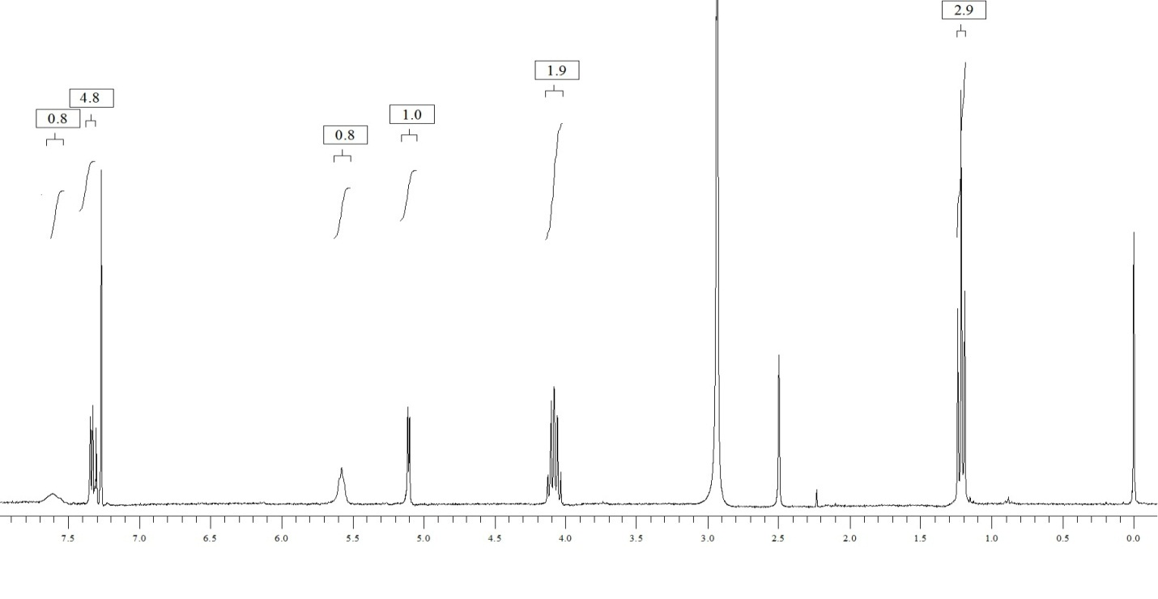
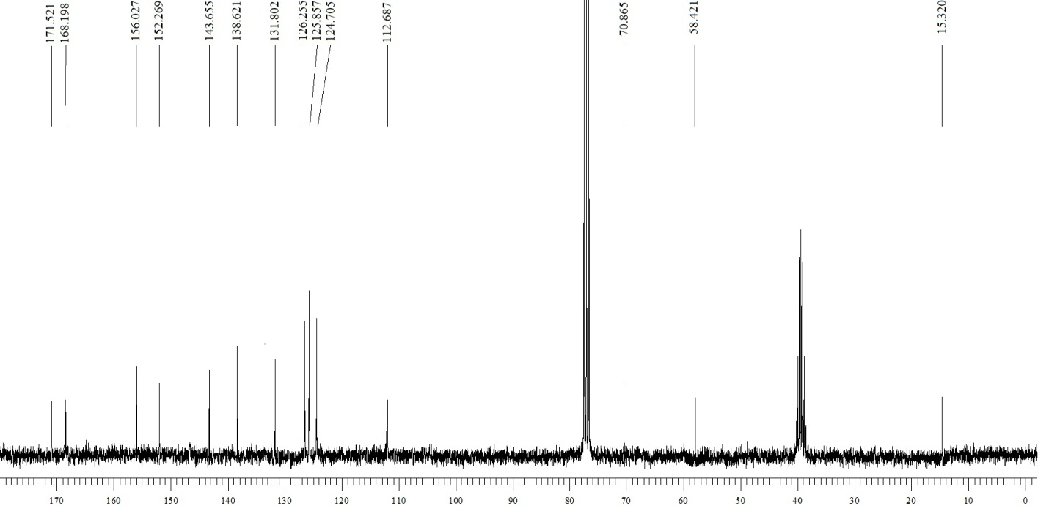

Ethyl 2-oxo-4-(p-tolyl)-6-(trifluoromethyl)-1,2,3,4-tetrahydropyrimidine-5-carboxylate (4b):
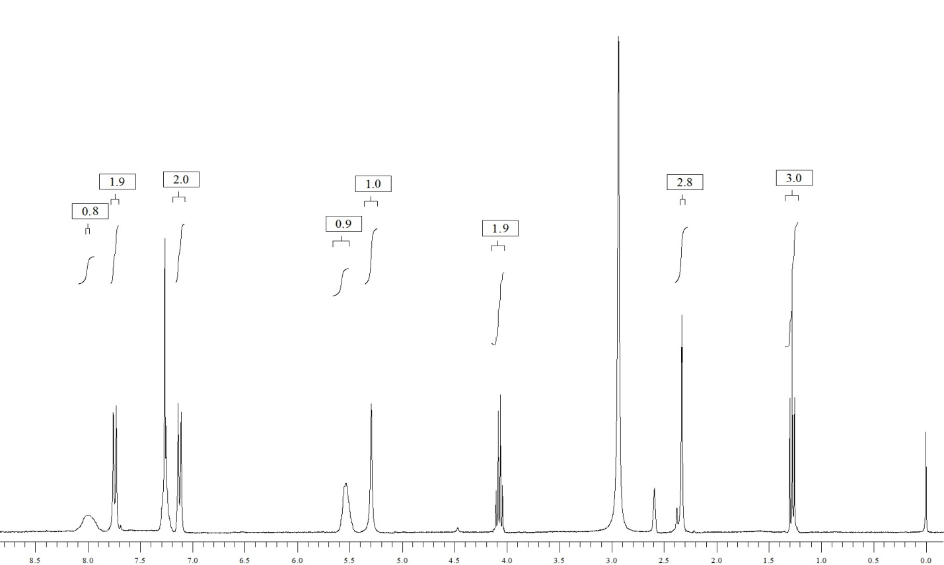
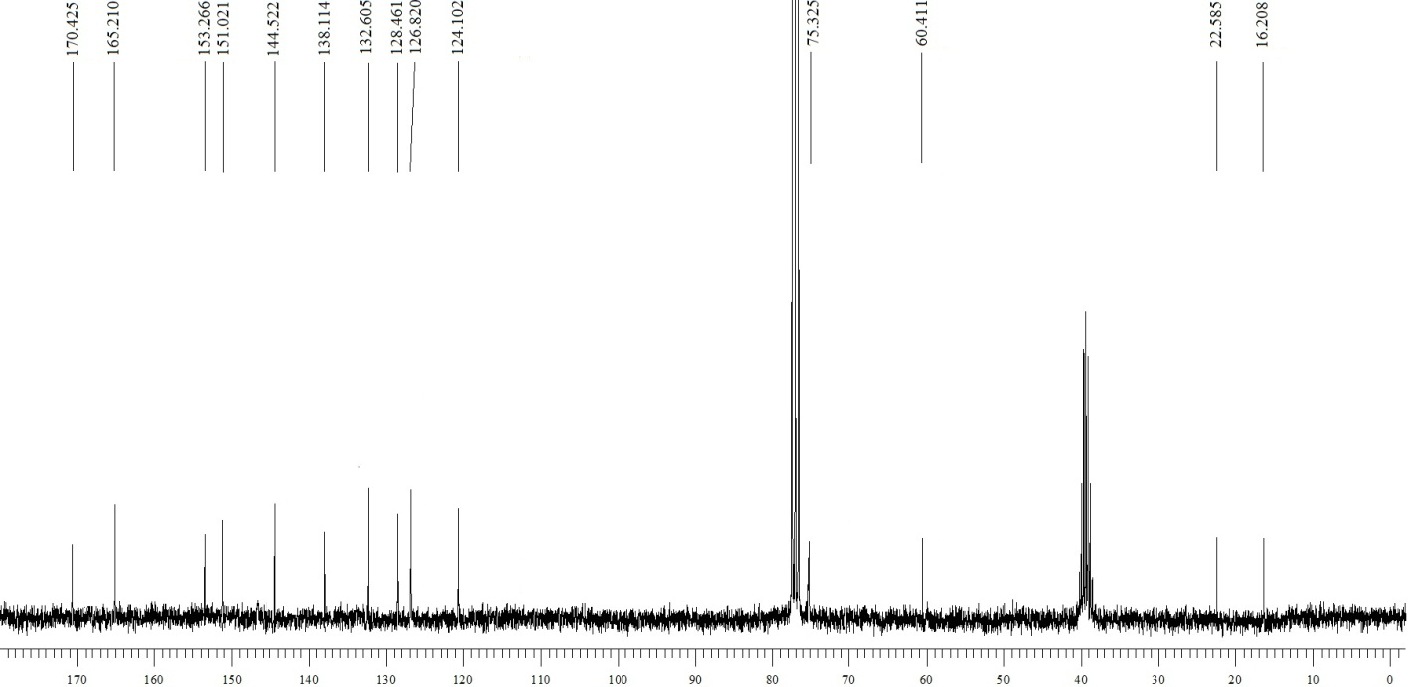

Ethyl 4-(4-chlorophenyl)-2-oxo-6-(trifluoromethyl)-1,2,3,4-tetrahydropyrimidine-5-carboxylate (4c):
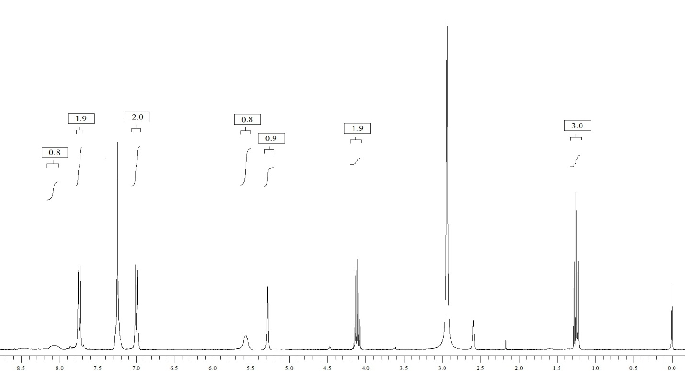
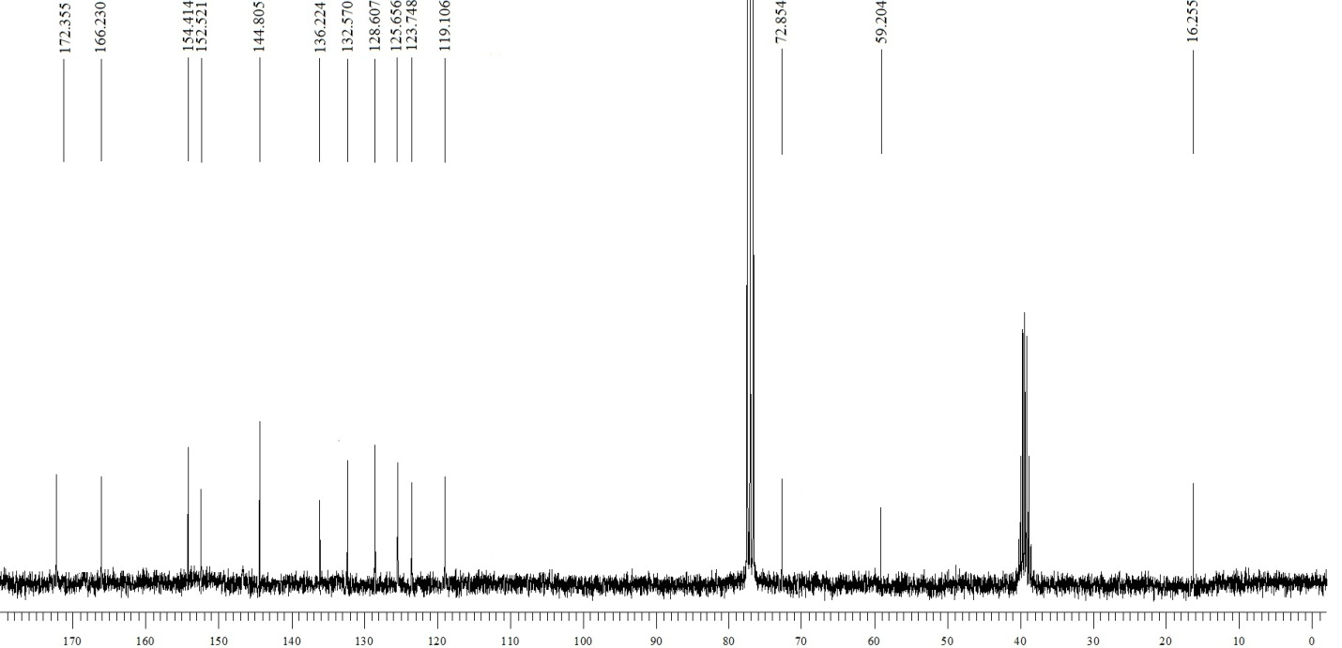

Ethyl 4-(4-bromophenyl)-2-oxo-6-(trifluoromethyl)-1,2,3,4-tetrahydropyrimidine-5-carboxylate (4d):
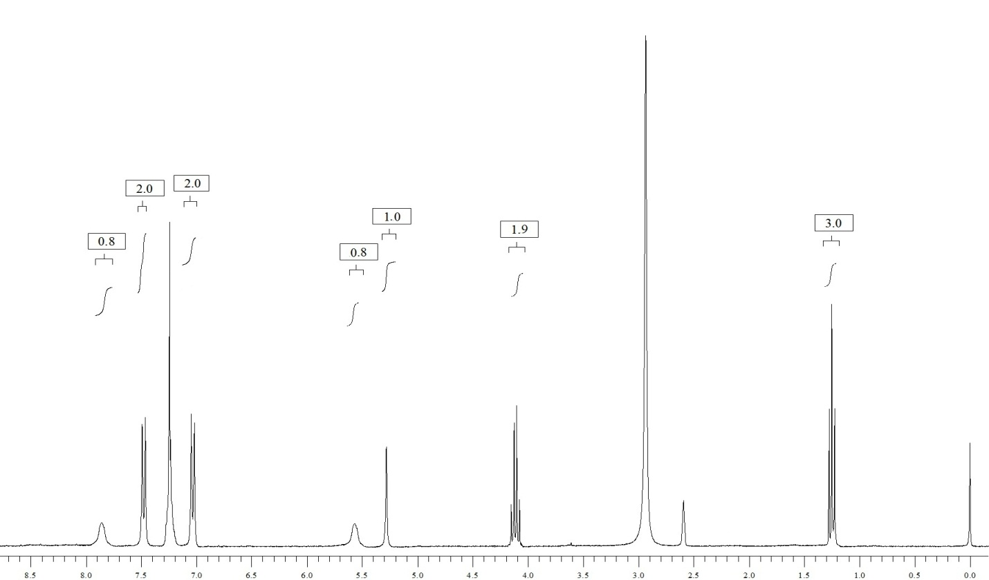
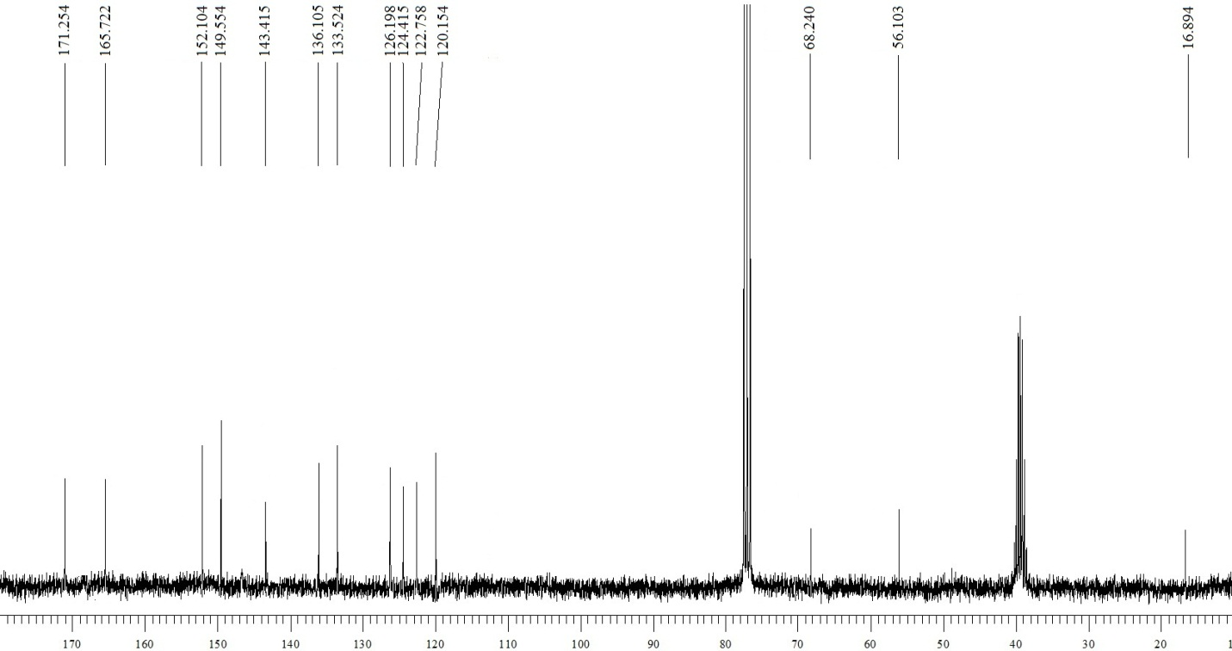

Ethyl 4-(4-methoxyphenyl)-2-oxo-6-(trifluoromethyl)-1,2,3,4-tetrahydropyrimidine-5-carboxylate (4e):
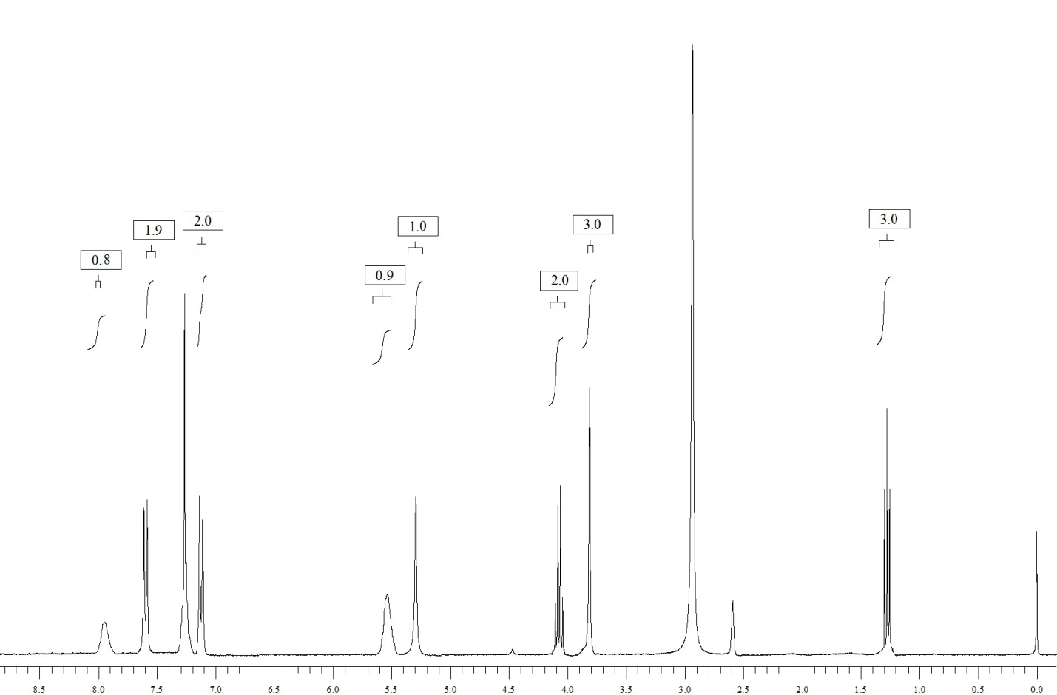
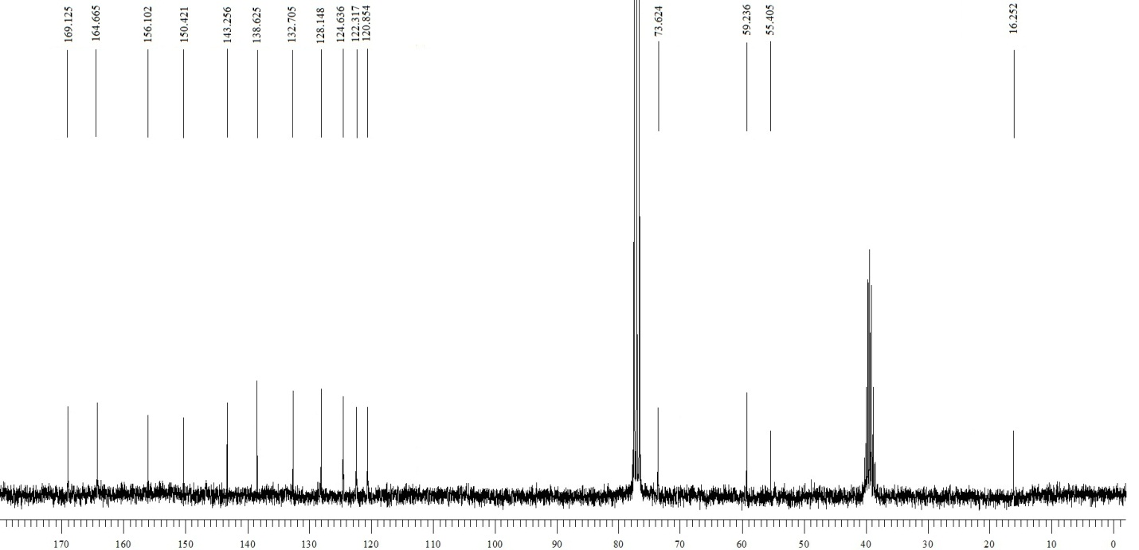

Ethyl 2-oxo-4-(o-tolyl)-6-(trifluoromethyl)-1,2,3,4-tetrahydropyrimidine-5-carboxylate (4f):
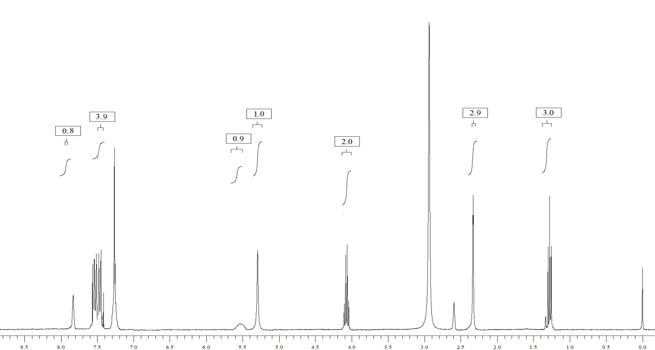
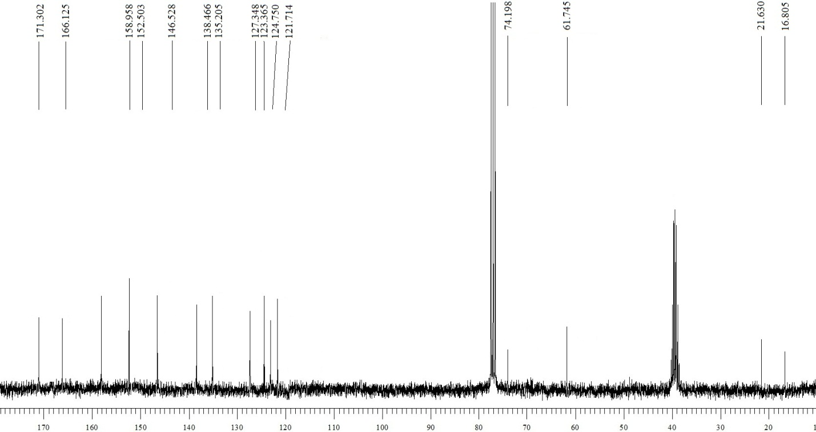

Ethyl 4-(4-fluorophenyl)-2-oxo-6-(trifluoromethyl)-1,2,3,4-tetrahydropyrimidine-5-carboxylate (4g):
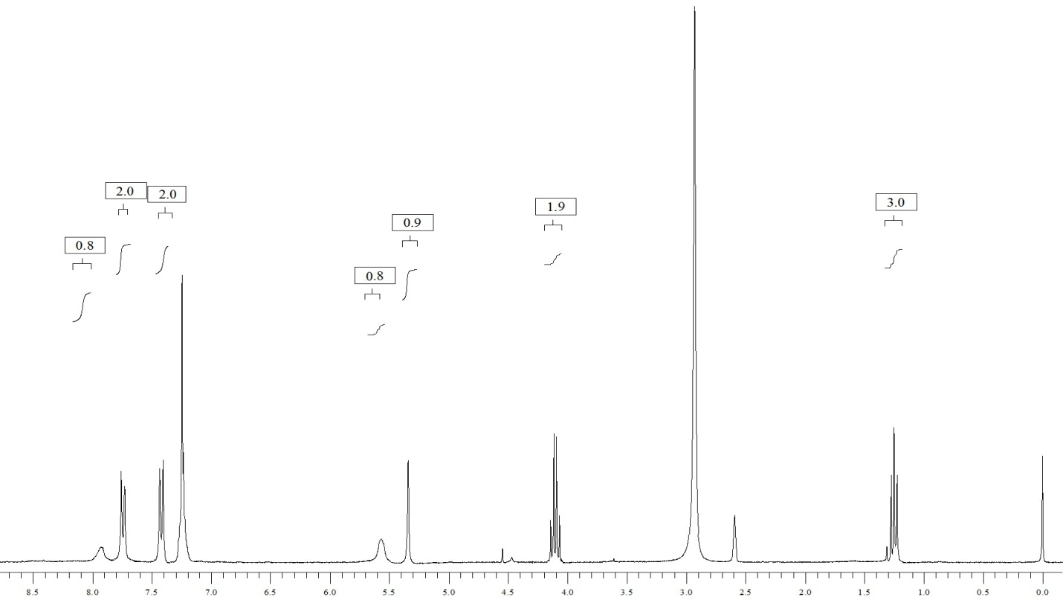
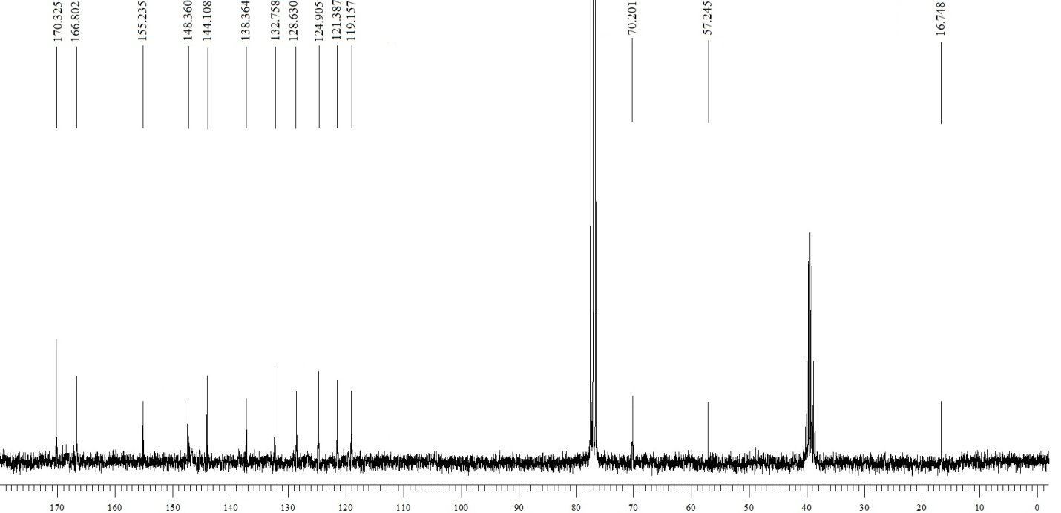

Ethyl 4-(4-nitrophenyl)-2-oxo-6-(trifluoromethyl)-1,2,3,4-tetrahydropyrimidine-5-carboxylate (4h):
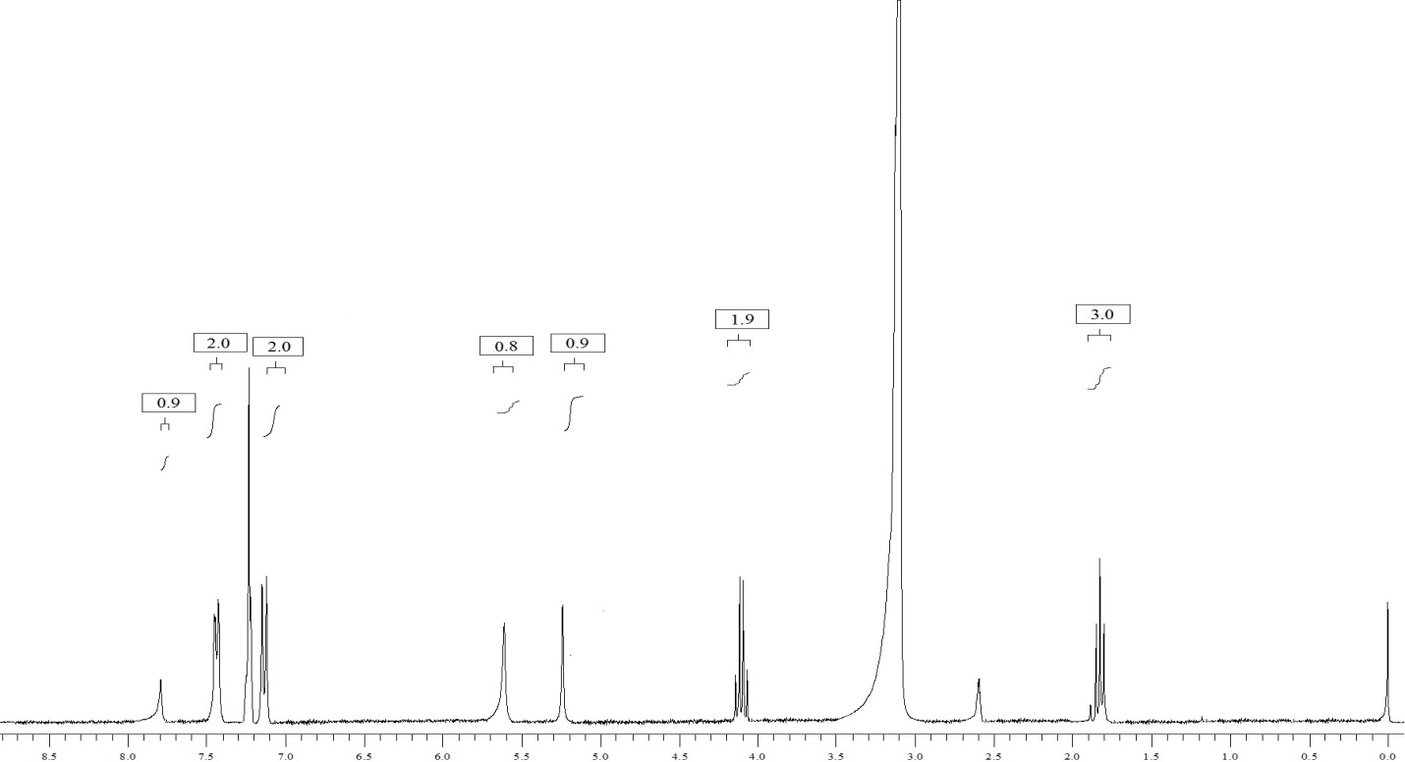
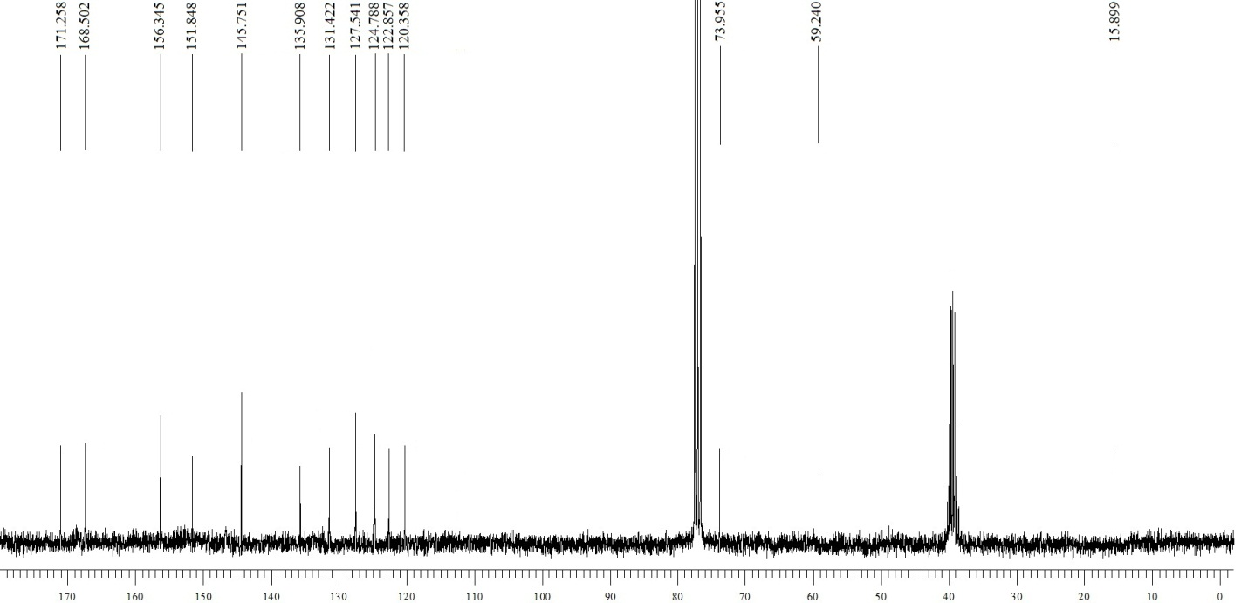

Ethyl 2-oxo-6-(trifluoromethyl)-4-(3-(trifluoromethyl)phenyl)-1,2,3,4-tetrahydropyrimidine-5-carboxylate (4i):
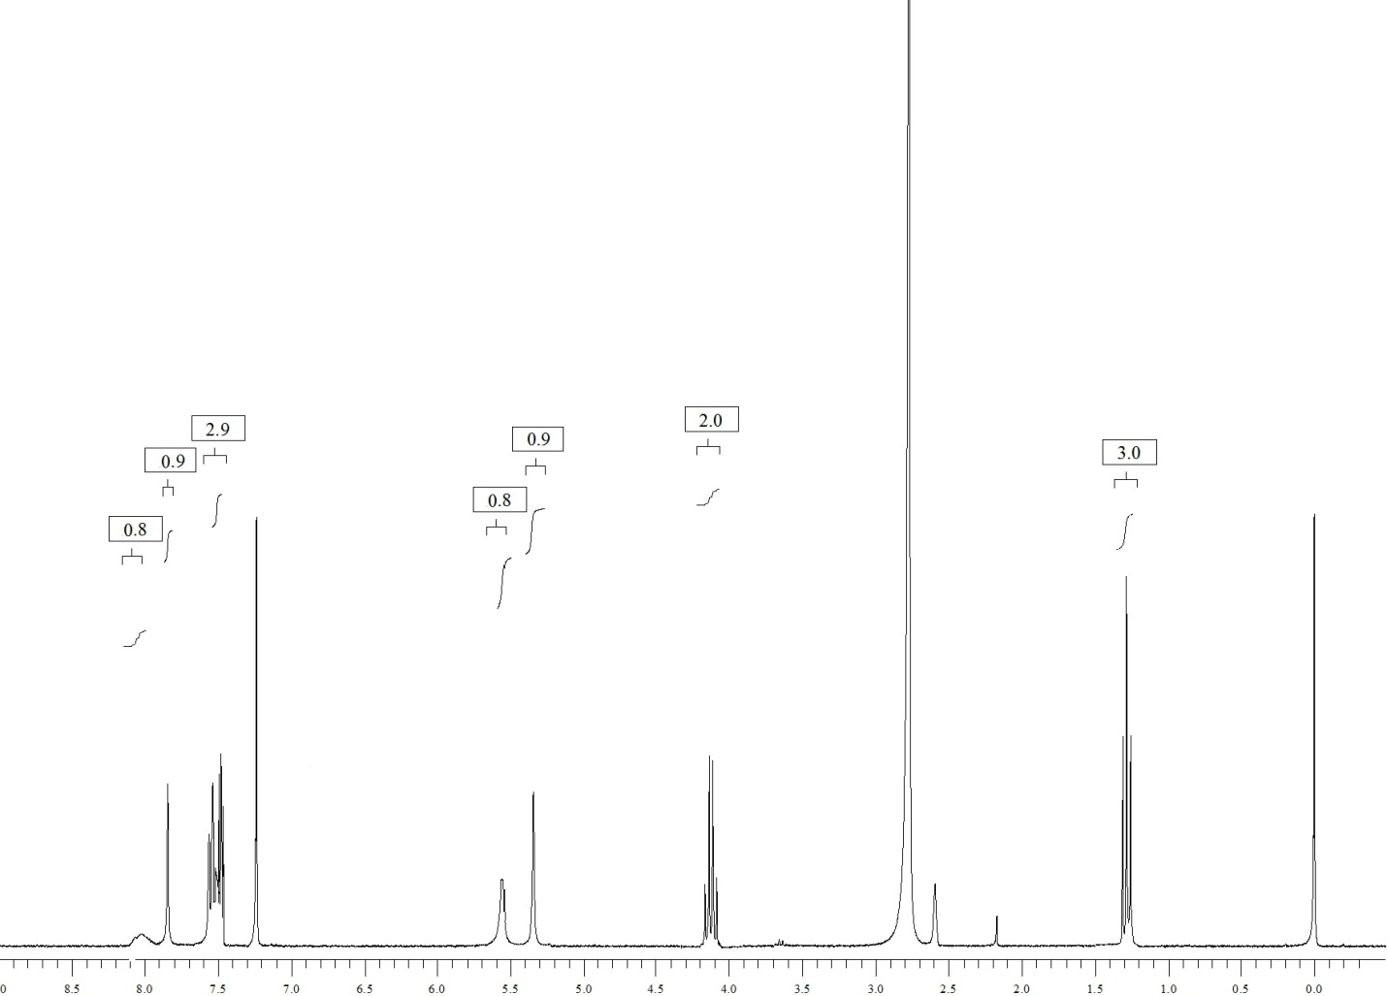
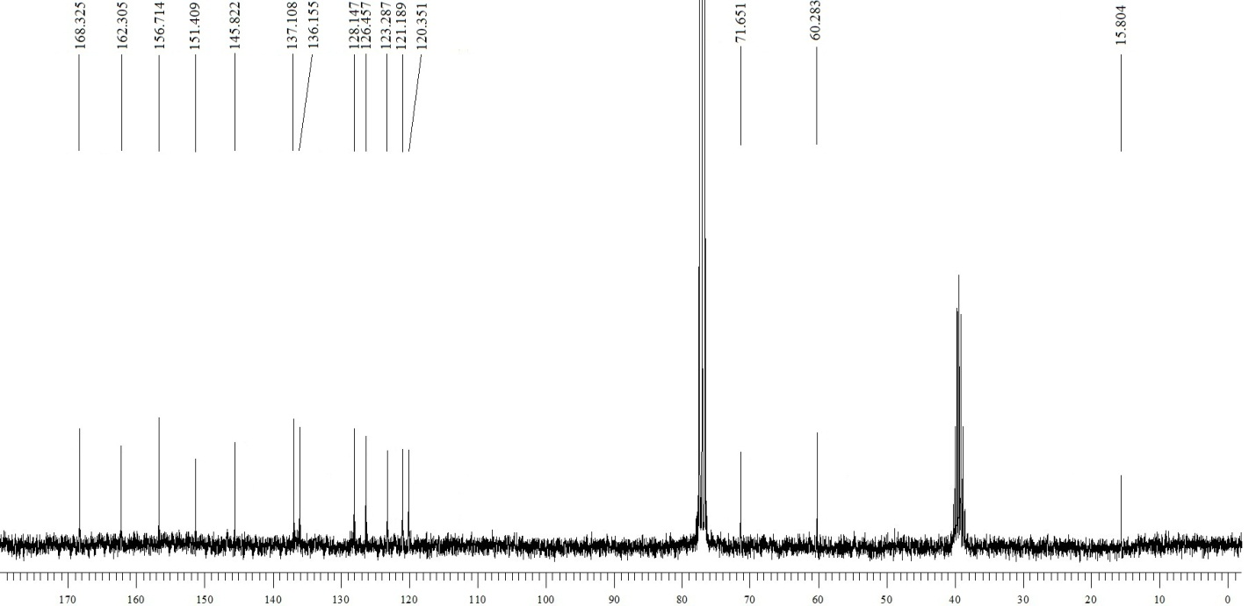

Ethyl 4-(4-cyanophenyl)-2-oxo-6-(trifluoromethyl)-1,2,3,4-tetrahydropyrimidine-5-carboxylate (4j):

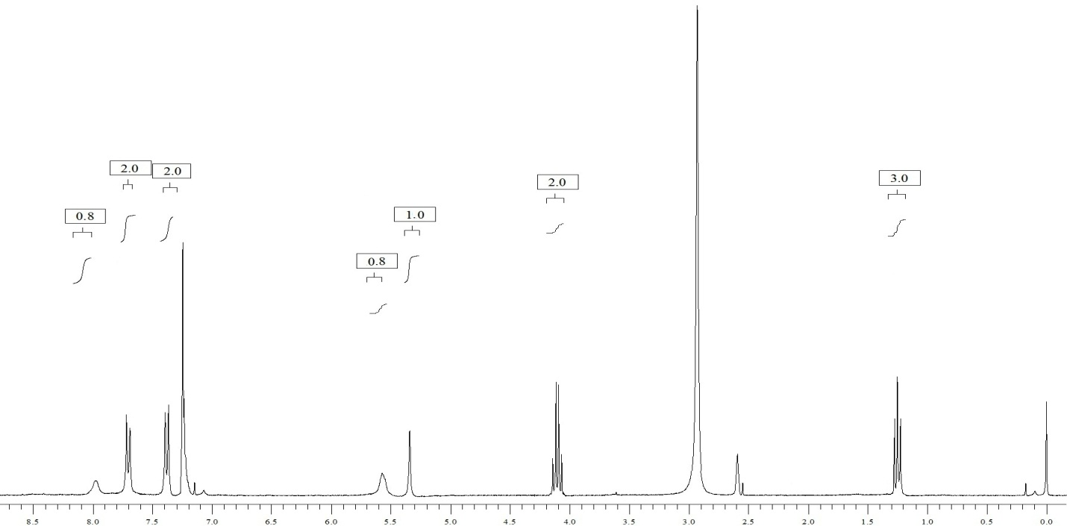
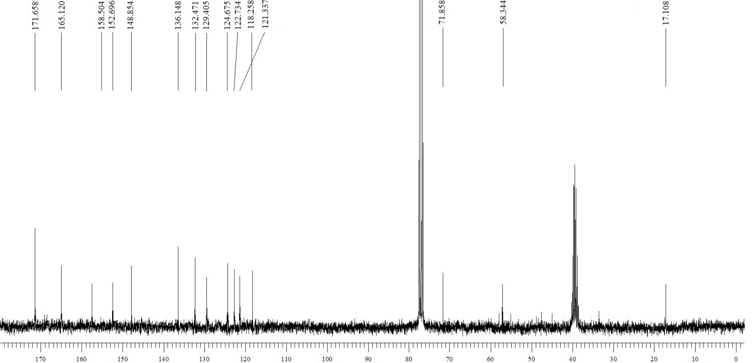

Ethyl 4-(furan-2-yl)-2-oxo-6-(trifluoromethyl)-1,2,3,4-tetrahydropyrimidine-5-carboxylate (4k):
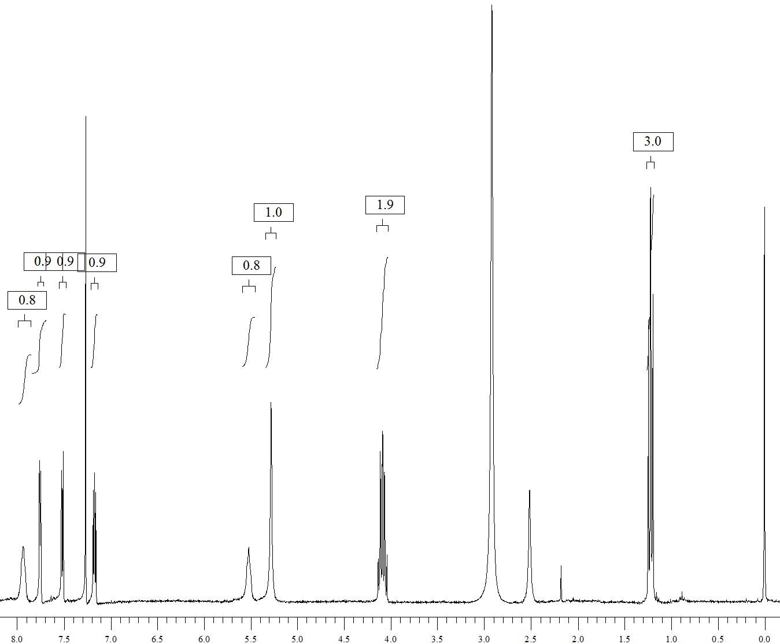
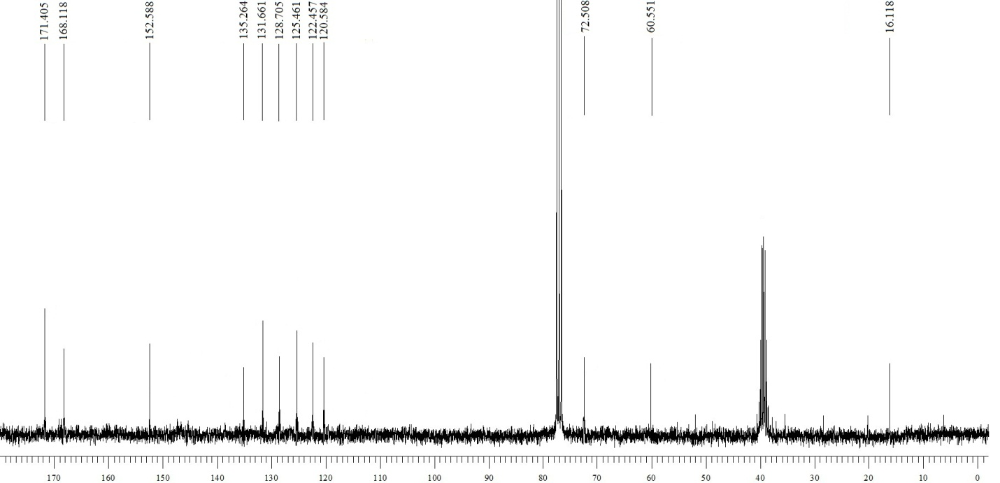

Ethyl 2-oxo-4-(thiophen-2-yl)-6-(trifluoromethyl)-1,2,3,4-tetrahydropyrimidine-5-carboxylate (4l):

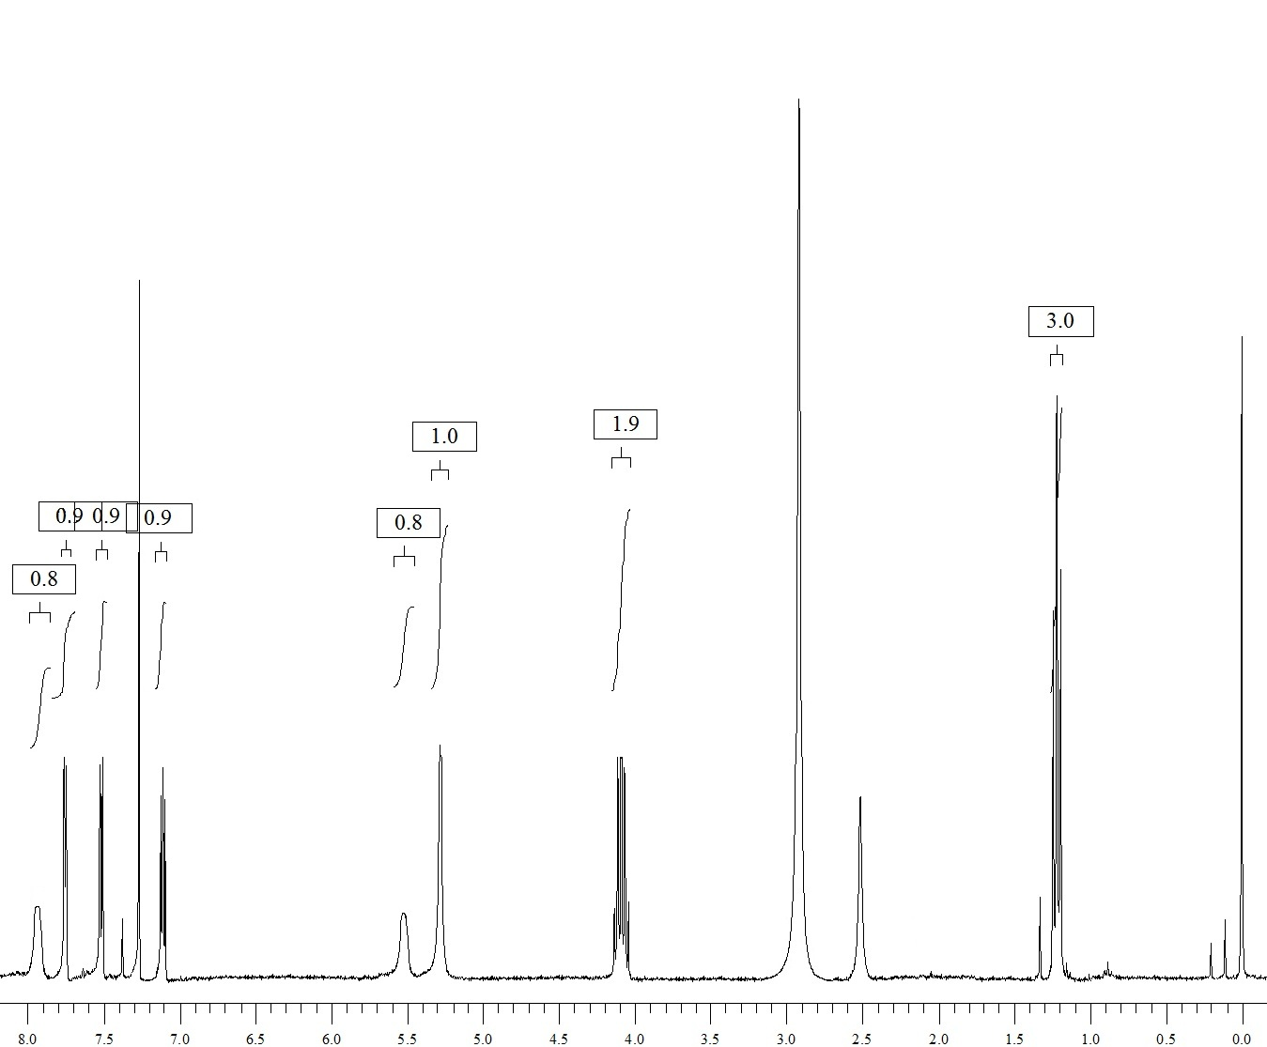
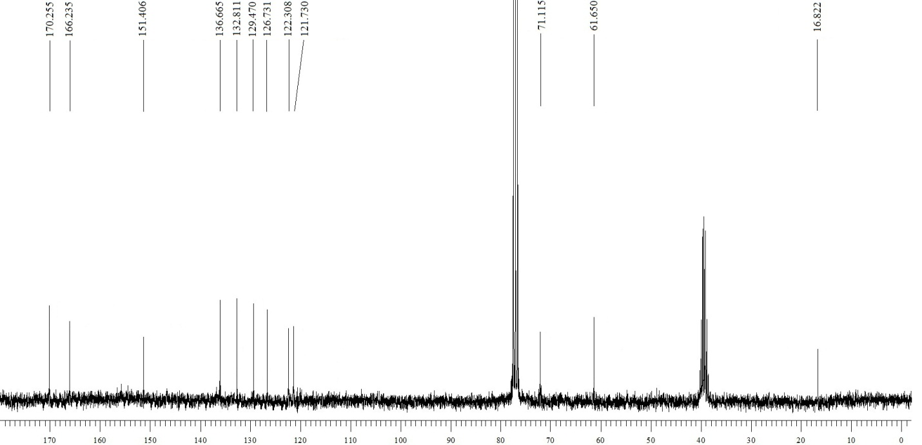

Ethyl 4-(2,4-difluorophenyl)-2-oxo-6-(trifluoromethyl)-1,2,3,4-tetrahydropyrimidine-5-carboxylate (4m):
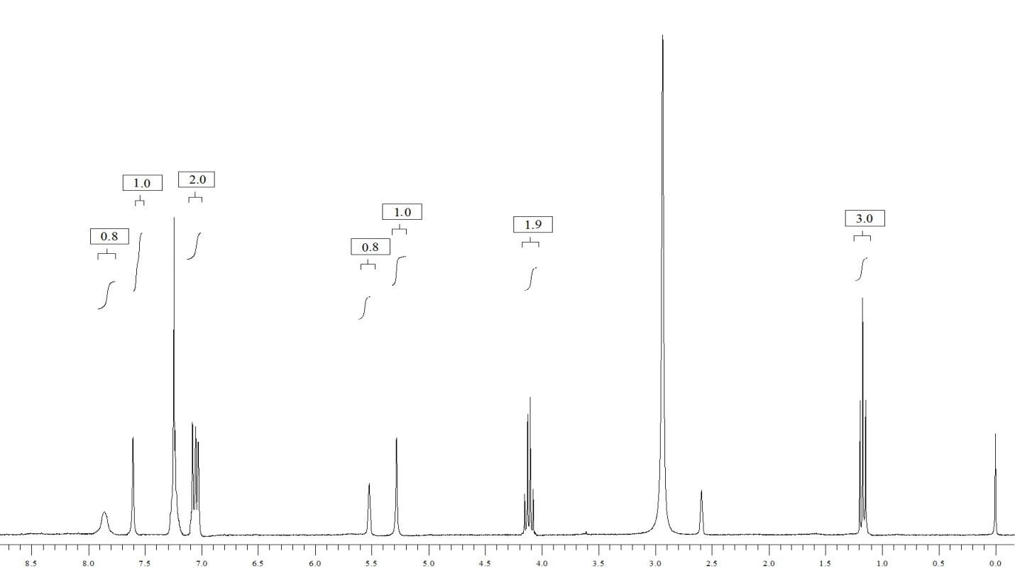
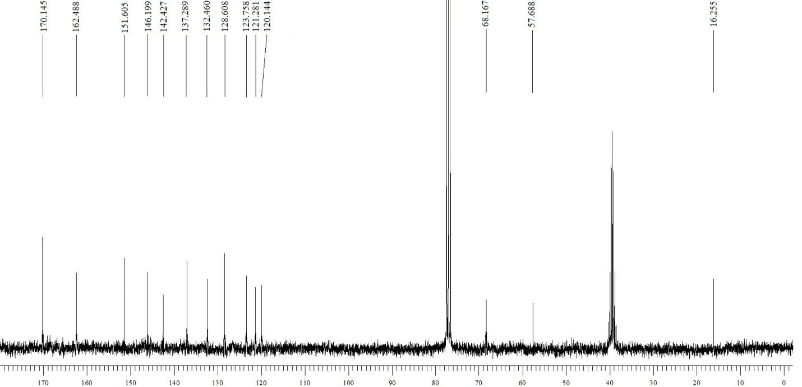

Ethyl 4-(3-nitrophenyl)-2-oxo-6-(trifluoromethyl)-1,2,3,4-tetrahydropyrimidine-5-carboxylate (4n):
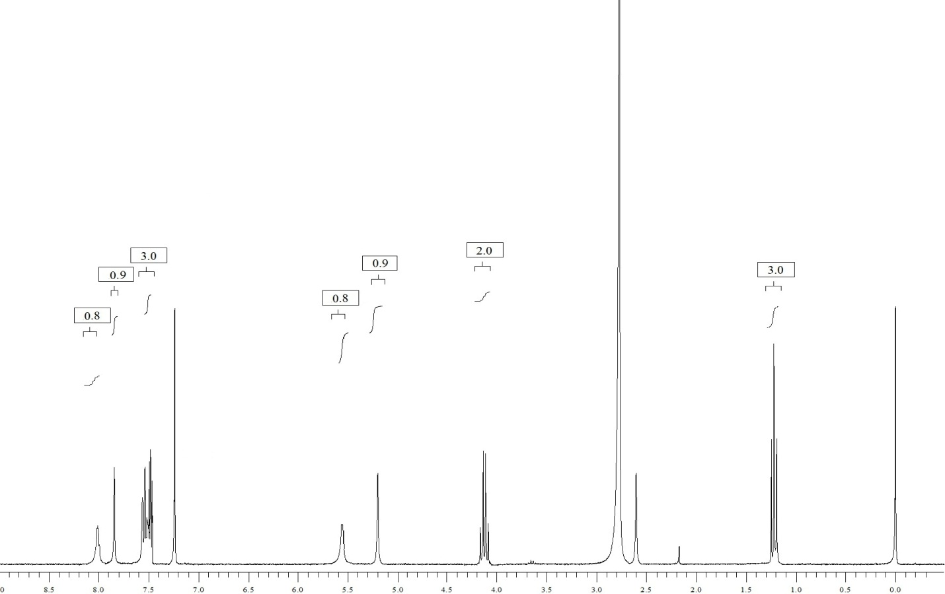
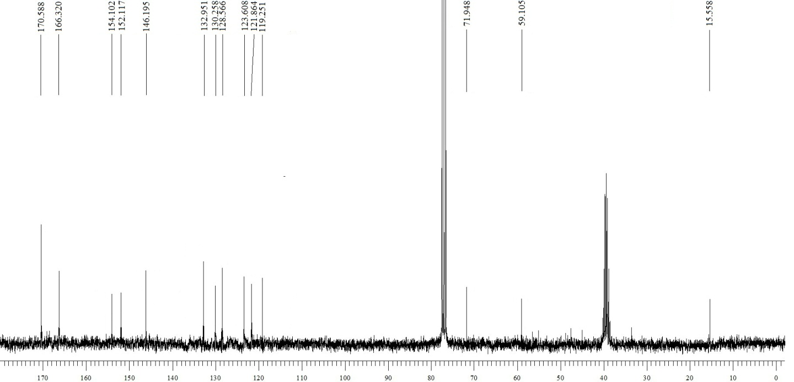

(E)-ethyl 2-oxo-4-styryl-6-(trifluoromethyl)-1,2,3,4-tetrahydropyrimidine-5-carboxylate (4o):
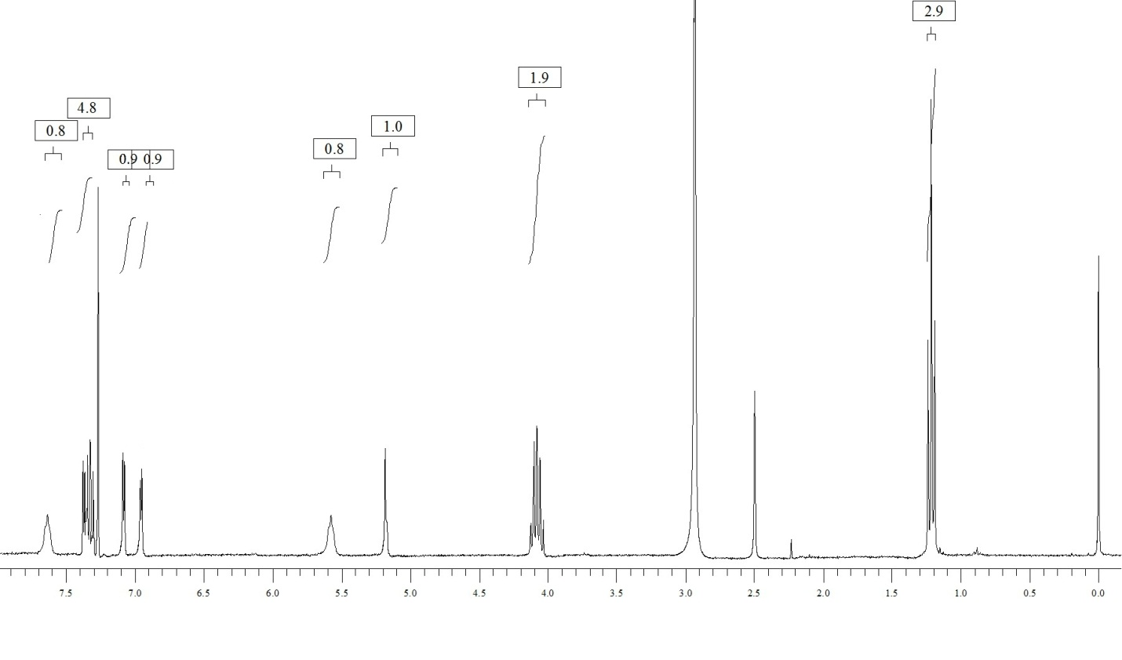
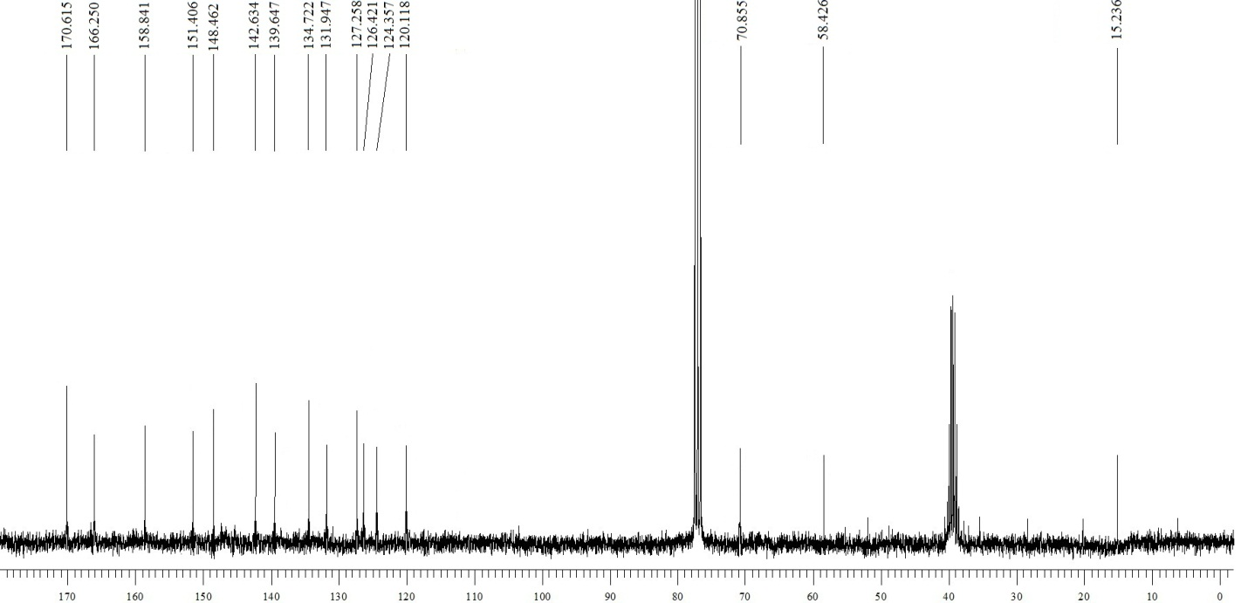

Ethyl 4-(naphthalen-2-yl)-2-oxo-6-(trifluoromethyl)-1,2,3,4-tetrahydropyrimidine-5-carboxylate (4p):

