Supporting Information
for
Iron-catalyzed Deoxygenation and 2-Sulfonylation of Quinoline N-Oxides by Sodium Sulfinates towards 2-Sulfonyl quinolines
Ping Li,^{a,} Yangji Jiang,^{a,} Han Li,^{b} Wanrong Dong,^{*,a} Zhihong Peng,^{*,a} and Delie An^{*,a}
a State Key Laboratory of Chemo/Biosensing and Chemometrics, College of Chemistry and Chemical Engineering, Hunan University, Changsha 410082, P. R. China;.
b No.3 Middle School of Tianjin, Tianjin 300131, P. R. China
e-mails: wanrongdong@hnu.edu.cn; pzh7251@hnu.edu.cn; deliean@hnu.edu.cn.
† P. Li and Y. Jiang devoted equal contribution to the publication.

Content | Page
General information | SI-2
General procedure for the 2-sulfonylation reaction | SI-2
Data | SI-2
Spectra | SI-9

General information
All product mixtures were analyzed by thin layer chromatography glass-backed silica TLC plates with a fluorescent indicator from Branch of Qingdao Haiyang Chemical CO. LTD. UV-active compounds were detected with a UV lamp (λ = 254 nm). For flash column chromatography, silica gel (200 - 300 mesh) was used as stationary phase and a mixture of petroleum and ethyl acetate was used as eluent. ¹H and ¹³C NMR spectra were recorded on a Varian INOVA-400 in deuterated chloroform at 25 °C with residue solvent peaks as internal standards (δ = 7.26 ppm for ¹H-NMR and δ = 77.16 ppm for ¹³C-NMR). Chemical shifts δ are reported in ppm, and spin-spin coupling constants (J) are given in Hz, while multiplicities are abbreviated by s (singlet), d (doublet), t (triplet), q (quartet) and m (multiplet) and some C-P couplings were ignored due to complexity. Mass spectra were recorded on a ThermoFinnigan MAT95XP microspectrometer and High resolution mass spectra (HRMS) were recorded on Agilent Technologies Accurate Mass Q-TOF 6530 microspectrometer. Melting points were recorded on a national standard melting point apparatus (Model: Taike XT-4) and were uncorrected.
General procedure for the 2-sulfonylation reaction
A Schlenk tube (35 mL) equipped with a magnetic bar was loaded with the solution of quinoline N-oxide 1 (0.5 mmol), sodium sulfinate 2 (1.0 mmol) and FeCl₃∙6H₂O (20 mol%) in a mixture of CH₃CN and H₂O (5.0 mL, ca. 9:1 by volume). Then, TBHP (70% in decane, 1.0 mmol) and pyridine (1.0 mmol) were added to the solution dropwise via a syringe and the reaction mixture was allowed to stir at 80 °C for ca. 12 h. After the completion of the reaction (monitored by TLC), the mixture was washed with brine (15 mL) and then extracted with dichloromethane (15 mL × 3). The organic phase was combined and then concentrated. The oily crude product was purified by column chromatography using silica gel (200 - 300 mesh) as stationary phase and a mixture of petroleum and ethyl acetate as eluent to give the desired product in noted yields.
Data
2-(Phenylsulfonyl) quinoline (3aa): White solid (110.3 mg, 82%), m.p.: 164 - 165 ºC. R_{f} = 0.33 (petroleum:EtOAc = 5:1). ¹H NMR (400 MHz, CDCl₃) δ = 8.36 (d, J = 8.5 Hz, 1H), 8.20 (d, J = 8.5 Hz, 1H), 8.18 - 8.10 (m, 3H), 7.86 (d, J = 8.2 Hz, 1H), 7.76 (t, J = 7.7 Hz, 1H), 7.66 - 7.56 (m, 2H), 7.52 (t, J = 7.5 Hz, 2H) (ppm). ¹³C NMR (100 MHz, CDCl₃) δ = 158.2, 147.5, 139.2, 138.9, 133.8, 131.1, 130.4, 129.3, 129.2, 129.1, 128.9, 127.8, 117.8 (ppm). IR (in KBr): ν = 3053, 2961, 2846, 2114, 1585, 1453, 1430, 1315, 1252, 1165, 1136, 1067, 814, 768, 707, 645, 549 (cm⁻¹). MS (EI): m/z = 269.0, 204.1(100), 128.0, 101.0, 77.0. HRMS (ESI-TOF) (m/z): [M + H]⁺ Calcd for C₁₅H₁₂NO₂S: 270.0583; Found. 270.0582.
2-(4-Tosyl) quinoline(3ab): White solid (116.1 mg, 82%), mp: 143 - 144 ºC, R_{f}= 0.29 (petroleum:EtOAc = 5:1). ¹H NMR (400 MHz, CDCl₃) δ = 8.35 (d, J = 8.5 Hz, 1H), 8.17 (t, J = 8.8 Hz, 2H), 8.01 (d, J = 8.1 Hz, 2H), 7.86 (d, J = 8.2 Hz, 1H), 7.77 (t, J = 7.7 Hz, 1H), 7.64 (t, J = 7.5 Hz, 1H), 7.32 (d, J = 8.0 Hz, 2H), 2.39 (s, 3H) (ppm).¹³C NMR (100 MHz, CDCl₃) δ = 158.5, 147.6, 144.9, 138.8, 136.3, 131.1, 130.5, 129.9, 129.24, 129.17, 128.9, 127.8, 117.8, 21.8 (ppm). IR (in KBr): ν = 3030 , 2910, 2878, 1701, 1596, 1498, 1456, 1423, 1322, 1295, 1259, 1167, 1100, 816, ,787, 723, 659, 546 (cm⁻¹). MS (EI): m/z = 283.1, 218.1 (100), 204.1, 139.0, 128.1, 101.0, 91.1, 75.0. HRMS (ESI-TOF) m/z: [M + H]⁺ Calcd for C₁₆H₁₄NO₂S: 284.0740; Found. 284.0745.
2-(2-Tolylsulfonyl) quinoline (3ac): White solid (99.1 mg, 70%), mp: 118 - 119ºC, R_{f} = 0.31 (petroleum:EtOAc = 5:1). ¹H NMR (400 MHz, CDCl₃) δ =8.40 (d, J = 8.5 Hz, 1H), 8.31 (d, J = 7.9 Hz, 1H), 8.18 (d, J = 8.6 Hz, 1H), 8.12 (d, J = 8.5 Hz, 1H), 7.89 (d, J = 8.1 Hz, 1H), 7.78 (t, J = 7.6 Hz, 1H), 7.67 (t, J = 7.5 Hz, 1H), 7.51 (t, J = 7.4 Hz, 1H), 7.43 (t, J = 7.7 Hz, 1H), 7.26 (d, J = 7.0 Hz, 1H), 2.56 (s, 3H)(ppm).¹³C NMR (100 MHz, CDCl₃) δ =158.4, 147.3, 139.3, 138.7, 137.3, 134.0, 132.6, 131.1, 130.8, 130.6, 129.3, 129.0, 127.8, 126.5, 117.9, 20.8 (ppm). IR (in KBr): ν = 3064, 2964, 2927, 2855, 1684, 1580, 1498, 1456, 1423, 1376, 1314, 1295, 1259, 1168, 1143, 1126, 1057, 829, 805, 754, 710, 700, 639, 613, 577, 552, 511 (cm⁻¹). MS (EI): m/z = 283.0, 218.1 (100), 128.1, 101.0, 77.0. HRMS (ESI-TOF) m/z: [M + H]⁺ Calcd for C₁₆H₁₄NO₂S: 284.0740; Found. 284.0738.
2-((4-(tert-Butyl)phenyl)sulfonyl) quinoline (3ad): White solid (131.6 mg, 81%), mp: 197 - 198 ºC, R_{f}= 0.36 (petroleum:EtOAc = 5:1). ¹H NMR (400 MHz, CDCl₃) δ = 8.36 (d, J = 8.5 Hz, 1H), 8.20 (d, J = 8.7 Hz, 2H), 8.06 (d, J = 8.4 Hz, 2H), 7.86 (d, J = 8.2 Hz, 1H), 7.78 (t, J = 7.7 Hz, 1H), 7.65 (t, J = 7.5 Hz, 1H), 7.53 (d, J = 8.4 Hz, 2H), 1.30 (s, 9H) (ppm). ¹³C NMR (100 MHz, CDCl₃) δ = 158.5, 157.8, 147.6, 138.8, 136.3, 131.1, 130.6, 129.3, 129.0, 128.9, 127.8, 126.3, 118.0, 35.4, 31.1 (ppm). IR (in KBr): ν = 3056, 2966, 1760, 1580, 1634, 1450, 1380, 1322, 1271, 1167, 1090, 1075, 830, 750, 689, 555 (cm⁻¹). MS (EI): m/z = 325.0, 310.0, 260.1, 246.0 (100), 204.0, 128.0, 101.0, 77.0. HRMS (ESI-TOF) m/z: [M + H]⁺ Calcd for C₁₉H₂₀NO₂S: 326.1209; Found. 326.1213.
2-((4-Methoxyphenyl)sulfonyl) quinoline (3ae): White solid (107.6 mg, 72%), mp: 129 - 130 ºC, R_{f}= 0.29 (petroleum:EtOAc = 4:1). ¹H NMR (400 MHz, CDCl₃) δ = 8.35 (d, J = 8.5 Hz, 1H), 8.17 (dd, J = 8.4, 5.4 Hz, 2H), 8.07 (d, J = 8.8 Hz, 2H), 7.86 (d, J = 8.2 Hz, 1H), 7.77 (t, J = 7.6 Hz, 1H), 7.64 (t, J = 7.5 Hz, 1H), 6.99 (d, J = 8.7 Hz, 2H), 3.84 (s, 3H) (ppm). ¹³C NMR (100 MHz, CDCl₃) δ = 164.0, 158.8, 147.6, 138.8, 131.4, 131.0, 130.6, 130.5, 129.2, 128.9, 127.8, 117.7, 114.5, 55.8 (ppm). IR (in KBr): ν = 3055, 2920, 2842, 1577, 1507, 1497, 1319, 1250, 1167, 1140, 1080, 1027, 832, 740, 720, 603, 537 (cm⁻¹). MS (EI): m/z = 298.9, 235.1 (100), 220.0, 155.0, 128.0, 101.2, 77.0. HRMS (ESI-TOF) m/z: [M + H]⁺ Calcd for C₁₆H₁₄NO₃S: 300.0689; Found. 300.0686.
2-((4-Fluorophenyl)sulfonyl) quinoline (3af): White solid (113.4 mg, 79%), mp: 121 - 122 ºC, R_{f} = 0.36 (petroleum:EtOAc = 5:1). ¹H NMR (400 MHz, CDCl₃) δ = 8.42 (d, J = 8.5 Hz, 1H), 8.29 (d, J = 8.2 Hz, 2H), 8.24 (d, J = 8.5 Hz, 1H), 8.15 (d, J = 8.5 Hz, 1H), 7.90 (d, J = 8.2 Hz, 1H), 7.81 (t, J = 6.4 Hz, 3H), 7.69 (t, J = 7.5 Hz, 1H)(ppm). ¹³C NMR (100 MHz, CDCl₃) δ = 157.5, 147.6, 142.8, 139.1, 135.46 (d, J_{C-F} = 32.9 Hz), 131.4, 130.5, 129.9, 129.7, 129.1, 127.9, 126.3 (q, J_{C-F} = 7.3Hz), 117.7 (ppm). ¹⁹F NMR (375 MHz, CDCl₃) δ = -63.23 (ppm). IR (in KBr): ν = 3054, 2939, 2841, 1967,1632, 1581, 1495, 1441, 1392, 1327, 1240, 1180, 1156, 1075, 973, 824, 757, 678, 595, 543 (cm⁻¹). MS (EI): m/z = 287.0, 272.0 (100), 204.1, 128.0, 101.0, 75.0. HRMS (ESI-TOF) m/z: [M + H]⁺ Calcd for C₁₅H₁₁FNO₂S: 288.0489; Found. 288.0483.
2-((4-Chlorophenyl)sulfonyl) quinoline (3ag): White solid (121.2 mg, 80%), mp: 136 - 137 ºC, R_{f} = 0.32 (petroleum:EtOAc = 5:1). ¹H NMR (400 MHz, CDCl₃) δ = 8.39 (d, J = 8.5 Hz, 1H), 8.20 (d, J = 8.5 Hz, 1H), 8.14 (d, J = 8.5 Hz, 1H), 8.08 (d, J = 8.4 Hz, 2H), 7.88 (d, J = 8.2 Hz, 1H), 7.79 (t, J = 7.7 Hz, 1H), 7.66 (t, J = 7.5 Hz, 1H), 7.50 (d, J = 8.2 Hz, 2H)(ppm). ¹³C NMR (100 MHz, CDCl₃) δ = 157.9, 147.6, 140.7, 139.0, 137.6, 131.3, 130.7, 130.4 , 129.5,129.5, 129.0, 127.9, 117.6 (ppm). IR (in KBr): ν = 3027, 2938, 2854, 1956, 1817, 1784, 1532, 1496, 1380,1323, 1135, 1042, 947, 880, 731, 687, 596, 512(cm⁻¹). MS (EI): m/z = 303.0, 272.1, 239.0 (100), 204.1, 128.1, 101.0, 75.0. HRMS (ESI-TOF) m/z: [M + H]⁺ Calcd for C₁₅H₁₁ClNO₂S: 304.0194; Found. 304.0191.
2-((4-Bromophenyl)sulfonyl) quinoline (3ah): White solid (144.4 mg, 83%), mp: 144 - 145 ºC, R_{f} = 0.34 (petroleum:EtOAc = 5:1). ¹H NMR (400 MHz, CDCl₃) δ = 8.39 (d, J = 8.5 Hz, 1H), 8.19 (d, J = 8.5 Hz, 1H), 8.14 (d, J = 8.5 Hz, 1H), 8.00 (d, J = 8.5 Hz, 2H), 7.88 (d, J = 8.2 Hz, 1H), 7.79 (t, J = 7.6 Hz, 1H), 7.69 - 7.64 (m, 3H) (ppm). ¹³C NMR (100 MHz, CDCl₃) δ = 157.8, 147.6, 139.0, 138.2, 132.5, 131.3, 130.7, 130.4, 129.5, 129.3, 129.0, 127.9, 117.6 (ppm). IR (in KBr): ν = 3014, 2950, 2836, 1678, 1561, 1488, 1397, 1321, 1287, 1160, 1127, 1073, 1008, 954, 825, 739, 657, 566 (cm⁻¹). MS (EI): m/z = 348.0, 283.9 (100), 204.1, 128.0, 101.0, 75.0. HRMS (ESI-TOF) m/z: [M + H]⁺ Calcd for C₁₅H₁₁BrNO₂S: 347.9688; Found. 347.9693.
2-((2-Bromophenyl)sulfonyl) quinoline (3ai): White solid (118.3 mg, 68%), mp: 162 - 163 ºC, R_{f} = 0.30 (petroleum:EtOAc = 5:1). ¹H NMR (400 MHz, CDCl₃) δ = 8.54 (d, J = 7.8 Hz, 1H), 8.43 (d, J = 8.6 Hz, 1H), 8.34 (d, J = 8.5 Hz, 1H), 8.03 (d, J = 8.5 Hz, 1H), 7.91 (d, J = 8.2 Hz, 1H), 7.76 (t, J = 7.7 Hz, 1H), 7.68 (d, J = 7.3 Hz, 1H), 7.62 (t, J = 7.9 Hz, 2H), 7.48 (t, J = 7.6 Hz, 1H)(ppm). ¹³C NMR (100 MHz, CDCl₃) δ = 157.4, 147.3, 138.5, 138.4, 135.2, 135.0, 132.8, 131.0, 130.4, 129.4, 129.1, 127.93, 127.89, 121.5, 118.8 (ppm). IR (in KBr): ν =3016, 2964, 2917, 2850, 1733, 1684, 1559, 1506, 1499, 1318, 1169, 1145, 1088, 1023, 753, 737, 668, 636, 612, 572 (cm⁻¹). MS (EI): m/z = 348.0, 284.0, 268.0, 204.0 (100), 128.1, 101.0, 75.0. HRMS (ESI-TOF) m/z: [M + H]⁺ Calcd for C₁₅H₁₁BrNO₂S: 347.9688; Found. 347.9687.
2-((4-Iodophenyl)sulfonyl) quinoline (3aj): White solid (134.3 mg, 68%), mp: 149 - 150 ºC, R_{f} = 0.29 (petroleum:EtOAc = 5:1). ¹H NMR (400 MHz, CDCl₃) δ = 8.39 (d, J = 8.5 Hz, 1H), 8.19 (d, J = 8.5 Hz, 1H), 8.14 (d, J = 8.6 Hz, 1H), 7.88 (d, J = 7.1 Hz, 3H), 7.84 (d, J = 8.4 Hz, 2H), 7.79 (t, J = 7.6 Hz, 1H), 7.66 (t, J = 7.4 Hz, 1H) (ppm). ¹³C NMR (100 MHz, CDCl₃) δ = 157.8, 147.6, 139.0, 138.8, 138.5, 131.3, 130.5, 130.4, 129.5, 129.0, 127.9, 117.6, 102.1 (ppm). IR (in KBr): ν = 3084, 2963, 1928, 1614, 1563, 1381, 1324, 1137, 1101, 1003, 823, 641, 573 (cm⁻¹). MS (EI): m/z = 394.9, 331.0 (100), 204.1, 128.0, 101.0, 76.0. HRMS (ESI-TOF) m/z: [M + H]⁺ Calcd for C₁₅H₁₁INO₂S: 395.9550; Found. 395.9555.
2-((4-(Trifluoromethyl)phenyl)sulfonyl quinoline (3ak): White solid (123.0 mg, 73%), mp: 127 - 128 ºC, R_{f} = 0.29 (petroleum:EtOAc = 5:1). ¹H NMR (400 MHz, CDCl₃) δ = 8.42 (d, J = 8.5 Hz, 1H), 8.29 (d, J = 8.2 Hz, 2H), 8.24 (d, J = 8.5 Hz, 1H), 8.15 (d, J = 8.6 Hz, 1H), 7.90 (d, J = 8.2 Hz, 1H), 7.80 (d, J = 8.1 Hz, 3H), 7.68 (t, J = 7.5 Hz, 1H)(ppm). ¹³C NMR (100 MHz, CDCl₃) δ = 157.5, 147.6, 142.8, 139.2, 135.4 (d, J_{C-F} = 32.8 Hz), 131.4, 130.5, 129.8, 129.7, 129.1, 127.9, 126.3 (q, J_{C-F} = 3.7 Hz), 123.3 (d, J_{C-F} = 271.4 Hz), 117.7 (ppm). ¹⁹F NMR (376 MHz, CDCl₃) δ = -63.23 (ppm). IR (in KBr): ν = 3016, 2950, 2916, 2851, 1970, 1835, 1735, 1687, 1576, 1498, 1400, 1391, 1319, 1166, 1056, 1016, 877, 832, 790, 688, 590, 541 (cm⁻¹). MS (EI): m/z = 336.9, 272.0 (100), 204.0, 128.0, 101.0, 77.0. HRMS (ESI-TOF) m/z: [M + H]⁺ Calcd for C₁₆H₁₁F₃NO₂S: 338.0457; Found. 338.0461.
2-((4-Nitrophenyl)sulfonyl) quinoline (3al): Yellow solid (117.7 mg, 75%), mp: 137 - 138 ºC, R_{f} = 0.34 (petroleum:EtOAc = 4:1). ¹H NMR (400 MHz, CDCl₃) δ = 8.44 (d, J = 8.5 Hz, 1H), 8.36 (q, J = 8.9 Hz, 4H), 8.25 (d, J = 8.6 Hz, 1H), 8.12 (d, J = 8.6 Hz, 1H), 7.91 (d, J = 8.2 Hz, 1H), 7.82 (t, J = 7.7 Hz, 1H), 7.70 (t, J = 7.5 Hz, 1H)(ppm). ¹³C NMR (100 MHz, CDCl₃) δ = 157.1, 150.9, 147.6, 144.9, 139.3, 131.6, 130.7, 130.4, 129.9, 129.2, 128.0, 124.3, 117.6 (ppm). IR (in KBr): ν = 2920, 2849, 1718, 1684, 1647, 1559, 1539, 1521, 1506, 1490, 1473, 1457,1419 ,1340 ,1170, 1075, 738, 668, 546 (cm⁻¹). MS (EI): m/z = 313.9, 248.9 (100), 204.0, 128.0, 101.0, 75.0. HRMS (ESI-TOF) m/z: [M + H]⁺ Calcd for C₁₅H₁₁N₂O₄S: 315.0434; Found. 315.0430.
3-(2-Quinolinylsulfonyl) aniline (3am): White solid (113.6 mg, 80%), mp: 141 - 142 ºC, R_{f} = 0.35 (petroleum:EtOAc = 5:1). ¹H NMR (400 MHz, CDCl₃) δ = 8.99 (s, 1H), 8.52 - 8.43 (m, 3H), 8.27 (d, J = 8.5 Hz, 1H), 8.13 (d, J = 8.6 Hz, 1H), 7.92 (d, J = 8.2 Hz, 1H), 7.80 (m, J = 15.4, 7.7 Hz, 2H), 7.70 (t, J = 7.5 Hz, 1H)(ppm). ¹³C NMR (100 MHz, CDCl₃) δ = 157.2, 148.4, 147.6, 141.3, 139.3, 134.9, 131.5, 130.5, 130.4, 129.8, 129.2, 128.3, 128.0, 124.6, 117.6 (ppm). IR (in KBr): ν = 3108, 3086, 2954, 2920, 2873, 2848, 1533, 1497, 1354, 1325, 1305, 1118, 1173, 1096, 879, 826, 764, 732, 674, 613, 570 (cm⁻¹). MS (EI): m/z = 284.0, 249.0, 204.0, 128.0(100), 101.0, 77.0. HRMS (ESI-TOF) m/z: [M + H]⁺ Calcd for C₁₅H₁₃N₂O₂S: 285.0692; Found. 285.0691.
2-(2-Naphthylsulfonyl) quinoline (3an): White solid (125.9 mg, 79%), mp: 134 - 135 ºC, R_{f} = 0.32 (petroleum:EtOAc = 5:1). ¹H NMR (400 MHz, CDCl₃) δ = 8.75 (s, 1H), 8.37 (d, J = 8.5 Hz, 1H), 8.27 (d, J = 8.6 Hz, 1H), 8.15 (d, J = 8.6 Hz, 1H), 8.08 (d, J = 8.7 Hz, 1H), 8.00 (d, J = 7.9 Hz, 1H), 7.95 (d, J = 8.7 Hz, 1H), 7.88 - 7.84 (m, 2H), 7.76 (t, J = 7.7 Hz, 1H), 7.62 (m, 3H) (ppm). ¹³C NMR (100 MHz, CDCl₃) δ = 158.3, 147.6, 138.9, 136.2, 135.5, 132.3, 131.1, 130.9, 130.5, 129.6, 129.4, 129.3, 128.9, 128.0, 127.8, 127.6, 123.8, 117.9 (ppm). IR (in KBr): ν = 3076, 3012, 2989, 1650, 1577, 1497, 1412, 1320, 1169, 1132, 1096, 1067, 820, 719, 642, 560 (cm⁻¹). MS (EI): m/z = 318.9, 254.0 (100), 128.0, 101.0, 77.0. HRMS (ESI-TOF) m/z: [M + H]⁺ Calcd for C₁₉H₁₄NO₂S: 320.0740; Found. 320.0746.
2-(3-Pyridinylsulfonyl) quinoline (3ao): White solid (102.6mg, 76%), mp: 146 - 147 ºC, R_{f} = 0.34 (petroleum:EtOAc = 5:1). ¹H NMR (400 MHz, CDCl₃) δ = 9.33 (s, 1H), 8.82 (d, J = 4.8 Hz, 1H), 8.43 (t, J = 8.1 Hz, 2H), 8.23 (d, J = 8.5 Hz, 1H), 8.12 (d, J = 8.6 Hz, 1H), 7.90 (d, J = 8.2 Hz, 1H), 7.80 (t, J = 7.7 Hz, 1H), 7.68 (t, J = 7.5 Hz, 1H), 7.50 (dd, J = 8.0, 4.9 Hz, 1H) (ppm). ¹³C NMR (100 MHz, CDCl₃) δ = 157.6, 154.2, 150.2, 147.5, 139.2, 137.0, 135.7, 131.4, 130.4, 129.7, 129.1, 127.9, 123.8, 117.4 (ppm). IR (in KBr): ν = 3078, 2958, 2920, 2847, 1683, 1646, 1559, 1506, 1457, 1419, 1318, 1169, 1088, 1020, 842, 764, 744, 668, 651, 615, 573, 550 (cm⁻¹). MS (EI): m/z = 270.0, 205.0 (100), 128.0, 101.0, 77.0. HRMS (ESI-TOF) m/z: [M + H]⁺ Calcd for C₁₄H₁₁N₂O₂S: 271.0536; Found. 271.0544.
2-(2-Thiophenylsulfonyl) quinoline (3ap): White solid (98.9 mg, 72%), mp: 150 - 151 ºC, R_{f} = 0.42 (petroleum:EtOAc = 6:1). ¹H NMR (400 MHz, CDCl₃) δ = 8.40 (d, J = 8.5 Hz, 1H), 8.22 (d, J = 8.4 Hz, 2H), 7.91 (t, J = 5.8 Hz, 2H), 7.82 (t, J = 7.7 Hz, 1H), 7.73 (d, J = 4.9 Hz, 1H), 7.68 (t, J = 7.5 Hz, 1H), 7.14 (t, J = 4.4 Hz, 1H) (ppm). ¹³C NMR (100 MHz, CDCl₃) δ = 158.1, 147.6, 139.9, 139.0, 135.5, 135.4, 131.2, 130.5, 129.4, 129.1, 128.0, 127.9, 117.5 (ppm). IR (in KBr): ν = 2962, 2923, 2361, 1459, 1400, 1321, 1262, 1096, 1020, 803, 680, 810, 506 (cm⁻¹). MS (EI): m/z = 274.9, 246.0, 211.0 (100), 128.0, 101.0, 77.0, 59.0. HRMS (ESI-TOF) m/z: [M + H]⁺ Calcd for C₁₃H₁₀NO₂S₂: 276.0147; Found. 276.0153.
2-(Ethylsulfonyl) quinoline (3aq): White solid (53.0 mg, 48%), mp: 106 - 107 ºC, R_{f} = 0.37 (petroleum:EtOAc = 6:1). ¹H NMR (400 MHz, CDCl₃) δ = 8.44 (d, J = 8.5 Hz, 1H), 8.23 (d, J = 8.5 Hz, 1H), 8.14 (d, J = 8.5 Hz, 1H), 7.94 (d, J = 8.2 Hz, 1H), 7.86 (t, J = 7.7 Hz, 1H), 7.72 (t, J = 7.5 Hz, 1H), 3.58 (m, J = 7.4 Hz, 2H), 1.37 (t, J = 7.4 Hz, 3H)(ppm). ¹³C NMR (100 MHz, CDCl₃) δ = 156.6, 147.4, 138.9, 131.3, 130.4, 129.4, 129.3, 128.0, 117.6, 46.5, 7.1 (ppm). IR (in KBr): ν = 2918, 1580, 1506, 1497, 1310, 1169, 1123, 1096, 833, 766, 685, 560, 508(cm⁻¹). MS (EI): m/z = 220.9, 192.9, 145.0, 129.0 (100), 128.0, 101.0, 77.0. HRMS (ESI-TOF) m/z: [M + H]⁺ Calcd for C₁₁H₁₂NO₂S: 222.0583; Found. 222.0580.
6-Methyl-2-(phenylsulfonyl) quinoline (3ba): White solid (115.9 mg, 82%), mp: 147 - 148 ºC, R_{f} = 0.34 (petroleum:EtOAc = 5:1). ¹H NMR (400 MHz, CDCl₃) δ = 8.26 (d, J = 8.5 Hz, 1H), 8.18 - 8.10 (m, 3H), 8.05 (d, J = 8.5 Hz, 1H), 7.63 - 7.56 (m, 3H), 7.52 (t, J = 7.4 Hz, 2H), 2.54 (s, 3H) (ppm). ¹³C NMR (100 MHz, CDCl₃) δ = 157.3, 146.3, 139.8, 139.5, 138.0, 133.7, 133.5, 130.2, 129.2, 129.1, 126.5, 117.9, 21.9 (ppm). IR (in KBr): ν = 3060, 2940, 2841, 1687, 1583, 1511, 1432, 1310, 1256, 1153, 1116, 1095, 871, 812, 752, 733, 698, 654, 612, 597, 545 (cm⁻¹). MS (EI): m/z = 282.9, 218.0 (100), 204.0, 142.0, 129.0, 115.0, 77.0. HRMS (ESI-TOF) m/z: [M+ H]⁺ Calcd for C₁₆H₁₄NO₂S: 284.0740; Found. 284.0742
4-Methyl-2-(phenylsulfonyl) quinoline (3ca): White solid (101.8 mg, 72%), mp: 139 - 140 ºC, R_{f} = 0.35 (petroleum:EtOAc = 5:1). ¹H NMR (400 MHz, CDCl₃) δ = 8.15 (t, J = 9.4 Hz, 3H), 8.06 - 7.99 (m, 2H), 7.76 (t, J = 7.6 Hz, 1H), 7.66 (t, J = 7.6 Hz, 1H), 7.61 - 7.57 (m, 1H), 7.53 (t, J = 7.5 Hz, 2H), 2.79 (s, 3H) (ppm). ¹³C NMR (100 MHz, CDCl₃) δ = 157.8, 148.1, 147.4, 139.4, 133.8, 131.2, 130.7, 129.2, 129.12, 129.06, 128.95, 124.0, 118.3, 19.3 (ppm). IR (in KBr): ν = 3064, 2921, 2847, 1577, 1506, 1447, 1322, 1312, 1168, 1158, 1140, 1080, 857, 778, 759, 731, 688, 668, 622, 579, 565, 506 (cm⁻¹). MS (EI): m/z = 282.9, 218.0, 204.0, 128.0, 115.0, 101.0, 77.0. HRMS (ESI-TOF) m/z: [M + H]⁺ Calcd for C₁₆H₁₄NO₂S: 284.0740; Found. 284.0745.
6-Methoxy-2-(phenylsulfonyl) quinoline (3da): White solid (119.6mg, 80%), mp: 148 - 149 ºC, R_{f} = 0.27 (petroleum:EtOAc = 4:1). ¹H NMR (400 MHz, CDCl₃) δ = 8.21 (d, J = 8.6 Hz, 1H), 8.15 - 8.09 (m, 3H), 8.03 (d, J = 9.3 Hz, 1H), 7.57 (t, J = 7.3 Hz, 1H), 7.50 (t, J = 7.5 Hz, 2H), 7.40 (dd, J = 9.3, 2.6 Hz, 1H), 7.07 (d, J = 2.6 Hz, 1H), 3.92 (s, 3H)(ppm). ¹³C NMR (100 MHz, CDCl₃) δ = 160.0, 155.5, 143.7, 139.6, 137.0, 133.6, 131.9, 130.5, 129.1, 128.9, 124.4, 118.4, 104.7, 55.8 (ppm). IR (in KBr): ν = 3069, 2991, 2966, 2360, 1619, 1506, 1499, 1320, 1239, 1166 1146, 1085, 1028, 731, 596, 576, 510 (cm⁻¹). MS (EI): m/z = 298.9, 234.0 (100), 204.0, 158.0, 146.0, 115.0, 77.0. HRMS (ESI-TOF) m/z: [M + H]⁺ Calcd for C₁₆H₁₄NO₃S: 300.0689; Found. 300.0692.
6-Fluoro-2-(phenylsulfonyl) quinoline (3ea): White solid (130.5 mg, 91%), mp: 117 - 118 ºC, R_{f} = 0.31 (petroleum:EtOAc = 5:1). ¹H NMR (400 MHz, CDCl₃) δ = 8.33 (d, J = 8.6 Hz, 1H), 8.22 (d, J = 8.6 Hz, 1H), 8.20 - 8.10 (m, 3H), 7.63 - 7.58 (m, 1H), 7.58 - 7.51 (m, 3H), 7.49 (d, J = 8.5 Hz, 1H)(ppm). ¹³C NMR (100 MHz, CDCl₃) δ = 162.0 (d, J_{C-F} = 251.7 Hz), 157.8 (d, J_{C-F} = 3.2 Hz), 144.6, 139.1, 138.2 (d, J_{C-F} = 5.8 Hz), 133.9, 133.2 (d, J_{C-F}= 9.6 Hz), 129.9 (d, J_{C-F} = 10.6 Hz), 129.3, 129.2, 121.8 (d, J_{C-F} = 26.0 Hz), 118.6, 110.9 (d, J_{C-F} = 22.1 Hz) (ppm). ¹⁹F NMR (376 MHz, CDCl₃) δ = -108.13 (s) (ppm). IR (in KBr): ν = 3069, 2963, 2920, 2849, 1627, 1559, 1500, 1447, 1381, 1323, 1308, 1228, 1166, 1128, 1076, 1019, 965, 886, 800, 745, 722, 689, 645, 600, 538 (cm⁻¹). MS (EI): m/z = 286.9, 222.0, 146.0, 126.0, 77.0. HRMS (ESI-TOF) m/z: [M + H]⁺ Calcd for C₁₅H₁₁FNO₂S: 288.0489; Found. 288.0483.
6-Chloro-2-(phenylsulfonyl) quinoline (3fa): White solid (129.2 mg, 85%), mp: 130 - 131 ºC, R_{f} = 0.34 (petroleum:EtOAc = 5:1). ¹H NMR (400 MHz, CDCl₃) δ = 8.29 (d, J = 8.6 Hz, 1H), 8.22 (d, J = 8.6 Hz, 1H), 8.13 (d, J = 7.8 Hz, 2H), 8.08 (d, J = 9.1 Hz, 1H), 7.85 (s, 1H), 7.70 (dd, J = 9.1, 2.0 Hz, 1H), 7.61 (t, J = 7.3 Hz, 1H), 7.54 (t, J = 7.6 Hz, 2H)(ppm). ¹³C NMR (100 MHz, CDCl₃) δ = 158.5, 145.9, 138.9, 138.0, 135.4, 134.0, 132.2, 132.0, 129.5, 129.3, 129.2, 126.5, 118.8 (ppm). IR (in KBr): ν = 2955, 2849, 1993, 1942, 1923, 1844, 1830, 1772, 1734, 1684, 1647, 1559, 1539, 1521, 1506, 1490, 1448, 1395, 1135, 1319, 1308, 1165, 1070, 1106, 951, 887, 829, 784, 727, 689, 668, 591, 526 (cm⁻¹). MS (EI): m/z = 303.9, 237.9 (100), 204.0, 162.0, 127.0, 77.0. HRMS (ESI-TOF) m/z: [M + H]⁺ Calcd for C₁₅H₁₁ClNO₂S: 304.0194; Found. 304.0191.
6-Bromo-2-(phenylsulfonyl) quinoline (3ga):
White solid (140.9 mg, 81%), mp: 130 - 131 ºC, R_{f} = 0.36 (petroleum:EtOAc = 5:1). ¹H NMR (400 MHz, CDCl₃) δ = 8.28 (d, J = 8.6 Hz, 1H), 8.22 (d, J = 8.6 Hz, 1H), 8.12 (d, J = 8.0 Hz, 2H), 8.04 - 7.99 (m, 2H), 7.82 (d, J = 9.1 Hz, 1H), 7.62 (t, J = 7.3 Hz, 1H), 7.54 (t, J = 7.7 Hz, 2H)(ppm). ¹³C NMR (100 MHz, CDCl₃) δ = 158.6, 146.1, 138.9, 137.9, 134.8, 134.0, 132.0, 129.9, 129.3, 129.2, 123.8, 118.8 (ppm). IR (in KBr): ν = 2960, 2920, 2849, 1734, 1684, 1653, 1559, 1506, 1486, 1448, 1387, 1323, 1308, 1163, 1136, 1104, 1076, 948, 877, 828, 781, 727, 687, 668, 585, 520 (cm⁻¹). MS (EI): m/z = 348.0, 283.8, 204.0, 127.0, 77.0, 51.0. HRMS (ESI-TOF) m/z: [M + H]⁺ Calcd for C₁₅H₁₁BrNO₂S: 347.9688; Found. 347.9690
3-Bromo-2-(phenylsulfonyl) quinoline (3ha): White solid (121.8 mg, 70%), mp: 139 - 140 ºC, R_{f} = 0.37 (petroleum:EtOAc = 5:1). ¹H NMR (400 MHz, CDCl₃) δ = 8.53 (s, 1H), 8.09 (d, J = 7.6 Hz, 2H), 7.95 (d, J = 8.4 Hz, 1H), 7.77 (dd, J = 16.0, 8.1 Hz, 2H), 7.68 (m, J = 7.1 Hz, 2H), 7.58 (t, J = 7.5 Hz, 2H)(ppm). ¹³C NMR (100 MHz, CDCl₃) δ =154.6, 144.6, 143.1, 138.1, 134.0, 131.2, 130.4, 130.2, 130.9, 128.8, 126.7, 111.5 (ppm). IR (in KBr): ν = 3065, 2961, 2921, 2850, 1647, 1559, 1448, 1319, 1308, 1298, 1168, 1140, 1080, 966, 754, 725, 687, 639, 616, 564 (cm⁻¹). MS (EI): m/z = 348.0, 283.8, 204.0, 127.0, 77.0, 51.0. HRMS (ESI-TOF) m/z: [M + H]⁺ Calcd for C₁₅H₁₁BrNO₂S: 347.9688; Found. 347.9684.
6-Nitro-2-(phenylsulfonyl) quinoline (3ia):White solid (81.6 mg, 52%), mp: 175–176 ºC, R_{f} = 0.31 (petroleum:EtOAc = 4:1). ¹H NMR (400 MHz, CDCl₃) δ = 8.84 (s, 1H), 8.61 (d, J = 8.6 Hz, 1H), 8.53 (d, J = 9.3 Hz, 1H), 8.38 (d, J = 8.6 Hz, 1H), 8.30 (d, J = 9.3 Hz, 1H), 8.15 (d, J = 7.8 Hz, 2H), 7.66 (t, J = 7.3 Hz, 1H), 7.58 (t, J = 7.5 Hz, 2H) (ppm). ¹³C NMR (100 MHz, CDCl₃) δ = 161.8, 149.3, 147.2, 141.1, 138.2, 134.4, 132.5, 129.5, 129.4, 127.9, 124.5, 124.4, 119.5 (ppm). IR (in KBr): ν = 3095, 3069, 2962, 2917, 1718, 1623, 1558, 1539, 1533, 1490, 1448, 1352, 1339, 1328, 1310, 1167, 1133, 1083, 1074, 823, 741, 723, 685, 676, 668, 587, 546 (cm⁻¹). MS (EI): m/z = 313.9, 248.9 (100), 203.0, 127.0, 100.0, 77.0. HRMS (ESI-TOF) m/z: [M + H]⁺ Calcd for C₁₅H₁₁N₂O₄S: 315.0434; Found. 315.0438.
2-(Phenylsulfonyl) benzo[h]quinoline (3ja): White solid (76.5 mg, 48%), mp: 178 - 179 ºC, R_{f} = 0.32 (petroleum:EtOAc = 4:1). ¹H NMR (400 MHz, CDCl₃) δ = 9.08 (d, J = 6.2 Hz, 1H), 8.35 (s, 2H), 8.25 (d, J = 7.2 Hz, 2H), 7.86 (d, J = 7.7 Hz, 2H), 7.73 (d, J = 2.8 Hz, 2H), 7.66 (d, J = 8.8 Hz, 1H), 7.63 – 7.53 (m, 3H) (ppm). ¹³C NMR (100 MHz, CDCl₃) δ = 156.8, 146.4, 139.3, 138.0, 134.0, 133.8, 130.9, 130.8, 129.38, 129.35, 129.1, 128.0, 127.9, 127.9, 125.0, 124.5, 118.5 (ppm). IR (in KBr): ν = 2920, 2851, 1646, 1559, 1506, 1447, 1321, 1165, 1148, 1134, 1088, 1071, 847, 803, 761, 719, 687, 644, 636, 575, 561, 543 (cm⁻¹). MS (EI): m/z = 318.9, 255.0 (100), 178.0, 151.0, 77.0. HRMS (ESI-TOF) m/z: [M + H]⁺ Calcd for C₁₉H₁₄NO₂S: 320.0740; Found. 320.0736.
1-(Phenylsulfonyl) isoquinoline (3l'a): White solid (36.3 mg, 27%), mp: 132 - 133 ºC, R_{f} = 0.35 (petroleum:EtOAc = 5:1). ¹H NMR (400 MHz, CDCl₃) δ = 9.16 (d, J = 8.4 Hz, 1H), 8.43 (d, J = 5.4 Hz, 1H), 8.09 (d, J = 7.7 Hz, 2H), 7.91 (d, J = 6.9 Hz, 1H), 7.78 (dd, J = 11.4, 3.9 Hz, 3H), 7.65 (t, J = 7.3 Hz, 1H), 7.56 (t, J = 7.5 Hz, 2H) (ppm). ¹³C NMR (100 MHz, CDCl₃) δ = 157.1, 140.7, 139.2, 137.9, 133.8, 131.3, 129.4, 129.3, 129.0, 127.7, 125.4, 125.2, 124.5 (ppm). IR (in KBr): ν = 3065, 2964, 2924, 1583, 1558, 1449, 1298, 1140, 1080, 874, 830, 753, 721, 681, 591, 570 (cm⁻¹). MS (EI): m/z = 268.9, 252.9, 157.9 (100), 145.0, 94.0, 77.0, 51.0. HRMS (ESI-TOF) m/z: [M + H]⁺ Calcd for C₁₅H₁₂NO₂S: 270.0583; Found. 270.0587.
3-(Phenylsulfonyl) isoquinoline (3la): White solid (55.1 mg, 41%), mp: 124 - 125 ºC, R_{f} = 0.32 (petroleum:EtOAc = 5:1). ¹H NMR (400 MHz, CDCl₃) δ = 9.24 (s, 1H), 8.67 (s, 1H), 8.13 (d, J = 7.6 Hz, 2H), 8.03 (d, J = 8.2 Hz, 2H), 7.85 (t, J = 7.5 Hz, 1H), 7.79 (t, J = 7.5 Hz, 1H), 7.61 - 7.57 (m, 1H), 7.52 (t, J = 7.4 Hz, 2H)(ppm). ¹³C NMR (100 MHz, CDCl₃) δ = 153.9, 152.2, 139.6, 135.5, 133.7, 132.1, 130.5, 129.6, 129.2, 129.0, 128.4, 128.0, 121.4 (ppm). IR (in KBr): ν = 3066, 2962, 2921, 2848, 1646, 1559, 1448, 1387, 1308, 1260, 1158, 1135, 1094, 1056, 1025, 800, 757 (cm⁻¹). MS (EI): m/z = 268.9, 252.9, 157.9 (100), 145.0, 94.0, 77.0, 51.0. HRMS (ESI-TOF) m/z: [M + H]⁺ Calcd for C₁₅H₁₂NO₂S: 270.0583; Found. 270.0580.

Spectra:
¹H, ¹³C-NMR spectra of 3aa
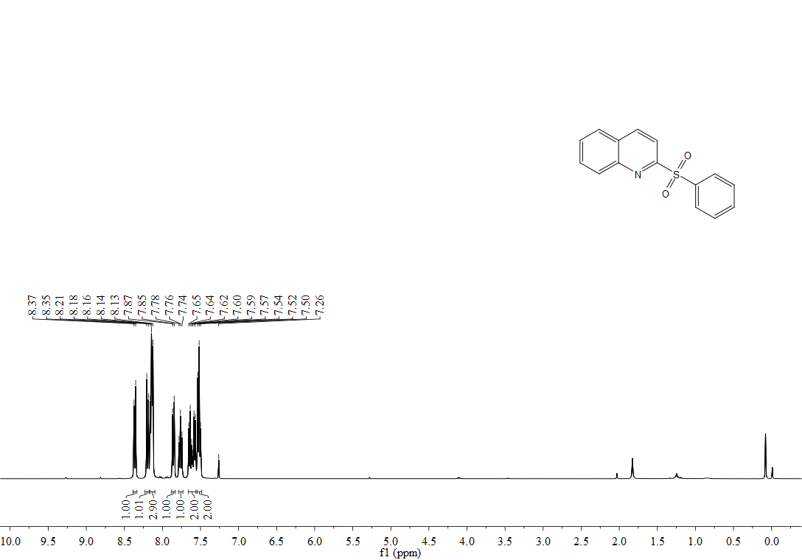
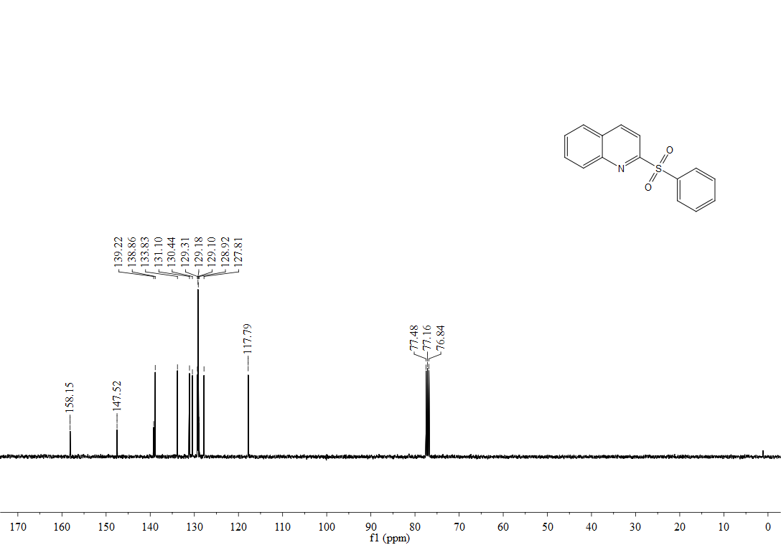
¹H, ¹³C-NMR spectra of 3ab
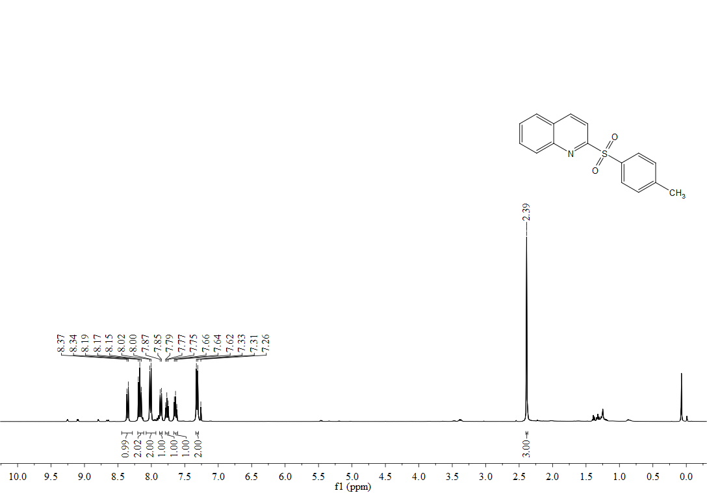
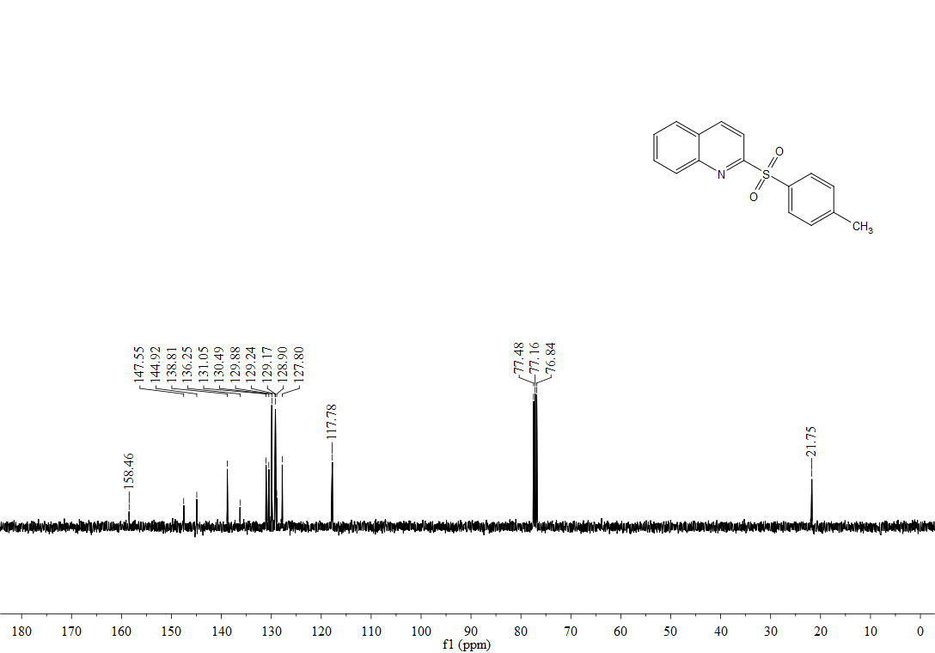

¹H, ¹³C-NMR spectra of 3ac
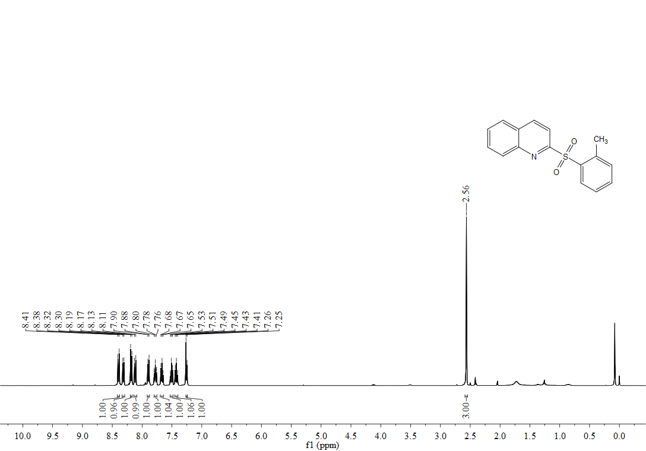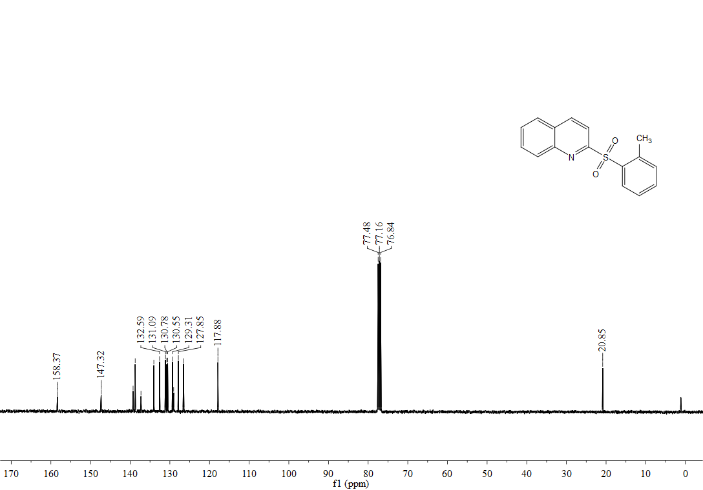

¹H, ¹³C-NMR spectra of 3ad
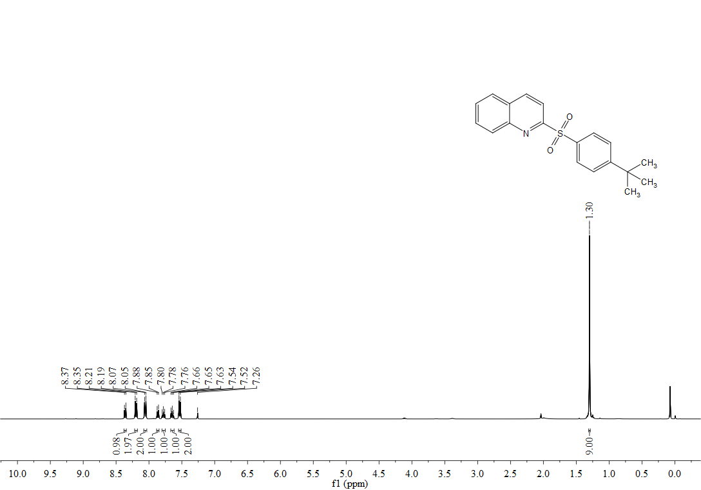
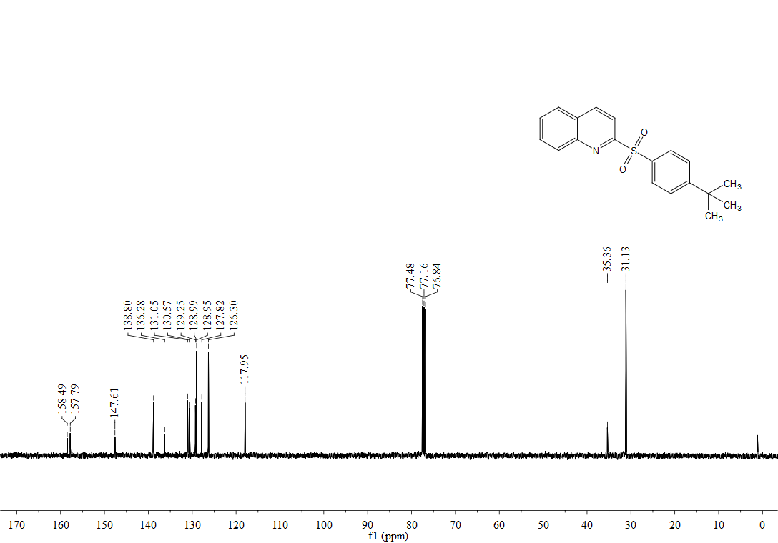

¹H, ¹³C-NMR spectra of 3ae
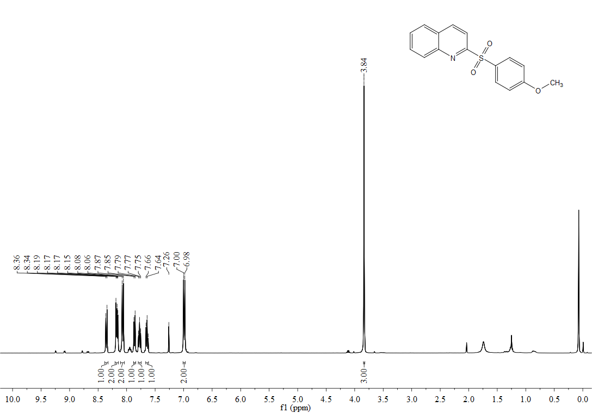
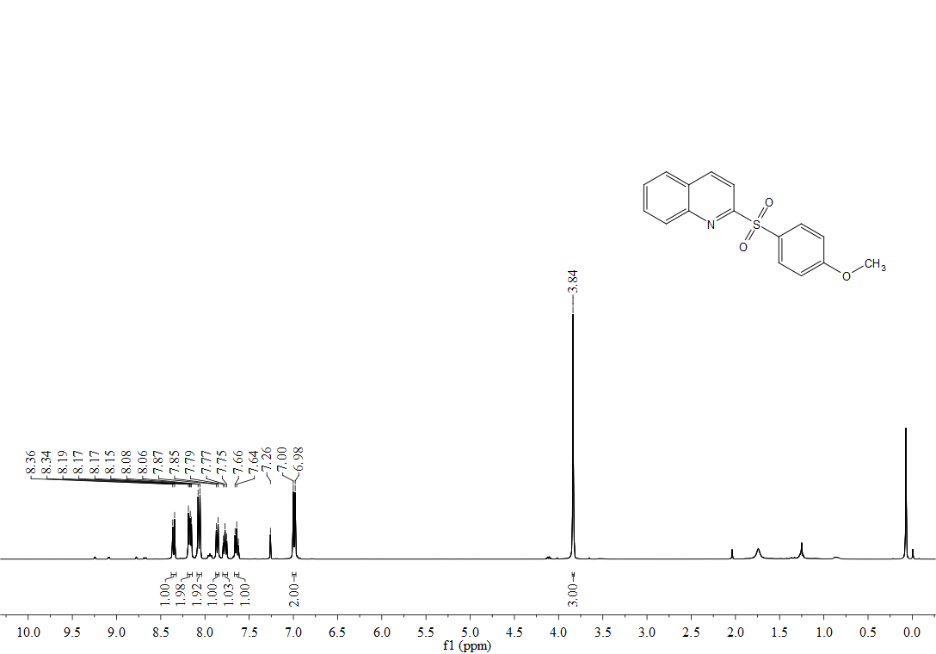

¹H, ¹⁹F,¹³C-NMR spectra of 3af
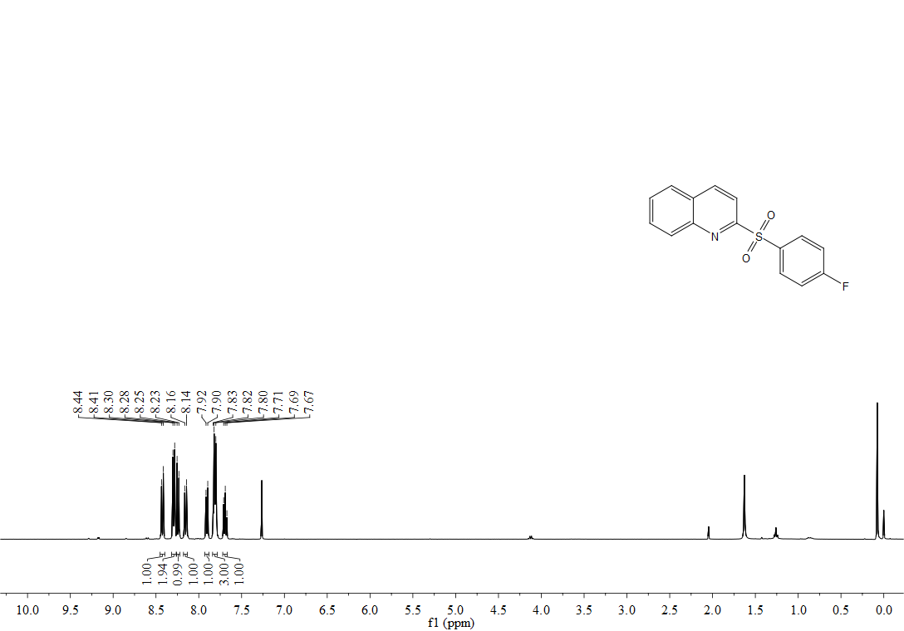

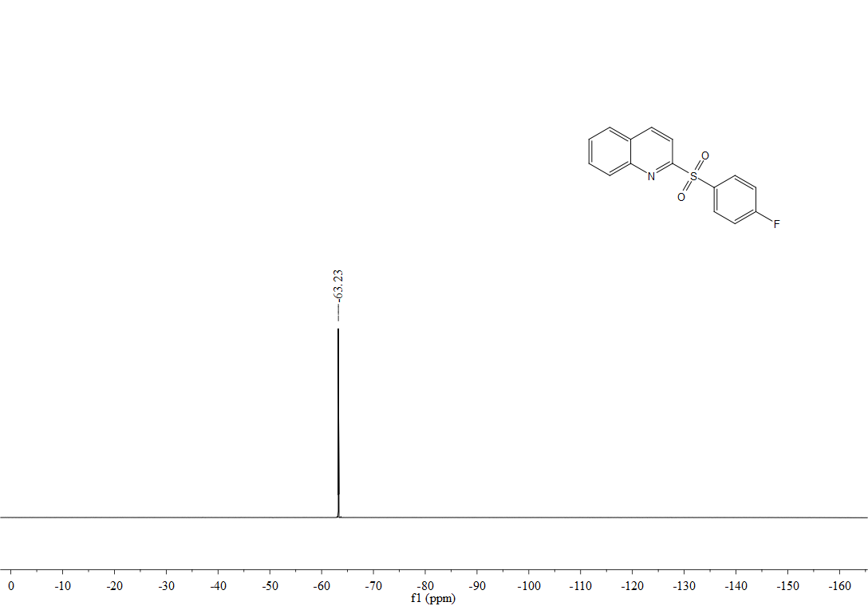
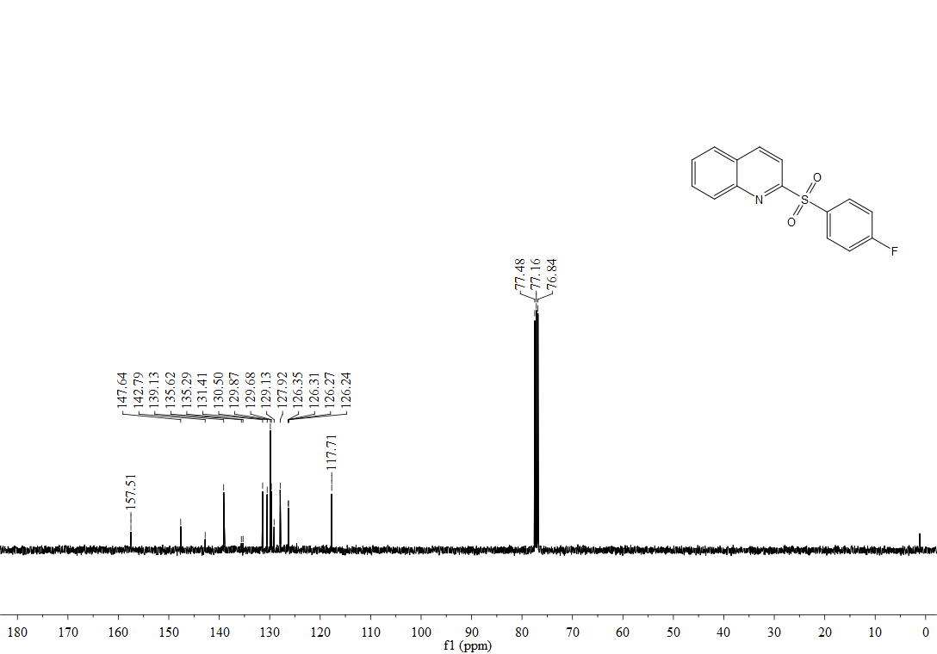

¹H, ¹³C-NMR spectra of 3ag
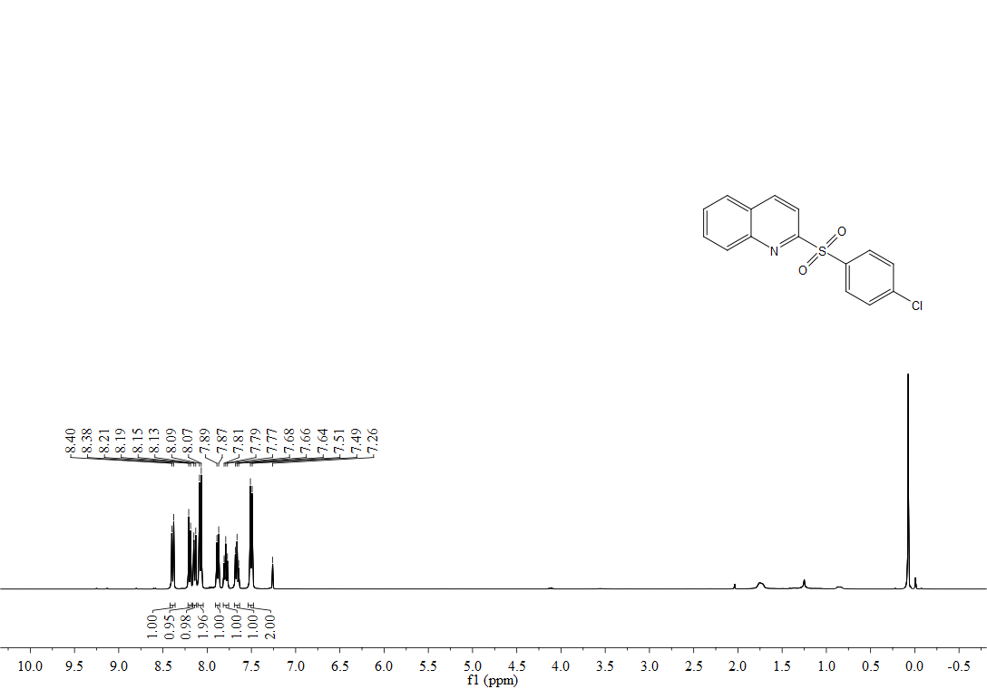
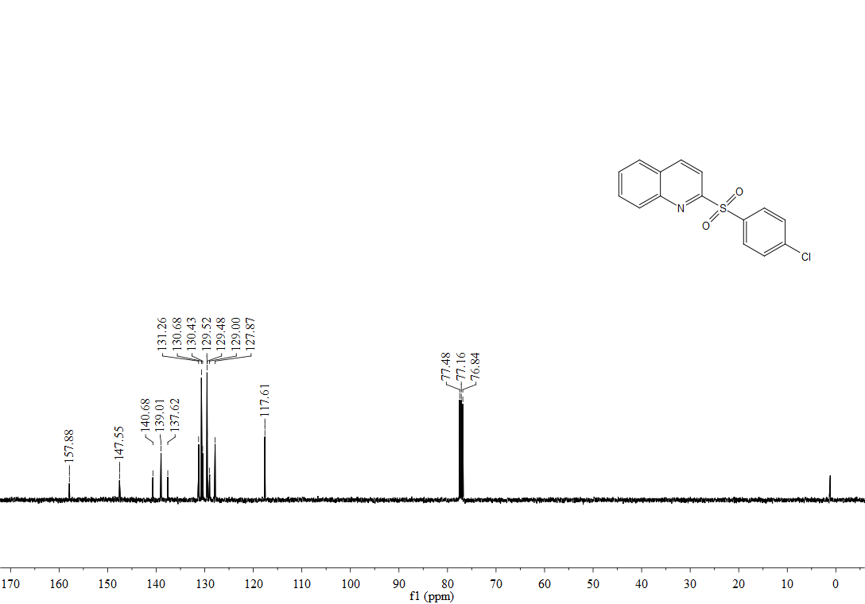

¹H, ¹³C-NMR spectra of 3ah
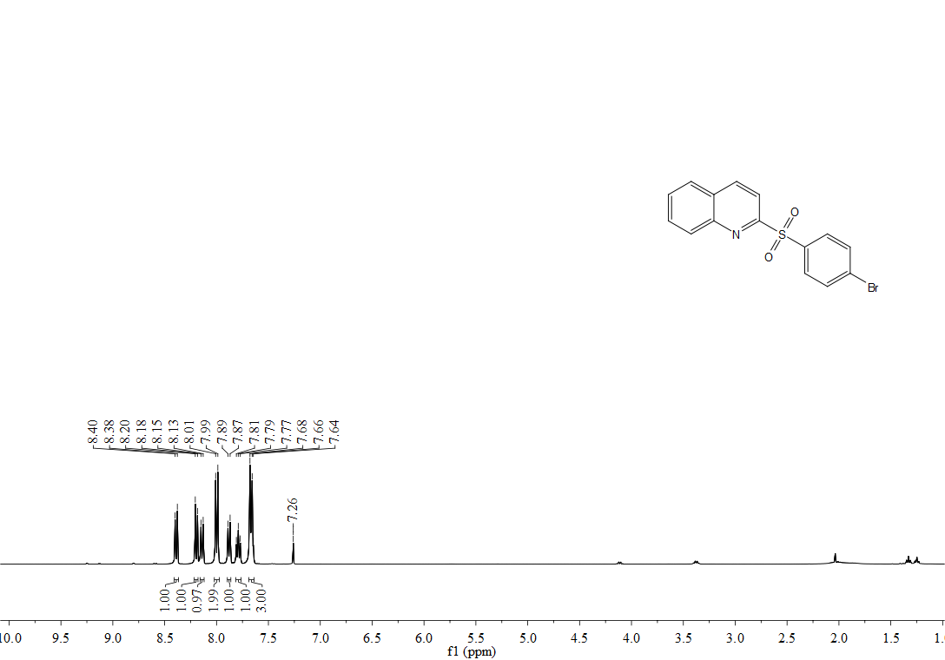
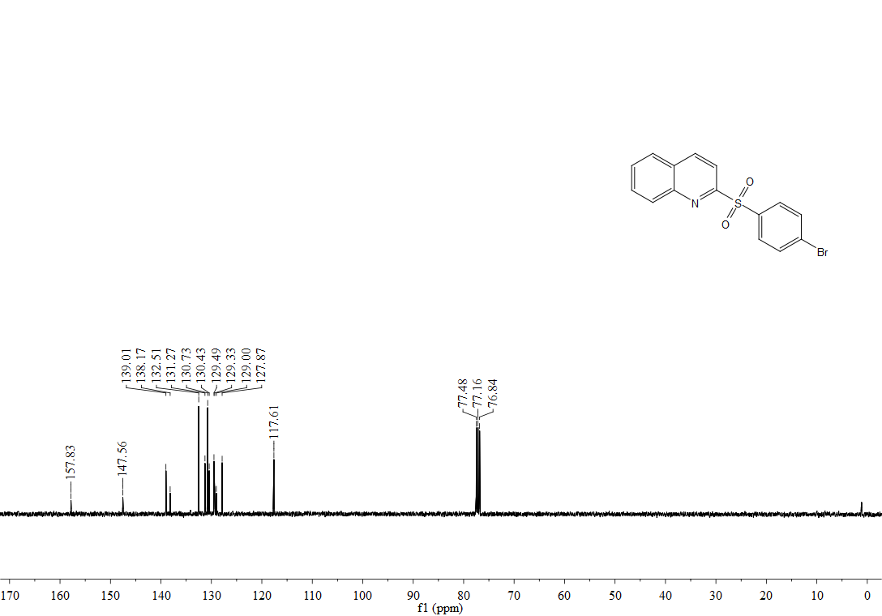

¹H, ¹³C-NMR spectra of 3ai
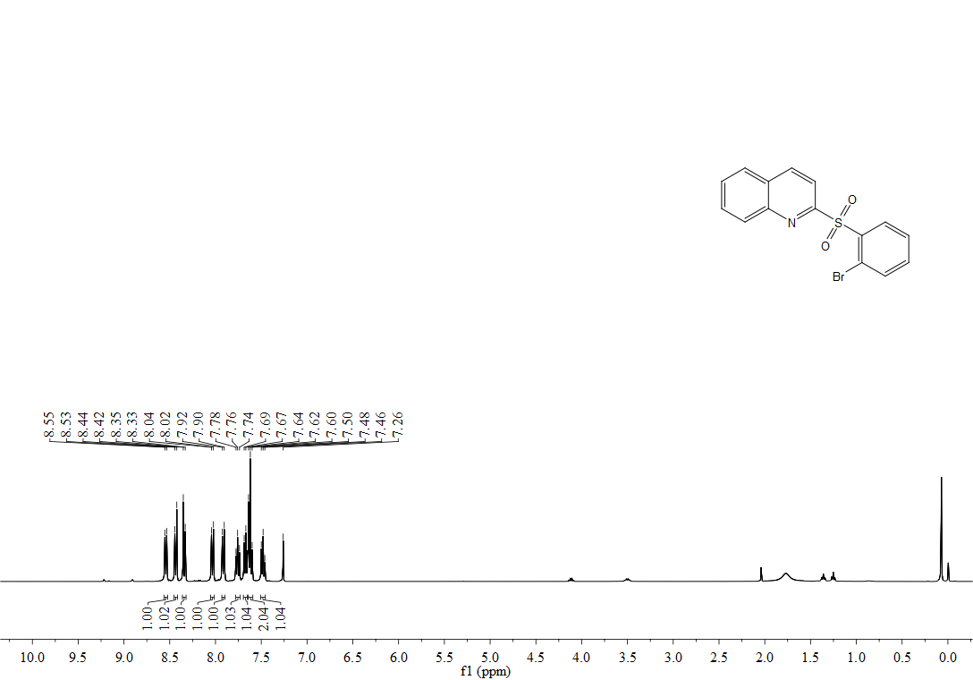
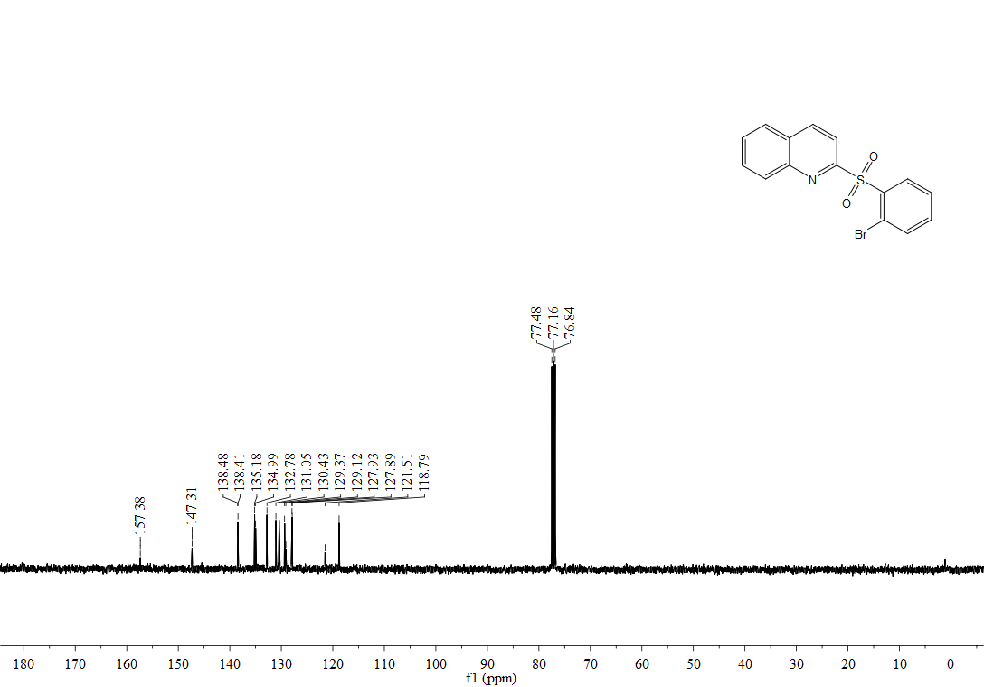

¹H, ¹³C-NMR spectra of 3aj
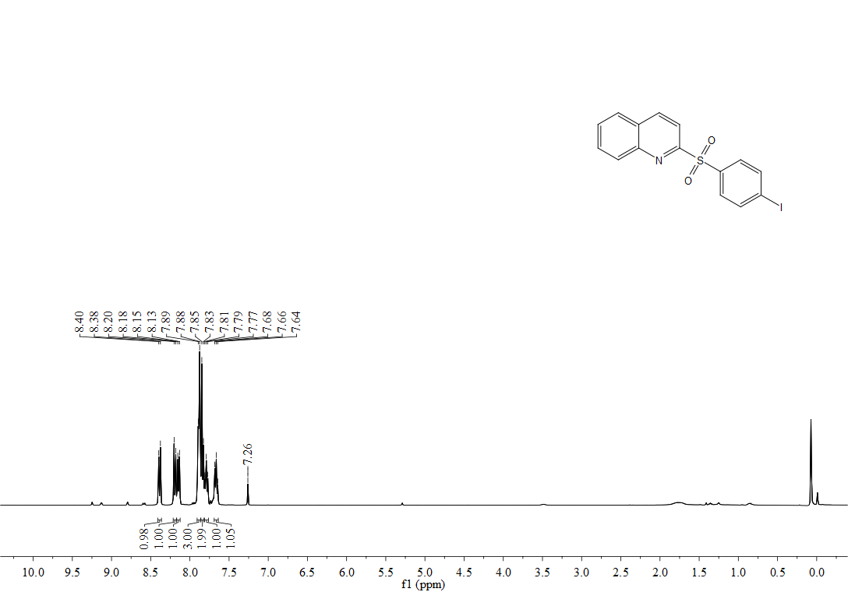
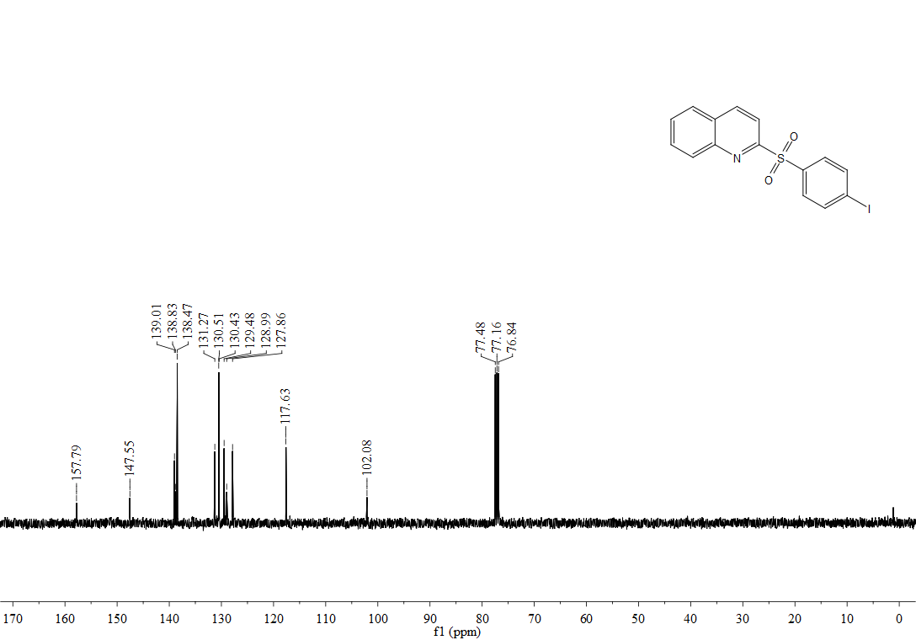

¹H, ¹⁹F,¹³C-NMR spectra of 3ak
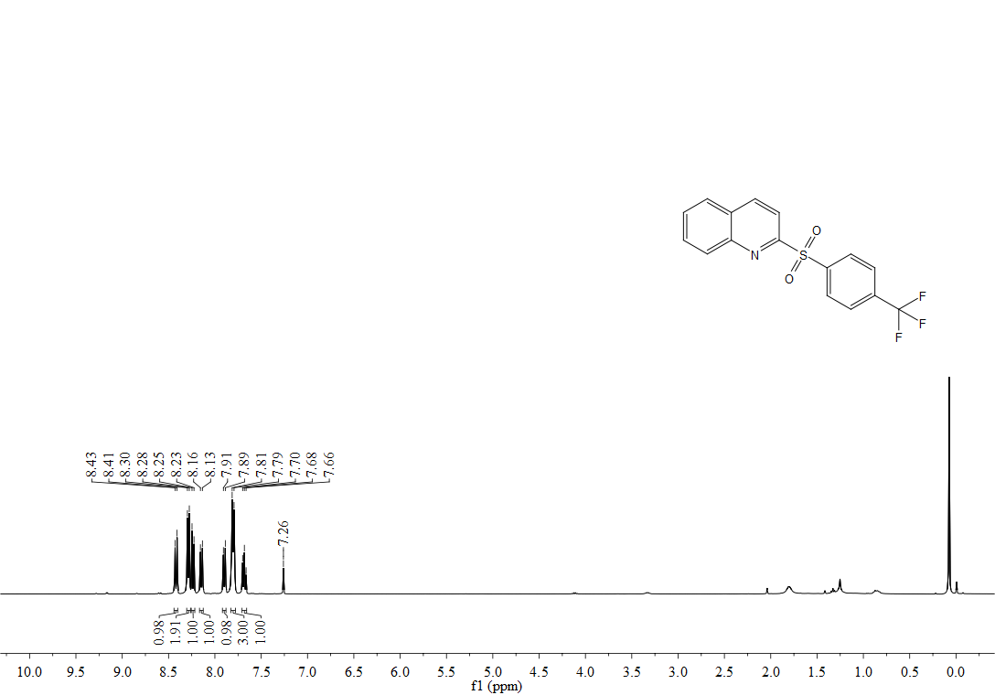
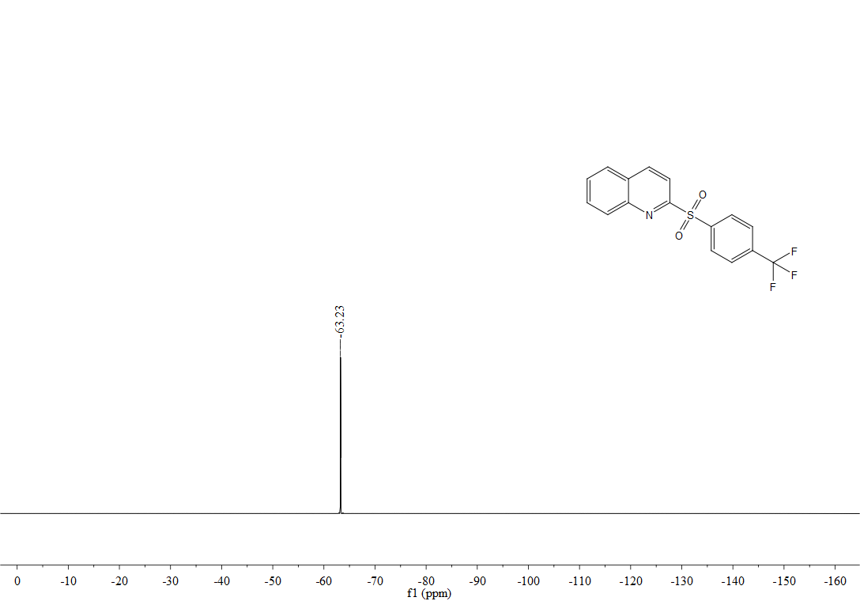
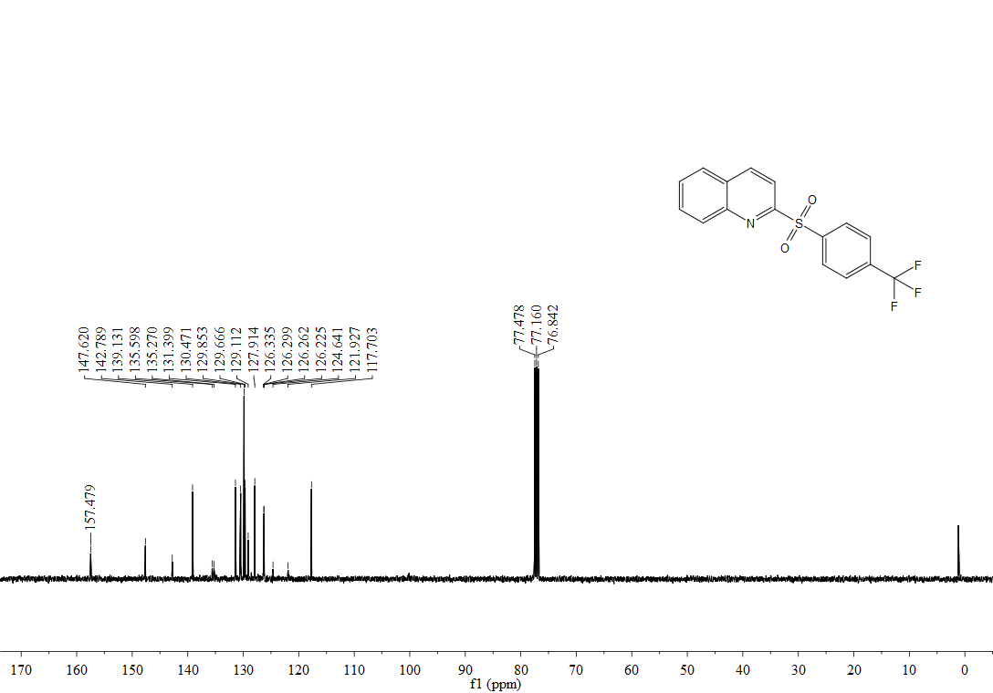

¹H, ¹³C-NMR spectra of 3al
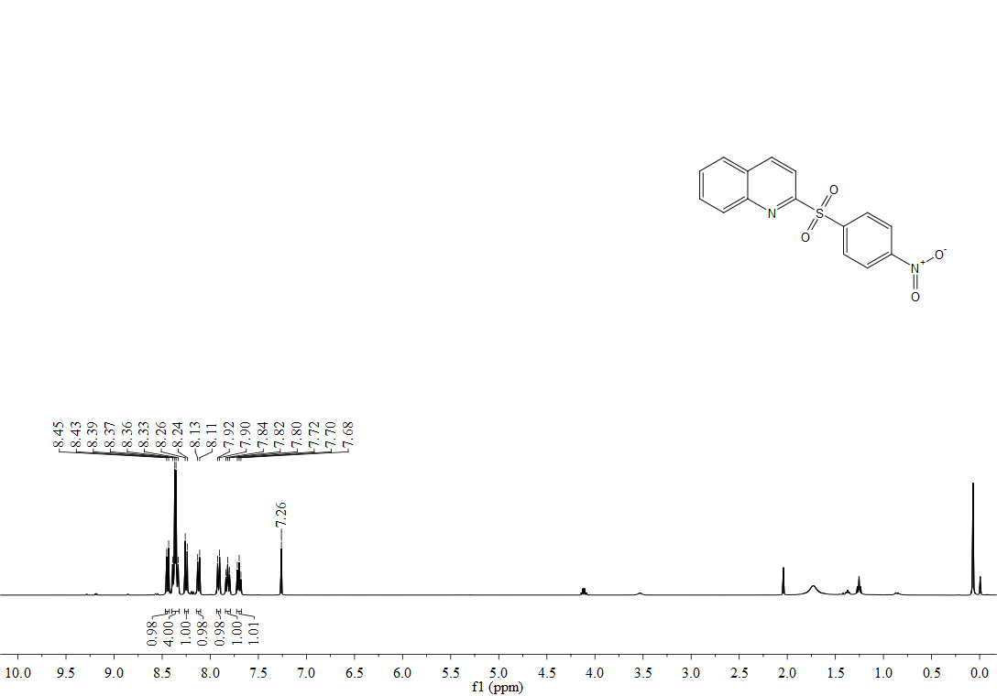
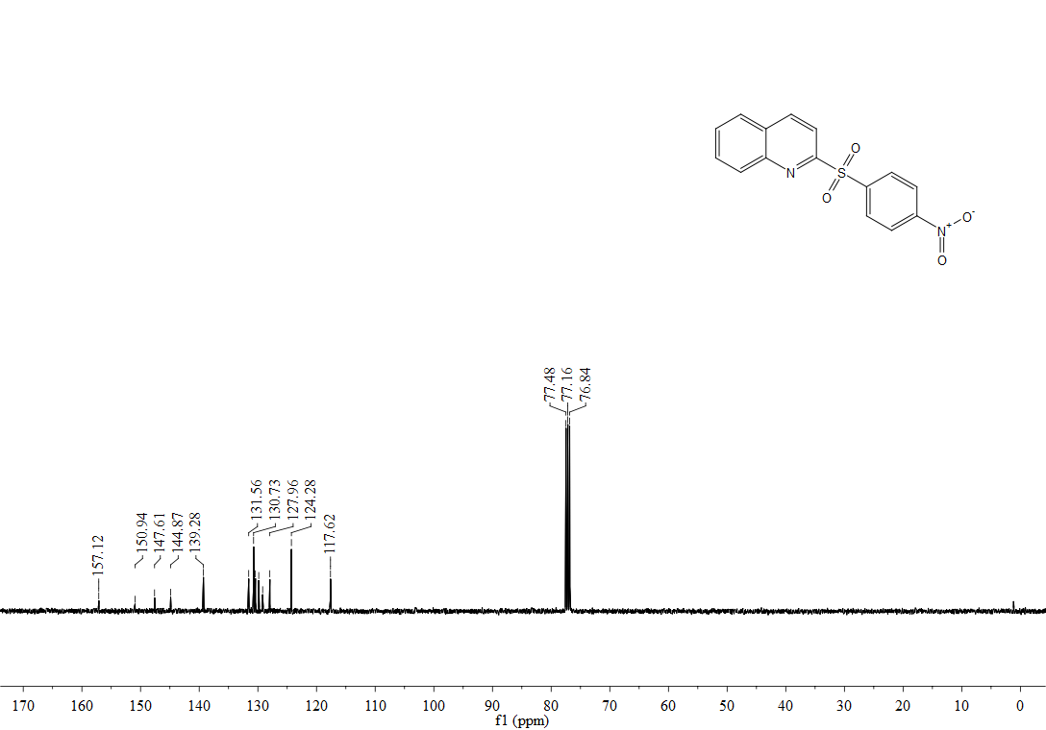

¹H, ¹³C-NMR spectra of 3am
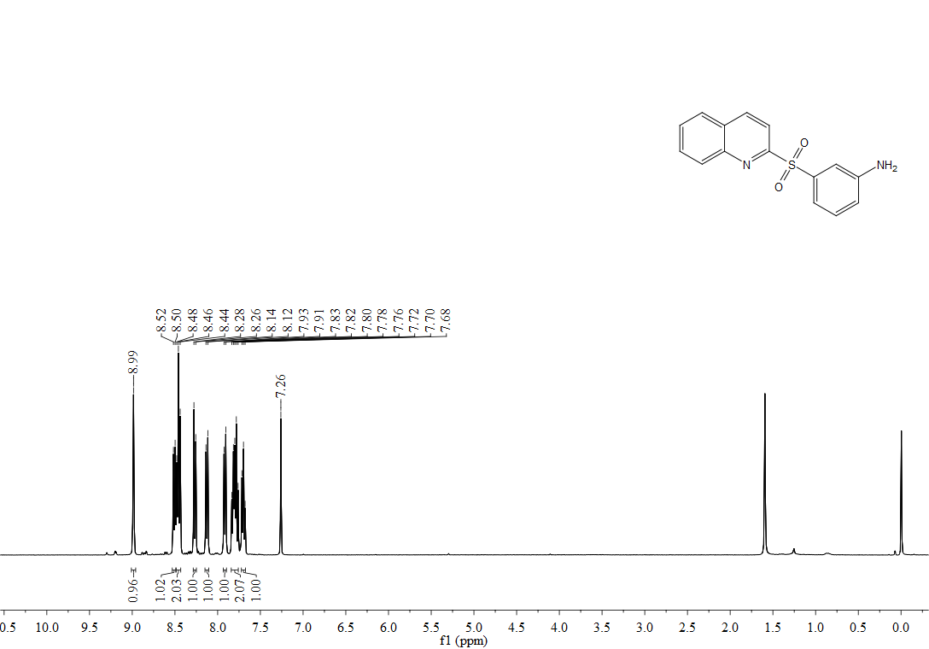
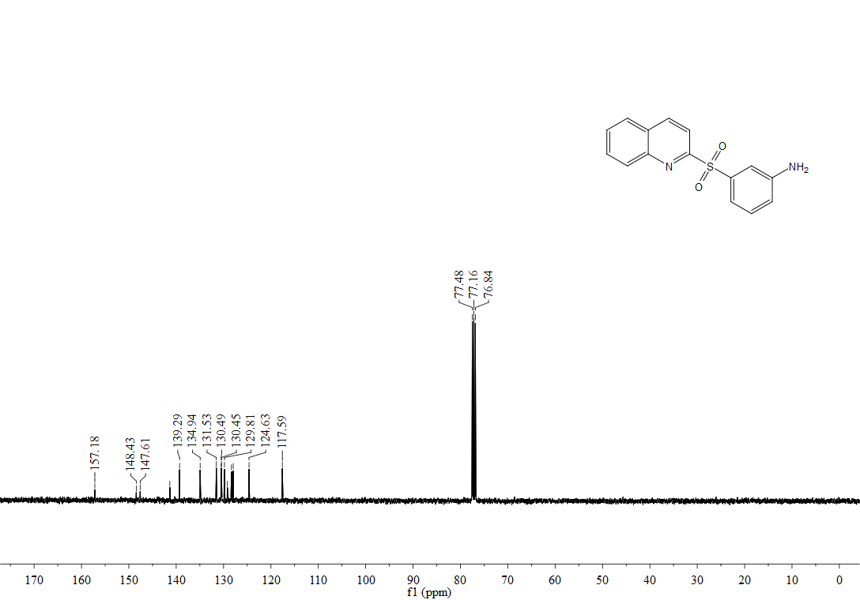

¹H, ¹³C-NMR spectra of 3an
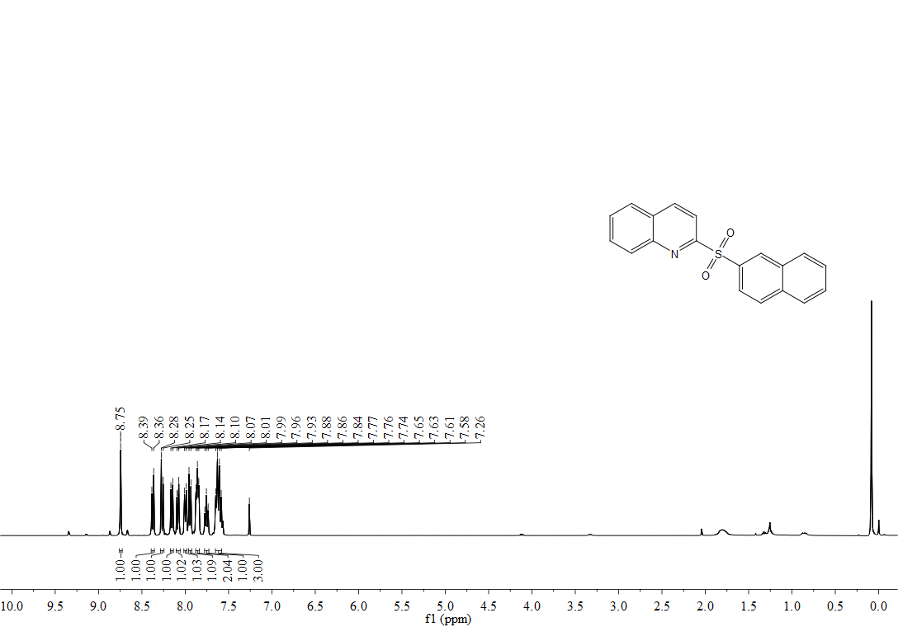
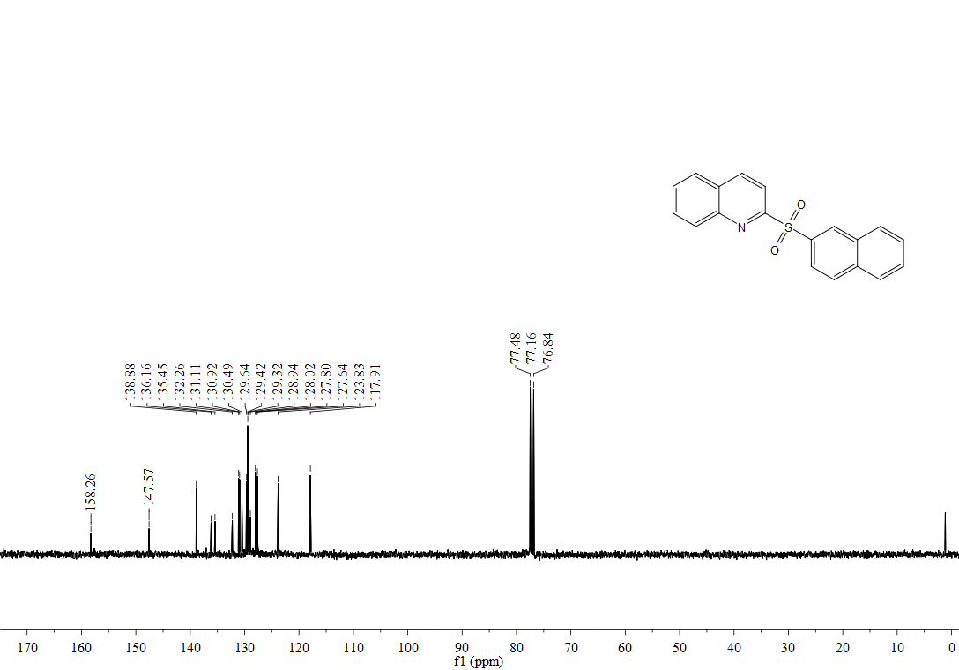

¹H, ¹³C-NMR spectra of 3ao
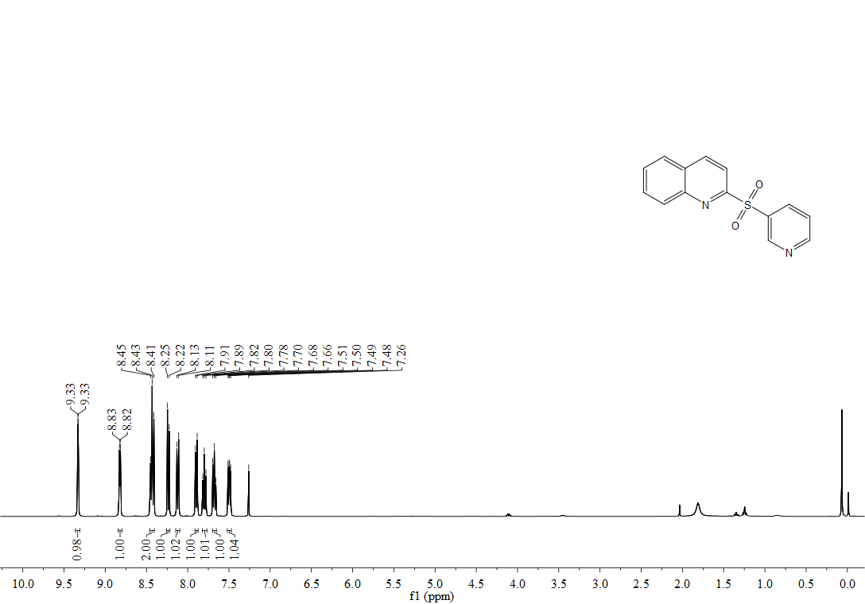
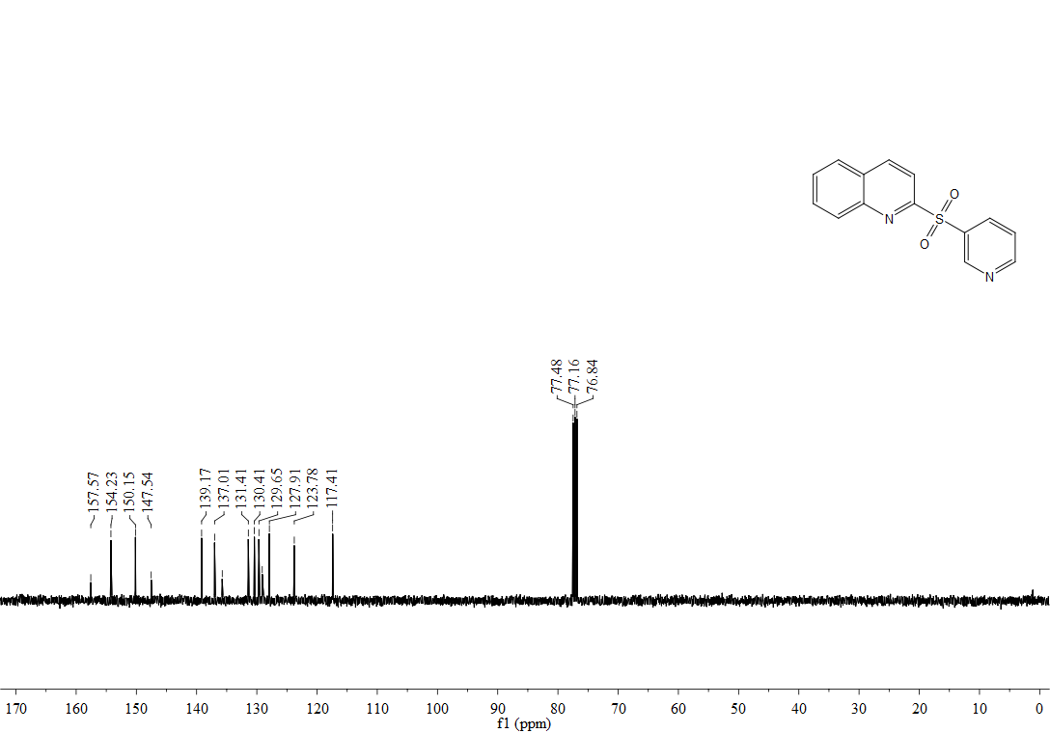

¹H, ¹³C-NMR spectra of 3ap
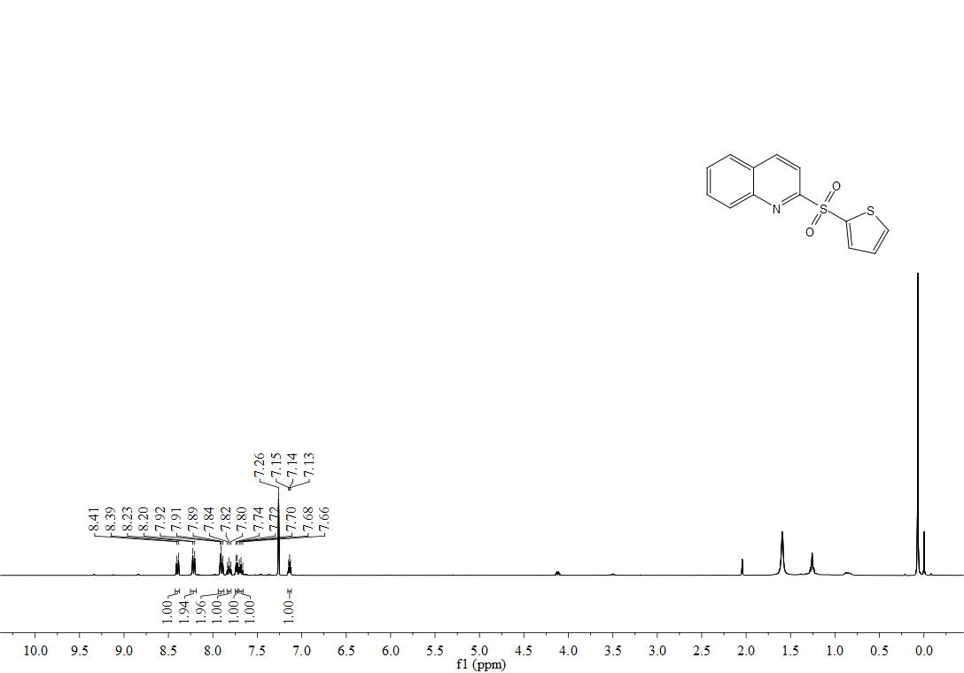
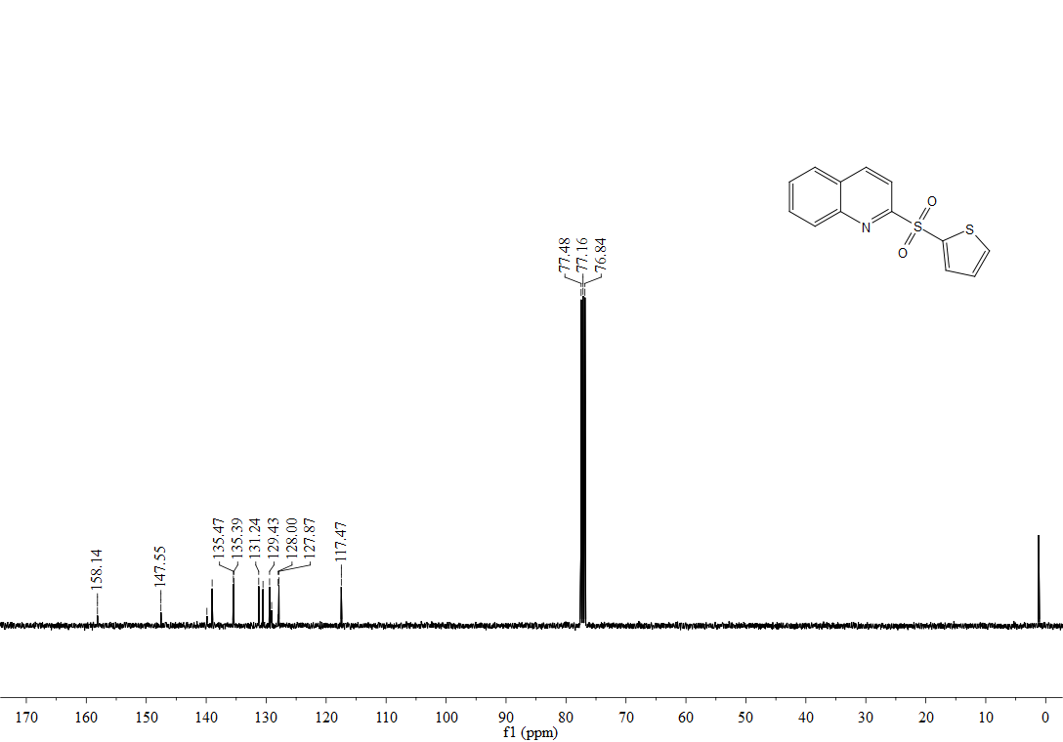

¹H, ¹³C-NMR spectra of 3aq
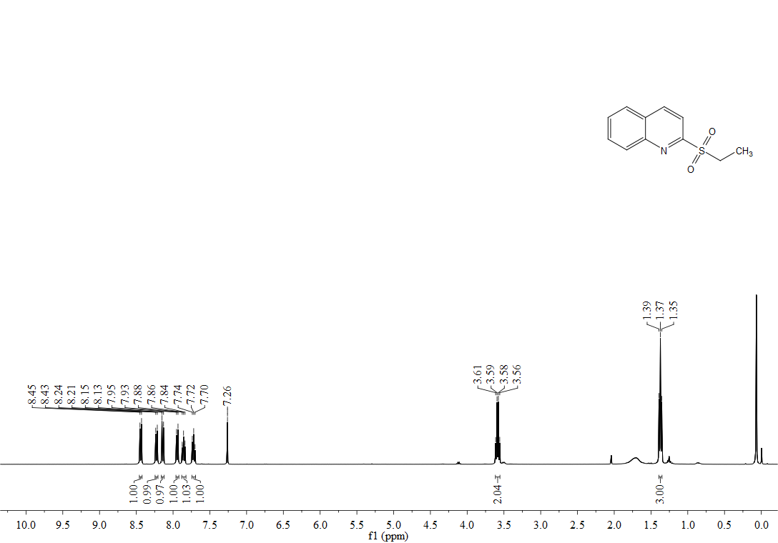
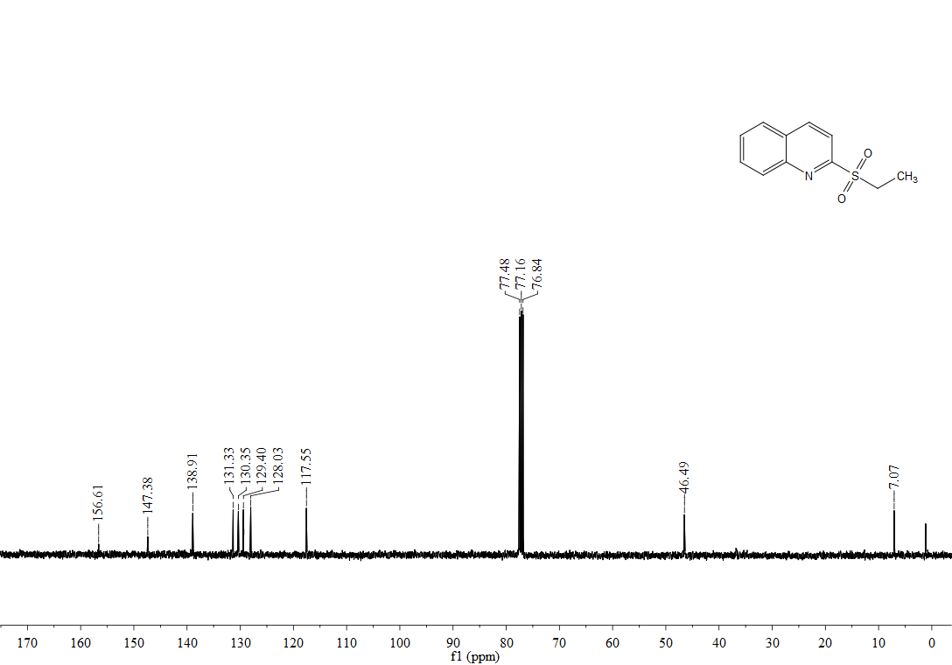

¹H, ¹³C-NMR spectra of 3ba
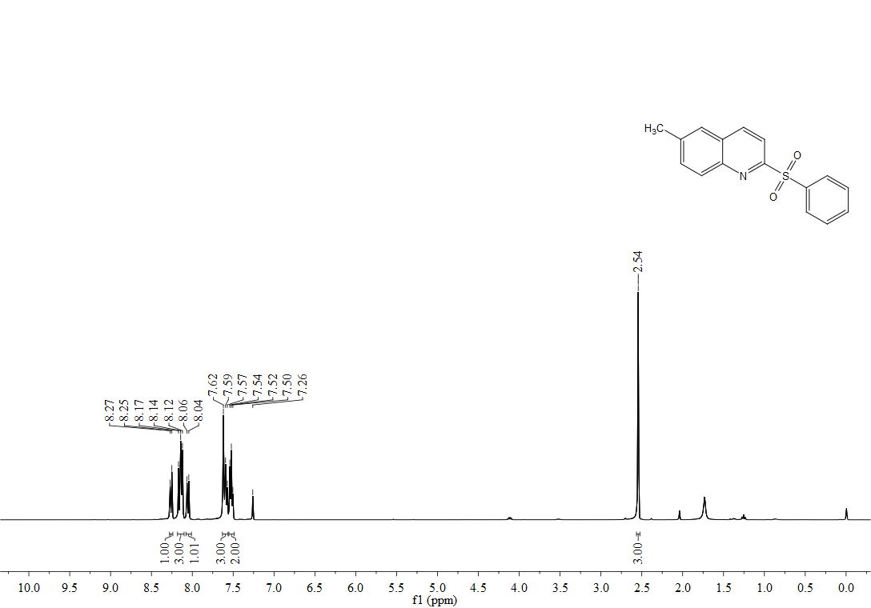
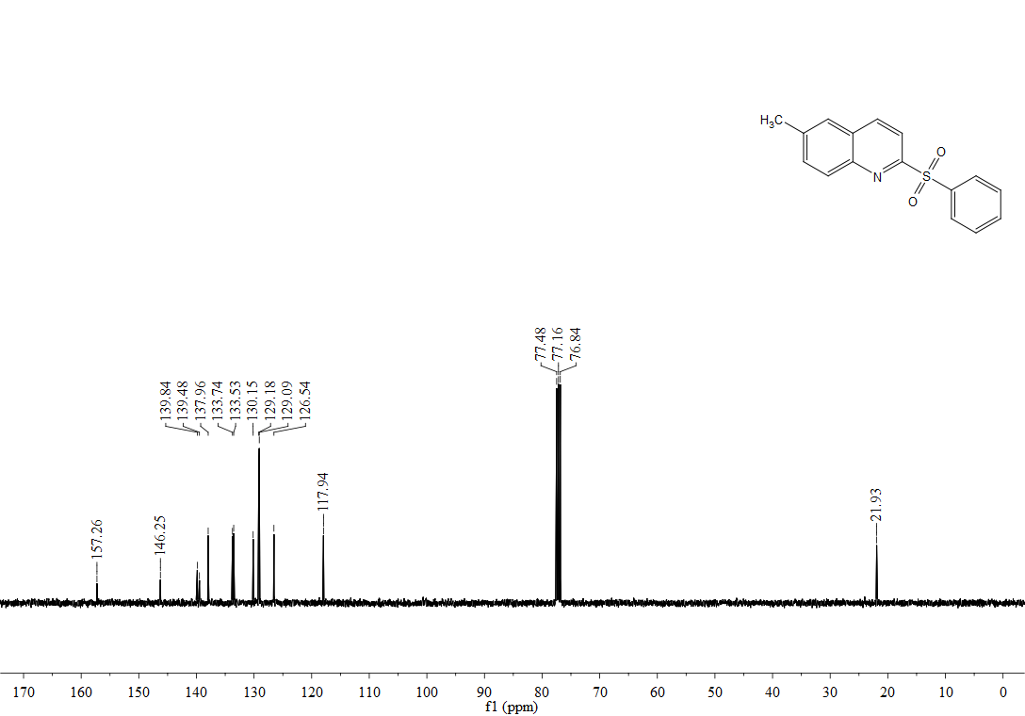

¹H, ¹³C-NMR spectra of 3ca
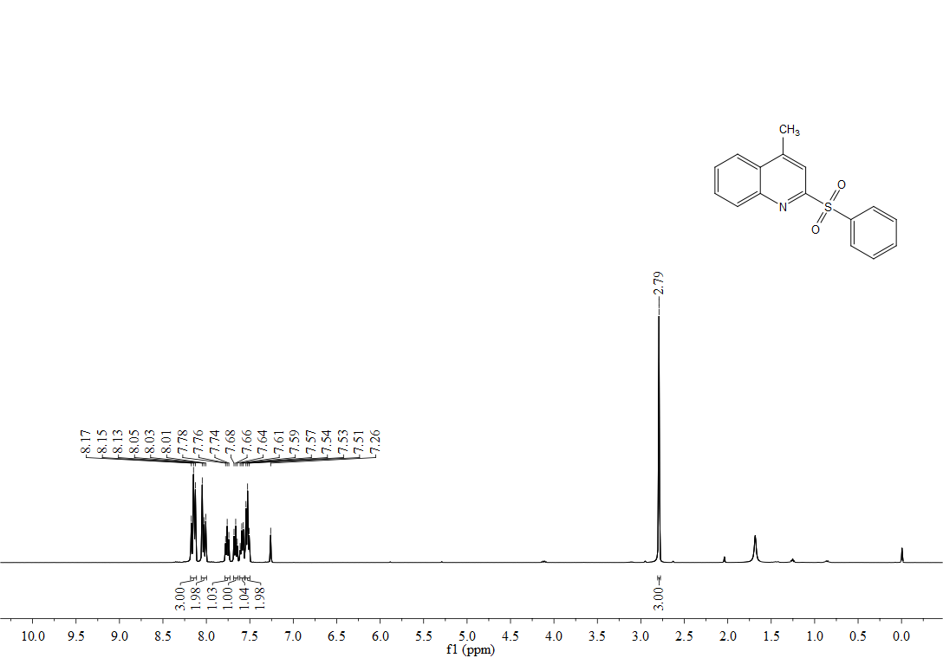
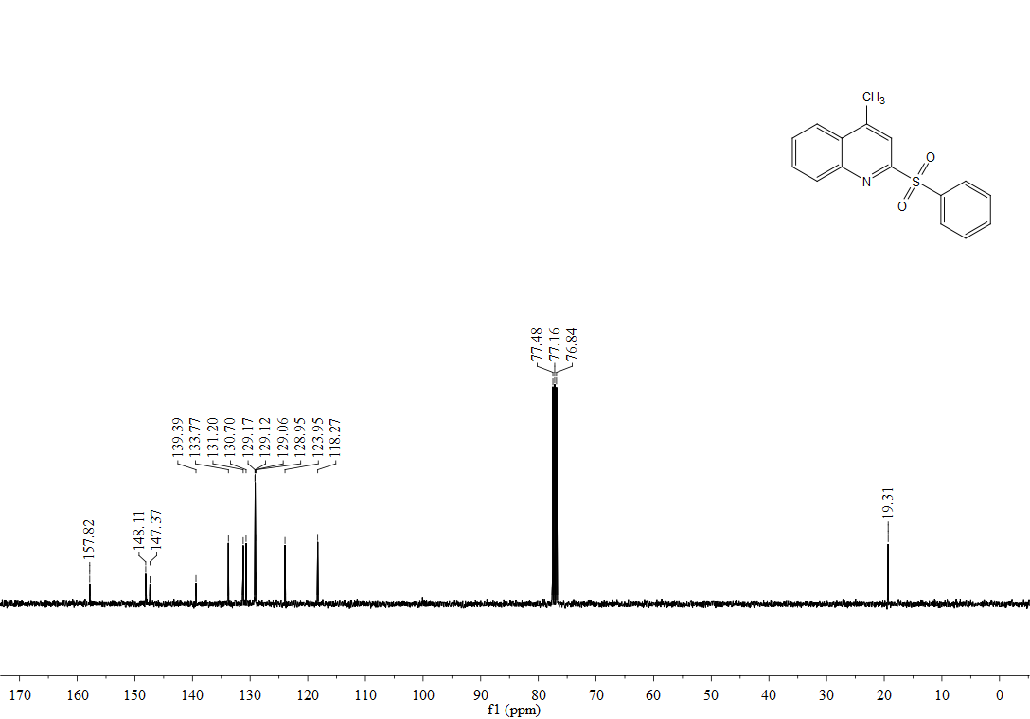

¹H, ¹³C-NMR spectra of 3da
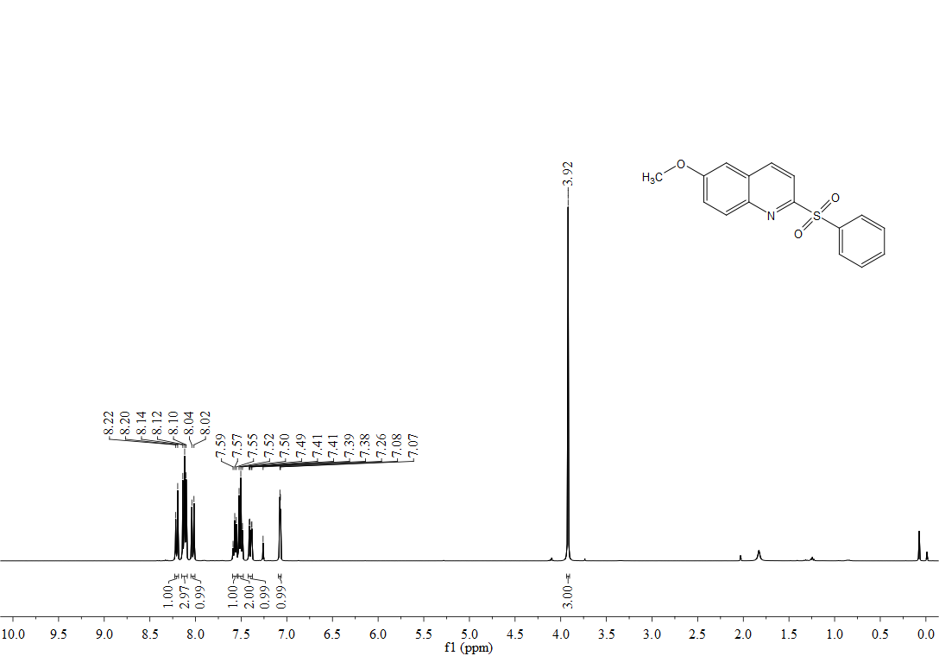
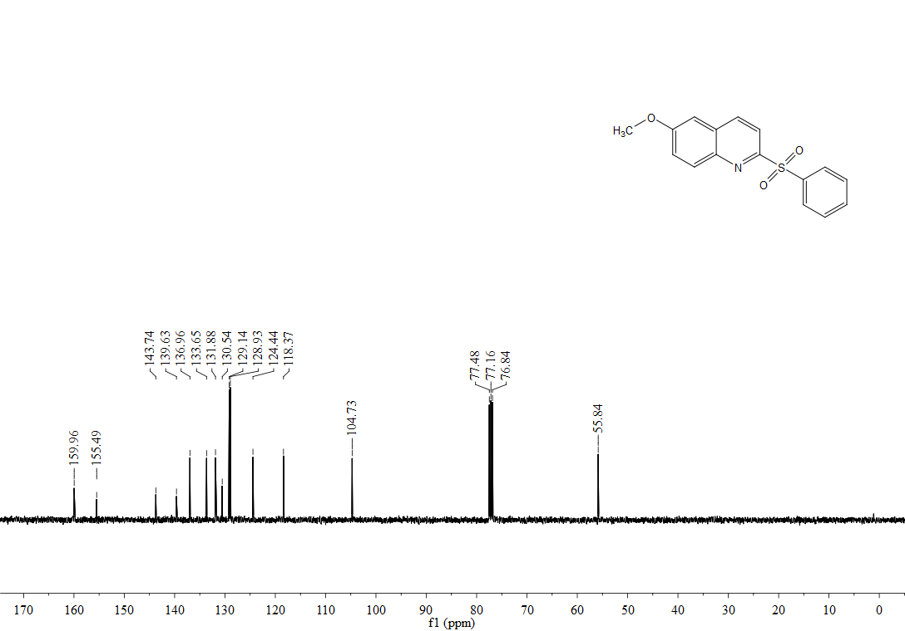

¹H, ¹⁹F, ³C-NMR spectra of 3ea
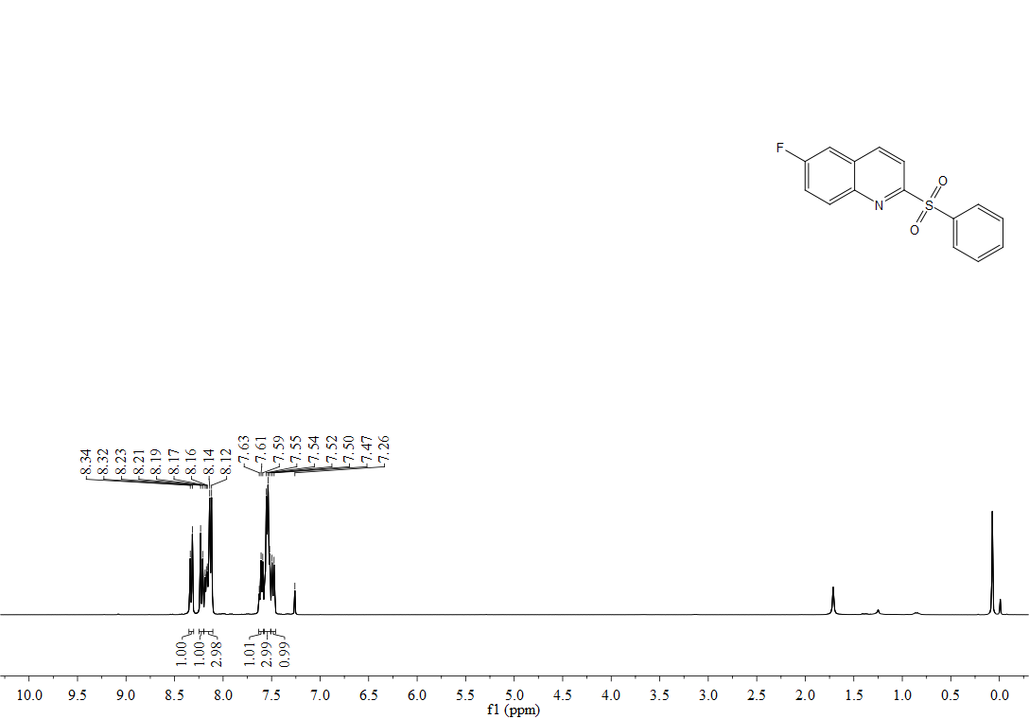
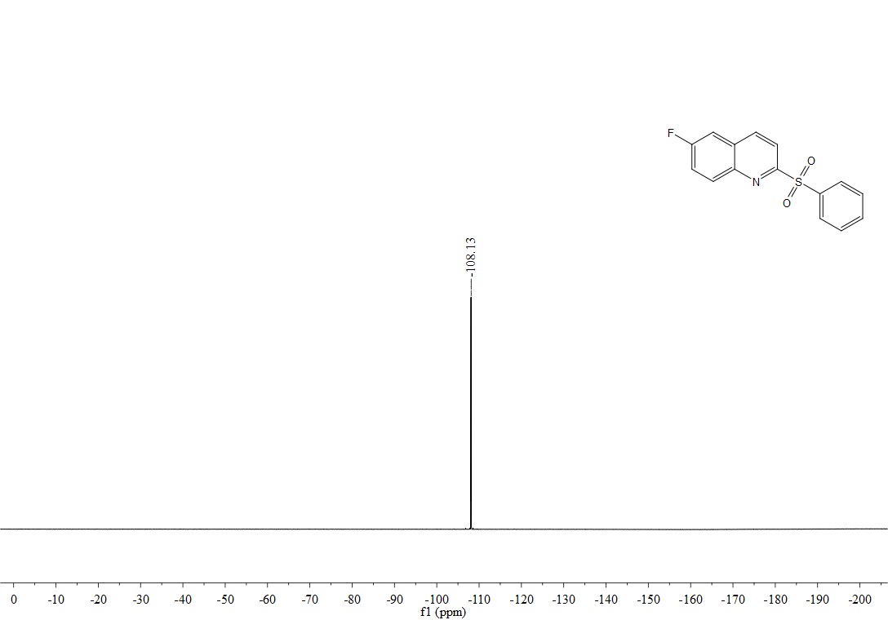
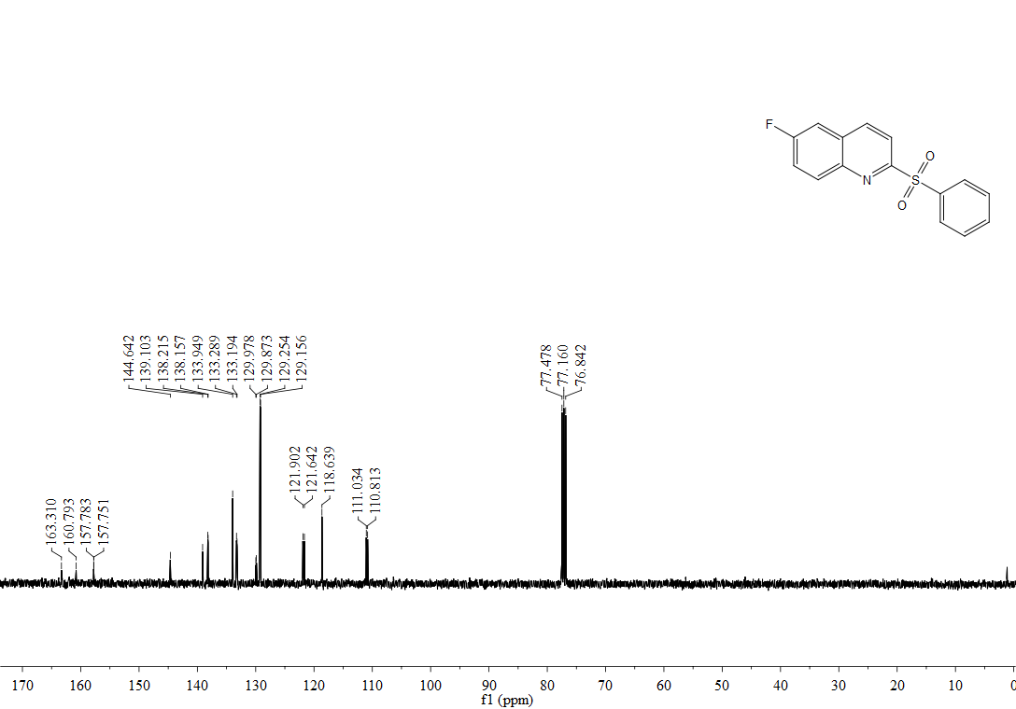

¹H, ¹³C-NMR spectra of 3fa
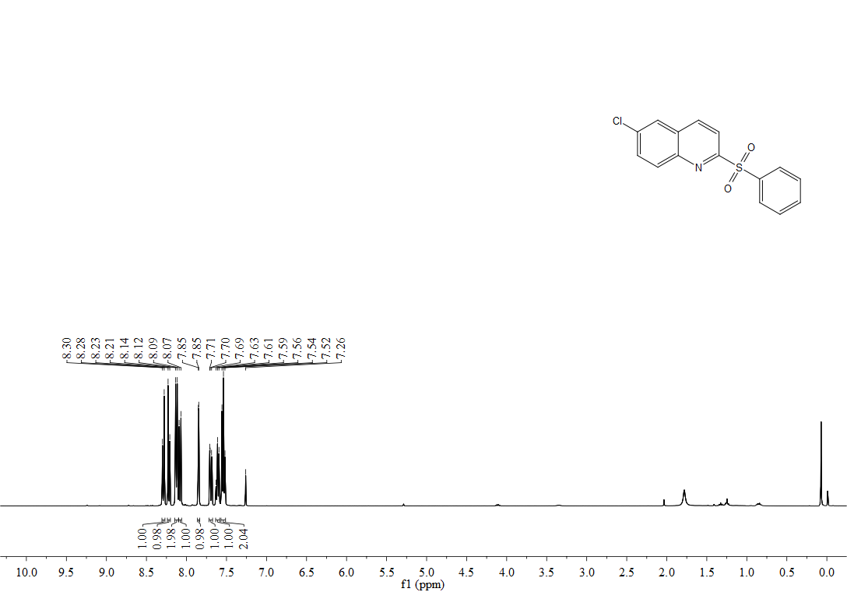
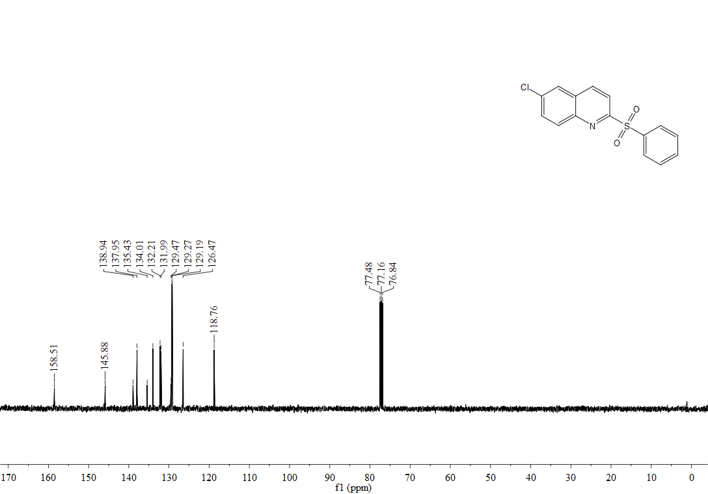

¹H, ¹³C-NMR spectra of 3ga
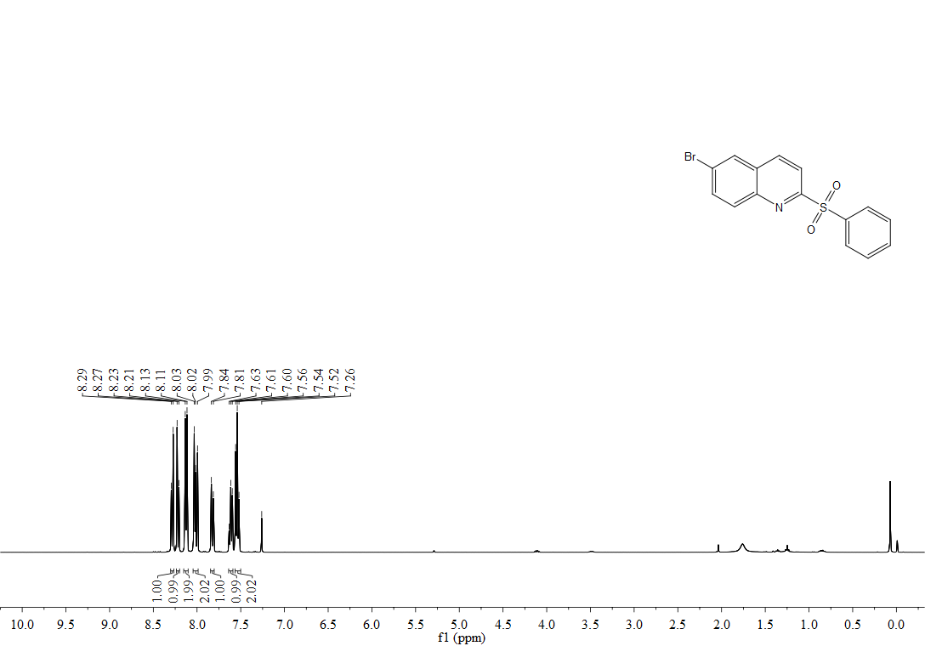
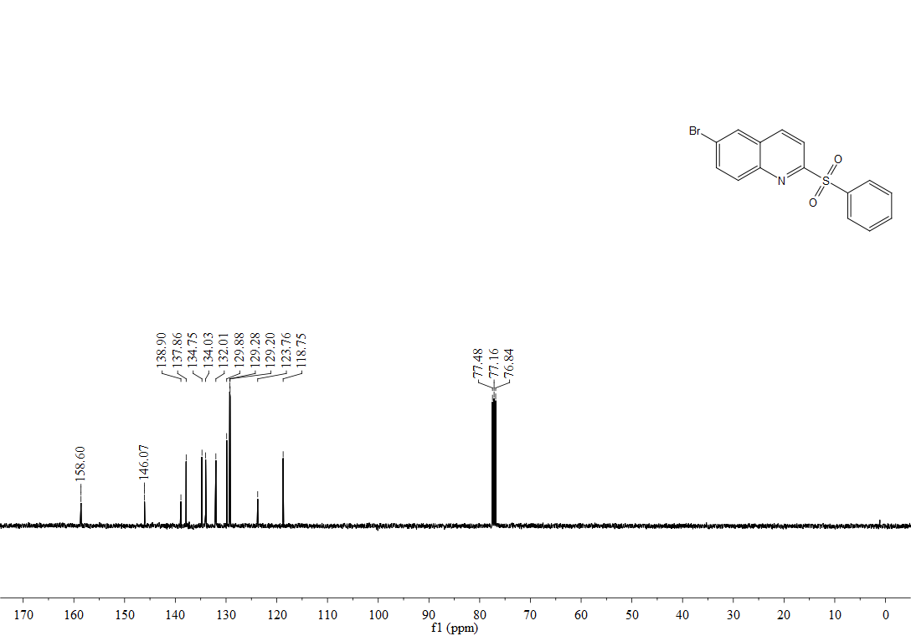

¹H, ¹³C-NMR spectra of 3ha
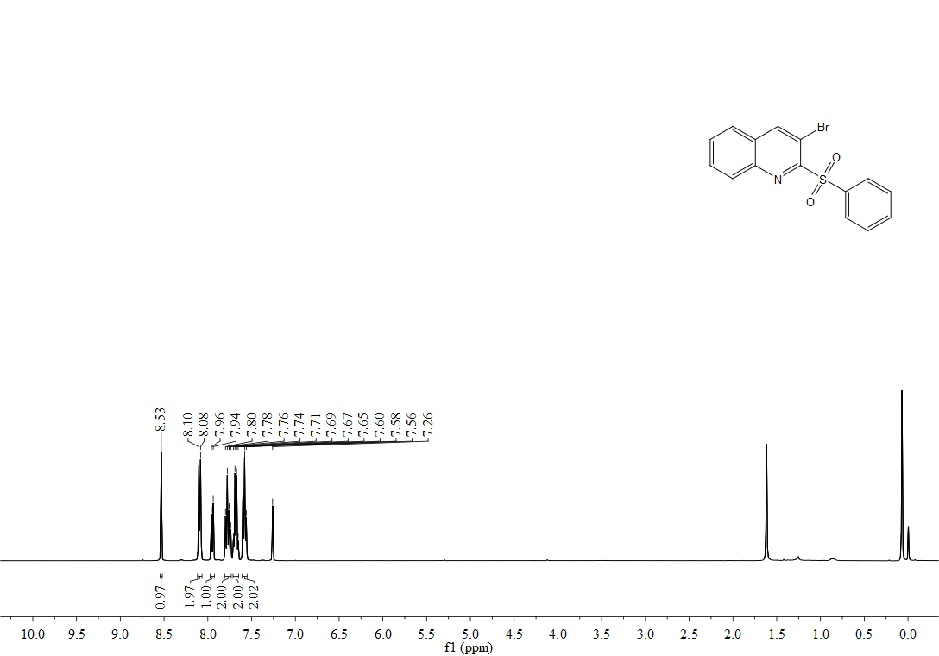
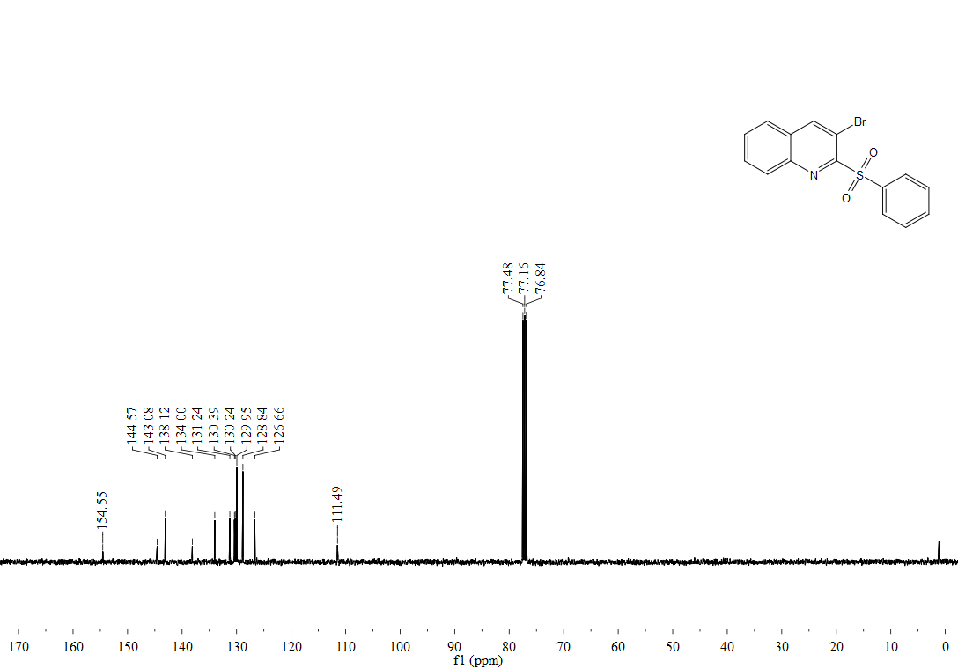

¹H, ¹³C-NMR spectra of 3ia
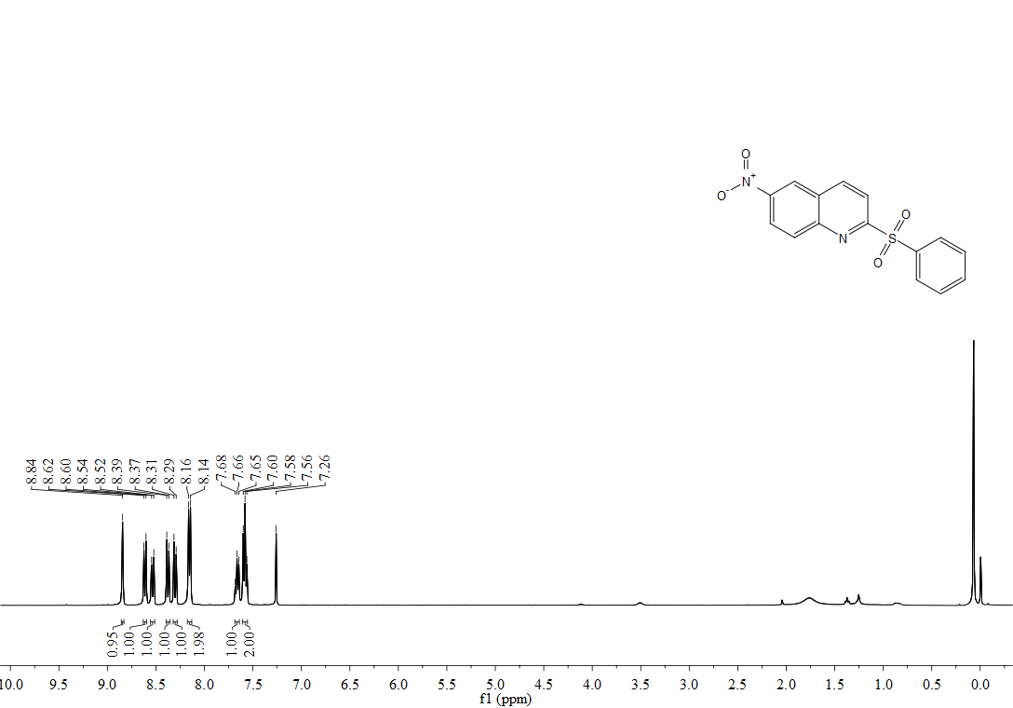
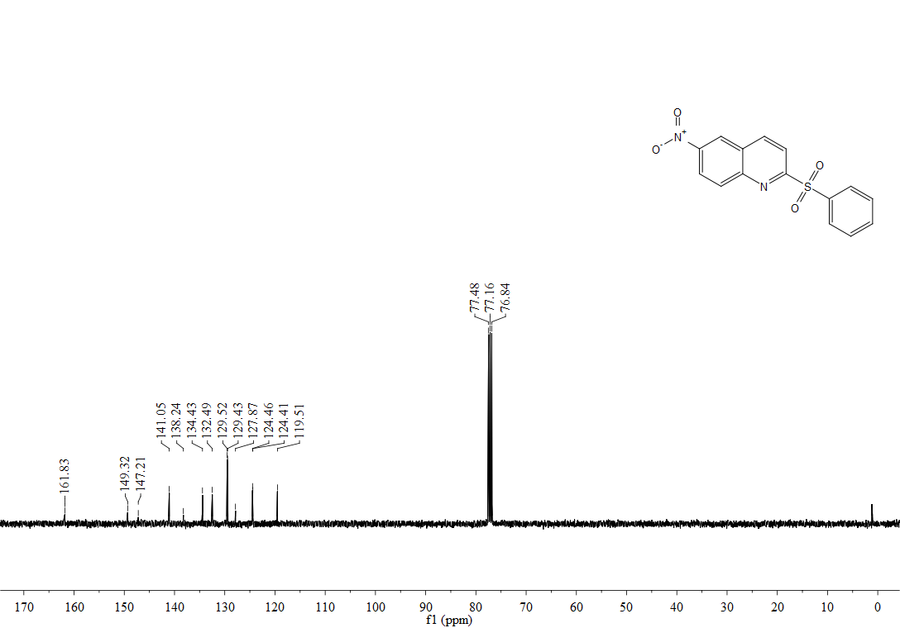

¹H, ¹³C-NMR spectra of 3ja
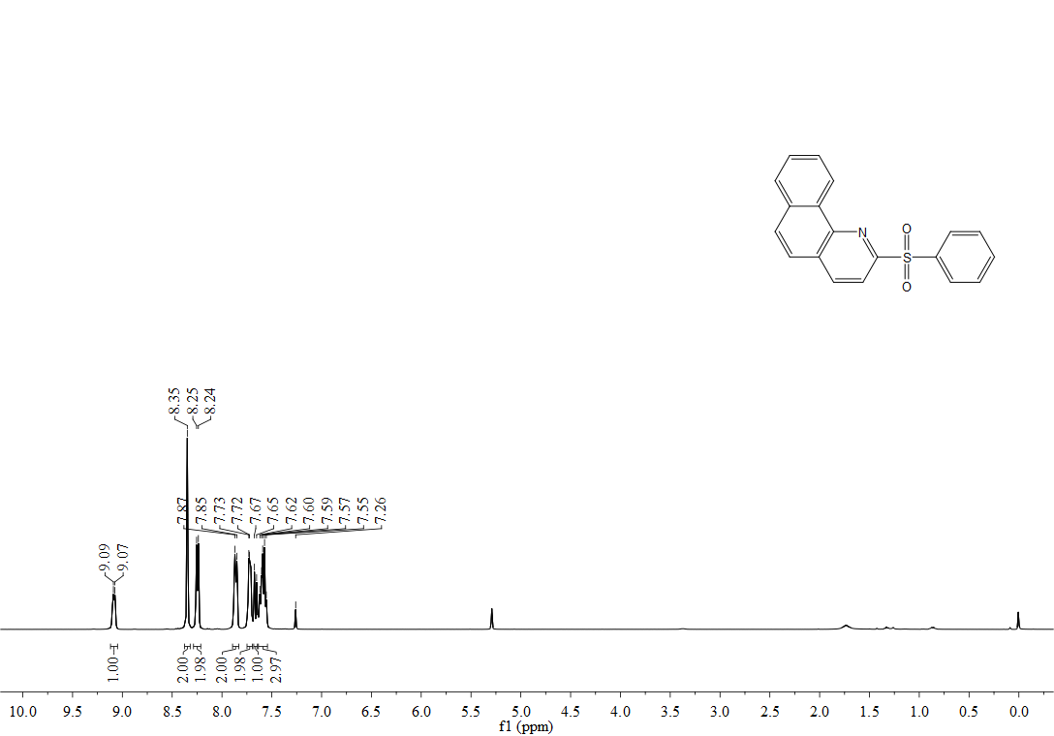
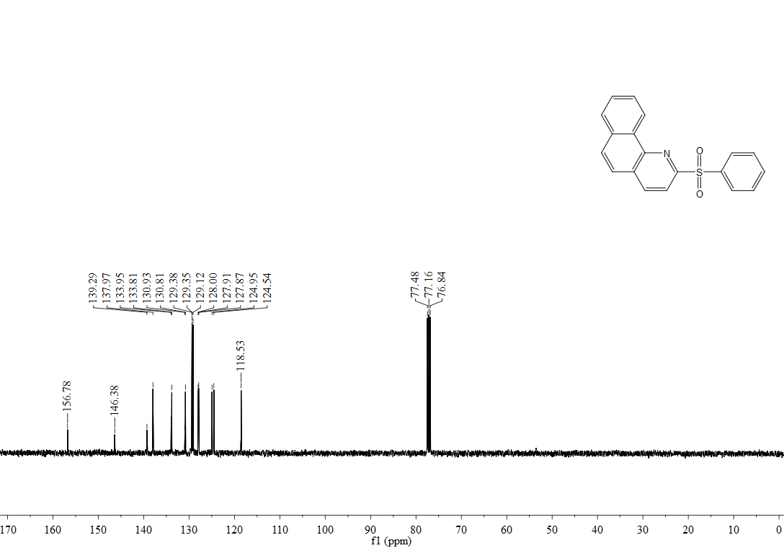

¹H, ¹³C-NMR spectra of 3l’a
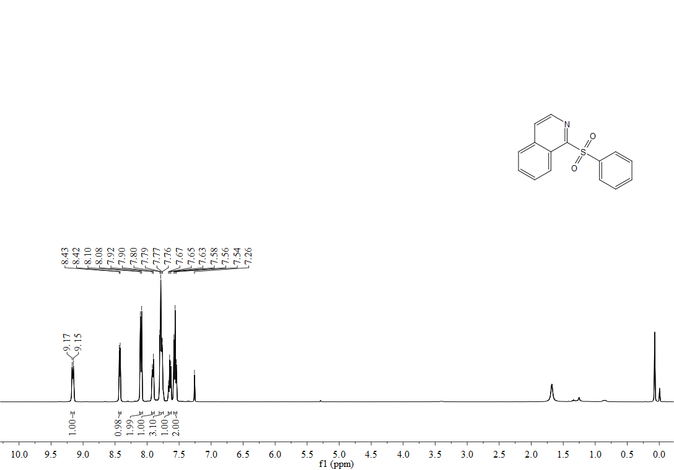
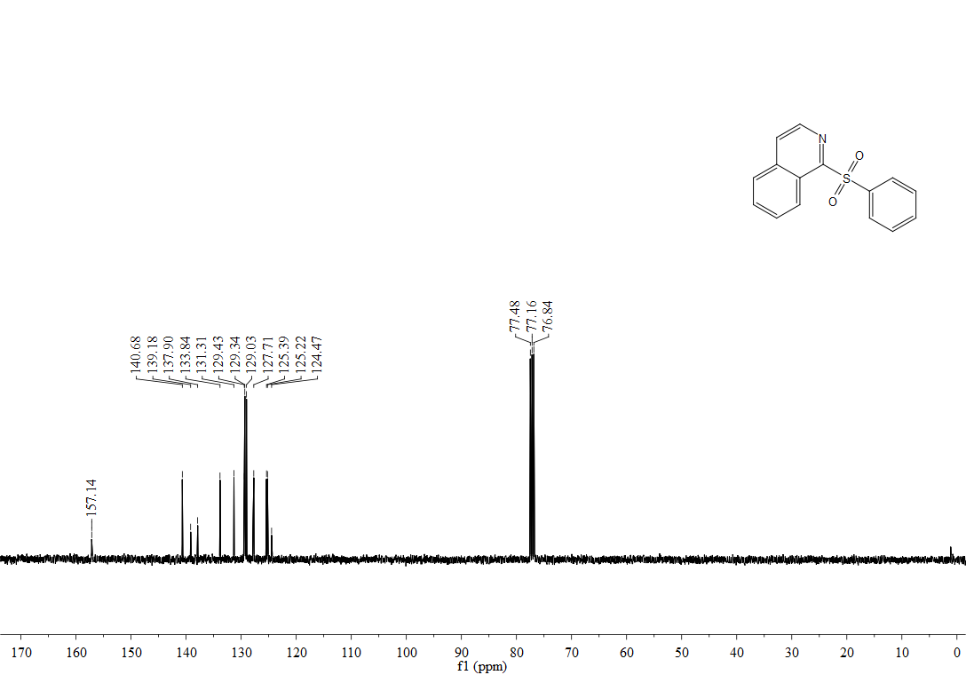

¹H, ¹³C-NMR spectra of 3la
