**SUPPORTING INFORMATION**

**Unexpected Formation of *β*,*meso*-Directly Linked Diporphyrins**

**underAdler-Longo Reaction Conditions**

Baris Temelli*, Hilal Kalkan

Hacettepe University, Department of Chemistry, 06800, Ankara, Turkey

[temelli@hacettepe.edu.tr](mailto:temelli@hacettepe.edu.tr)

**Synthesis of Compound 1b.**

The mixture of 5,10,15,20-*p*-isopropyltetraphenylporphyrin **4** (0.245 mmol) and Cu(OAc)2 in 40 mL toluene/methanol (7:2) was refluxed at 120 oC for 7 hours. The mixture was cooled to room temperature and the solvent was removed under reduced pressure. The crude product was washed with hot water. Dried copper complex (0.240 mmol) was dissolved in DCE (20 mL) and added dropwise to the mixture of DMF (24.4 mmol) and POCl3 (15.8 mmol) at 0 oC under N2 atmosphere. The mixture was refluxed 5 hours and poured to cooled 5% NaOH solution (170 mL). Organic phase was washed with water and NaHCO3. Aqueous phases were extracted with CH2Cl2. Solvent was removed under reduced pressure and crude product was purified by flash column chromatography over silica gel with EtOAc: n-hexane (1:2).

**Compound 1b**: Yield: 86 mg (44%), purple solid, mp > 300 °C, R*f* : 0.61 (1:6 EtOAc/hekzan), FT-IR (ATR): 669, 757, 806, 925, 971, 1020, 1060, 1191, 1216, 1347, 1469, 1497, 1558, 1671, 1741, 2368, 2857, 2927, 2961 cm-1, UV/Vis (CHCl3): λmax (log ε): 440(5.02), 530(3.77), 575(3.42), 610(3.29), 670(3.44). 1H NMR (400 MHz, CDCl3): δ - (2.55-2.59) (m, 2H, N-H), 1.39 (br s, 24H, CH3), 3.10 (br s, 4H, CH), 7.44 (br s, 8H, Ar-H), 8.00 (br s, 8H, Ar-H), 8.67-8.79 (m, 6H, *β*-H), 9.11 (s, 1H, *β*-H), 9.35 (s, 1H, CHO). 13C NMR (100 MHz, CDCl3) δ 22.4 (two peaks), 22.6, 29.7, 32.0, 121.6, 126.7, 127.2, 127.7, 127.9, 128.8, 132.3, 132.7, 132.9, 133.0, 133.4, 134.5, 134.6, 136.2, 141.6, 142.1, 142.3, 143.2, 146.2, 150.1, 150.6, 151.3, 151.7, 190. HRMS (ESI) *m/z* calcd for C57H55N4O (M+H)+ 811.4370, found 811.4375.

**Diporphyrin 3a**.11b Yield: 15 mg (13%), purple solid, mp > 300 °C, R*f* : 0.14 (1:1 CH2Cl2/n-hexane), FT-IR (ATR): 667, 700, 749, 801, 964, 980, 1002, 1032, 1072, 1122, 1174, 1215, 1349, 1441, 1472, 1560, 1597, 1717, 2853, 2926, 3023 cm-1. 1H NMR (400 MHz, CDCl3): δ -2,83 (brs, 2H, N-H), -2,38 (br s, 2H, N-H), 4.04 (t, *J*= 6.8 Hz, 1H, *p*-204, Ar-H), 4.73 (t, *J*= 7.6 Hz, 2H, *m*-203,5, Ar-H), 6.88 (d, *J*= 6.9 Hz, 2H, *o*-202,6,Ar-H), 7.62-7.83 (m, 18H, Ar-H), 8.14-8.23 (m, 6H, 5 Ar-H, 1 *β*-H), 8.28-8.34 (m, 4H, Ar-H), 8.36-8.41 (m, 1H, Ar-H), 8.44-8.47 (m, 2H, Ar-H), 8.58 (d, *J*= 4.8 Hz, 2H, *β*-H), 8.61-8.66 (m, 2H, *β*-H), 8.83-8.92 (m, 5H, *β*-H), 8.90 (d, *J*= 4.5 Hz, 1H, *β*-H), 8.97 (d, *J*= 4.7 Hz, 1H, *β*-H), 9.00 (d, *J*= 4.7 Hz, 1H, *β*-H), 9.68 (s, 1H, *β*-H). 13C NMR (100 MHz, CDCl3) δ 120.1, 120.3, 120.4, 120.7, 122.5, 122.6, 124.3, 126.8, 127.0, 127.1, 127.6, 127.9, 128.0, 128.2, 132.5, 134.7, 134.8, 135.0, 135.2, 139.3, 142.2, 142.5, 142.6, 142.7. HRMS (ESI) *m/z* calcd for C82H55N8 (M+H)+ 1151.4544, found 1151.4518.

**Diporphyrin 3b**. Yield: 14 mg (10%), purple solid, mp > 300 °C, R*f* : 0.71 (1:1 CHCl3/n-hexane), FT-IR (ATR): 2955, 2926, 2850, 1733, 1467, 1375, 1182, 1112, 966, 805, 738, 723, 679 cm-1. 1H NMR (400 MHz, CDCl3): δ -2,72 (br s, 3H, N-H), 0.95 (s, 3H, CH3), 0.96 (s, 3H, CH3), 1.53-1.58 (m, 36 H, CH3), 2.04 (s, 1H, CH), 3.23-3.28 (m, 6H, CH), 4.03-4.08 (m, 2H, *m*-203,5, Ar-H), 4.97-5.04 (m, 2H, *o*-202,6,Ar-H), 7.47-7.55 (m, 3H), 7.58-7.61 (m, 9H), 7.71-7.81 (m, 4H), 7.98-8.02 (m, 2H), 8.08-8.14 (m, 5H), 8.14-8.19 (m, 5H), 8.66-8.69 (m, 3H), 8.83-8.90 (m, 8H, *β*-H). 13C NMR (100 MHz, CDCl3) δ 21.6, 21.7, 21.9, 30.4, 30.7, 31.0, 120.0, 120.1, 120.6, 122.7, 127.6, 128.1, 128.9, 130.9, 133.3, 134.6 (two peaks), 134.7, 135.0, 137.6, 137.9, 138.8, 138.9, 139.0, 139.6. HRMS (ESI) *m/z* calcd for C103H97N8 (M+H)+ 1445.7831, found 1445.7892.

**Synthesis of Compound 4.**

To a mixture of *2*-formyl 5,10,15,20-tetraphenylporphyrin **1** (0.300 mmol) and pyrrole (12.0 mmol) was added TFA (0.03 mmol) at room temperature under N2 atmosphere. H2O (5 mL) was added to the mixture after 3 hours and aqueous phase was extracted with CH2Cl2. Solvent was removed under reduced pressure and crude product was purified by flash column chromatography over silica gel with CHCl3 : n-hexane (3:2).

**Compound 4.** Yield: 160 mg, (72%), purple solid, mp > 300 °C, R*f* : 0.67 (CHCl3), FT-IR (ATR): 2955, 2930, 2857, 1720, 1595, 1472, 1445, 1384, 1350, 1262, 1225, 1179, 1124, 1075, 1008, 968, 806, 751, 696, 663 cm-1, UV/Vis (CHCl3): λmax (log ε): 425(5.05), 525(3.94). 1H NMR (400 MHz, CDCl3): δ -2.72 (br s, 2H, porphyrin N-H), 4.20-4.23 (m, 1H, *meso*-H), 5.65-5.66 (m, 2H, C3-H), 6.00-6.01 (m, 2H, C4-H), 6.54-6.68 (m, 2H, C5-H), 7.52-7.66 (m, 13H), 7.88-7.90 (m, 2H), 8.12-8.22 (m, 7H), 8.52-8.53 (m, 1H), 8.70-8.94 (m, 6H). 13C NMR (100 MHz, CDCl3) δ 44.9, 108.2, 110.2, 120.1, 120.4, 120.7, 122.8, 123.7, 125.0, 125.5, 125.8, 126.1, 128.9, 129.1, 129.3, 129.6, 130.0, 132.5, 134.0, 134.7, 134.8, 134.9, 135.0, 135.2, 139.0, 139.1, 139.3, 139.8, 140.0. HRMS (ESI) *m/z* calcd for C53H39N6 (M+H)+ 759.3231, found 759.3230.

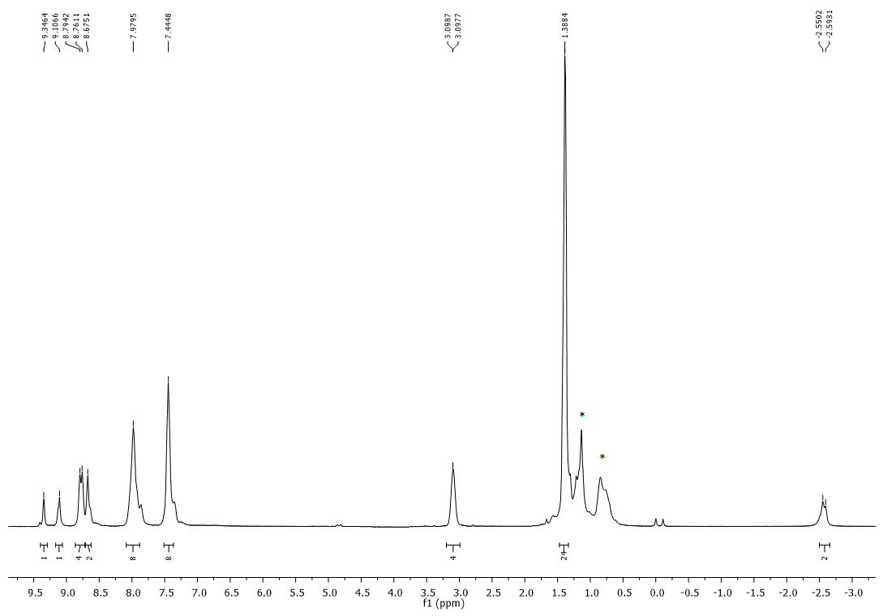

Figure S1. 1H NMR spectrum of **1b** (Solvent: CDCl3)

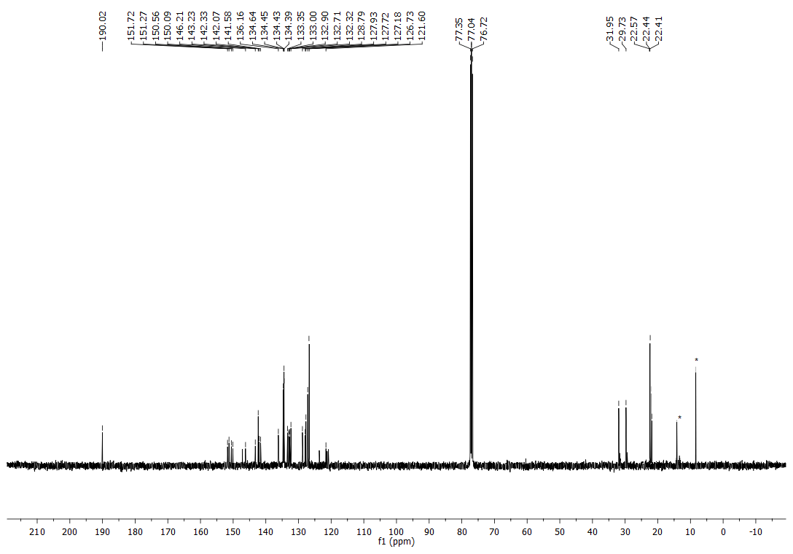

Figure S2. 13C NMR spectrum of **1b** (Solvent: CDCl3)

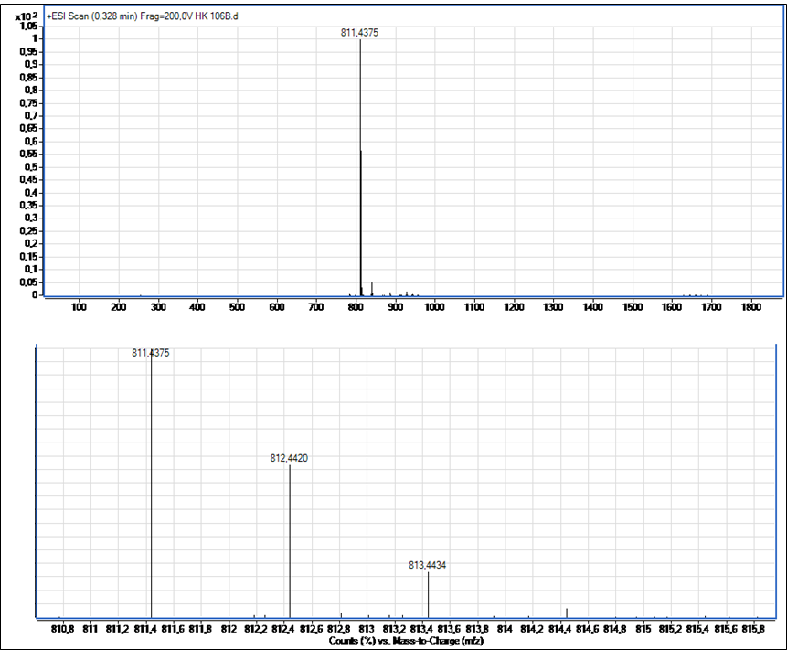

Figure S3. HRMS of **1b**.

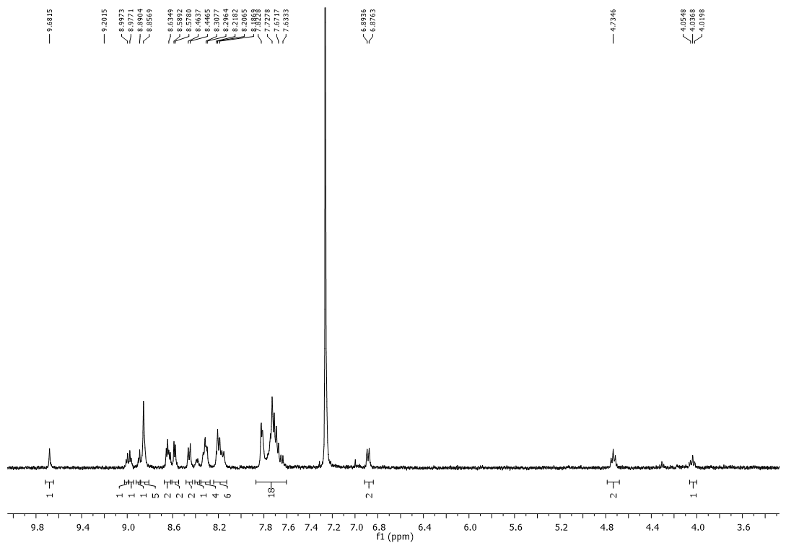

Figure S4. 1H NMR spectrum of **3a** (Solvent: CDCl3)



Figure S5. 1H NMR spectrum of **3a** (7.5-9.2 ppm, Solvent: CDCl3)

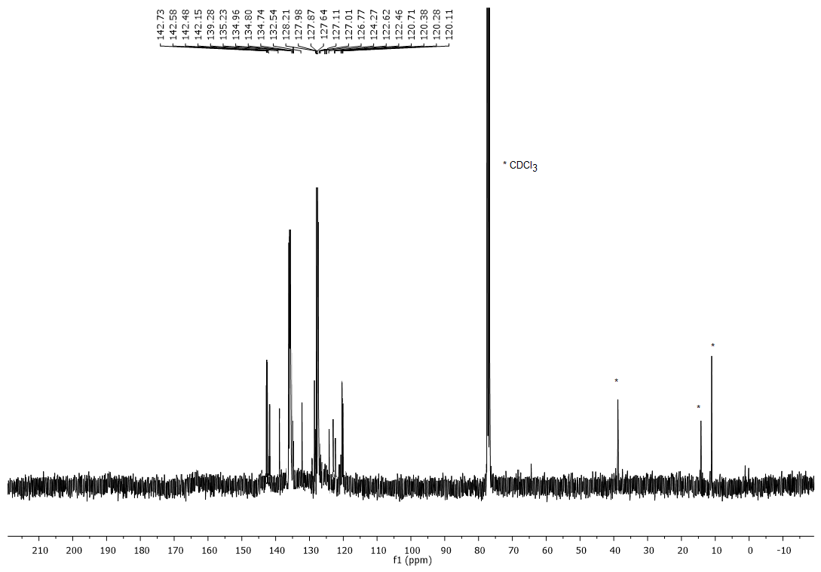Figure S6. 13C NMR spectrum of **3a** (Solvent: CDCl3)

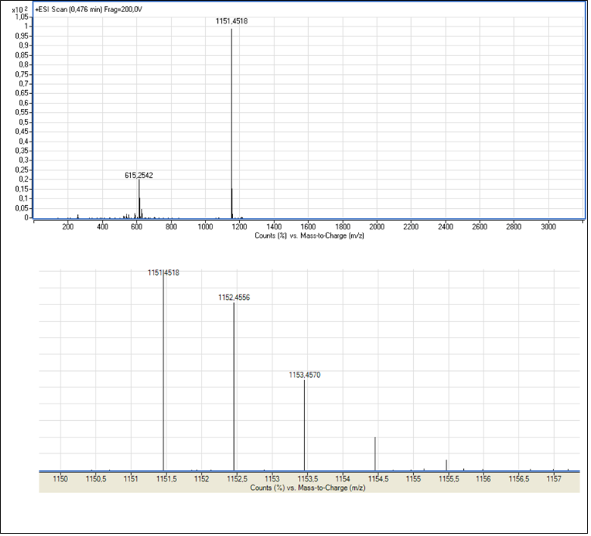

Figure S7. HRMS of **3a**.

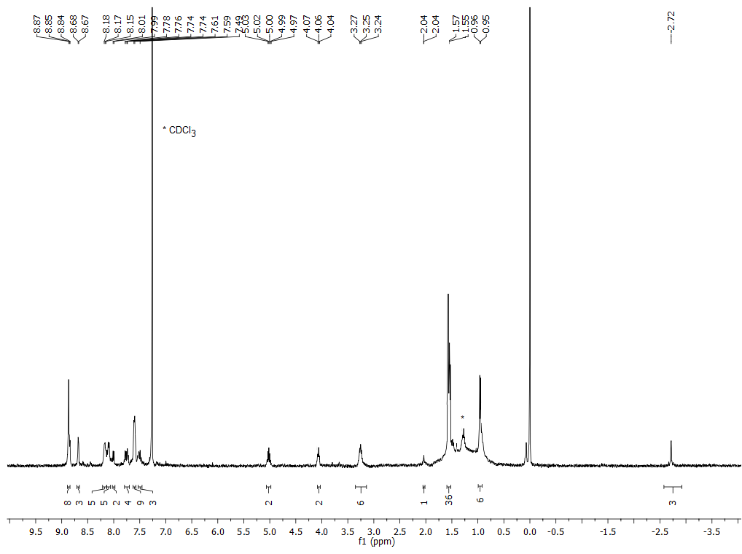

Figure S8. 1H NMR spectrum of **3b** (Solvent: CDCl3)

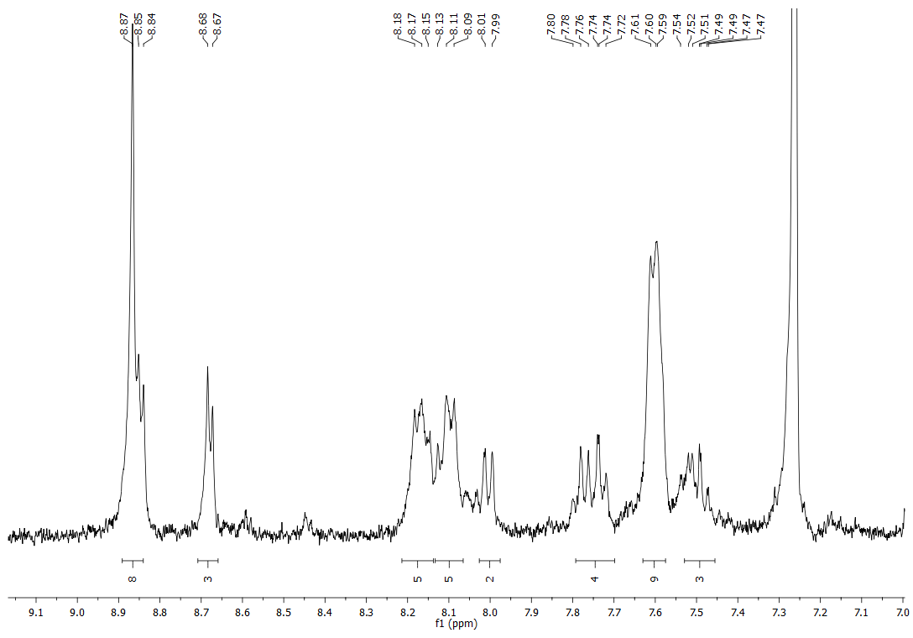

Figure S9. 1H NMR spectrum of **3b** (7.0-9.2 ppm, Solvent: CDCl3)

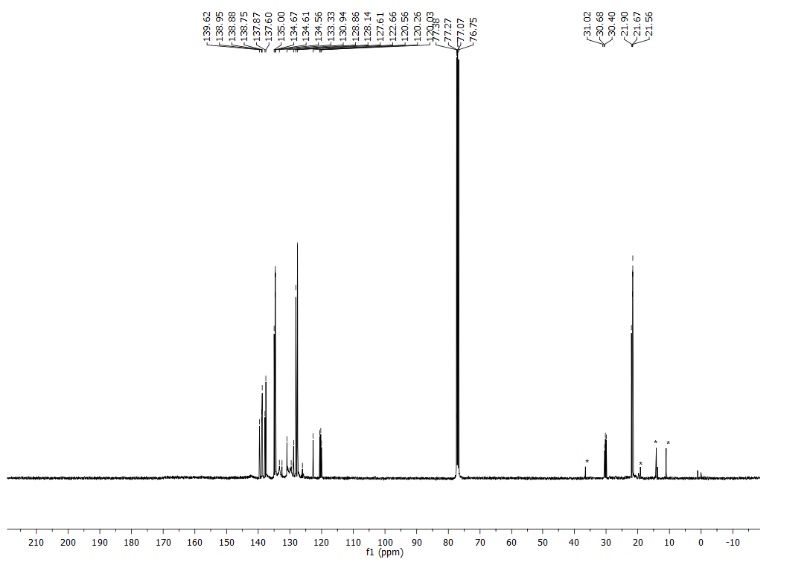

Figure S10. 13C NMR spectrum of **3b** (Solvent: CDCl3)

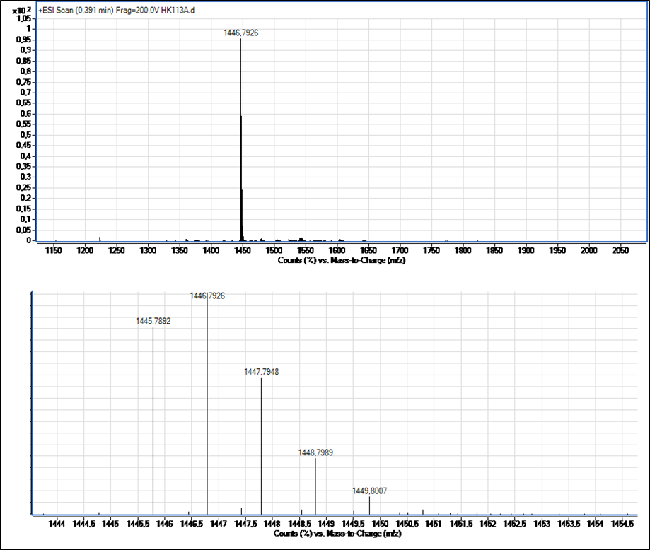

Figure S11. HRMS of **3b**.

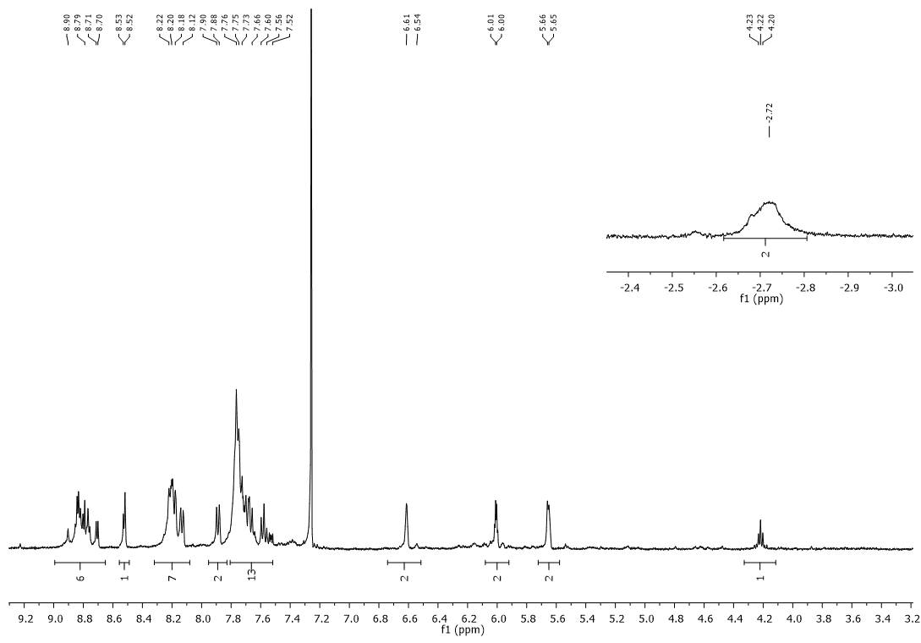

Figure S12. 1H NMR spectrum of **4** (Solvent: CDCl3)

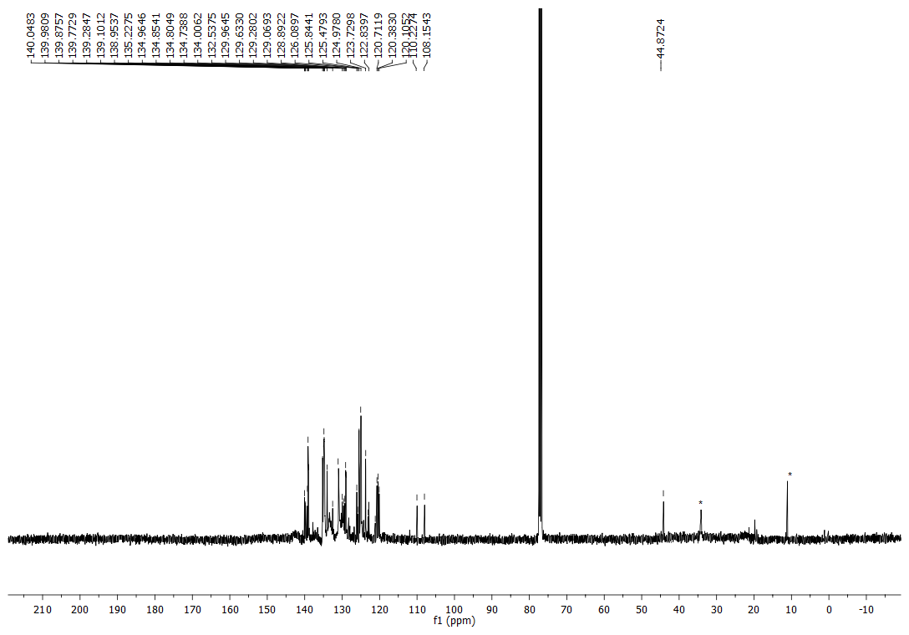

Figure S13. 13C NMR spectrum of **4** (Solvent: CDCl3)

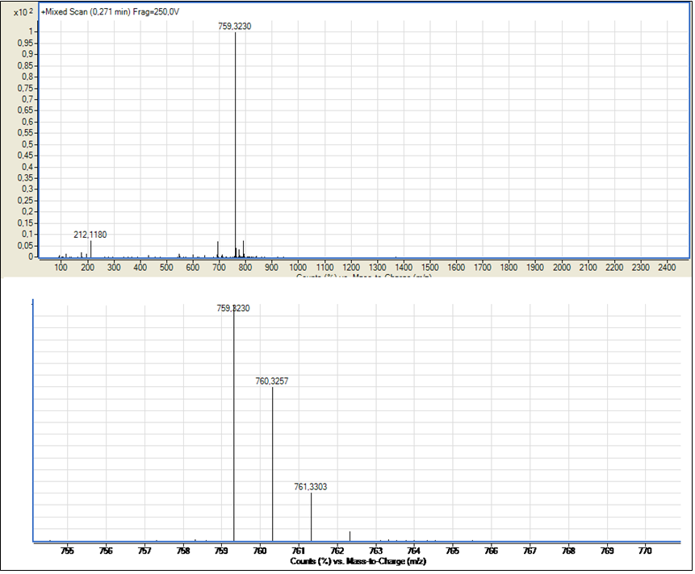

Figure S14 HRMS of **4.**

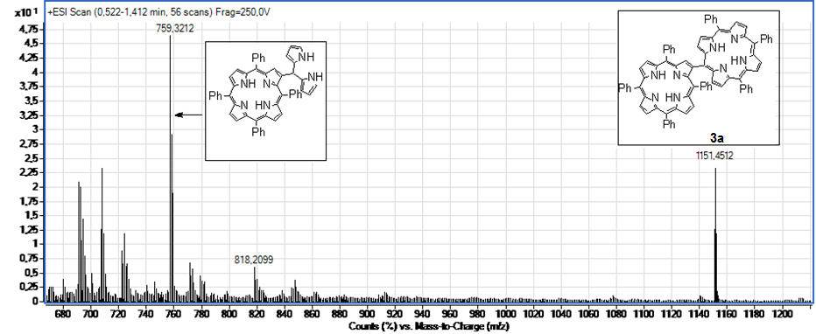

Figure S15. HRMS - reaction mixture of **3a**.

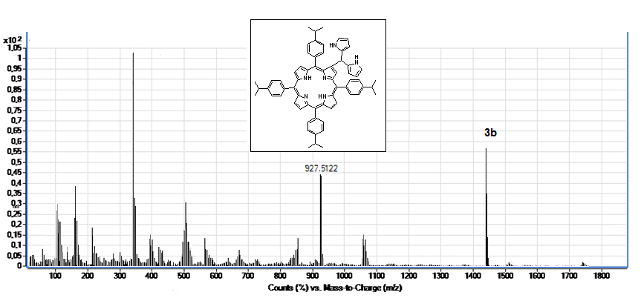

Figure S16. HRMS - reaction mixture of **3b**.