SUPPLEMENTAL INFORMATION

Biogenic Iron Oxides for Phosphate Removal

Raimonda Buliauskaitė¹, Philipp Wilfert^{2,3}, Prashanth Suresh Kumar^{2,3}, Weren W.J.M. de Vet⁴, Geert-Jan Witkamp³, Leon Korving²*, Mark C.M. van Loosdrecht³

¹Department of Environmental Technology, Kaunas University of Technology, Radvilenu pl. 19, LT-50254 Kaunas, Lithuania
²Wetsus, European Centre of Excellence for Sustainable Water Technology, Oostergoweg 7, 8911 MA Leeuwarden, The Netherlands.
³Dept. Biotechnology, Delft University of Technology, Julianalaan 67 2628 BC Delft, The Netherlands
⁴WML Drinking Water Company, PO box 1060, 6201 BB Maastricht, The Netherlands

Corresponding Author*: E-mail: leon.korving@wetsus.nl; Tel: +31652438349

Contents
This SI file includes Fig S1, S2, S3 and tables S1 to S5. Total no of pages = 8.

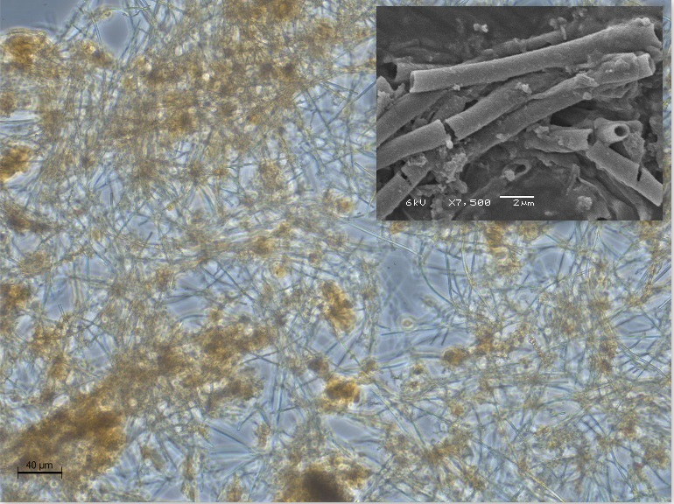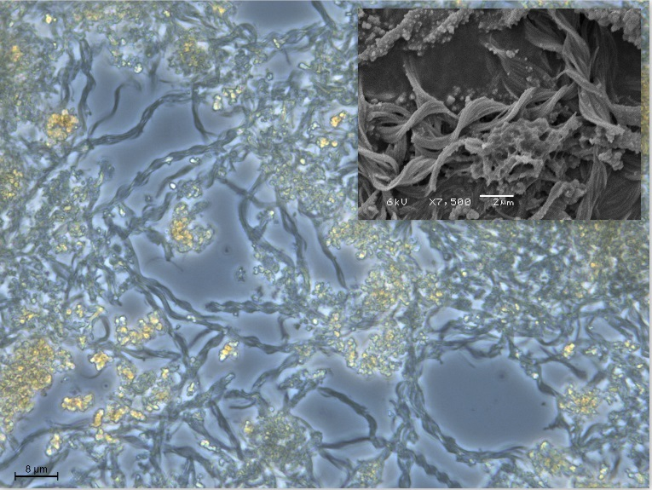
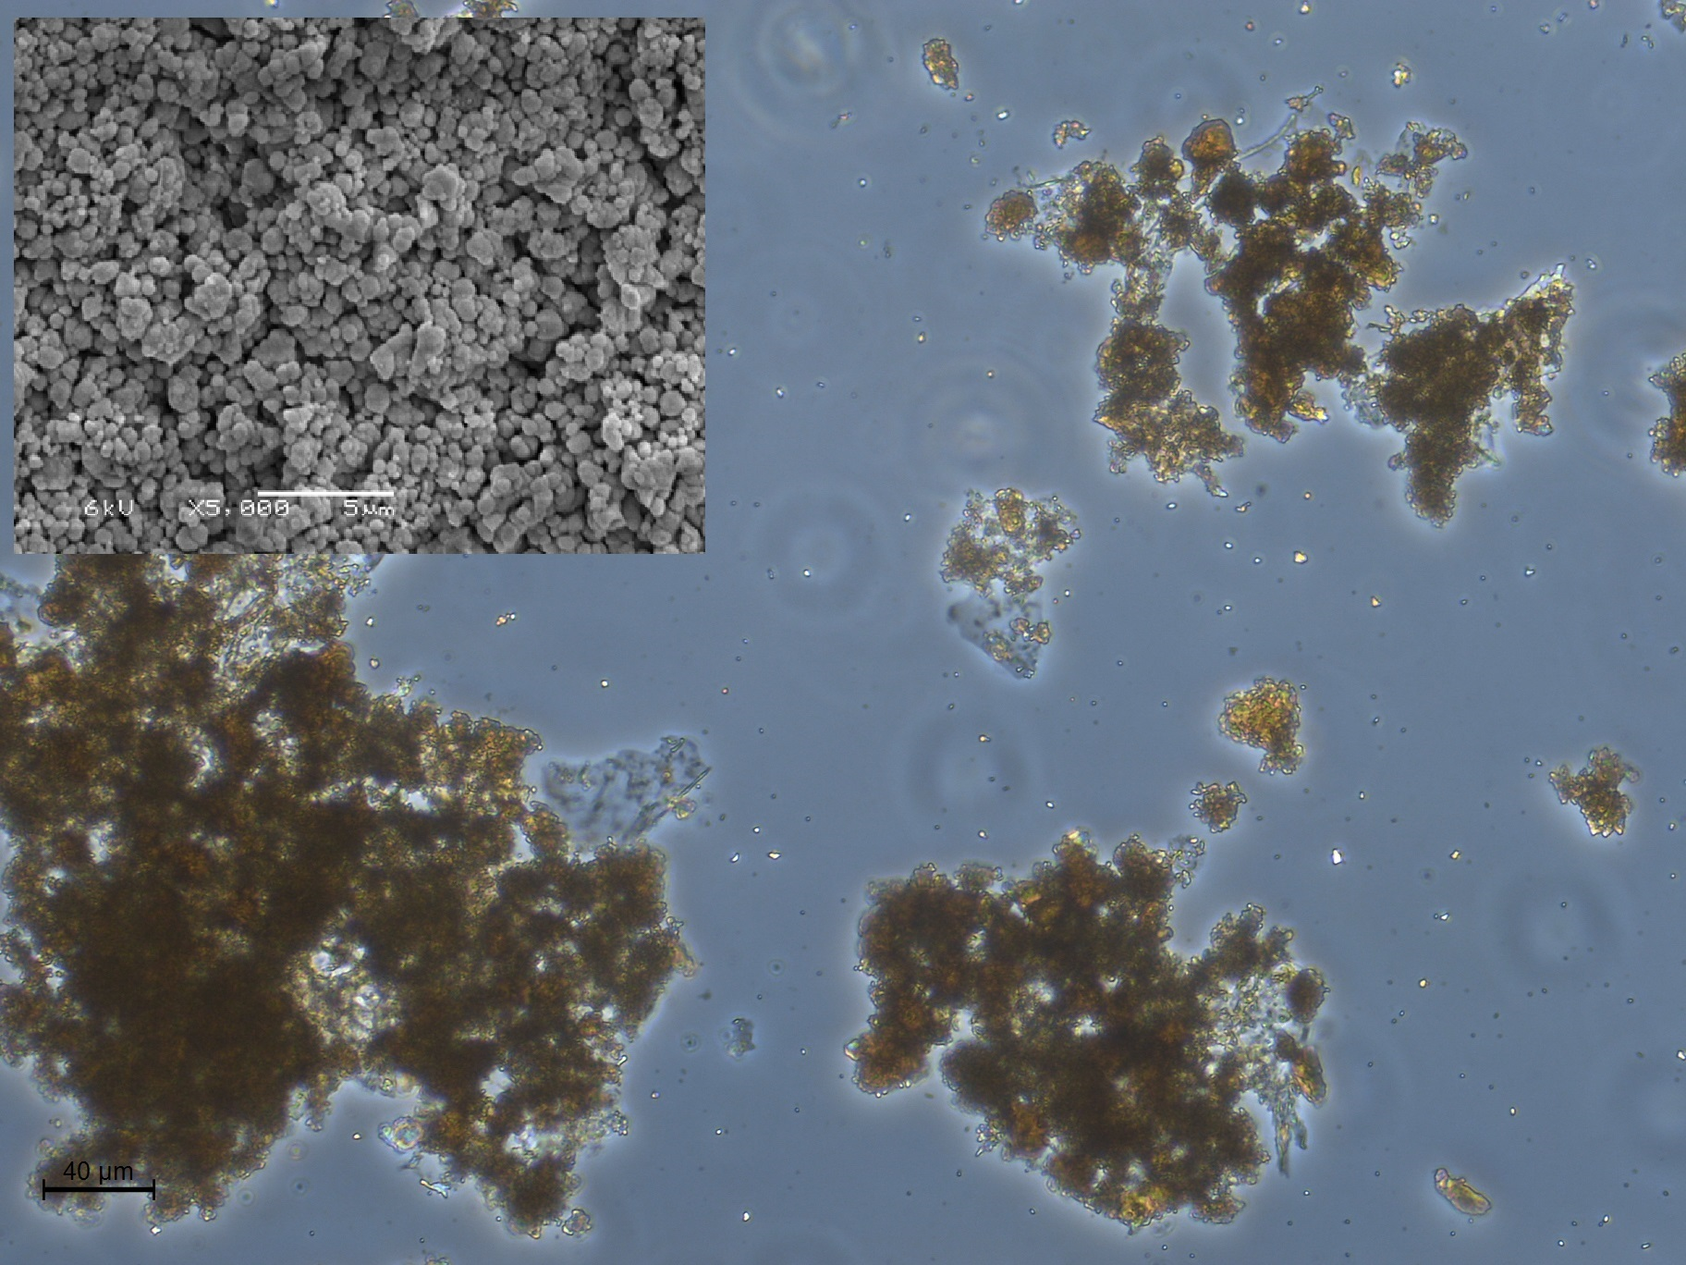
Fig.S1. Light microscopy and SEM images of Leptothrix sp. sheats (left), Gallionella sp. stalks (right) and chemical iron oxide precipitates (ChFeOPrecip) (below). Leptothrix sp. is a sheathed filamentous bacterium and form oxyhydroxides as a hollow microtubes. Gallionella sp. produce iron oxides, which have the shape of twisted stalks. ChFeOPrecip show common uniform spherical like morphology. SEM image of the granulated ferric hydroxide (GEH) particle surface showing its porous structure [1], which results in a high surface area. Light microscopy photos: on the lelft bar equals 40 µm, on the right equals 8 µm, below equals 40 µm. SEM images: on the lelft and right bars equal 2 µm, below equals 5 µm.

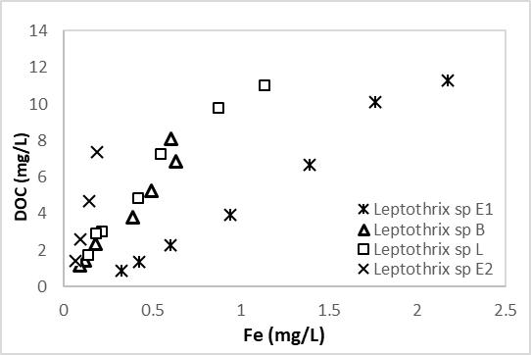
Fig.S2. Correlation of DOC and Fe concentrations in the supernatant after isotherms with MQ washed BioFeO of Leptothrix sp., where E, B and L letters refer to the sampling locations

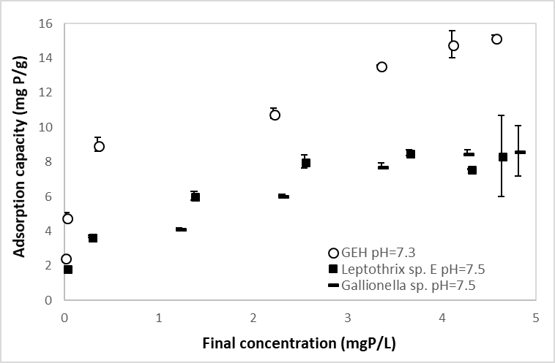
Fig.S3. Isotherms for MQ washed GEH, Leptothrix sp. and Gallionella sp. at around pH = 7.5

Total and volatile solids were calculated according to the equations below:
g/kg Total Solids = A-B×1000C-B
g/kg Volatile Solids = A-D×1000A-B
where,
A = weight of dried residue + dish, g,
B = weight of dish, g,
C = weight of wet sample + dish, g,
D = weight of residue + dish after ignition, g.

Table S1. Characteristics of BioFeO, ChFeOPrecip and GEH prior to phosphate adsorption experiments
 | Leptothrix sp. E non-washed | Leptothrix sp. E saline- washed | Leptothrix sp.  E, B, L¹ MQ washed | Gallionella sp. MQ washed | ChFeOPrecip MQ washed | GEH  MQ washed
Fe, mgFe/g | 237.4 ± 4.0 (n=2) | 204.7 ± 0.4 (n=2) | 235.7 ± 13.0 (n=6) | 390.8 ± 10.3 (n=2) | 339.2 ± 4.3 (n=2) | 566.1 ± 4.9 (n=2)
P, mgP/g | <0.3 ± 0.1 (n=2) | <0.4 ± 0.0 (n=2) | 3.3 ± 2.6 (n=6) | 31.0 ± 0.3 (n=2) | 10.4 ± 0.4 (n=2) | <0.4 ± 0.0 (n=2)
Ca, mgCa/g | 25.0 ± 0.2 (n=2) | 3.3 ± 0.1 (n=2) | 10.3 ± 3.4 (n=6) | 31.7 ± 0.4 (n=2) | 35.6 ± 0.2 (n=2) | <0.4 ± 0.0 (n=2)
VS, g/kg TS | 445.5² ± 61.6 (n=17) | 434.4 ± 12.3 (n=4) | 437.4 ± 72.3 (n=12) | – | 102.3 ± 14.7 (n=4) | –
Fe/P molar ratio | >337.6 | >291.1 | 39.6 | 7.0 | 18.1 | >805.1
XRD | – | – | amorphous | amorphous | – | –
¹
Leptothrix sp., where E, B and L letters refer to the sampling locations
² Average VS value of non-washed Leptothrix sp. E, B and L
The pseudo-second order kinetic model is described by the following equation:
$$q_{t}= \frac{(k{q_{e}}^{2}t)}{(1+(kq_{e}t))}$$
where,
q_{t} is the adsorption capacity at time t,
k is the rate constant of adsorption (g/mg min),
q_{e} is the adsorption capacity at equilibrium.
The difference between q_{e} determined by fitting with model and q_{e} reached experimentally is a measure of how close the samples were to adsorption equilibrium.

Table S2. Kinetic parameters for the adsorption of phosphate by BioFeO, ChFeOPrecip and GEH
Sample | q_{e}, mgP/g (fitted) | q_{e}, mgP/g (experimental, after 4 days) | k, µgP/g min | q_{e} reached experimentally in comparison to q_{e} estimated with model (%)
Leptothrix sp. E non-washed | 10.3 ±0.0 | 10.1 ±0.0 | 7.5 x 10⁻¹ ± 1.1 x 10⁻¹ | 98.0
Leptothrix sp. E MQ washed | 5.4 ± 0.1 | 4.1 ±0.0 | 1.3 x 10⁻¹ ± 1.7 x 10⁻³ | 75.9
ChFeOPrecip  MQ washed | 8.2 ± 0.6 | 7.4 ±0.4 | 3.3 x 10⁻¹ ± 1.1 x 10⁻¹ | 90.2
GEH MQ washed grinded, ≤100 µm | 10.4 ± 0.0 | 10.0 ±0.05 | 4.3 x 10⁻¹ ± 2.1 x 10⁻² | 96.1

Table S3. P_{ortho} and P_{total} concentrations in the supernatant after adsorption experiments with BioFeO, P_{initial}=5-6 mgP/l (Leptothrix sp. from Earnwâld after 7 days, Leptothrix sp. from Beetsterzwaag and Lettelbert after 4 days)
TS, g/l | Leptothrix sp. E non-washed |  | Leptothrix sp. E MQ washed |  | Leptothrix sp. E saline washed |  | Leptothrix sp. B MQ washed |  | Leptothrix sp. L MQ washed |  | Gallionella sp.  MQ washed
 | P_{ortho, mg/l} | P_{total, mg/l} | P_{ortho, mg/l} | P_{total, mg/l} | P_{ortho, mg/l} | P_{total, mg/l} | P_{ortho, mg/l} | P_{total, mg/l} | P_{ortho, mg/l} | P_{total, mg/l} | P_{ortho, mg/l} | P_{total, mg/l}
0.2 | - | - | 0.3 ± 0.0 | 0.4 ± 0.0 | 0.1 ± 0.0 | - | 0.1 ± 0.0 | 0.2 ± 0.0 | 0.1 ± 0.0 | 0.2 ± 0.0 | - | -
0.1 | 0.0 ± 0.0 | - | 1.0 ± 0.0 | 1.2 ± 0.0 | 0.5 ± 0.0 | - | 0.6 ± 0.1 | 0.7 ± 0.1 | 0.7 ± 0.3 | 0.8 ± 0.4 | - | -
0.05 | 0.1 ± 0.0 | 0.2 ± 0.0 | 2.2 ± 0.2 | 2.2 ± 0.2 | 1.4 ± 0.0 | 1.8 ± 0.0 | 1.8 ± 0.1 | 1.9 ± 0.1 | 1.5 ± 0.0 | 1.7 ± 0.0 | 1.2 ± 0.0 | 1.2 ± 0.0
0.025 | 1.1 ± 0.1 | - | 3.5 ± 0.1 | 3.4 ± 0.1 | 2.4 ± 0.1 | 3.0 ± 0.1 | 3.1 ± 0.0 | 3.2 ± 0.0 | 2.9 ± 0.0 | 3.0 ± 0.0 | 2.3 ± 0.0 | 2.2 ± 0.0
0.0125 | 2.6 ± 0.1 | 2.8 ± 0.0 | 4.2 ± 0.1 | 4.0 ± 0.1 | 3.3 ± 0.0 | 4.0 ± 0.0 | 4.0 ± 0.0 | 4.0 ± 0.1 | 3.8 ± 0.0 | 3.9 ± 0.0 | 3.4 ± 0.0 | 3.1 ± 0.0
0.00625 | 3.6 ± 0.2 | - | 4.7 ± 0.0 | 4.4 ± 0.0 | 3.7 ± 0.0 | 4.5 ± 0.1 | 4.4 ± 0.0 | 4.4 ± 0.0 | 4.2 ± 0.2 | 4.3 ± 0.2 | 4.3 ± 0.0 | 4.0 ± 0.2
0.00313 | 4.8 ± 0.1 | - | 4.9 ± 0.0 | 4.6 ± 0.0 | 4.0 ± 0.0 | 5.0 ± 0.0 | 4.6 ± 0.0 | 4.5 ± 0.0 | 4.6 ± 0.0 | 4.6 ± 0.0 | 4.8 ± 0.1 | 4.5 ± 0.2

The Langmuir adsorption model is expressed as follows:
qe= qmKLCe(1 + KLCe)
Where,
q_{m} = Maximum adsorption capacity (mg P/g),
q_{e} = Adsorption capacity at equilibrium (mg P/g),
C_{e} = Concentration at equilibrium (mg P/L),
K_{L} = Equilibrium constant for the Langmuir adsorption (L/mg P).

Table S4. Langmuir isotherms constants for the adsorption of phosphate by Leptothrix sp and GEH
Sample | q_{m,} mgP/g dried solids | q_{m},  mgP/g Fe | K_{l,} L/mgP | RMSE¹
Leptothrix sp., saline washed (once) not dried  by Rentz et al. [2] | 10.8-39.9 | 46.9-165.0 | - | -
Leptothrix sp. E non-washed not dried | 24.7 ± 0.2 | 109.6 ± 1.0 | 3.6 ± 0.1 | 1.7 ± 0.0
GEH grinded, ≤100 µm MQ washed dried | 18.0 ± 0.3 | 31.8 ± 0.5 | 12.1 ± 0.8 | 1.3 ± 0.2
¹RMSE - Root-mean-square error for the fit of experimental data to the isotherms model using non-linear regression.

Table S5. Actual maximum phosphate adsorption capacities observed after 4 days adsorption by BioFeO and GEH
Sample | Actual adsorption capacities, mgP/g dried solids | Actual adsorption capacities, mgP/g Fe | Final P concentration in the solution, mgP_{ortho} /l
Leptothrix sp. E non-washed not dried | 26.0 ± 0.3 | 115.3 ± 1.4 | 5.4 ± 0.0
Leptothrix sp. E MQ washed not dried | 6.4 ± 1.2 | 27.5 ± 5.2 | 5.1 ± 0.0
Leptothrix sp. E, B, L MQ washed not dried | 7.3 ± 0.7 | 31.0 ± 3.1 | 4.8 ± 0.3
Gallionella sp. MQ washed dried | 8.7 ± 1.5 | 22.1 ± 3.8 | 4.8 ± 0.1
GEH grinded (≤100 µm) MQ washed dried | 19.3 ± 0.1 | 34.1 ± 0.2 | 4.5 ± 0.0
ChFeOPrecip MQ washed dried | 12.6 ± 0.3 | 37.2 ± 0.9 | 3.6 ± 0.1

R E F E R E N C E S
[1] Boels L, Keesman KJ, Witkamp GJ. Adsorption of Phosphonate Antiscalant from Reverse Osmosis Membrane Concentrate onto Granular Ferric Hydroxide. Environ Sci Technol. 2012;46:9638−9645.
[2] Rentz JA, Turner IP, Ullman JL. Removal of phosphorus from solution using biogenic iron oxides. Water Res. 2009;43:2029–2035.

