**Global and regional climate responses to national-committed emission reductions under the Paris Agreement**

**Fang Wang1*, Quansheng Ge1, Deliang Chen2*, Jürg Luterbacher3,4, Katarzyna B Tokarska5, Zhixin Hao1**

1Key Laboratory of Land Surface Pattern and Simulation, Institute of Geographic Sciences and Natural Resources Research, Chinese Academy of Sciences, Beijing 100101, China.

2 Regional climate Group, Department of Earth Sciences, University of Gothenburg, Box 460, 405 30 Gothenburg, Sweden.

3Department of Geography, Climatology, Climate Dynamics and Climate Change, Justus-Liebig University, Senckenbergstrasse 1, D-35390, Giessen, Germany.

4Centre for International Development and Environmental Research, Justus-Liebig University Giessen, Senckenbergstr. 3, D-35390 Giessen, Germany.

5School of Earth and Ocean Sciences, University of Victoria, Victoria, British Columbia V8W 3V6, Canada.

﻿ **1. Supplementary Figures**



Fig. S1 Simulated global mean temperature increase as a function of cumulative greenhouse gas emissions from different RCP scenarios. The thick black lines give the fitted linear trends (upper and lower) over an amount of cumulative emissions from 400 to 1500 GtCe. Until now, more than 400 GtCe have been emitted (the 2012 level). The units GtCe are referring to ‘GtC equivalent’.

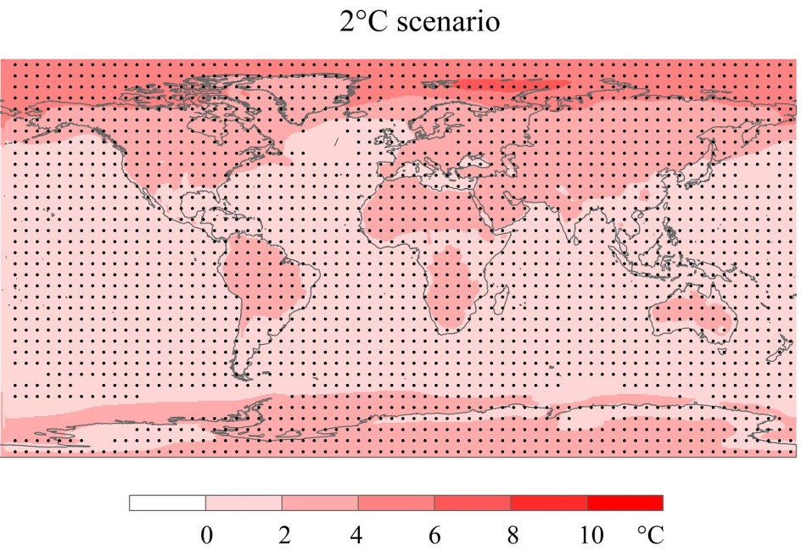

**a**

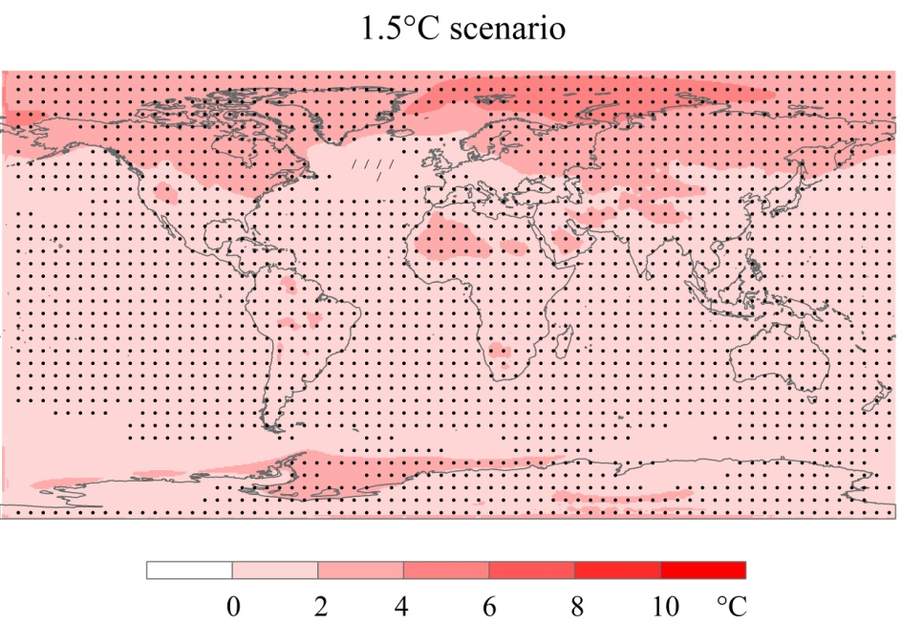

**b**

Fig. S2 The global distribution of surface temperature change under the long-term goal. a, 2°C scenario; b, 1.5°C scenario. Temperature anomalies are relative to 1850-1900 levels and the data from 42 simulations and 46 simulations were used to produce an average state of warming pattern for 2°C and 1.5°C warming, respectively (see Methods). Stippling indicates regions where the multi-model mean change exceeds two standard deviations of natural internal variability and where at least 75 % of models agree on the sign of change.

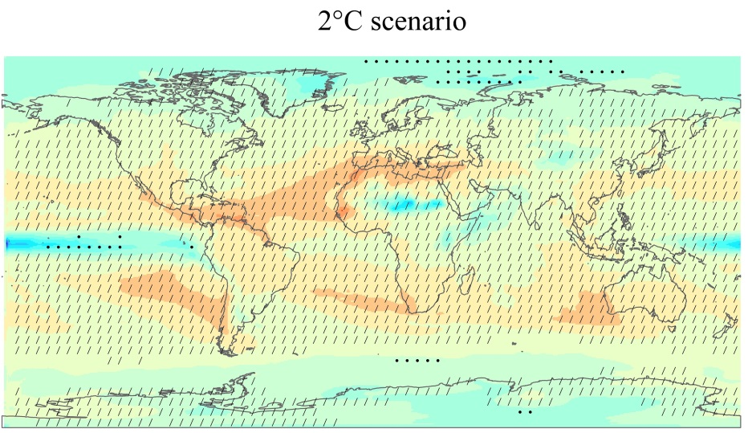

**a**

**b**

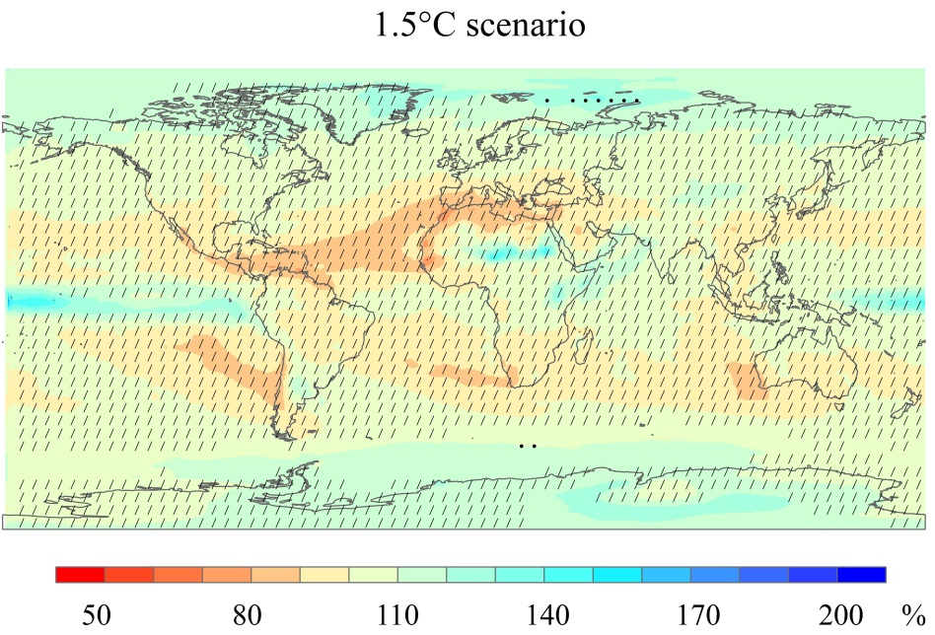

Fig. S3 The global distribution of precipitation change under the long-term goal. a, 2°C scenario; b, 1.5 scenario. Precipitation changes are expressed as a percentage of the 1850-1900 levels; the data from 42 simulations were used to produce average precipitation pattern for 2°C and 46 simulations for 1.5°C warming. Regions with large change and high model agreement are stippled.

**2. Supplementary Tables**

**Table S1.** The submitted national mitigation objectives included in INDCs from Jan. 2015 to Oct. 2017

| Country | Submitted Date | GHG Reduction Target  Unconditional Conditional | | Quantified | Share of global 2013 emissions (%) |
| --- | --- | --- | --- | --- | --- |
| **Group of 20 (G20)** |  |  |  |  | ~75% |
| Argentina | Oct., 2015 | 15% below baseline scenario in 2030 | 30% below baseline scenario in 2030 | Yes |  |
| Australia | Aug., 2015 | 26-28% by 2030 compared to 2005 level | No | Yes |  |
| Brazil | Sep., 2015 | 37% by 2025 compared to 2005 level | No | Yes |  |
| Canada | May, 2015 | 30% by 2030 compared to 2005 level | No | Yes |  |
| China | Jul., 2015 | 60-65% emission intensity by 2030 compared to 2005 levels | No | Yes |  |
| EU28 | Mar., 2015 | ≥ 40% by 2030 compared to 1990 levels | No | Yes |  |
| India | Oct., 2015 | No | Emission intensity 33-35% by 2030 compared to 2005 levels | Yes |  |
| Indonesia | Sep., 2015 | 29% below baseline scenario in 2030 | 41% below baseline scenario in 2030 | Yes |  |
| Japan | Jul., 2015 | 26% by 2030 compared to 2013 level | No | Yes |  |
| Mexico | Mar., 2015 | 22% below baseline scenario in 2030 | 36% below baseline scenario in 2030 | Yes |  |
| Russian Federation | Apr., 2015 | 25-30% by 2030 compared to 1990 levels | No | Yes |  |
| Saudi Arabia | Nov., 2015 | Actions only |  | No |  |
| South Africa | Sep., 2015 | Trajectory target, 398-614 Mt CO2-eq for 2025-2030 | No | Yes |  |
| Republic of Korea | Jun., 2015 | 37% below baseline scenario in 2030 | No | Yes |  |
| Turkey | Sep., 2015 | 21% below baseline scenario in 2030 | No | Yes |  |
| United States | Mar., 2015 | 26-28% by 2025 compared to 2005 level | No | Yes |  |
| **Non G20 countries** |  |  |  |  | ~24% |
| **Small Island States** |  |  |  |  |  |
| Antigua and Barbuda | Oct., 2015 | Actions only | No | No |  |
| Bahamas | Nov., 2015 | No | 30% below baseline scenario in 2030 | Yes |  |
| Barbados | Sep., 2015 | 23% by 2030 compared to 2008 level | No | Yes |  |
| Belize | Oct., 2015 | No | Actions only | No |  |
| Cabo Verde | Sep., 2015 | Renewable Energy and Energy; Efficiency Targets | No | No |  |
| Comoros | Sep., 2015 | No | 84% below baseline scenario in 2030 | Yes |  |
| Cook Islands | Nov., 2015 | Renewable energy target | No | No |  |
| Cuba | Nov., 2015 | Actions only | No | No |  |
| Dominica | Oct., 2015 | No | 17.9% by 2020; 39.2% by 2025; and 44.7% by 2030 compared to 2014 levels | Yes |  |
| Dominican Republic | Aug., 2015 | No | 25% by 2030 compared to 2010 level | Yes |  |
| Fiji | Nov., 2015 | Energy sector 30% below baseline scenario in 2030 | No | Yes |  |
| Grenada | Sep., 2015 | 30% by 2025 compared to 2010 level (indicative 40% by 2030) | No | Yes |  |
| Guinea-Bissau | Sep., 2015 | No | Actions only | No |  |
| Guyana | Sep., 2015 | No | 52 Mt CO2-eq in 2025 | Yes |  |
| Haiti | Sep., 2015 | 5% below baseline scenario in 2030 | 26% below baseline scenario in 2030 | Yes |  |
| Jamaica | Nov., 2015 | 7.8% below baseline scenario in 2030 | 10% below baseline scenario in 2030 | Yes |  |
| Kiribati | Sep., 2015 | 12.8% below baseline scenario in 2030 | 61.8% below baseline scenario in 2030 | Yes |  |
| Maldives | Sep., 2015 | 10% below baseline scenario in 2030 | 24% below baseline scenario in 2030 | Yes |  |
| Marshall Island | Jul., 2015 | 32% by 2025 and 45% by 2030 compared to 2010 level | No | Yes |  |
| Mauritius | Sep., 2015 | No | 30% below baseline scenario in 2030 | Yes |  |
| Micronesia | Nov., 2015 | 28% by 2025 compared to 2000 level | 35% by 2025 compared to 2000 level | Yes |  |
| Nauru | Nov., 2015 | Actions only | No | No |  |
| Niue | Nov., 2015 | Renewable energy 38% by 2020 | Renewable energy 80% by 2025 | Yes |  |
| Palau | Nov., 2015 | Energy emission 22% below 2005 level in 2025; 45% Renewable Energy target by 2025; 35% Energy Efficiency target by 2025 | No | Yes |  |
| Papua New Guinea | Sep., 2015 | Non-GHG target and actions | No | No |  |
| Saint Kitts and Nevis | Jan.,2016 | No | 22% below baseline scenario in 2025;  35% below baseline scenario in 2030 | Yes |  |
| Saint Lucia | Nov., 2015 | 16% by 2025 and 23% by 2030 below baseline scenario | No | Yes |  |
| Saint Vincent and Grenadines | Nov., 2015 | 22% below baseline scenario in 2030 | No | Yes |  |
| Samoa | Oct., 2015 | Renewable energy target | No | No |  |
| Sao Tome and Principe | Sep., 2015 | No | 24% by 2030 compared to 2005 levels | Yes |  |
| Seychelles | Sep., 2015 | 122.5 ktCO2-eq (21.4%) in 2025 and estimated 188 ktCO2e in 2030 (29.0%) relative to baseline emissions | No | Yes |  |
| Singapore | Jul., 2015 | 36% emission intensity by 2030 compared to 2005 levels | No | Yes |  |
| Solomon Islands | Sep., 2015 | 12% by 2025 and 30% by 2030 compared to 2015 level | 27% by 2025 and 45% by 2030 compared to 2015 level | Yes |  |
| Suriname | Oct., 2015 | Actions only | No | No |  |
| Trinidad and Tobago | Aug., 2015 | Transportation 30% by 2030 compared to 2013 levels; 3 sectors 15% below baseline scenario in 2030 | No | Yes |  |
| Timor-Leste | Mar., 2017 | Sector actions | No | No |  |
| Tonga | Dec., 2015 | Renewable energy target | No | No |  |
| Tuvalu | Nov., 2015 | 60% by 2025 compared to 2010 level | No | Yes |  |
| Vanuatu | Sep., 2015 | only renewable energy target | No | No |  |
| **Other countries** |  |  |  |  |  |
| Afghanistan | Oct., 2015 | No | 13.6% below baseline scenario in 2030 | Yes |  |
| Albania | Sep., 2015 | 11.5% below baseline scenario in 2030 (CO2) | No | Yes |  |
| Algeria | Sep., 2015 | 7% below baseline scenario in 2030 | 22% below baseline scenario in 2030 | Yes |  |
| Andorra | Apr., 2015 | 37% below baseline scenario in 2030 | No | Yes |  |
| Angola | Nov., 2015 | 35% below baseline scenario in 2030 | 50% below baseline scenario in 2030 | Yes |  |
| Armenia | Sep., 2015 | No | total aggregate emissions, 633 Mt CO2-eq for 2015-2030 | Yes |  |
| Azerbaijan | Sep., 2015 | 35% by 2030 compared to 1990 levels | No | Yes |  |
| Bahrain | Nov., 2015 | Actions only | No | No |  |
| Bangladesh | Sep., 2015 | 5% below baseline scenario in 2030 in the power, transport and industry sectors | 15% below baseline scenario in 2030 | Yes |  |
| Belarus | Sep., 2015 | 28% by 2030 compared to 1990 levels | No | Yes |  |
| Benin | Aug., 2015 | No | 21.4% below baseline scenario in 2030 | Yes |  |
| Bhutan | Oct., 2015 | ≤ 6.3 MtCO2-eq by 2030 for CO2 | No | Yes |  |
| Bolivia | Oct., 2015 | Renewable energy and LUCF targets | No | No |  |
| Bosnia and Herzegovina | Oct., 2015 | 20% below baseline scenario in 2030 | 23% below baseline scenario in 2030 | Yes |  |
| Botswana | Oct., 2015 | 15% by 2030 compared to 2010 levels | No | Yes |  |
| Brunei | Dec., 2015 | Energy sector 63% below baseline scenario in 2035; Land Transport sector to reduce emissions from morning peak hour vehicle use by 40% below baseline scenario in 2035 | No | Yes |  |
| Burkina Faso | Oct., 2015 | 6.6% below baseline scenario in 2030 | 18.2% below baseline scenario in 2030 | Yes |  |
| Burundi | Nov., 2015 | 3% below baseline scenario in 2030 | 20% below baseline scenario in 2030 | Yes |  |
| Cambodia | Sep., 2015 | No | 27% below baseline scenario in 2030 | Yes |  |
| Cameroon | Sep., 2015 | No | 32% below baseline scenario in 2030 | Yes |  |
| Central African Republic | Sep., 2015 | No | 5% below baseline scenario in 2030 | Yes |  |
| Chad | Sep., 2015 | 18.2% below baseline scenario in 2030 | 71% below baseline scenario in 2030 | Yes |  |
| Chile | Jan., 2016 | 30% emission intensity by 2030 compared to 2007 level (CO2) | 35-45% emission intensity by 2030 compared to 2007 level (CO2) | Yes |  |
| Congo | Oct., 2015 | No | 48% below baseline scenario in 2025 | Yes |  |
| Cote d'Ivoire | Sep., 2015 | 28% below baseline scenario in 2030 | No | Yes |  |
| Colombia | Sep., 2015 | 20% below baseline scenario in 2030 | 30% below baseline scenario in 2030 | Yes |  |
| Democratic Republic of Congo | Aug., 2015 | No | 17% below baseline scenario in 2030 | Yes |  |
| Costa Rica | Sep., 2015 | a maximum of 9.374 Mt CO2-eq in 2030 | No | Yes |  |
| Democratic People's Republic of Korea | Oct., 2016 | 8% below baseline scenario in 2030 | 32.25% below baseline scenario in 2030 | Yes |  |
| Djibouti | Oct., 2015 | 40% below baseline scenario in 2030 | 60% below baseline scenario in 2030 | Yes |  |
| Ecuador | Oct., 2015 | 20.4-25 % below baseline scenario in 2025 | 37.5-45.8% below baseline scenario in 2025 | Yes |  |
| Egypt | Nov., 2015 | Actions only | No | No |  |
| El Salvador | Nov., 2015 | Actions only | No | No |  |
| Equatorial Guinea | Sep., 2015 | No | 20% by 2030 compared to 2010 level | Yes |  |
| Eritrea | Sep., 2015 | 39.2% below baseline scenario in 2030 | 80.6% below baseline scenario in 2030 | Yes |  |
| Ethiopia | Jun., 2015 | ≤ 145 Mt CO2-eq net emissions in 2030 | No | Yes |  |
| Gabon | Apr., 2015 | ≥ 50% below baseline scenario in 2025 | No | Yes |  |
| Gambia | Sep., 2015 | No | Actions only | No |  |
| Georgia | Sep., 2015 | 15% below baseline scenario in 2030 | 25% below baseline scenario in 2030 | Yes |  |
| Ghana | Sep., 2015 | 15% below baseline scenario in 2030 | 45% below baseline scenario in 2030 | Yes |  |
| Guatemala | Sep., 2015 | 11.2% below baseline scenario in 2030 | 22.6% below baseline scenario in 2030 | Yes |  |
| Guinea | Oct., 2015 | No | 13% by 2030 compared to 1994 level | Yes |  |
| Honduras | Oct., 2015 | No | 15% below baseline scenario in 2030 | Yes |  |
| Iceland | Jun., 2015 | 40% by 2030 compared to 1990 levels | No | Yes |  |
| Iran | Nov., 2015 | 4% below baseline scenario in 2030 | 12% below baseline scenario in 2030 | Yes |  |
| Iraq | Nov., 2015 | 13% below baseline scenario in 2035 | 15% below baseline scenario in 2035 | Yes |  |
| Israel | Oct., 2015 | per capita emissions to 7.7 tCO2-eq by 2030 | No | Yes |  |
| Jordan | Oct., 2015 | 1.5% below baseline scenario in 2030 | 14% below baseline scenario in 2030 | Yes |  |
| Kazakhstan | Sep., 2015 | 15% by 2030 compared to 1990 levels | 25% by 2030 compared to 1990 levels | Yes |  |
| Kenya | Jul., 2015 | No | 30% below baseline scenario in 2030 | Yes |  |
| Kuwait | Nov., 2015 | Actions only | No | No |  |
| Kyrgyzstan | Oct., 2015 | 11.49-13.75% below baseline scenario in 2030 | 29-30.9% below baseline scenario in 2030 | Yes |  |
| Laos | Oct., 2015 | No | Actions only | No |  |
| Lebanon | Oct., 2015 | 15% below baseline scenario in 2030 | 30% below baseline scenario in 2030 | Yes |  |
| Lesotho | Sep., 2015 | 10% below baseline scenario in 2030 | 35% below baseline scenario in 2030 | Yes |  |
| Liberia | Sep., 2015 | No | 10% below baseline scenario in 2030 | Yes |  |
| Liechtenstein | Apr., 2015 | 40% by 2030 compared to 1990 levels | No | Yes |  |
| Macedonia | Aug., 2015 | 30% below baseline scenario in 2030 (CO2) | 36% below baseline scenario in 2030 | Yes |  |
| Madagascar | Sep., 2015 | No | 14% below baseline scenario in 2030 | Yes |  |
| Malaysia | Jan., 2016 | Emission intensity 35% by 2030 compared to 2005 levels | Emission intensity 45% by 2030 compared to 2005 levels | Yes |  |
| Malawi | Oct., 2015 | Actions only | Actions only | No |  |
| Mali | Sep., 2015 | No | 29% (agriculture), 31% (energy), 21% (LUCF) below baseline scenario in 2030 | Yes |  |
| Mauritania | Sep., 2015 | No | 22.3% below baseline scenario in 2030 | Yes |  |
| Moldova | Sep., 2015 | 64-67% by 2030 compared to 1990 levels | 78% by 2030 compared to 1990 levels | Yes |  |
| Monaco | Aug., 2015 | 50% by 2030 compared to 1990 levels | No | Yes |  |
| Mongolia | Sep., 2015 | No | 14% below baseline scenario in 2030 | Yes |  |
| Montenegro | Sept., 2015 | 30% by 2030 compared to 1990 levels | No | Yes |  |
| Morocco | Jun., 2015 | 13% below baseline scenario in 2030 | 32% below baseline scenario in 2030 | Yes |  |
| Mozambique | Oct., 2015 | No | Actions only | No |  |
| Myanmar | Sep., 2015 | Actions only | No | No |  |
| Namibia | Sep., 2015 | No | 89% below baseline scenario in 2030 | Yes |  |
| Nepal | Feb., 2016 | Non-GHG target and actions | No | No |  |
| New Zealand | Jul., 2015 | 30% by 2030 compared to 2005 level | No | Yes |  |
| Niger | Sep., 2015 | 3.5% below baseline scenario in 2030 | 34.6% below baseline scenario in 2030 | Yes |  |
| Nigeria | Nov., 2015 | 20% below baseline scenario in 2030 | 45% below baseline scenario in 2030 | Yes |  |
| Norway | Mar., 2015 | ≥ 40% by 2030 compared to 1990 levels | No | Yes |  |
| Oman | Oct., 2015 | 2% below baseline scenario in 2030 | No | Yes |  |
| Pakistan | Nov., 2016 | No | 20% below baseline scenario in 2030 | Yes |  |
| Panama | Apr., 2016 | Non-GHG target and actions |  | No |  |
| Paraguay | Oct., 2015 | 10% below baseline scenario in 2030 | 20% below baseline scenario in 2030 | Yes |  |
| Peru | Sep., 2015 | 20% below baseline scenario in 2030 | 30% below baseline scenario in 2030 | Yes |  |
| Philippines | Oct., 2015 | No | 70% below baseline scenario in 2030 | Yes |  |
| Qatar | Nov., 2015 | Actions only |  | No |  |
| Republic of Serbia | Jul., 2015 | 9.8% by 2030 compared to 1990 levels | No | Yes |  |
| Rwanda | Dec., 2015 | Actions only | No | No |  |
| San Marino | Sep., 2015 | 20% by 2030 compared to 2005 levels | No | Yes |  |
| Senegal | Sep., 2015 | 4%, 7%, 6% below baseline scenario in 2030 | 10%, 23%, 31% below baseline scenario in 2030 | Yes |  |
| Sierra Leone | Oct., 2015 | net emissions o7.58 MtCO2-eq by 2035 | No | Yes |  |
| Somalia | Nov., 2015 | Actions only | No | No |  |
| South Sudan | Nov., 2015 | Actions only | No | No |  |
| Sri Lanka | Apr., 2016 | 7% below baseline scenario in 2030 | 23% below baseline scenario in 2030 | Yes |  |
| Sri Lanka | Oct., 2015 | 7% below baseline scenario in 2030 | 23% below baseline scenario in 2030 | Yes |  |
| Sudan | Nov., 2015 | 3 sectors target | No | No |  |
| Swaziland | Sep., 2015 | No | Actions only | No |  |
| Switzerland | Feb., 2015 | 50% by 2030 compared to 1990 levels | No | Yes |  |
| Tajikistan | Sep., 2015 | 10-20% by 2030 compared to 1990 levels | 25-35% by 2030 compared to 1990 levels | Yes |  |
| Tanzania | Oct., 2015 | 10-20% below baseline scenario in 2030 | No | Yes |  |
| Thailand | Oct., 2015 | 20% below baseline scenario in 2030 | 25% below baseline scenario in 2030 | Yes |  |
| Togo | Oct., 2015 | 11.14% below baseline scenario in 2030 | 31.14% below baseline scenario in 2030 | Yes |  |
| Tunisia | Sep., 2015 | 13% by 2030 compared to 2010 levels | 41% by 2030 compared to 2010 levels | Yes |  |
| Turkmenistan | Oct., 2015 | No | Emission peaks by 2030 | Yes |  |
| Uganda | Oct., 2015 | Actions only |  | No |  |
| Ukraine | Sept., 2015 | 40% by 2030 compared to 1990 levels | No | Yes |  |
| United Arab Emirates | Oct., 2015 | Renewable energy target | No | No |  |
| Uruguay | Sep., 2015 | 8 intensity targets and 1 fixed level target | No | Yes |  |
| Uzbekistan | Apr., 2017 | 10% emission intensity by 2030 compared to 2010 levels | No | Yes |  |
| Venezuela | Dec., 2015 | 20% below baseline scenario in 2030 | No | Yes |  |
| Vietnam | Oct., 2015 | 8% below baseline scenario in 2030 | 25% below baseline scenario in 2030 | Yes |  |
| Yemen | Nov., 2015 | 1% below baseline scenario in 2030 | 14% below baseline scenario in 2030 | Yes |  |
| Zambia | Sep., 2015 | 25% by 2030 compared to 2010 levels | 47% by 2030 compared to 2010 levels | Yes |  |
| Zimbabwe | Sep., 2015 | No | 33% below baseline scenario in 2030 | Yes |  |

Table S2. Overview of scenarios from CMIP5 simulations used to examine climate sensitivity and INDC implications in this study

|  |  |  |  |  |
| --- | --- | --- | --- | --- |
| Model name | RCP2.6 | RCP4.5 | RCP6.0 | RCP8.5 |
| BCC_CSM 1.1 | ✓ | ✓ | ✓ | ✓ |
| BCC_CSM 1.1m | ✓ | ✓ | ✓ | ✓ |
| CanESM2 | ✓ | ✓ | N | ✓ |
| CESM1-BGC | N | ✓ | N | ✓ |
| HadGEM2-CC | N | ✓ | N | ✓ |
| HadGEM2-ES | ✓ | ✓ | N | ✓ |
| IPSL-CM5A-LR | ✓ | ✓ | ✓ | ✓ |
| IPSL-CM5A-MR | ✓ | ✓ | ✓ | ✓ |
| IPSL-CM5B-LR | N | ✓ | N | ✓ |
| MIROC-ESM | ✓ | ✓ | ✓ | ✓ |
| MIROC-ESM-CHEM | ✓ | ✓ | ✓ | ✓ |
| MPI-ESM-LR | ✓ | ✓ | N | ✓ |
| MPI-ESM-MR | ✓ | ✓ | N | ✓ |
| NorESM1-ME | ✓ | ✓ | ✓ | ✓ |

*N* represents no data in RCP simulation.

Table S3. Overview of scenarios included in examine “2oC scenarios” from CMIP5 simulations used in this study

|  |  |  |  |  |
| --- | --- | --- | --- | --- |
| Model name | RCP2.6 | RCP4.5 | RCP6.0 | RCP8.5 |
| BCC_CSM 1.1 | – | ✓ | ✓ | ✓ |
| BCC_CSM 1.1m | ✓ | ✓ | ✓ | ✓ |
| CanESM2 | ✓ | ✓ | N | ✓ |
| CESM1-BGC | N | ✓ | N | ✓ |
| HadGEM2-CC | N | ✓ | N | ✓ |
| HadGEM2-ES | ✓ | ✓ | N | ✓ |
| IPSL-CM5A-LR | ✓ | ✓ | ✓ | ✓ |
| IPSL-CM5A-MR | ✓ | ✓ | ✓ | ✓ |
| IPSL-CM5B-LR | N | ✓ | N | ✓ |
| MIROC-ESM | ✓ | ✓ | ✓ | ✓ |
| MIROC-ESM-CHEM | ✓ | ✓ | ✓ | ✓ |
| MPI-ESM-LR | – | ✓ | N | ✓ |
| MPI-ESM-MR | – | ✓ | N | ✓ |
| NorESM1-ME | – | ✓ | ✓ | ✓ |

*N* represents no data in RCP simulation; - represents that the ‘2oC’ is not reached in the simulation.

Table S4. Overview of scenarios included in examine “1.5oC scenarios” from CMIP5 simulations used in this study

|  |  |  |  |  |
| --- | --- | --- | --- | --- |
| Model name | RCP2.6 | RCP4.5 | RCP6.0 | RCP8.5 |
| BCC_CSM 1.1 | ✓ | ✓ | ✓ | ✓ |
| BCC_CSM 1.1m | ✓ | ✓ | ✓ | ✓ |
| CanESM2 | ✓ | ✓ | N | ✓ |
| CESM1-BGC | N | ✓ | N | ✓ |
| HadGEM2-CC | N | ✓ | N | ✓ |
| HadGEM2-ES | ✓ | ✓ | N | ✓ |
| IPSL-CM5A-LR | ✓ | ✓ | ✓ | ✓ |
| IPSL-CM5A-MR | ✓ | ✓ | ✓ | ✓ |
| IPSL-CM5B-LR | N | ✓ | N | ✓ |
| MIROC-ESM | ✓ | ✓ | ✓ | ✓ |
| MIROC-ESM-CHEM | ✓ | ✓ | ✓ | ✓ |
| MPI-ESM-LR | ✓ | ✓ | N | ✓ |
| MPI-ESM-MR | ✓ | ✓ | N | ✓ |
| NorESM1-ME | ✓ | ✓ | ✓ | ✓ |

*N* represents no data in RCP simulation.