Titanium-catalyzed hydrosilylation of olefins: A comparison study on Cp2TiCl2/Sm and Cp2TiCl2/LiAlH4 catalyst system

Xiaoling Yanga, Ying Baia*, Jiayun Lia, Yu Liua, Jiajian Penga*, Tianbo Lib, Rui Langb and Botao Qiaob

aKey Laboratory of Organosilicon Chemistry and Material Technology of Ministry of Education, Hangzhou Normal University, Hangzhou 311121, China

bDalian Institute of Chemical Physics, Chinese Academy of Sciences, Dalian 116011, China

Email: ybai@hznu.edu.cn

**Supplemental Materials**

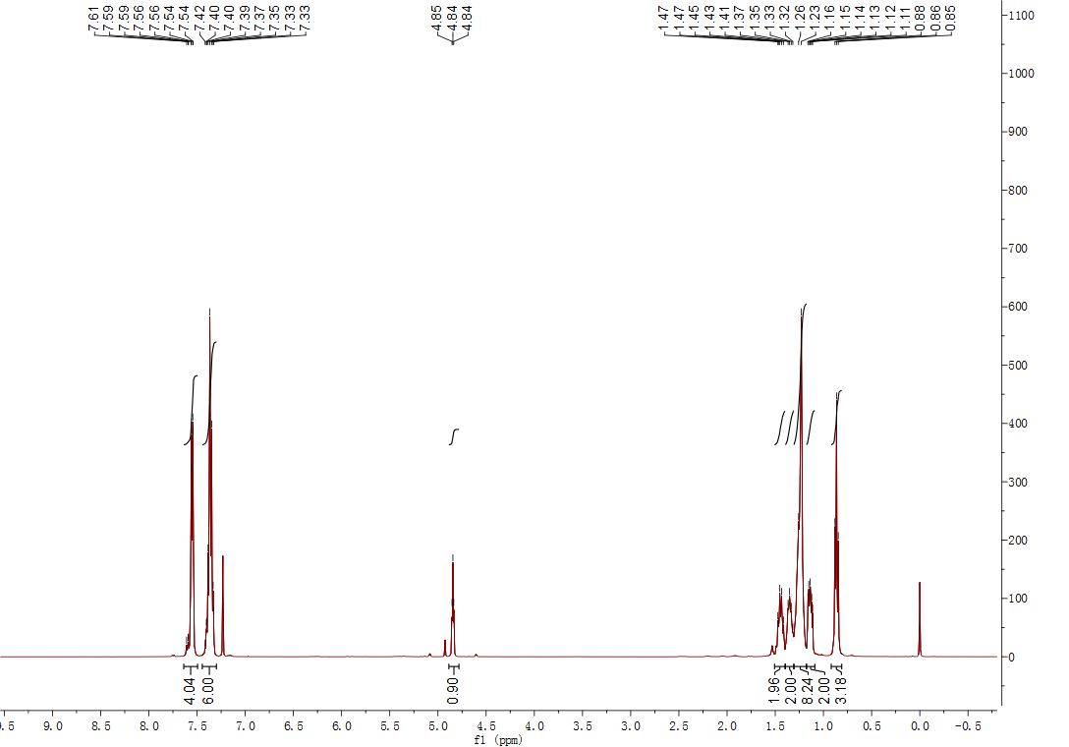

**Figure S 1**: 1H NMR of product from 1-octene / PhSiH2

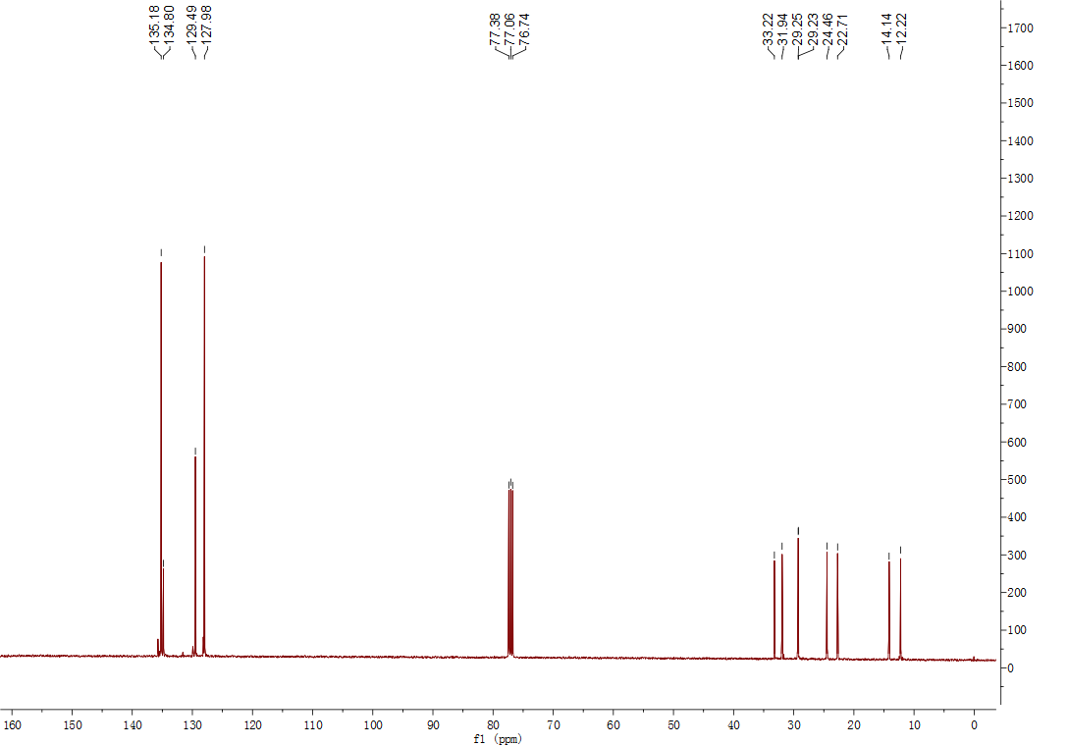

**Figure S 2**: 13C NMR of product from 1-octene / PhSiH2

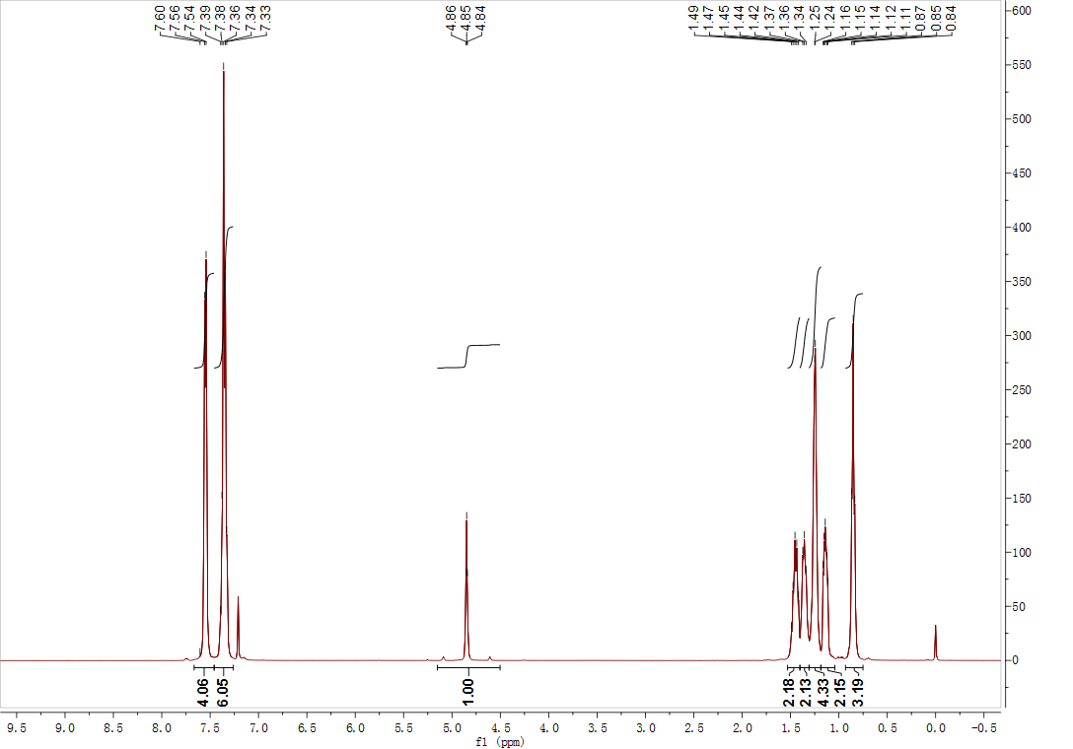

**Figure S 3**: 1H NMR of product from 1-hexene / PhSiH2

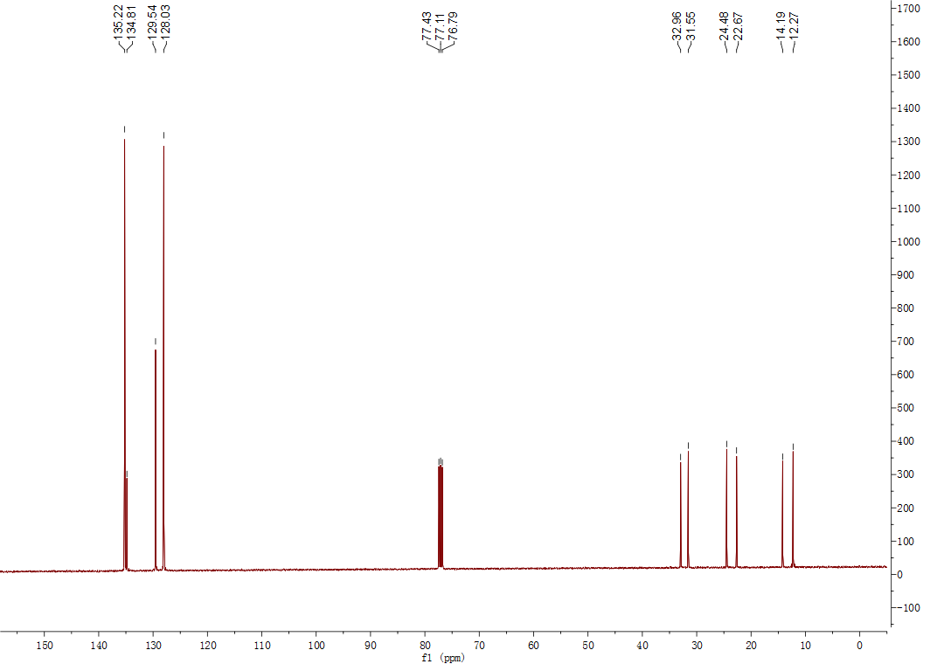

**Figure S 4**: 13C NMR of product from 1-hexene / PhSiH2

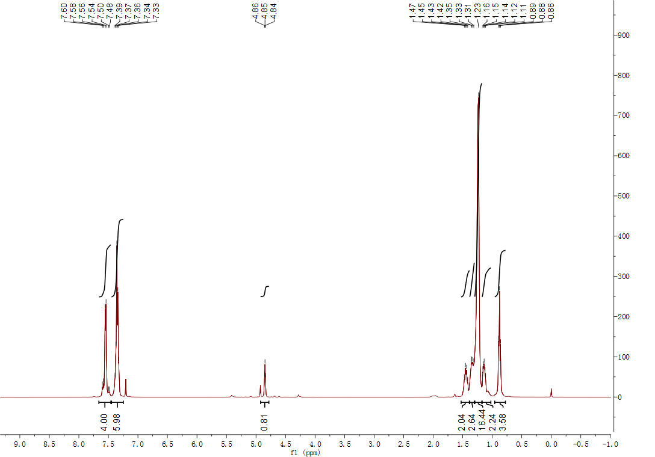

**Figure S 5**: 1H NMR of product from 1-decene / PhSiH2

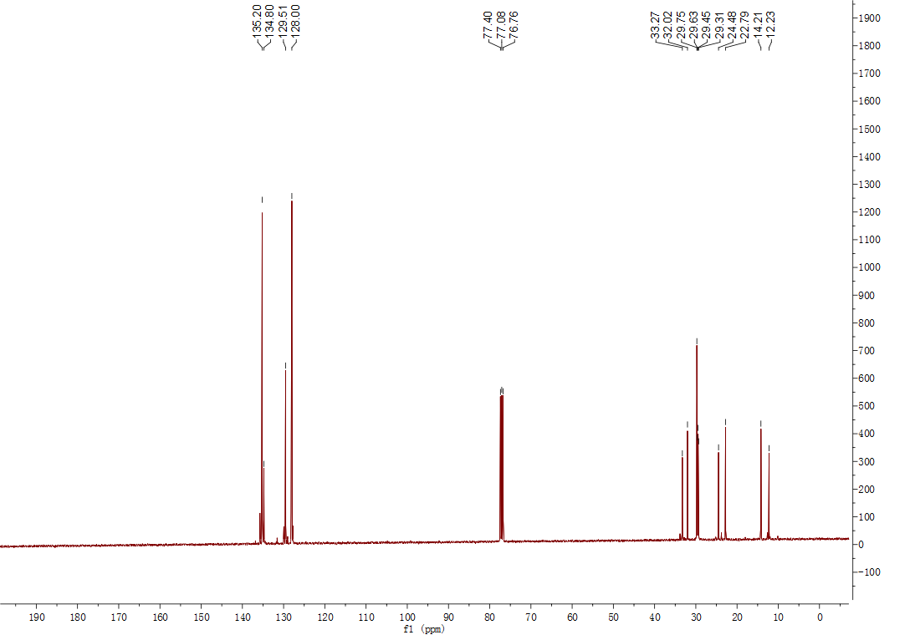

**Figure S 6**: 13C NMR of product from 1-decene / PhSiH2

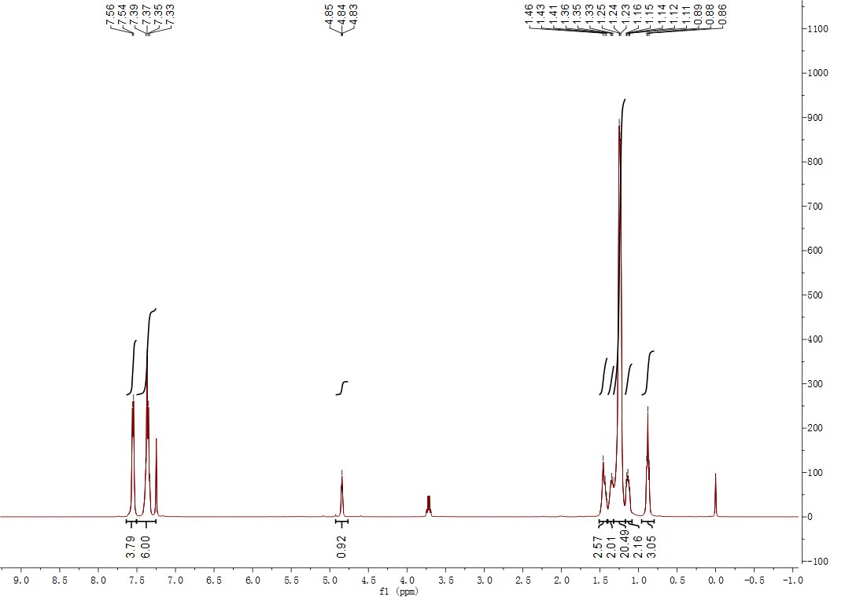

**Figure S 7**: 1H NMR of product from 1-dodecene / PhSiH2

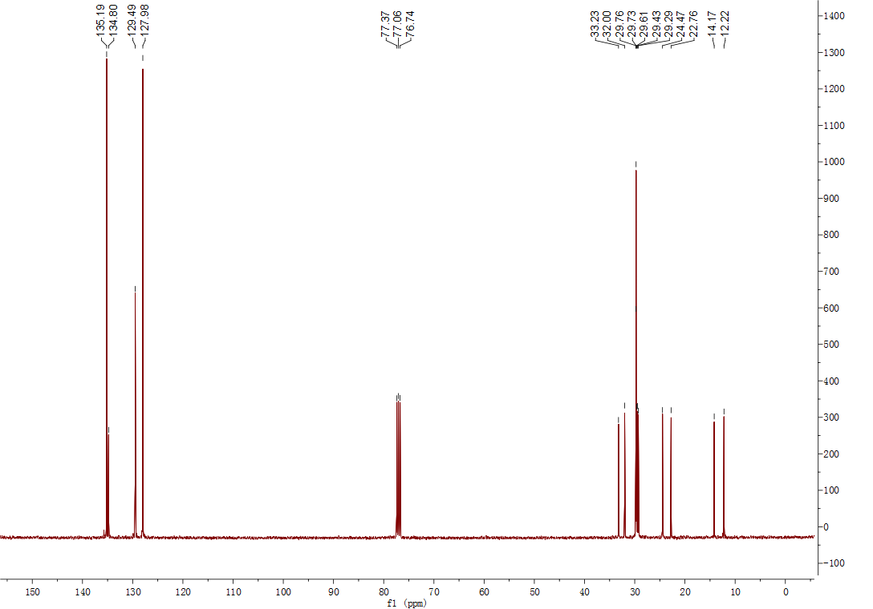

**Figure S 8**: 13C NMR of product from 1-dodecene / PhSiH2

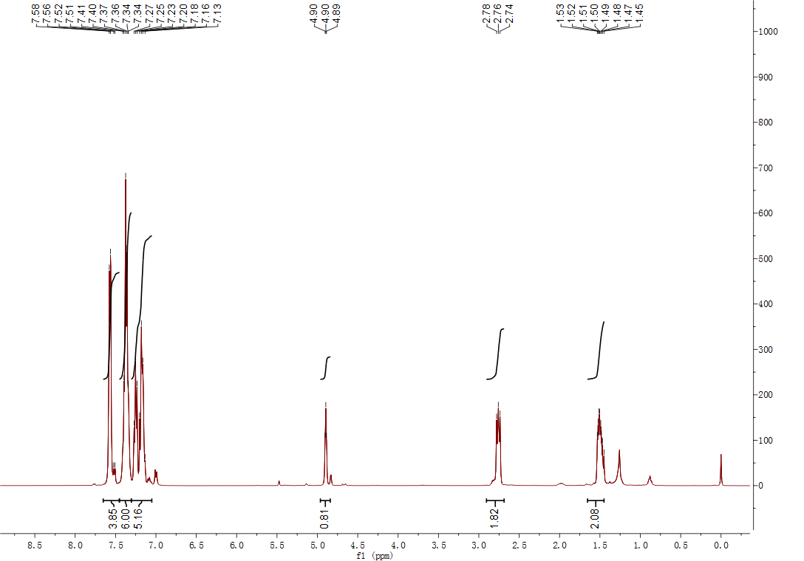

**Figure S 9**: 1H NMR of product from styrene / PhSiH2

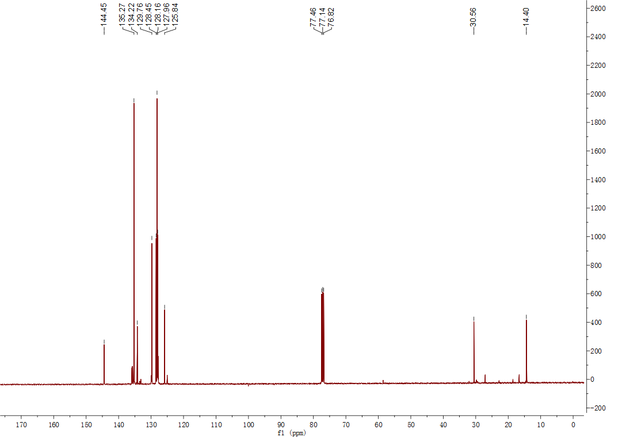

**Figure S 10**: 13C NMR of product from styrene / PhSiH2