Layered Double Hydroxides (LDHs): As Efficient Heterogeneous Catalyst for the Cyanosilylation of Aromatic Aldehydes
Javad Mokhtari,*^{[a]} Fahimeh Afi,^{[a]} Fatemeh Tahoori*^{[b]}
ªDepartment of Chemistry, Science and Research Branch, Islamic Azad University, P.O. Box 14515/775,Tehran, Iran.
^{b}Razi Vaccine and Serum Research Institute, Agricultural Research and Extension Organization (AREEO), Karaj, Iran
E-mail: j.mokhtari@srbiau.ac.ir
Supplemental Materials
Spectral data for compounds 3:
2-phenyl-2-((trimethylsilyl)oxy)acetonitrile (3a) [1]:
Yield: 95%; ¹H NMR (500 MHz, CDCl₃):δ 0.27 (s, 9H, -OSi(CH₃)₃), 5.55 (s, 1H, -CHCN), 7.40-7.51 (m, 5H, CH Ar).¹³C NMR (125 MHz, CDCl₃):δ-0.1, 63.8, 119.4, 126.5, 129.1, 129.5, 136.5. Elemental Analysis: C, 64.34; H, 7.36; N, 6.82; found C, 64.32; H, 7.35; N, 6.81.

2-(p-tolyl)-2-((trimethylsilyl)oxy)acetonitrile (3b) [1]:
Yield: 96%; ¹H NMR (500 MHz, CDCl₃):δ0.21 (s, 9H, -OSi(CH₃)₃), 2.36 (s, 3H, Ph-CH₃), 5.45 (s, 1H, -CHCN), 7.21 (d,J=8.5 Hz,2H, CH Ar), 7.35 (d,J=8 Hz,2H, CH Ar). Elemental Analysis: C, 65.71; H, 7.81; N, 6.39; found C, 65.69; H, 7.80; N, 6.37.

2-(4-nitrophenyl)-2-((trimethylsilyl)oxy)acetonitrile (3c) [2]:
Yield: 92%; ¹H NMR (500 MHz, CDCl₃):δ0.26 (s, 9H, -OSi(CH₃)₃),5.58 (s, 1H, -CHCN), 7.65 (d,J=8.5 Hz,2H, CH Ar), 8.26 (d,J=8.5 Hz,2H, CH Ar). Elemental Analysis: C, 52.78; H, 5.64; N, 11.19; found C, 52.73; H, 5.60; N, 11.17.

2-(4-methoxyphenyl)-2-((trimethylsilyl)oxy)acetonitrile (3d) [2]:
Yield: 93%; ¹H NMR (500 MHz, CDCl₃):δ0.19 (s, 9H, -OSi(CH₃)₃), 3.81 (s, 3H, Ph-OCH₃), 5.42 (s, 1H, -CHCN), 6.90 (d,J=9.0 Hz,2H, CH Ar), 7.36 (d,J=8.5 Hz, 2H, CH Ar). Elemental Analysis: C, 61.24; H, 7.28; N, 5.95; found C, 61.26; H, 7.25; N, 5.94.

2-(4-chlorophenyl)-2-((trimethylsilyl)oxy)acetonitrile (3e) [2]:
Yield: 95%;¹H NMR (500 MHz, CDCl₃) δ=0.05 (s, 9H, -OSi(CH₃)₃), 5.28 (s, 1H, -CHCN), 7.52 (d,J=3.5 Hz, 2H, CH Ar), 7.68 (d,J=3.5 Hz,2H, CH Ar). Elemental Analysis: C, 55.10; H, 5.89; N, 5.84; found C, 55.07; H, 5.86; N, 5.83.

2-(o-tolyl)-2-((trimethylsilyl)oxy)acetonitrile (3f) [1]:
Yield: 89%; Elemental Analysis: C, 65.71; H, 7.81; N, 6.39; found C, 65.69; H, 7.82; N, 6.37.

2-(4-(dimethylamino)phenyl)-2-((trimethylsilyl)oxy)acetonitrile (3g) [3]:
Yield: 92%; ¹H NMR (500 MHz, CDCl₃):δ0.18 (s, 9H, -OSi(CH₃)₃), 2.95 (s, 6H, -N(CH₃)₂), 5.38 (s, 1H, -CHCN), 6.69 (d,J=8.5 Hz, 2H, CH Ar), 7.29 (d,J=9 Hz, 2H, CH Ar). Elemental Analysis: C, 62.86; H, 8.12; N, 11.28; found C, 62.84; H, 8.09; N, 11.26.
2-(4-bromophenyl)-2-((trimethylsilyl)oxy)acetonitrile (3h) [4]:
Yield: 92%; Elemental Analysis: C, 46.48; H, 4.96; N, 4.93; found C, 46.45; H, 4.94; N, 4.91.

2-(2-chlorophenyl)-2-((trimethylsilyl)oxy)acetonitrile (3i) [1]:
Yield: 88%; Elemental Analysis: C, 55.10; H, 5.89; N, 5.84; found C, 55.11; H, 5.88; N, 5.82

2-(2-nitrophenyl)-2-((trimethylsilyl)oxy)acetonitrile (3j) [4]:
Yield: 90%; Elemental Analysis: C, 52.78; H, 5.64; N, 11.19; found C, 52.75; H, 5.62; N, 11.16.

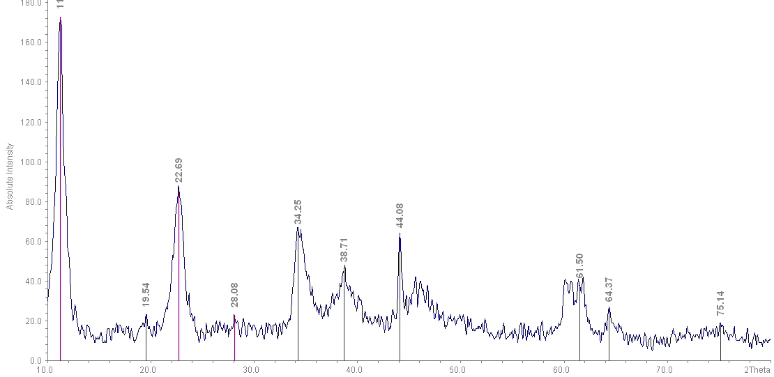
Figure S 1. XRD patterns of Mg-Al-Cu-LDH

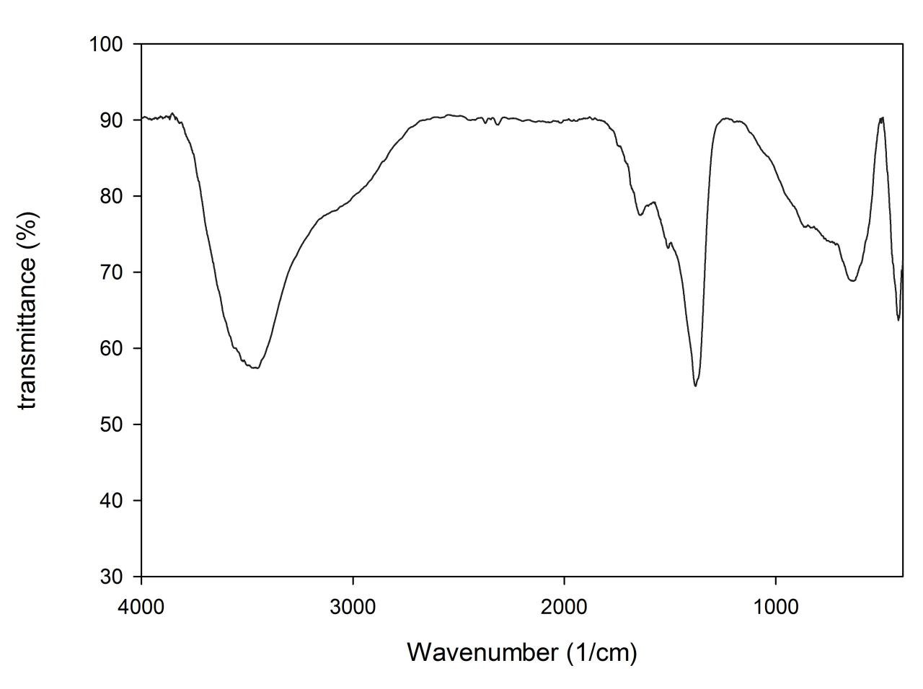
Figure S 2. IR Spectra of Mg-Al-Cu-LDH
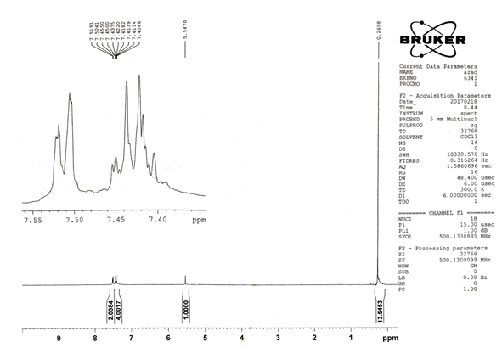
Figure S 3. ¹H NMR of 2-phenyl-2-((trimethylsilyl)oxy)acetonitrile
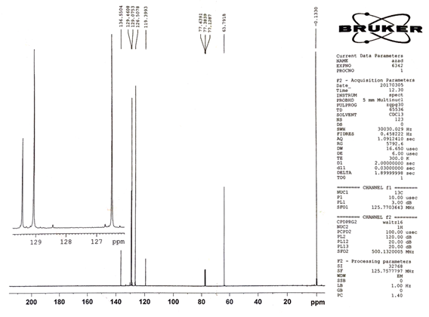
Figure S 4. ¹³C NMR of 2-phenyl-2-((trimethylsilyl)oxy)acetonitrile

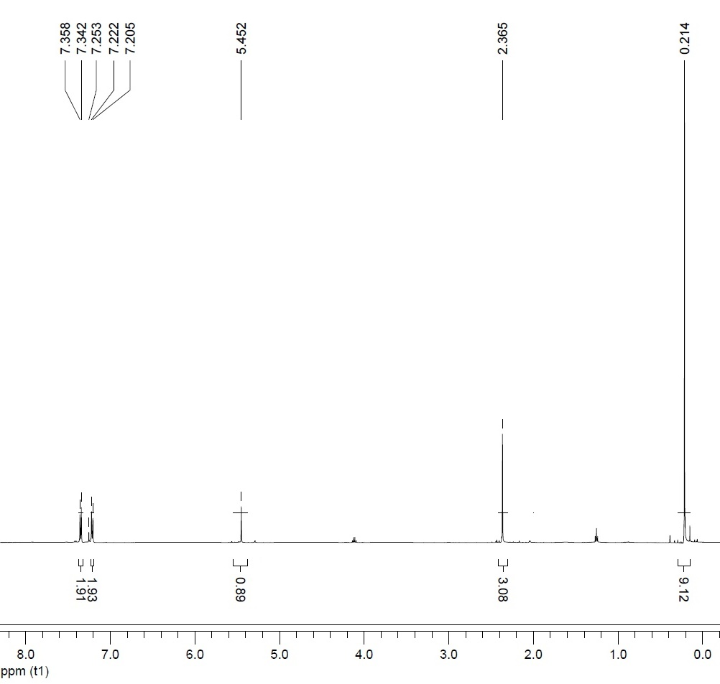
Figure S 5. ¹H NMR of 2-(p-tolyl)-2-((trimethylsilyl)oxy)acetonitrile

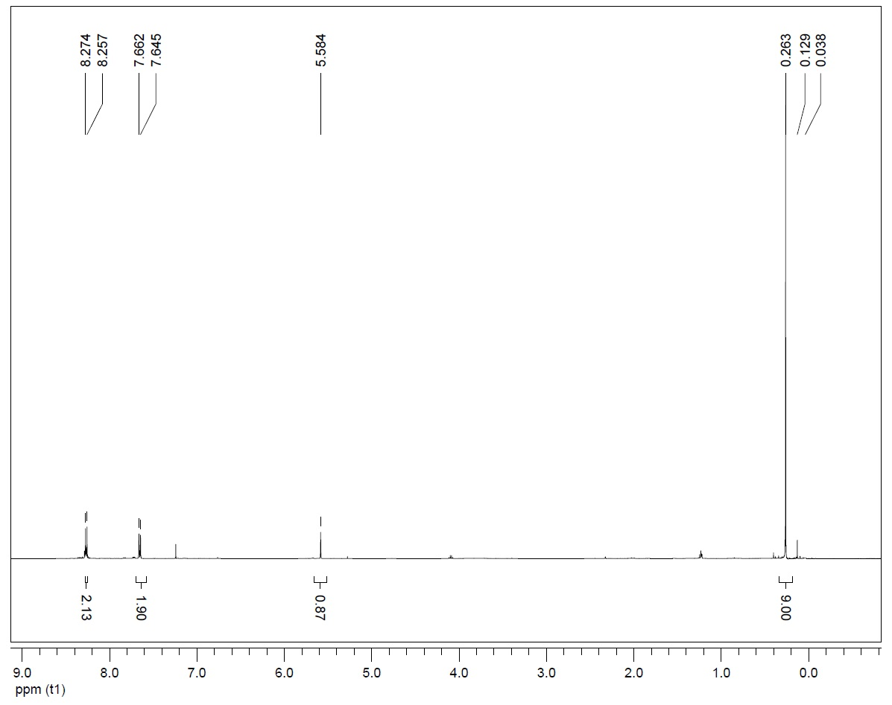
Figure S 6. ¹H NMR of 2-(4-nitrophenyl)-2-((trimethylsilyl)oxy)acetonitrile
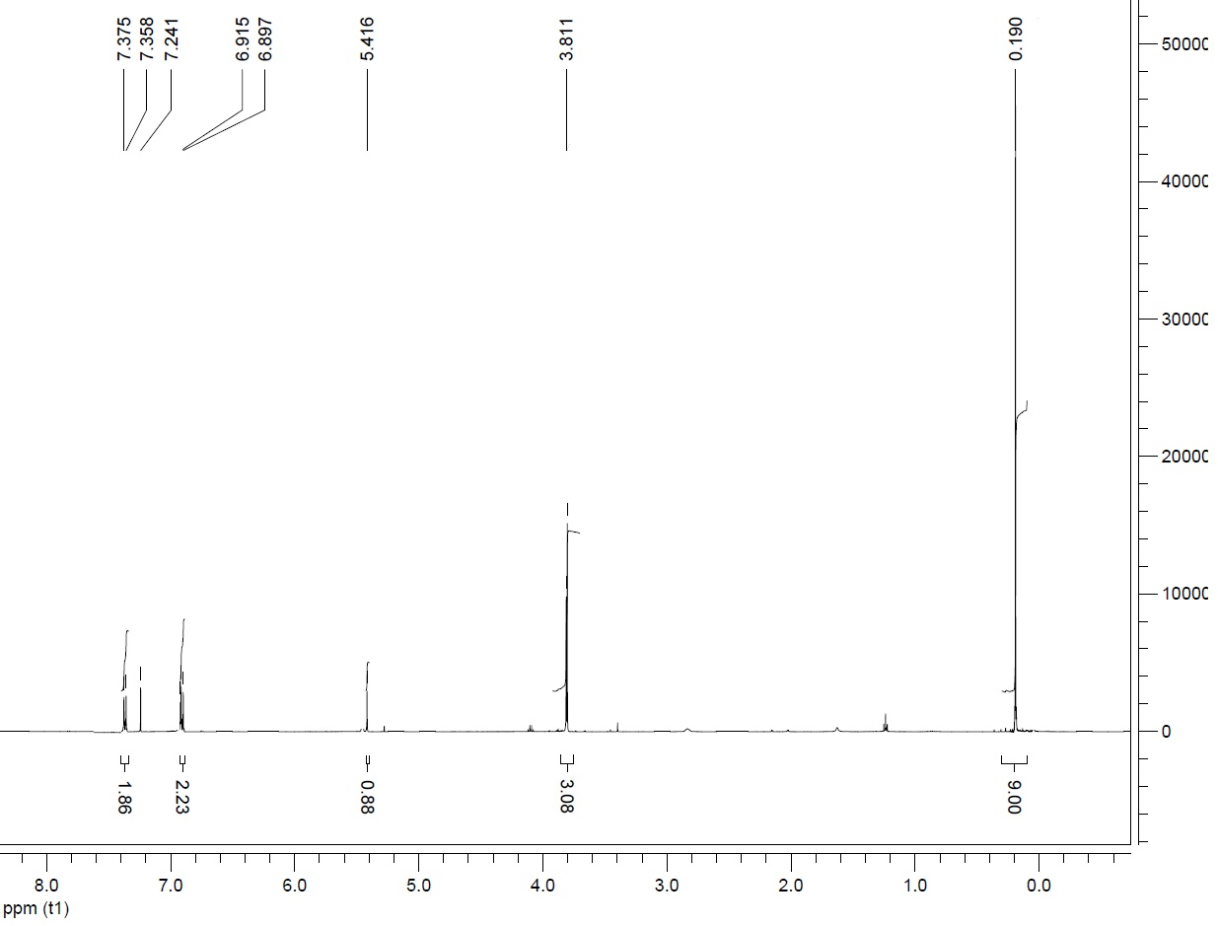
Figure S 7. ¹H NMR of 2-(4-methoxyphenyl)-2-((trimethylsilyl)oxy)acetonitrile

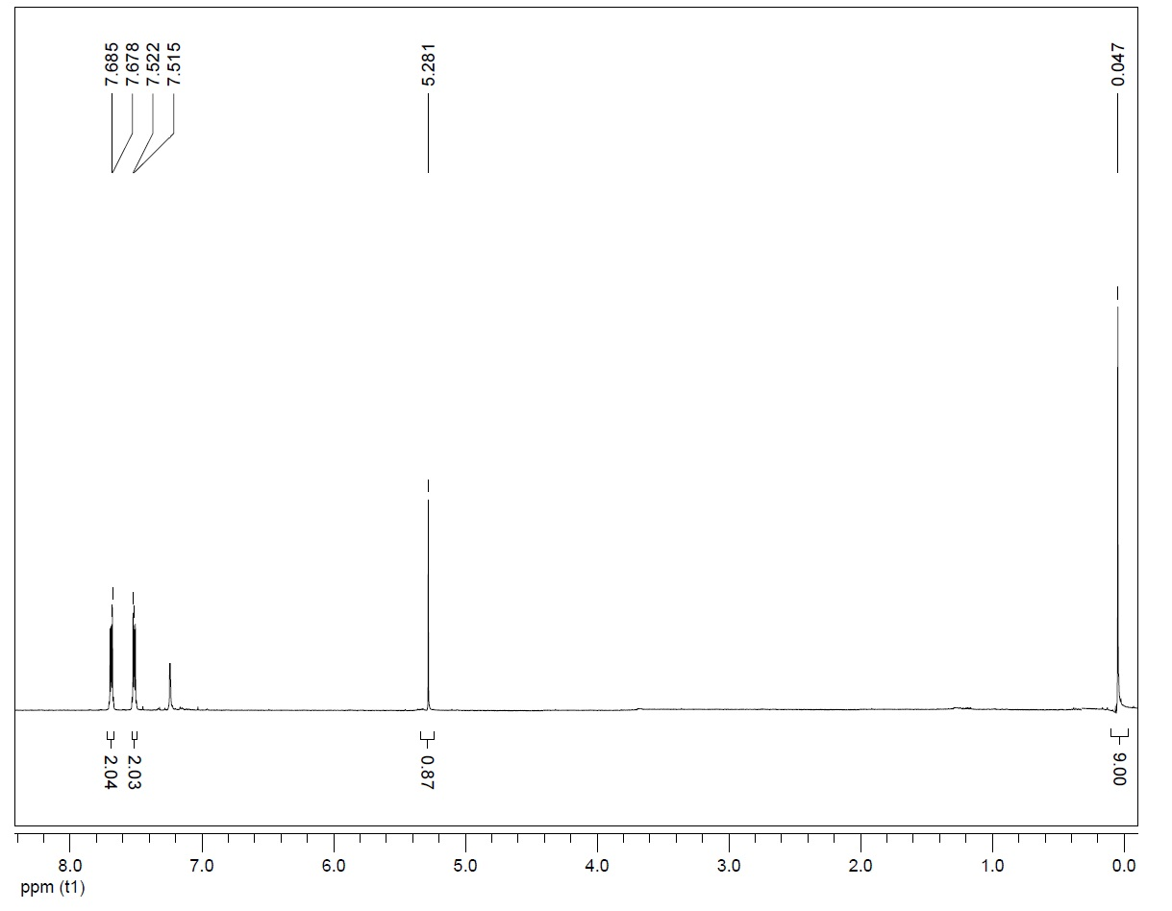
Figure S 8. ¹H NMR of 2-(4-chlorophenyl)-2-((trimethylsilyl)oxy)acetonitrile

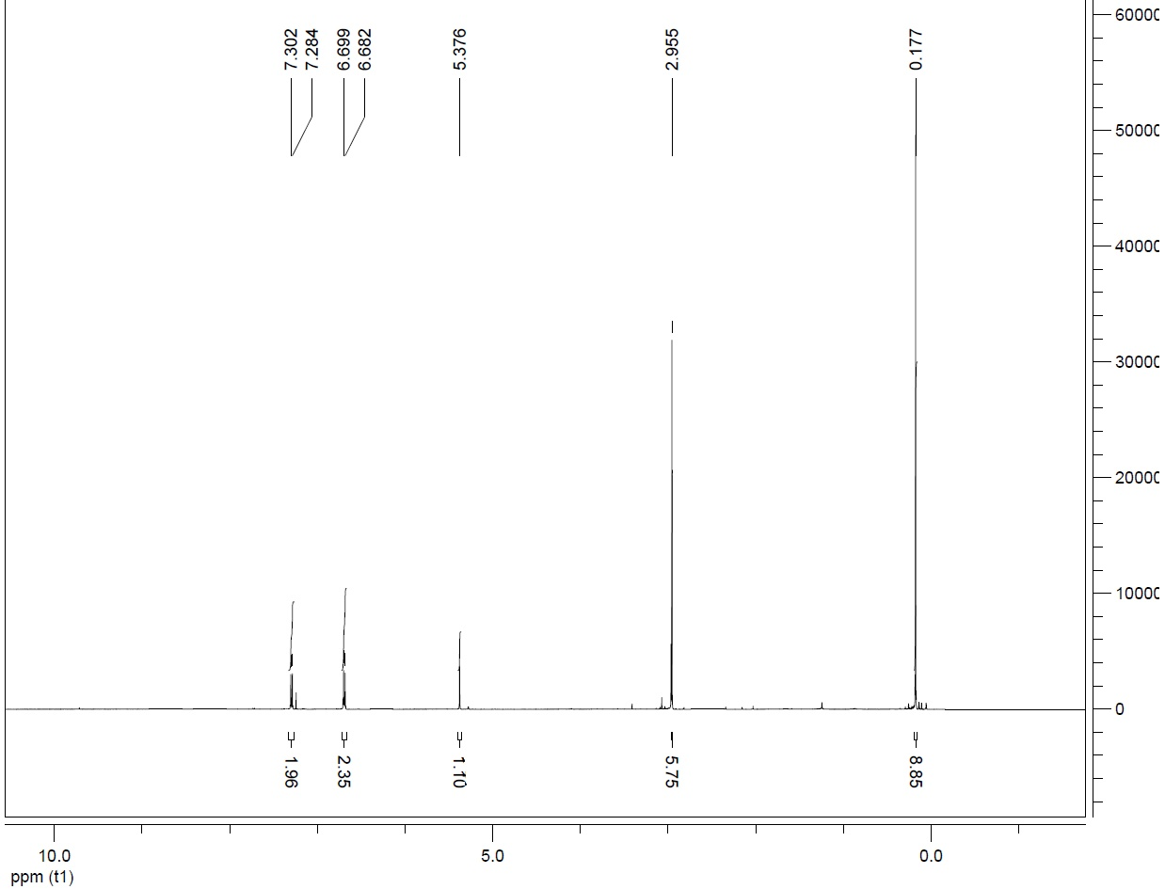
Figure S 9. ¹H NMR of 2-(4-(dimethylamino)phenyl)-2-((trimethylsilyl)oxy)acetonitrile
References:

- Kurono, N.; Arai, K.; Uemura, M.; Ohkuma, T. [Ru(phgly)₂(binap)]/Li₂CO₃: A Highly Active, Robust, and Enantioselective Catalyst for the Cyanosilylation of Aldehydes. Angew. Chem. Int. Ed. 2008, 47, 6643-6646. DOI: 10.1002/anie.200801501.
- Strappaveccia, G; Lanari, D.; Gelman, D.; Pizzo, F.; Rosati, O.; Curinib, M.; Vaccaro, L. Efficient synthesis of cyanohydrin trimethylsilyl ethers via 1,2-chemoselective cyanosilylation of carbonyls. Green Chem., 2013, 15, 199-204. DOI: 10.1039/C2GC36442E.
- Pourmousavi, S. A.; Salahshornia, H. Efficient, Rapid and Solvent-free Cyanosilylation of Aldehydes and Ketones Catalyzed by SbCl₃. Bull. Korean Chem. Soc. 2011, 32, 1575-1578. DOI:10.5012/bkcs.2011.32.5.1575.
- Dekamin, M. G; Mokhtari, J.; Naimi-Jamal, M. R. Organocatalytic cyanosilylation of carbonyl compounds by tetrabutylammonium phthalimide-N-oxyl. Catal. Commun. 2009, 10, 582-585. DOI: 10.1016/j.catcom.2008.10.036.

