Supporting information for

Chemical constituents from culture of the fungus Hericium alpestre

Table of Contents
Figure S1. ¹ H NMR (600 MHz, DMSO-d ₆) spectrum of 1
Figure S2. ¹³ C NMR (150 MHz, DMSO-d ₆) spectrum of 1
Figure S3. The HMQC spectrum for 1
Figure S4. The HMBC spectrum for 1
Figure S5. The ¹ H- ¹ H COSY spectrum for 1
Figure S6. The ESI-MS of compounds 1
Figure S7. The absorption spectrum compound 1
Table S1. ¹H (600 MHz) and ¹³C NMR (150 MHz) spectral data of 1 in DMSO-d ₆
Figure S8. Chemical structure of compound 1
Figure S9. Crystal Structure of compound 2
Table S2. Crystallographic Data for compound 2
Figure S10. The ESI-MS of compounds 2
Figure S11. Chemical structure of compound 2
Figure S12. ¹ H NMR (600 MHz, CF₃COOH + D₂O) spectrum of 3
Figure S13. ¹³ C NMR (150 MHz, CF₃COOH + D₂O) spectrum of 3
Figure S14. The HMQC spectrum for 3
Figure S15. The HMBC spectrum for 3
Figure S16. The ¹ H- ¹ H COSY spectrum for 3
Figure S17. The ESI-MS of compounds 3
Figure S18. Crystal Structure of compound 3
Table S3. Crystallographic Data for compound 3
Table S4. ¹H (600 MHz) and ¹³C NMR (150 MHz) spectral data of 3 in CF₃COOH + D₂O.
Figure S19. Chemical structure of compound 3
Figure S20. ¹ H NMR (600 MHz, CDCl₃) spectrum of 4
Figure S21. ¹³ C NMR (150 MHz, CDCl₃) spectrum of 4
Figure S22. Chemical structure of compound 4
Figure S23. ¹ H NMR (600 MHz, CD₃OD) spectrum of 5
Figure S24. ¹³ C NMR (150 MHz, CD₃OD) spectrum of 5
Figure S25. Chemical structure of compound 5
Figure S26. ¹ H NMR (600 MHz, CDCl₃) spectrum of 6
Figure S27. ¹³ C NMR (150 MHz, CDCl₃) spectrum of 6
Figure S28. Chemical structure of compound 6
Figure S29. ¹ H NMR (600 MHz, CDCl₃) spectrum of 7
Figure S30. ¹³ C NMR (150 MHz, CDCl₃) spectrum of 7
Figure S31. Chemical structure of compound 7
Figure S32. ¹ H NMR (600 MHz, CDCl₃) spectrum of 8
Figure S33. ¹³ C NMR (150 MHz, CDCl₃) spectrum of 8
Figure S34. Chemical structure of compound 8
Figure S35. ¹ H NMR (600 MHz, CD₃OD) spectrum of 9
Figure S36. ¹³ C NMR (150 MHz, CD₃OD) spectrum of 9
Figure S37. Chemical structure of compound 9
Figure S38. ¹ H NMR (600 MHz, CD₃OD) spectrum of 10
Figure S39. ¹³ C NMR (150 MHz, CD₃OD) spectrum of 10
Figure S40. Chemical structure of compound 10
Figure S41. ¹ H NMR (600 MHz, CDCl₃) spectrum of 11
Figure S42. ¹³ C NMR (150 MHz, CDCl₃) spectrum of 11
Figure S43. Chemical structure of compound 11
Figure S44. ¹ H NMR (600 MHz, CDCl₃) spectrum of 12
Figure S45. ¹³ C NMR (150 MHz, CDCl₃) spectrum of 12
Figure S46. Chemical structure of compound 12
Figure S47. Crystal Structure of compound 13
Table S5. Crystallographic Data for compound 13
Figure S48. Chemical structure of compound 13
Figure S1. The ¹ H NMR spectrum for compound 1
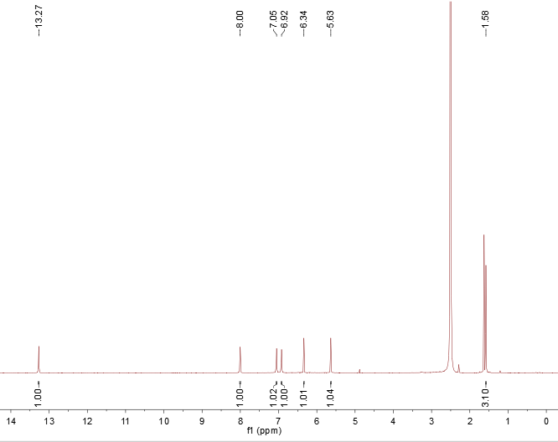

Figure S2. The ¹³C NMR spectrum for 1
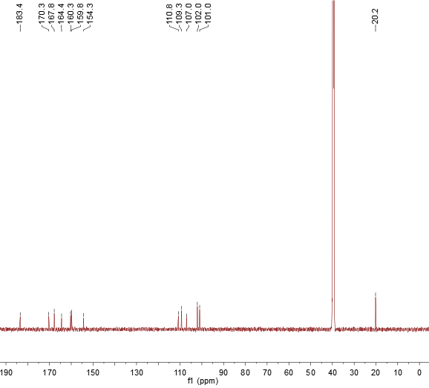

Figure S3. The HMQC spectrum for 1
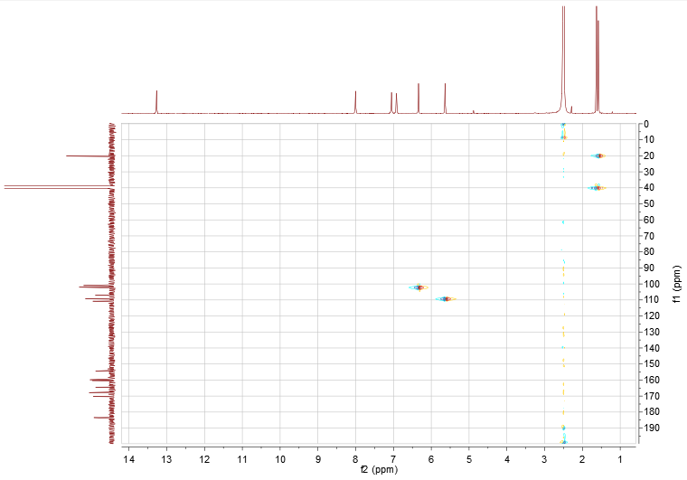

Figure S4. The HMBC spectrum for 1
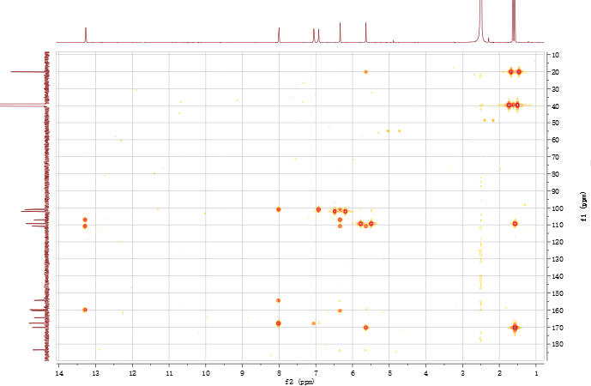

Figure S5. The ¹ H- ¹ H COSY spectrum for 1
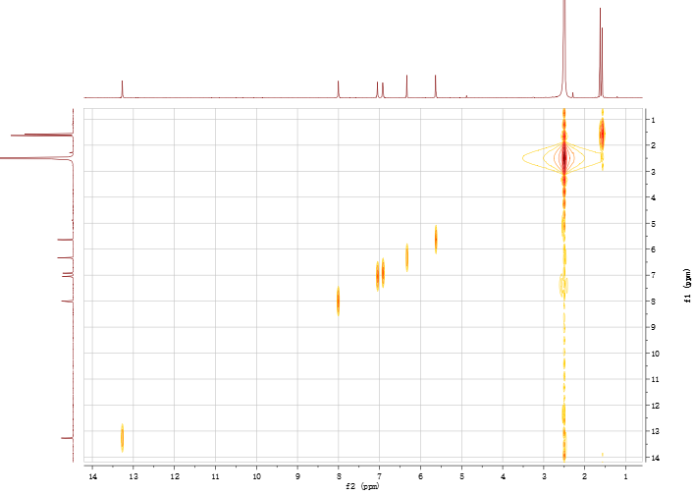

Figure S6. The EIS-MS (-Q1) for compound 1
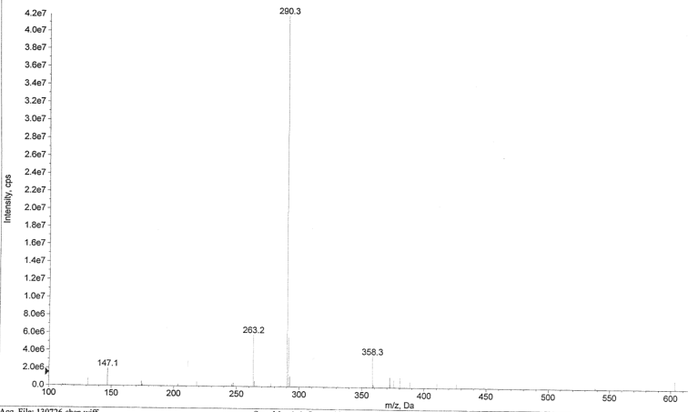

Table S1. ¹H (600 MHz) and ¹³C NMR (150 MHz) spectral data of 1 in DMSO-d ₆.
Position δ H (J, Hz) δ C HMBC*
2 170.3
3 5.63 (1H, s) 109.3 C-2, C-4, C-11, C-1′
4 183.4
5 159.8
6 107.0
7 154.3
8 6.34 (1H, s) 102.0 C-8, C-10, C-11, C-12
9 160.3
10 110.8
11 164.4
12 8.00 (1H, s) C-8, C-13, C-1″
13 101.0
1′ 1.58 (3H, s) 20.2 C-2, C-3
1″ 167.8
OH-5 4.91 (1H, s) C-5, C-11, C-12
OH-13 6.92 (1H, s) C-8, C-1″
OH-1″ 13.27 (1H, s) C-1″
* HMBC correlations are from proton(s) stated to the indicated carbon

Figure S7. The absorption spectrum compound 1
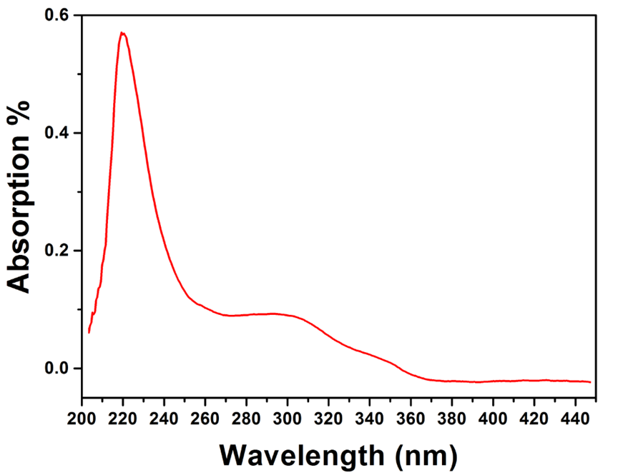

Figure S8. Chemical structure of compound 1

Figure S9. Crystal structure of compound 2. Atom colors, O = Red, gray = C, light gray = H
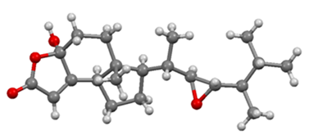

Table S2. Crystallographic Data for compound 2
Sample | compound 2
Formula | C₂₁H₃₂O₄
Mr [g·mol⁻¹] | 348.47
Crystal system | Monoclinic
Space group | P2 (1)
a (Å) | 8.4702 (8)
b (Å) | 8.2636 (6)
c (Å) | 14.0379 (11)
V (Å³) | 973.66 (14)
Z | 2
Dχ(Mg cm⁻³) | 1.189
μ (mm⁻¹) | 0.642
F (000) | 380
Crystal size(mm³) | 0.27 × 0.18 × 0.12
R,wR² | 0.0891, 0.2888 (2230)

Figure S10. The EIS-MS (+Q1) for compound 2
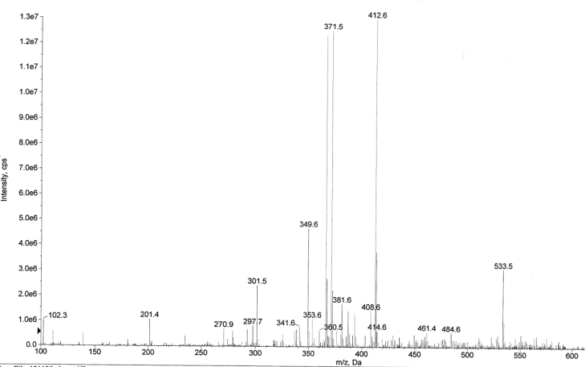

Figure S11. Chemical structure of compound 2

Figure S12. The ¹ H NMR spectrum for 3
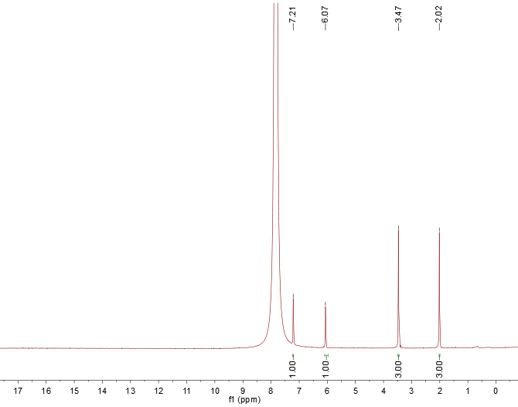

Figure S13. The ¹³ C NMR spectrum for 3
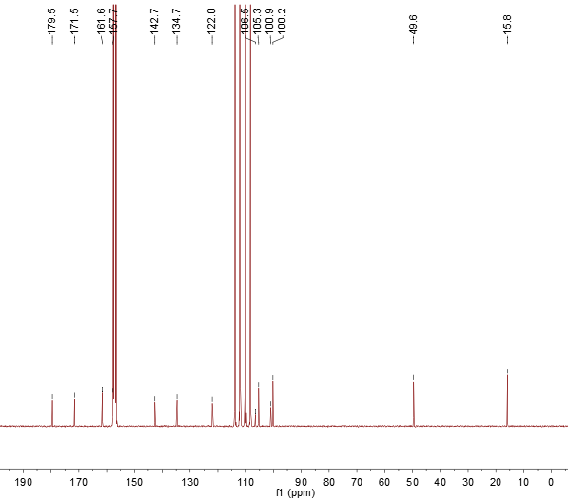

Figure S14. The HMQC spectrum for 3
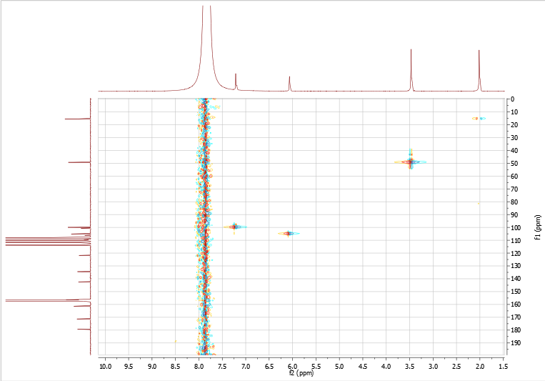

Figure S15. The HMBC spectrum for 3
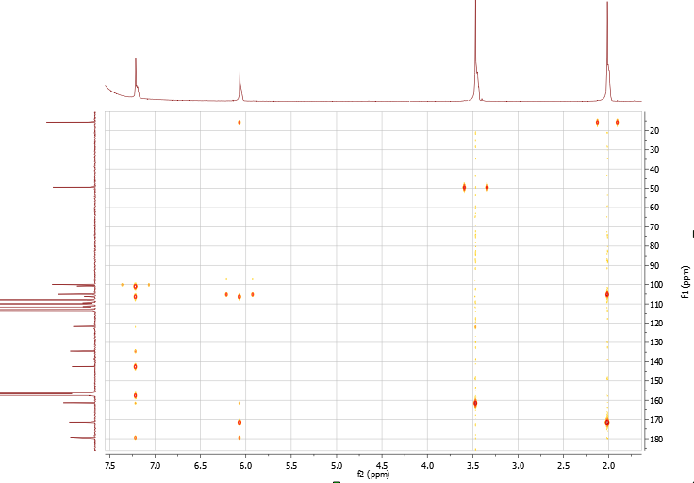

Figure S16. The ¹ H- ¹ H COSY spectrum for 3
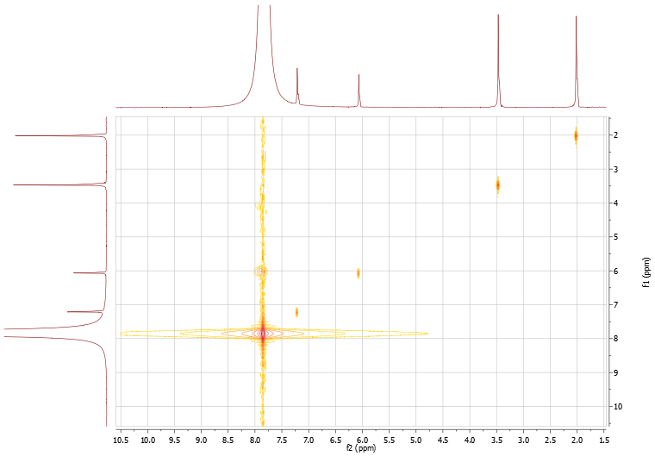

Figure S17. The ESI-MS (+Q1) for compound 3
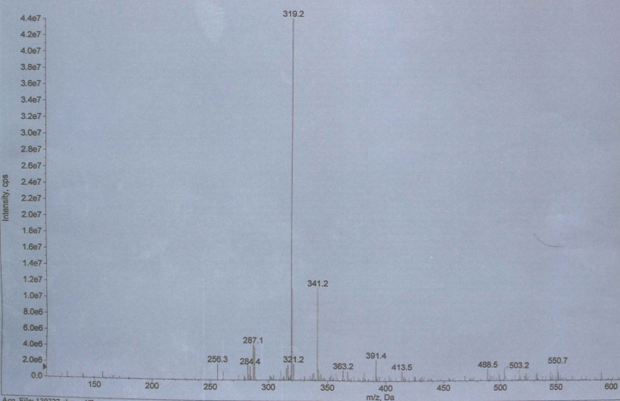

Figure S18. Crystal structure of compound 3
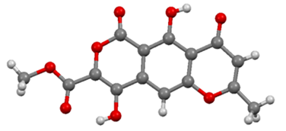

Table S3. Crystallographic Data for compound 3
Sample | compound 3
Formula | C₅H₁₀O₈
Mr [g·mol⁻¹] | 318.04
Crystal system | Orthorhombic
Space group | P2(1)2(1)2(1)
a (Å) | 3.8376 (3)
b (Å) | 14.8469 (11)
c (Å) | 22.1559 (18)
V (Å³) | 1262.36 (17)
Z | 2
Dχ(Mg cm⁻³) | 1.674
μ (mm⁻¹) | 0.139
F (000) | 656
Crystal size(mm³) | 0.38 × 0.09 × 0.06
R,wR² | 0.0521, 0.1039 (2234)

Table S4. ¹H (600 MHz) and ¹³C NMR (150 MHz) spectral data of 3 in CF₃COOH + D₂O
Position δ H (J, Hz) δ C HMBC*
2 171.5
3 6.07 (1H, s) 105.3 C-1′, C-2, C-4, C-12
4 179.5
5 122.0
9 142.6
10 7.21 (1H, s) 100.2 C-9, C-11, C-12, C-13
11 157.7
12 106.5
13 100.9
14 134.7
1′ 2.02 (3H, s) 15.8 C-2, C-3
1″ 161.5
3″ 3.47 (3H, s) 49.6 C-1″
* HMBC correlations are from proton(s) stated to the indicated carbon

Figure S19. Chemical structure of compound 3

Figure S20. The ¹ H NMR spectrum for 4
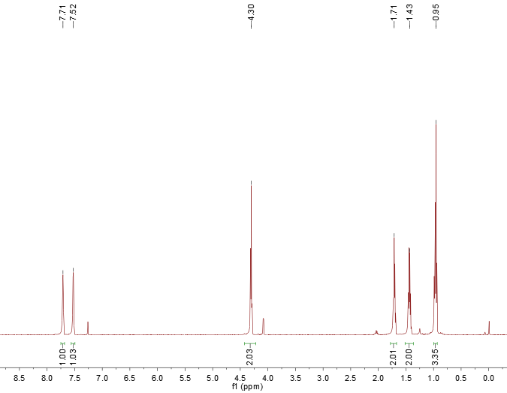

Figure S21. The ¹³ C NMR spectrum for 4
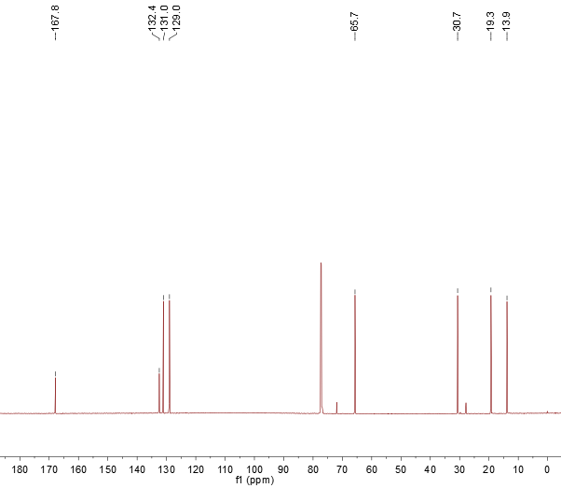

Figure S22. Chemical structure of compound 4

Figure S23. The ¹ H NMR spectrum for 5
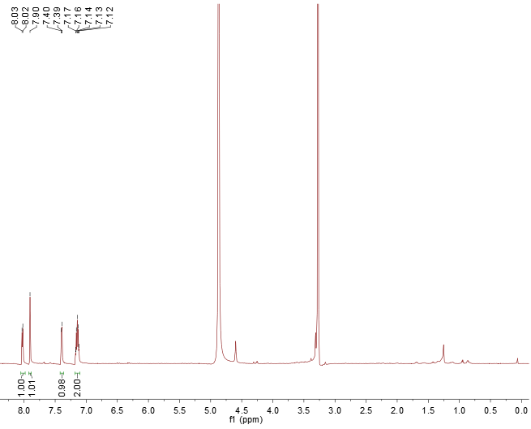

Figure S24. The ¹³ C NMR spectrum for 5
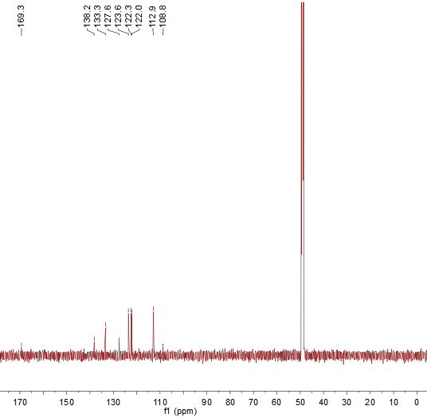

Figure S25. Chemical structure of compound 5

Figure S26. The ¹ H NMR spectrum for 6
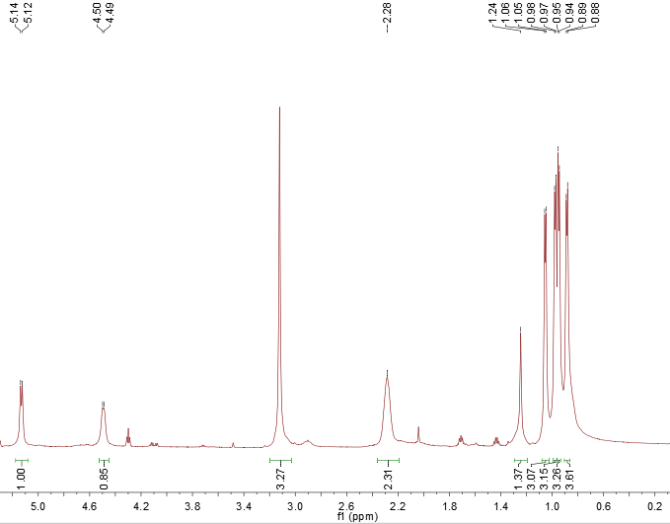

Figure S27. The ¹³ C NMR spectrum for 6
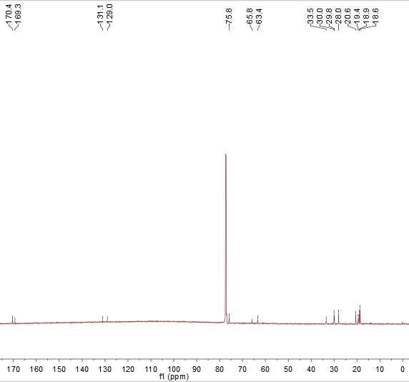

Figure S28. Chemical structure of compound 6

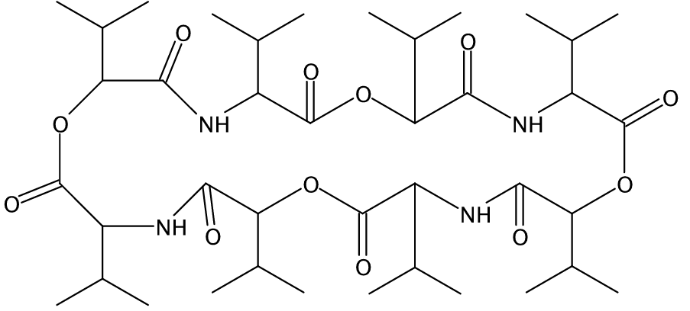

Figure S29. The ¹ H NMR spectrum for 7
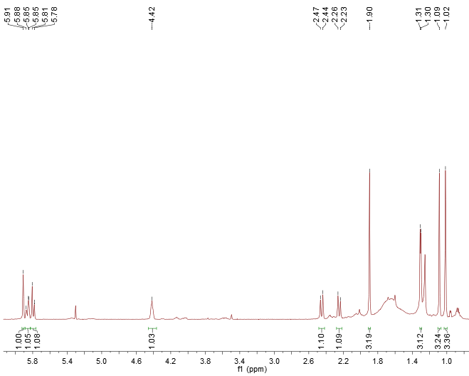

Figure S30. The ¹³ C NMR spectrum for 7
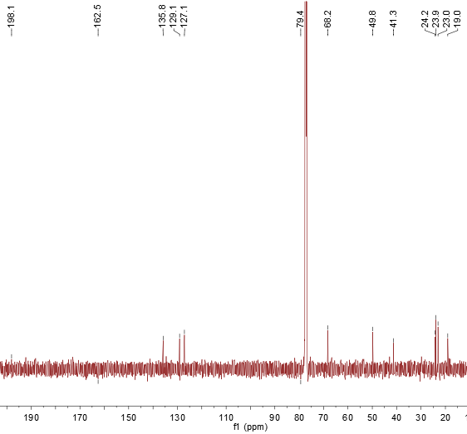

Figure S31. Chemical structure of compound 7

Figure S32. The ¹ H NMR spectrum for 8
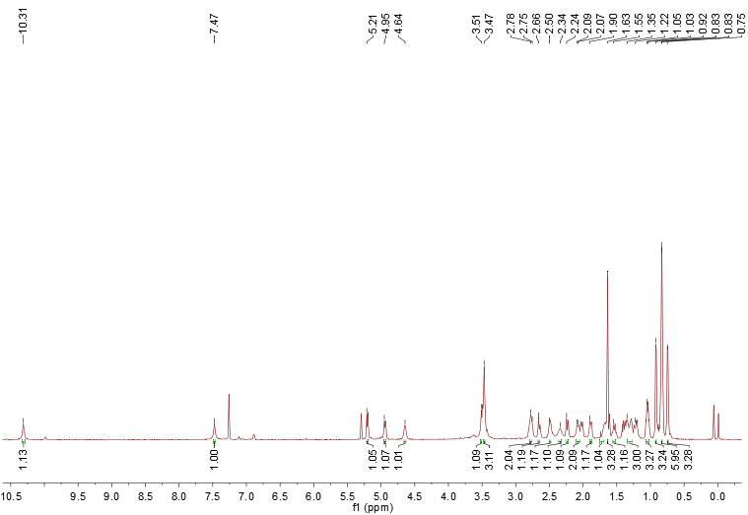

Figure S33. The ¹³ C NMR spectrum for 8
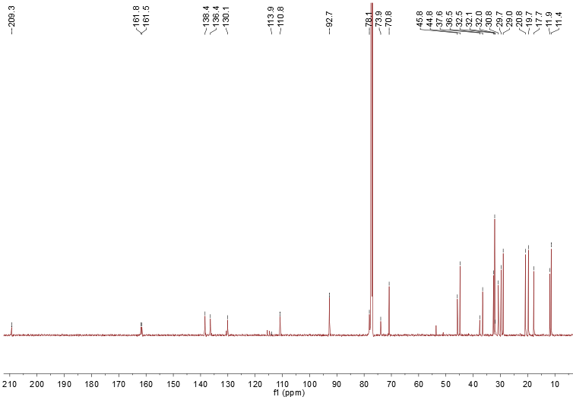

Figure S34. Chemical structure of compound 8

Figure S35. The ¹ H NMR spectrum for 9
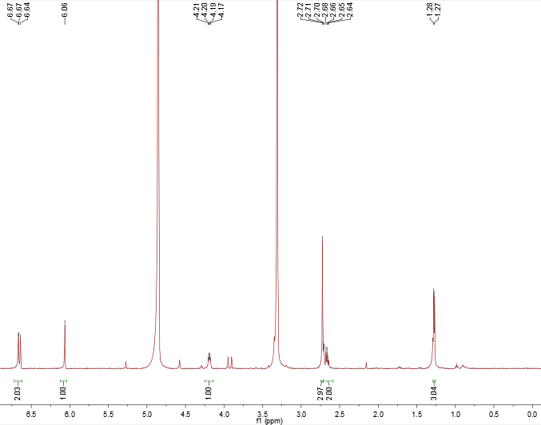

Figure S36. The ¹³ C NMR spectrum for 9
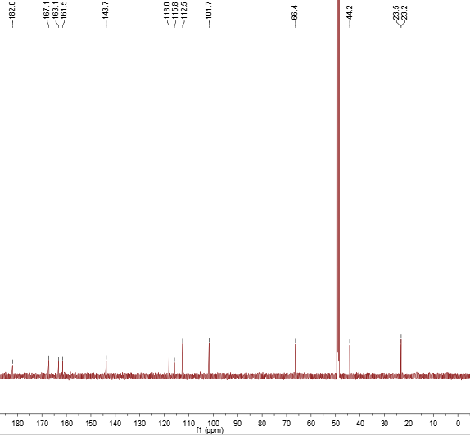

Figure S37. Chemical structure of compound 9

Figure S38. The ¹ H NMR spectrum for 10
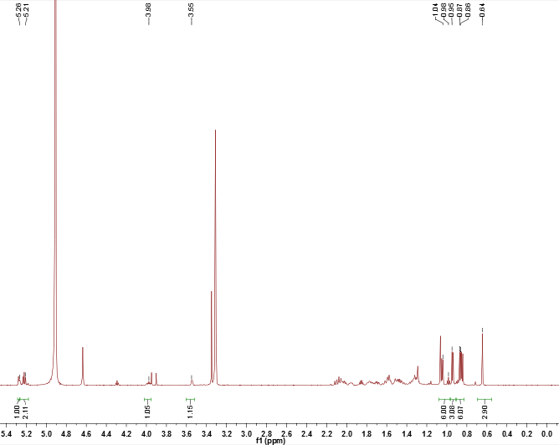

Figure S39. The ¹³ C NMR spectrum for 10
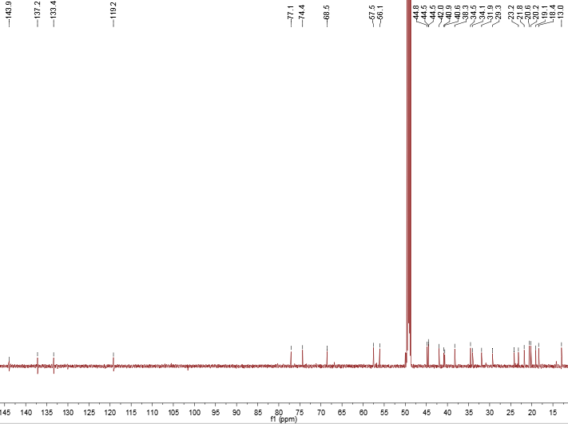

Figure S40. Chemical structure of compound 10

Figure S41. The ¹ H NMR spectrum for 11
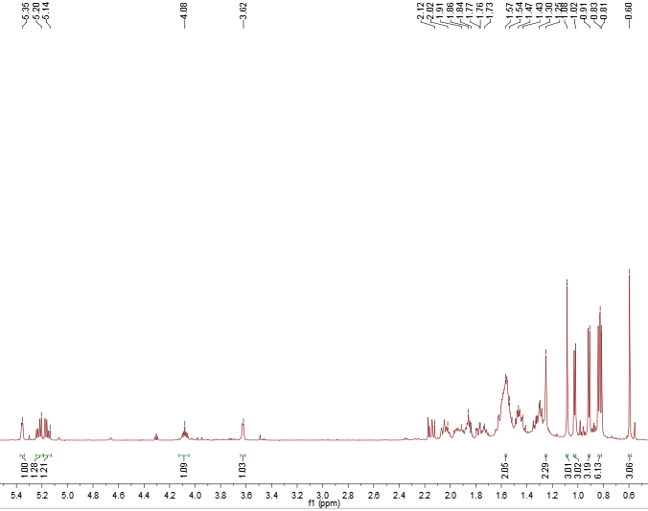

Figure S42. The ¹³ C NMR spectrum for 11
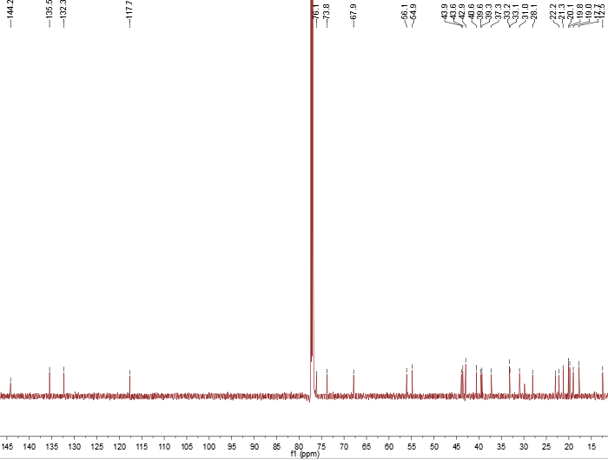

Figure S43. Chemical structure of compound 11

Figure S44. The ¹ H NMR spectrum for 12
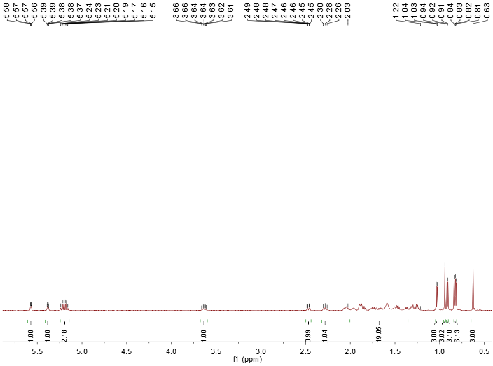

Figure S45. The ¹³ C NMR spectrum for 12
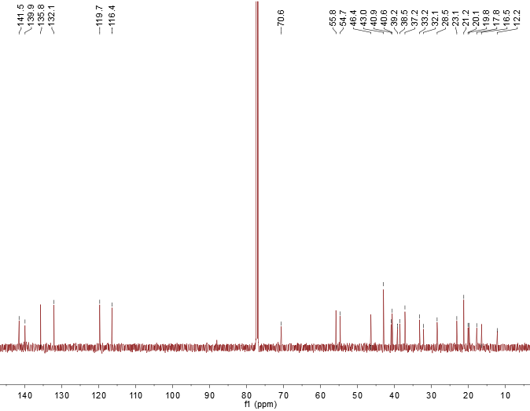
Figure S46. Chemical structure of compound 12

Figure S47. Crystal structure of compound 13. Atom colors, O = Red, gray = C, light gray = H, light blue = N.
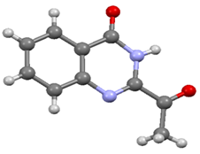
Table S5. Crystallographic Data for compound 13
Sample | compound 13
Formula | C₁₀H₈N₂O₂
Mr [g·mol⁻¹] | 188.18
Crystal system | Triclinic
Space group | P-1
a (Å) | 5.2891 (6)
b (Å) | 8.5464 (9)
c (Å) | 10.2537 (9)
V (Å³) | 443.44 (8)
Z | 2
Dχ(Mg cm⁻³) | 1.409
μ (mm⁻¹) | 0.101
F (000) | 196
Crystal size(mm³) | 0.41 × 0.17 × 0.08
R,wR² | 0.0467, 0.1404 (1534)

Figure S48. Chemical structure of compound 13
