**Supporting information**

for

**A clip-like host that undergoes self-assembly and competitive guest-induced disassembly in water**

Meagan A. Beatty, Jil A. Busmann, Noah G. Fagen, Graham A. E. Garnett, Fraser Hof*

**Table of contents**

1. 1H and 13C spectra of novel compounds
2. Further dimer characterization
   1. ITC characterization of **2**
   2. Comparison of 1H NMR spectra of **2** in CD3OD and D2O
   3. 1-D DOSY characterization
3. Host-guest characterization
   1. Single point 1H titrations of BM with **2**
   2. Full 1H titrations with select guests (**7**, **9**, **13**, **14**) with **2**
   3. UV-Vis and Fluorescence titrations of BM and LCG with **2**
   4. VT-NMR of 1:1 complex of **2** and LCG
4. 1H and 13C spectra of novel compounds

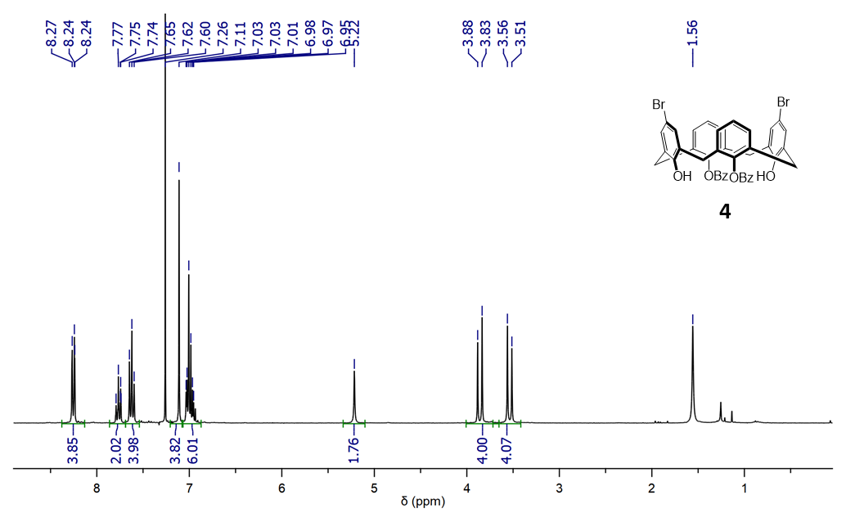

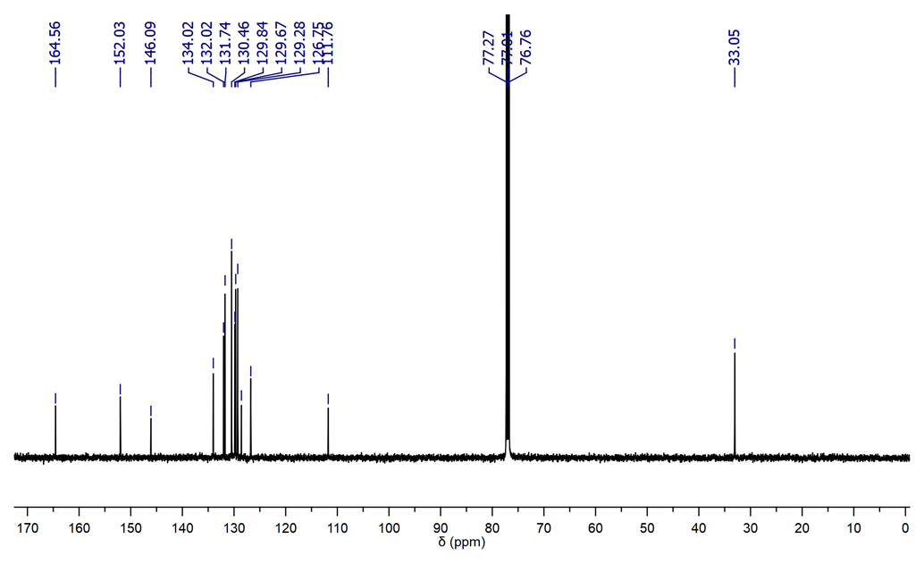

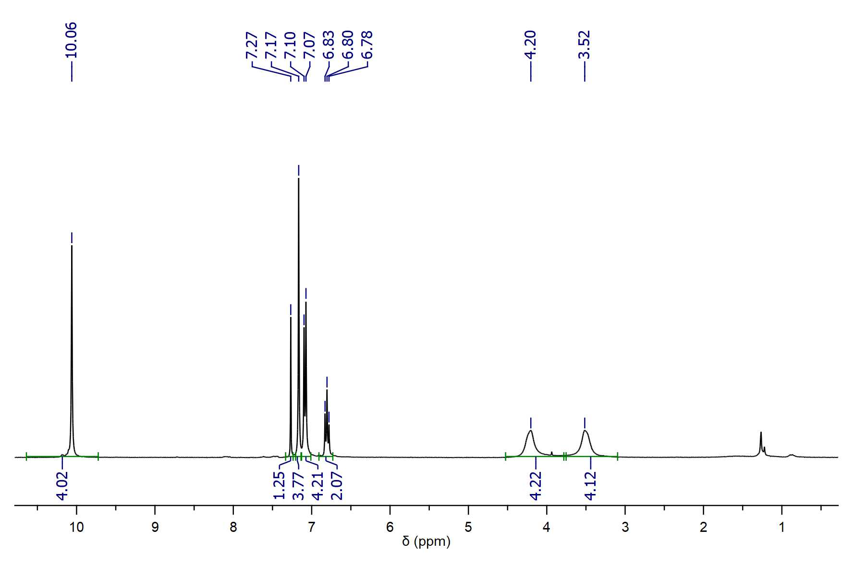

**5**

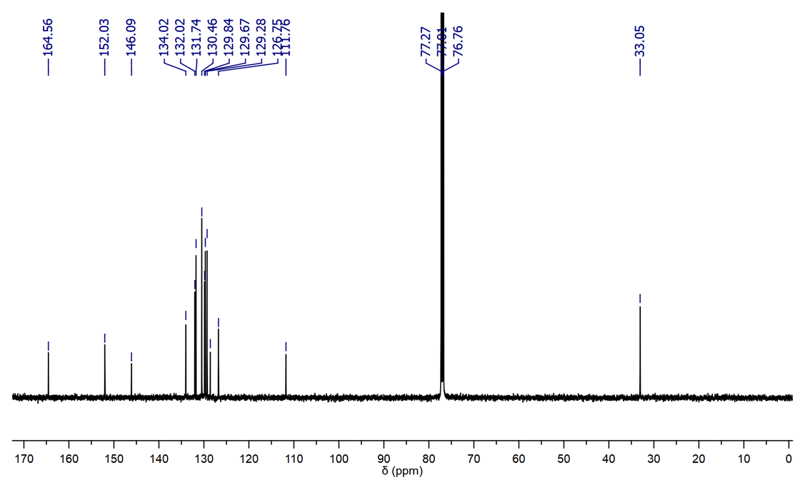

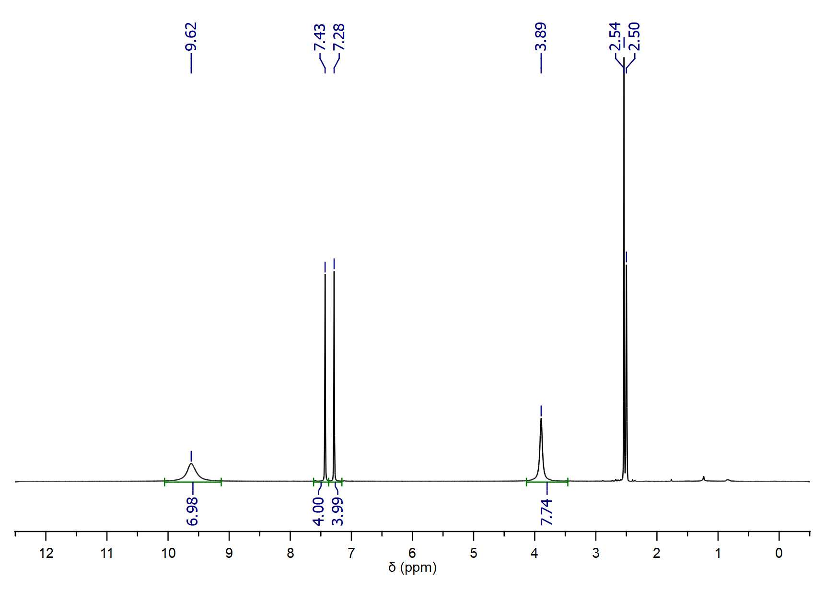

**6**

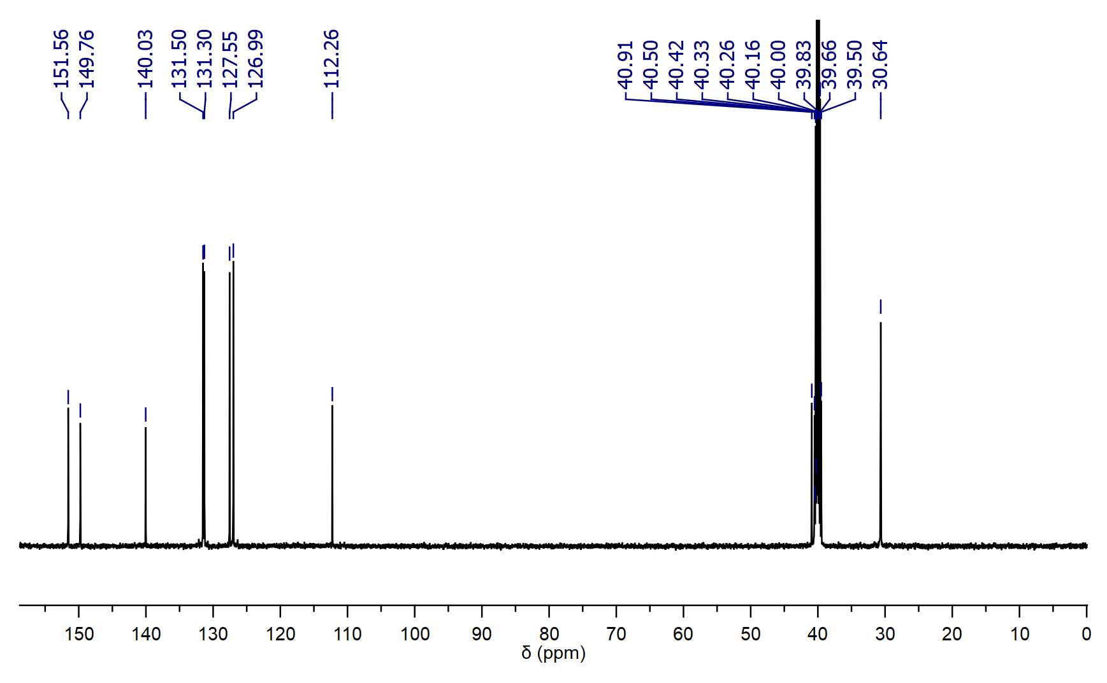

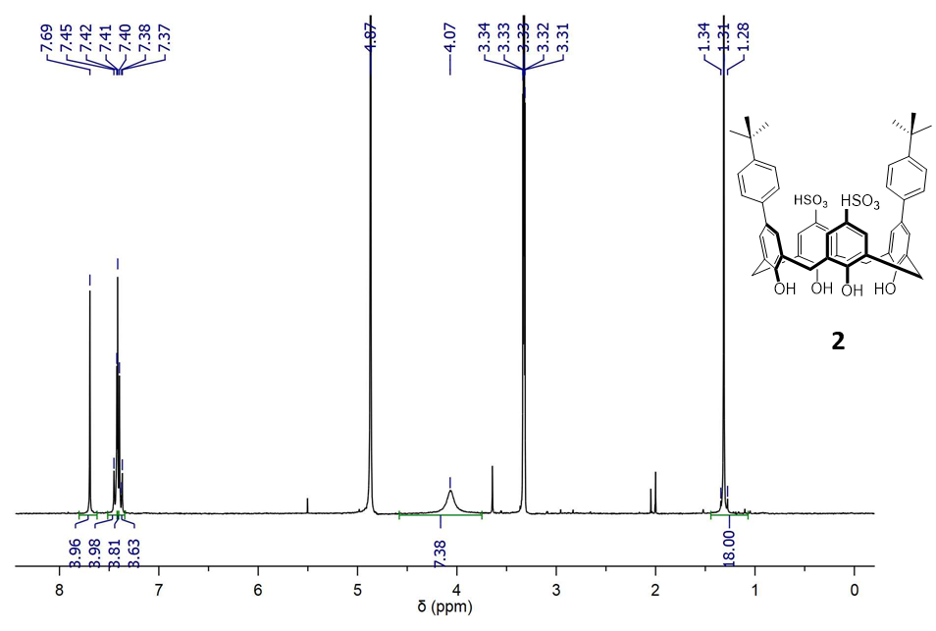

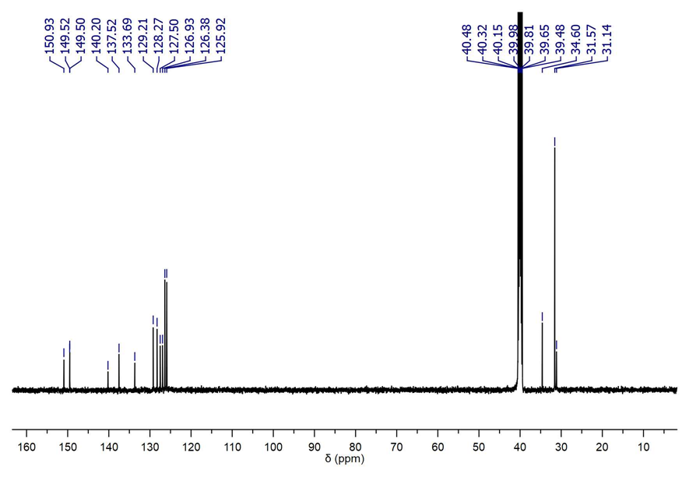

1. Further dimer characterization
   1. ITC characterization of **2**

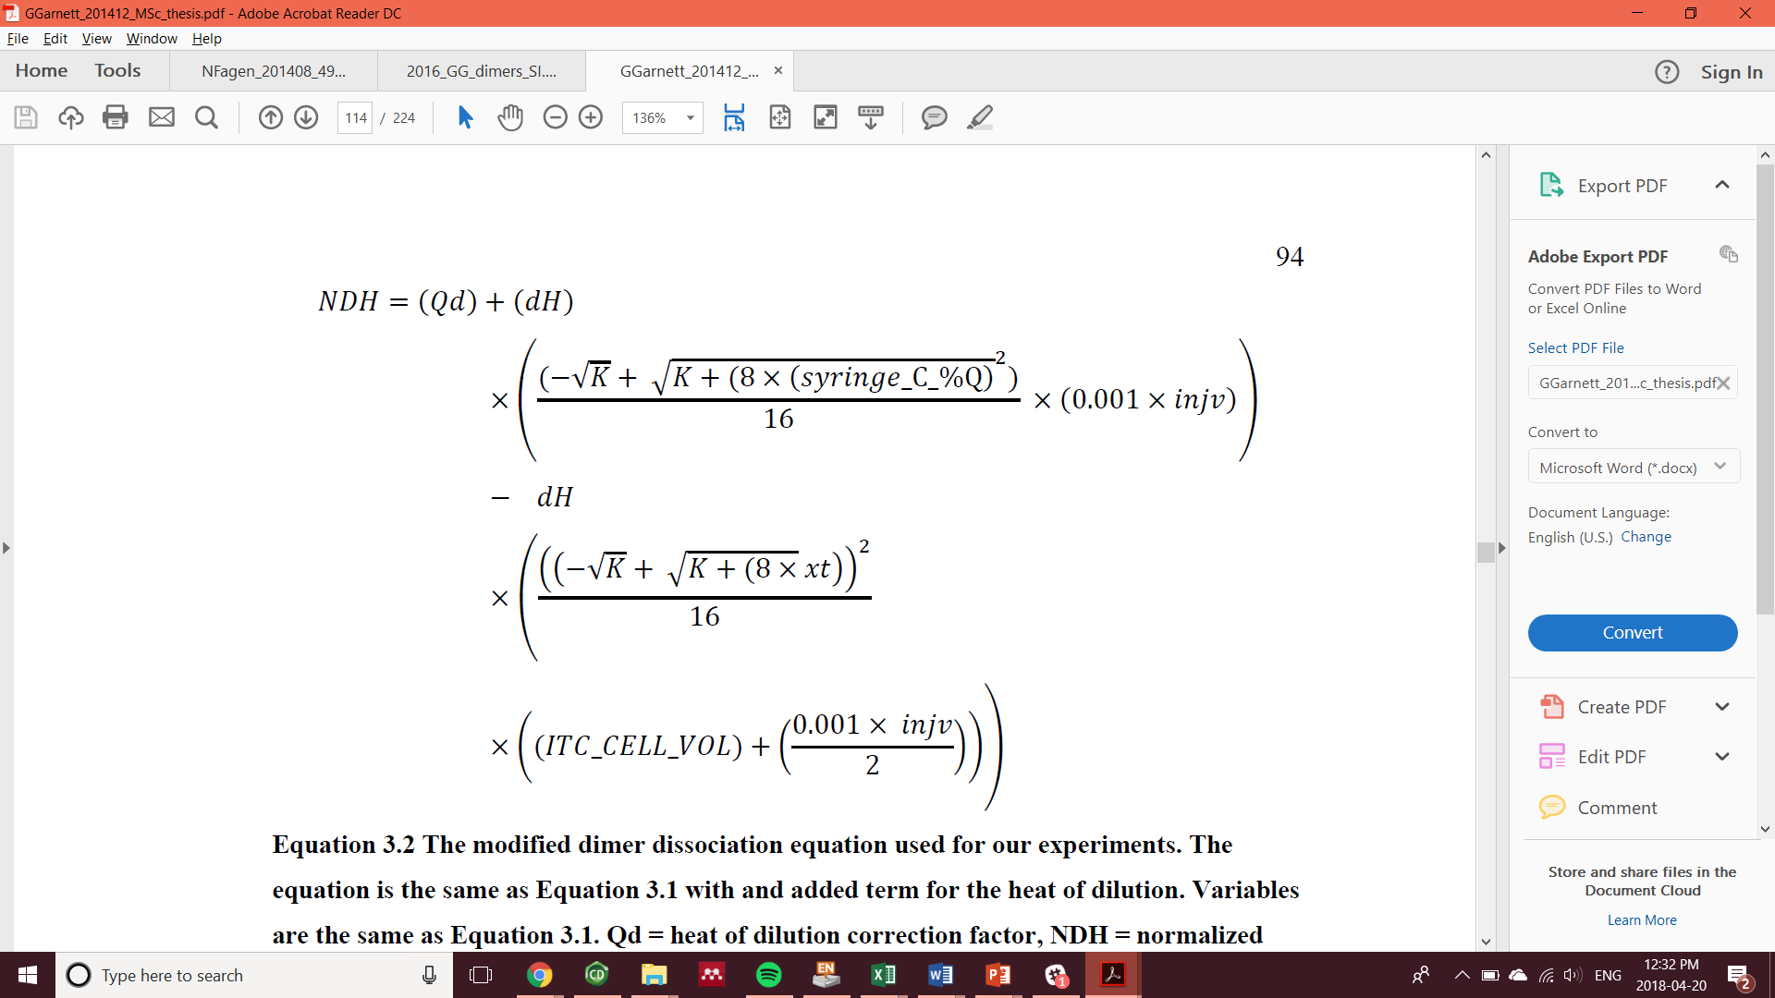

The modified dimer dissociation equation used with a second heat term (highlighted yellow) to account for the heat of dilution, (Qd). Normalized heat change for injection (NDH), heat resulting from injections (dH), syringe concentration (syringe_C_%Q), volume injected (injy), concentrations of injected solute in sample cell (xt), the sample cell volume (ITC_CELL_VOL).

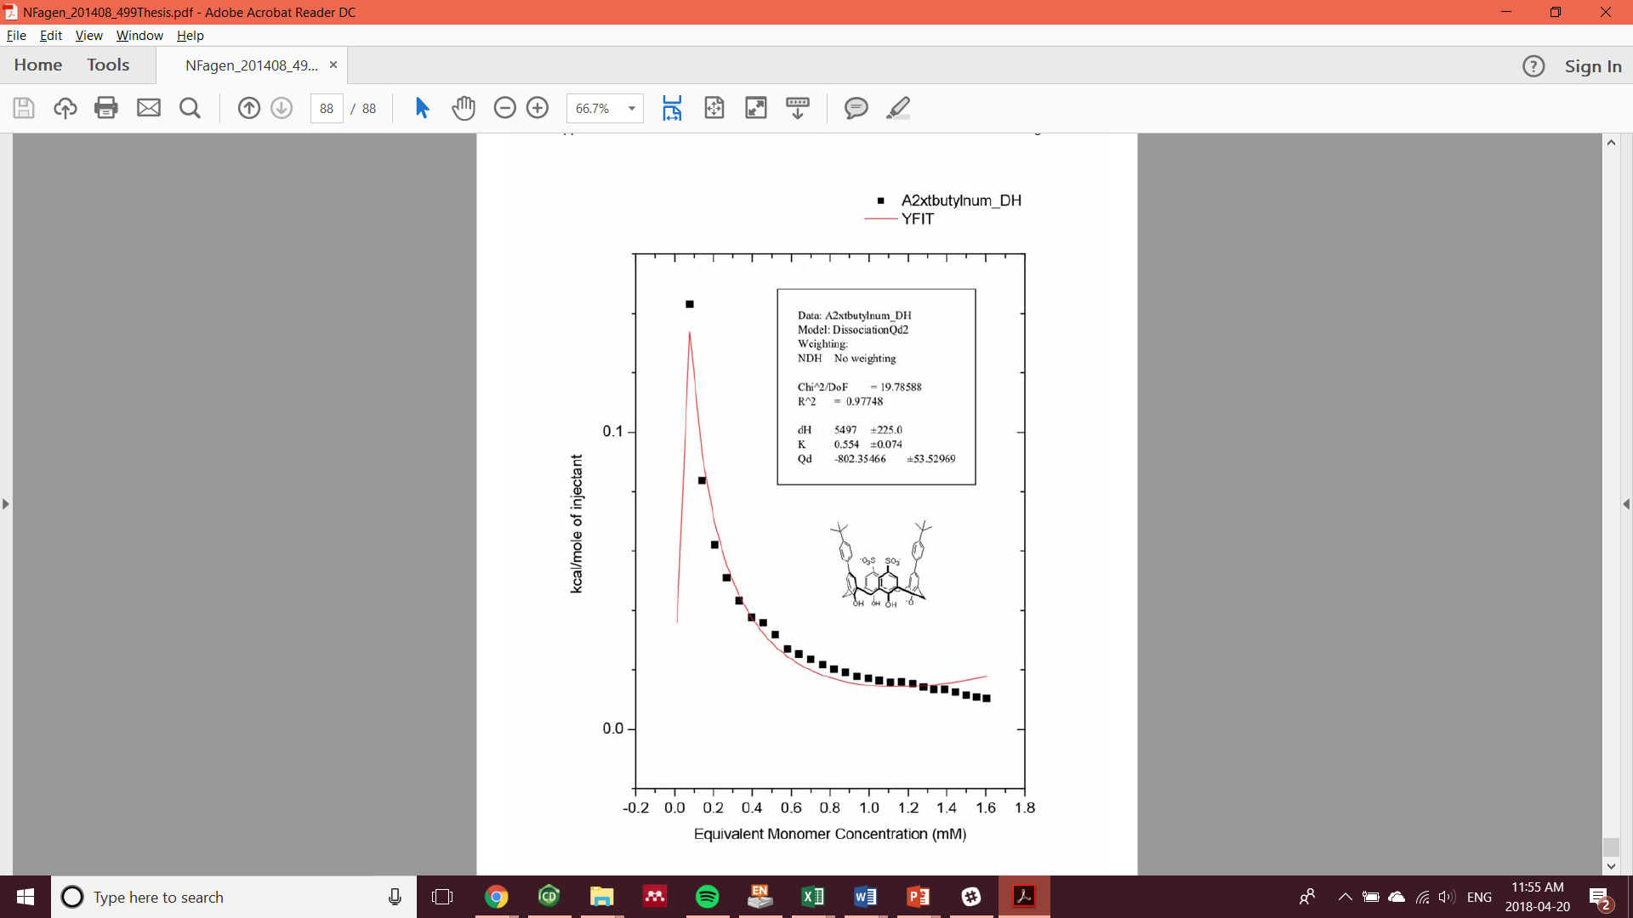

Figure S1. ITC dilutions of **2** fitted with the above dimer dissociation model

|  |  |  |  |  |  |
| --- | --- | --- | --- | --- | --- |
| Table S1. Calculations for thermodynamic properties | | | | | |
|  |  | ΔG= -RTln(keq) | | 303.15 | K |
|  |  |  |  | 8.314 | J mol-1 K-1 |
|  |  |  |  |  |  |
| Kd | **0.554** | mM |  |  |  |
| Keq | 1805.054 | M-1 |  |  |  |
|  |  |  |  |  |  |
| ΔH | **5.497** | kcal/mol |  |  |  |
| ΔG | -4.5168 | kcal/mol |  |  |  |
| -TΔS | -10.0138 | kcal/mol |  |  |  |
| ΔS | 33.0325 | cal/mol |  |  |  |

* 1. Comparison of 1H NMR spectra of **2** in CD3OD and D2O

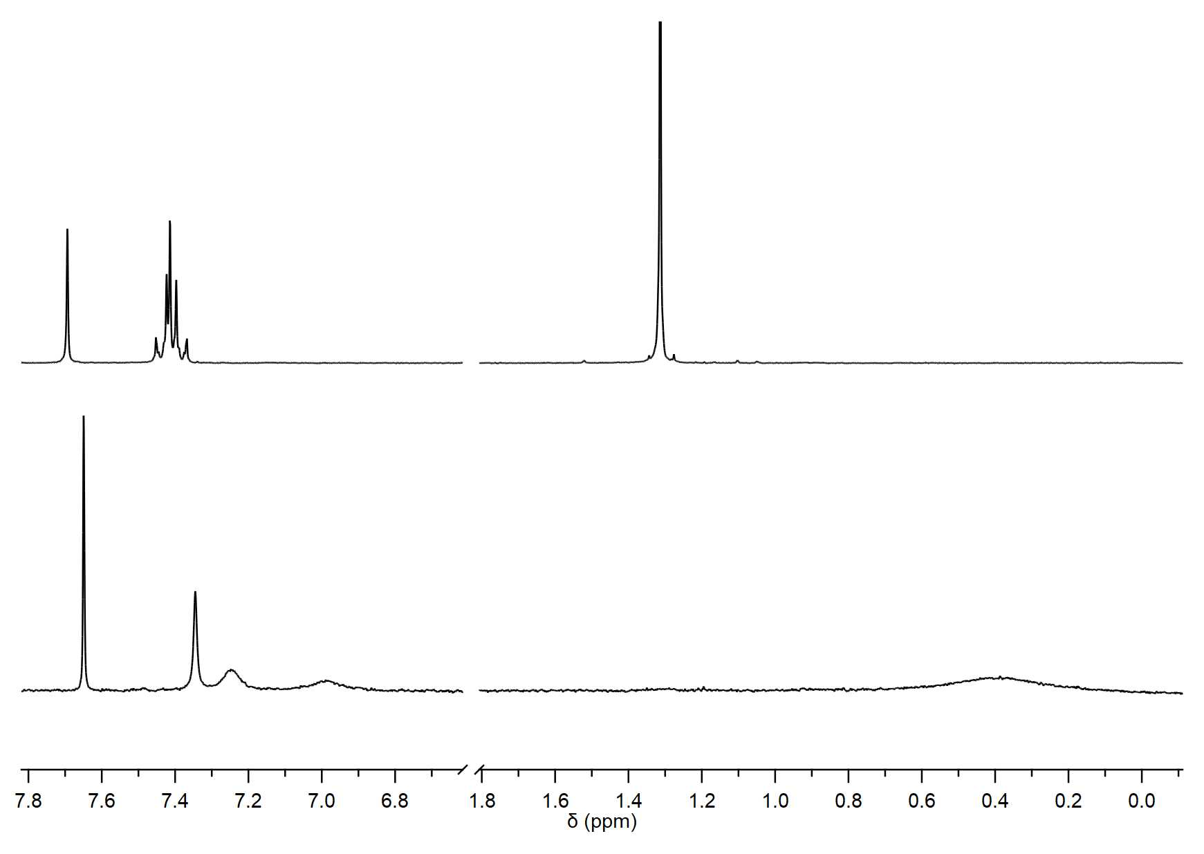

**2** (monomer) in CD3OD

**2** (dimer) in D2O

Figure S2. **2** in CD3OD (top) as a monomer and in D2O as a dimer. The upfield shift and sharpening of the *t*-butyl singlet, and Ph doublets are diagnostic of encapsulation.

* 1. 1-D DOSY characterization

PSC and **2** were mixed together (1 mM ea.) in 20% CD3OD in Na2HPO4/NaH2PO4 (50 mM, pD 8.5) buffer to insure the diffusion coefficients obtained for both hosts came from the same sample conditions.

Table S2. Diffusion coefficient measured, and hydrodynamic radius calculated from indicated resonances in **PSC** (1 mM) from 1-D DOSY.

|  |  |  |  |
| --- | --- | --- | --- |
|  | D (m2/s) (a) | | rH (Å) (b) |
| PSC | 2.23E-10 | **7.30** | |
|  |  |  | |
| Ha | 1.90E-10 | 8.54 | |
| Hb | 1.91E-10 | 8.52 | |
| Hc | 1.92E-10 | 8.49 | |
| Hd | 1.92E-10 | 8.47 | |
|  |  |  | |
|  | av. D | av. rH | |
|  | 1.91E-10 | **8.51 ± 0.03** | |
|  |  |  | |

(a)20% CD3OD in Na2HPO4/NaH2PO4 (50 mM, pD 8.5) buffer at 300 K. (b) viscosity used in Stokes-Einstein equation, 1.35 x 10-3 Pa·s (*1*).

Table S3. Diffusion coefficients measured, and hydrodynamic radii calculated from indicated resonances in **2** (1.5 mM) from 1-D DOSY.

|  |  |  |  |
| --- | --- | --- | --- |
|  | D (m2/s)(a) | | rH (Å)(b) |
| Ha | 2.24E-10 | 11.27 | |
| Hb | 2.23E-10 | 11.32 | |
| Hc | 2.22E-10 | 11.35 | |
|  |  |  | |
|  | av. D | av. rH | |
|  | 2.23E-10 | **11.31 ± 0.04** | |

(a) Na2HPO4/NaH2PO4 (50 mM, pD 8.5) buffer at 300 K. (b) viscosity used in Stokes-Einstein equation, 8.70 x 10-4 Pa·s (*1*).

1. Host-guest characterization

All NMR titrations are conducted in Na2HPO4/NaH2PO4 (50 mM, pD 8.5) buffer at 300 K.

* 1. Single point 1H titrations of BM with **2**

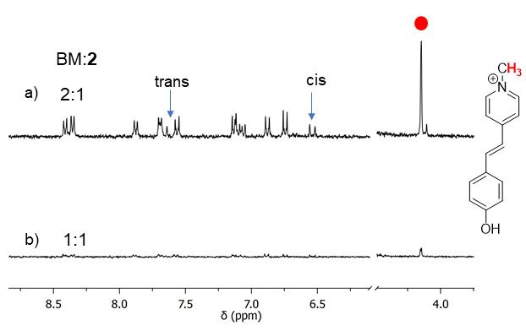

Figure S3. a) 2:1 ([**2**] = 1 mM) Brooker’s merocyanine (BM):**2** reveals only free (red dot) BM as a mixture of trans and cis while b) 1:1 (1 mM) shows a flat 1H spectrum indicative of another soluble hetero-aggregate – similar to 1:1 LCG:**2**.

* 1. Full 1H titrations with select guests (**7**, **9**, **13**, **14**) with **2**

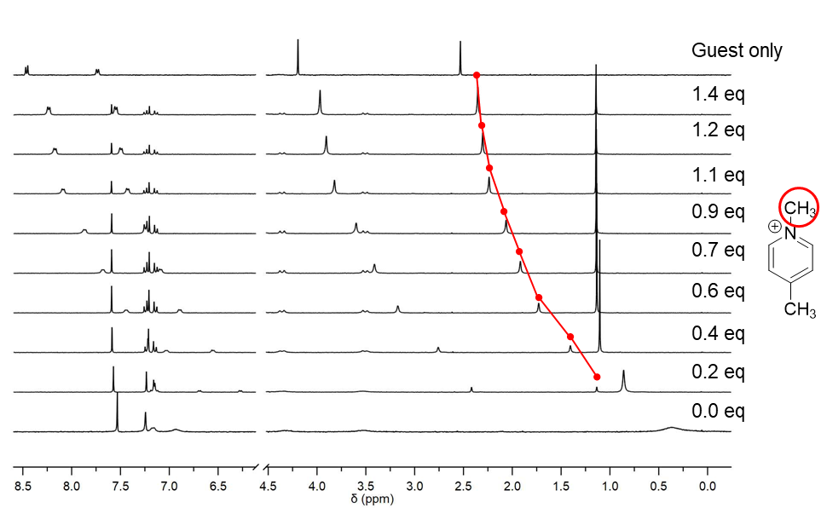

Figure S4. 1H titrations of *N*-methyl-4-methyl-pyridinium (**7**) (20 mM) into **2** (1 mM) shows slow exchange resonances of the methyl singlet (red) travel from encapsulated and upfield towards to unbound state, downfield.

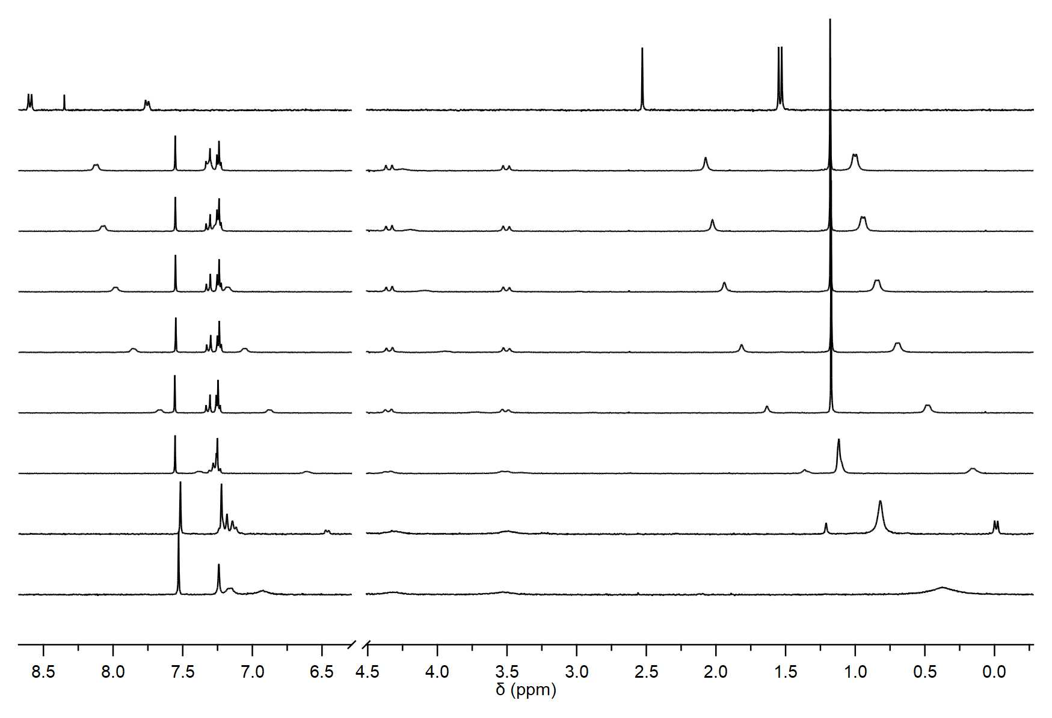

0.0 eq

0.2 eq

0.4 eq

0.6 eq

0.7 eq

0.9 eq

1.1 eq

1.2 eq

Guest only

Figure S5. 1H titrations of *iso*-propyl-4-methyl-pyridinium (**9**) (20 mM) into **2** (1 mM) shows the fast exchange resonances of the *iso*-propyl doublet (red) travel from encapsulated and upfield towards to unbound state, downfield.

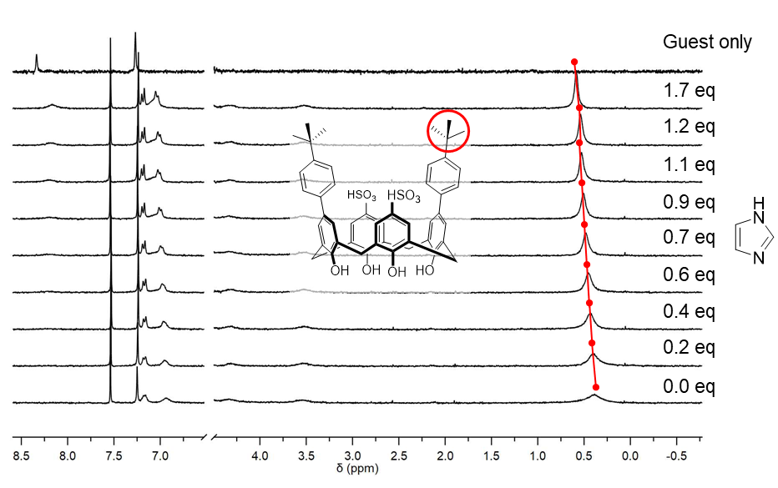

Figure S6. 1H titrations of imidazole (**14**) (20 mM) into **2** (1 mM) shows slight change in chemical shift of the *t*-butyl singlet (red) even with excess hence imidazole is not a strong guest to dissociate the dimer.

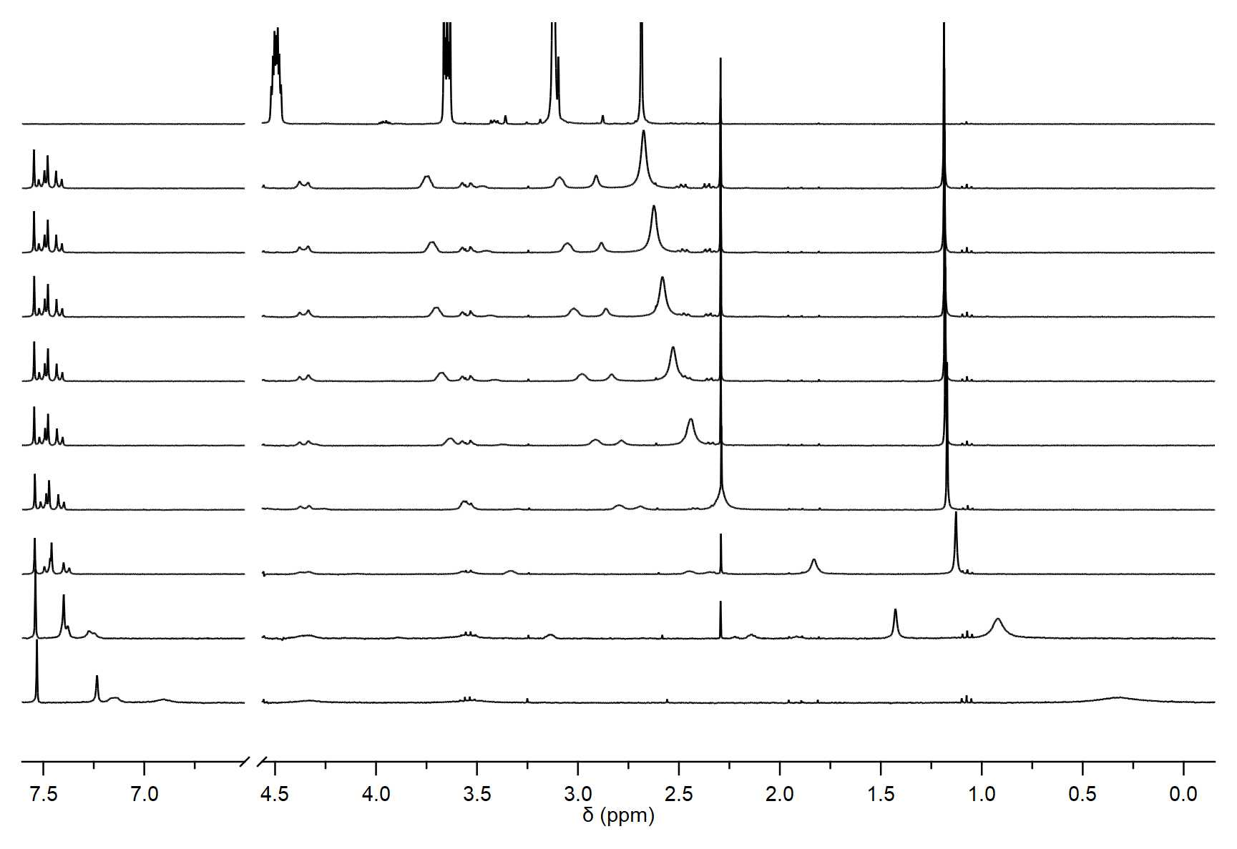

0.0 eq

0.2 eq

0.4 eq

0.7 eq

0.9 eq

1.1 eq

1.2 eq

1.4 eq

1.7 eq

Guest only

Figure S7. 1H titrations of suxamethonium (**15**) (20 mM) into **2** (1 mM) shows the fast exchange resonances of the guest’s quaternary methyl ammonium singlet (red) travel from upfield as an encapsulated guest towards the unbound state, downfield.

* 1. UV-Vis and Fluorescence titrations of BM and LCG with **2**

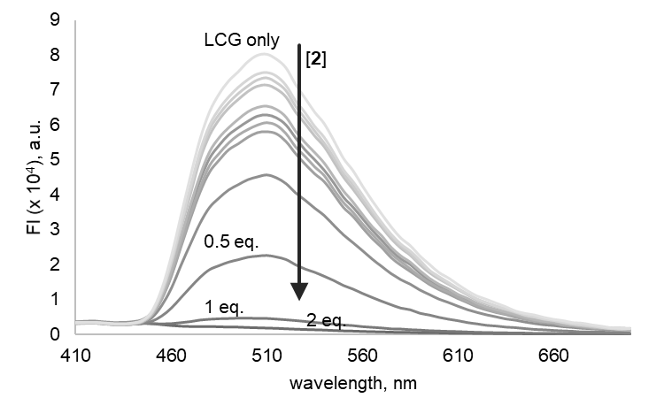

Figure S8. Fluorescence titrations of **2** (2 μM to 2 nM) into LCG (1 μM, λex. 368 nm, λem. 410 – 700 nm) in Na2HPO4/NaH2PO4 (10 mM, pH 8.5) buffered H2O shows the concentration-dependant quenching of LCG by **2**. Only a slight excess of **2** is required for complete quenching of LCG.

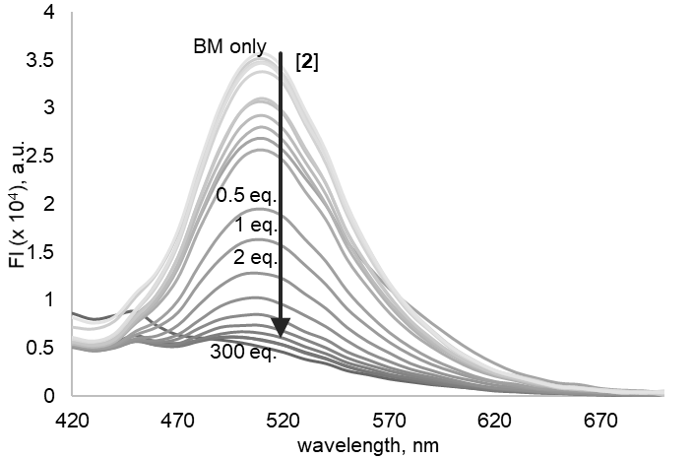

Figure S9. Fluorescence titrations of **2** (3 mM to 80 nM) into BM (10 μM, λex. 382 nm, λem. 420 – 700 nm) in Na2HPO4/NaH2PO4 (10 mM, pH 8.5) buffered H2O shows the concentration-dependant quenching of LCG by **2**. Excess of **2** is required for complete quenching of BM.

* 1. VT-NMR of 1:1 complex of **2** and LCG

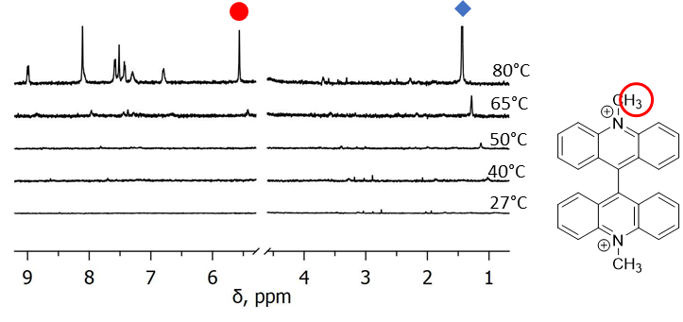

Figure S10. The flat 1H spectra of the 1:1 LCG:**2** (1 mM) complex fully dissociates at 80⁰C and resonances appear from the unbound dye (red dot) and monomeric **2** (blue diamond) in Na2HPO4/NaH2PO4 (50 mM, pH 8.5) buffered D2O.

(1) Thompson, J. W.; Kaiser, T. J.; Jorgenson, J. W., *J. Chromatogr. A* **2006,** *1134*, 201-209.