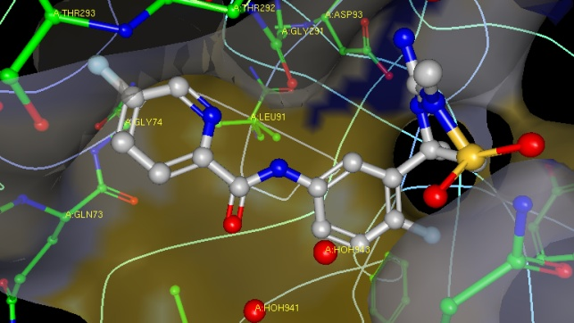
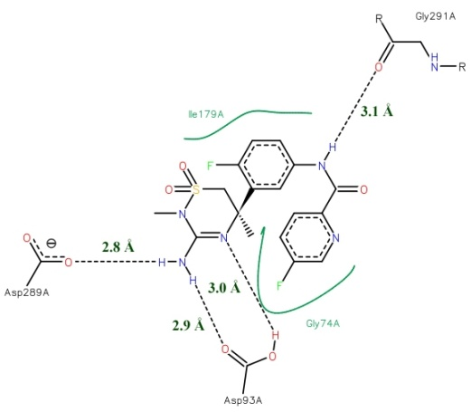

Figure S1. Shows the intermolecular interaction of the verubecestat-BACE1 complex from reported results.
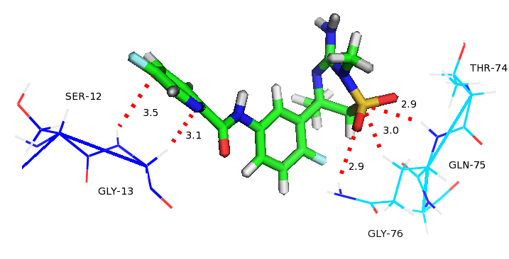
Hydrophobic Interactions

Halogen type Interactions
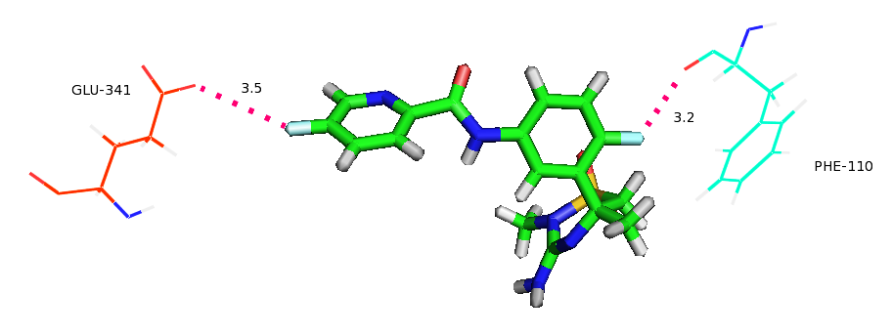

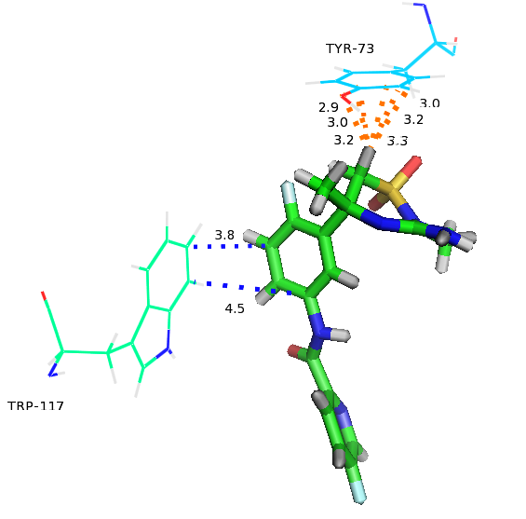

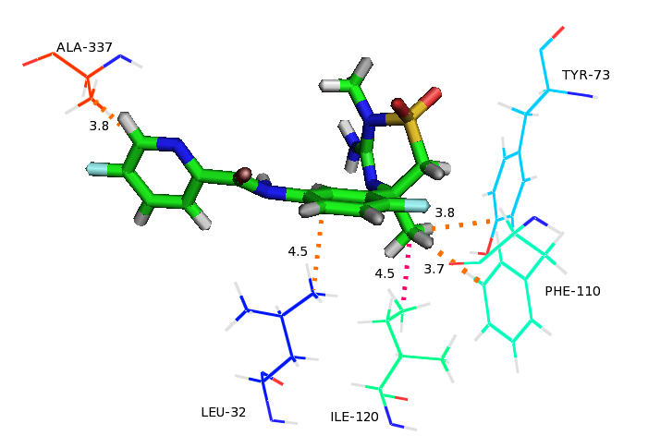

Figure S2. Shows the different types important intermolecular interactions of the verubecestat-BACE1 complex.

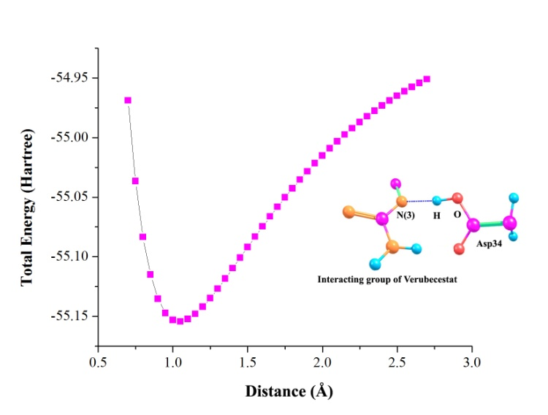

(a)
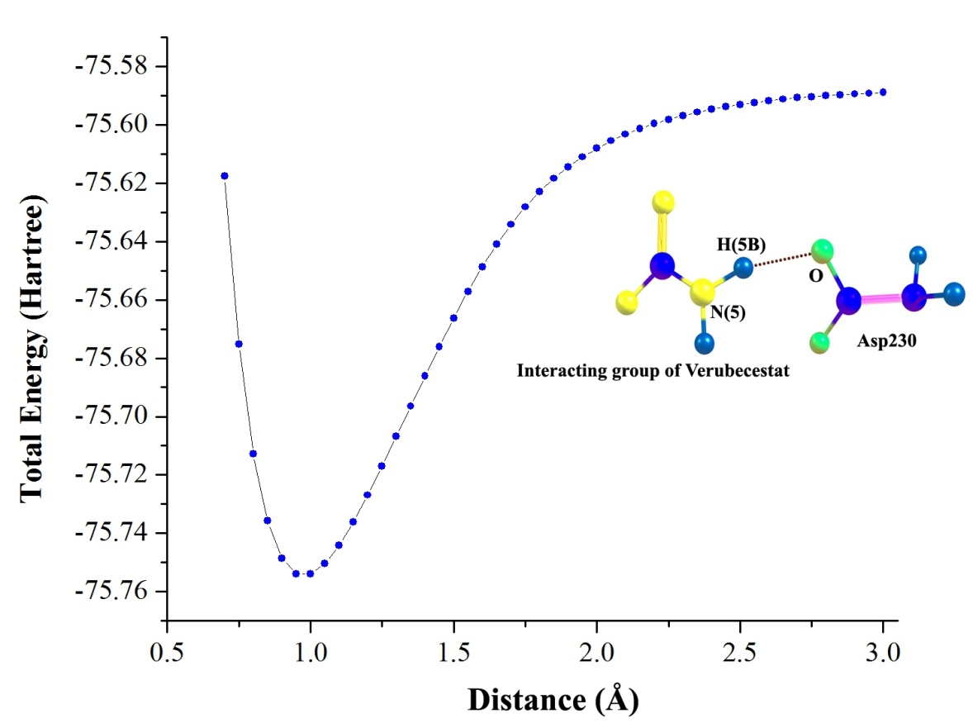

(b)
Figure S3: Shows the Potential energy surface scanning of the catalytic dyad interaction of N−H∙∙∙O interaction with Asp34 and Asp230.

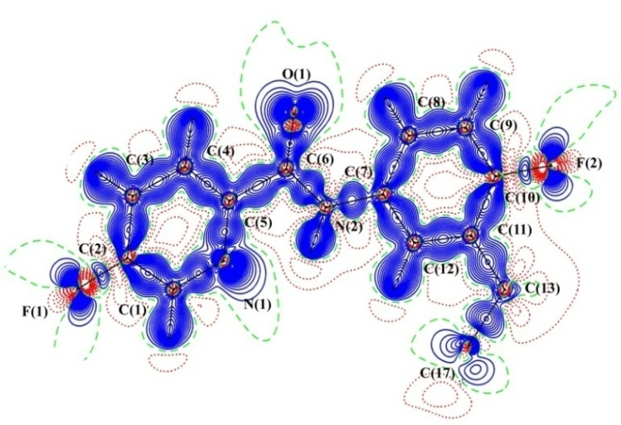
QM/MM
Gas Phase

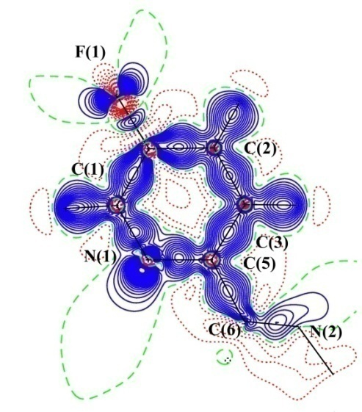

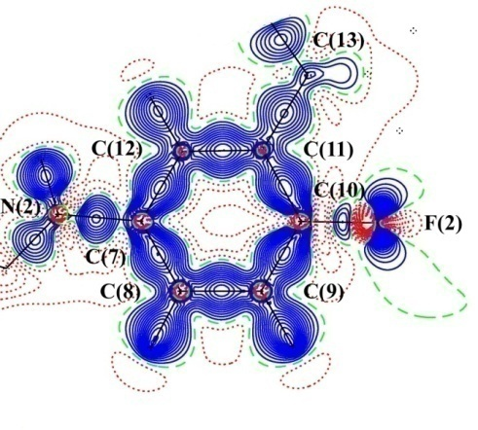

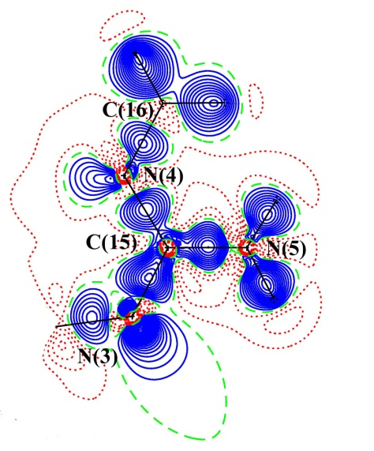

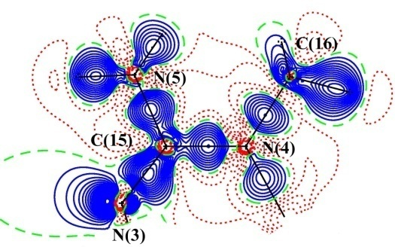

(continue…)
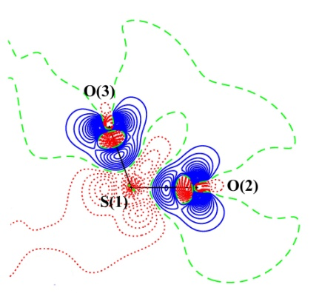
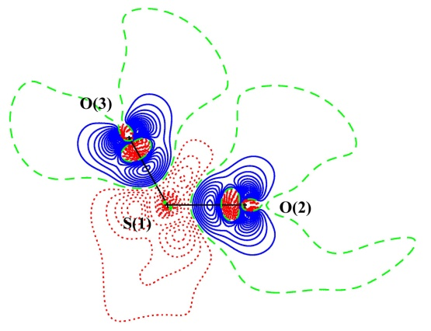

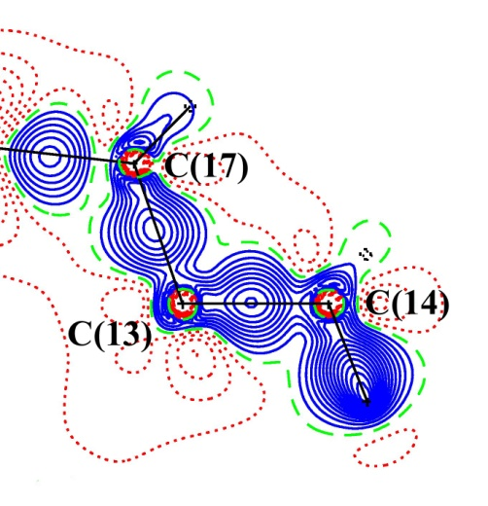
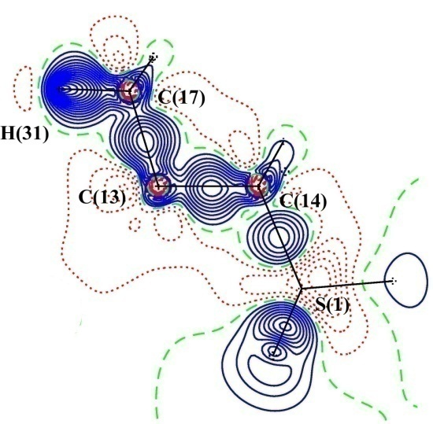

Figure S4. The deformation electron density map of verubecestat molecule in the gas phase and in the active site of β-Secretase from QM/MM. The blue colour represents positive contours (solid lines), the red colour represents negative contours (dotted lines) and green colour represents zero contours (dashed lines) are drawn at 0.05 eÅ⁻³ intervals.

QM/MM
Gas Phase

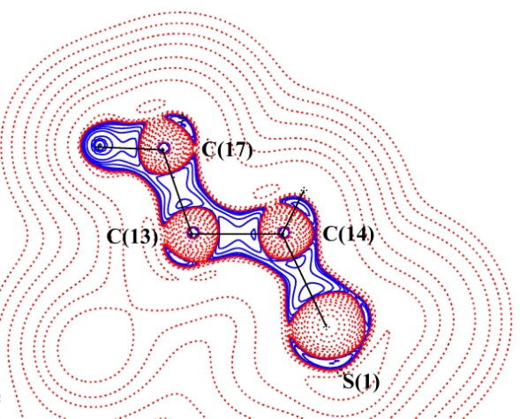
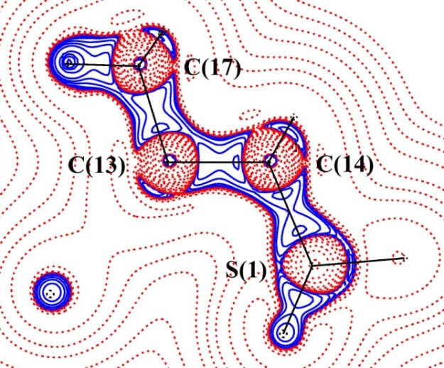

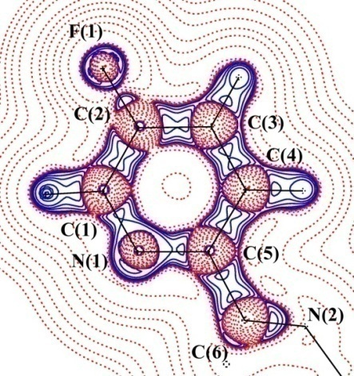

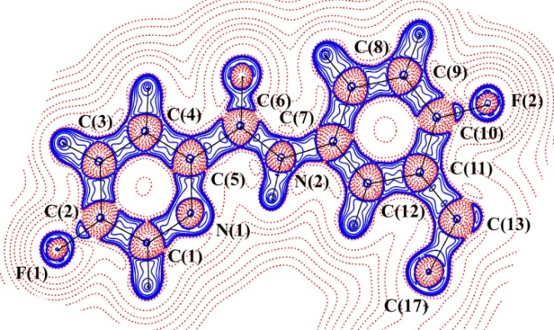

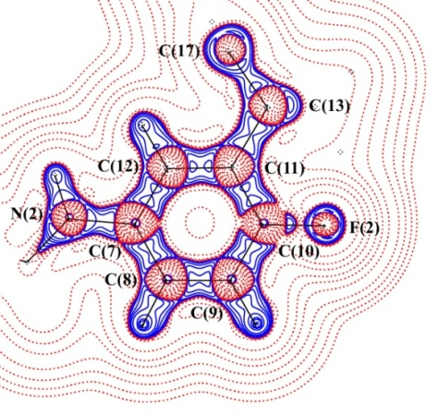

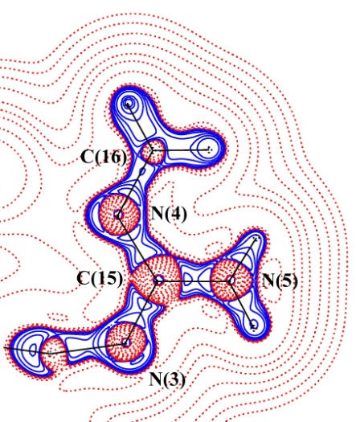

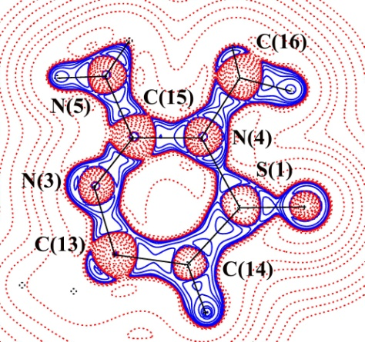

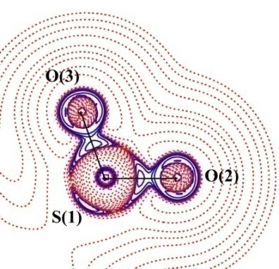
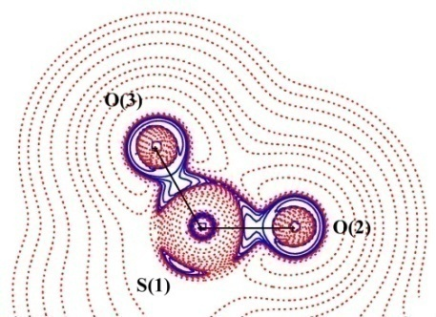

Figure S5. The Laplacian of electron density map of verubecestat molecule in the gas phase and in the active site of BACE1 from QM/MM. Contours are drawn in logarithmic scale, 3.0 x 2^{N} eÅ⁻⁵, where N = 2, 4 and 8×10^{n}, n= -2, -1, 0, 1, 2. Blue (solid lines): positive contour, Red (dashed lines): negative contour.

Table S1. The geometrical parameters of verubecestat molecule in gas phase (I) [HF/6-311G** and B3LYP/6-311G**] and in the active site of BACE1 (II) [single point energy B3LYP/6-311G** from QM/MM] calculated from HF and DFT level of theory.
Bonds | I |  |  | II
 | HF | DFT |  | QM/MM
Bonds Lengths (Å)
C(1)–C(2) | 1.379 | 1.390 |  | 1.405
C(2)–C(3) | 1.374 | 1.385 |  | 1.402
C(3)–C(4) | 1.381 | 1.389 |  | 1.391
C(4)–C(5) | 1.385 | 1.395 |  | 1.401
C(5)–C(6) | 1.511 | 1.512 |  | 1.507
C(7)–C(8) | 1.385 | 1.399 |  | 1.396
C(7)–C(12) | 1.390 | 1.400 |  | 1.409
C(8)–C(9) | 1.383 | 1.390 |  | 1.391
C(9)–C(10) | 1.370 | 1.381 |  | 1.395
C(10)–C(11) | 1.385 | 1.395 |  | 1.411
C(11)–C(12) | 1.383 | 1.391 |  | 1.387
C(11)–C(13) | 1.540 | 1.543 |  | 1.522
C(13)–C(14) | 1.545 | 1.553 |  | 1.562
C(13)–C(17) | 1.540 | 1.549 |  | 1.538
C(1)–N(1) | 1.314 | 1.330 |  | 1.351
C(5)–N(1) | 1.319 | 1.338 |  | 1.361
C(6)–N(2) | 1.346 | 1.362 |  | 1.423
C(7)–N(2) | 1.408 | 1.406 |  | 1.438
C(13)–N(3) | 1.448 | 1.454 |  | 1.484
C(15)–N(3) | 1.256 | 1.279 |  | 1.337
C(15)–N(4) | 1.399 | 1.408 |  | 1.460
C(16)–N(4) | 1.469 | 1.468 |  | 1.482
C(15)–N(5) | 1.378 | 1.388 |  | 1.370
C(6)–O(1) | 1.196 | 1.222 |  | 1.220
S(1)–O(2) | 1.422 | 1.458 |  | 1.485
S(1)–O(3) | 1.421 | 1.457 |  | 1.508
S(1)–N(4) | 1.664 | 1.721 |  | 1.758
S(1)–C(14) | 1.760 | 1.792 |  | 1.800
F(1)–C(2) | 1.321 | 1.344 |  | 1.336
F(2)–C(10) | 1.340 | 1.368 |  | 1.348
C(1)–H(1) | 1.074 | 1.085 |  | 1.104
C(3)–H(3) | 1.074 | 1.083 |  | 1.098
C(4)–H(4) | 1.071 | 1.081 |  | 1.103
C(8)–H(8) | 1.068 | 1.078 |  | 1.105
C(9)–H(9) | 1.074 | 1.082 |  | 1.099
C(12)–H(12) | 1.071 | 1.082 |  | 1.053
C(14)–H(14A) | 1.082 | 1.090 |  | 1.110
C(14)–H(14B) | 1.078 | 1.088 |  | 1.128
C(16)–H(16A) | 1.078 | 1.088 |  | 1.105
C(16)–H(16B) | 1.082 | 1.092 |  | 1.110
C(16)–H(16C) | 1.081 | 1.092 |  | 1.100
C(17)–H(17A) | 1.082 | 1.090 |  | 1.106
C(17)–H(17B) | 1.082 | 1.090 |  | 1.106
C(17)–H(17C) | 1.085 | 1.092 |  | 1.104
N(2)–H(2) | 0.994 | 1.013 |  | 1.019
N(5)–H(5A) | 0.993 | 1.008 |  | 1.017
N(5)–H(5B) | 0.995 | 1.01 |  | 1.026
Bond Angles (°)
C(1)–C(2)–C(3) | 120.5 | 120.7 |  | 120.2
C(2)–C(3)–C(4) | 117.4 | 117.4 |  | 117.8
C(3)–C(4)–C(5) | 118.4 | 118.7 |  | 119.9
C(4)–C(5)–C(6) | 118.7 | 118.8 |  | 120.8
C(7)–C(8)–C(9) | 118.7 | 118.7 |  | 119.3
C(7)–C(12)–C(11) | 122.3 | 122.1 |  | 121.3
C(8)–C(7)–C(12) | 119.6 | 119.7 |  | 120.8
C(8)–C(9)–C(10) | 120.2 | 120.0 |  | 119.7
C(9)–C(10)–C(11) | 122.7 | 122.9 |  | 121.7
C(10)–C(11)–C(13) | 122.1 | 122.4 |  | 120.6
C(10)–C(11)–C(12) | 116.2 | 116.2 |  | 117.3
C(12)–C(11)–C(13) | 121.6 | 121.2 |  | 121.9
C(11)–C(13)–C(14) | 112.1 | 111.6 |  | 107.6
C(11)–C(13)–C(17) | 108.7 | 108.5 |  | 109.5
C(14)–C(13)–C(17) | 107.5 | 107.0 |  | 109.0
C(2)–C(1)–N(1) | 121.3 | 121.4 |  | 120.6
C(4)–C(5)–N(1) | 122.8 | 122.9 |  | 121.1
C(6)–C(5)–N(1) | 118.4 | 118.2 |  | 117.9
C(2)–C(6)–N(2) | 113.8 | 112.9 |  | 113.3
C(8)–C(7)–N(2) | 123.7 | 123.1 |  | 124.1
C(12)–C(7)–N(2) | 116.5 | 117.0 |  | 115.6
C(14)–C(13)–N(3) | 111.9 | 113.0 |  | 111.0
C(11)–C(13)–N(3) | 110.2 | 110.2 |  | 113.9
C(17)–C(13)–N(3) | 105.8 | 106.1 |  | 105.4
C(5)–N(1)–C(1) | 119.2 | 118.7 |  | 119.8
C(7)–N(2)–C(6) | 128.5 | 128.9 |  | 125.5
C(13)–N(3)–C(15) | 125.8 | 125.3 |  | 123.8
C(15)–N(4)–C(16) | 121.5 | 122.3 |  | 118.7
N(3)–C(15)–N(5) | 127.8 | 118.0 |  | 117.4
N(4)–C(15)–N(3) | 113.7 | 127.9 |  | 121.0
N(4)–C(15)–N(5) | 118.3 | 113.9 |  | 121.4
N(4)–S(1)–C(14) | 98.9 | 97.2 |  | 102.0
O(1)–C(6)–N(2) | 126.0 | 126.2 |  | 123.8
O(1)–C(6)–C(5) | 120.0 | 120.8 |  | 122.6
O(2)–S(1)–N(4) | 106.6 | 105.8 |  | 109.3
O(3)–S(1)–N(4) | 109.6 | 110.0 |  | 108.9
O(2)–S(1)–C(14) | 110.0 | 110.6 |  | 113.6
O(3)–S(1)–C(14) | 110.9 | 110.7 |  | 112.6
O(2)–S(1)–O(3) | 118.6 | 119.7 |  | 109.8
S(1)–N(4)–C(15) | 117.8 | 117.2 |  | 118.3
S(1)–N(4)–C(16) | 115.5 | 115.5 |  | 118.2
S(1)–C(14)–C(13) | 112.5 | 112.1 |  | 115.0
F(1)–C(2)–C(3) | 120.2 | 120.0 |  | 120.3
F(1)–C(2)–C(1) | 119.1 | 119.1 |  | 119.3
F(2)–C(10)–C(11) | 119.7 | 119.6 |  | 119.5
F(2)–C(10)–C(9) | 117.4 | 117.4 |  | 118.6
C(2)–C(1)–H(1) | 120.3 | 120.2 |  | 122.8
C(2)–C(3)–H(3) | 120.3 | 120.1 |  | 120.1
C(4)–C(3)–H(3) | 122.2 | 122.3 |  | 121.9
C(3)–C(4)–H(4) | 121.9 | 122.2 |  | 119.6
C(5)–C(4)–H(4) | 119.5 | 118.9 |  | 120.4
C(7)–C(8)–H(8) | 120.7 | 120.0 |  | 122.7
C(7)–C(12)–H(12) | 119.2 | 119.8 |  | 119.3
C(8)–C(9)–H(9) | 120.8 | 121.0 |  | 119.9
C(9)–C(8)–H(8) | 120.4 | 121.1 |  | 117.8
C(10)–C(9)–H(9) | 118.9 | 118.9 |  | 120.2
C(11)–C(12)–H(12) | 118.4 | 117.9 |  | 119.3
C(13)–C(14)–H(14A) | 110.5 | 111.0 |  | 109.7
C(13)–C(14)–H(14B) | 113.2 | 112.7 |  | 106.6
C(13)–C(17)–H(17A) | 111.7 | 111.5 |  | 111.7
C(13)–C(17)–H(17B) | 108.9 | 108.7 |  | 111.5
C(13)–C(17)–H(17C) | 109.6 | 109.6 |  | 110.5
C(6)–N(2)–H(2) | 114.8 | 113.7 |  | 110.6
C(7)–N(2)–H(2) | 116.5 | 117.2 |  | 111.8
C(15)–N(5)–H(5A) | 117.2 | 117.7 |  | 117.6
C(15)–N(5)–H(5B) | 111.1 | 111.1 |  | 120.4
N(1)–C(1)–H(1) | 118.3 | 118.3 |  | 116.5
N(4)–C(16)–H(16A) | 108.1 | 107.9 |  | 112.3
N(4)–C(16)–H(16B) | 109.9 | 109.9 |  | 109.0
N(4)–C(16)–H(16C) | 111.2 | 111.9 |  | 110.2
S(1)–C(14)–H(14A) | 104.8 | 104.7 |  | 110.4
S(1)–C(14)–H(14B) | 106.0 | 106.0 |  | 110.4
H(5A)–N(5)–H(5B) | 113.2 | 113.7 |  | 115.5
H(14A)–C(14)–H(14B) | 109.0 | 109.5 |  | 103.8
H(16A)–C(16)–H(16B) | 107.2 | 107.0 |  | 108.3
H(16A)–C(16)–H(16C) | 109.7 | 109.6 |  | 108.2
H(16B)–C(16)–H(16C) | 110.3 | 110.1 |  | 108.3
H(17A)–C(17)–H(17B) | 109.0 | 109.2 |  | 107.7
H(17A)–C(17)–H(17C) | 109.1 | 109.3 |  | 107.8
H(17B)–C(17)–H(17C) | 108.2 | 108.2 |  | 107.1
Torsion Angles (°)
C(1)–C(2)–C(3)–C(4) | 0.0 | 0.0 |  | 3.4
C(2)–C(3)–C(4)–C(5) | 0.0 | 0.0 |  | 0.0
C(3)–C(4)–C(5)–C(6) | 179.9 | 179.9 |  | 173.7
C(7)–C(8)–C(9)–C(10) | 0.0 | -0.1 |  | -0.8
C(7)–C(12)–C(11)–C(13) | 177.9 | 177.9 |  | -178.9
C(7)–C(12)–C(11)–C(10) | 0.7 | 0.5 |  | 0.6
C(8)–C(7)–C(12)–C(11) | -0.3 | -0.2 |  | -5.4
C(8)–C(9)–C(10)–C(11) | 0.3 | 0.4 |  | -4.0
C(9)–C(10)–C(11)–C(13) | -177.9 | -177.9 |  | -176.3
C(9)–C(10)–C(11)–C(12) | -0.7 | -0.6 |  | 4.0
C(10)–C(11)–C(13)–C(17) | 63.4 | 62.8 |  | 67.1
C(10)–C(11)–C(13)–C(14) | -55.4 | -54.8 |  | -51.3
C(12)–C(7)–C(8)–C(9) | -0.0 | 0.0 |  | 5.4
C(12)–C(11)–C(13)–C(14) | 127.5 | 127.8 |  | 128.2
C(12)–C(11)–C(13)–C(17) | -113.6 | -114.4 |  | -113.2
C(3)–C(4)–C(5)–N(1) | 0.0 | -0.0 |  | -3.9
C(3)–C(2)–C(1)–N(1) | -0.0 | -0.0 |  | -3.2
C(4)–C(5)–C(6)–N(2) | -179.4 | -179.6 |  | 41
C(9)–C(8)–C(7)–N(2) | -179.6 | -179.8 |  | -179.0
C(10)–C(11)–C(13)–N(3) | 179.0 | 178.6 |  | -175.0
C(11)–C(12)–C(7)–N(2) | 179.2 | 179.6 |  | 178.6
C(12)–C(11)–C(13)–N(3) | 2.0 | 1.4 |  | 4.5
C(8)–C(9)–C(10)–F(2) | -179.7 | -179.6 |  | 175.8
C(12)–C(11)–C(10)–F(2) | 179.3 | 179.4 |  | -175.7
C(13)–C(11)–C(10)–F(2) | 2.1 | 2.0 |  | 3.8
C(4)–C(5)–C(6)–O(1) | 0.5 | 0.3 |  | -134.4
C(1)–N(1)–C(5)–C(4) | 0.0 | 0.0 |  | 4.2
C(1)–N(1)–C(5)–C(6) | -179.9 | -179.9 |  | -173.4
C(5)–N(1)–C(1)–C(2) | -0.0 | -0.0 |  | -0.6
C(6)–N(2)–C(7)–C(8) | -5.4 | -1.7 |  | 28.7
C(6)–N(2)–C(7)–C(12) | 174.9 | 178.3 |  | -155.5
C(7)–N(2)–C(6)–C(5) | -179.8 | 179.7 |  | 177.8
C(15)–N(3)–C(13)–C(11) | 108.0 | 108.2 |  | 89.3
C(15)–N(3)–C(13)–C(14) | -17.5 | -17.4 |  | -32.4
C(15)–N(3)–C(13)–C(17) | -134.4 | -134.4 |  | -150.4
C(7)–N(2)–C(6)–O(1) | 0.1 | -0.2 |  | -6.7
C(13)–N(3)–C(15)–N(4) | 1.2 | 2.2 |  | -17.6
C(13)–N(3)–C(15)–N(5) | -178.1 | -176.9 |  | 162.4
C(16)–N(4)–C(15)–N(3) | -170.5 | -174.0 |  | -160.9
C(16)–N(4)–C(15)–N(5) | 8.8 | 5.2 |  | 18.9
C(14)–S(1)–N(4)–C(15) | 39.1 | 42.0 |  | -17.5
C(14)–S(1)–N(4)–C(16) | -165.3 | -162.0 |  | -172.9
C(17)–C(13)–C(14)–S(1) | 161.9 | 163.5 |  | 169.0
C(11)–C(13)–C(14)–S(1) | -78.4 | -77.8 |  | -72.1
C(4)–C(3)–C(2)–F(1) | 179.9 | -179.9 |  | -176.3
N(3)–C(13)–C(14)–S(1) | 46.0 | 47.0 |  | 53.2
N(4)–S(1)–C(14)–C(13) | -53.7 | -55.3 |  | -27.8
N(2)–C(6)–C(5)–N(1) | 0.5 | 0.3 |  | -141.2
N(1)–C(1)–C(2)–F(1) | -179.9 | 179.9 |  | 176.6
O(2)–S(1)–N(4)–C(15) | 153.3 | 155.9 |  | -138.1
O(2)–S(1)–N(4)–C(16) | -51.2 | -48.0 |  | 66.4
O(3)–S(1)–N(4)–C(15) | -76.9 | -73.2 |  | 101.7
O(3)–S(1)–N(4)–C(16) | 78.4 | 82.7 |  | -53.6
O(3)–S(1)–C(14)–C(13) | 61.3 | 59.3 |  | -144.4
O(2)–S(1)–C(14)–C(13) | -165.2 | -165.4 |  | 89.7
O(1)–C(6)–C(5)–N(1) | -179.4 | -179.6 |  | 43.3
S(1)–N(4)–C(15)–N(3) | -16.6 | -19.7 |  | 43.7
S(1)–N(4)–C(15)–N(5) | 162.7 | 159.4 |  | -136.2
C(1)–C(2)–C(3)–H(3) | 179.9 | 179.9 |  | -176.0
C(2)–C(3)–C(4)–H(4) | 179.9 | 179.9 |  | -179.1
C(3)–C(2)–C(1)–H(1) | -179.9 | -179.9 |  | 176.3
C(5)–C(4)–C(3)–H(3) | -179.9 | -179.9 |  | 179.4
C(6)–C(5)–C(4)–H(4) | 0.0 | -0.0 |  | -7.1
C(7)–C(8)–C(9)–H(9) | 179.9 | 179.8 |  | -179.3
C(8)–C(7)–C(12)–H(12) | 179.6 | 179.6 |  | 173.5
C(10)–C(9)–C(8)–H(8) | 179.9 | 179.9 |  | -179.3
C(11)–C(10)–C(9)–H(9) | -179.5 | -179.5 |  | 174.4
C(12)–C(7)–C(8)–H(8) | -179.9 | -179.9 |  | -176.1
C(10)–C(11)–C(12)–H(12) | -179.2 | -179.4 |  | -178.3
C(11)–C(13)–C(14)–H(14A) | 164.6 | 165.2 |  | 162.5
C(11)–C(13)–C(14)–H(14B) | 41.8 | 41.8 |  | 50.6
C(11)–C(13)–C(17)–H(17A) | -62.4 | -61.1 |  | -57.1
C(11)–C(13)–C(17)–H(17B) | 58.1 | 59.3 |  | 63.5
C(11)–C(13)–C(17)–H(17C) | 176.4 | 177.6 |  | -177.3
C(13)–C(11)–C(12)–H(12) | -2.0 | -2.0 |  | 2.0
C(14)–C(13)–C(17)–H(17A) | 59.2 | 59.4 |  | 60.5
C(14)–C(13)–C(17)–H(17B) | 179.8 | -179.9 |  | -178.8
C(14)–C(13)–C(17)–H(17C) | -61.8 | -61.7 |  | -59.6
C(17)–C(13)–C(14)–H(14A) | 45.0 | 46.6 |  | 43.7
C(17)–C(13)–C(14)–H(14B) | -77.7 | -76.7 |  | -68.1
C(5)–N(1)–C(1)–H(1) | 179.9 | 179.9 |  | 179.7
C(15)–N(4)–C(16)–H(16A) | 174.4 | 177.5 |  | -32.9
C(15)–N(4)–C(16)–H(16B) | -68.6 | -66.0 |  | 87.3
C(15)–N(4)–C(16)–H(16C) | 53.8 | 56.7 |  | -153.7
C(5)–C(6)–N(2)–H(2) | -0.0 | 0.0 |  | 38.6
C(8)–C(7)–N(2)–H(2) | 174.7 | 177.8 |  | 167.5
C(12)–C(7)–N(2)–H(2) | -4.8 | -2.0 |  | -16.7
N(1)–C(5)–C(4)–H(4) | 179.9 | -179.9 |  | 175.2
N(2)–C(7)–C(8)–H(8) | 0.4 | 0.1 |  | -0.5
N(2)–C(7)–C(12)–H(12) | -0.7 | -0.4 |  | -2.3
N(3)–C(13)–C(14)–H(14A) | -70.8 | -69.7 |  | -72.0
N(3)–C(13)–C(14)–H(14B) | 166.3 | 166.7 |  | 176.0
N(3)–C(13)–C(17)–H(17A) | 179.0 | -179.5 |  | 179.8
N(3)–C(13)–C(17)–H(17B) | -60.3 | -59.0 |  | -59.4
N(3)–C(13)–C(17)–H(17C) | 57.9 | 59.1 |  | 59.7
N(3)–C(15)–N(5)–H(5A) | -145.1 | 32.6 |  | 8.7
N(3)–C(15)–N(5)–H(5B) | -12.6 | -147.9 |  | 159.6
N(4)–C(15)–N(5)–H(5A) | 35.4 | 166.4 |  | 171.2
N(3)–C(15)–N(5)–H(5B) | 167.9 | -14.2 |  | -20.3
N(4)–S(1)–C(14)–H(14A) | 66.4 | 65.2 |  | 97.1
N(4)–S(1)–C(14)–H(14B) | -178.2 | -178.9 |  | -148.5
O(1)–C(6)–N(2)–H(2) | 179.9 | -179.9 |  | -146.0
O(2)–S(1)–C(14)–H(14B) | 70.2 | 71.0 |  | -31.0
O(3)–S(1)–C(14)–H(14A) | -178.3 | 179.9 |  | -19.4
O(3)–S(1)–C(14)–H(14B) | -63.0 | -64.1 |  | 94.7
S(1)–N(4)–C(16)–H(16A) | 19.9 | 22.9 |  | 122.3
S(1)–N(4)–C(16)–H(16B) | 136.8 | 139.3 |  | -117.4
S(1)–N(4)–C(16)–H(16C) | -100.6 | -97.8 |  | 1.5
F(1)–C(2)–C(1)–H(1) | 0.0 | 0.0 |  | -3.8
F(1)–C(2)–C(3)–H(3) | -0.0 | -0.0 |  | 4.1
F(2)–C(10)–C(9)–H(9) | 0.3 | 0.3 |  | -5.7
H(4)–C(4)–C(3)–H(3) | 0.0 | 0.0 |  | 0.3
H(9)–C(9)–C(8)–H(8) | -0.1 | -0.1 |  | 2.1

