Supporting Information
Polyoxometalates decorated with metal-organic moieties as new molecular photo- and electro-catalysts

SHIFA ULLAH KHAN, MANSOOR AKHTAR, FAHEEM ULLAH KHAN, JUN PENG*, AFTAB HUSSAIN, HONGFEI SHI, JING DU, GANGYAN and YANGGUANG LI*

Contents

- Additional structural figures of compounds 1-3
- Selected bond lengths, bond angles and BVS calculations of compounds 1-3
- Additional physical measurements of compounds 1-3

- Additional structural figures of compounds 1-3

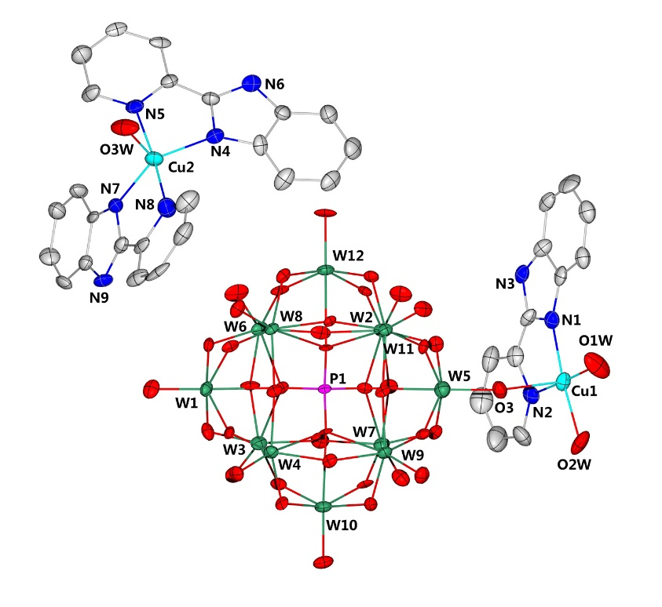
Figure S1. ORTEP view of the basic unit in compound 1 with thermal ellipsoids of 50%. H atoms and lattice water molecules are omitted for clarity.

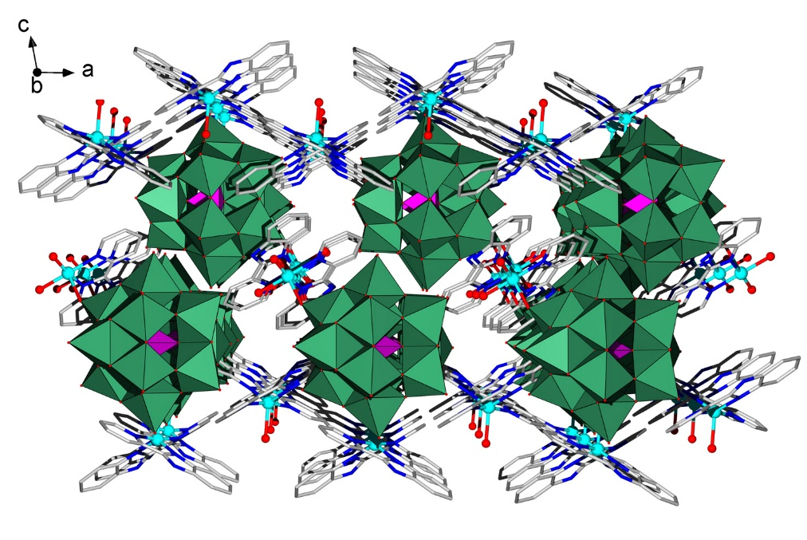
Figure S2. Ball-and-stick and polyhedral view of the packing arrangement of compound 1 viewed along b axis. H atoms and lattice water molecules are omitted for clarity.

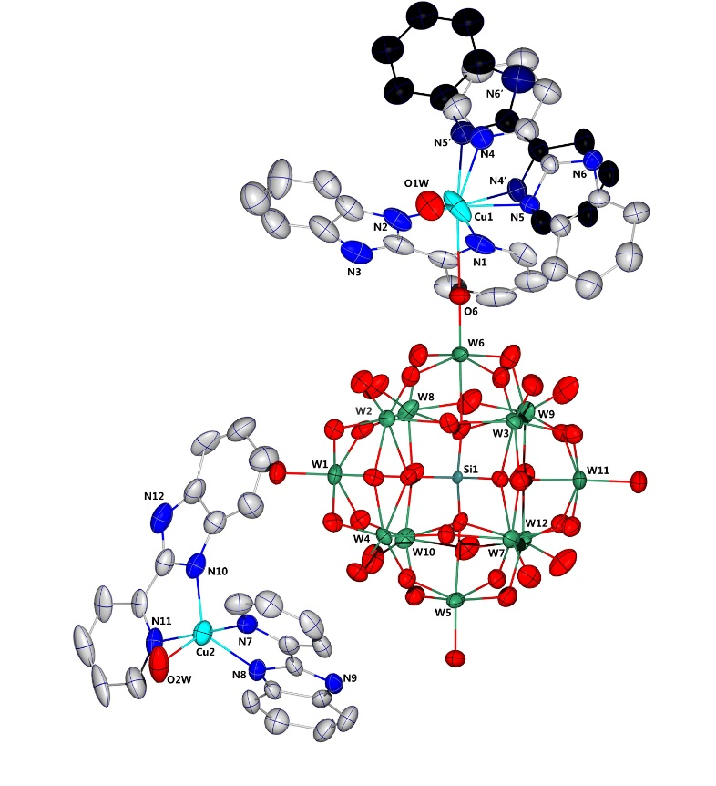
Figure S3. ORTEP view of the basic unit in compound 2 with thermal ellipsoids of 50%. H atoms and lattice water molecules are omitted for clarity. One of the PBI ligand one Cu(1) center is disordered into two possible positions.

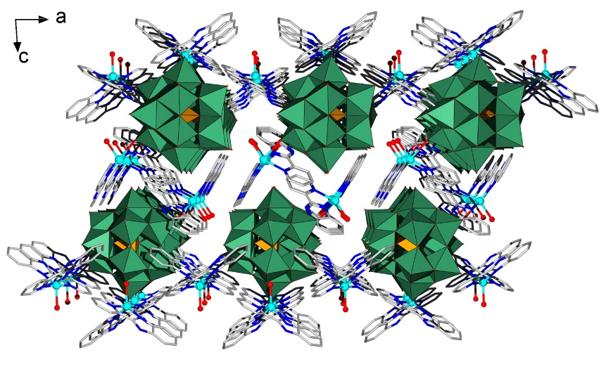
Figure S4. Ball-and-stick and polyhedral view of the packing arrangement of compound 2 viewed along b axis. H atoms and lattice water molecules are omitted for clarity.

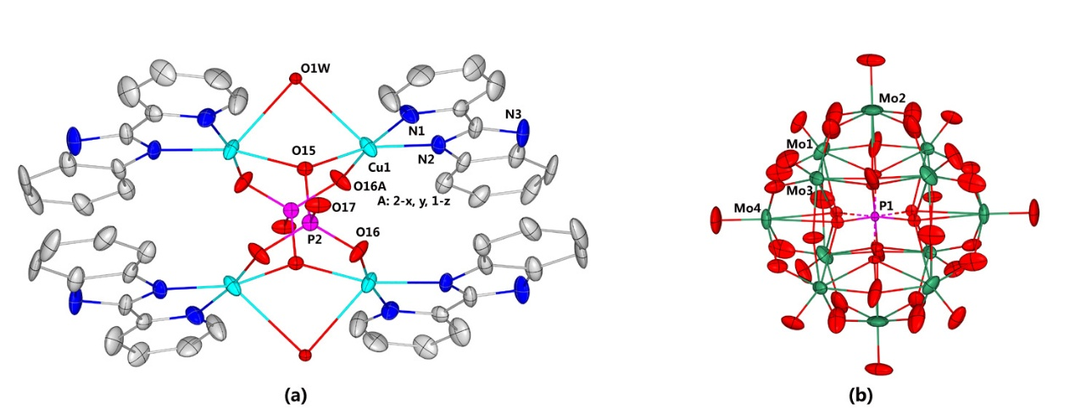
Figure S5. ORTEP view of cationic cluster (a) and polyoxoanion (b) in compound 3 with thermal ellipsoids of 30%. H atoms and lattice water molecules are omitted for clarity.

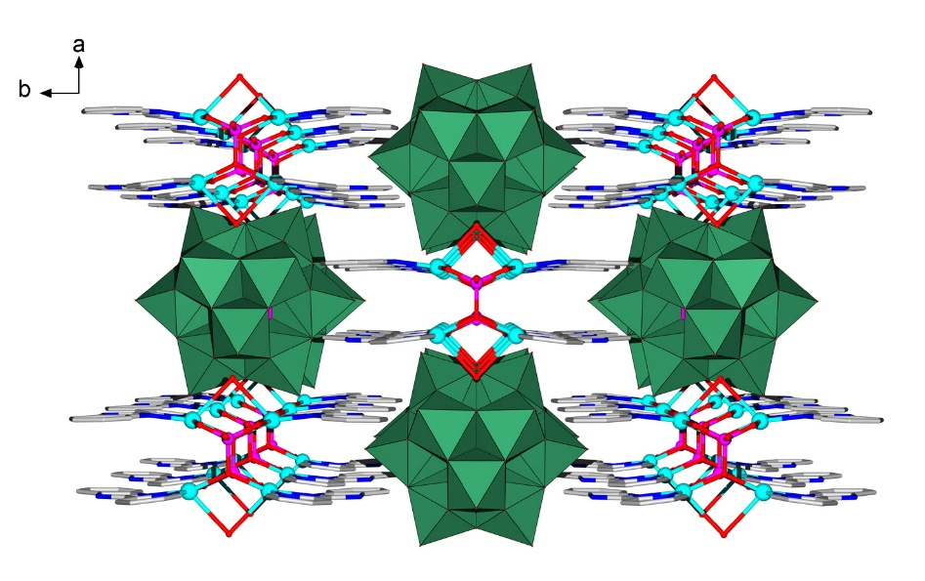
Figure S6. Ball-and-stick and polyhedral view of the packing arrangement of compound 3 viewed along c axis. H atoms and lattice water molecules are omitted for clarity.

- Selected bond lengths, bond angles and BVS calculations of compounds 1-3
Table S1. Selected bond lengths (Å) and angles (°) in compound 1.
W(1)-O(5) | 1.700(10) | W(2)-O(13) | 1.918(9)
W(1)-O(20) | 1.925(9) | W(2)-O(17) | 1.911(9)
W(1)-O(25) | 1.913(9) | W(2)-O(22) | 1.921(9)
W(1)-O(31) | 2.428(9) | W(2)-O(26) | 2.446(8)
W(1)-O(36) | 1.899(9) | W(2)-O(32) | 1.707(9)
W(1)-O(39) | 1.924(9) | W(2)-O(35) | 1.902(10)
W(3)-O(6) | 1.705(9) | W(4)-O(1) | 1.739(9)
W(3)-O(9) | 1.917(9) | W(4)-O(21) | 1.896(9)
W(3)-O(20) | 1.928(10) | W(4)-O(29) | 1.917(9)
W(3)-O(30) | 1.914(9) | W(4)-O(34) | 1.932(9)
W(3)-O(31) | 2.435(9) | W(4)-O(36) | 1.917(9)
W(3)-O(38) | 1.909(10) | W(4)-O(40) | 2.453(9)
W(0AA)-O(12) | 2.428(8) | W(6)-O(28) | 1.881(9)
W(0AA)-O(14) | 1.907(9) | W(6)-O(30) | 1.940(9)
W(0AA)-O(15) | 1.699(9) | W(6)-O(31) | 2.458(9)
W(0AA)-O(16) | 1.910(9) | W(6)-O(35) | 1.925(10)
W(0AA)-O(24) | 1.923(9) | W(6)-O(37) | 1.700(10)
W(0AA)-O(33) | 1.914(9) | W(6)-O(39) | 1.918(9)
W(7)-O(2) | 1.692(10) | W(8)-O(4) | 1.698(10)
W(7)-O(11) | 1.914(9) | W(8)-O(12) | 2.425(9)
W(7)-O(18) | 1.923(9) | W(8)-O(16) | 1.924(9)
W(7)-O(22) | 1.930(9) | W(8)-O(21) | 1.921(9)
W(7)-O(26) | 2.452(9) | W(8)-O(23) | 1.914(9)
W(7)-O(38) | 1.891(10) | W(8)-O(25) | 1.898(9)
W(9)-O(10) | 1.711(9) | W(10)-O(8) | 1.679(9)
W(9)-O(19) | 1.926(9) | W(10)-O(9) | 1.895(9)
W(9)-O(27) | 1.904(9) | W(10)-O(11) | 1.901(9)
W(9)-O(33) | 1.910(9) | W(10)-O(19) | 1.962(9)
W(9)-O(34) | 1.908(9) | W(10)-O(29) | 1.926(9)
W(9)-O(40) | 2.441(9) | W(10)-O(40) | 2.420(8)
W(11)-O(3) | 1.736(10) | W(12)-O(7) | 1.730(9)
W(11)-O(14) | 1.912(9) | W(12)-O(12) | 2.451(8)
W(11)-O(17) | 1.936(9) | W(12)-O(13) | 1.896(9)
W(11)-O(18) | 1.921(9) | W(12)-O(23) | 1.922(9)
W(11)-O(26) | 2.421(9) | W(12)-O(24) | 1.896(9)
W(11)-O(27) | 1.928(9) | W(12)-O(28) | 1.930(9)
P(1)-O(12) | 1.544(9) | P(1)-O(31) | 1.541(9)
P(1)-O(26) | 1.535(10) | P(1)-O(40) | 1.545(9)
Cu(1)-O(3) | 2.286(10) | Cu(2)-N(4) | 2.036(13)
Cu(1)- N(1) | 1.967(13) | Cu(2)-N(5) | 2.002(8)
Cu(1)-N(2) | 2.017(9) | Cu(2)-N(7) | 2.029(12)
Cu(1)-O(1W) | 1.948(12) | Cu(2)-N(8) | 2.011(9)
Cu(1)-O(2W) | 1.969(11) | Cu(2)-O(3W) | 2.146(12)

Table S2. Bond valence sum (BVS) calculation result of W atoms in compound 1.
W | BVSª | W | BVSª | W | BVSª
W1 | 6.10 | WOAA | 5.77 | W9 | 6.04
W2 | 6.04 | W6 | 6.07 | W10 | 6.02
W3 | 6.02 | W7 | 6.11 | W11 | 6.07
W4 | 5.84 | W8 | 6.09 | W12 | 5.95
The average BVS value of each W: 6.01, suggesting that all W centers are +6 oxidation state.
Bond | Bond length | BVS | Bond | Bond length | BVS
Cu1-O2W | 1.969 | 0.43 | Cu2-O3W | 2.146 | 0.27
Cu1-O1W | 1.948 | 0.46 | Cu2-N5 | 2.002 | 0.53
Cu1-O3 | 2.286 | 0.18 | Cu2-N8 | 2.011 | 0.51
Cu1-N1 | 1.967 | 0.59 | Cu2-N4 | 2.036 | 0.49
Cu1-N2 | 2.017 | 0.51 | Cu2-N7 | 2.029 | 0.48
Cu1 |  | 2.16 | Cu2 |  | 2.28
BVS results suggest that both Cu centers are +2 oxidation state;
BVS value of O1W is quite close to 0.5, suggesting that O1W could be a OH⁻ group;
BVS values of O2W and O3W are less than 0.5, representing the coordinated water molecules.
a: $V_{i}= \sum_{j}{e_{}^{\frac{(r0-rij)}{0.37}}}$ W-O, r₀ = 1.917; Cu-O, r₀ = 1.649; Cu-N, r₀ = 1.751.¹⁻²

Table S3. Selected bond lengths (Å) and angles (°) in compound 2.
W(1)-O(33) | 1.708(8) | W(2)-O(5) | 1.710(8)
W(1)-O(25) | 1.899(8) | W(2)-O(31) | 1.893(8)
W(1)-O(13) | 1.908(8) | W(2)-O(24) | 1.893(8)
W(1)-O(38) | 1.921(8) | W(2)-O(4) | 1.912(8)
W(1)-O(36) | 1.917(8) | W(2)-O(13) | 1.934(8)
W(1)-O(15) | 2.357(7) | W(2)-O(15) | 2.349(7)
W(3)-O(17) | 1.707(9) | W(4)-O(3) | 1.683(8)
W(3)-O(19) | 1.905(8) | W(4)-O(10) | 1.908(8)
W(3)-O(24) | 1.900(8) | W(4)-O(38) | 1.918(8)
W(3)-O(21) | 1.919(9) | W(4)-O(4) | 1.927(8)
W(3)-O(14) | 1.927(9) | W(4)-O(8) | 1.924(8)
W(3)-O(2) | 2.353(8) | W(4)-O(15) | 2.368(7)
W(5)-O(1) | 1.693(9) | W(6)-O(6) | 1.709(8)
W(5)-O(8) | 1.881(8) | W(6)-O(31) | 1.891(8)
W(5)-O(12) | 1.905(8) | W(6)-O(27) | 1.922(9)
W(5)-O(11) | 1.936(9) | W(6)-O(19) | 1.902(8)
W(5)-O(30) | 1.963(9) | W(6)-O(39) | 1.931(9)
W(5)-O(35) | 2.386(8) | W(6)-O(34) | 2.338(8)
W(7)-O(22) | 1.713(9) | W(8)-O(7) | 1.698(9)
W(7)-O(12) | 1.883(8) | W(8)-O(16) | 1.889(9)
W(7)-O(10) | 1.888(8) | W(8)-O(25) | 1.888(8)
W(7)-O(14) | 1.924(8) | W(8)-O(28) | 1.918(10)
W(7)-O(29) | 1.951(9) | W(8)-O(39) | 1.932(9)
W(7)-O(2) | 2.353(8) | W(8)-O(34) | 2.360(8)
W(9)-O(37) | 1.698(9) | W(10)-O(32) | 1.694(9)
W(9)-O(26) | 1.883(9) | W(10)-O(36) | 1.871(8)
W(9)-O(18) | 1.914(9) | W(10)-O(16) | 1.903(9)
W(9)-O(28) | 1.931(10) | W(10)-O(11) | 1.933(9)
W(9)-O(27) | 1.930(9) | W(10)-O(23) | 1.958(9)
W(9)-O(34) | 2.345(8) | W(10)-O(35) | 2.364(8)
W(11)-O(40) | 1.708(9) | W(12)-O(9) | 1.704(9)
W(11)-O(20) | 1.886(9) | W(12)-O(26) | 1.913(9)
W(11)-O(18) | 1.900(9) | W(12)-O(30) | 1.911(9)
W(11)-O(29) | 1.911(9) | W(12)-O(20) | 1.913(9)
W(11)-O(21) | 1.936(9) | W(12)-O(23) | 1.930(9)
W(11)-O(2) | 2.357(7) | W(12)-O(35) | 2.330(7)
Si(1)-O(35) | 1.616(8) | Si(1)-O(2) | 1.628(8)
Si(1)-O(15) | 1.617(7) | Si(1)-O(34) | 1.633(7)
Cu(1)-N(4) | 2.17(3) | Cu(2)-N(7) | 1.982(11)
Cu(1)-N(2) | 1.932(13) | Cu(2)-N(11) | 1.991(12)
Cu(1)-O(1W) | 2.016(10) | Cu(2)-N(10) | 2.024(13)
Cu(1)-N(1) | 2.098(13) | Cu(2)-N(8) | 2.050(11)
Cu(1)-N(4) | 2.29(3) | Cu(2)-O(2W) | 2.054(11)
N(4)-Cu(1)-N(2) | 172.0(9) | N(7)-Cu(2)-N(11) | 175.5(5)
N(4)-Cu(1)-O(1W) | 111.3(10) | N(7)-Cu(2)-N(10) | 99.1(5)
N(4)-Cu(1)-N(1) | 98.7(10) | N(7)-Cu(2)-N(8) | 82.3(5)
N(4)-Cu(1)-N(5) | 78.0(11) | N(7)-Cu(2)-O(2W) | 87.2(5)

Table S4. Bond valence sum (BVS) calculation result of W atoms in compound 2.
W | BVSª |  | W | BVSª | W | BVSª
W1 | 6.15 |  | W5 | 6.11 | W9 | 6.08
W2 | 6.20 |  | W6 | 6.19 | W10 | 6.21
W3 | 6.19 |  | W7 | 6.12 | W11 | 6.18
W4 | 6.17 |  | W8 | 6.24 | W12 | 6.18
The average BVS value of each W: 6.17, suggesting that all W centers are +6 oxidation state.
Bond |  | Bond length | BVS | Bond | Bond length | BVS
Cu(1)-N(4) |  | 2.29 | 0.69 | Cu(2)-N(7) | 1.982 | 0.54
Cu(1)-N(2) |  | 1.932 | 0.6 | Cu(2)-N(11) | 1.991 | 0.51
Cu(1)-O(1W) |  | 2.016 | 0.37 | Cu(2)-N(10) | 2.024 | 0.48
Cu(1)-N(1) |  | 2.098 | 0.39 | Cu(2)-N(8) | 2.050 | 0.45
Cu(1)-N(5) |  | 2.24 | 0.27 | Cu(2)-O(2W) | 2.054 | 0.34
Cu1 |  |  | 2.33 | Cu2 |  | 2.33
BVS results suggest that both Cu centers are +2 oxidation state;
BVS values of O1W and O2W are less than 0.5, representing the coordinated water molecules.
a: $V_{i}= \sum_{j}{e_{}^{\frac{(r0-rij)}{0.37}}}$ W-O, r₀ = 1.917; Cu-O, r₀ = 1.649; Cu-N, r₀ = 1.751.¹⁻²

Table S5. Selected bond lengths (Å) and angles (°) in compound 3.
Mo(1)-O(6) | 1.637(6) | Mo(2)-O(8) | 1.621(10)
Mo(1)-O(4) | 1.862(7) | Mo(2)-O(7) | 1.857(8)
Mo(1)-O(7) | 1.882(8) | Mo(2)-O(7)#1 | 1.857(8)
Mo(1)-O(5) | 1.910(4) | Mo(2)-O(9) | 1.881(8)
Mo(1)-O(10)#1 | 1.902(7) | Mo(2)-O(9)#1 | 1.881(8)
Mo(1)-O(2)#1 | 2.422(9) | Mo(2)-O(2)#1 | 2.493(10)
Mo(1)-O(1) | 2.508(9) | Mo(2)-O(2) | 2.493(10)
Mo(3)-O(12) | 1.668(6) | Mo(4)-O(13) | 1.644(9)
Mo(3)-O(10) | 1.866(7) | Mo(4)-O(11) | 1.858(6)
Mo(3)-O(9) | 1.887(7) | Mo(4)-O(11)#2 | 1.858(6)
Mo(3)-O(14) | 1.896(3) | Mo(4)-O(4) | 1.917(7)
Mo(3)-O(11) | 1.916(6) | Mo(4)-O(4)#2 | 1.917(7)
Mo(3)-O(2) | 2.377(9) | Mo(4)-O(1) | 2.412(14)
Cu(1)-O(16) | 1.896(6) | Mo(4)-O(3)#3 | 2.476(13)
Cu(1)-O(15)#4 | 2.034(4) | Cu(1)-O(15) | 2.034(4)
Cu(1)-N(2) | 1.974(7) | Cu(1)-O(1AW)#5 | 2.034(4)
Cu(1)-N(1) | 2.014(7)
P(1)-O(3) | 1.448(12) | P(1)-O(2) | 1.568(10)
P(1)-O(3)#3 | 1.448(12) | P(1)-O(2)#3 | 1.568(10)
P(1)-O(1) | 1.505(13) | P(1)-O(2)#1 | 1.568(10)
P(1)-O(1)#3 | 1.505(13) | P(1)-O(2)#2 | 1.568(10)
P(2)-O(16) | 1.509(6) | P(2)-O(15) | 1.544(7)
P(2)-O(16)#6 | 1.509(6) | P(2)-O(17) | 1.557(7)
O(16)#4-Cu(1)-N(2) | 91.3(3) | O(16)#4-Cu(1)-O(15) | 92.2(2)
O(16)#4-Cu(1)-N(1) | 171.7(3)
Symmetry transformations used to generate equivalent atoms: #1 -x+1,y,-z+2; #2 x,-y+2,z; #3 -x+1,-y+2,-z+2; #4 -x+2,y,-z+1; #5 x,-y+1,z

Table S6. Bond valence sum (BVS) calculation result of Mo atoms in compound 3.
Mo |  | BVSª |  |  | Mo |  | BVSª
Mo1 |  | 6.22 |  |  | Mo3 |  | 6.11
Mo2 |  | 6.46 |  |  | Mo4 |  | 6.21
The average BVS value of each Mo: 6.25, suggesting that all Mo centers are +6 oxidation state.
Bond | Bond length |  | BVS | Bond |  | Bond length |  | BVS
Cu(1)-O(16) | 1.896 |  | 0.50 | P(2)-O(16) |  | 1.509 |  | 1.36
Cu(1)-N(2) | 1.974 |  | 0.55 | P(2)-O(16)#6 |  | 1.509 |  | 1.36
Cu(1)-N(1) | 2.014 |  | 0.49 | P(2)-O(15) |  | 1.544 |  | 1.24
Cu(1)-O(15) | 2.034 |  | 0.35 | P(2)-O(17) |  | 1.557 |  | 1.16
Cu(1)-O(1AW) | 2.034 |  | 0.13
Cu1 |  |  | 2.03 | P2 |  |  |  | 5.12
BVS results suggest that Cu1 is +2 oxidation state; P2 is +5 oxidation state
BVS values of O1AW is less than 0.5, representing the coordinated water molecule. The terminal O17 atom of {PO₄} is close to 1.0, suggesting that such O atom could be easy to be protonated.
a: $V_{i}= \sum_{j}{e_{}^{\frac{(r0-rij)}{0.37}}}$ r₀ = 1.89 for Mo-O; r₀ = 1.649 for Cu-O and r₀ = 1.751 for Cu-N; r₀ = 1.617 for P-O; ¹⁻²

3. Additional physical measurements of compounds 1-3
  - IR spectra
In the IR spectrum of compound 1 (Figure S7), four characteristic peaks of [PW₁₂O₄₀]⁴⁻ are observed in the range of 1000-700 cm⁻¹. The characteristic band at 1013 cm⁻¹ is attributed to ν(P–O); band at 967 cm⁻¹ is attributed to ν(W–Od); band at 913cm⁻¹ is attributed to ν(W–Ob–W); band at 746 cm⁻¹ is attributed to ν(W–Oc–W) respectively. In the IR spectrum of compound 2 (Figure S8), four characteristic peaks of [SiW₁₂O₄₀]³⁻ are observed in the range of 1000-700 cm⁻¹. The peaks assigned at 1018 cm⁻¹, 967 cm⁻¹, 911cm⁻¹ and 742 cm⁻¹ are attributed to the vibrations of v(W=Od), ν(Si–O), v(W–Ob/c–W), respectively. In the IR spectrum of compound 3 (Figure S9), four characteristic peaks of [PMo₁₂O₄₀]⁴⁻ are observed in the range of 1000-700 cm⁻¹. The peaks at 1013, 967, 913, and 746 cm⁻¹ are attributed to the vibrations of v(P-O), v(Mo=Od) and v(Mo–Ob/c–Mo), respectively. In addition for all three compounds, the weaker peaks at ca. 2980-3118 cm⁻¹are endorsed to the vibrations of the v(C-H) in phenyl rings of PBI ligand. Moreover, the Peaks in the regions of 1615-1300 cm⁻¹ may belongs to the vibrations of the v(C=C), v(C=N) and v(C=N) in phenyl and pyradyl rings of PBI ligand in Compounds 1-3. The peaks at ca. 3415 cm⁻¹ are attributed to the vibrations of v(H₂O).

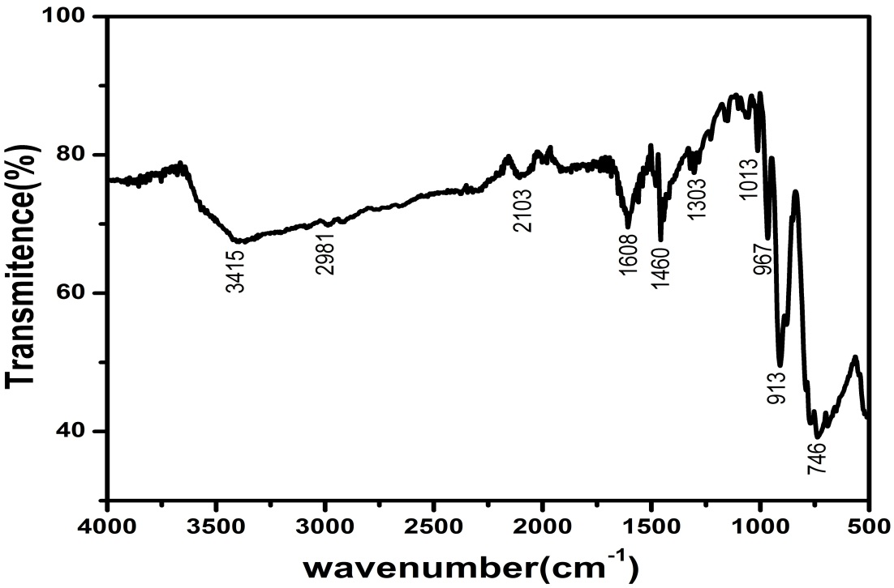
Figure S7. IR spectrum of compound 1.

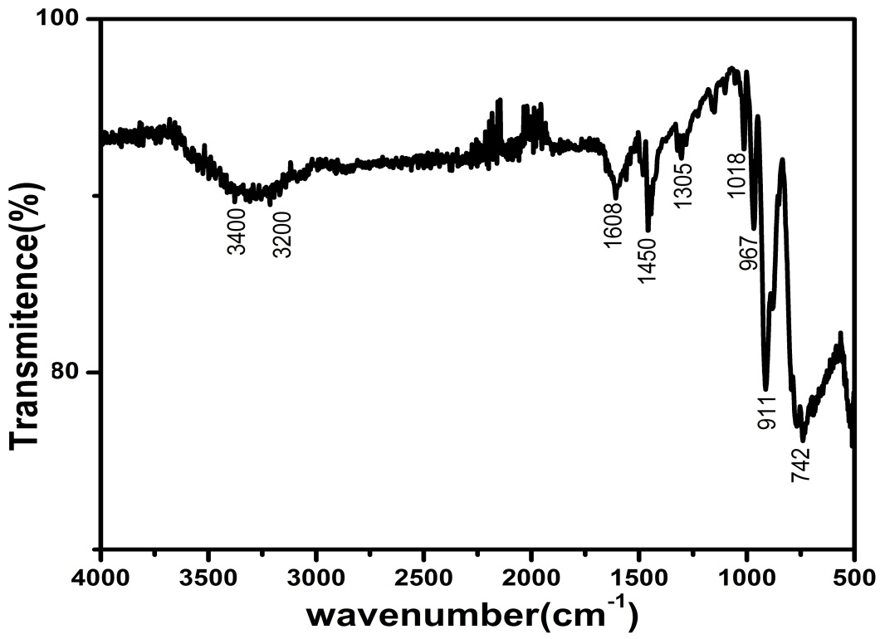
Figure S8. IR spectrum of compound 2.

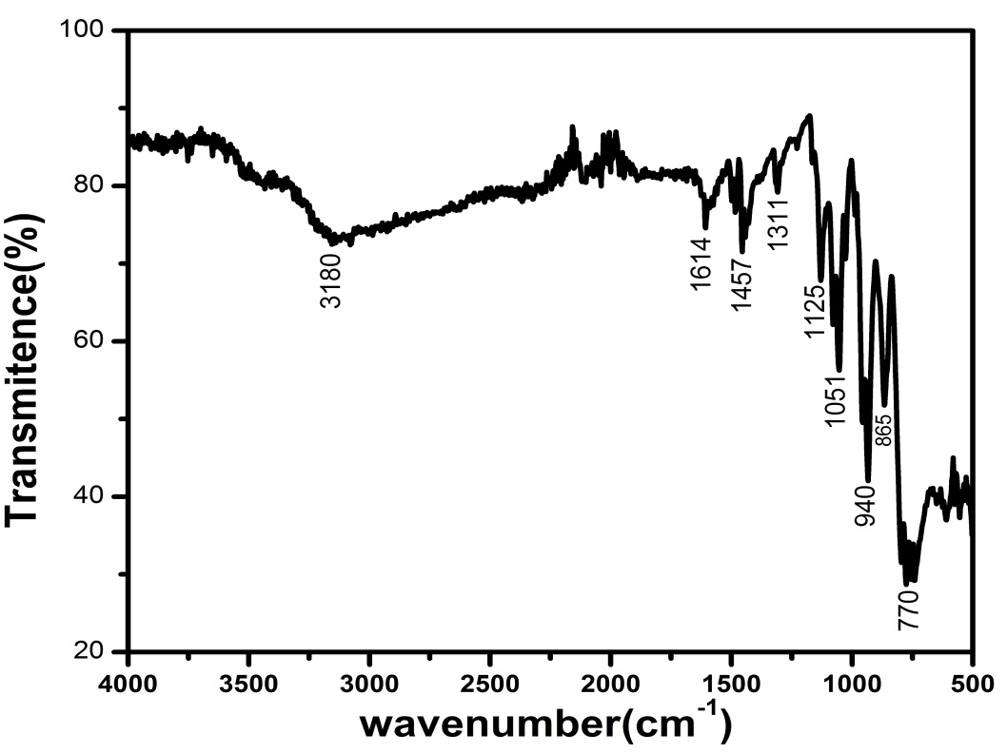
Figure S9. IR spectrum of compound 3.

3.2. TG curve obtained from compounds 1-3
The TG curves of compounds 1-3 roughly show over all two-step weight loss. The TG curve of compound 1 shows two step weight loss (Fig. S10). The first step weight loss of 2.40% (calcd.2.36%) in the temperature range of 50 ~ 180 °C corresponds to the loss of five lattice water molecules and coordinated water molecules. The second weight loss from 350 ~ 800 °C is ascribed to the loss of C, N atoms (decomposition of organic ligand and the loss of composition water) and the formation of CuO and WO3. The whole weight loss of 31.3% is in agreement with the calculated value 31%.
Compound 2 display similar two step weight loss (Fig. S11). The first step weight loss of 3.53% (calcd.3.50%) in the temperature range of 50 ~ 230 °C corresponds to the loss of four lattice water molecules and coordinated water molecules. The second weight loss from 300 ~ 800 °C is ascribed to the loss of C, N atoms and the formation of CuO and WO3. The whole weight loss of 29.54% is in agreement with the calculated value 28.1%.
The TG curve of compound 3 show two step weight loss (Fig.S12). The first step weight loss up to 350 °C assigned to the loss of lattice and composed water molecules. The second sharp weight loss 400 ~ 800 °C is ascribed to the loss of C, N atoms and the formation of CuO and MoO₃. The whole weight loss of 35.2% is in agreement with the calculated value 34.8%.

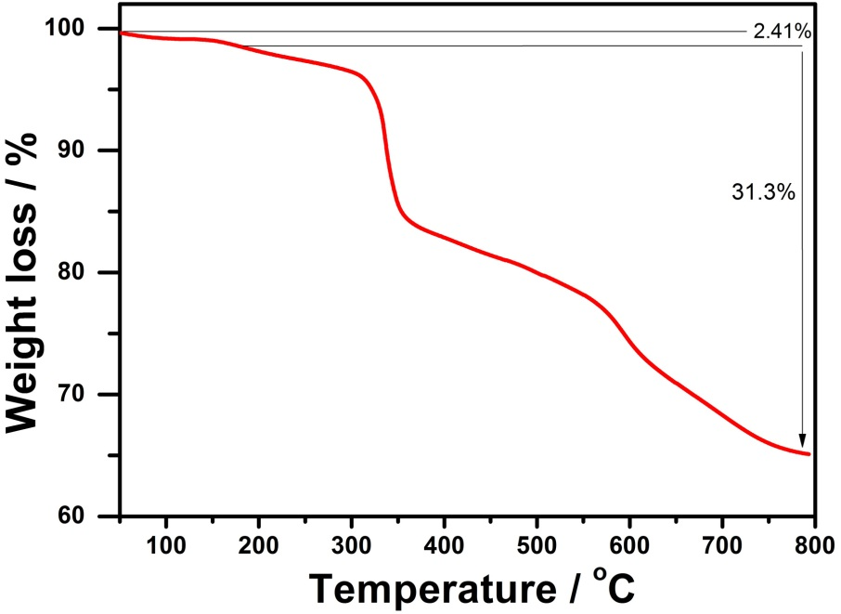
Figure S10. TG curve of compound 1.

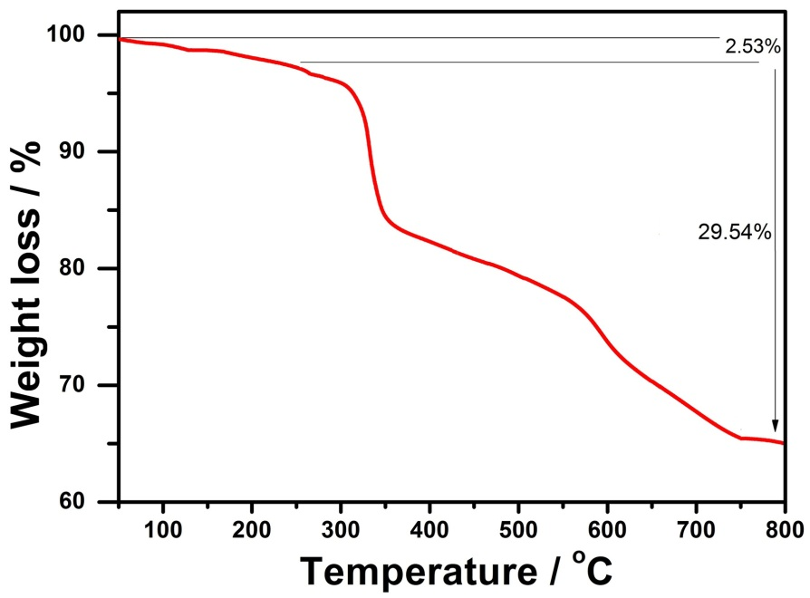
Figure S11. TG curve of compound 2.

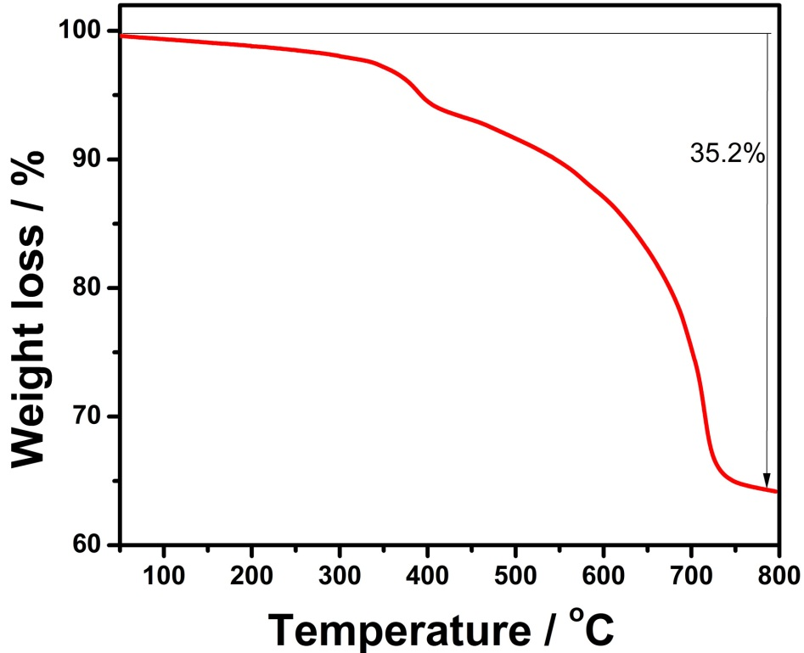
Figure S12. TG curve of compound 3.

3.3. Powder X-ray diffractions
Phase purities of compounds 1–3 were checked by PXRD comparisons of the samples with simulated single-crystal XRD data at room temperature. As shown in Fig13-15, the simulated and experimental XRD peak patterns of compounds 1-3 are all in good agreement, perhaps a slightly differences in reflection intensities are probably due to preferential orientations in the powder samples of compounds 1-3.

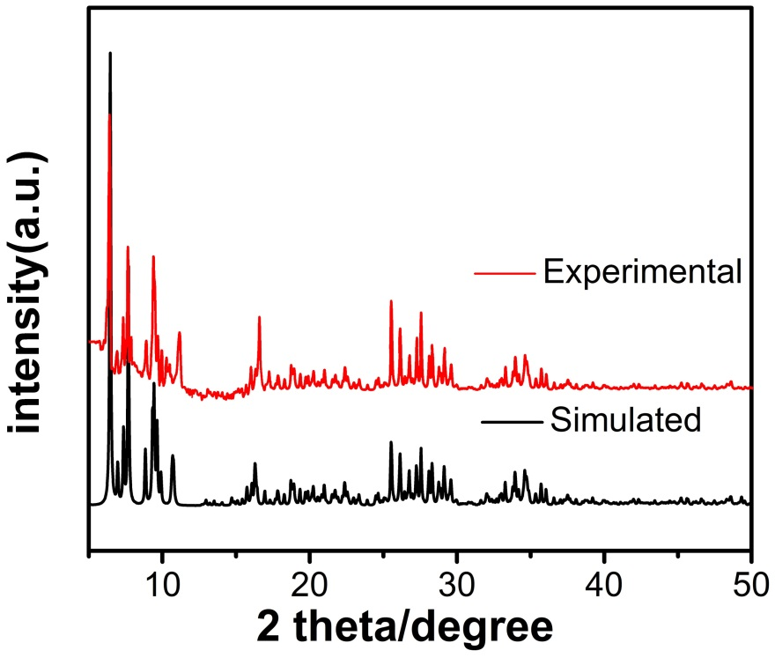
Figure S13. Simulated (black) and experimental (red) XRD patterns of compound 1.

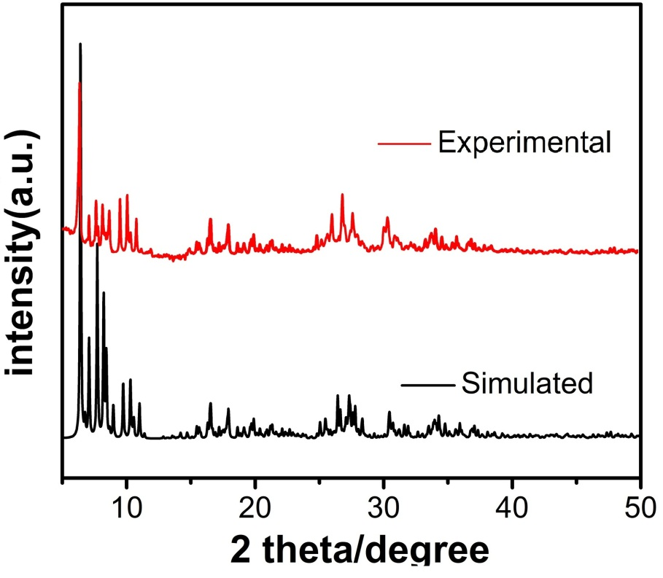
Figure S14. Simulated (black) and experimental (red) XRD patterns of compound 2.

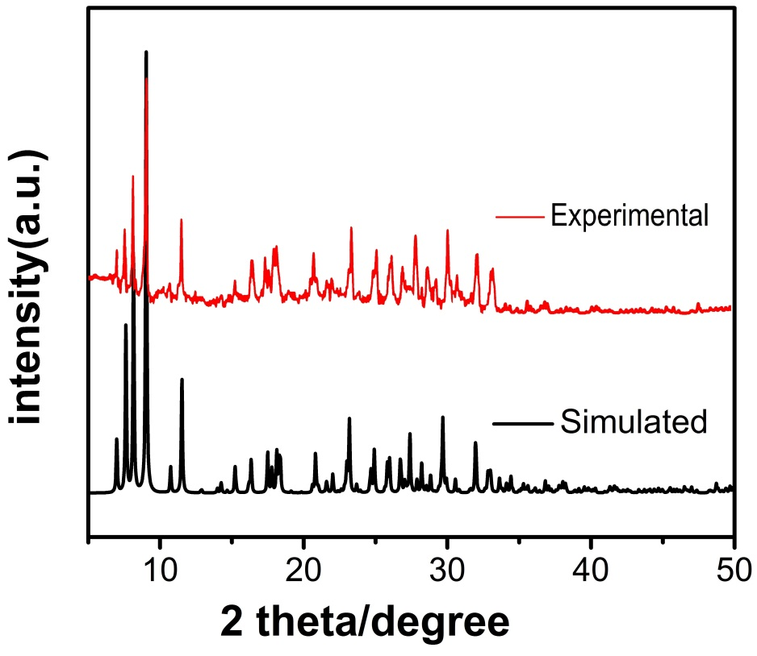
Figure S15. Simulated (black) and experimental (red) XRD patterns of compound 3.

3.4. The catalytic results of comparative experiments of starting materials and naked POM

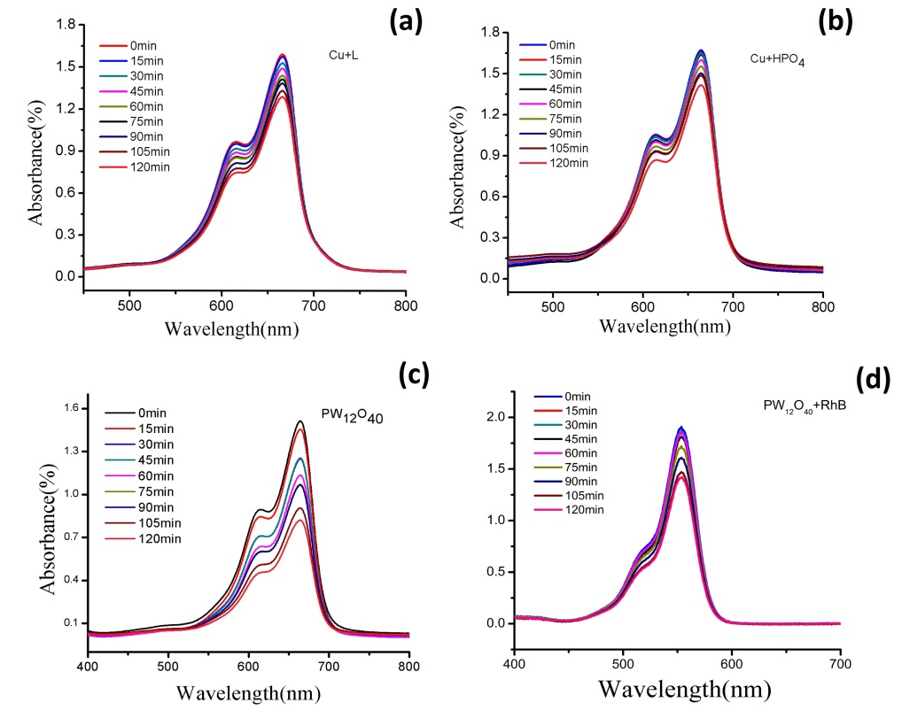
Figure S16. Photocatalytic degradation experiment of the precursors (a) MB+Cu+PBI, (b)MB+Cu+Na₂HPO₄, (c) MB+H₃PW₁₂O₄₀, (d) RhB+ H₃PW₁₂O₄₀.

3.5. Preparations of n-CPE (n=1–4)
The n-CPE (n =1–3) was prepared as follows: 10 mg of compound and 90 mg of graphite powder were mixed, and ground together to homogeneous, into which 0.2 mL of paraffinic oil was added with stirring. The such-obtained paste was packed into a glass tube with 2.0 mm inner diameter, and the surface was wiped with paper. The electrical contact was established with a copper rod through the back of the electrode.

References
[1] I.D. Brown, D. Altermatt. Acta Crystallogr., B41, 244 (1985).
[2] W. Liu, H.H. Thorp. Inorg. Chem., 32, 4102 (1993).

