Appendix:
Figure A1. Sensitivity of accuracy to the feature threshold values (linear feature ranged from 0.5 to 1 and angular feature ranged from 0 to 10 degrees) in the three experiment datasets. (a), (b) and (c) are the precision rate, recall rate and quality rate distribution of different linear and angular feature for UHM Dataset, respectively; (d), (e) and (f) are the precision rate, recall rate and quality rate distribution of different linear and angular feature for HNL Dataset, respectively; (g), (h) and (i) are the precision rate, recall rate and quality rate distribution of different linear and angular feature for MNST Dataset, respectively.
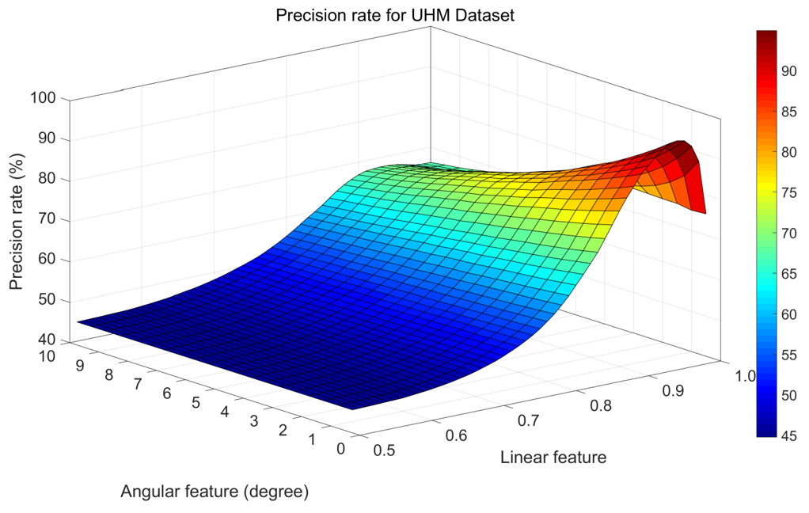
(a)
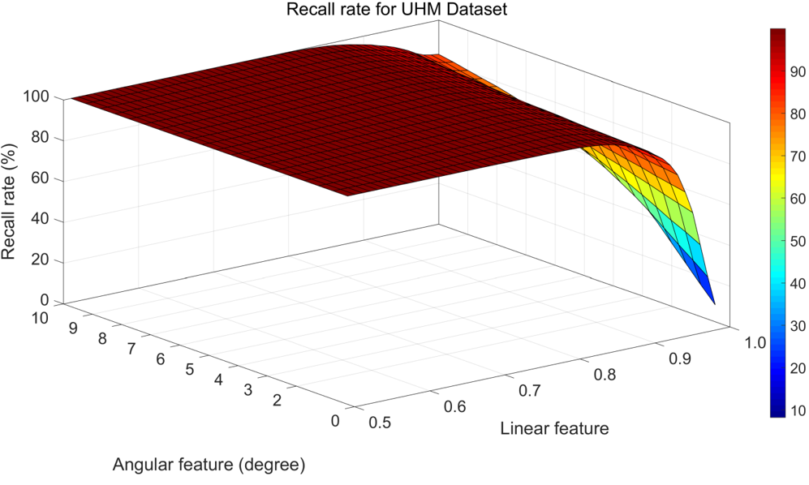
(b)
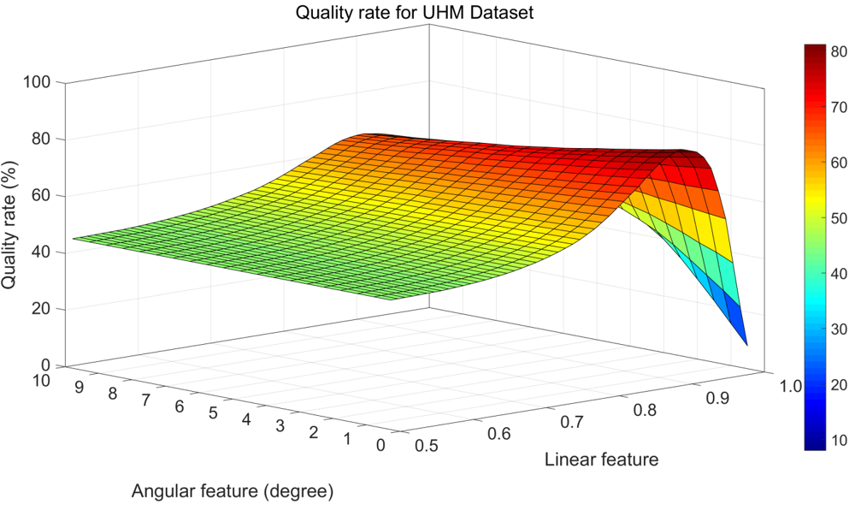
(c)
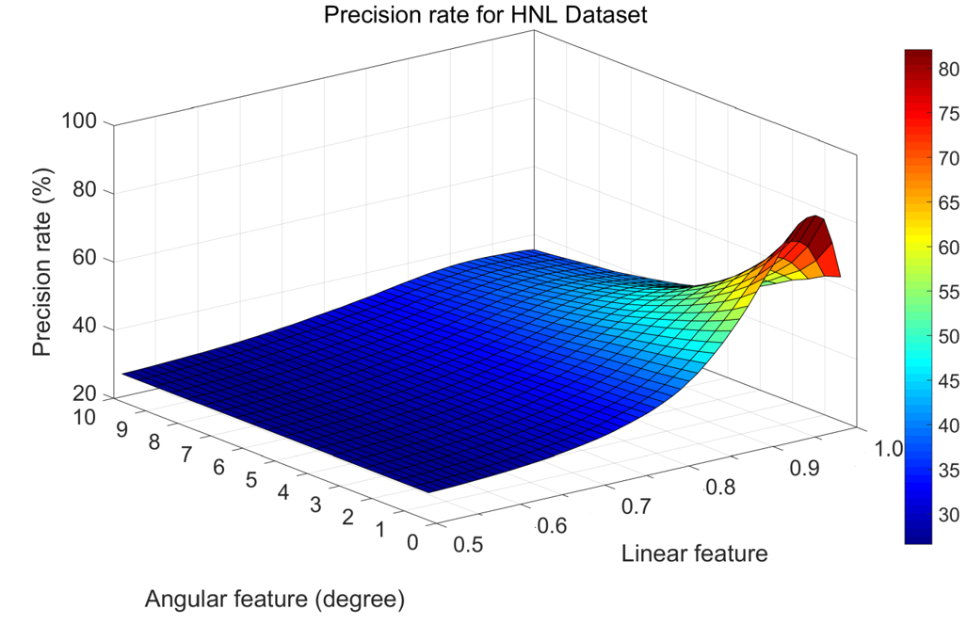
(d)
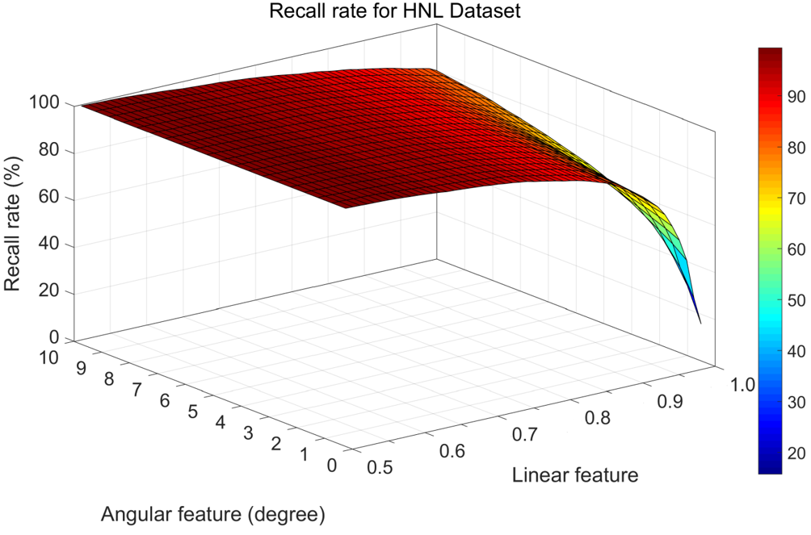
(e)
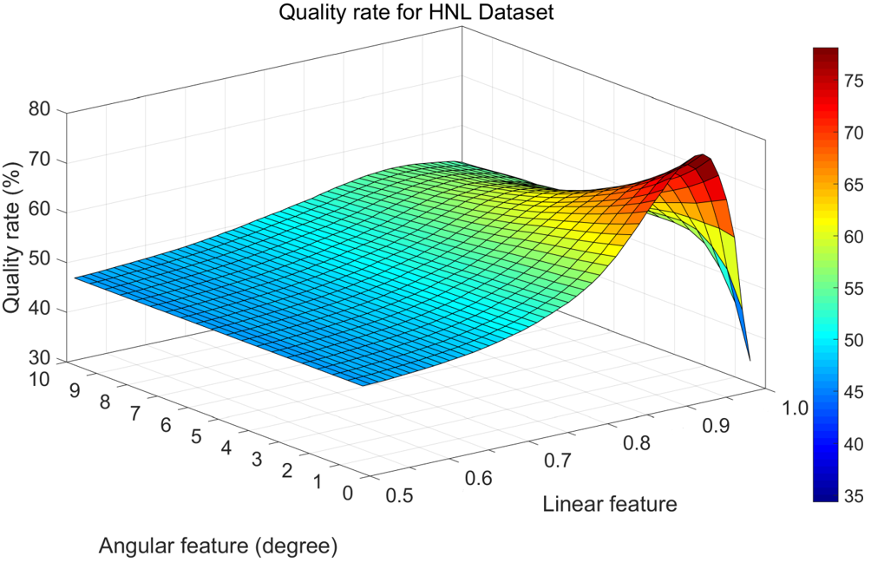
(f)
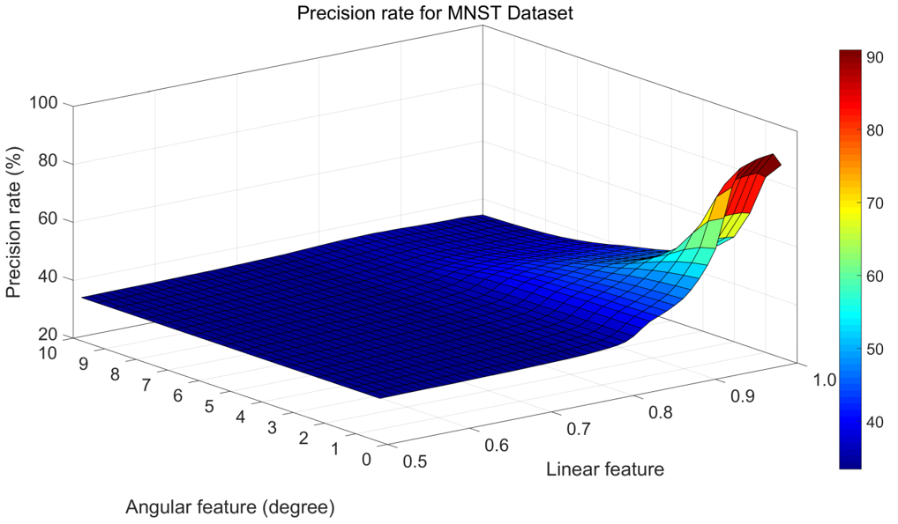
(g)
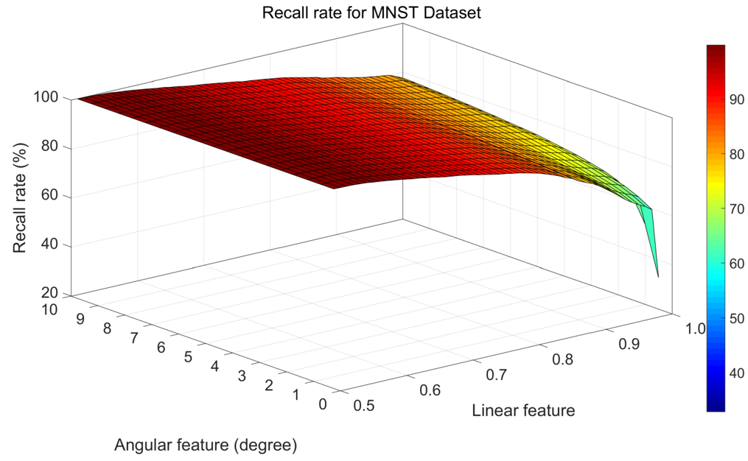
(h)
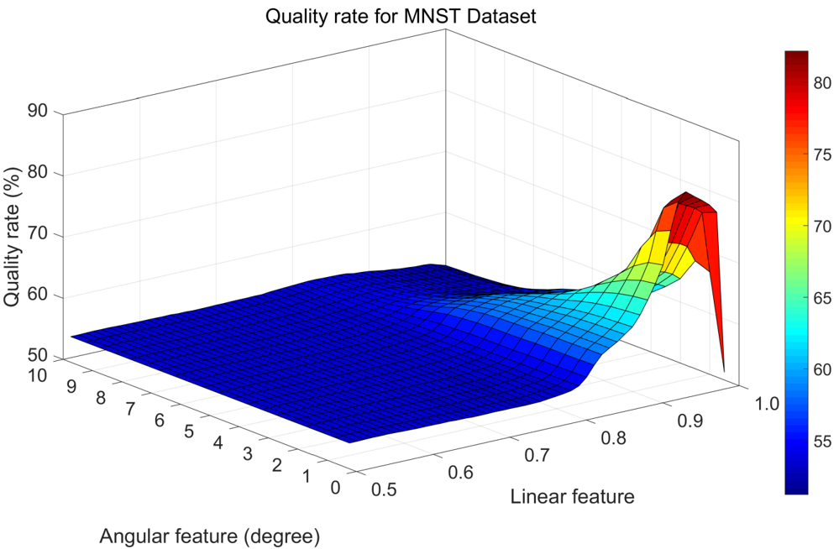
(i)

