Supporting Material for

Interaction between Pollution and Climate Change Augments Ecological Risk to a Coastal Ecosystem
Yonglong Lu^{1,2,3 *}, Ruoshi Wang^{1,3}, Yajuan Shi¹, Chao Su^{1,2}, Jingjing Yuan^{1,2}, Andrew C. Johnson⁴, Alan Jenkins⁴, Robert C. Ferrier⁵, Deliang Chen⁶, Hanqin Tian⁷, Jerry Melillo⁸, Shuai Song¹，Aaron M. Ellison⁹
¹State Key Laboratory of Urban and Regional Ecology, Research Center for Eco-Environmental Sciences, Chinese Academy of Sciences, Beijing 100085, China
²University of Chinese Academy of Sciences, Beijing 100049, China
³Renmin University of China, 59 Zhongguancun Road, Beijing 100872, China
⁴Centre for Ecology and Hydrology, Maclean Building, Crowmarsh Gifford Wallingford, Oxon, OX 10 8BB, UK
⁵James Hutton Institute, Aberdeen AB15 8QH, Scotland, UK
⁶Department of Earth Sciences, University of Gothenburg, 405 30 Gothenburg, Sweden
⁷International Center for Climate and Global Change Research, and School of Forestry and Wildlife Sciences, Auburn University, Auburn, AL 36849, USA
⁸The Ecosystem Center, Marine Biological Laboratory, Woods Hole, MA 02543, USA
⁹Harvard University, Harvard Forest, 324 North Main Street, Massachusetts 01366, USA
*Corresponding author: yllu@rcees.ac.cn

S1 Supplementary figure of Bohai Sea region

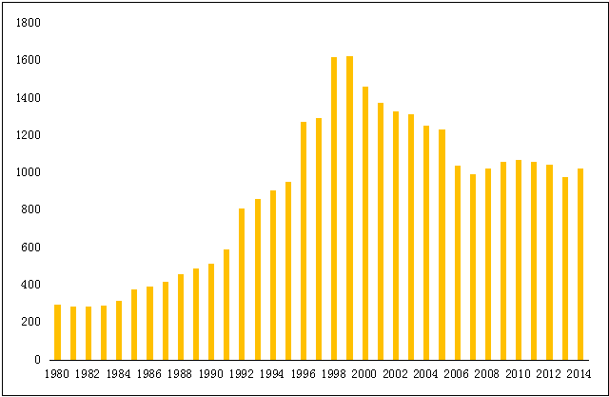
Figure S1 Yield of capture fisheries in Bohai Sea (1980-2014) (thousand tons)

S2 Supplementary materials for pollution risk assessment
S2.1 DIN and SRP
Table S1 Concentrations of dissolved inorganic nitrogen (DIN) in seawater of Bohai Sea
Location | Year | Sample size | Concentration (μg/L) | References
Bohai Bay | 1980 | 49 | 299.00 | S4
Central Sea | 1982-1983 | Nd | 28.00 | S5
Central Sea | 1992-1993 | Nd | 27.52 | S2
Central Sea | 1998-1999 | Nd | 80.00 | S5
Bohai Sea | 1982 | 52 | 73.30 | S6
Bohai Sea | 1992 | 52 | 147.25 | S6
Bohai Sea | 1998 | 52 | 427.00 | S6
Bohai Bay | 1995 | 20 | 998.00 | S7
Bohai Bay | 2003 | 20 | 300.00 | S7
Laizhou Bay | 1997.9 | 43 | 312.70 | S8
Laizhou Bay | 1998.6 | 43 | 598.40 | S8
Bohai Sea | 2002 | 120 | 193.44 | S9
Bohai Sea | 2003 | Nd | 239.00 | S10
Coastal sea | 2003 | Nd | 329.00 | S10
Bohai Sea | 2004 | Nd | 401.00 | S11
Coastal sea | 2004 | Nd | 430.00 | S11
Bohai Sea | 2005 | Nd | 215.80 | S12
Coastal sea | 2005 | Nd | 280.70 | S12
Bohai Sea | 2006 | Nd | 270.00 | S13
Bohai Sea | 2007 | Nd | 380.00 | S14
Bohai Sea | 2009 | Nd | 224.40 | S15
Bohai Bay | 2007 | 15 | 611.30 | S16
Bohai Bay | 2008 | 15 | 823.58 | S16
Bohai Bay | 2009 | 15 | 281.10 | S16
Bohai Bay | 2010 | 15 | 543.40 | S16
Bohai Bay | 2011 | 15 | 458.50 | S16
Bohai Bay | 2012 | 15 | 731.10 | S16
Liaodong Bay-Huludao | 2008 | 8 | 134.00 | S17
Liaodong Bay-Jinzhou | 2008 | 4 | 278.00 | S17
Liaodong Bay-Panjin | 2008 | 4 | 356.00 | S17
Liaodong Bay-Yingkou | 2008 | 4 | 443.00 | S17
Liaodong Bay-Dalian | 2008 | 7 | 174.00 | S17
Liaodong Bay | 2014.5 | 20 | 510.80 | S18
Liaodong Bay | 2014.8 | 20 | 287.65 | S18
Liaodong Bay | 2014.10 | 20 | 425.90 | S18

Table S2 Concentrations of soluble reactive phosphorus (SRP) in seawater of Bohai Sea
Location | Year | Sample size | Concentration (μg/L) | References
Bohai Bay | 1980 | 49 | 5.33 | S4
Bohai Sea | 1982 | 52 | 92.15 | S6
Bohai Sea | 1992 | 52 | 24.70 | S6
Bohai Sea | 1998 | 52 | 30.40 | S6
Bohai Bay | 2003 | 20 | 20.00 | S7
Laizhou Bay | 1997 | 43 | 58.9 | S8
Laizhou Bay | 1998 | 43 | 27.60 | S8
Bohai Sea | 2003 | Nd | 12.20 | S10
Coastal sea | 2003 | Nd | 15.20 | S10
Bohai Sea | 2004 | Nd | 11.0 | S11
Coastal sea | 2004 | Nd | 13.1 | S11
Bohai Sea | 2005 | Nd | 19.30 | S12
Coastal sea | 2005 | Nd | 27.20 | S12
Bohai Sea | 2006 | Nd | 30.00 | S13
Bohai Sea | 2007 | Nd | 20.00 | S14
Bohai Sea | 2009 | Nd | 13.40 | S15
Bohai Bay | 2007 | 15 | 24.30 | S16
Bohai Bay | 2008 | 15 | 20.66 | S16
Bohai Bay | 2009 | 15 | 14.43 | S16
Bohai Bay | 2010 | 15 | 9.62 | S16
Bohai Bay | 2011 | 15 | 13.30 | S16
Bohai Bay | 2012 | 15 | 15.28 | S16
Liaodong Bay-Huludao | 2008 | 8 | 11.00 | S17
Liaodong Bay-Jinzhou | 2008 | 4 | 5.00 | S17
Liaodong Bay-Panjin | 2008 | 4 | 32.00 | S17
Liaodong Bay-Yingkou | 2008 | 4 | 13.00 | S17
Liaodong Bay-Dalian | 2008 | 7 | 16.00 | S17
Liaodong Bay | 2014.5 | 20 | 17.51 | S18
Liaodong Bay | 2014.8 | 20 | 11.47 | S18
Liaodong Bay | 2014.10 | 20 | 19.44 | S18

Table S3 Concentrations of DO in seawater of Bohai Sea
Location | Year | Sample size | Concentration (μg/L) | References
Bohai sea | 2002 | 120 | 6510 | S9
Bohai Sea | 2003 | nd | 6340 | S10
Coastal sea | 2003 | nd | 6200 | S10
Bohai Sea | 2004 | nd | 6529 | S11
Coastal sea | 2004 | nd | 6508 | S11
Bohai Sea | 2005 | nd | 6570 | S12
Coastal sea | 2005 | nd | 6330 | S12
Bohai Sea | 2006 | nd | 6500 | S13
Bohai Sea | 2007 | nd | 6890 | S14
Bohai Sea | 2009 | nd | 6630 | S15
Bohai Bay | 2007 | 15 | 7330 | S16
Bohai Bay | 2010 | 15 | 7720 | S16
Bohai Bay | 2011 | 15 | 7400 | S16
Bohai Bay | 2012 | 15 | 7450 | S16
Liaodong Bay | 2014.5 | 20 | 9042 | S18
Liaodong Bay | 2014.8 | 20 | 7256 | S18
Liaodong Bay | 2014.10 | 20 | 8098 | S18

Table S4 Concentrations of Chl-a in seawater of Bohai Sea
Location | Year | Sample size | Concentration (μg/L) | References
Bohai sea | 2002 | 120 | 1.82 | S9
Bohai Sea | 2003 | Nd | 5.30 | S10
Coastal sea | 2003 | Nd | 5.30 | S10
Bohai Sea | 2004 | Nd | 3.04 | S11
Coastal sea | 2004 | Nd | 3.91 | S11
Bohai Sea | 2005 | Nd | 2.85 | S12
Coastal sea | 2005 | Nd | 4.03 | S12
Bohai Sea | 2006 | Nd | 2.82 | S13
Bohai Sea | 2007 | Nd | 2.97 | S14
Bohai Sea | 2009 | Nd | 2.57 | S15
Bohai Bay | 2007 | 15 | 2.86 | S16
Bohai Bay | 2008 | 15 | 5.76 | S16
Bohai Bay | 2010 | 15 | 3.17 | S16
Bohai Bay | 2011 | 15 | 2.84 | S16
Bohai Bay | 2012 | 15 | 5.20 | S16

The data from Table S1 to S4 were applied to estimate the ecological risks of eutrophication in aquatic systems by using the trophic index (TRIX)(S1)

$TRIX=\frac{Log\left(Chl-a×\left[\%DO\right]×DIN×SRP+1.5\right)}{1.2}$

where Chl-a is the concentration of chlorophyll-a, %DO is the absolute value of the oxygen saturation deviation and is calculated as |100 - %DO|. The four following trophic levels were defined: high with TRIX < 4, good with 4 < TRIX < 5, fair with 5 < TRIX < 6, and poor with TRIX > 6. Here we used TRIX=4.5 to calculate risk of DIN and SRP by quotient method:
Risk=(TRIX-4.5)/4.5
Risk_{1980~2014}=24.0%

S2.2 Petroleum hydrocarbons

Table S5 Concentrations of petroleum hydrocarbons (PHs) in seawater of Bohai Sea
Location | Year | Sample size | Concentration (μg/L) | References
Bohai Bay | 1996 | 16 | 140.00 | S19
Bohai Bay | 1997 | 16 | 139.00 | S19
Bohai Bay | 1998 | 16 | 78.50 | S19
Bohai Bay | 1999 | 16 | 128.00 | S19
Bohai Bay | 2000 | 16 | 72.10 | S19
Bohai Bay | 2001 | 16 | 35.80 | S19
Bohai Bay | 2002 | 16 | 173.00 | S19
Bohai Bay | 2003 | 16 | 95.90 | S19
Bohai Bay | 2004 | 16 | 51.80 | S19
Bohai Bay | 2005 | 16 | 48.90 | S19
Bohai Bay | 2002 | 7 | 26.80 | S20
Liaodong Bay | 2002 | 16 | 23.50 | S20
Laizhou Bay | 2002 | 11 | 42.00 | S20
Central Bohai | 2002 | 23 | 20.20 | S20
Bohai Channel | 2002 | 5 | 25.70 | S20
Bohai Sea | 2003 | Nd | 42.70 | S10
Coastal sea | 2003 | Nd | 54.70 | S10
Bohai Sea | 2004 | Nd | 104.90 | S11
Coastal sea | 2004 | Nd | 140.30 | S11
Bohai Sea | 2005 | Nd | 58.00 | S12
Coastal sea | 2005 | Nd | 75.00 | S12
Bohai Sea | 2006 | Nd | 50.00 | S13
Bohai Sea | 2007 | Nd | 80.00 | S14
Bohai Sea | 2009 | Nd | 33.50 | S15
Bohai Bay | 2007 | 15 | 39.50 | S16
Bohai Bay | 2008 | 15 | 30.40 | S16
Bohai Bay | 2009 | 15 | 13.87 | S16
Bohai Bay | 2010 | 15 | 31.30 | S16
Bohai Bay | 2011 | 15 | 55.00 | S16
Bohai Bay | 2012 | 15 | 35.00 | S16
Bohai Bay | Spring 2010 | 4 | 10.50 | S21
Bohai Bay | Autumn 2010 | 4 | 23.93 | S21
Liaodong Bay | 2014.5 | 20 | 10.97 | S18
Liaodong Bay | 2014.8 | 20 | 18.51 | S18
Liaodong Bay | 2014.10 | 20 | 20.21 | S18

Table S6 Toxicity data of PHs
 | Species Scientific Name | Species Group | EC50/LC50 (ug/l)
1 | Allorchestes compressa | Amphipod | 10.00
2 | Eualus sp. | Crustaceans | 349.85
3 | Evasteriastroschelii | Invertebrates | 716.04
4 | Mysis oculata | Crustaceans | 1048.71
5 | Mysis oculata | Crustaceans | 1289.93
6 | Daphnia magna | Crustaceans; Standard Test Species | 2244.08
7 | Artemia sp. | Crustaceans | 4671.60
8 | Daphnia magna | Crustaceans | 4670.17
9 | Calanus hyperboreus | Crustaceans | 73000.00
10 | Palaemonetes sp. | Crustaceans | 4400558.68
11 | Skeletonema costatum | Algae | 13641727.31

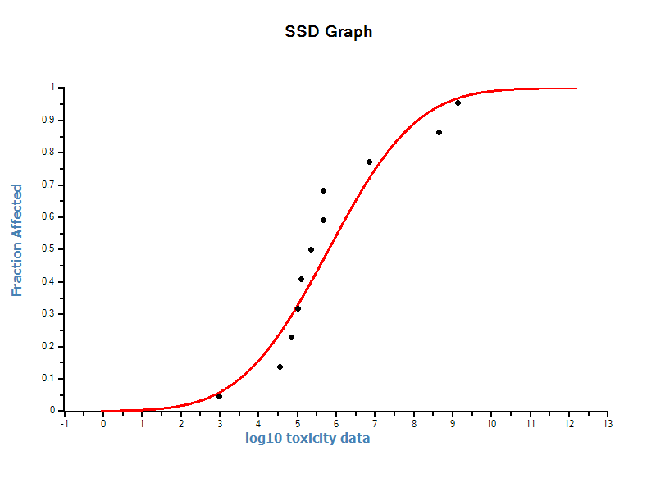
Figure S2 Species Sensitivity Distribution(SSD) of PHs toxicity
Risks of PHs were calculated with probabilistic ecological risk assessment (RMPERA) method based on toxicity data of indigenous species.
Risk_{PHs}=100%

S2.3 Pb
Table S7 Concentrations of Pb in seawater of Bohai Sea
Location | Year | Sample size | Concentration (μg/L) | References
Bohai Bay | 1996-2005 | 22 | 4.43 | S22
Liaodong Bay | 2001-2004 summer | 16 | 4.91 | S23
Bohai Sea | 2002 | 52 | 3.29 | S24
Bohai Sea | 2003 | 52 | 1.16 | S24
Bohai Sea | 2003 | 42 | 1.10 | S25
Bohai Bay | 2003 | 20 | 7.10 | S26
Bohai Sea | 2003 | Nd | 1.48 | S10
Coastal sea | 2003 | Nd | 1.77 | S10
Bohai Bay | 2004 | 17 | 8.38 | S27
Bohai Sea | 2004 | Nd | 1.95 | S11
Coastal sea | 2004 | Nd | 1.87 | S11
Bohai Sea | 2006-2007 | Nd | 2.43 | S28
Bohai Bay | 2007 | 15 | 1.68 | S16
Bohai Bay | 2008 | 15 | 0.70 | S16
Bohai Bay | 2009 | 15 | 0.42 | S16
Bohai Bay | 2010 | 15 | 0.42 | S16
Bohai Bay | 2011 | 15 | 5.60 | S16
Bohai Bay | 2012 | 15 | 1.68 | S16
Liaodong Bay-Huludao | 2008 | 8 | 2.00 | S17
Liaodong Bay-Jinzhou | 2008 | 4 | 6.00 | S17
Liaodong Bay-Panjin | 2008 | 4 | 0.10 | S17
Liaodong Bay-Yingkou | 2008 | 4 | 2.60 | S17
Liaodong Bay-Dalian | 2008 | 7 | 1.20 | S17
Northern Bohai | 2008 | Nd | 2.62 | S29
Northern Liaodong Bay | 2009 | 20 | 3.43 | S30
Laizhou bay | 2010 | Nd | 0.88 | S31
Coastal Bohai Bay | 2011 | 18 | 3.13 | S32

Table S8 Toxicity data of Pb
Rank | Species Scientific Name | Species Group | EC50/LC50 (ug/l)
1 | Heterotrich Ciliate | Invertebrates | 12.85
2 | Chaetoceros sp. | Algae, Moss, Fungi | 105.00
3 | Ulva pertusa | Algae, Moss, Fungi | 489.00
4 | Nannochloropsisgaditana | Algae, Moss, Fungi | 740.00
5 | Rhodomonassalina | Algae, Moss, Fungi | 900.00
6 | Isochrysisgalbana | Algae, Moss, Fungi | 1340.00
7 | Tetraselmischuii | Algae, Moss, Fungi | 2640.00
8 | Brachionusplicatilis | Invertebrates; Standard Test Species | 4000.00
9 | Phaeodactylumtricornutum | Algae, Moss, Fungi | 5000.00
10 | Skeletonemacostatum | Algae, Moss, Fungi; Standard Test Species | 7940.00

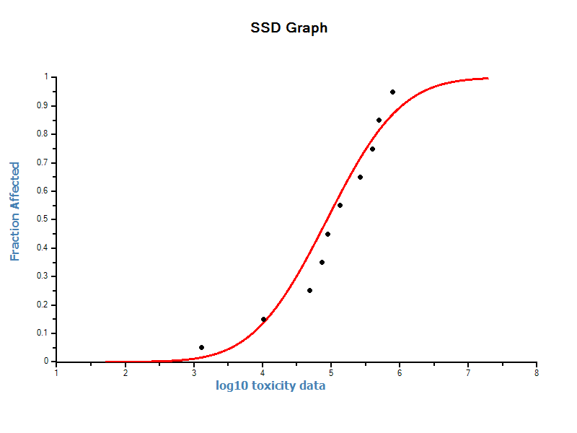
Figure S3 Species Sensitivity Distribution(SSD) of Pb toxicity
Risks of PHs was calculated with probabilistic ecological risk assessment (RMPERA) method based on toxicity data of indigenous species.
RISK_{Pb}=1.02%

S2.4 Concentrations of other pollutants and over standard rate
Table S9 Concentrations of Hg in seawater of Bohai Sea
Location | Year | Sample size | Concentration (μg/L) | References
Bohai Bay | 1980-1981 | 8 | 0.039 | S33
Bohai Bay | 1996-2005 | 22 | 0.050 | S22
Bohai Sea | 2002 | 52 | 0.070 | S24
Bohai Sea | 2003 | 52 | 0.270 | S24
Bohai Sea | 2003 | 42 | 0.030 | S25
Bohai Bay | 2003 | 20 | 0.040 | S26
Bohai Sea | 2003 | Nd | 0.043 | S10
Coastal sea | 2003 | Nd | 0.047 | S10
Bohai Bay | 2004 | 17 | 0.080 | S27
NothernBohai Sea | 2008 | 17 | 1.000 | S34
Estuary of Huanghe | 2009 | Nd | 0.380 | S35
Bohai Bay | 2010 | 15 | 0.087 | S16
Bohai Bay | 2011 | 15 | 0.053 | S16
Bohai Bay | 2012 | 15 | 0.108 | S16
Laizhou bay | 2010 | Nd | 0.056 | S31
Coastal Bohai Bay | 2011 | 18 | 0.037 | S32

Table S10 Concentration of Cd in seawater of Bohai Sea
Location | Year | Sample size | Concentration (μg/L) | References
Jinzhou Bay | 1992-1993 | 22 | 1.13 | S36
Bohai Bay,surface water | 1996-2005 | 22 | 0.2 | S22
Liaodong Bay | 2001-2004 summer | 16 | 1.04 | S23
Bohai Sea | 2002 | 52 | 0.47 | S24
Bohai Sea | 2003 | 52 | 0.35 | S24
Bohai Sea | 2003 | 42 | 0.31 | S25
Bohai Bay | 2003 | 20 | 0.12 | S26
Bohai Sea | 2003 | Nd | 0.56 | S10
Coastal sea | 2003 | Nd | 0.69 | S10
Bohai Bay | 2004 | 17 | 0.38 | S27
Bohai Sea | 2006-2007 | Nd | 0.16 | S28
Bohai Bay | 2007 | 15 | 0.22 | S16
Bohai Bay | 2009 | 15 | 0.10 | S16
Bohai Bay | 2010 | 15 | 0.08 | S16
Bohai Bay | 2011 | 15 | 0.44 | S16
Bohai Bay | 2012 | 15 | 0.16 | S16
Bohai Bay | 2008 | 20 | 0.15 | S37
Northern Liaodong Bay | 2009 | 20 | 0.60 | S30
Laizhou bay | 2010 | Nd | 0.28 | S31
Coastal Bohai Bay | 2011 | 18 | 0.36 | S32

Table S11 Over standard rate of pollution stressors
Stressors | Sea water quality standard (μg/L) * | Median concentration (μg/L) | Over standard rate
DIN | 200 | 310 | 0.55
SRP | 15 | 20.3 | 0.35
PHs | 50 | 31.5 | 0.00
Pb | 1 | 1.68 | 0.68
Hg | 0.05 | 0.055 | 0.10
Cd | 1 | 0.33 | 0.00
*China sea water quality standard (GB 3097-1997), standards for first class seawater (fisheries area) (S38)

S3 Supplementary materials for climate change risk assessment
S3.1 Ocean warming
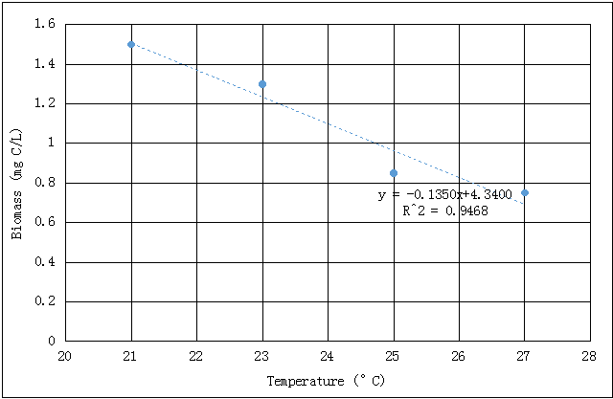
Figure S4 Effect of temperature on plankton biomass (S39)
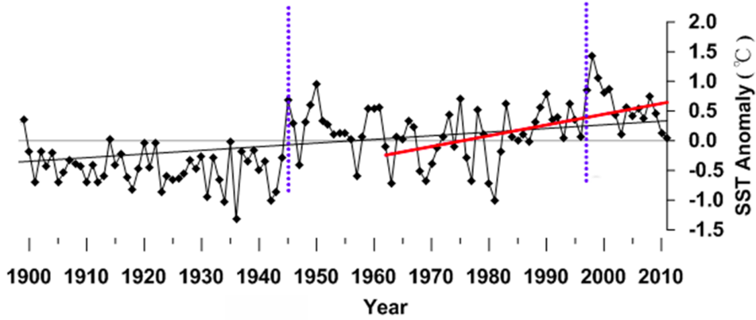
Figure S5 Annual SST anomaly from the 1900 to 2010 mean in Bohai (S40)
1945 and 2006 (blue dotted line) were two sudden change years. SST increased 0.015 ℃/a on average from 1960 to 2010. SST of Bohai in the summer of 1980 was 23.9 ℃ (S41), and it was 24.4℃ in 2014.

SST rise risk= (effect 2014-effect 1980)/effect 1980=6.4%

S3.2 Ocean acidification
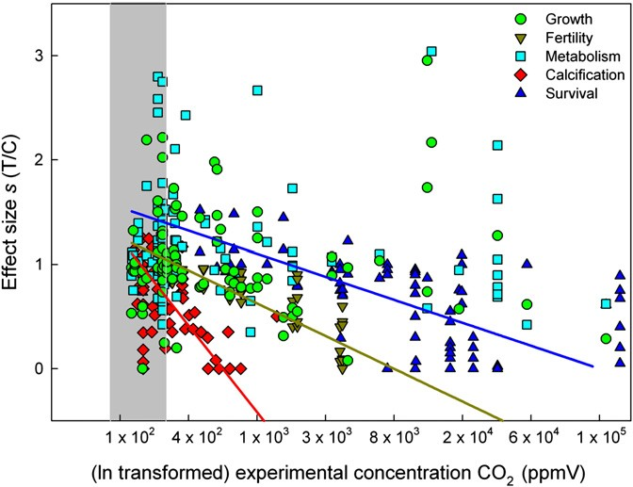
Figure S6 Effect of CO₂ concentration on plankton (S42)
Table. S12 Effect of CO₂ concentration on plankton
 | Intercept | Slope(a) | F-value | P
Calcification | 6.226 | -0.830 | 15.00 | <0.001
Fertility | 3.141 | -0.314 | 67.59 | <0.0001
Survival | 2.864 | -0.220 | 29.34 | <0.0001
All | -7.383 | 1.058 | 12.81 | <0.001
We choose survival as the risk assessment endpoint in this study.
Survival Rate(SR)=-0.220*ln (CO₂) +2.864
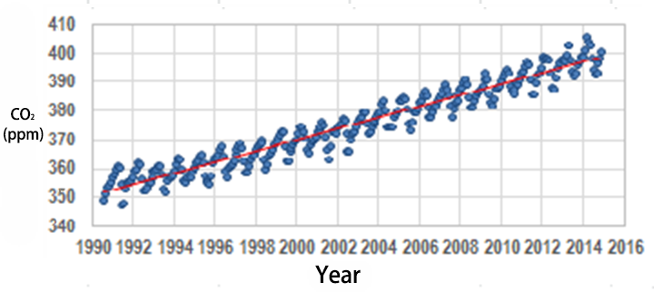
Figure S7 Monthly average CO₂ concentration from 1990 to 2014 in China (S43)
CO₂ (1980) = 339.1 ppm；CO₂ (2014) = 404.4 ppm
Ocean acidification risk = (SR 2014-SR 1980)/SR 1980 = 2.3%

S3.3 UV-B
The UV-B spectrum (280nm~315nm) of UV light that is most harmful to organisms.
Table S13 UV-B effects on planktons (S46-S48)
Species | Endpoint | UV-B (kJ/m²)
Schmacheriainopinus male | 24h-LD50 | 5.77
Schmacheriainopinuscopepodite | 24h-LD50 | 3.573
Harpacticus sp. Female | EC50 | 2.51
E.pacifica male | 24h-LD50 | 2.653
E.pacifica female | 24h-LD50 | 5.158
E.pacificacopepodite | 24h-LD50 | 2.347
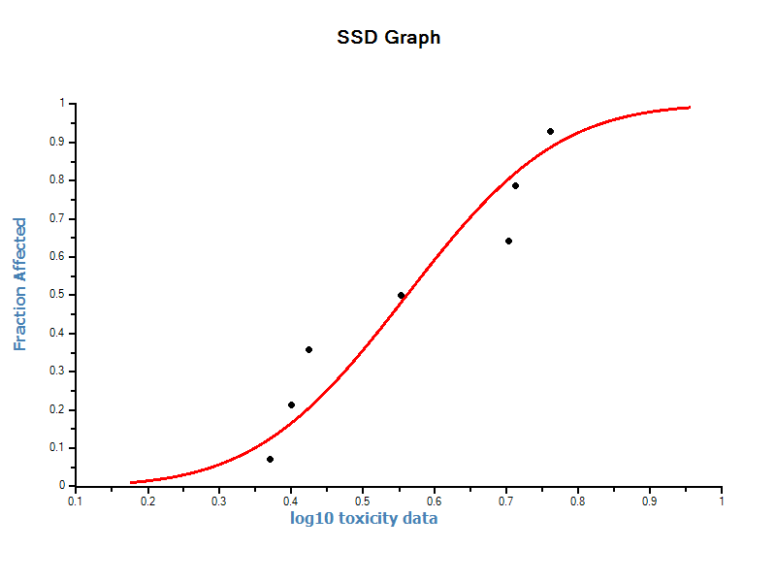
Fig S8 SSD of UV-B effects on planktons (HC₅=1.8 kJ/m²)

Table S14 UV-B radiation of 5 observation stations around Bohai area (KJ/m²/d)
Station | 2006-2012 UV(S49) | 1991 UV* | 2012-UV* | 1991 UV-B** | 2012 UV-B** | 1991 UV-B in sea*** | 2012 UV- B in sea***
JZW | 523.0 | 510.4 | 526.5 | 13.8 | 14.2 | 3.6 | 3.7
NM | 614.0 | 601.4 | 617.5 | 16.2 | 16.7 | 4.2 | 4.3
NMG | 703.0 | 690.4 | 706.5 | 18.6 | 19.1 | 4.8 | 5.0
SYG | 515.0 | 502.4 | 518.5 | 13.6 | 14.0 | 3.5 | 3.6
YC | 480.0 | 467.4 | 483.5 | 12.6 | 13.1 | 3.3 | 3.4
(*The linear trends of long-term annual mean daily whole UV radiation were 0.7 kJ/m²/d per year during 1991-2012 (S50). **UV-B makes up about 2.7% of the total UV radiation energy reaching earth surface(S51); ***For UV of 310nm spectrum in ocean, radiation energy deceases 14% while water depth increases 1 m(S52). The average depth of Bohai is 18m. Here we use the median value, in the depth of 9 m, oceanic UV-B decreases to 26% on surface earth.)

UV-B rise risk=risk (2012)-risk (1991) =1.7%

Table S15 Risk results of climate change stressors
Stressors | Risk
Ocean warming (SST, °C) | 6.4%
Ocean acidification (CO₂, ppm) | 2.3%
Sea level rise (mm) | 10.7%
UV-B(KJ/m²) | 1.7%

Table S16 Change rate of climate change stressors
Stressors | 1980 | 2014 | Change rate over 35 years
SST (°C) | 23.9 | 24.4 | 0.021
CO₂ (ppm) | 339.1 | 404.4 | 0.19
Sea level (mm) | 17916.00(S45) | 18018.00(S45) | 0.006
UV-B (KJ/m²) | 3.9 (1991) | 4.0(2012) | 0.026

S4 Supplementary tables of relative vulnerability weights and impact weights

Table S17 Ranking systems for each vulnerability measure used to assess how threats affect ecosystems (Adapted from S53)
Vulnerability measure | Category | Rank | Notes
Scale (km²) | no impact | 0
 | 0-10 | 1
 | 10-100 | 2
 | 100-1000 | 3
 | >1000 | 4
Frequency | never occurs | 0
 | rare | 1
 | occasional | 2 | frequent but irregular
 | annual or regular | 3 | frequent and seasonal
 | persistent | 4
Functional and structure impact | no impact | 0
 | species | 1
 | population | 2 | single trophic level affected
 | community | 3 | multiple trophic level affected
 | ecosystem | 4
Resistance | no impact | 0
 | high | 1
 | medium | 2
 | low | 3
 | no resistance | 4
Recovery time (years) | no impact | 0
 | <1 | 1
 | 1-10 | 2
 | 10-100 | 3
 | >100 | 4
All score data were rescaled between 0 and 1.

Table S18 Relative vulnerability weights
Stressors |  | Coastal ecosystems |  |  |  |  |  | Marine ecosystems
 |  | Estuarine zone |  | Salt marsh | Rocky intertidal | Intertidal mud (reed marsh) | Beach | Seagrass bed | Rocky reef | Sea water | Deep benthic
Climate change | Ocean warming | 0.21 | 0.18 |  | 0.30 | 0.19 | 0.50 | 0.26 | 0.26 | 0.25 | 0.28
 | Ocean acidification | 0.16 | 0.17 |  | 0.10 | 0.14 | 0.00 | 0.18 | 0.15 | 0.14 | 0.19
 | UV-B rise | 0.13 | 0.14 |  | 0.10 | 0.18 | 0.00 | 0.06 | 0.09 | 0.11 | 0.03
Pollution | DIN&SRP | 0.20 | 0.19 |  | 0.16 | 0.20 | 0.13 | 0.31 | 0.15 | 0.22 | 0.15
 | PHs | 0.09 | 0.12 |  | 0.13 | 0.10 | 0.17 | 0.07 | 0.15 | 0.12 | 0.13
 | Heavy metals | 0.21 | 0.20 |  | 0.21 | 0.20 | 0.20 | 0.12 | 0.20 | 0.16 | 0.22

Table S19 Impact weights of climate change on pollution stressors
 | Ocean warming | Ocean acidification | UV-B
DIN&SRP | 0.54 | 0.30 | 0.16
PHs | 0.16 | 0.54 | 0.30
Heavy metals | 0.25 | 0.50 | 0.25

Table S20 Impact weights of pollution on climate change stressors
 | DIN&SRP | PHs | Heavy metals
Ocean warming | 0.5 | 0.25 | 0.25
Ocean acidification | 0.14 | 0.33 | 0.53
UV-B | 0.16 | 0.54 | 0.3

References
S1. Vollenweider, R.A., Giovanardi, F., Montanari, G., Rinaldi, A. Characterization of the trophic conditions of marine coastal waters with special reference to the NW Adriatic Sea: proposal for a trophic scale, turbidity and generalized water quality index. Environmetrics 9, 329-357 (1998)

S2. Herrera-Silveira, J.A., Morales-Ojeda, S.M. Evaluation of the health status of a coastal ecosystem in southeast Mexico: assessment of water quality, phytoplankton and submerged aquatic vegetation. Marine Pollution Bulletin 59, 72-86 (2009).
S3. Solomon, K., Giesy, J., Jones, P. Probabilistic risk assessment of agrochemicals in the environment. Crop Protection 19, 649-655 (2000)
S4. Zou, J., Dong L., Qin, B. Exploration of Eutrophication and Red Tide of Bohai Sea. Chinese Journal of Marine Environmental Science 2,41-54 (1983) (In Chinese)
S5. Yu, Z., Mi, T., Xie, B., Yao, Q., Zhang, J. Changes of the Environmental Parameters and Their Relationship in Recent Twenty Years in the Bohai Sea. Chinese Journal of Marine Environmental Science 19, 15-19 (2000) (In Chinese)
S6. Jiang, H., Cui, Y., Chen, B., Chen, J., Song, Y. The variation trend of nutrient salts in the Bohai Sea. Marine Fisheries Research26, 61-67 (2005) (In Chinese)
S7. Zheng, B., Qin, Y., Meng, W., Zhang, L., Wang, J. Historical Evolvement Trends of Nutrients in Waters of Bohai Bay from 1985 to 2003. Chinese Journal of Environmental Science28, 494-499 (2007) (In Chinese)
S8. Qu, K. et al. Then plane distributions and seasonal variations of nutrients in the East of Laizhou Bay. Marine Fisheries Research23, 37-46 (2002) (In Chinese)
S9. Wang, X., Cui, Z., Guo, Q., Han, X., Wang, J. Distribution of nutrients and eutrophication assessment in the Bohai Sea of China. Chinese Journal of Oceanology and Limnology27, 177-183 (2009)
S10. State Oceanic Administration, PRC. China marine statistical yearbook 2014. Beijing: China Ocean Press (2004) (in Chinese)
S11. State Oceanic Administration, PRC. China marine statistical yearbook 2014. Beijing: China Ocean Press (2005) (in Chinese)
S12. State Oceanic Administration, PRC. China marine statistical yearbook 2014. Beijing: China Ocean Press (2006) (in Chinese)
S13. State Oceanic Administration, PRC. China marine statistical yearbook 2014. Beijing: China Ocean Press (2007) (in Chinese)
S14. State Oceanic Administration, PRC. China marine statistical yearbook 2014. Beijing: China Ocean Press (2008) (in Chinese)
S15. State Oceanic Administration, PRC. China marine statistical yearbook 2014. Beijing: China Ocean Press (2010)
S16. Peng, S. The nutrient, total petroleum hydrocarbon and heavy metal contents in the seawater of Bohai Bay, China: Temporal-spatial variations, sources, pollution statuses, and ecological risks. Marine Pollution Bulletin95, 445-451 (2015)
S17. Qin, Y., Zheng, B., Zhang, L., Lei, K., Jia, J. Pollution Characteristics Analysis of Water Quality in Liaodong Bay from 2004 to 2008. Research of Environmental Sciences23, 987-992 (2010) (In Chinese)
S18. Marine monitoring information. Dalian City Oceanic and Fishery Administration. (2012) http://www.hyyyyj.dl.gov.cn/web/kxh_ycjc_control.aspx
S19. Li, Y., Zhao, Y., Peng, S., Zhou, Q., Ma, L. Q. Temporal and spatial trends of total petroleum hydrocarbons in the seawater of Bohai Bay, China from 1996 to 2005. Marine Pollution Bulletin60, 238-243 (2010)
S20. Wang, X., Deng, N., Li, K., Shi, X., Zhu, C. Petroleum pollution condition and estimation of it environmental capacities summer in Bohai Sea. Marine Environmental Science23, 14-18 (2004) (In Chinese)
S21. Shang, X., Lou, A., Sun, X., Sun, Y. Numerical simulation of petroleum hydrocarbons transport in Bohai Sea and the influences on water quality. Marine Environmental Science34, 58-65 (2015) (In Chinese)
S22. Mao, T., Dai, M., Peng, S., Li, G. Temporal-Spatial Variation Trend Analysis of Heavy Metals (Cu, Zn, Pb, Cd, Hg) in Bohai Bay in 10 Years. Journal of Tianjin University42, 817-825 (2009) (In Chinese)
S23. Wan, L. et al. Comprehensive assessment of the situation of water quality of Liaodong Bay in summer. Transactions of Oceanology and Limnology 4, 87-92 (2007) (In Chinese)
S24. Wang, J., Chen, S., Xia, T. Environmental risk assessment of heavy metals in Bohai Sea, North China. International Conference on Ecological Informatics and Ecosystem Conservation2 1632-1642 (2010)
S25. Wang, C., Wang, X. Spatial distribution of dissolved Pb, Hg, Cd, Cu and as in the Bohai sea. Journal of Environmental Sciences19, 1061-1066 (2007)
S26. Meng, W., Qin, Y., Zheng, B., Zhang, L. Heavy metal pollution in Tianjin Bohai Bay, China. Chinese Journal of Environmental Sciences20, 814-819 (2008)
S27. Peng, S. et al. Distribution of Dissolved Heavy Metals in Sea Water of the Bohai Bay. Energy Conservation and Carbon off in Asia City: 6th International Symposium of Asia-Institute-of-Urban-Environment, 693-696 (2011)
S28. Pan, K., Wang, W. X. Trace metal contamination in estuarine and coastal environments in China. Science of the Total Environment421, 3-16 (2012)
S29. Kong, P. et al. Distribution and bioaccumulation of lead in the coastal watersheds of the Northern Bohai and Yellow Seas in China. Environmental geochemistry and health37, 491-506 (2015)
S30. Zhao, S., Zhao, Q., Yuan, X., Ding, L. Spatio-temporal Distribution and Pollution Risk Assessment on Pb and Cd in North Area of Liaodong Bay in 2009. Chinese Journal of Marine Environmental Science 30, 780-788 (2011) (In Chinese)
S31. Lu, D., Zheng, B., Fang, Y., Shen, G., Liu, H. Distribution and pollution assessment of trace metals in seawater and sediment in Laizhou Bay. Chinese Journal of Oceanology and Limnology 33, 1053-1061 (2015)
S32. Jiang, H., Liu, Y. Heavy Metal Pollution Status and Distribution of Seawater in Coastal Area of Tianjin. Chinese Journal of Science & Technology Information 26, 135-137 (2012) (In Chinese)
S33. Zhang, Y., Song, J., Yuan, H., Xu, Y., He, Z. Concentrations of Cadmium and Zinc in Seawater of Bohai Bay and Their Effects on Biomarker Responses in the Bivalve Chlamysfarreri. Archives of Environmental Contamination and Toxicology59, 120-128 (2010)
S34. Luo, W. et al. Mercury in coastal watersheds along the Chinese Northern Bohai and Yellow Seas. Journal of Hazardous Materials215, 199-207 (2012)
S35. Liu, F. et al. Water pollution of Yellow River estuary coastal wetland. China Environmental Science31, 1705-1710 (2011) (In Chinese)
S36. Gao, X., Zhou, F., Chen, C.-T. A. Pollution status of the Bohai Sea: an overview of the environmental quality assessment related trace metals. Environment international62, 12-30 (2014)
S37. Zhang, Y., Chen, X. Enrichment and Transportation of Mercury in Ecosystem of Bohai Bay. Chinese Journal of Environmental Science5, 27-30 (1984) (In Chinese)
S38.Ministry of Environmental Protection, PRC. China sea water quality standard (GB 3097-1997) (1997) (In Chinese)
S39. O’Connor, M. I., Piehler, M.F., Leech, D.M., Anton, A., Bruno, J.F. Warming and Resource Availability Shift Food Web Structure and Metabolism. PLoS Biology7, e1000178 (2009)
S40. Baoleerqimuge. The long term change characteristics of China offshore sea surface temperature and its effect on coastal climate. (Doctoral dissertation) (2014) (In Chinese)
S41. Fang, G. et al. Long term changes and interrelations of annual variations of the hydrographical and meteorological parameters of the Bohai Sea during recent 30 years. Oceanologia et limnologiasinica33, 515-525 (2002) (In Chinese)
S42. Hendriks, I.E., Duarte, C.M., A’ lvarez, M. Vulnerability of marine biodiversity to ocean acidification: A meta-analysis. Estuarine, Coastal and Shelf Science86, 157-164(2010)
S43. Weather Bureau, PRC. China greenhouse gas bulletin 2013. (2014) (In Chinese) http://zwgk.cma.gov.cn/web/index_2.jsp?sid=101
S44.Liu, Y., Wu, L., Han, M., Ren, J. Assessment of trend and impacts of sea level rise in the Liao he River Delta. ActaOceanologicaSinica20, 73-82 (1998) (In Chinese)
S45.State Oceanic Administration, PRC. China sea level bulletin (2014) (In Chinese) http://www.soa.gov.cn/zwgk/hygb/zghpmgb/201503/t20150318_36408.html
S46. Li, Y., Tang, X., Yu, J., Feng, L. Effects of UV-B radiation on the mortality and ingestion of Schmacheriainopinus. Periodical of ocean university of China 36(Sup.), 109-113 (2006) (In Chinese)
S47. Tan, H., Su, G., Yu, J., Tang, X. The comparative studies on sensitivity of SchmackeriainopinusBurckhardt and EurytemorapacificaSato to UV-B radiation enhancement. Periodical of ocean university of China 40(Sup.), 117-121 (2010) (In Chinese)
S48. Saito, H., Taguchi, S. Influence of UVB radiation on hatching success of marine copepod Paracalanusparvus s.1., Journal of Experimental Marine Biology and Ecology, 282, 135-147 (2003)
S49. Wang. L. et al. Long-term variations of ultraviolet radiation in China from measurements and model reconstructions. Energy78, 928-938 (2014)
S50. Hu, B., Wang, Y. Variation Characteristics of Ultraviolet Radiation over the North China Plain. Advances in Atmospheric Sciences31, 110–117 (2014)
S51. Wang, J., Hou, H. Research of solar ultraviolet radiation in the Qingdao region. Periodical of ocean university of China 36, 671-676 (2006) (In Chinese)
S52. Smith, R.C., Cullen, J.J. Effects of UV radiation on phytoplankton. Reviews of Geophysics, 33, 1211-1223 (1995)
S53. Halpern, B.S., Selkoe, K.A., Micheli, F., Kappel, C.V. Evaluating and ranking the vulnerability of global marine ecosystems to anthropogenic threats. Conservation Biology21, 1301–1315 (2007)

