Supplementary Material Veilleux et al.
Table S1. Total number, mean length (mm), range (minimum and maximum) of lengths, and type of acoustic transmitter used for fish in Toronto Harbour by year tagged. For tag type, T=temperature sensor, P=pressure sensor.
 |  | Year
Species |  | 2010 | 2011 | 2012 | 2013
Largemouth Bass | Number | 17 | 18 | 20 | 28
Micropterus salmoides | Mean ± SD | 436 ± 66 | 444 ± 56 | 445 ± 68 | 337 ± 117
 | Range | 301-497 | 305-500 | 307-535 | 156-481
 | Tag type | V13P, V13TP | V13TP | V13TP | V7, V9TP, V13TP
Northern Pike | Number | 17 | 18 | 20 | 19
Esox lucius | Mean ± SD | 755 ± 166 | 740 ± 135 | 765 ± 122 | 691 ± 159
 | Range | 476-965 | 520-964 | 556-1003 | 325-901
 | Tag type | V13P, V13TP | V13TP | V13TP | V9TP, V13TP
Common Carp | Number | 17 | - | 20 | 12
Cyprinus carpio | Mean ± SD | 706 ± 114 | - | 631 ± 88 | 555 ± 50
 | Range | 340-854 | - | 470-741 | 497-677
 | Tag type | V13P, V13TP | - | V13TP | V13TP
Walleye | Number | - | 3 | 7 | 2
Sander vitreus | Mean ± SD | - | 655 ± 21 | 552 ± 96 | 523 ± 53
 | Range | - | 635-676 | 423-703 | 485-560
 | Tag type | - | V13 | V13, V13TP | V13TP
Brown Bullhead | Number | - | - | 14 | -
Ameiurus nebulosus | Mean ± SD | - | - | 364 ± 30 | -
 | Range | - | - | 312-408 | -
 | Tag type | - | - | V13 | -
Yellow Perch | Number | - | - | 10 | -
Perca flavescens | Mean ± SD | - | - | 230 ± 25 | -
 | Range | - | - | 177-271 | -
 | Tag type | - | - | V9 | -
White Sucker | Number | - | - | - | 10
Catostomus commersonii | Mean ± SD | - | - | - | 477 ± 51
 | Range | - | - | - | 403-562
 | Tag type | - | - | - | V13

Table S2. Number of individual fish tagged with acoustic transmitters that were detected across seasons (Summer = Su, Fall = Fa, Winter = Wi, Spring = Sp) within each slip (Jarvis = Ja, Parliament = Pa, Peter = Pe, Spadina = Sp), across all slips, and in total. Data are presented for six of the seven species in the current study with the exception of Brown Bullhead, which were never detected in a slip during this study.
 | Summer |  |  |  | Fall |  |  |  | Winter |  |  |  | Spring |  |  |  | Num. Individuals By Season
Species | Ja | Pa | Pe | Sp | Ja | Pa | Pe | Sp | Ja | Pa | Pe | Sp | Ja | Pa | Pe | Sp | Su | Fa | Wi | Sp | Total
Largemouth Bass | 0 | 0 | 1 | 1 | 0 | 0 | 0 | 0 | 0 | 0 | 0 | 0 | 0 | 1 | 0 | 0 | 1 | 0 | 0 | 1 | 2
Common Carp | 0 | 1 | 1 | 4 | 0 | 3 | 2 | 3 | 0 | 0 | 0 | 0 | 2 | 4 | 3 | 2 | 5 | 5 | 0 | 6 | 12
Yellow Perch | 0 | 0 | 0 | 0 | 0 | 0 | 0 | 1 | 0 | 0 | 0 | 0 | 0 | 0 | 0 | 0 | 0 | 1 | 0 | 0 | 1
Northern Pike | 0 | 0 | 4 | 6 | 0 | 0 | 6 | 8 | 1 | 0 | 7 | 6 | 5 | 2 | 13 | 13 | 6 | 9 | 8 | 15 | 16
Walleye | 0 | 0 | 0 | 1 | 1 | 2 | 1 | 0 | 2 | 1 | 2 | 1 | 2 | 6 | 1 | 1 | 1 | 2 | 2 | 6 | 7
White Sucker | 0 | 0 | 0 | 0 | 0 | 0 | 0 | 0 | 0 | 0 | 0 | 0 | 0 | 2 | 0 | 0 | 0 | 0 | 0 | 2 | 2
Species Richness | 0 | 1 | 5 | 4 | 1 | 2 | 3 | 3 | 2 | 1 | 2 | 2 | 3 | 5 | 3 | 3 | 4 | 4 | 2 | 5 | 6
Total # Individuals | 0 | 1 | 5 | 12 | 1 | 5 | 9 | 12 | 3 | 1 | 9 | 7 | 9 | 15 | 17 | 16 | 13 | 17 | 10 | 30 | 40

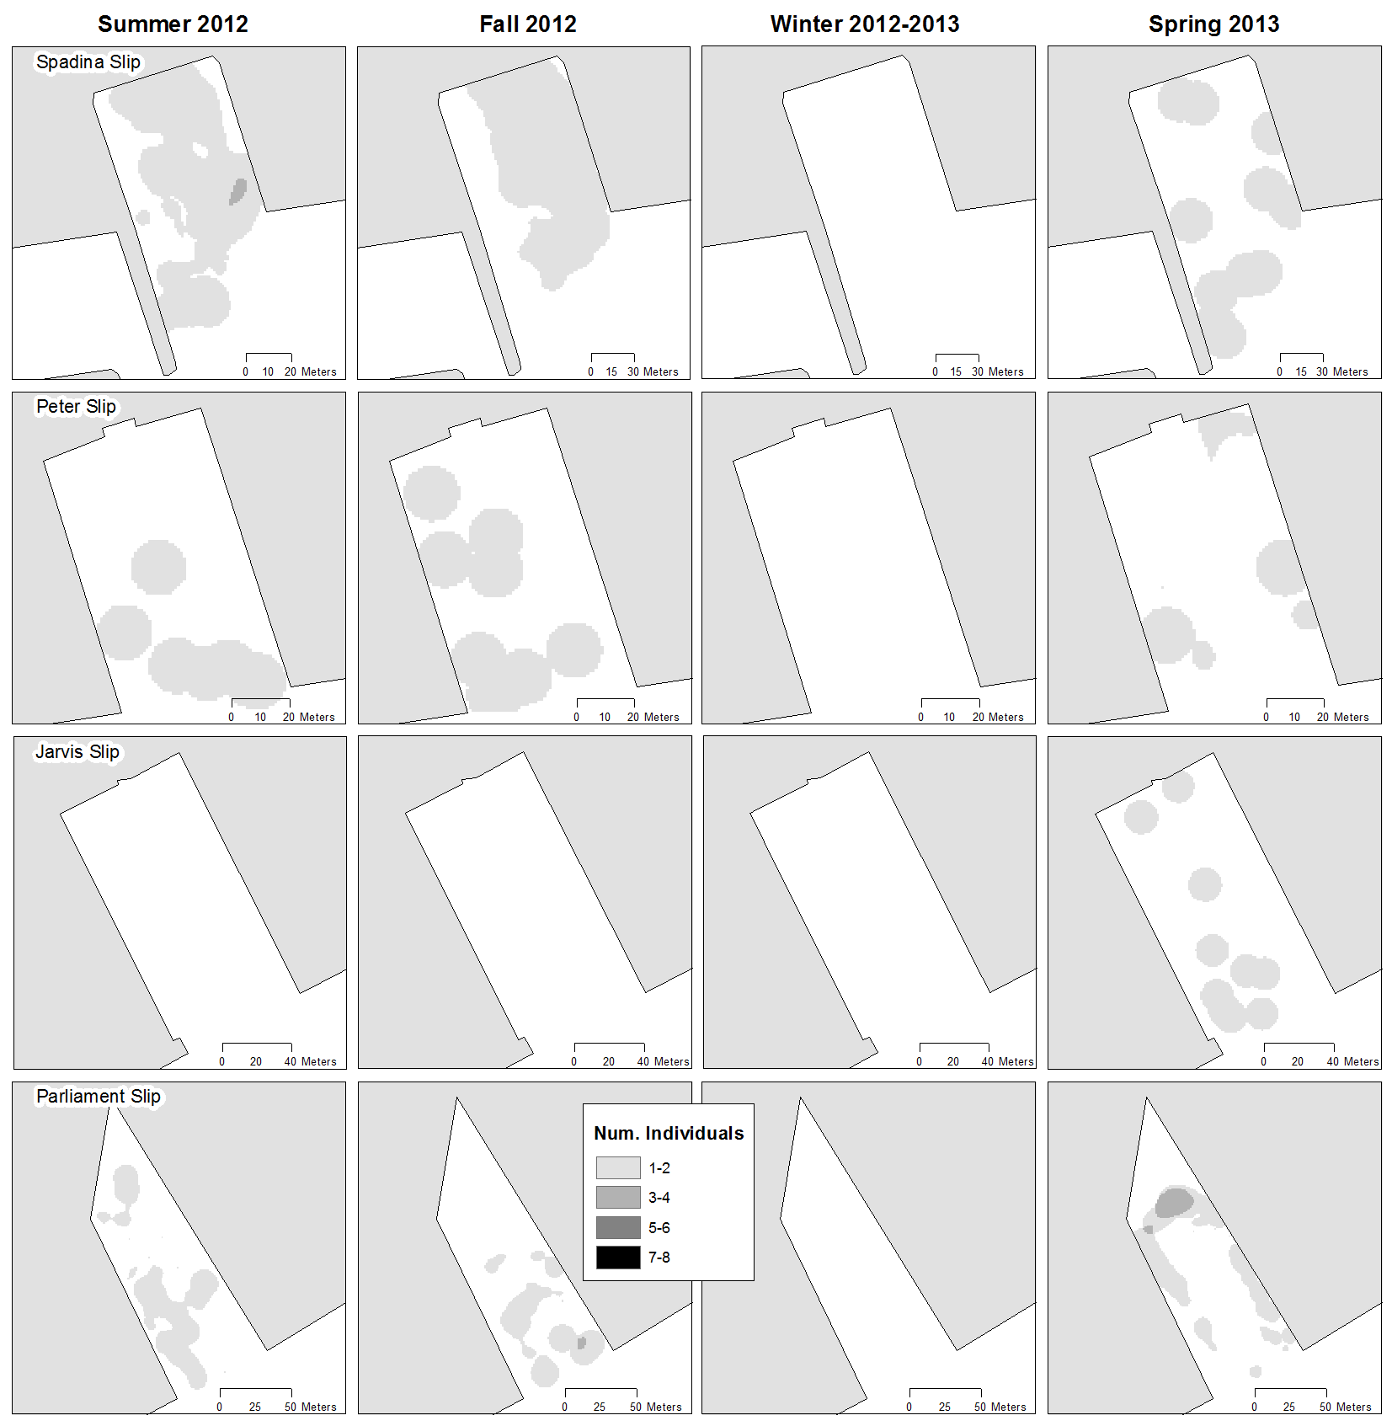
Figure S1. Aggregated 95% percent volume contours for Common Carp in each slip by season. Darker areas represent areas frequented by numerous individuals during a season.

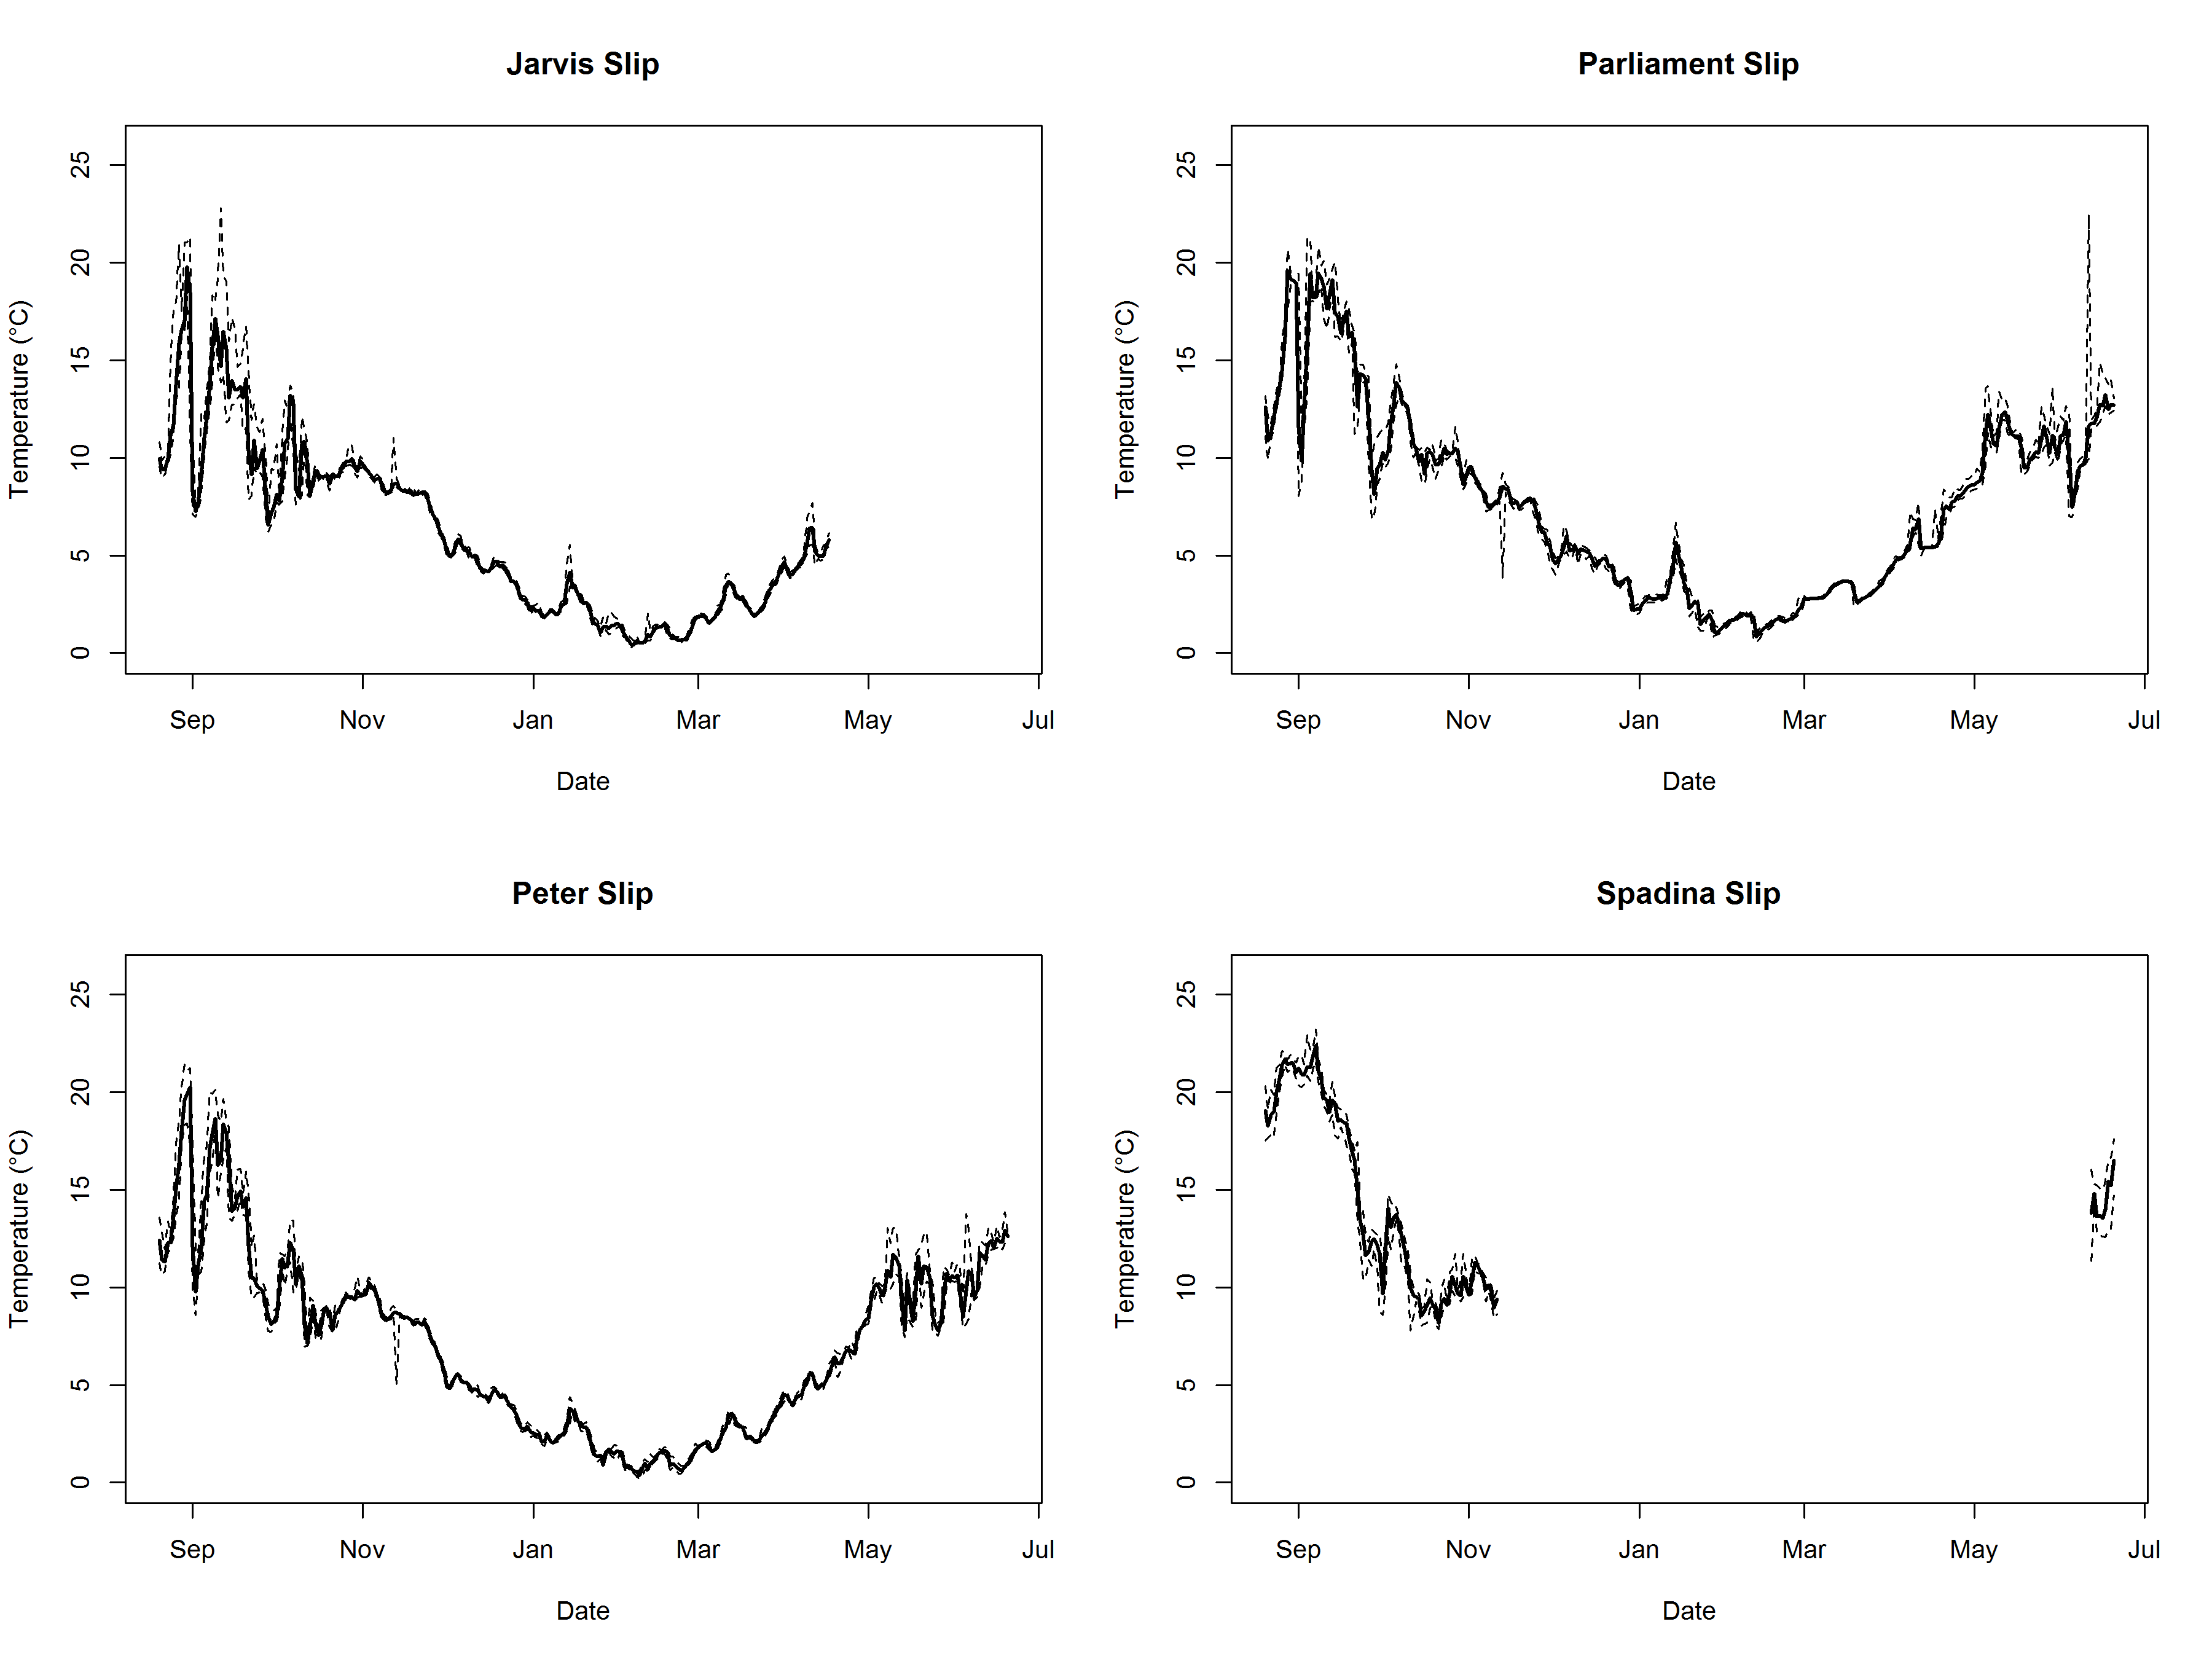
Figure S2. Daily mean temperature (solid line) with observed daily min and max (dashed lines) within each slip as measured by Hobo temperature data loggers (Onset Computer Corporation, Bourner, MA). The time series spans the duration of the study starting on 20 August 2012 until 20 June 2013. Data were lost for winter and spring in Spadina Slip when the temperature logger failed. Darker areas represent areas frequented by numerous individuals during a season.

