Electronic Supplements

High, low, or familiar? Nest site preferences of experienced laying hens

E. Tobias Krause^{1,*}, Lars Schrader¹

¹ Institute of Animal Welfare and Animal Husbandry, Friedrich-Loeffler-Institut, Doernbergstrasse 25/27, 29223 Celle, Germany

Egg weights of the laying hens of the four different strains

The mean egg massed differed between the four strains and was also affected from body mass with heavier hens laying heavier eggs (GLM, strain F_{3,53}=12.63, p<0.0001, body mass F_{1,53}=16.89, p<0.0001). WLA hens laid eggs with an average weight of 61.49g ± 0.91 S.E., BLA hens 61.43g ± 0.91, R11 hens 57.41g ± 1.27 and L68 hens 53.96g ± 1.18. LSD post-hoc test revealed that egg masses of WLA hens differed from L68 and R11 (both p<0.008) but not from BLA (p=0.96). BLA egg masses differed also from L68 and R11 (both p<0.014). R11 and L68 egg masses did not differ from each other (p=0.082).

Fig S1: Sketch of the home compartments hens are usually housed in prior to and after experimental periods. The elevated part (0.7m high) on the left side covered by a grid and including three perches (solid dark lines). On the right hand, a litter floor area is available (white area). A group nest is provided at the edge of the elevated part (grey area).

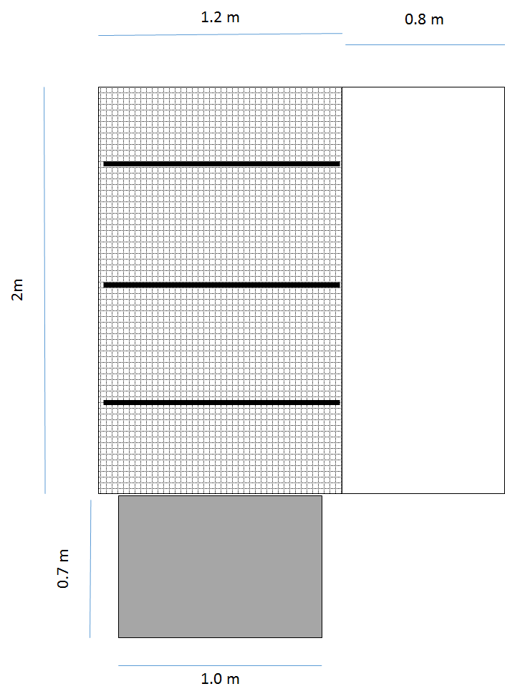

Fig. S2: The experimental setup used for testing the preferences in experiment 2. a) The experimental compartment with an elevated part (0.7m) on the left side covered by a grid and including three perches On the elevated part one row nest was provided, at the same location where usually the familiar nest in the home compartments was offered. On the right hand, a litter floor area is available where also a row of experimental nests was provided. b) The experimental nests in the litter floor part were provided at only ground level, the other height were locked.

