Supporting information
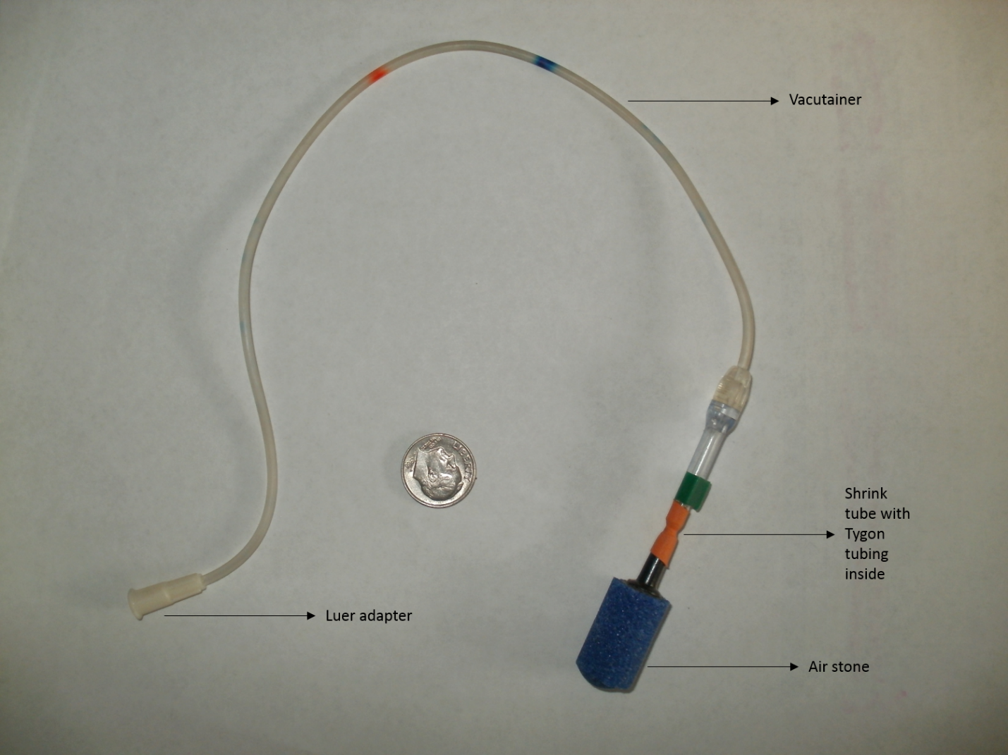
Fig. S1 Photograph of gradient sampling well.

Fig. S2 Carbon dioxide efflux rate (mg m⁻² hr⁻¹ of CO₂) shown by crop, season, year, and location at a) Hayden, b) Jefferson, and c) Pilchuck. Data presented are LS Means from 4-way RM analysis. Bars represent standard error (n=10, poplar; n=5, agriculture). Statistically significant differences (p ≤ 0.05) between crops at specific season and year are indicated with (*) above the bars. Season codes: Su=summer, F=fall, W=winter, and Sp=spring.

Fig. S3 Carbon dioxide efflux rate (mg m⁻² hr⁻¹ of CO₂) shown by crop and year, averaged among locations and seasons. Data presented are LS Means from 4-way RM analysis. Bars represent standard error (n=50-120 for poplar, n=25-60 for agriculture). Statistically significant differences (p ≤ 0.05) are indicated with different letters above the mean bars, bars with same letters are not statistically different. The 2012 data includes summer and fall, while the 2016 data includes, winter, spring, and summer.

Fig. S4 Annual CO₂ efflux rate (Mg ha⁻¹ yr⁻¹ of CO₂) shown by crop, year, and location. Bars represent standard error. Data presented are LS Means from 3-way annual RM analysis. Dotted lines separate years. Bars with same letters are not statistically different (p ≤ 0.05). Year 1 is the annual flux from summer 2013 to spring 2014, year 2 is annual flux for summer 2014 to spring 2015, and year 3 is annual flux for summer 2015 to spring 2016. Year 1 Hayden agriculture annual flux rate was unable to be calculated due to missing temperature data. Poplar n=10 and agriculture n=5.

Effect | CO₂ flux  (kg ha⁻¹ yr⁻¹ CO₂ eq⁴) | CH₄ flux  (kg ha⁻¹ yr⁻¹ CO₂ eq) | N₂O flux  (kg ha⁻¹ yr⁻¹ CO₂ eq)
Crop¹
Agriculture | 59474 (2201)a | -59 (6)b | 80 (141)a
Poplar | 41205 (1557)b | -26 (5)a | 172 (115)a
Location²
Hayden | 47527 (2335)z | -25 (8)y | n.d.³
Jefferson | 40183 (2335)z | -40 (6)yz | 185 (115)y
Pilchuck | 63306 (2335)y | -62 (6)z | 66 (141)y
¹CO₂ and CH₄ flux differed by crop (CO₂ p<0.01, CH₄ p=0.01). N₂O flux did not differ by crop. Values followed by the same letter are not significantly different (alpha=0.05). Poplar n=10 and agriculture n=5 for CO₂, poplar n=7 and agriculture =5 for CH₄ and poplar n=4 and agriculture n=3 for N₂O.
²CO₂ and CH₄ flux differed by location (CO₂ p<0.01, CH₄ p=0.05). N₂O flux did not differ by location.
³Hayden N₂O fluxes were not calculated due to missing data.
⁴CO₂-eq is the CO₂ equivalent based on 100-year time frame using a global warming potential (GWP) of 28 for CH₄ and 298 for N₂O (Myhre et al., 2013).
Table S1 Comparison of annual GHG flux rates expressed as CO₂ equivalents (eq) calculated from fall 2014 through summer 2015 shown by crop and location. Data presented from 2-way annual analysis and presented as LS means. Parentheses designate standard errors. Negative flux indicates uptake by soil.

Fig. S5 Carbon dioxide efflux rate (mg m⁻² hr⁻¹ of CO₂) at Pilchuck in the three seasons following herbicide treatment, a) spring 2013, b) summer 2013, and c) fall 2013. Bars represent standard error. Statistically significant differences (p ≤ 0.05) are indicated with different letters above the mean bars. During plantation establishment, poplar planting rows were sprayed with herbicide, leaving an untreated alley between planting rows.

Fig. S6 Carbon dioxide efflux rate (mg m⁻² hr⁻¹ of CO₂) shown by crop, location, and season. Data presented are LS Means from 4-way RM analysis. Bars represent standard error (n=40 for poplar; n=20 for agriculture). Dotted lines separate seasons. Bars with same letters, within season, are not statistically different (p ≤ 0.05). Location codes: HA=Hayden, JF=Jefferson, and PL=Pilchuck. Crop codes: Ag=agriculture and Pop=poplar.

Fig. S7 Van’t Hoff equation plots from Pilchuck demonstrating R_{s}’s dependence on soil temperature. Data from 2014.

