**Supplementary Materials**

**for**

**A lab-scale spinning basket membrane module for the assessment of Humic acids ultrafiltration with effect of sonication on membrane fouling**

Suman Saha and Chandan Das

**Table caption**

|  |  |
| --- | --- |
| Table No. | Table title |
| Table S1 | Linearized forms and significances of different blocking mechanisms |

**Figure captions**

|  |  |
| --- | --- |
| Fig. No. | Figure Title |
| Fig.S1 | Pictorial view of spinning basket membrane module (SBMM) |
| Fig.S2 | Variation of permeate flux with respect to time at different operating pressures condition with different rotational speeds at (a)10.47, (b)20.99, (c)52.36 and (d)73.30 rad s-1. |

Table S1 Linearized forms and significances of different blocking mechanisms [27]

|  |  |  |  |
| --- | --- | --- | --- |
| Different blocking mechanism | Linearized form (Briao et al., 2012) | Physical significance | Model Constants (*k*) (Briao et al., 2012) |
| CPBM |  | Fouling occur at the membrane pore entrance |  |
| SPBM |  | Retentate particles deposition over the pore walls | , (m-1/2s-1/2) |
| IPBM |  | Pore clogging with particle deposition on membrane surface | , (m-1) |
| CFM |  | Membrane surface deposition of the retentate particles and gel layer creation | , (m-2s-2) |

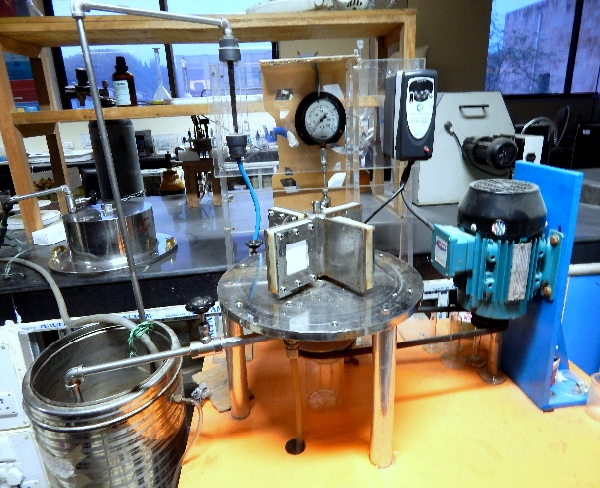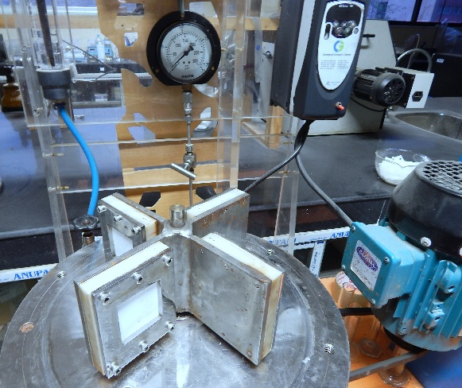

Fig. S1.Pictorial view of spinning basket membrane module (SBMM)

|  |  |
| --- | --- |
|  |  |
|  |  |

Fig. S2.Variation of permeate flux with respect to time at different operating pressures condition with different rotational speeds at (a)10.47, (b)20.99, (c)52.36 and (d)73.30 rad s-1.