Supplemental Information for

Thermal/optical reflectance equivalent organic and elemental carbon determined from federal reference and equivalent method fine particulate matter samples using Fourier transform infrared spectrometry

Andrew T. Weakley¹, Satoshi Takahama,² Ann M. Dillner¹*
¹Air Quality Research Center, Crocker Nuclear Laboratory, University of California Davis, Davis, CA 95616
² ENAC/IIE Swiss Federal Institute of Technology Lausanne (EPFL), Lausanne, Switzerland

Table S1: Breakdown of the FRM filters available for validation against CSN TOR data by site. Comparing the total available FRM to CSN samples we can estimate the total number of possible filters available for analysis a priori. For example, if only 83 Elizabeth FRM filters are available this determines that, at most, only 83 samples can be matched by date to CSN samples. The total number of available CSN samples also set a maximum number of potential matches in the same way. Sites with a collocated FRM or CSN sampler are distinguished from typical sites by assigning a sampler number of (2). The existence of a sampler in the FRM and not the CSN (and vice versa) further places limits on the number of samples available for site-date matching. Overall, it’s possible to determine that only 847 of the available 2401 FRM samples may be matched to CSN samples by site and date. Table S2 (below) provides the results of matching. Finally, sites in non-compliance with NAAQS for 2013 included Fresno, CA, Providence, RI, and Salt Lake City, UT. These three sites have daily sample collection. Therefore, at least two-thirds of these samples cannot match CSN samples, which were collected every third day during 2013.
Site | AQS site identification | Total FRM Available (includes blanks) | Total CSN Available | All possible FRM filter matches | FRM filters with no possible matches
Seattle, WA (1) | 53-033-0080 | 127 | 96 | 96 | 31
Seattle, WA (2) | 53-033-0080 | 73 | 0 | 0 | 73
Birmingham, AL (1) | 01-073-0023 | 156 | 0 | 0 | 156
Birmingham, AL (2) | 01-073-0023 | 59 | 0 | 0 | 59
Elizabeth, NJ | 34-039-0004 | 83 | 91 | 83 | 0
Fresno, CA | 06-019-0011 | 412 | 105 | 105 | 307
Great Craig, OH | 39-035-0060 | 131 | 26 | 26 | 105
Phoenix, AZ | 04-013-9997 | 133 | 114 | 114 | 19
Providence, RI | 44-007-1010 | 372 | 99 | 99 | 273
Boston, MA (1) | 25-025-0042 | 117 | 106 | 106 | 11
Boston, MA (2) | 25-025-0042 | 0 | 61 | 0 | 61
Salt Lake City, UT | 49-035-3006 | 365 | 98 | 98 | 267
Washington, DC (1) | 11-001-0043 | 239 | 120 | 120 | 119
Washington, DC (2) | 11-001-0043 | 134 | 0 | 0 | 134
Total | - | 2401 | 916 | 847 | 1554
Table S2: Description of FRM filters matched to CSN filters given a total of 847 potential matches (see Table S1). Of the 847 potential matches 701 were matched to CSN TOR data and 146 were not matched by site and date. Samples unmatched (presumably) at random (UMAR =64) are distinguished from those samples unmatched not at random (UMNAR= 81). UMAR describes a situation where an FRM sample was not matched to a CSN sample for presumably random reasons, e.g., aerosol collection did not fall on the same date. UMNAR describes a situation where samples were not matched given logged issues related to samples not received by AQRC (N=17; NJ) or filters were not amenable to FT-IR analysis (N=64; UT).
Site | Total possible non-blanks | Total matched non-blanks | Total Unmatched | Unmatched at random (UMAR) | Unmatched not at random (UMNAR)
Seattle, WA (1) | 96 | 87 | 9 | 9 | 0
Seattle, WA (2) | 0 | - | - | - | -
Birmingham, AL (1) | 0 | - | - | - | -
Birmingham, AL (2) | 0 | - | - | - | -
Elizabeth, NJ | 83 | 65 | 18 | 1 | 17
Fresno, CA | 105 | 92 | 13 | 13 | 0
Great Craig, OH | 26 | 23 | 3 | 3 | 0
Phoenix, AZ | 114 | 108 | 6 | 6 | 0
Providence, RI | 99 | 93 | 6 | 6 | 0
Boston, MA (1) | 106 | 99 | 7 | 7 | 0
Boston, MA (2) | 0 | - | - | - | -
Salt Lake City, UT | 98 | 28 | 70 | 6 | 64
Washington, DC | 120 | 106 | 14 | 14 | 0
Washington, DC | 0 | - | - | - | -
Total | 847 | 701 | 146 | 65 | 81

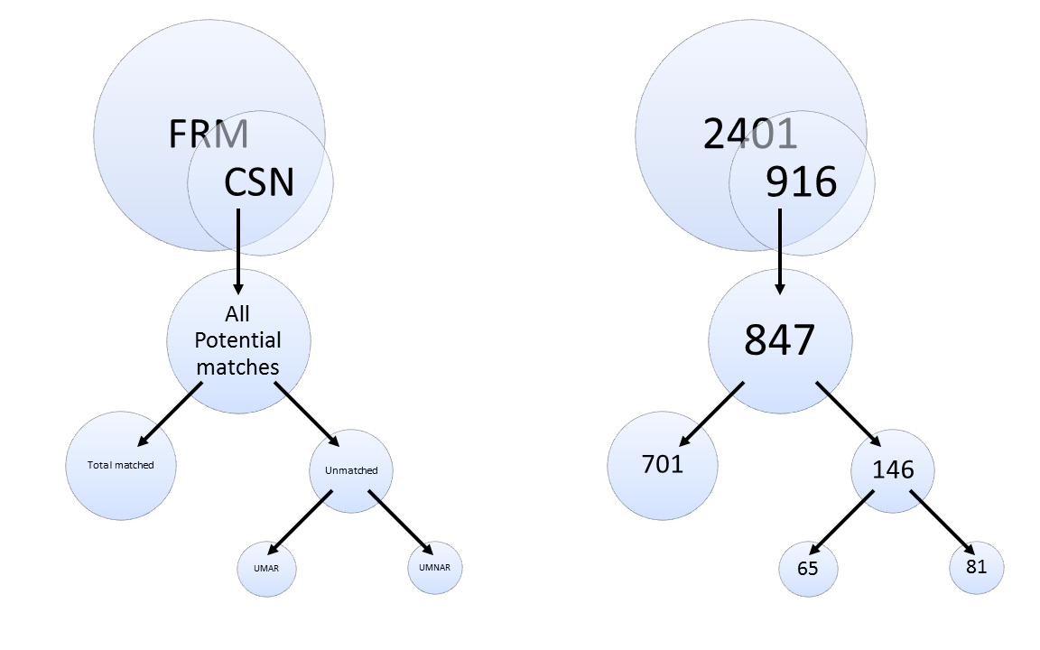
Figure S1: Companion figure to Table S1 and S2.

