Supplement
Table S1: Components and development factors of urban transformative capacity (cf. Wolfram, 2016b)
Capacity component / development factors
C1 Inclusive and multiform urban governance
C1.1 Participation and inclusiveness
- Citizens and civil society organizations, as well as private businesses and their representations, participate directly in the deliberation of actions with state actors (government, administration).
- Formerly excluded stakeholders are involved actively and supported to enable their contribution.
C1.2 Diverse governance modes and network forms
- There is diversity of formal and informal actor networks and governance modes.
- There is diversity of centralized and decentralized actor networks and governance modes (top-down/bottom-up; hierarchy/market/negotiation).
- Governance helps to build social capital (trusted actor relations).
- Governance helps to build political capital (mobilization and support).
- Overall actor network density (number of ties between actors involved) and cohesion (alignment of their interests) are balanced and not extreme (very high/low).
C1.3 Sustained intermediaries and hybridization
- There are intermediaries positioned between societal stakeholders that bridge relevant gaps amid sectors (public, private and civil society), action domains (e.g. energy/transport/land use), and/or spatial scales.
- Intermediaries have a stable financial and organizational basis.
- There are key individuals acting as boundary spanners or knowledge brokers between sectors, action domains and scales.
- Intermediaries effectively align different actor interests and help to create a shared discourse.
C2 Transformative leadership (in the public, private and civil society sectors)
- There is place-based and/or issue-driven leadership in various sectors, oriented at systemic change for sustainability.
- Leadership embraces joint problem-solving, shared decision-making and open processes.
- Leadership articulates visions, emphasizes values and inspires enthusiasm.
- Leadership feeds local issues into regional/national/global arenas and processes.
- Leadership translates global/national/regional issues into local arenas and processes.
- There is political leadership and commitment to systemic change for sustainability.
C3 Empowered and autonomous communities of practice (place-based and/or issue-driven)
C3.1 Addressing social needs and motives
- Communities of practice (CoP) genuinely articulate social needs.
- Social needs are analyzed and deficits in meeting them are identified.
- Deficits in meeting social needs inform action priorities in public policy.
C3.2 Community empowerment and autonomy
- Conditions of citizen powerlessness and disempowerment are identified.
- Stakeholder association and formation of CoP’s is actively supported.
- CoP’s have access to resources they require to meet social needs (information, time, space, skills, tools, social networks, social organization, financing).
- Actions are taken to enhance feelings of self-efficacy and self-determination of CoP.
- The level of CoP autonomy is effectively being raised.
C4 System(s) awareness and memory
C4.1 Baseline analysis and system(s) awareness
- New knowledge of systemic relations between ways of thinking (cultures), organizing (structures) and doing (practices) is actively developed to understand deficits in meeting social needs.
- Governance structures, institutions and stakeholder conflicts are subject to dedicated analysis.
- Analysis aims to move from status description towards a systemic explanation, and ultimately anticipation, of (non-) change dynamics (barriers/drivers).
- All knowledge about urban systems is open source and widely shared, helping to create collective self-awareness and memory.
- Strategic knowledge management is carried out to enable transfers between different forms of knowledge (implicit/explicit; simple/complex; systemic/sectoral) and temporalities of knowledge (past, present, future).
C4.2 Recognition of path dependencies
- Stakeholders explicitly recognize different degrees of obduracy/changeability within current systems (e.g. concerning institutions, regulations, infrastructures, built environs, routines, values).

C5 Urban sustainability foresight
C5.1 Diversity and transdisciplinary co-production of knowledge
- Knowledge about future un-/desirable urban developments is co-produced by actively involving diverse stakeholders from across sectors, action domains and scales - experts and laymen.
- Science stakeholders are directly involved in knowledge co-production, including both technical and non-technical disciplines.
C5.2 Collective vision for radical sustainability changes
- Long-term change is conceived of as a ‘radical’ departure from the current state and development path of multiple urban SES and STS.
- There is an explicit future vision, widely shared among stakeholders, reflecting the social needs identified and the existing diversity of values.
- The vision has a strong motivating effect on stakeholders to contribute to its achievement.
- The vision provides orientation for a wide range of urban strategies, programs and projects, allowing for flexibility and leaving options open.
C5.3 Alternative scenarios and future pathways
- Scenarios of future urban development are created that reflect co-evolutionary processes (mutual shaping of social, ecological, economic and technological dimensions).
- Different scenarios illustrate alternative future pathways resulting from stakeholder choices and uncertainties.
- Scenarios clarify options for action, their preconditions and implications for the relevant stakeholders, specifying objectives and critical milestones (thresholds).
C6 Diverse community-based experimentation with disruptive solutions
- Diverse experimentation is undertaken by place-based and/or issue-driven communities of practice.
- Experiments are guided by a shared vision, and by preferred scenarios/pathways (if available).
- Experiments deal with disruptive urban sustainability solutions, seeking to rebalance economic, social and ecological development.
- Experiments are multi-dimensional, simultaneously addressing innovations in urban environments, cultures, institutions, governance, markets and technology.
C7 Innovation embedding and coupling
C7.1 Access to resources for capacity development
Stakeholders share and/or enable access to basic resources for transformative capacity development (C1-6) incl. human-, knowledge-, time-, financial-, technical- and organizational resources.
C7.2 Planning and mainstreaming transformative action
- Options for innovation arising from foresight and/or experiments are integrated with possible actor coalitions to form 'systemic alternatives' (combinations of actors, institutions, resources, etc.).
- Practical approaches for coalition building and decision making procedures that enable innovation embedding are developed systematically.
- Stakeholder organizations, plans and/or programs are adjusted to remove innovation barriers and support transformative actions.
- Priority transformative actions are further specified through concrete work plans (management, resources, timing).
C7.3 Reflexive and supportive regulatory frameworks
- Pertinent regulations are aligned with the vision and adjusted to remove innovation barriers and support transformative actions.
- Pertinent regulations leave room for alternative solutions and context-specific interpretation and implementation.
- Pertinent regulations enable to use wider resource streams for transformative action (financial, human, technical, organizational).
C8 Reflexivity and social learning
- Reflexive monitoring is carried out on all dimensions of urban transformative capacity development (C1-7).
- Participants in experiments have methodical and practical skills for enabling reflexivity (monitoring, assessment, evaluation).
- Wider stakeholder and leadership reflexivity is enabled through diverse formal and informal interaction formats, providing room for critically questioning progress towards the vision.
- Practical know-how for initiating and performing radical change for sustainability (i.e. transformational knowledge) is managed systematically.
C9 Working across human agency levels
- Capacity development (C1-8) involves multiple levels of agency in the public, private and civil society sectors, including I) individuals, H) households, G) social groups, O) organizations, N) networks (of individuals, groups, etc.) and S) society.
C10 Working across political-administrative levels and geographical scales
- Capacity development (C1-8) reflects interactions between relevant political-administrative levels and geographical scales in terms of the topics addressed and stakeholders involved, including A) inner-urban areas (site, block, neighborhood, borough, district) (U), urban territories (city and its metropolitan area) (R), regional territories (e.g. counties, provinces), N) national territories, G) inter- and transnational spaces.

Table S2: Case study city selection and balancing criteria for a ‘most different cases’ design
Criteria | Changwon | Gwangju | Seoul
Size (inh.) 2015 | 1.047.488 | 1.466.143 | 9.631.482
Political orientation (party of mayor in the last two/three consecutive legislation periods) | progressive/ conservative | progressive / progressive | conservative/ progressive
Political-administrative function (according to Korean law) | Specific city authority, 5 districts (created 2010) | Metropolitan city authority, 5 districts | Special city authority, 25 districts
Highest government function (according to Korean law) | Provincial capital | Autonomous city | National capital
Ex-ante assessment* of sustainability orientations in local policy (public website / urban master plan) | average / weak | strong / average | average / average
Identified as energy transition ‘good practice case’ (Delphi survey, n=43) | 11/43 | 13/43 | 21/43
*4-level scale: absent, weak, average, strong

Table S3: List of stakeholders selected for personal interviews and individual transformative capacity assessment
No. | Affiliation | Stakeholder group
 | Changwon
C1 | Changwon government, Department of Urban Planning | Local government
C2 | Changwon government, Urban regeneration division | Local government
C3 | Changwon government, Economic development division | Local government
C4 | Nurim maeul community | Civil society
C5 | Yongho-dong village community | Civil society
C6 | Kyeongnam solar energy coop | Business (social enterprise)
C7 | EM KOREA CO. ltd. | Business (industry)
C8 | Haeahn architecture | Business
C9 | Changwon urban regeneration center | Intermediary (public)
C10 | Kyeongnam information society | NGO (local)
C11 | Bonggok Institute For Lifelong Education | NGO (local), intermediary
C12 | Gihl Lab | NGO (local), intermediary
C13 | Kyeongnam University, Division of Architecture | Research
C14 | Changwon University, Architecture Department | Research
C15 | Kyeongnam University, Department of Social Welfare | Research
 | Gwangju
G1 | Gwangju government, urban regeneration department | Local government
G2 | Gwangju government, community building department | Local government
G3 | Gwangju government, energy department | Local government
G4 | Jeollanam do government, Regional Planning Division | Regional government
G5 | Sinsiwa guesthouse | Civil society
G6 | Sihwa Munhwa village studio | Civil society
G7 | Daeinart Market Community | Civil society
G8 | Dong Myong Engineering and Consulting (DMEC) | Business
G9 | Elephant coop | Business (social enterprise)
G10 | Korea Electric Power Corporation (KEPCO) | Business (industry)
G11 | International Climate & Environment Center | NGO (local), intermediary
G12 | Gwangju NGO Center | NGO (local), intermediary
G13 | Green Gwangju 21 | Intermediary (public)
G14 | Gwangju University, urban planning department | Research
G15 | Gwangju development institute, energy & environment dep. | Research
G16 | Gwangju development institute, community building dep. | Research
 | Seoul
S1 | Seoul Metropolitan Govmt. (SMG), urban regeneration div. | Local government
S2 | SMG, climate and environment bureau | Local government
S3 | SMG, citizen energy cooperation divison | Local government
S4 | SMG, community building division | Local government
S5 | Seongdaegol People, Dongjak-gu | Civil society
S6 | Energy self-reliant village community, Songpa-gu | Civil Society
S7 | Solidarity for Urban Areas | NGO (local)
S8 | Transition City Sinchon (Seoul) | NGO (local)
S9 | Korean Federation for Environmental Movements | NGO (national)
S10 | ICLEI Local Governments for Sustainability, Korea | NGO (national)
S11 | Seoul Village Community Support Center | Intermediary (public)
S12 | Seoul Social Enterprise Support Center | Intermediary (public)
S13 | Korea Electric Power Corporation (KEPCO) | Business (industry)
S14 | Toadhousing company | Business
S15 | Root Energy | Business (social enterprise)
S16 | Sungmisan alternative school | Business (social enterprise)
S17 | Yonsei University, Department of Urban Planning | Research
S18 | Seoul Institute, Dept. of Urban Planning and Design Research | Research

Figure S1: Location and scale of the selected case study cities in the South Korean urban context (greyscale indicates urbanization rate in %)
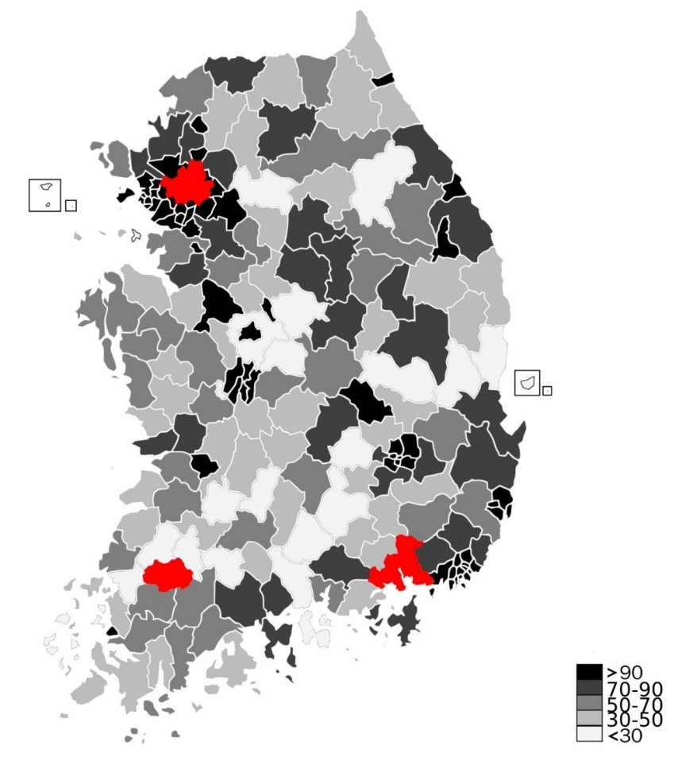
South Korea
Gwangju

Changwon

Seoul

