**Online Appendix.**

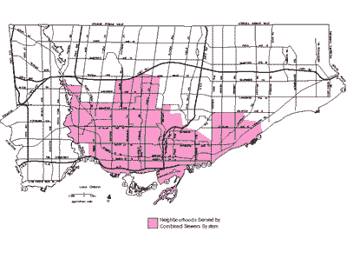

Appendix Figure S1a. Combined sewer service area (pink colour) in City of Toronto.

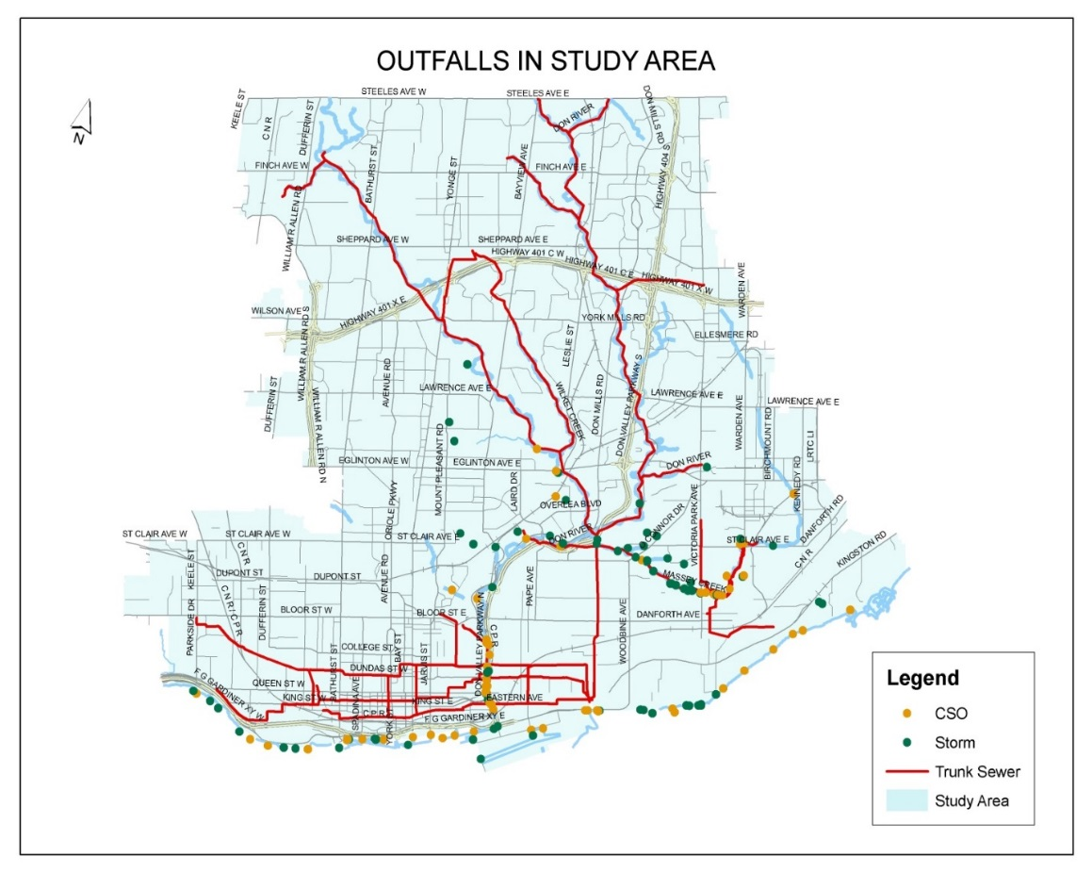

Appendix Figure S1 b. The spine of the sanitary trunk sewer system and combined sewer system and combined sewer overflow locations and stormwater discharge locations.

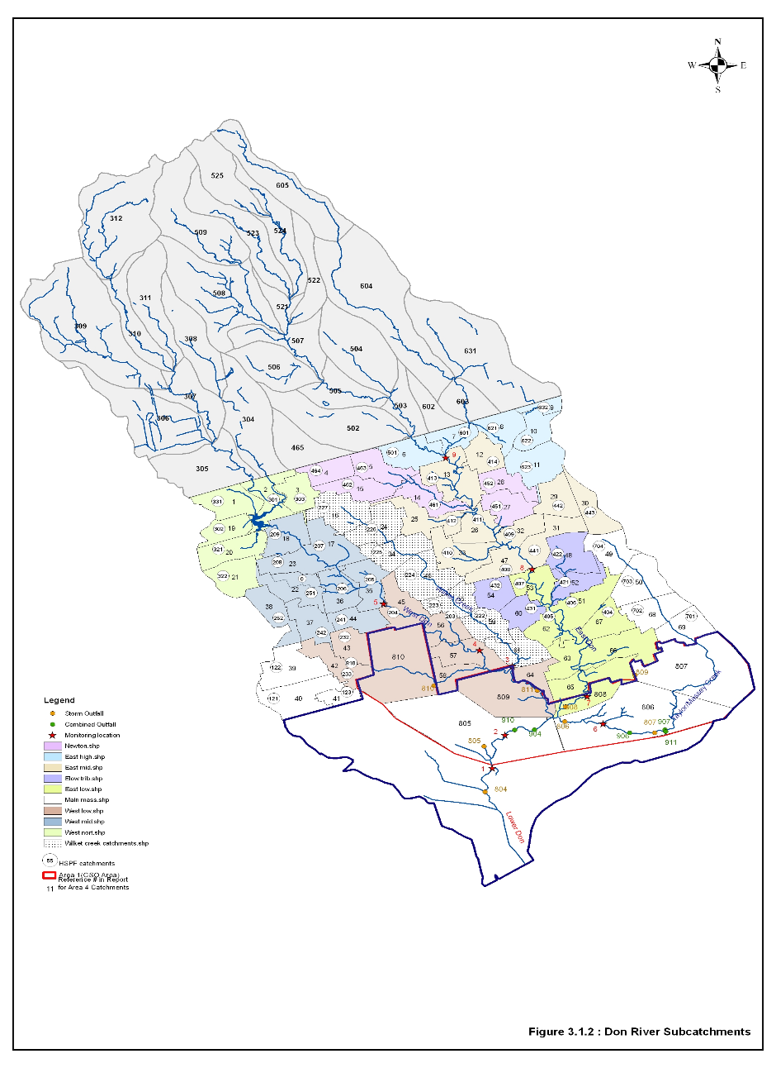

Appendix Figure S2. Catchments used in the HSPF model in the Don R watershed north of the combined sewer service area. (Different colours within City of Toronto on map represent clusters of catchments (polygons) within subwatersheds of West Don R, East Don R, Wilket Creek, and Taylor- Massey Creek)

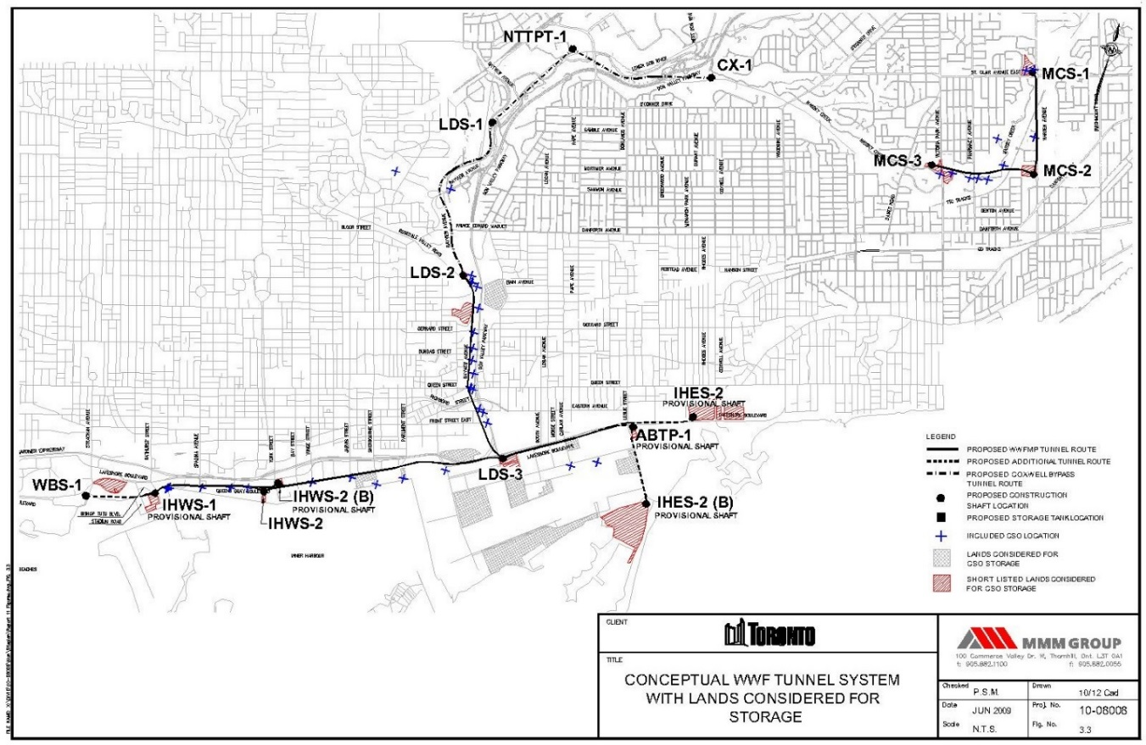

Appendix Figure S3. Concept Plan for intercepting Wet Weather discharges to the Lower Don River, Taylor Massey Creek, and Inner Harbour. The Concept Plan involves a set of linked below ground WWF Storage Tunnels: Taylor Massey Tunnel (MCS-1 to MCS-3) flows to the Coxwell Bypass(CX-1 to NTTPT-1 to LDS-3) which flows to the Inner Harbour East Tunnel (LDC-3 to ABTP-1) which discharges to the Treatment Plant; Inner Harbour West Tunnel (IHWS-1 to LDC-3) also flows to the Inner Harbour East Tunnel.

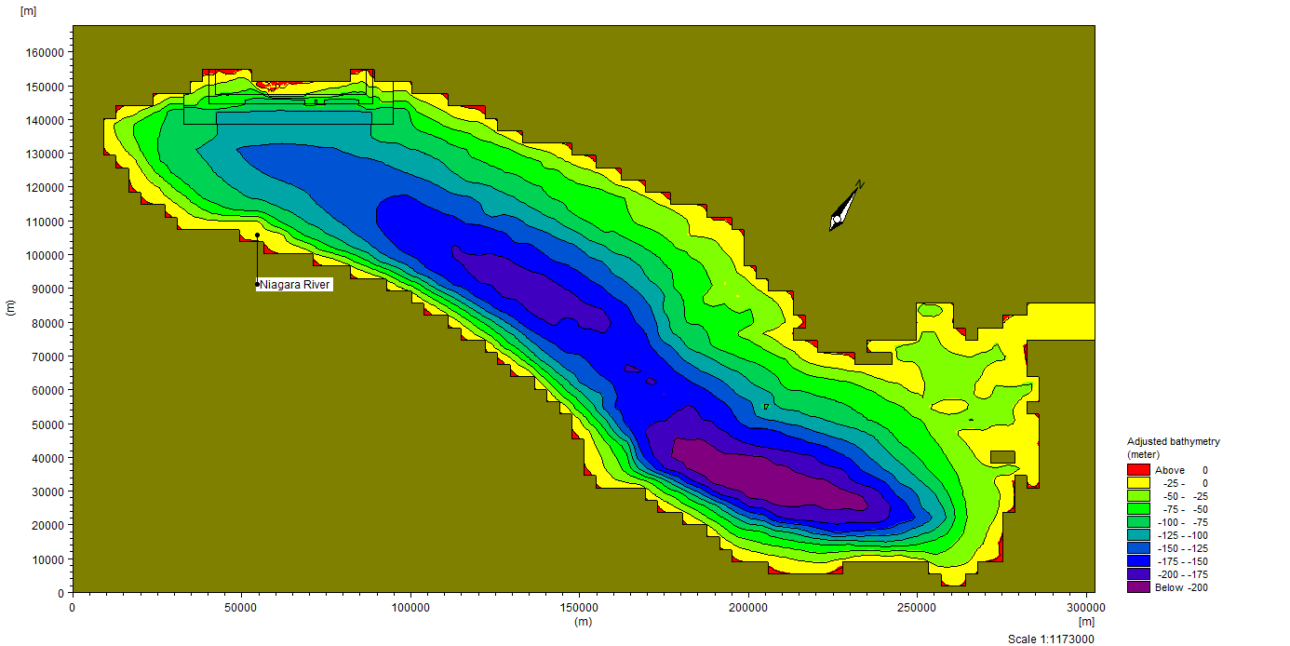

Appendix Figure S4a. Whole Lake Model representation and nested grids focusing in the Toronto Area waterfront

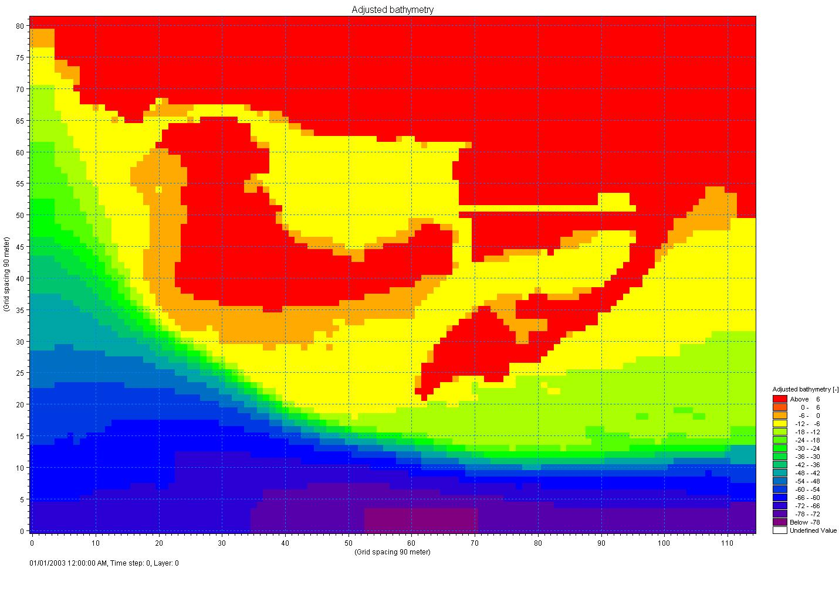

Appendix Figure S4b. 90 m Inner Harbour Grid used for the nearshore area of the Toronto Waterfront.



Appendix Figure S5 Calibration of Watershed Model for *E. coli.* Red lines represent geometric mean (solid line) and upper limit and lower limit (dotted lines) for dry weather discharges in the respective tributaries (from west to east Etobicoke Creek, Mimico Creek, Humber River, Don River, Highland Creek, Rouge River). Green lines represent geometric mean (solid line) and upper limit and lower limit (dotted lines) for wet weather discharges in the respective tributaries to Lake Ontario Coastal Zone. Brown square represents model calibration for dry weather discharges and dark green diamond represents model calibration in wet weather discharges in the respective tributaries.



Appendix Figure S6. Location of Inner Harbour *E coli* sampling stations

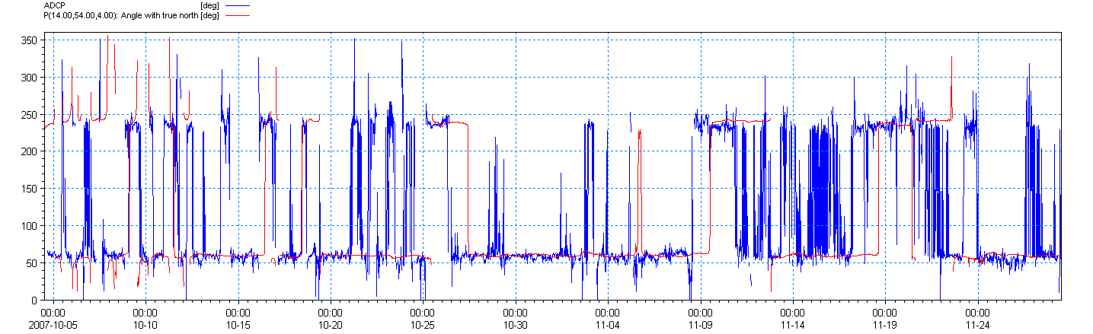

Appendix Figure S7a. Current direction calibration study for Inner Harbour (Western Gap; blue line – observations, red line model simulations)

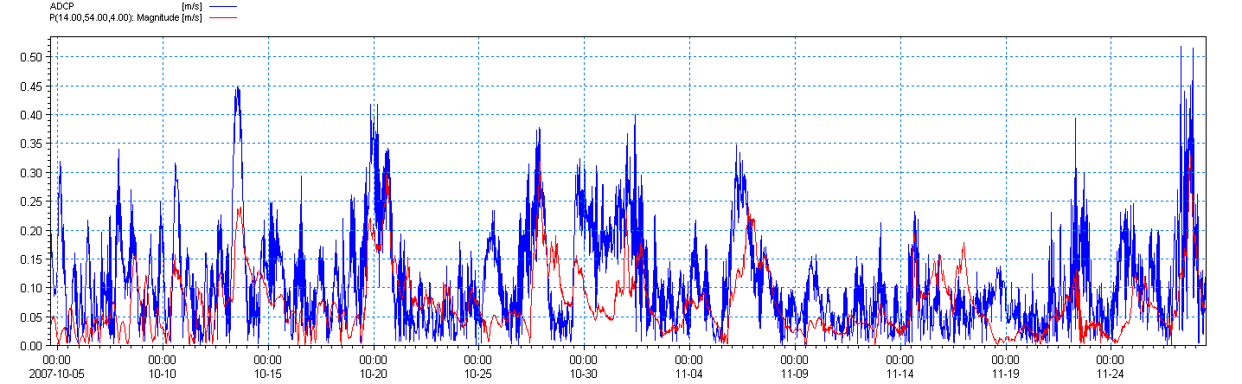

Appendix Figure S7b. Current speed calibration study for Inner Harbour (Western Gap; blue line – observations, red line model simulations)

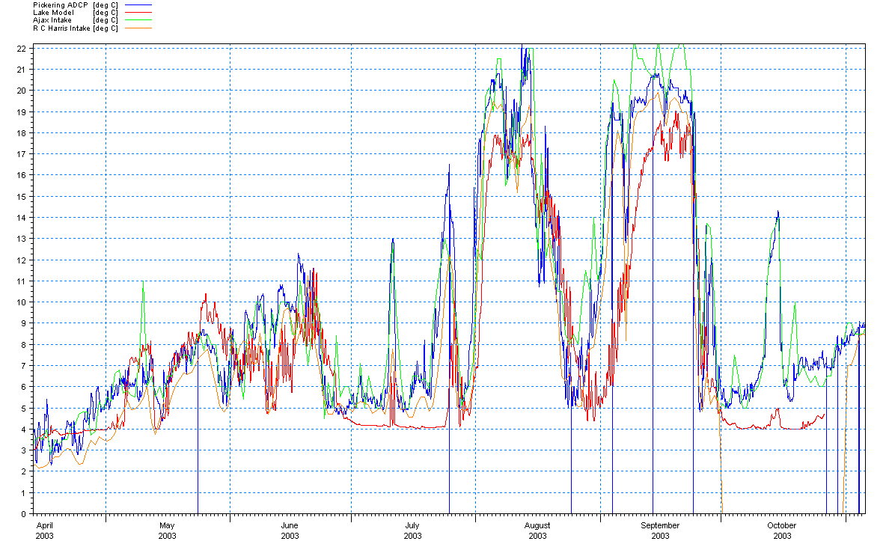

Appendix Figure 8S Calibration study comparing observed and computed temperatures at water treatment plant intakes (Ajax, R C Harris), and at the Pickering ADCP

Appendix Figure S9. Model Calibration Study for 2008 for *E. coli* Index, "portion of swimming season in the Inner Harbour above the recreational swimming water quality objective (100 E coli/ 100 mL)". X – axis is observed data for the Index in 2008; Y – axis is model calculations for the Index for 2008.

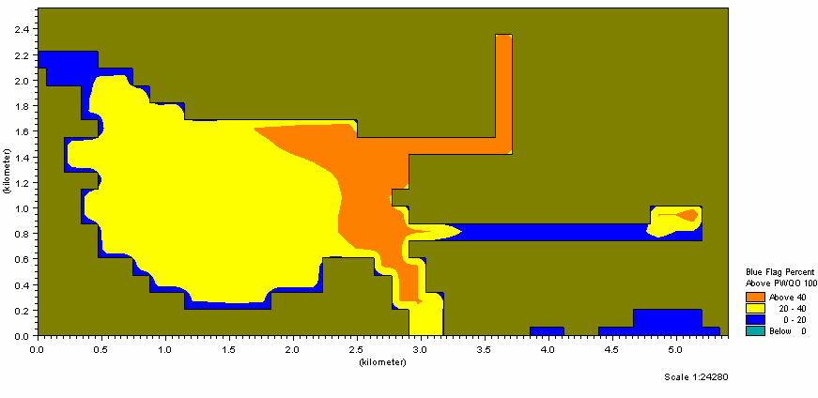

FiF

Appendix Figure S10a. Base Case Conditions in the Inner Harbour for Blue Flag Index.

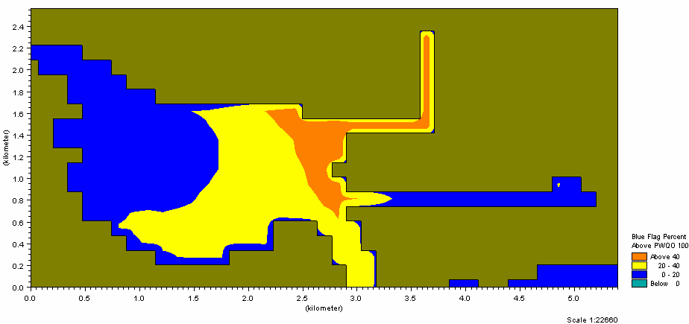

Appendix Figure S10b. Blue Flag Index in Inner Harbour for F5.5 CSO Control Level

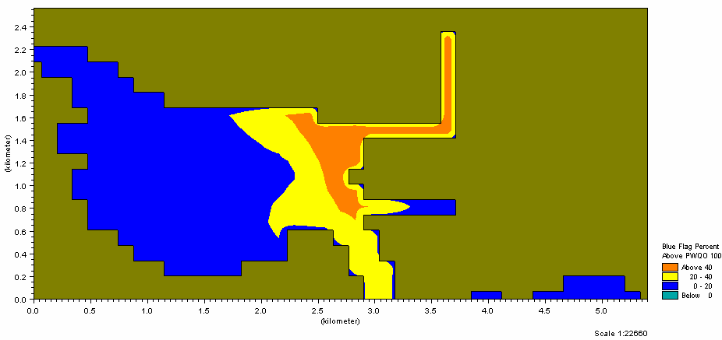

Appendix Figure S10 c. Blue Flag Index in Inner Harbour for ‘one overflow per season’ Control Level



Appendix Figure S11 Inner Harbour Blue Flag Index response to WWF Storage Costs

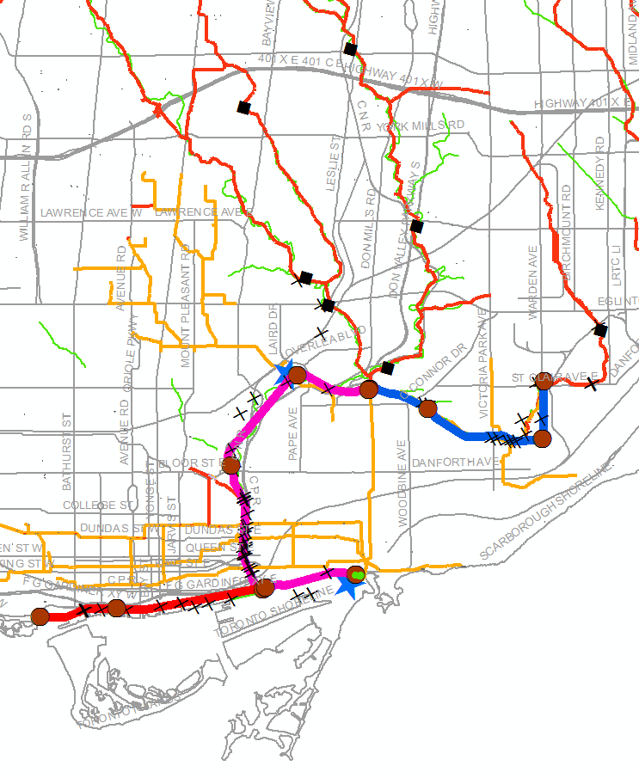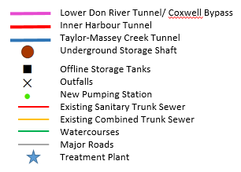

Appendix Figure S12. Location of Tunnel and other (remote) Storage Elements and new Treatment Plant for the DR & CW Project. Note that Solution from EA Study resulted in a system of connected Tunnels to provide the storage capacity, whereas Concept Plan (Figure S3) had some tunnels separated from each other.

**Appendix Tables**

Appendix Table S1 Seasonal Flow Volumes and *E. coli* Densities in major discharges to Inner Harbour calculated by the watershed models

|  |  |  |  |  |
| --- | --- | --- | --- | --- |
| Discharge  Location to Inner Harbour | 2007 | | 2008 | |
| Total Flow(m3 in the season) | *E coli* (#/100 ml) | Total Flow(m3 in the season) | *E coli* (#/100 ml) |
| Don River | 5.35E+07 | 16,000 | 8.93E+07 | 40,000 |
| To Bathurst Slip | 1.29E+06 | 1.4 E06 | 2.25E+06 | 1.4 E06 |
| To Jarvis Slip | 4.55E+04 | 1.6 E06 | 7.06E+04 | 2.2 E06 |
| To Spadina Slip | 6.73E+04 | 4.4 E05 | 9.63E+04 | 2.1 E06 |
| To Sherbourne Slip | 1.20E+05 | 1.8 E06 | 1.90E+05 | 1.4 E06 |
| To Simcoe Slip | 1.43E+05 | 9.5 E05 | 1.85E+05 | 7.2 E05 |
| To Yonge Slip | 6.27E+04 | 7.4 E05 | 1.04E+05 | 7.4 E05 |
| To Rees Slip | 2.65E+03 | 0.2 E05 | 6.14E+03 | 0.3 E05 |
| To Parliament Slip | 5.57E+04 | 1.0 E06 | 2.35E+05 | 4.0 E05 |

Appendix Table S2 – Lake Ontario Model Calibration Parameters

|  |  |  |
| --- | --- | --- |
| Parameter | Value | Comments/Rationale * |
| **Hydrodynamic Model** | | |
| Timestep | 30 to 90 seconds | Range depends on finest resolution and water depth, usually 90m requires 30 to 45 seconds, 270m grid can handle 90 seconds |
| Transport scheme | Quickest-Sharp | Best Fnorm and temperature correlations |
| Turbulence model | Mixed κ-ε Smagorinsky | Best Fnorm and temperature correlations |
| Eddy Viscosity Coefficient-dimensionless | 0.4 default | Golders (2009) found 0.8 decreased vertical mixing. |
| Temperature Dispersion Coefficients- dimensionless | Horizontal 0.1  Vertical 0.001 | Horizontal not found to be sensitive in Lake Ontario  High vertical values limit stratification, no thermocline development |
| Temperature Dispersion Scheme | Eddy velocity relationship |  |
| **Heat Exchange Coefficients** | | |
| Dalton’s Law constant - dimensionless | 0.5 default | Golders (2009) used 1.0 |
| Dalton’s Law wind constant - dimensionless | 0.9 default | Golders (2009) used 0.3 |
| Sun Constant a - dimensionless | .395 default 0.295 | Golders (2009) used default |
| Sun constant b - dimensionless | .691 default 0.371 | Golders (2009) used default |
| Displacement (Day light saving) | -1 hour |  |
| Standard Meridian | -75 degree | For solar heating – coordinates sun rise with model grid |
| Beta in Beer’s Law | Default 0.3/m | Golders (2009) used 0.6 |
| Light Extinction Coefficient | Default 1.0 | Golders (2009) used 1.4 |
| Runge-Kutta | 2nd order | End of Heat Exchange |
| Bed Roughness | Default 0.05m | Golders (2009) used 0.01m to slightly increase speeds. |
| **AD Module** | | |
| Substances | Both conservative and first order decay |  |
| Initial ambient conditions | Zero (mg/L) or #/100mL |  |
| Decay rates | Tritium – half life some 12 years (1/s) |  |
| Dispersion Coefficients | default |  |
| Dispersion scheme | Eddy velocity relationship |  |
| Water Quality Constituents | | |
| E Coli Removal Rate | E.Coli T90 57 hours |  |

*Golders is a separate study which calibrated the model with current meter Lake Ontario data from further east of Toronto

Appendix Table S3. Comparison of Observed E Coli data with Model Forecasts for the index: "portion of the swimming season above the PWQO"

|  |  |  |  |  |
| --- | --- | --- | --- | --- |
| Percent of Time above PWQO value (100#/100mL) | | | | |
|  | Observed | Model | Observed | Model |
|  | 2007 | 2007 | 2008 | 2008 |
| Western Gap and Offshore | | | | |
|  |  |  |  |  |
| IH-1 | 36 | 15.4 | 50 | 42.6 |
| IH-8 | 32 | 19.4 | 46 | 49.4 |
| IH-9 | 32 | 19.8 | 50 | 51.1 |
| IH-11 | 20 | 15.2 | 42 | 46.6 |
| IH-12 | 20 | 12.8 | 42 | 49.4 |
| MOE 1364 | 20 | 18.1 | 44 | 51.7 |
| IH-10 | 36 | 39.3 | 52 | 65.9 |
| IH-6 | 40 | 19.7 | 52 | 45.4 |
| Average | 29.5 |  | 47.3 |  |
| Don Mouth and North Shore | | | | |
| L-10 | 40 | 20.2 | 54 | 52.2 |
| IH-2 | 36 | 18.7 | 58 | 43.4 |
| IH-3 | 40 | 29.6 | 58 | 60.4 |
| IH-4 | 44 | 50.2 | 58 | 72.9 |
| IH-5 | 88 | 100 | 85 | 100. |
| IH-7 | 52 | 54.8 | 65 | 93.4 |
| L-12 | 68 | 76.3 | 81 | 90.7 |
| Average | 52.6 |  | 65.6 |  |
| Eastern Gap | | | | |
| 61E | 20 | 33.5 | 59 | 70.2 |
| IH-13 | 28 | 29.2 | 44 | 71.4 |
| Average | 24 |  | 51.5 |  |
|  |  |  |  |  |
|  |  |  |  |  |
| Global Average | 38.4 | 33.7 | 55.3 | 62.2 |
|  |  |  |  |  |
|  |  |  |  |  |