Supplementary Material
Manganese(III) porphyrins with oxidation properties

NIHARIKA ANAND and SUDHA YADAVA*

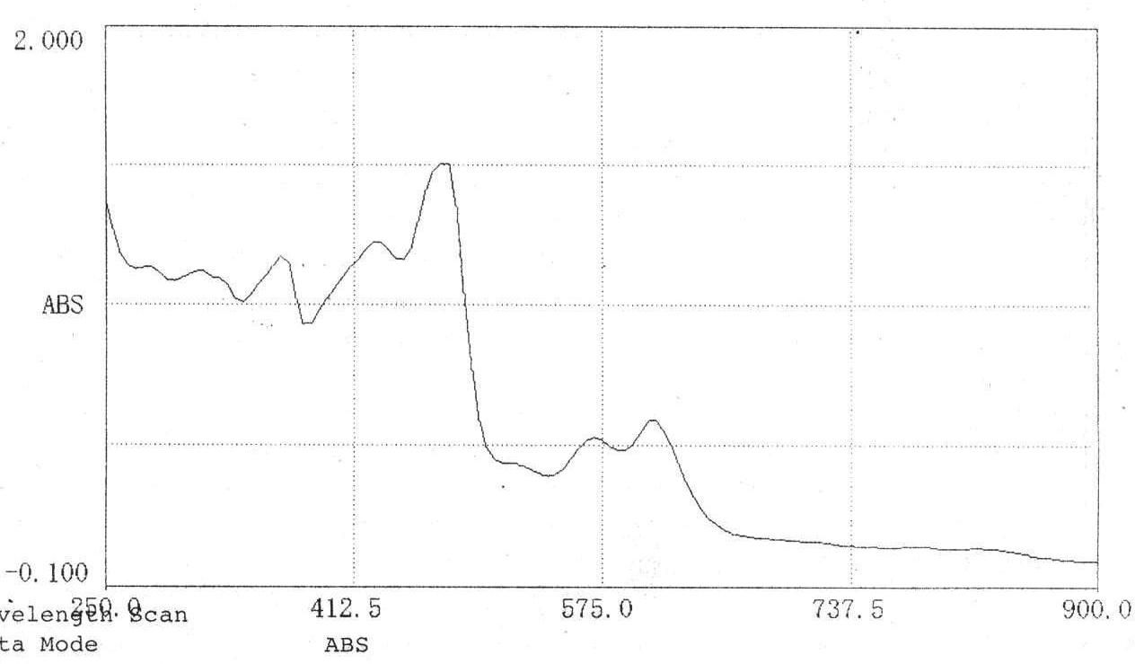
Figure 1. UV-visible spectrum of Mn(THMPP)Cl(4-MeIm).

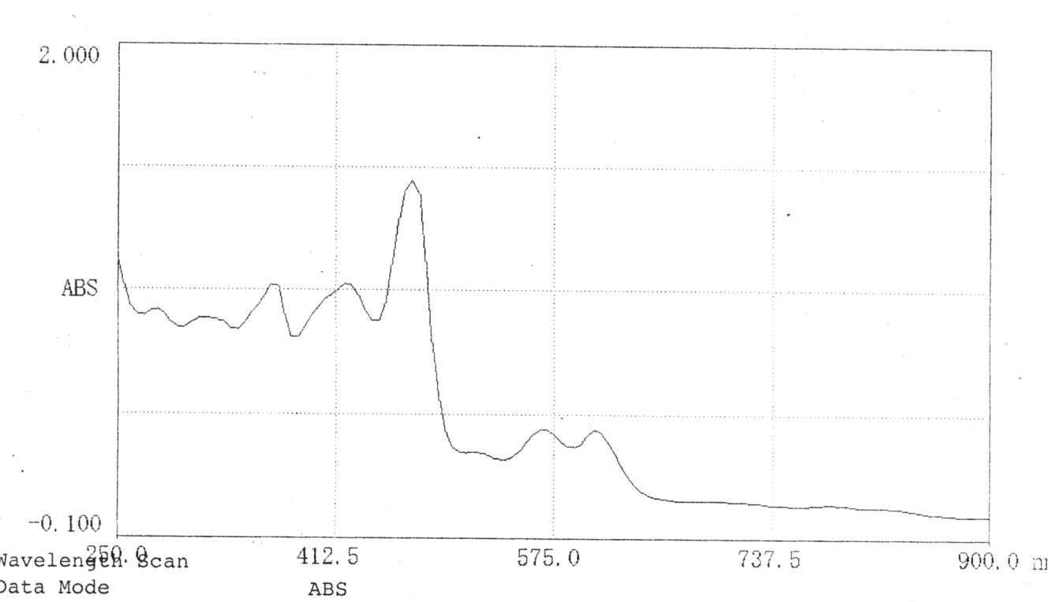
Figure 2. UV-visible spectrum of Mn(THMPP)Br(4-MeIm).

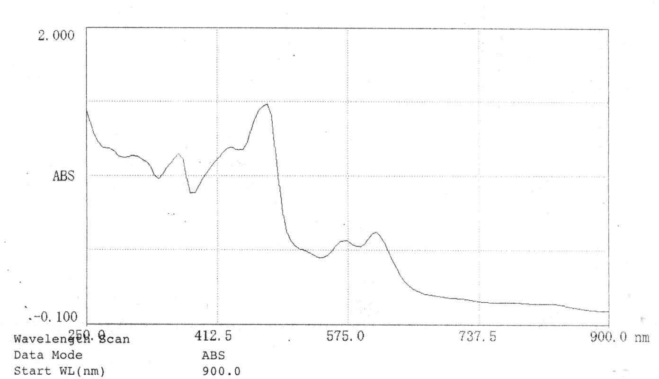
Figure 3. UV-visible spectrum of Mn(THMPP)N₃(4-MeIm).

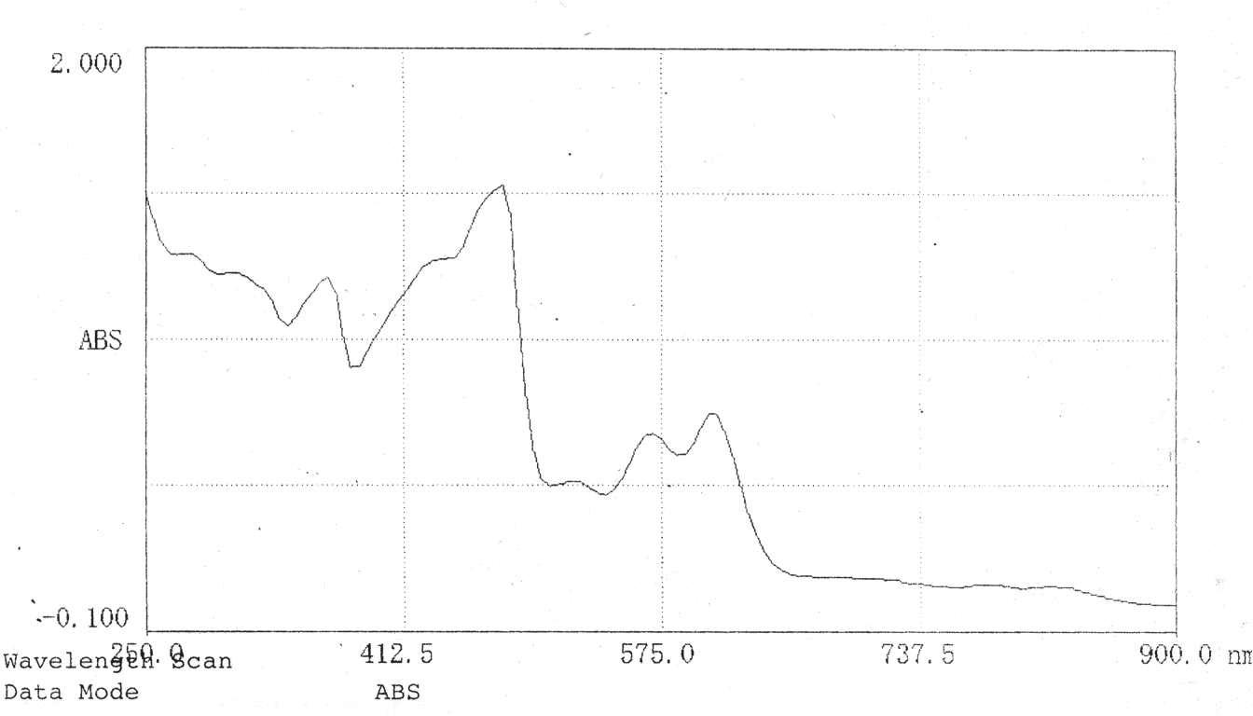
Figure 4. UV-visible spectrum of Mn(THMPP)NCS(4-MeIm).

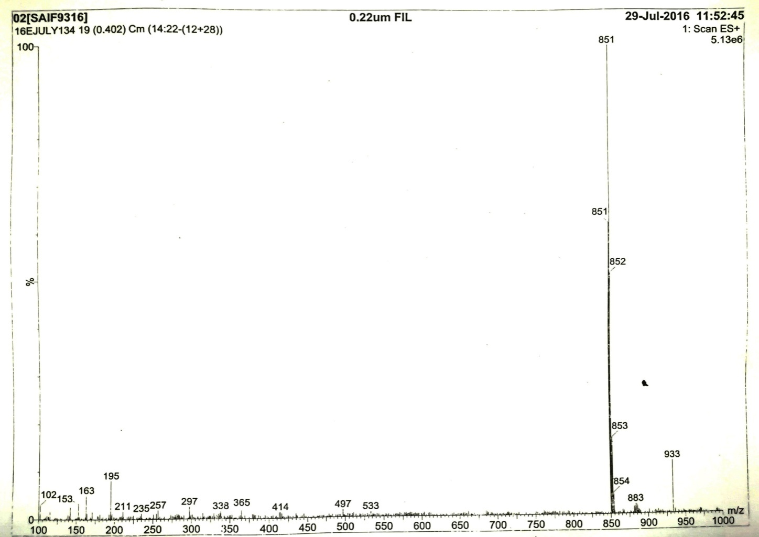
Figure 5. ESI-MS of Mn(THMPP)Cl(4-MeIm).

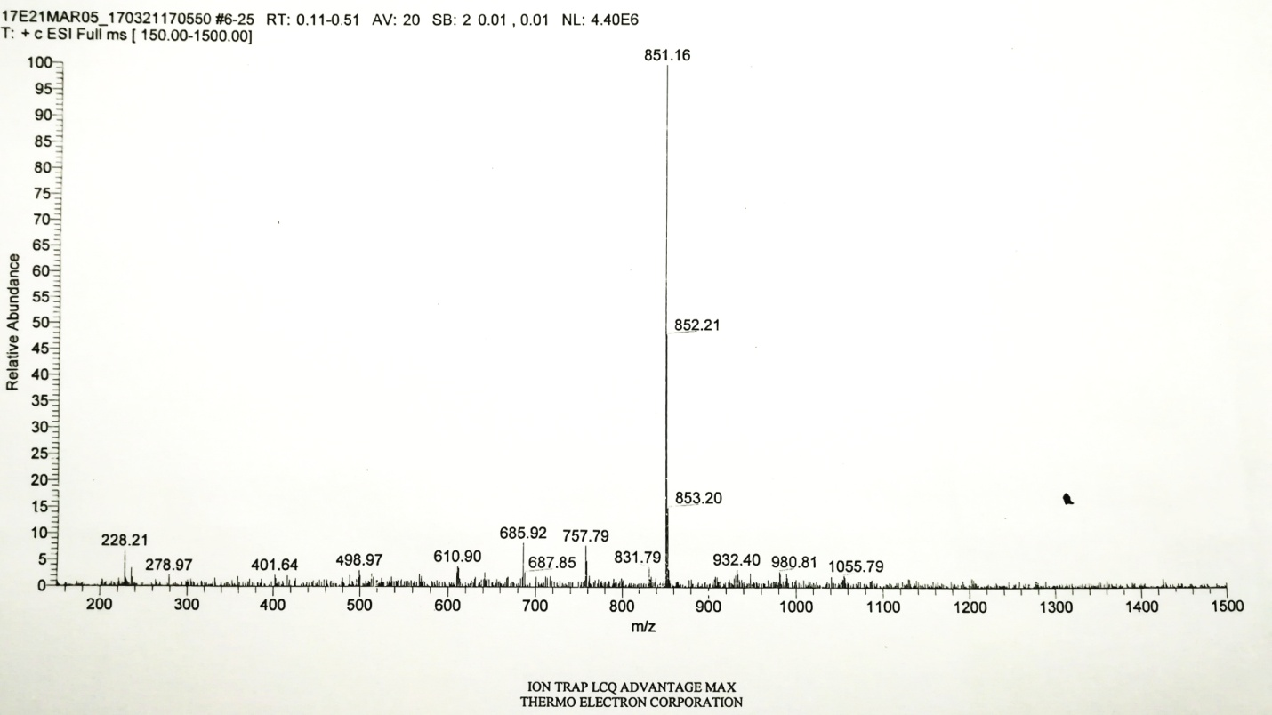
Figure 6. ESI-MS of Mn(THMPP)Br(4-MeIm).

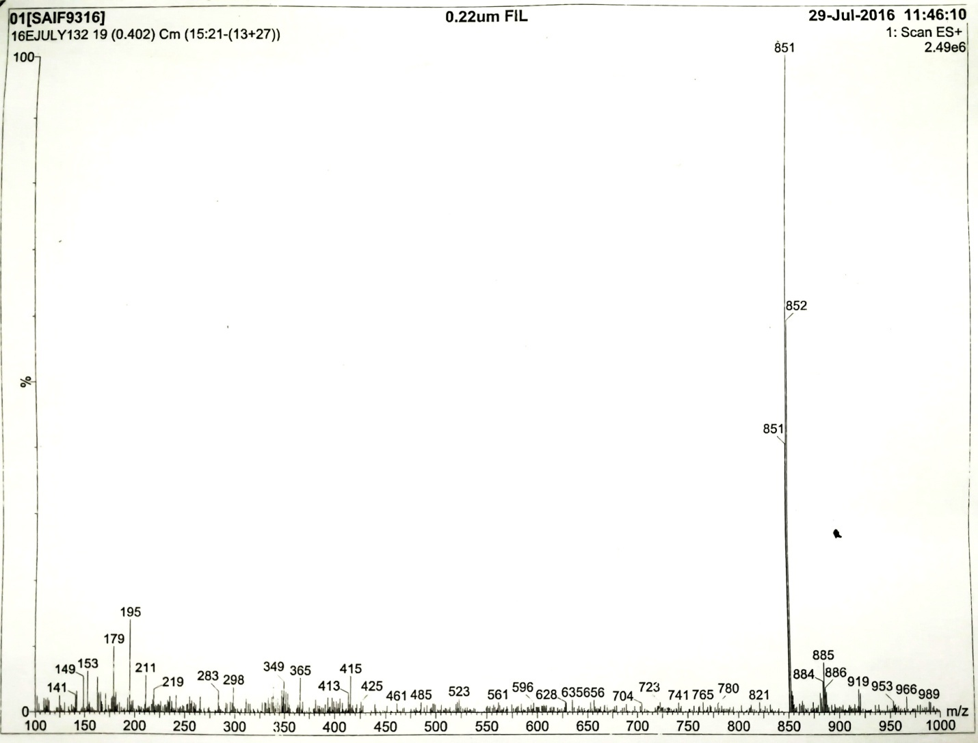
Figure 7. ESI-MS of Mn(THMPP)N₃(4-MeIm).

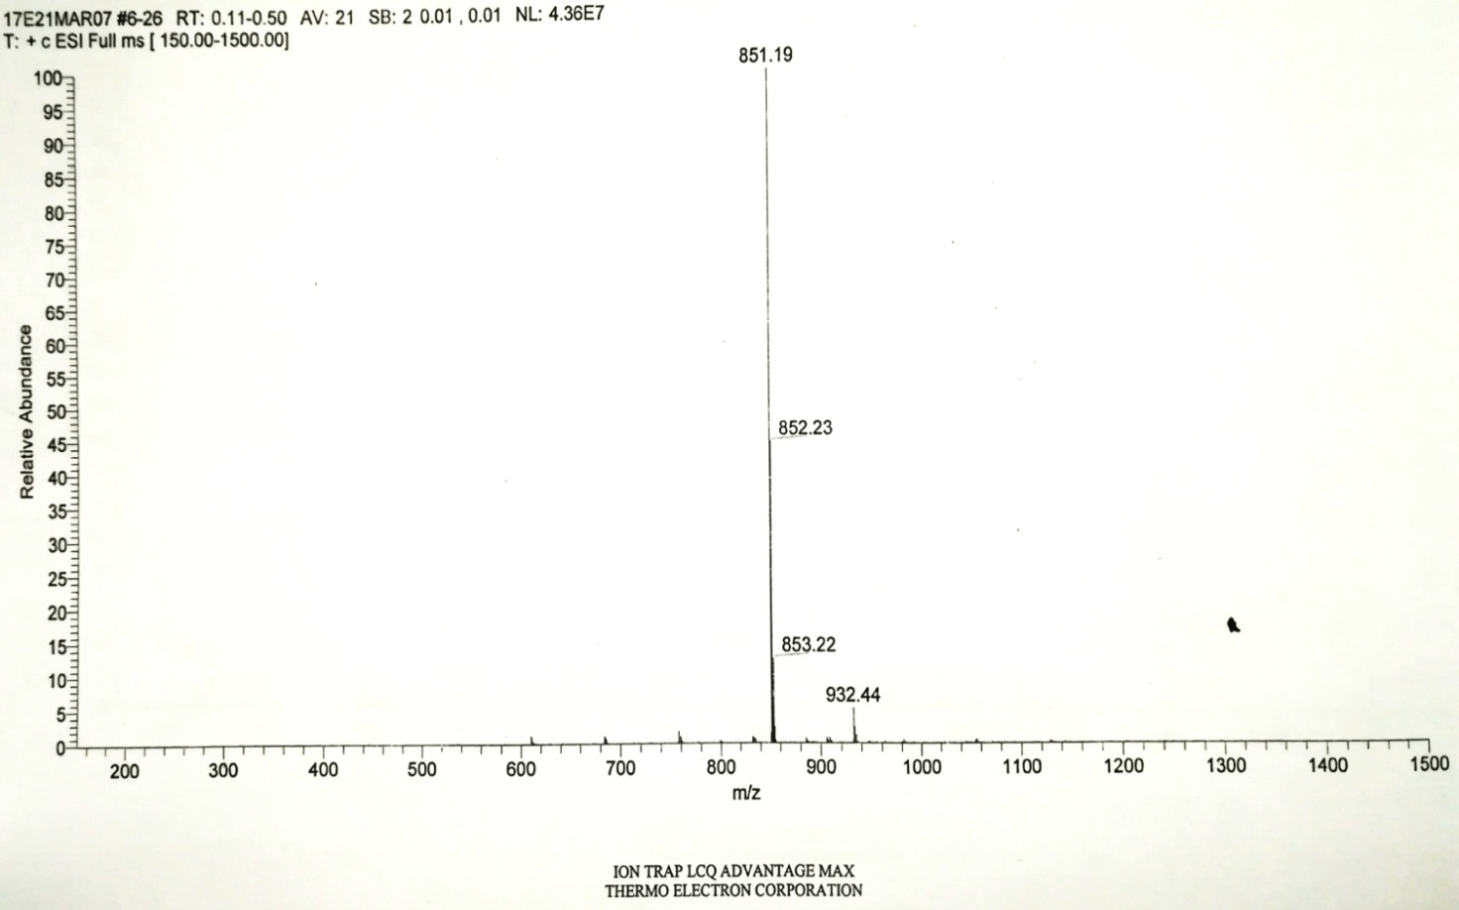
Figure 8. ESI-MS of Mn(THMPP)NCS(4-MeIm).

