Treated residue from aluminium lamination as adsorbent of toxic reactive dyes – a kinetic, equilibrium and thermodynamic study
* Tiago José Marques Fraga.¹; Marilda Nascimento Carvalho.¹; Daysianne Santos Marques Fraga.¹; Maria do Carmo Lourenço da Silva.¹; Joelma Morais Ferreira.²; Maurício Alves da Motta Sobrinho.¹
1 Federal University of Pernambuco, Department of Chemical Engineering, 1235 Prof. Moraes Rego Avenue, Cidade Universitária, Recife, PE, Brazil, zip code: 50670-901
2 Federal University of Paraíba, Centre of Technology and Regional Development, Escoteiros Street, W/N, Mangabeira VII, Joao Pessoa, PB, Brazil, zip code: 58051-900

*Corresponding author: email: tiago.fraga2012@gmail.com; phone: +55 81 995095559; ORCID: 0000-0002-5683-7307; LinkedIn profile: https://www.linkedin.com/in/tiago-fraga-a7ba1938/; Facebook profile: https://www.facebook.com/tiago.fraga.39

Supplementary Material
Factorial Planning 2³for DB
For all factorial design studies, the experiments started from the initial concentration (10 mg∙L⁻¹), solution volume (25 mL), pH (natural solution 6.5). In the planning carried out for the Drimaren Blue (DB), the best results were obtained under the following conditions: adsorbent mass of 1.00 g, temperature of 25ºC and agitation speed of 100 rpm, where 22,75 % of dye removal and adsorption capacity of 0.057 mg∙g⁻¹. The results with the values of the tests performed in the factorial design for the dye DA are presented in Table S1. According to Pareto’s diagram (Figure S1) and the response surface (Figure S2), the temperature, adsorbent dosage and steering velocity were the variables which most influenced the experiments.

Table S1. Experimental data for the factorial planning 2³ for the DB with the following variables: Temperature (in ºC), adsorbent dosage (in grams) and steering velocity (in rpm).
T (ºC) | ω (rpm) |  | m (g) | C_{(A)} (mg/L) | C_{(B)} (mg/L) | error (%) | R (%) | q_{med} (mg/g) | pH _{final}
65 |  | 300 | 3 | 7.947 | 7.683 | 3.38 | 22.45 | 0.019 | 6.04
65 |  | 300 | 1 | 8.848 | 8.692 | 1.78 | 12.98 | 0.033 | 6.38
65 |  | 100 | 3 | 7.551 | 7.311 | 3.23 | 26.27 | 0.022 | 6.48
65 |  | 100 | 1 | 8.475 | 8.56 | 1.00 | 15.48 | 0.039 | 6.50
25 |  | 300 | 3 | 5438 | 5.39 | 0.89 | 46.28 | 0.039 | 6.48
25 |  | 300 | 1 | 8.247 | 8.764 | 6.08 | 15.60 | 0.039 | 6.60
25 |  | 100 | 3 | 5.21 | 4.982 | 4.47 | 49.43 | 0.042 | 6.60
25 |  | 100 | 1 | 7.947 | 7.623 | 4.16 | 22.75 | 0.057 | 6.53
45 |  | 200 | 2 | 6.291 |  |  |  |  | 6.47
45 |  | 200 | 2 | 5.882 | 6.002 |  | 40.44 | 0.051
45 |  | 200 | 2 | 5.834

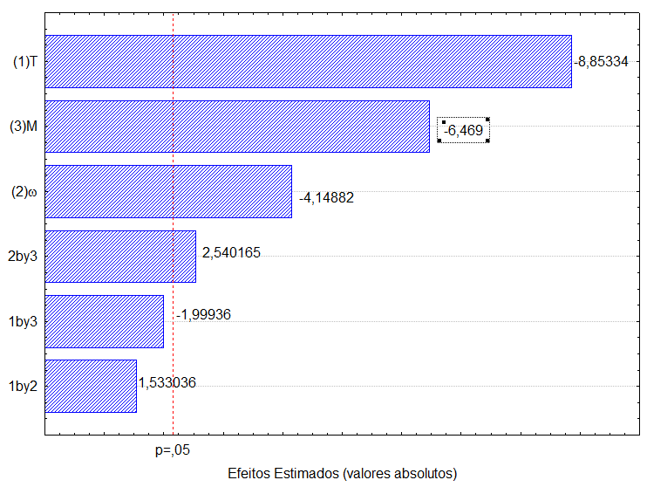
Figure S1. Pareto diagram corresponding to the effect of the variables: adsorbent dosage (m); temperature (T); and agitation speed (ω) in DB adsorption.

Factorial Planning 2³for DR
The Drimaren Red (DR) obtained the best results under the following conditions: adsorbent mass of 1.00 g, temperature of 25 ° C and agitation speed of 300 rpm, where 18.30 % of dye removal and adsorption capacity of 0.046 mg∙g⁻¹. The tests performed in the factorial design for the DV dye are presented in Table S2. Factorial planning showed that the temperature negatively influences the adsorption (Figure S2).

Table S2. Experimental data for the factorial planning 2³ for the DR with the following variables: Temperature (in ºC), adsorbent dosage (in grams) and steering velocity (in rpm).
T (ºC) | ω (rpm) | m (g) | C_{(A)} (mg/L) | C_{(B)} (mg/L) | error (%) | R (%) | q_{med} (mg/g) | pH _{final}
65 | 300 | 3 | 8.435 | 8.100 | 4.05 | 17.54 | 0.015 | 6.16
65 | 300 | 1 | 9.672 | 9.691 | 0.20 | 3.43 | 0.009 | 6.33
65 | 100 | 3 | 8.487 | 8.320 | 1.99 | 16.18 | 0.014 | 6.42
65 | 100 | 1 | 9.748 | 9.438 | 3.23 | 4.31 | 0.011 | 6.64
25 | 300 | 3 | 5.856 | 5.894 | 0.65 | 41.40 | 0.035 | 6.47
25 | 300 | 1 | 8.196 | 8.186 | 0.12 | 18.30 | 0.046 | 6.57
25 | 100 | 3 | 6.442 | 6.257 | 2.91 | 36.67 | 0.031 | 6.43
25 | 100 | 1 | 8.497 | 8.326 | 2.03 | 16.10 | 0.040 | 6.64
45 | 200 | 2 | 7.785 |  |  |  |  | 6.64
45 | 200 | 2 | 7.585 | 7.785 |  | 22.34 | 0.028
45 | 200 | 2 | 7.986

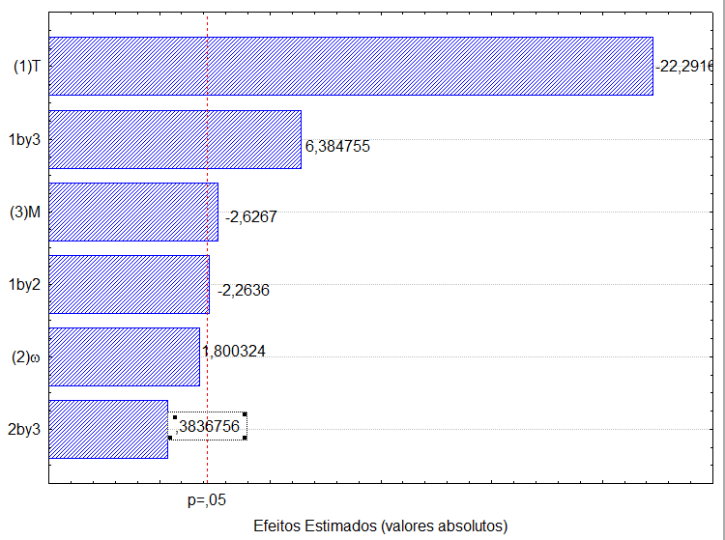
Figure S2. Pareto diagram corresponding to the effect of the variables: adsorbent dosage (m); temperature (T); and agitation speed (ω) in DR adsorption.

Factorial Planning 2³for DG
The Drimaren Gold (DG) obtained the highest value of q under the following conditions: adsorbent mass of 1.0 g, temperature of 25ºC and agitation speed of 300 rpm, where 25.49 % of dye removal and capacity of adsorption of 0.064 mg∙g⁻¹ ± 5%, even though there was the greatest error in reading the final concentrations (Table S3). Pareto analysis shows that the temperature was the variable which most negatively influenced the adsorption (Figure S3).

Table S3. Experimental data for the factorial planning 23 for the DG with the following variables: Temperature (in ºC), adsorbent dosage (in grams) and steering velocity (in rpm).
T (ºC) | ω (rpm) | m (g) | C_{(A)} (mg/L) | C_{(B)} (mg/L) | error (%) | R (%) | q_{med} (mg/g) | pH _{final}
65 | 300 | 3 | 7.406 | 7.481 | 1.01 | 25.92 | 0.022 | 6.77
65 | 300 | 1 | 9.673 | 9.856 | 1.87 | 2.82 | 0.007 | 6.68
65 | 100 | 3 | 7.541 | 7.470 | 0.95 | 25.30 | 0.021 | 6.62
65 | 100 | 1 | 8.518 | 8.777 | 3.00 | 13.94 | 0.035 | 6.78
25 | 300 | 3 | 4.588 | 4.604 | 0.35 | 54.26 | 0.045 | 6.44
25 | 300 | 1 | 7.692 | 7.282 | 5.48 | 25.49 | 0.064 | 6.47
25 | 100 | 3 | 6.601 | 6.267 | 5.19 | 35.97 | 0.030 | 6.52
25 | 100 | 1 | 7.940 | 7.821 | 1.51 | 21.57 | 0.054 | 6.84
45 | 200 | 2 | 7.179 |  |  |  |  | 6.51
45 | 200 | 2 | 7.174 | 7.104 |  | 29.30 | 0.037
45 | 200 | 2 | 6.958

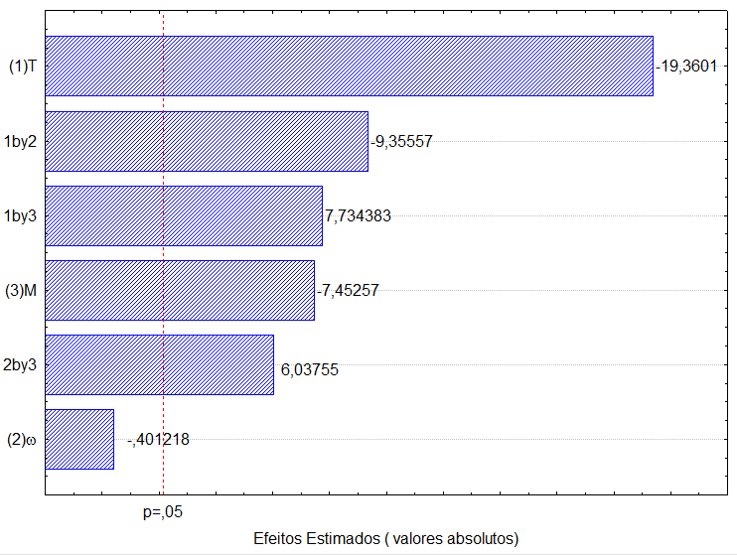
Figure S3. Pareto diagram corresponding to the effect of the variables: adsorbent dosage (m); temperature (T); and agitation speed (ω) in DG adsorption.

pH effect

Figure S4. Effect of pH in the adsorption of DB, DR and DG. Experiments performed at 25ºC, 25 mL 3.0g of TTR and 300 rpm.

BET data summary
The Table S4 summarizes the BET information for TTR. The analysis was performed for the samples sieved in 105, 75 and 44 mm, and non-sieved TTR before and after the adsorption.

Table S4. BET data summary for different TTR samples.
Sample | S_{BET}, m²∙g⁻¹ | V_{p}, cm³∙g⁻¹ | Pore size, Å
TTR sieved at 105 μm | 141.58 | 1.81∙10⁻² | 105.76
TTR sieved at 75 μm | 84.24 | 1.05∙10⁻² | 108.75
TTR sieved at 44 μm | 40.96 | 4.58∙10⁻³ | 96.25
non-sieved TTR | 55.38 | 2.34∙10⁻² | 181.43
TTR after DR adsorption | 53.24 | 1.68∙10⁻³ | 174.43

