Supplementary Material

Transition metal salts of quinoline: Synthesis, structure and magnetic behavior of (QuinH)₂[MX₄]·2H₂O [Quin = quinoline; M = Mn, Co, Cu, Zn], (QuinH)₂[MnBr₂(H₂O)₂](Br)₂ and (QuinH)[Cu(Quin)Br₃]

CHRISTOPHER P. LANDEE, JEFFREY C. MONROE, ROBERT KOTARBA, MATTHEW POLSON, JAN L. WIKAIRA and MARK M. TURNBULL*

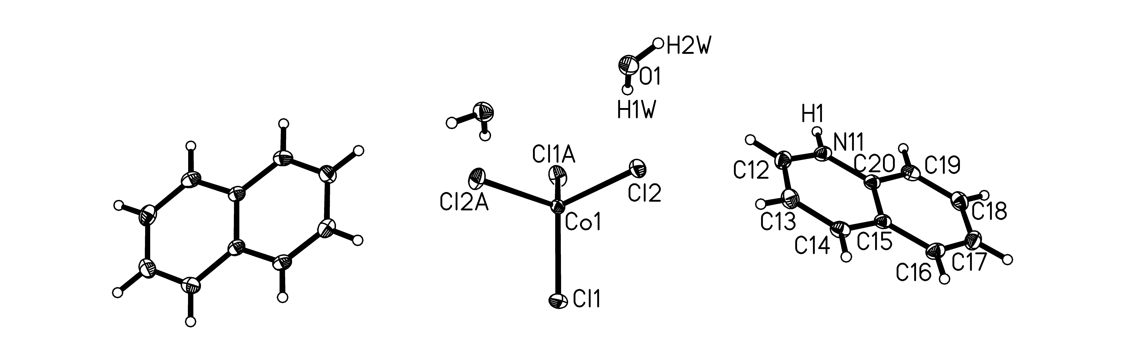
Figure S1. The molecular unit of 1 showing 50% probability thermal ellipsoids. Hydrogen atoms are shown as spheres of arbitrary size. Only the asymmetric unit, Cu-coordination sphere and those hydrogen atoms whose positions were refined are labelled.

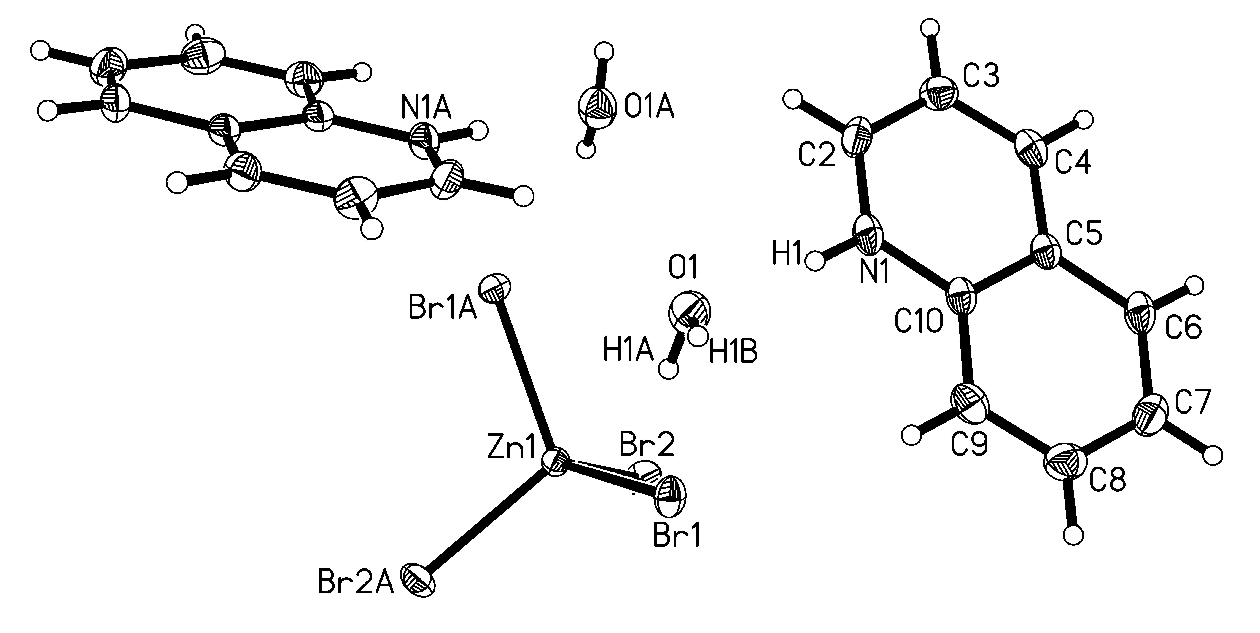

Figure S2. The molecular unit of 3 showing 50% probability thermal ellipsoids. Hydrogen atoms are shown as spheres of arbitrary size. Only the asymmetric unit, Cu-coordination sphere and those hydrogen atoms whose positions were refined are labelled.

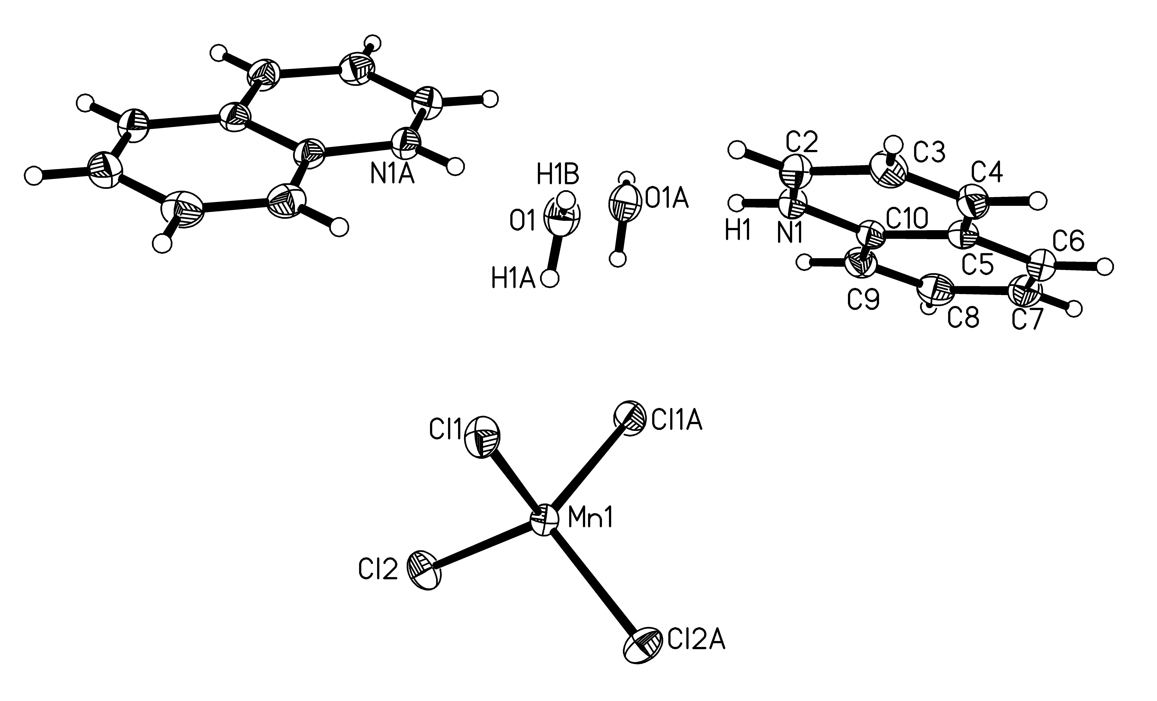
Figure S3. The molecular unit of 4 showing 50% probability thermal ellipsoids. Hydrogen atoms are shown as spheres of arbitrary size. Only the asymmetric unit, Cu-coordination sphere and those hydrogen atoms whose positions were refined are labelled.

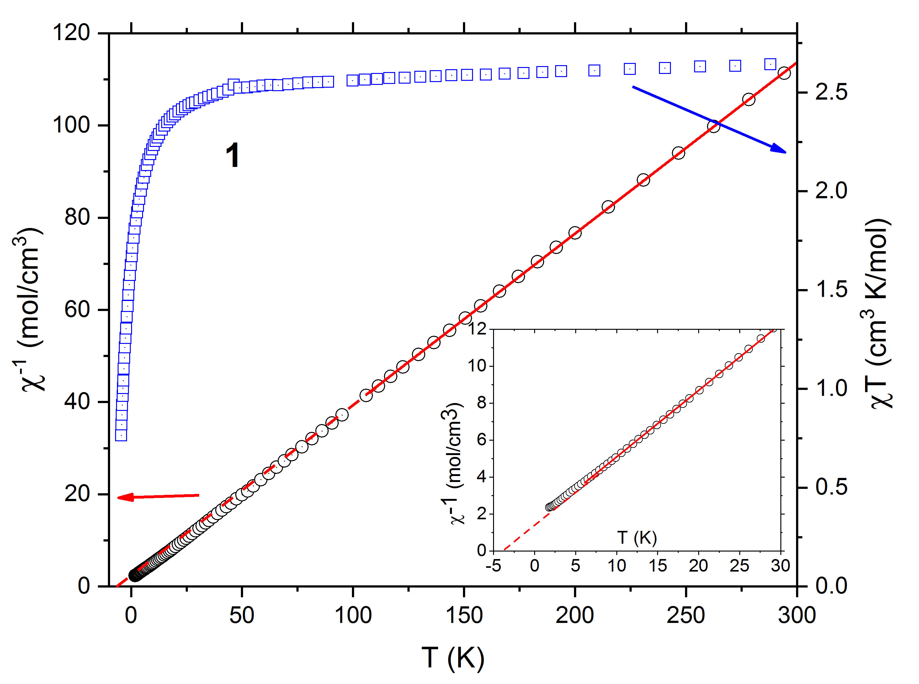
Figure S4. The inverse susceptibility (∇, left vertical axis) and χ_{m}T product (, right vertical axis) of 1 are plotted in figure S1. the solid red line through the susceptibility in the main panel corresponds to the results of a Curie-Weiss fit to the high-temperature data between 50 and 310 K, with parameters C = 2.78(2) cm³ K/mol and θ_{HT} = -4.2(2) K. The dashed red line represents the extension of the fitted line to the temperature axis. Insert: The inverse susceptibility data 5 and 25 K are C = 2.77 cm³ K mol⁻¹ and θ_{LT} = -4.2(2) K (solid red line). The dashed red line represents the extension of the fitted line to the temperature axis.
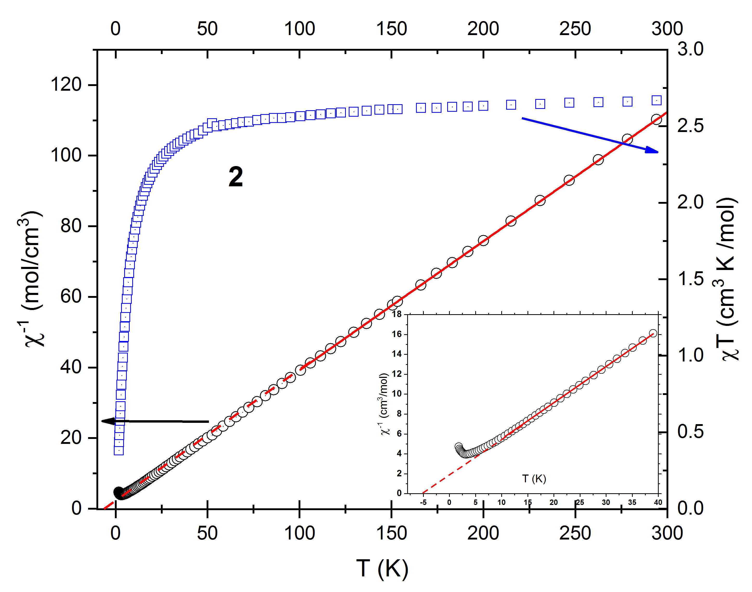
Figure S5. The inverse susceptibility (Ο, left vertical axis) and χ_{m}T product (, right vertical axis) of 2 are plotted in figure S2. The data between 100 and 310 K corresponds to parameters C = 2.75(2) cm³ K mol⁻¹ and θ_{HT} = -7.2(5) K; when applied to the data between 10 and 40 K (insert), the parameters are C = 2.74(2) cm³ K mol⁻¹ and θ_{LT} = -5.1(2) K. respectively. The dashed red line in the insert is the extrapolation of the fit to the temperature axis.

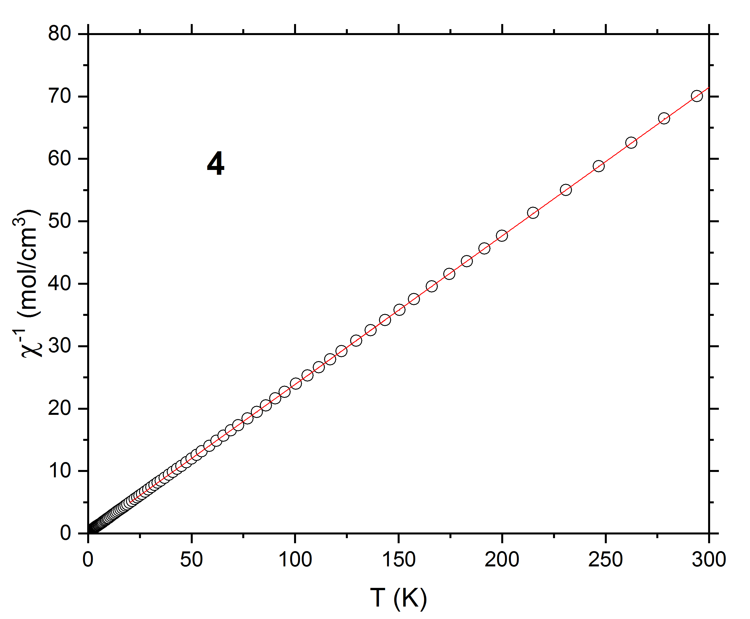
Figure S6. Inverse susceptibility as a function of temperature for 4. The red line through the χ⁻¹ data corresponds to the Curie-Weiss fit with parameters C = 4.20(1) cm³ K/mol and θ = -0.45(6) K.

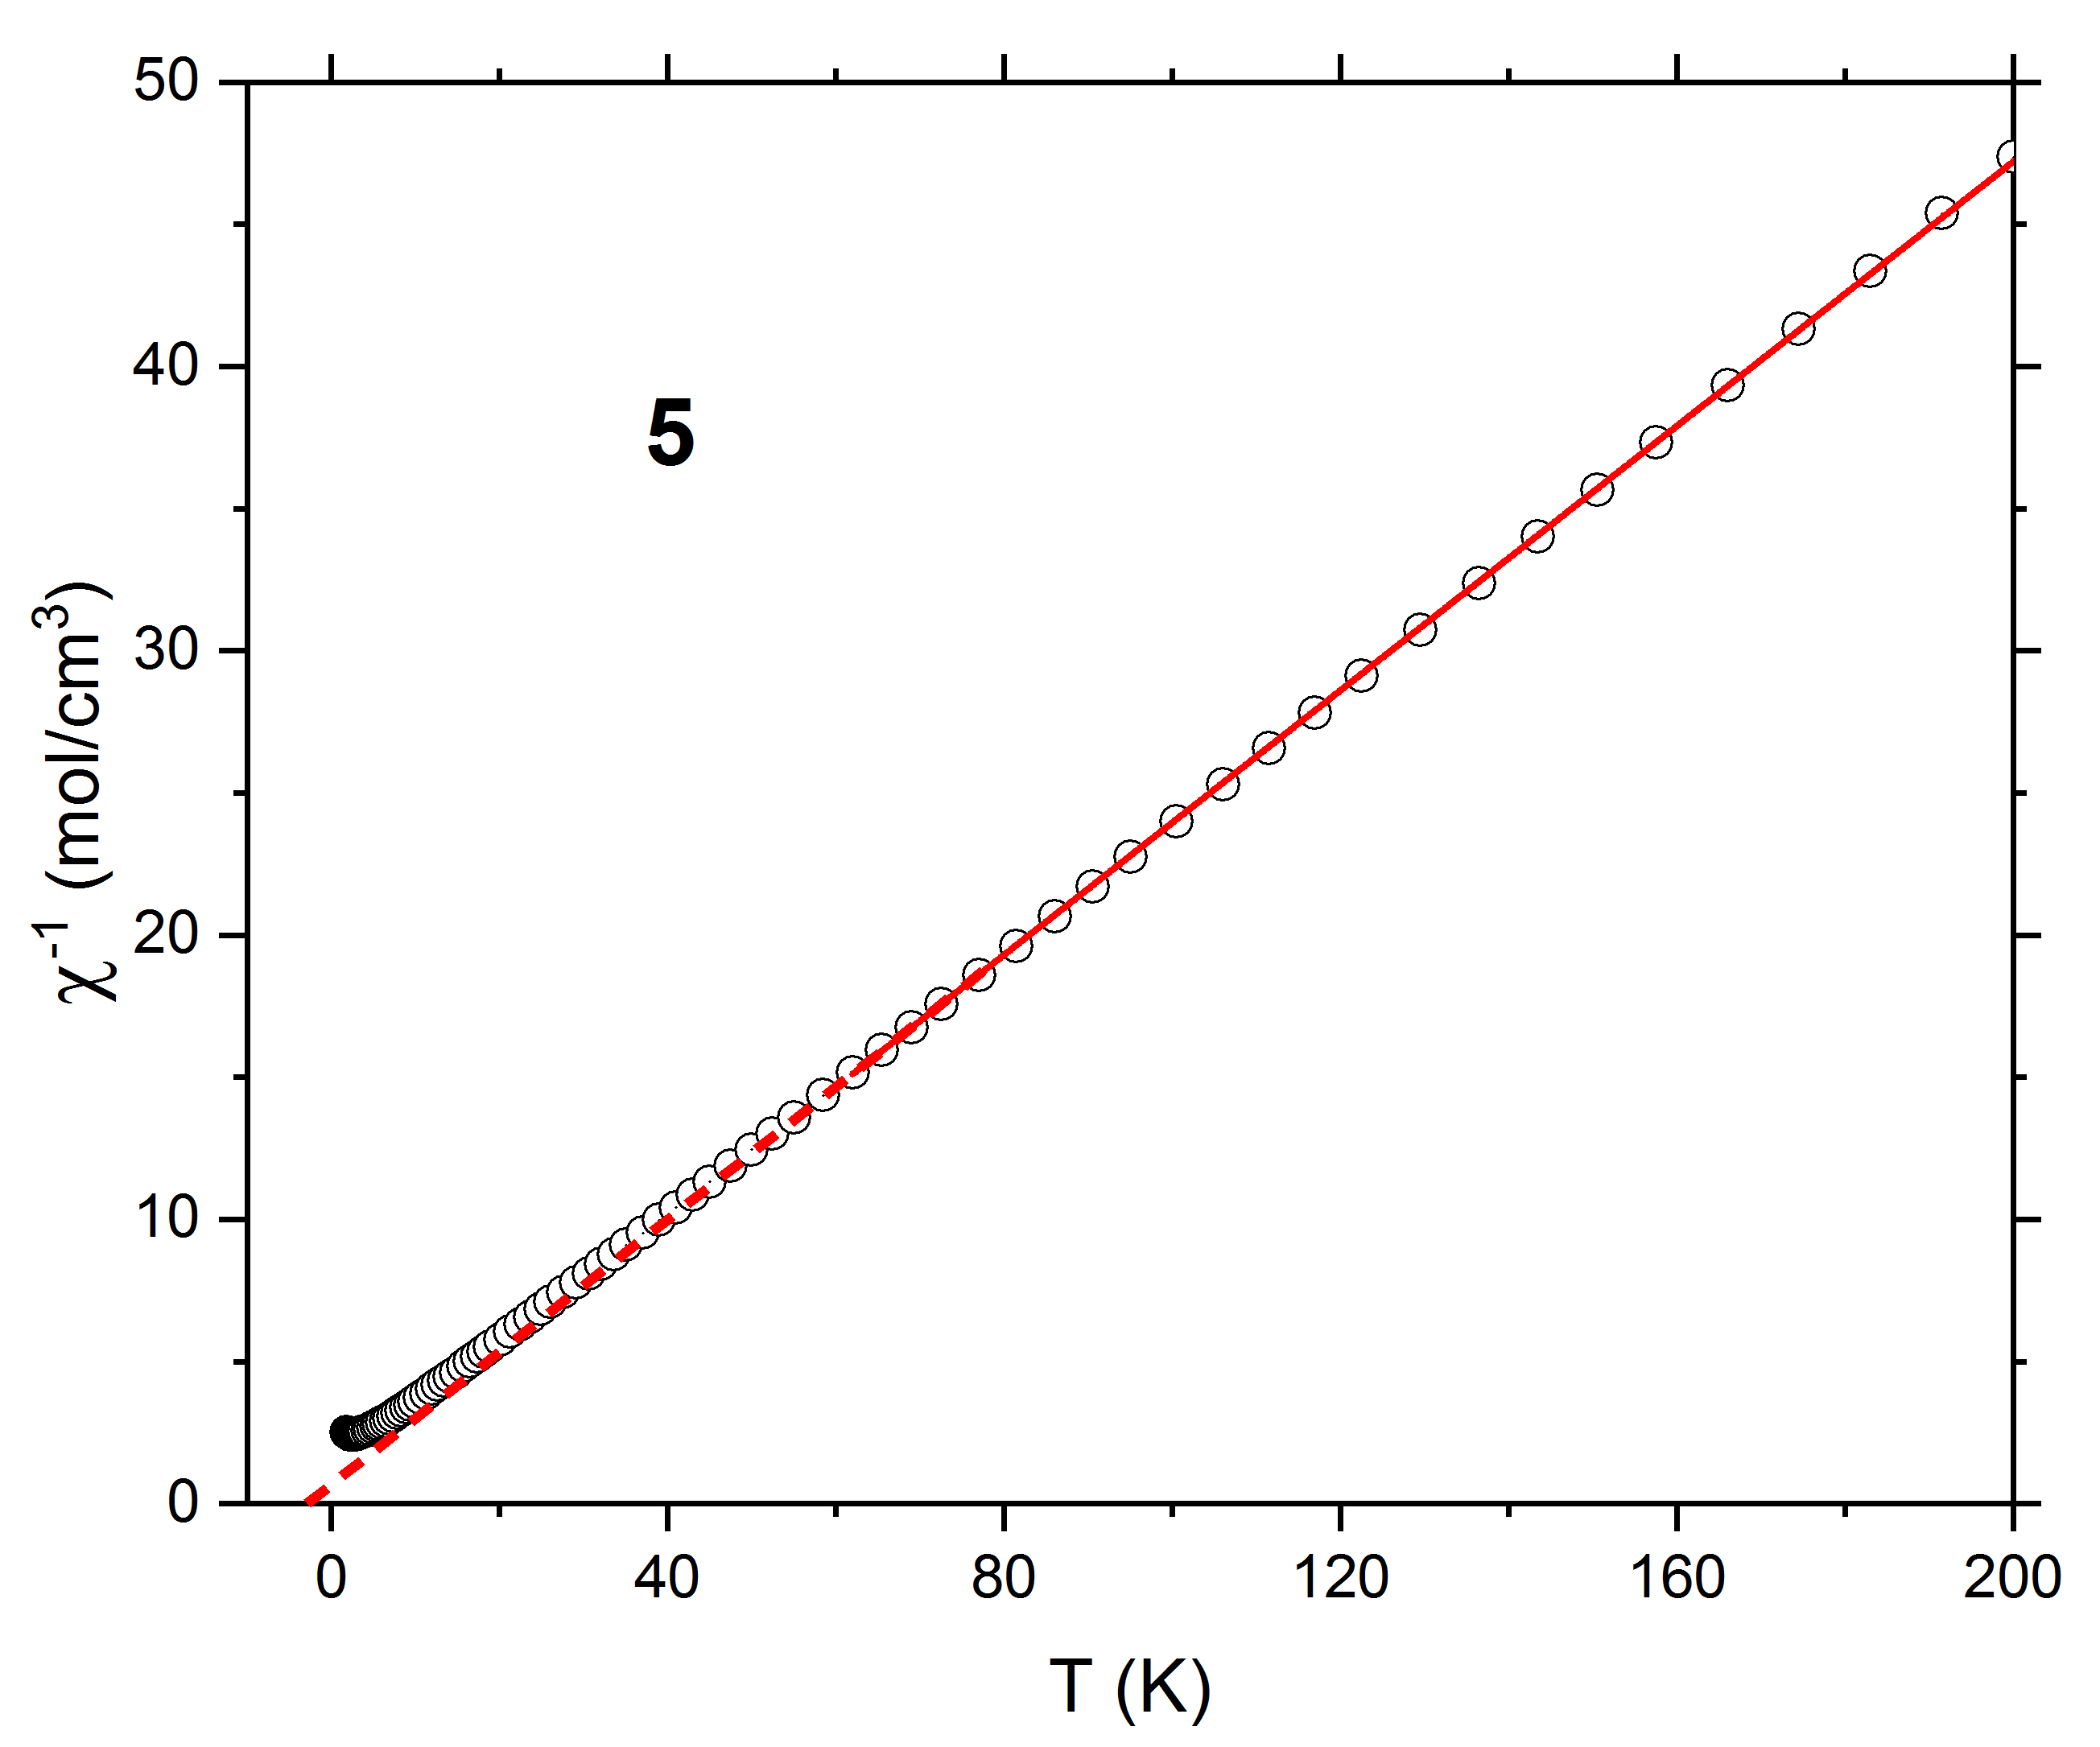
Figure S7. The inverse susceptibility of 5 are plotted in figure S2. The data between 100 and 310 K corresponds to parameters C = 4.30(2) cm³ K mol⁻¹ and θ_{HT} = -3.0(2) K. The dashed red line in the insert is the extrapolation of the fit to the temperature axis.

