SUPPLEMENTAL INFORMATION
Optimizing Ozone-Biofiltration Systems for Organic Carbon Removal in Potable Reuse Applications

Mac Giffordª, Ashley Selvy^{b}, Daniel Gerrity^{b}*

*Corresponding Author:
University of Nevada Las Vegas, Department of Civil and Environmental Engineering and Construction, 4505 S Maryland Parkway, Las Vegas, NV 89154; phone: 702-895-3955; fax: 702-895-3936; email: daniel.gerrity@unlv.edu

Affiliations:
ªPortland Water Bureau, Water Quality and Compliance, Portland OR 97006
^{b}University of Nevada Las Vegas, Department of Civil and Environmental Engineering and Construction, Las Vegas, NV 89154

April 2018
In preparation for Ozone: Science and Engineering (Taylor & Francis)
Text S1: Details of full-scale water reclamation facility.
The pilot-scale ozone biofiltration system was constructed at a full-scale water reclamation facility in the Las Vegas metropolitan area (Figure S1). The facility employs secondary biological treatment in a membrane bioreactor (MBR) operated with a solids retention time of 8–10 days for full nitrification and partial denitrification. Even though the facility is designed to do so, the secondary biological treatment process does not actually accomplish biological phosphorus removal because the influent wastewater lacks the necessary fatty acids to drive the process. The MBR filtrate (prior to disinfection) serves as the influent to the pilot-scale ozone-biofiltration system.
Figure S1. Treatment train schematic for the full-scale water reclamation facility.

Text S2: Details of pilot-scale ozone-biofiltration system.
Figure S2 illustrates the layout of the pilot-scale ozone-biofiltration system, and corresponding photos of the ozone contactors and biofilter columns are provided in Figures S3A and S3B, respectively. In Figure S2, the green circles denote the non-filtered water samples, the pink asterisks mark the sampling locations for the biofilter effluents, the blue ‘Xs’ signify the upper media sampling ports (depth = 15 cm), and the white ‘Xs’ represent the lower media sampling ports (depth = 45 cm). The sample port for the non-ozonated MBR filtrate (i.e., pilot influent) was located prior to ozone injection, and the sample port for the ozonated MBR filtrate was located immediately after the ozone contactors but prior to biofiltration. During the initial long-term operational phase, biofilter columns C1-C4 and the ‘Control’ biofilter column were filled with 1.2-mm diameter anthracite. During later phases of the project, biofilter column C3 was switched to the 0.95-mm diameter exhausted granular activated carbon (GAC) [i.e., biological activated carbon (BAC)].
Figure S2. Schematic of the pilot-scale ozone-biofiltration system.
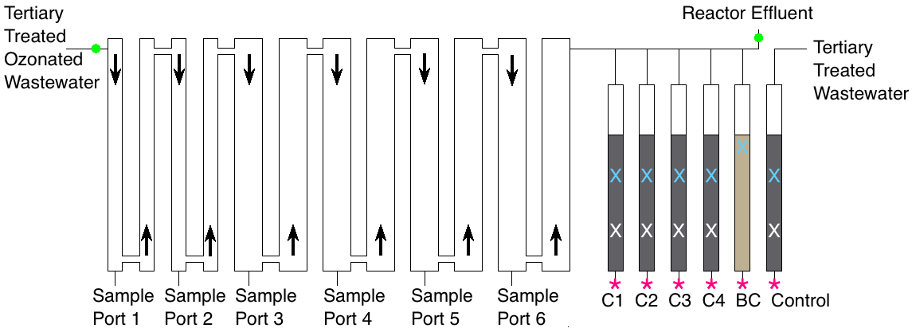
Reactor Effluent

Figure S3. Pilot-scale (A) ozone contactors and (B) biofilter columns.
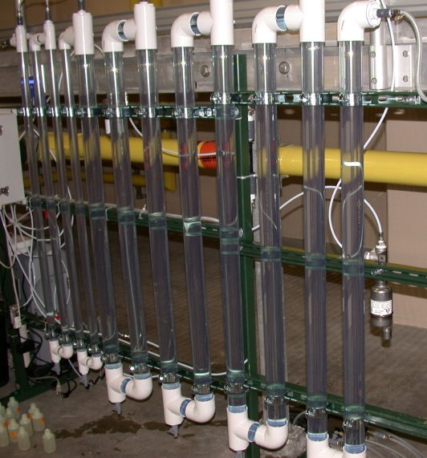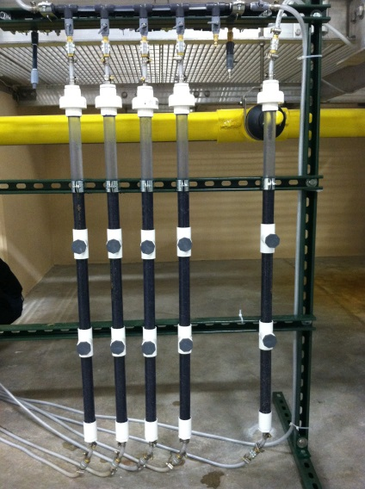
B.
A.
For the pilot-scale system, concentrated oxygen was generated at a flow rate of between 0.5–3 L min⁻¹ and a pressure of 20 psig using a portable medical system equipped with molecular sieves (AirSep, Denver, CO). After passing through an air filter to remove particulates, the oxygen traveled to an air dryer (Magnum-600, Ozone Solutions Inc., Hull, Iowa) and then to a Nano dielectric ozone generator (Absolute Ozone, Edmonton, AB, Canada). The output from the ozone generator traveled either through a bypass line to a catalytic destruct unit or to a Venturi injector (Mazzei, Bakersfield, CA), where the ozone was injected into the process flow. The bypass line was controlled by a standard gas flow meter. In addition to check valves, the feed gas line was equipped with a water trap that prevented water from entering the feed gas tubing and backing up into the generator, as well as a pressure gauge to monitor feed gas pressure entering the Venturi injector. After ozone injection, water traveled through 12 ozone contactors connected in series. The first four contactors were 2.54 cm in diameter and the last 8 contactors were 5.08 cm in diameter. Ozone off-gas was collected in Teflon tubing at the top of each contactor and was sent to a catalytic destruct unit. The ozone off-gas line was also protected by a water trap that prevented water from reaching the catalytic destruct unit.
Text S3: Ozone analysis by indigo trisulfonate.
Potassium indigo trisulfonate is dark blue in color but will quickly decolorize in the presence of ozone as the chemical is oxidized. A spectrophotometer can then be used to determine the absorbance of the indigo trisulfonate solution at 600 nm. The extent of decolorization, or bleaching, during ozonation can then be used to calculate the dissolved ozone concentration.
Analysis of ozone residual during ozone demand-decay testing was conducted by placing 10 mL of potassium indigo trisulfonate test solution in several 100-mL volumetric flasks that had been previously weighed. Ozonated source water was then added to each flask at predetermined time intervals to induce a noticeable color change due to the combined effects of oxidation and/or dilution. The flasks, which now contained indigo trisulfonate plus sample, were weighed to determine the mass of sample added, which was later converted to volume. The absorbance of each sample was then measured with a spectrophotometer, and the absorbance of each sample was converted to a dissolved ozone concentration using SI Eq. S1:
${\text{O}}_{\text{3}}\text{(mg/L)=}\frac{{\text{V}}_{\text{blank+indigo }}\text{×}{\text{ Absorbance}}_{\text{blank}} \text{-}{\text{ V}}_{\text{sample+indigo}}\text{ ×}{\text{ Absorbance}}_{\text{sample}}}{\text{f × }{\text{V}}_{\text{sample}}\text{ × b}}$ (Eq. S1)
where, f represents the proportionality constant (0.42) and b is the cell path length (1 cm) (Rakness et al. 2010). The dissolved ozone residual data were then modeled as a first order decay process (SI Eq. S2), which could then be used to calculate the corresponding ozone exposures (i.e., CT values) using SI Eq. S3.
${\text{O}}_{\text{3}}\text{ residual [mg}{ L}^{-1}\text{] = }\left(\text{(}{\text{O}}_{\text{3}}\text{/TOC)*TOC - IOD}\right)\text{*}{\text{e}}^{\text{-kt}}$ (Eq. S2)
$\text{CT [mg min }L^{-1}\text{] = }\frac{\text{(}{\text{O}}_{\text{3}}\text{/TOC)*TOC-IOD}}{\text{k}}\text{*}\left(\text{1-}{\text{e}}^{\text{-kt}}\right)$ (Eq. S3)
where, CT is the ozone exposure (mg min L⁻¹), TOC is the concentration of total organic carbon (mg L⁻¹), IOD is the instantaneous ozone demand (mg L⁻¹), k is the first order ozone decay rate constant (min⁻¹), and t is time (min) (Gerrity et al. 2014).

Text S4: Total organic carbon (TOC) analysis.
A Shimadzu TOC-V_{csh} (Kyoto, Japan) was used for total organic carbon analysis using the non-purgeable organic carbon method. With this method, acid is added to the sample to decrease the pH and convert inorganic carbon (i.e., carbonate species) to CO₂, and then the sample is purged with hydrocarbon-free compressed air to eliminate the CO₂. The sample is then sent to a combustion chamber where the remaining organic carbon is converted to CO₂ via catalytic oxidation at 680°C. The CO₂ is then sent to a non-dispersive infrared detector, and the signals are converted to TOC concentration based on standards.
A stock solution using 0.53 g of potassium hydrogen phthalate and 250 mL of deionized water was used to produce a 1000 mg L⁻¹ TOC stock solution. The stock solution was replaced every two months. Standard solutions of 0, 4, 8, 12, 16, and 20 mg_{C} L⁻¹ were prepared using 0, 200, 400, 600, 800, and 1000 μL of stock solution in 50-mL volumetric flasks. These were prepared fresh for each sampling event.
For this study, all glassware were cleaned according to the guidelines provided in Standard Method 5310B. The samples were collected in amber vials (with no headspace), capped with Teflon lined lids, and kept cool prior to analysis. After the samples were acidified using 5 N HCl to reduce the pH to less than 2, the samples were covered with parafilm to reduce contamination potential, loaded in the autosampler, and analyzed according to the method parameters provided in SI Table 1. These settings were used for both sample analysis and calibration curve determination.

Table S1. Non-purgeable organic carbon analysis parameters.
Injection Volume | 80 µL
Number of Injections | 3/7
Standard Deviation Max | 0.100
CV Max | 3.00%
Number of washes | 2
Auto Dilution | 1
Sparge Time | 1:30 min
Acid Addition | 0

Text S5: Target trace organic compounds (TOrCs) and nitrosamines.
Table S2 summarizes the 96 TOrCs and 9 nitrosamines analyzed by Eurofins Eaton Analytical (Monrovia, CA) for this study. A total of 34 TOrCs and 3 nitrosamines were detected at reportable concentrations in at least one sample; the corresponding concentrations are provided in Table 3 in the main text. Azithromycin and 4-nonylphenol were not reported due to high background levels in the instrument during analysis.
Table S2. List of TOrCs and nitrosamines analyzed by Eurofins Eaton Analytical.
TOrCs
1,7-Dimethylxanthine | Chlorotoluron | Iopromide | Propylparaben
2,4-D | Cimetidine | Isobutylparaben | Quinoline
4-nonylphenol | Clofibric Acid | Isoproturon | Simazine
4-tert-octylphenol | Cotinine | Ketoprofen | Sucralose
Acesulfame-K | Cyanazine | Ketorolac | Sulfachloropyridazine
Acetaminophen | DACT | Lidocaine | Sulfadiazine
Albuterol | DEA | Lincomycin | Sulfadimethoxine
Amoxicillin | DEET | Linuron | Sulfamerazine
Androstenedione | Dehydronifedipine | Lopressor | Sulfamethazine
Atenolol | DIA | Meclofenamic Acid | Sulfamethizole
Atrazine | Diazepam | Meprobamate | Sulfamethoxazole
Azithromycin | Diclofenac | Metazachlor | Sulfathiazole
Bendroflumethiazide | Diltiazem | Methylparaben | Sulfometuron-methyl
Bezafibrate | Diuron | Metolachlor | TCEP
Bisphenol A | Erythromycin | Naproxen | TCPP
Bromacil | Estradiol | Nifedipine | TDCPP
Butalbital | Estrone | Norethisterone | Testosterone
Butylparaben | Ethinyl Estradiol | Oxolinic Acid | Theobromine
Caffeine | Ethylparaben | Pentoxifylline | Theophylline
Carbadox | Flumeqine | Phenazone | Thiabendazole
Carbamazepine | Fluoxetine | Phenytoin | Triclocarban
Carisoprodol | Gemfibrozil | Primidone | Triclosan
Chloramphenicol | Ibuprofen | Progesterone | Trimethoprim
Chloridazone | Iohexal | Propazine | Warfarin
Nitrosamines
N-nitrosodibutylamine (NDBA)
N-nitrosodiethylamine (NDEA)
N-nitrosodimethylamine (NDMA)
N-nitrosodi-n-propylamine (NDPA)
N-nitrosodiphenylamine (NDPhA)
N-nitrosomethylethylamine (NMEA)
N-nitrosomorpholine (NMOR)
N-nitrosopiperidine (NPIP)
N-nitrosopyrollidine (NPYR)
*Bolded compounds were detected at reportable concentrations in at least one sample
**Some abbreviations are defined in the main text
Text S6: Results of ozone demand-decay testing of the MBR filtrate.
Ozone demand and decay are due to a combination of natural ozone decay in pure water and reactions with organic and inorganic compounds present in the ozonated water matrix. The demand-decay curves for the MBR filtrate with O₃/TOC ratios of 0.5, 1.0, and 1.5 are shown in Figure S3; the instantaneous ozone demand (IOD; i.e., the demand at 30 sec) exceeded the transferred ozone dose for an O₃/TOC ratio of 0.25. The corresponding regression equations for these ozone dosing conditions are shown in Eqs. S4-S6.
Figure S3. Ozone demand decay curves for the MBR filtrate.

O₃/TOC = 0.25: N/A: Instantaneous Ozone Demand > Applied Ozone Dose
O₃/TOC = 0.50: O₃ (mg/L) = 1.89e^{-0.89t} R² = 0.98 (Eq. S4)
O₃/TOC = 1.00: O₃ (mg/L) = 3.56e^{-0.17t} R² = 0.98 (Eq. S5)
O₃/TOC = 1.50: O₃ (mg/L) = 5.68e^{-0.09t} R² = 0.97 (Eq. S6)
Text S7: First order TOC biodegradation models for the biofiltration process.
Pseudo first order models were developed to determine rate constants for biodegradation of bulk organic matter during biofiltration, as shown in Figure S4. These models were then used in conjunction with Eqs. 5-8 in the main text to predict effluent TOC concentrations when using ozone-biofiltration in a potable reuse application (Figure S5).
Figure S4. Linear regression of BDOC removal as a function of O₃/TOC ratio and EBCT.
A. O₃/TOC = 0.35
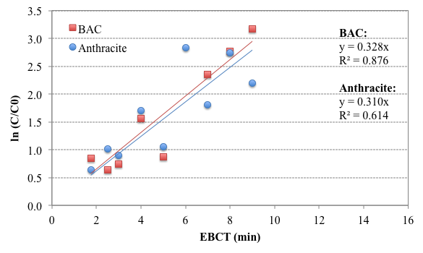
B. O₃/TOC = 0.62
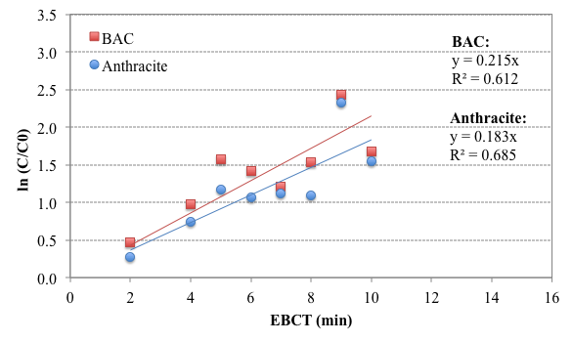
C. O₃/TOC = 1.12
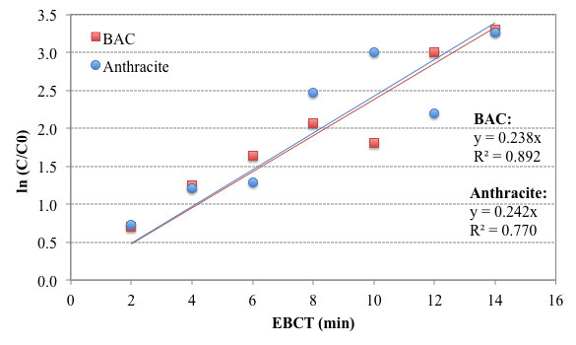
Figure S5. (A) Maximum TOC removal achievable with BAC or anthracite as a function of O₃/TOC ratio, (B) predicted effluent TOC concentration as a function of O₃/TOC ratio and EBCT for ozone-BAC, and (C) predicted effluent TOC concentration as a function of O₃/TOC ratio and EBCT for ozone-anthracite. Maximum TOC removal was calculated using Eqs. 7-8 in the main text, and the predicted TOC concentrations were calculated using Eqs. 5-8 in the main text and an assumed initial TOC concentration of 6 mg L⁻¹.
A. Maximum TOC Removal
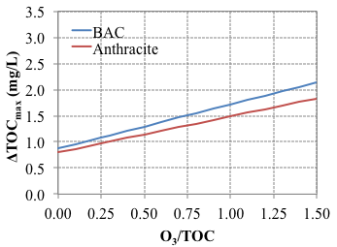
C. Effluent TOC for ozone-anthracite
B. Effluent TOC for ozone-BAC

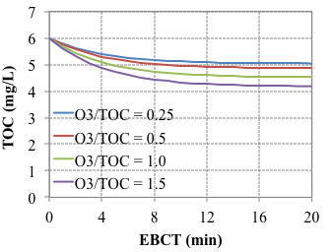
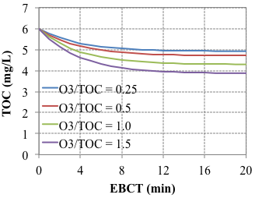

References
Gerrity, D., E. Owens-Bennett, T. Venezia, B. Stanford, M. Plumlee, J. Debroux, and R. Trussell. 2014. "Applicability of ozone and biological activated carbon for potable reuse." Ozone: Science & Engineering 36 (2):123-127. doi: https://doi.org/10.1080/01919512.2013.866886.
Rakness, K., E. Wert, M. Elovitz, and S. Mahoney. 2010. "Operator-friendly technique and quality control considerations for indigo colorimetric measurement of ozone residual." Ozone: Science & Engineering 32 (1):33-42.

