Supplement

Figure S1: Size-exclusion chromatography of the maltose-binding protein (MBP). Size-exclusion chromatography on a Superose12 column (GE Healthcare) was performed for MBP (17 µM). Absorbance at 280 nm is shown. Gelfiltration was performed with a linear flow rate of 0.5 ml/min and the elution volume (ml) is indicated. Two peaks could be identified belonging to an aggregation of proteins with a size of >2,000 kDa (peak 7.3 ml) and to the monomeric MBP with 42 kDa (peak 13.7 ml). Calibration of the column was performed using the gel-filtration mass standard (Bio-Rad Laboratories) containing thyroglobulin (670 kDa), IgG (158 kDa), ovalbumin (44 kDa), myoglobulin (17 kDa) and vitamin B12 (1.35 kDa).

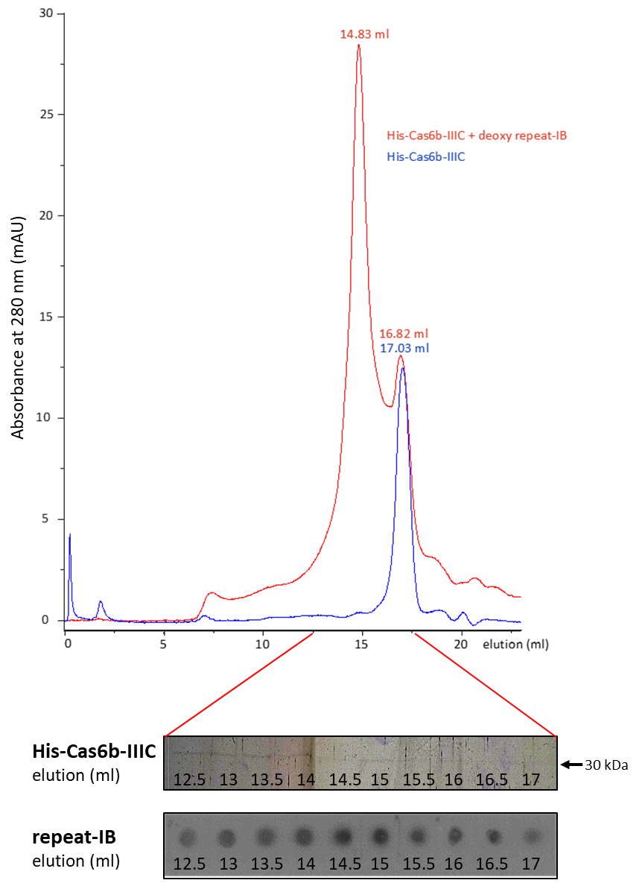
Figure S2: Size-exclusion chromatography of the Cas6b-IIIC endonucleases of M. mazei Gö1 in the absence and presence of repeat RNA substrate. Size-exclusion chromatography on a Superose12 column (GE Healthcare) was performed with His-fusion protein Cas6b-IIIC from M. mazei Gö1 (10 µM). Absorbance at 280 nm is shown for the respective proteins in blue and in red for a sample containing the respective protein pre-incubated in the presence of the deoxy-repeat-IB variant (5 µM). Gel filtration was performed with a linear flow rate of 0.5 ml/min using buffer A (see Material and Methods) and elution volume (ml) is indicated. The eluted protein was identified with a silver-stained SDS-gel and co-eluting RNA was detected via northern dot blot analysis using a 5’ radioactive labeled repeat-IB probe.

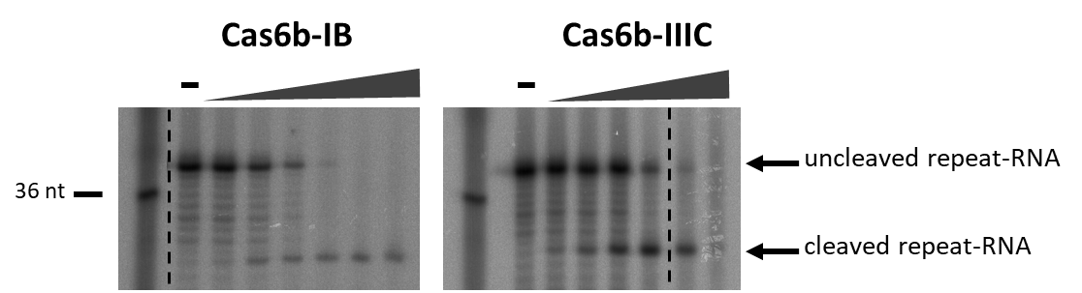
Figure S3: Endonuclease activity of heterologously expressed Cas6b-IB and Cas6b-IIIC proteins. The cleavage assay was performed with 5` radioactively labeled repeat-IB RNA in the presence of Cas6b-IB (0 ng, 10 ng, 50 ng, 100 ng, 500 ng, 1 mg, 2.5 mg) and Cas6b-IIIC (0 ng, 10 ng, 50 ng, 100 ng, 500 ng, 1 mg, 2.5 mg) protein. Cleavage patterns were analyzed with an 8 % acrylamide gel with 7 M urea on a sequencing gel.

Figure S4: Quantification of absolute transcript numbers of cas6b-IB (dark grey) and cas6b-IIIC (light grey) in the wild type under standard conditions. Indicated are the respective molecule numbers per 50 ng of total RNA with technical standard deviations of three biological replicates (RNA1, RNA2 and RNA3).

Figure S5: Effects of the deletion of one M. mazei cas6b gene on the transcription of the respective other or the crRNA in general. Quantitative (q) RT-PCR of the crRNA-IB and crRNA–IIIC and the genes cas6b-IB or cas6b-IIIC of the M. mazei strains ∆cas6b-IB and ∆cas6b-IIIC respectively compared to the wt. Indicated are the respective log2 fold changes with standard deviations of two biological replicates under control conditions and high salt stress (500 mM NaCl).

Figure S6: Effects of high salt stress on the transcription of crRNA and cas6b genes in Methanosarcina mazei. Quantitative (q) RT-PCR of the crRNA-IB and crRNA–IIIC and the genes cas6b-IB and cas6b-IIIC of the M. mazei wild type strain. Indicated are the respective log2 fold changes with standard deviations of biological replicates under high salt stress (500 mM NaCl) in comparison to control condition.

Figure S7: Putative ribosome binding sites of cas6b-IB and cas6b-IIIC. Depicted are the 5’ untranslated regions of the two genes encoding CRISPR endonucleases cas6b-IB and cas6b-IIIC. Based on the ribosome binding site (RBS) consensus sequence for M. mazei ‘AGGAGG’ as reported by Jäger et al. [1] a RBS was identified for cas6b-IB (highlighted in bold). Only a weak RBS (underlined) was identified for cas6b-IIIC.

Table S1: Strains and plasmids
Strain or plasmid | Genotype or description | Source or reference
Strain
M.mazei Gö1 | wild type | DSMZ No. 3647
M. mazei* | potential cell wall mutant | [2]
M. mazei ∆cas6b-IB | M. mazei* ∆cas6b-IB::pac, pur^{R} | This study
M. mazei ∆cas6b-IIIC | M. mazei* ∆cas6b-IIIC::pac, pur^{R} | This study
E. coli DH5a | general cloning strain | [3]
E. coli JM109 λpir | general cloning strain | [4]
E. coli BL21-CodonPlus®-RIL | general cloning strain,  containing the pRIL plasmid (ileW, leuY, proL) | Stratagene
E. coli Rosetta™ | general cloning strain,  containing the pRARE plasmid | Novagen
Plasmid
pBlueskript SK⁺ | general cloning vector | Stratagene
pCR4-TOPO | general cloning vector | Invitrogen
pDrive | general cloning vector | Qiagen
pMAL-c2 | general cloning vector, malE under the control of the tac promoter | New England BioLabs
pWM321 | shuttle vector | [5]
pRS207 | pBlueskript SK⁺ containing pac-cassette | [2]
pRS714 | Cas6b-IB in pET28a | [6]
pRS833 | Cas6b-IIIC in pET28a | [6]
pRS1040 | pBlueskript SK⁺ containing upstream and downstream fragment of cas6b-IB | This study
pRS1041 | pBlueskript SK⁺ containing up- and downstream fragments with pac-cassette replacing cas6b-IB to construct ∆cas6b-IB | This study
pRS1042 | pBlueskript SK⁺ containing upstream and downstream fragment of cas6b-IIIC | This study
pRS1043 | pBlueskript SK⁺ containing up- and downstream fragments with pac-cassette replacing cas6b-IIIC to construct ∆cas6b-IIIC | This study
pRS1078 | pCR4-TOPO containing cas6b-IB | This study
pRS1080 | pCR4-TOPO containing cas6b-IIIC | This study
pRS1079 | pMAL-c2 containing cas6b-IB | This study
pRS1081 | pMAL-c2 containing cas6b-IIIC | This study

Table S2.: Primer pairs used for cloning, RT-PCR and sequencing. Additional attached cleavage sites of restriction enzymes are underlined.

Primer designations | 5`→3`
Mutant construction
∆MM560_1 _for | GGGCCCTTCCTTCAAAAAAATACCTC
∆MM560_1 _rev | GAGCTCGGATCCAAACAAGTCTCCATATCA
∆MM560_2_ for | GGATCCGGGGGTGATATTGTGC
∆MM560_2_ rev | GAGCTCCATTCAAGAGCAAGAGAGTC
∆MM3359_1_ for | GGGCCCAAATCGGGCTCAAGAATGTT
∆MM3359_1_ rev | GAGCTCGGATCCAAAATCTATAAAGAATTTTTTAC
∆MM3359_2 _for | GGATCCCATTTGTATTATTTGATCC
∆MM3359_2 _rev | GAGCTCTACAATGAGAATAATACGCC
MM560_ for | GAATACTTTCAATGTATATAAACTACACTTG
MM560_ rev | AAGCTTTTATATTTTTTTAATTGAACCATATCC
MM3359_ for | GAATACTTTCAATGAGTCCAGGGAATATTAAG
MM3359_ rev | AAGCTTCTAAATATCATTGAAGTTAGAATAATTCC
Northern blot analysis
crRepeat-IB | CTTGTTTTAATGGATCTTGCTCGC
RT-PCR analysis
qRT_MM1215_for | TCAAGAGCGAGGGCATGAATG
qRT_MM1215_rev | GCACTACCGAGAACAATAGCC
qRT_MM1621_for | TAGGAGGTTTTCTCGGAAGCG
qRT_MM1621_for | AAGCGTATCTCCATCAAGCCC
qRT_MM2181_for | GCCTCCATGAGAAGAATGCTC
qRT_MM2181_for | CTTCAAGGTCTCCAACTCCTG
qRT_MM560_for | CGGATTAGACGAAGGTTCAA
qRT_MM560_rev | TAAAGCGAGCCAAGGAGTT
qRT_crRNA-IB_for | AGGGTTTGATAATTTTCCAG
qRT_ crRNA-IB_rev | AAAAGCGGTGTTAAGTCAG
qRT_MM3359_for | ATGAGTCCAGGGAATATTAAG
qRT_MM3359_rev | TACTGCACAAGAGGGTAGC
qRT_crRNA-IIIC_for | TCCAAACCACTAAAAAAACC
qRT_crRNA-IIIC_rev | AAGGATCTCATACGTGAATTAG

REFERENCES

1. Jäger, D., et al., Deep sequencing analysis of the Methanosarcina mazei Gö1 transcriptome in response to nitrogen availability. Proc Natl Acad Sci U S A, 2009. 106(51): p. 21878-82.
2. Ehlers, C., et al., Development of genetic methods and construction of a chromosomal glnK(1) mutant in Methanosarcina mazei strain Gö1. Mol Genet Genomics, 2005. 273: p. 290-298.
3. Hanahan, D., Studies on transformation of Escherichia coli with plasmids. J Mol Biol, 1983. 166(4): p. 557-80.
4. Miller, V.L. and J.J. Mekalanos, A novel suicide vector and its use in construction of insertion mutations: osmoregulation of outer membrane proteins and virulence determinants in Vibrio cholerae requires toxR. J Bacteriol, 1988. 170(6): p. 2575-83.
5. Metcalf, W.W., et al., A genetic system for Archaea of the genus Methanosarcina: liposome-mediated transformation and construction of shuttle vectors. Proc Natl Acad Sci U S A, 1997. 94(6): p. 2626-31.
6. Nickel, L., et al., Two CRISPR-Cas systems in Methanosarcina mazei strain Gö1 display common processing features despite belonging to different types I and III. RNA Biol, 2013. 10(5): p. 779-91.

