Study of COI sequences from endemic New Zealand aphids highlights high mitochondrial DNA diversity in Rhopalosiphina (Hemiptera: Aphididae)

Colleen Podmore^{1,2}, Ian D. Hogg^{2,3}, Gabrielle M. Drayton⁴, Barbara I. P. Barratt^{5,7}, Ian A. W. Scott⁴, Robert G. Foottit⁶, David A. J. Teulon^{4,7}, Simon R. Bulman^{4,7,#}

¹ Analytica Laboratories, Ruakura Research Centre, 10 Bisley Road, Hamilton 3214, New Zealand
² Environmental Research Institute, School of Science, University of Waikato, New Zealand.
³ Polar Knowledge Canada, Canadian High Arctic Research Station, PO Box 2150, Cambridge Bay, Nunavut, X0B 0C0, Canada
⁴ New Zealand Institute for Plant & Food Research Ltd, Christchurch, New Zealand.
⁵ AgResearch Invermay Agricultural Centre, Private Bag 50034, Mosgiel 9053, New Zealand.
⁶ Agriculture and Agri-Food Canada, Ottawa Research and Development Centre and Canadian National Collection of Insects, Arachnids and Nematodes, K. W. Neatby Bldg, 960 Carling Aven., Ottawa, Ontario, K1A 0C6, Canada
⁷ Better Border Biosecurity (B3), New Zealand.

# For correspondence. E-mail. simon.bulman@plantandfood.co.nz; Tel. +64 (0)3 325 3944.

Abstract

Focussed searches were made across New Zealand between 2013-2016, for endemic aphids from the Schizaphis (Rhopalosiphina) genus, which is currently represented by two putative, undescribed species from the endemic host plants Aciphylla and Dracophyllum. Cytochrome c oxidase I (COI) gene sequences (48 in total) from the Schizaphis were analysed together with those from a broader collection of New Zealand endemic aphids that has been assembled since the year 2000. The bulk of the Schizaphis belonged to two clusters corresponding to the host plant genera. Two aphids from central North Island Dracophyllum represented a much diverged lineage without clear affiliations to other New Zealand Schizaphis. Inter-population variation in the New Zealand Schizaphis was high compared with that seen in international studies of Aphidinae and among populations of other endemic New Zealand Aphidina. Within Schizaphis from Dracophyllum, geography played an apparent role in genetic structuring, with populations from Taranaki (North Island) and especially Mt Lyford (South Island) being divergent from those on the South Island main divide. Two distinct lineages of Schizaphis, which co-occurred at some sites, were found on Aciphylla. Our sequence comparisons, including GMYC analyses, indicated up to five New Zealand Schizaphis lineages, and two newly discovered endemic Aphis species from the host plants Clematis and Hebe.

Keywords

Aphid, Schizaphis, populations, cytochrome oxidase I, DNA barcoding.
Introduction

Aphids are hemipteran insects that feed on the phloem of plants. There are an estimated 5000 species worldwide (C. Favre, Aphid Species File, 2018; http://Aphid.SpeciesFile.org), with most found in the temperate regions of the northern hemisphere (Blackman & Eastop 2006). Approximately 120 aphid species are found in New Zealand, with the majority introduced in the past 200 years (Teulon et al. 2013). Recognition that New Zealand harbours an indigenous aphid fauna was relatively recent, with the first identified native aphid, Aphis coprosmae Carver, only recognised in the 1950s (Teulon et al. 2013). After much intensified study over the last two decades, there are now considered to be at least 15 endemic species in New Zealand of which 11 belong to Aphidinae (Teulon et al. 2013).
Elongation factor 1α (EF1α) and cytochrome c oxidase II (COII) DNA sequence analyses show the presence of at least three lineages within native New Zealand Aphidinae; the monotypic Aphis coprosmae and the “Southern Hemisphere” lineages sit at basal positions in Aphis, while a third lineage falls within Schizaphis (Rhopalosiphina) (Von Dohlen & Teulon 2003; Kim et al. 2011). These New Zealand species are of scientific interest in the context of wider aphid evolution; the basal position of New Zealand Aphis in the Aphidini phylogeny (Kim et al. 2011) has raised the possibility that New Zealand aphids were progenitors of a later northern Aphidinae radiation (Von Dohlen & Teulon 2003). Nevertheless, much greater Aphidinae diversity in the Northern Hemisphere and the punctuated phylogenetic groupings of the New Zealand lineages, together suggest a role for dispersal in the distribution of the New Zealand aphid fauna.
The origin and affinities of New Zealand Schizaphis are unclear due to taxonomic uncertainties in the wider Rhopalosiphina and because of the unusual association between these aphids and dicotyledonous host plants. The two putative, undescribed, endemic Schizaphis species are circumscribed by their host plants; one lineage is from Aciphylla spp. (Apiaceae) while the other is found on Dracophyllum spp. (Ericaceae) (Teulon et al. 2013). Genus Dracophyllum is found in Australia, New Zealand and New Caledonia, but is especially species-rich and morphologically diverse in New Zealand (Wagstaff et al. 2010). Dracophyllum are characteristic shrubs of upland forests and heathlands, ranging from low-growing cushion plants to trees up to 14 m tall. The Aciphylla genus are rosette herbs of open habitats, many of which have spiny and leathery leaves (Radford et al. 2001). In stark contrast to the New Zealand species, global Schizaphis species are almost exclusively monoecious on monocotyledonous herbaceous plants, with some host alternating to Pyrus as a primary host. Rare exceptions include Schizaphis rotundiventris (Signoret), recorded from the African oil palm, and Schizaphis jaroslavi (Mordvilko) from Cocculus trilobus (Thunb.) DC (Blackman & Eastop 2006).
The genus Schizaphis (Aphidinae, Aphidini) was split from Rhopalosiphum Koch, based on tapering siphunculi and a single branched forewing media (Blackman & Eastop 2006). There are approximately 40 species of Schizaphis, with more than half found in Europe (Blackman & Eastop 2006). The New Zealand species have previously been placed in subgenus Euschizaphis, which differs from Schizaphis by the absence of marginal tubercles. However, evidence for placing the New Zealand aphids with Euschizaphis, which is represented only by species from arctic Canada and northern Europe, is debateable. Instead, New Zealand Schizaphis may be more closely related to subgenus Paraschizaphis, some members of which are found in east Asia (Blackman & Eastop 2006). As a consequence of these uncertainties, the New Zealand aphids are currently referred to as Schizaphis species, without subgeneric assignment. Moreover, molecular evidence shows that while Rhopalosiphina constitutes a distinct grouping, relationships within the subtribe are inconsistent; Rhopalosiphina requires greater molecular study and taxonomic revision (Foottit et al. 2008; Kim et al. 2011).
Most New Zealand endemic aphid species are considered to be rare (Kean & Stufkens 2005). The insects are present for short periods of the year, with colonies generally found on only a few leaves or shoots of a plant, and on a small proportion of the locally available hosts. As a result, almost all native New Zealand Aphidinae are known from a restricted set of populations. New Zealand Schizaphis are thought to be more widely distributed and potentially more common than other indigenous aphids. Aciphylla and Dracophyllum plants are widespread in alpine and shrubland habitats and a greater number of aphid populations have been found from these hosts than from other indigenous plants (Teulon et al 2013). Populations of Schizaphis are known from two Aciphylla sites in Central Otago and one at Porters Pass (Canterbury). The population at Porters Pass has been regularly observed for over a decade (Teulon et al. 2008), and large numbers of aphids are sometimes present. Schizaphis have been recorded on Dracophyllum from north–west Nelson, Buller, Canterbury, Marlborough, Westland, Taranaki, and Taupo (Teulon et al. 2013).
As with many other New Zealand insect groups (Buckley et al. 2015), little is known about the degree of genetic diversity within endemic New Zealand aphid species. Initial application of molecular markers confirmed the genetic separation of Schizaphis on Dracophyllum and Aciphylla (Von Dohlen & Teulon 2003). It has been suggested that the “Dracophyllum” Schizaphis consist of two lineages based on unpublished COII gene sequence evidence that Pureora aphids (central North Island) are genetically different from those at Arthur’s Pass, and that siphunculi were shorter in Mt Ngauruhoe and Saint Arnaud Range populations (Teulon et al. 2013).
Since multiple Schizaphis populations may be found through determined fieldwork, this represents one of the best opportunities to assess the extent of genetic variation within an endemic New Zealand aphid genus. In this study, we firstly sought to detect any genetic diversity within the currently recognised endemic Schizaphis taxa. Field collections of Schizaphis were made widely across New Zealand, and diversity was assessed by DNA barcoding of samples using mitochondrial COI sequences. The nature of genetic variation in Schizaphis was given context by comparisons with a COI sequence dataset from a broader collection of endemic New Zealand Aphidina, which we have accumulated since the year 2000.

Methods and Materials

Sample collection
The bulk of Schizaphis were collected between October 2013 and January 2016 from sites across New Zealand (Figure 1; Table 1). Aphids were collected by shaking Dracophyllum plants over a white tray or visually searching individual Aciphylla plants. Specimens were stored in 100% ethanol until molecular analyses. Prior to DNA extraction, specimens were photographed and collection details were recorded in the ‘Soil Aphids of New Zealand’ [SANZ] project (www.boldsystems.org).
Samples of endemic Aphis and Paradoxaphis (for simplicity, referred to collectively as Aphidina species) were obtained primarily during research excursions to detect parasitism of native aphids since 2008 (Table 1). Aphidina populations were also located by white tray methods, as for Schizaphis from Dracophyllum.

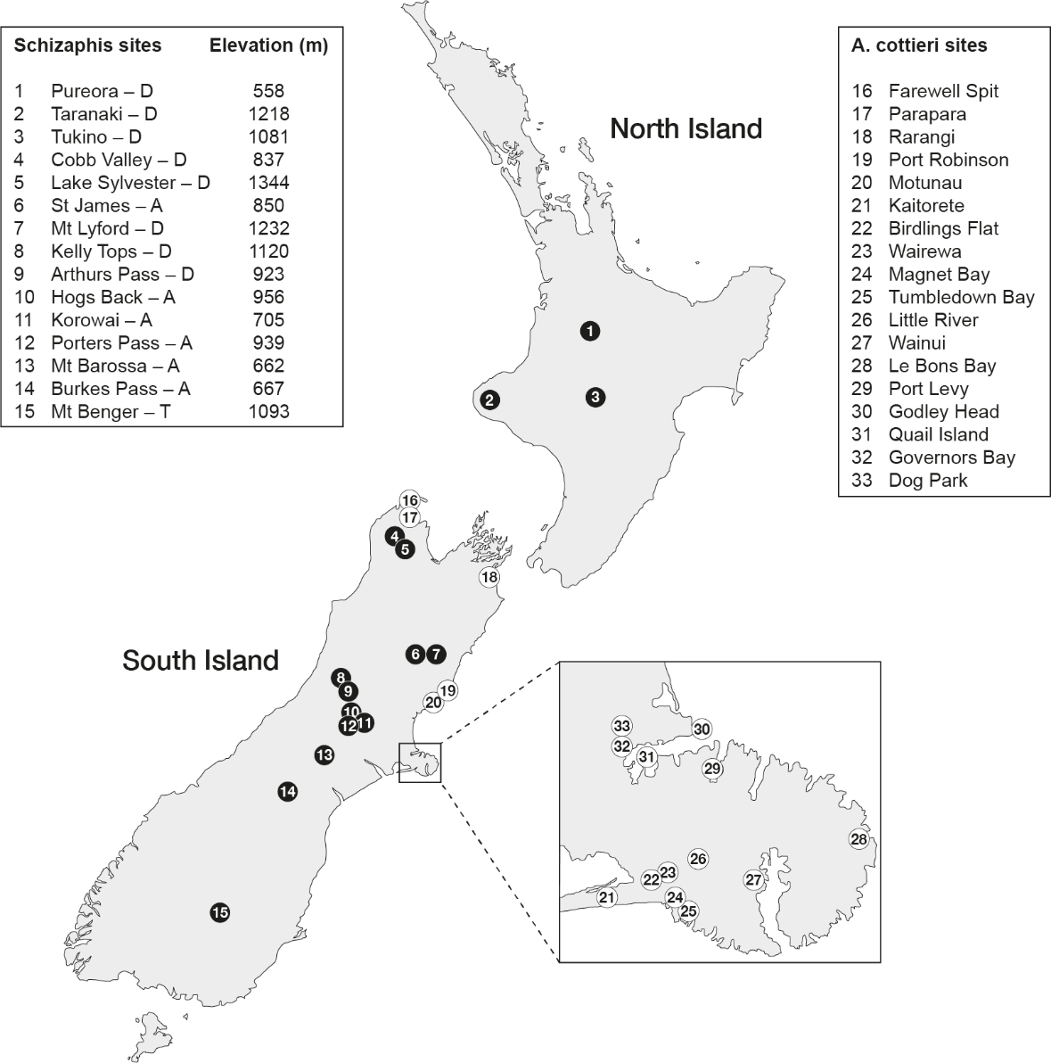

Figure 1. Schizaphis and Aphis cottieri sample sites in New Zealand. D, A or T following the names of Schizaphis sites (left panel) indicate collection from Dracophyllum, Aciphylla or tussock/turf. Inset shows enlargement of Banks Peninsula.

DNA analyses
DNA was extracted from individual aphid legs or whole aphids, using the Sigma Extract-N-Amp Tissue PCR Kit or a CTAB protocol (Russell & Bulman 2005). PCR reactions were 20μl in volume containing either the LCO1490 or C1-J1709 primers in combination with HCO2198 (Folmer et al. 1994; Simon et al. 2006). Samples processed at the Canadian Centre for DNA Barcoding (CCDB), were amplified and sequenced as overlapping fragments with the primers MLepF1/C_LepFolR and C_LepFolF/MEPTR1_t1 according to CCDB protocols (www.boldsystems.org). DNA amplicons were directly sequenced in both directions using the PCR amplification primers.
The PCR primers EF2 (Normark 1999) and EFF (5' ATGGAAATTCGAAACTGCCAAAT 3') were used to amplify the EF1α gene. The PCR primers plus EF2F (5’ CCACCCAGTCGCCCAA 3’) and EF1R (5’ GCACGAAAGCAACAGCAGC 3’) were used to sequence the resulting fragments. Primers other than EF2 were designed in this study.

Data analysis
Cytochrome c oxidase I (COI) sequences were also obtained from additional sources: 1. ‘Aphids of New Zealand’ (RFNZ) (www.boldsystems.org); 2. Scott et al. (2005); and 3. Genbank (Table 1). Reference EF1α sequences were downloaded from Genbank. Sequences were assembled and manually edited in Geneious version 6 (http://www.geneious.com; (Kearse et al. 2012)). The bulk of Schizaphis sequences and trace files were uploaded to the NZAPH project in the BOLD database (www.boldsystems.org) and cross-referenced to GenBank. The remaining Schizaphis sequences (Table 1) were deposited at Genbank under accession numbers KX911835-KX911838, and the Aphidina sequences under MH266483-MH266534. These included the sequences from Scott et al. (2005), which had not previously been made publicly available.
The DNA sequence datasets were aligned using Muscle (Edgar 2004). For displaying the COI sequences, maximum likelihood (ML) phylogenies were constructed with PHYML (Guindon & Gascuel 2003) using the HKY85 substitution model (Hasegawa et al. 1985). For examining the EF1α sequences, we also used Mr Bayes (Huelsenbeck & Ronquist 2001), with the HKY85 substitution model. One thousand bootstraps were completed as a measure of branch support (Felsenstein 1985). Genetic differences between sequences are given as uncorrected p-distances, which have been shown to be suitable for specimen identification in DNA barcoding studies (Collins et al. 2012).
Species delimitations were estimated using the Generalized Mixed Yule-Coalescent (GMYC) model (Fujisawa & Barraclough 2013), using workflows outlined in Michonneau (2017, August). Outgroups and identical sequences were removed before GMYC analyses. Ultrametric trees were constructed with BEAST v. 2.4.6 (Bouckaert et al. 2014), with an HKY+Gamma model. Trees were sampled every 1000 generations, and 10% of trees were discounted as initial burn-in. A Yule prior was chosen. Convergence was checked with Tracer v. 1.6 (http://tree.bio.ed.ac.uk/software/tracer/), while trees were combined with TreeAnnotator (both BEAST packages).

Results

Schizaphis samples were collected from 13 sites throughout New Zealand; colonies on Dracophyllum were located at eight sites (three new, not previously reported) and Aciphylla aphids at six sites (five new) (Table 1). The southern part of South Island was not surveyed for Schizaphis during this study; South Island visits were biased towards regions within a day trip of Christchurch. Dracophyllum aphids were obtained from Canterbury through to north–west Nelson, South Island, and in Taranaki, North Island (Figure 1). No aphids were found at Pureora National Park, where they have previously been located, but a single aphid was collected from Tukino, east of Tongariro National Park, North Island.
While Schizaphis from Dracophyllum have sometimes been described as relatively common (Teulon et al. 2013), our surveying reaffirmed the difficulty of locating these aphids. Insects were few in number and finding them required screening of large numbers of plants. Despite Dracophyllum being a characteristic and abundant member of the flora in alpine and open New Zealand habitats, aphids were found at few locations, and on a small percentage of plants at sites where they were present. For example, insects were found on single Dracophyllum plants at both Lake Sylvester and Kelly Tops, after searching dozens of plants at each site over the course of two afternoons. Several of the populations were found on small Dracophyllum shrubs in elevated alpine sites whereas aphids were not found on larger Dracophyllum plants, lower on the same mountains.
Although it was difficult to quantify our effort, “Aciphylla” aphids appeared more common than those from Dracophyllum. Aphids were present at many sites where clusters of Aciphylla were growing (as opposed to sites with only a few scattered plants), and sizeable colonies of insects were sometimes located by visual inspection of leaves. At Porters Pass and Mt Barossa, aphids were present on multiple plants and colonies frequently numbered many tens of insects. “Aciphylla” aphids were present from September to January whereas we found “Dracophyllum” aphids only in January. Aphids from Aciphylla were found over a much narrower geographic range than from Dracophyllum, with insects collected solely from the Canterbury region (although these sites were distributed across 250 km). Only in Canterbury were we able to find sizeable patches of Aciphylla during the insect collection phase of this project. “Dracophyllum” aphids were mostly found close to the ground in small shrubs, whereas the larger “Aciphylla” aphids were frequently found feeding on exposed surfaces of plants. Winged “Dracophyllum” aphids have only ever been seen in Pureora whereas winged “Aciphylla” aphids were common. Finding New Zealand aphid populations remains very challenging, and this inevitably limits the scope of population genetic studies when compared to some other insect groups.

Aphis cottieri colonies were located at 18 eastern and northern South Island sites from Banks Peninsula to Farewell Spit (Fig 1). In four locations, A. cottieri were collected in multiple years from the same plant or one growing within 1km. Almost all of the A. cottieri samples were from Muehlenbeckia complexa growing a short distance from the sea, at between 1-40m above sea level (Fig. 1). The most elevated site (“Dog Park”), was approximately 240m above sea level. In contrast to other endemic aphids, A. cottieri were easily located and seasonally abundant; multiple colonies, each of tens to hundreds of aphids, were observed on large numbers of plants, at Birdlings Flat, Canterbury, in the autumns of 2013–2017 (Bulman personal observation). Prior to this work, A. cottieri was primarily studied at Kaitorete Spit and Quail Island. The other collection locations reported here are new records.
Populations from other endemic Aphidina species were less commonly discovered than either A. cottieri or Schizaphis spp.. In the period since 2008 (Table 1), eight new collection locations encompassing five aphid species were discovered, including a new host record for Paradoxaphis aristoteliae on Aristotelia fruticosa. Because of the host specificity displayed by New Zealand Aphidina, two samples from native plant genera not known to harbour endemic aphids were considered to be unidentified, probably new species. These were an Aphis sp. from Clematis foetida at Te roto o Wairewa/Lake Forsyth (Canterbury) and an Aphis sp. from Hebe glaucophylla in the Cobb Valley (North-West Nelson). The Hebe aphids have since been seen at the same site over several years but the Clematis aphids were only seen on a single plant in a single year (Teulon et al. 2013).

In total, 48 COI sequences were obtained from New Zealand Schizaphis. ML analysis of these sequences together with those from other Rhopalosiphina (Table1) showed all Schizaphis clustering together, separate from aphids of other genera except Melanaphis luzullela (Hille Ris Lambers), which grouped with Schizaphis graminum (Rondani) (Fig. 2). Melanaphis luzullela was previously seen to cluster within Schizaphis in a multigene phylogenetic analysis (Kim et al. 2011). Consistent with the use of rapidly evolving COI sequences, bootstrap support was negligible for nodes separating the major groups of Schizaphis (Fig. 2). For example, our analysis showed a robust grouping of the non-New Zealand Schizaphis scirpicola Hille Ris Lambers, Schizaphis scirpi (Passerini) and S. rotundiventris, but no support for the placement of this group with respect to the New Zealand Schizaphis (Fig. 2). All but two New Zealand Schizaphis sequences fell into two broad “Dracophyllum” (D1-D3 in Fig. 2) and “Aciphylla” (A1-A2) clades separated by 6.8–10.3% distance (all divergence figures are given as uncorrected p-distances).
Nearly identical COI DNA sequences from Pureora and Tukino Dracophyllum aphids (D4), were very different from those of the other New Zealand Schizaphis. These two insects had no clear affinity to either of the two predominant “Dracophyllum” or “Aciphylla” clades (7.1–9.8% distance between this central North Island lineage and all other New Zealand Schizaphis).
The phylogenetic analyses resulted in a sequence from an undescribed New Zealand tussock/grassland aphid (T1) falling, without support, within the Schizaphis clade (7.8–10.4% divergence to recognised New Zealand Schizaphis). This aphid was collected from Mt Benger (Central Otago), and given a preliminary placement in Rhopalosiphina (Teulon et al. 2013).
There was considerable within-clade variation among the two major “Dracophyllum” and “Aciphylla” groups of aphids. “Dracophyllum” aphids from South Island sites at Cobb Valley, Lake Sylvester, Arthur’s Pass and Kelly Pass, were most closely related to one another (maximum 1.8% divergence; D1 in Fig. 2). North Island Mt Taranaki aphids (D2) and South Island Mt Lyford aphids (D3) formed two clades, respectively 1.5–3.2% and 3.2–5.5% different from the Arthur’s Pass/Cobb Valley aphids. Among the Aciphylla-feeding aphids, there were 14 identical sequences derived from aphids at all six collection sites (A1), but also a second highly distinct clade formed by three aphids (A2) (divergence of 5.7–6.6% between the two). Two of these “A2” aphids were collected from Porters Pass in 2004, while the third insect was collected from Mt Barossa, during the main sampling period of this study.

In total, 40 COI sequences from New Zealand A. cottieri were obtained. No variation was detected between individuals collected from within a colony, with the exception of a Quail Island aphid possessing a single unique nucleotide difference (we no longer have access to the electropherogram to assess the possibility that this is a sequencing error). The sequences from the 18 A. cottieri sites consisted of six haplotypes, varying from one another at only 4/454 nucleotide positions (Fig. 3; Supp. Table 1). The most divergent A. cottieri haplotype, from the Rarangi Beach population in Marlborough, displayed three additional nucleotide differences compared with other populations (max 1.3%). Apart from the Golden Bay samples, there was a suggestion that haplotypes may be separated according to geography; for example, haplotype 1 was found only in the Kaitorete/Birdlings Flat region (Supp. Table 1).
Among the other Aphidina, A. healyi aphids from Dolamore Park (Southland) displayed 3.1-3.3% dissimilarity from three other A. healyi populations that were, in turn, closely related to one another. Intra-specific COI DNA sequence variation in the remaining endemic Aphidina was lower or absent; a difference of 0.8-1.2% between four P. aristoteliae populations was the next highest level of variation within these species.
GMYC analysis of the Schizaphis sequence dataset produced a significant likelihood ratio test value of 0.017. Five maximum likelihood biological entities were predicted among the New Zealand Schizaphis samples (D1+D2, D3, D4, A1 and A2 in Fig. 2). GMYC analysis of the Aphidina dataset produced a non-significant likelihood ratio test result of 0.19. Maximum likelihood entities predicted for this dataset corresponded to each recognised aphid species on a different host plant, with the Dolamore Park A. healyi population representing the only subdivision of these established species. No maximum likelihood entities were predicted among the A. cottieri populations. The GMYC technique calibrates divergence thresholds based on internal comparison of tree structure (Fujisawa & Barraclough 2013). The long branch lengths between recognised New Zealand Aphidina species, coupled with a near absence of variation between populations of these species, presumably provided insufficient information to detect coalescent events (Talavera et al. 2013).
New EF1α sequences were obtained from four samples of endemic Aphidina species. Phylogenetic comparison of these sequences showed that the newly collected Aphis sp. from Clematis grouped within the “Southern Hemisphere cluster” (Kim et al. 2011) of New Zealand species whereas the Aphis sp. from Hebe clustered together with A. coprosmae (Supp. Fig. 1). The A. coprosmae lineage in turn clustered with recently published sequences from Protaphis sp. (Lagos et al. 2014).

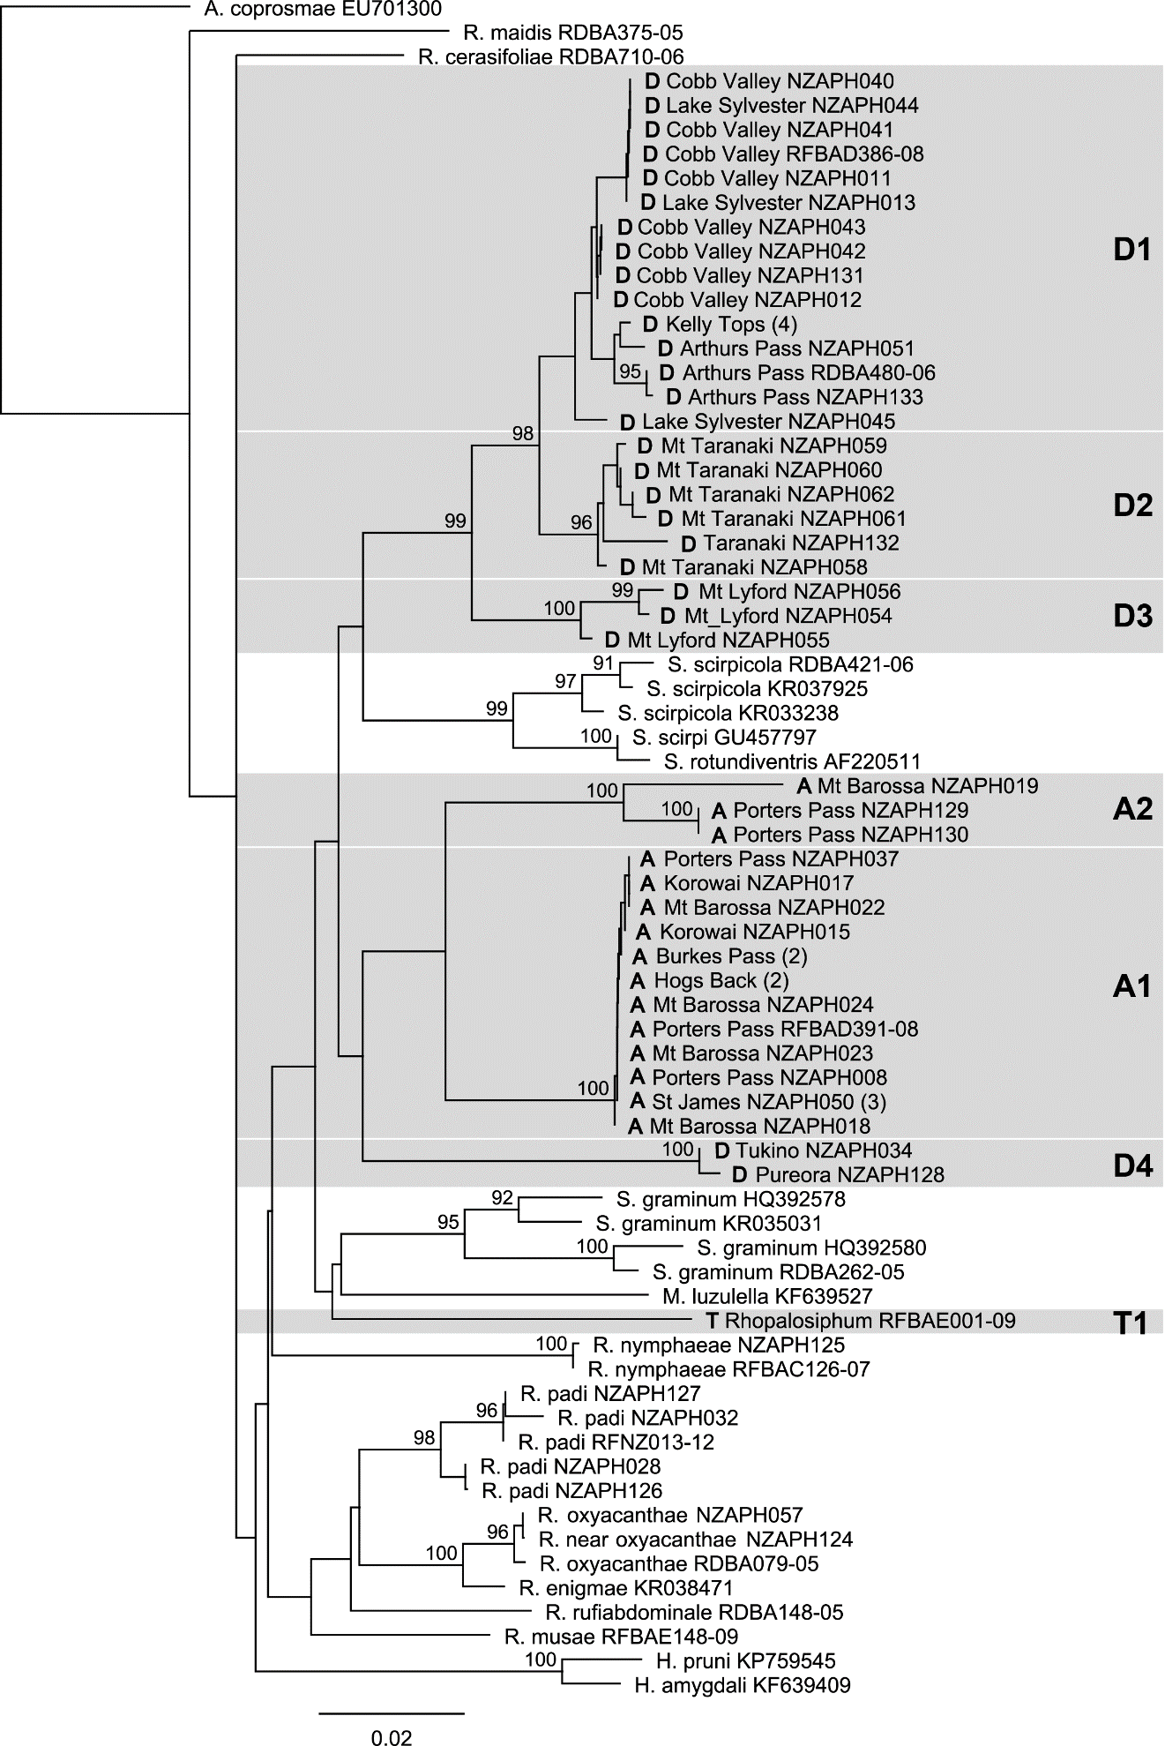
Figure 2. Phylogenetic tree of New Zealand Rhopalosiphina aphids. Cytochrome oxidase I DNA sequences analysed by ML. New Zealand Rhopalosiphina are shown with D (Dracophyllum), A (Aciphylla) or T (tussock-turf) prefixes to indicate plant hosts, followed by the geographical location of samples. Shaded areas annotated with D1-4, A1-2 and T1 represent groups of New Zealand Rhopalosiphina that may constitute distinct genetic lineages. Numbers above branches indicate ML bootstrap values greater than 90%. Numbers in brackets following some sample names indicate multiple identical sequences from individual aphids at a single location.

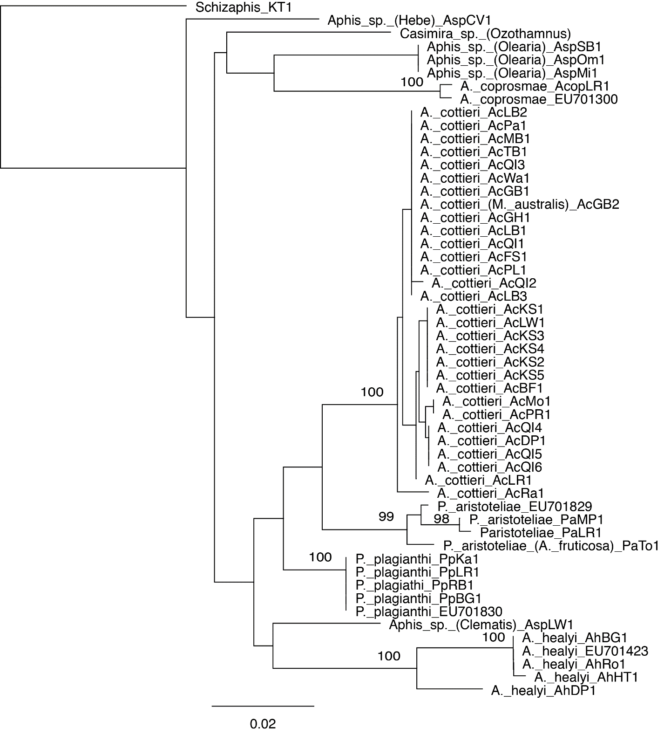

Figure 3. Endemic New Zealand Aphidina phylogeny. Partial cytochrome oxidase I DNA sequences analysed by ML. Species names of aphids are followed by sequence accession numbers (from this study or Genbank). Plant genus/species names in brackets are given for new host records, or for the hosts of new, undescribed species of aphids. Bootstrap values greater than 70% are shown at nodes.
Discussion

Our enlarged sampling of endemic New Zealand aphids has provided evidence of an unrecognised diversity of COI haplotypes in New Zealand Schizaphis. This collection was most extensive for Schizaphis from Dracophyllum. While New Zealand Dracophyllum are morphologically diverse (Wagstaff et al. 2010), the variation among Schizaphis collected from this genus seemed driven by geographic separation, with sequences clustering together according to geographical origin. Schizaphis COI DNA sequences from Pureora and Tukino (70km apart) Dracophyllum, showed that these aphids formed a highly divergent lineage from other New Zealand Schizaphis. This confirmed unpublished observations implying a third New Zealand Schizaphis lineage (Teulon et al. 2013). Among the other “Dracophyllum” Schizaphis populations, the South Island aphids from Cobb Valley, Lake Sylvester, Kelly Range and Arthur’s Pass were most closely related to one another. These samples derived from two pairs of sites from mid-South Island and north–west South Island, separated by approximately 400km of mountain range. This South Island group was genetically related to, but distinct from a population found in Taranaki, an observation consistent with the connection of the southern portion of North Island to upper South Island from the Miocene to as late as 1 Ma (Bunce et al. 2009). Many insect taxa display a linkage between current day populations in these two regions (Marske et al. 2011; Trewick & Bland 2012).
Surprisingly, Mt Lyford “Dracophyllum” aphids were more genetically distant from the other South Island aphids than were the Taranaki aphids. Some alpine New Zealand insect taxa show low levels of gene flow between populations, indicative of refugia on mountain ranges (Chinn & Gemmell 2004; Buckley & Simon 2007; O'Neill et al. 2009); variation at the Mt Lyford site might reflect separation of this population away from the main mountain divide populations. In past years, “Dracophyllum” Schizaphis have been found at Mt Isobel (Teulon et al. 2013), between Mt Lyford and the main divide, but we were not able to find any aphids at this site during our study. More intensive sampling from Dracophyllum on the Kaikoura ranges and Marlborough would illuminate the degree of Schizaphis diversity in eastern South Island.

Within the Aciphylla-hosted Schizaphis, two highly divergent lineages were revealed by our analyses. In contrast to observations of “Dracophyllum” Schizaphis populations, these “Aciphylla” aphids showed a sympatric distribution with one lineage more rarely detected in this study. Denser screening of known populations by DNA barcoding is required to understand the abundance of this uncommon lineage.

Intra-specific genetic divergences within New Zealand Schizaphis were high compared with variation seen in global surveys of aphids. Previous study of Aphididae COI sequences (Foottit et al. 2008) showed that within-species Kimura two-parameter distances (K2P) were usually less than 0.4%. In taxa such as Myzus cerasi, Macrosiphum euphorbiae and Neomyzus circumflexus, divergence was >1%, but the 3.14% variation observed in N. circumflexus was thought likely to indicate the presence of undescribed taxa. Among congeneric Aphidinae, divergence ranged from 0.46 to 11.3%, and from 0.96 to 8.27% between seven species of Rhopalosiphum (Foottit et al. 2008). K2P corrected distances have been shown to be close to p-distances up to 10% variation for COI (Collins et al. 2012). In this context, it appears that rather than two putative endemic Schizaphis species in New Zealand, there may be several undescribed species. With a discrete phylogenetic clustering, and divergence comparable to that between the main Aciphylla and Dracophyllum lineages, the central North Island aphids represent a distinct Schizaphis lineage. At a minimum of 3.2% distance, the Mt Lyford population also appears a strong candidate as a separate lineage. The status of the Taranaki aphids is more questionable; they are separated from other populations by a greater COI genetic distance than most other Aphididae species and semi-automated Barcode Index Number clustering (Ratnasingham & Hebert 2013) suggests they are a distinct group. Nevertheless, while GMYC analysis (Fujisawa & Barraclough 2013) of the Schizaphis dataset supported the North Island and Mt Lyford populations as distinct biological entities, it did not separate the Taranaki population from those on the main mountain ranges of South Island. As such, there is a case for proposing that there are up to three Schizaphis lineages on Dracophyllum and two cryptic Schizaphis lineages from Aciphylla within our collection. Separation of the Aciphylla lineages was also supported in the GMYC analysis. Confirming the boundaries between New Zealand Schizaphis lineages will require analysis of DNA sequences from additional genes.
Schizaphis COI variation was also high compared with endemic New Zealand Aphidina species, where, with the exception of a Southland A. healyi population, intra-species variation was relatively low or absent. For A. cottieri, we report a substantially increased number of known populations, but little intra-specific variation, with insects from Golden Bay having the same COI haplotype as those from Banks Peninsula. It nevertheless remains premature to draw firm conclusions about the relative population structures of endemic Schizaphis and Aphidina, given the variation in our sample sizes and distributions. Even for A. cottieri, where sampling sites spanned 360 km, the total collection was from a limited section of New Zealand, with no North Island or lower and inland South Island samples, where our searches were less extensive but where aphids have been historically collected (Teulon et al. 2013). The low variation observed for A. cottieri may be related to the location of these populations immediately adjacent to the coast, providing reduced dispersal barriers.

The presence of New Zealand Schizaphis on dicotyledonous hosts is enigmatic. There are very few examples of Rhopalosiphina feeding on dicotyledonous plants worldwide, giving no clear clues as to the origin of the New Zealand aphids. There are also no known Schizaphis native to Australia or New Caledonia, a source of dispersals to New Zealand by mobile and easily windborne insects such as aphids (Withers 2001; Munoz et al. 2004; Irwin et al. 2007). It is possible that Schizaphis ancestors independently dispersed from Australian Dracophyllum and Aciphylla hosts, but their aphid descendants are no longer to be found in Australia due to climatic changes. Conversely, the Schizaphis lineages may have evolved from a monocot-feeding New Zealand ancestor such as the Mt Benger aphid. An estimated divergence of 17 Ma for the two main New Zealand Schizaphis lineages (Kim et al. 2011) predates estimates from other studies for the colonisation of New Zealand by Aciphylla and Dracophyllum; New Zealand Dracophyllum species diverged from phylogenetically deep relict lineages in eastern Australia about 6.8 Ma, while Aciphylla diverged from overseas species approximately 8.4 Ma (Spalik et al. 2010; Wagstaff et al. 2010; Tanentzap et al. 2015). Alternatively, if the uncorrected rate of COI divergence in New Zealand Schizaphis has been near the Brower rate of 2.3% My⁻¹ (Brower 1994), the sequence difference between the main Schizaphis lineages reported here would be more consistent with their separation 4–5 Ma, coincident with Pliocene climate cooling, mountain uplift in New Zealand (Heenan & McGlone 2013), and with diversification of their hosts. These questions cannot be resolved with COI sequences alone, however, we were unable to obtain EF1α amplification from the key Schizaphis lineages described here, possibly due to the transport of the DNAs between Canada and New Zealand.
Generation of new EF1α DNA sequences did show that the undescribed Aphis sp. from Hebe was likely a sister taxon to A. coprosmae, whereas the new Aphis sp. from Clematis fell within the “Southern Hemisphere” Aphis radiation (Kim et al. 2011). Although we did not obtain EF1α sequence from the undescribed Aphis sp. from Olearia, analysis of COI sequences from this species hinted that it too may belong to the A. coprosmae lineage. If confirmed, the addition of two new aphid species to the formerly monotypic A. coprosmae lineage would change our view of endemic aphid evolution within New Zealand.

Concluding remarks
This study has revealed formerly unrecognised genetic diversity among New Zealand Schizaphis populations, and presented genetic data from newly discovered species of endemic Aphidina. This provides baseline information for fresh hypotheses about the evolution of New Zealand Schizaphis. For example, targeted sampling and new analyses may allow the delineation of genetic and geographical boundaries for Schizaphis from central North Island and eastern South Island Dracophyllum. Our discovery of two new Aphidina species, with limited known distributions, and from plant species not recognised as hosts to endemic aphids, further suggests that significant endemic aphid diversity may yet be discovered in New Zealand. In particular, searches may focus on southern South Island and the entire North Island, where sampling for New Zealand aphids has been most limited.

Table 1. Aphid sample details. Samples from countries other than New Zealand represent sequences used for comparisons of the Schizaphis dataset. $ = dates for sample collections; - = unknown. * = accession numbers from Genbank, BOLD or PFR. # PFR = Plant and Food Research, or GB = Genbank, or Boldsystems collections (SANZ = Soil Aphids of New Zealand, RFNZ = Aphids of New Zealand and BA = Barcoding the Aphididae).

Genus/Species | Location | Date$ | Accession* | Source#
Hyalopterus pruni | India | - | KP759545 | GB
Hyalopterus amygdali | France | - | KF639409 | GB
Melanaphis luzulella | France | - | KF639527 | GB
Rhopalosiphum cerasifoliae | Canada | - | RDBA710-06 | BA
Rhopalosiphum enigma | Canada | - | KR038471 | GB
Rhopalosiphum maidis | Canada | - | RDBA375-05 | BA
Rhopalosiphum musae | Waiatarua Res | - | RFBAE148-09 | RFNZ
Rhopalosiphum nymphaeae | Christchurch | - | NZAPH125 | SANZ
Rhopalosiphum near oxyacanthae | Geraldine | - | NZAPH124 | SANZ
Rhopalosiphum oxyacanthae | Tongariro | 2014 | NZAPH057 | SANZ
Rhopalosiphum oxyacanthae | Canada | - | RDBA079-05 | BA
Rhopalosiphum padi | Pureora | 2000 | NZAPH032 | SANZ
Rhopalosiphum padi | AgResearch | 2014 | NZAPH028 | SANZ
Rhopalosiphum padi | Mt Wellington | - | RFNZ013-12 | RFNZ
Rhopalosiphum rufiabdominale | Canada | - | RDBA148-05 | BA
Rhopalosiphum sp. | Mt Benger | 2003 | RFBAE001-09 | RFNZ
Schizaphis graminum | USA | - | HQ392578 | GB
Schizaphis graminum | USA | - | HQ392580 | GB
Schizaphis rotundiventris | Japan | - | AF220511 | GB
Schizaphis scirpicola | Canada | - | KR037925 | GB
Schizaphis scirpicola | Canada | - | KR033238 | GB
Schizaphis scirpicola | Canada | - | RDBA421-06 | BA
Schizaphis scirpi | Korea | - | GU457797 | GB
Schizaphis sp. Aciphylla | Porters Pass | 2004 | NZAPH129 | SANZ
Schizaphis sp. Aciphylla | Porters Pass | 2004 | NZAPH130 | SANZ
Schizaphis sp. Aciphylla | Porters Pass | - | RFBAD391-08 | RFNZ
Schizaphis sp. Aciphylla | Porters Pass | 2014 | NZAPH037 | SANZ
Schizaphis sp. Aciphylla | Porters Pass | 2014 | NZAPH008 | SANZ
Schizaphis sp. Aciphylla | Korowai | 2014 | NZAPH015 | SANZ
Schizaphis sp. Aciphylla | Korowai | 2014 | NZAPH017 | SANZ
Schizaphis sp. Aciphylla | Mt Barossa | 2014 | NZAPH018 | SANZ
Schizaphis sp. Aciphylla | Mt Barossa | 2014 | NZAPH019 | SANZ
Schizaphis sp. Aciphylla | Mt Barossa | 2014 | NZAPH022 | SANZ
Schizaphis sp. Aciphylla | Mt Barossa | 2014 | NZAPH023 | SANZ
Schizaphis sp. Aciphylla | Mt Barossa | 2014 | NZAPH024 | SANZ
Schizaphis sp. Aciphylla | St. James | 2014 | NZAPH050 | SANZ
Schizaphis sp. Aciphylla | St. James | 2014 | SJ1 | PFR
Schizaphis sp. Aciphylla | St. James | 2014 | SJ2 | PFR
Schizaphis sp. Aciphylla | Burkes Pass | 2015 | BP1 | PFR
Schizaphis sp. Aciphylla | Burkes Pass | 2015 | BP2 | PFR
Schizaphis sp. Aciphylla | Hogs Back | 2016 | HB1 | PFR
Schizaphis sp. Aciphylla | Hogs Back | 2016 | HB2 | PFR
Schizaphis sp. Dracophyllum | Pureora | 2000 | NZAPH128 | SANZ
Schizaphis sp. Dracophyllum | Tukino | 2014 | NZAPH034 | SANZ
Schizaphis sp. Dracophyllum | Cobb Valley | 2014 | NZAPH011 | SANZ
Schizaphis sp. Dracophyllum | Cobb Valley | 2014 | NZAPH012 | SANZ
Schizaphis sp. Dracophyllum | Cobb Valley | 2014 | NZAPH040 | SANZ
Schizaphis sp. Dracophyllum | Cobb Valley | 2014 | NZAPH041 | SANZ
Schizaphis sp. Dracophyllum | Cobb Valley | 2014 | NZAPH042 | SANZ
Schizaphis sp. Dracophyllum | Cobb Valley | 2014 | NZAPH043 | SANZ
Schizaphis sp. Dracophyllum | Cobb Valley | 2008 | NZAPH131 | SANZ
Schizaphis sp. Dracophyllum | Cobb Valley | 2008 | RFBAD386-0 | RFNZ
Schizaphis sp. Dracophyllum | Lake Sylvester | 2014 | NZAPH013 | SANZ
Schizaphis sp. Dracophyllum | Lake Sylvester | 2014 | NZAPH044 | SANZ
Schizaphis sp. Dracophyllum | Lake Sylvester | 2014 | NZAPH045 | SANZ
Schizaphis sp. Dracophyllum | Mt Lyford | 2015 | NZAPH054 | SANZ
Schizaphis sp. Dracophyllum | Mt Lyford | 2015 | NZAPH055 | SANZ
Schizaphis sp. Dracophyllum | Mt Lyford | 2015 | NZAPH056 | SANZ
Schizaphis sp. Dracophyllum | Taranaki | 2015 | NZAPH058 | SANZ
Schizaphis sp. Dracophyllum | Taranaki | 2015 | NZAPH059 | SANZ
Schizaphis sp. Dracophyllum | Taranaki | 2015 | NZAPH060 | SANZ
Schizaphis sp. Dracophyllum | Taranaki | 2015 | NZAPH061 | SANZ
Schizaphis sp. Dracophyllum | Taranaki | 2015 | NZAPH062 | SANZ
Schizaphis sp. Dracophyllum | Taranaki | 1998 | NZAPH132 | SANZ
Schizaphis sp. Dracophyllum | Arthur's Pass | 2005 | NZAPH133 | SANZ
Schizaphis sp. Dracophyllum | Arthur's Pass | 2014 | NZAPH051 | SANZ
Schizaphis sp. Dracophyllum | Arthur's Pass | 1998 | EU701901 | GB
Schizaphis sp. Dracophyllum | Kelly Tops | 2016 | KT1 | PFR
Schizaphis sp. Dracophyllum | Kelly Tops | 2016 | KT2 | PFR
Schizaphis sp. Dracophyllum | Kelly Tops | 2016 | KT3 | PFR
Schizaphis sp. Dracophyllum | Kelly Tops | 2016 | KT4 | PFR
Aphis coprosmae | Nelson Lakes | - | EU701300 | GB
Aphis coprosmae (C. rubra) | Little River | 2008 | AcopLR1 | PFR
Aphis cottieri | Kaitorete | 2001 | AcKS1 | PFR
Aphis cottieri | Kaitorete | 2004 | AcKS2 | PFR
Aphis cottieri | Kaitorete | 2005 | AcKS3 | PFR
Aphis cottieri | Kaitorete | 2005 | AcKS4 | PFR
Aphis cottieri | Kaitorete | 2015 | AcKS5 | PFR
Aphis cottieri | Quail Island | 2001 | AcQI1 | PFR
Aphis cottieri | Quail Island | 2001 | AcQI2 | PFR
Aphis cottieri | Quail Island | 2007 | AcQI3 | PFR
Aphis cottieri | Quail Island | 2007 | AcQI4 | PFR
Aphis cottieri | Quail Island | 2013 | AcQI5 | PFR
Aphis cottieri | Quail Island | 2014 | AcQI6 | PFR
Aphis cottieri | Le Bons Bay | 2006 | AcLB1 | PFR
Aphis cottieri | Le Bons Bay | 2010 | AcLB2 | PFR
Aphis cottieri | Le Bons Bay | 2015 | AcLB3 | PFR
Aphis cottieri | Dog Park | 2010 | AcDP1 | PFR
Aphis cottieri | Wairewa | 2010 | AcLW1 | PFR
Aphis cottieri | Motunau | 2010 | AcMo1 | PFR
Aphis cottieri | Governors Bay | 2010 | AcGB1 | PFR
Aphis cottieri | Governors Bay | 2010 | AcGB2 | PFR
Aphis cottieri | Port Levy | 2010 | AcPL1 | PFR
Aphis cottieri | Godley Head | 2010 | AcGH1 | PFR
Aphis cottieri | Tumbledown Bay | 2010 | AcTB1 | PFR
Aphis cottieri | Magnet Bay | 2010 | AcMB1 | PFR
Aphis cottieri | Wainui | 2011 | AcWa1 | PFR
Aphis cottieri | Rarangi | 2011 | AcRa1 | PFR
Aphis cottieri | Port Robinson | 2012 | AcPR1 | PFR
Aphis cottieri | Parapara | 2012 | AcPa1 | PFR
Aphis cottieri | Little River | 2015 | AcLR1 | PFR
Aphis cottieri | Farewell Spit | 2015 | AcFS1 | PFR
Aphis cottieri | Birdlings Flat | 2016 | AcBF1 | PFR
Aphis sp. (Clematis) | Wairewa | 2008 | AspLW1 | PFR
Aphis sp. (Hebe) | Cobb Valley | 2008 | AspCV1 | PFR
Aphis sp. (Olearia) | Middlemarch | 2008 | AspMi1 | PFR
Aphis sp. (Olearia) | St. Bathans | 2008 | AspSB1 | PFR
Aphis sp. (Olearia) | Omarama | 2008 | AspOm1 | PFR
Aphis healyi | HihiTahi | - | EU701423 | GB
Aphis healyi | HihiTahi | 2000 | AhHT1 | PFR
Aphis healyi | Dolamore Park | 2000 | AhDP1 | PFR
Aphis healyi | Blue-green River | 2003 | AhBR1 | PFR
Aphis healyi | Lake Rotoiti | 2016 | AhLR1 | PFR
Paradoxaphis aristoteliae | Hokonui | - | EU701829 | GB
Paradoxaphis aristoteliae | Little River | 2011 | PaLR1 | PFR
Paradoxaphis aristoteliae | Little River | 2012 | PaLR2 | PFR
Paradoxaphis aristoteliae | Little River | 2016 | PaLR3 | PFR
Paradoxaphis aristoteliae (A. fruticosa) | Torlesse | 2013 | PaTo1 | PFR
Paradoxaphis aristoteliae | Montgomery Park | 2015 | PaHo1 | PFR
Paradoxaphis plagianthi | Botanic Gardens | 2000 | PpBG1 | PFR
Paradoxaphis plagianthi | Riccarton Bush | - | EU701830 | GB
Paradoxaphis plagianthi | Riccarton Bush | 2004 | PpRB1 | PFR
Paradoxaphis plagianthi | Little River | 2012 | PpLR1 | PFR
Paradoxaphis plagianthi | Kaituna | 2013 | PpKa1 | PFR
Casimira sp. (Ozothamnus) | Catlins | - | CaCa1 | PFR

Supplementary information

Supplementary Table 1. Aphis cottieri cytochrome c oxidase haplotypes (Hap). Location/sequence = site where samples were collected and sequence accessions. ^{N} = variable nucleotide positions between populations, numbered from the 3’ end of the C1-J1709 PCR primer in the COI fragment. Numbers in [ ] = nucleotide differences present only in a single population or individual aphid. * = sequence containing possible sequencing error.

Location/sequence | Date | Nucleotide positions ^{N} | Hap
Kaitorete Spit AcKS1 | 2001 | 94C, 118G, 295C, 424G | 1
Kaitorete Spit AcKS2 | 2004 | 94C, 118G, 295C, 424G | 1
Kaitorete Spit AcKS3 | 2005 | 94C, 118G, 295C, 424G | 1
Kaitorete Spit AcKS4 | 2005 | 94C, 118G, 295C, 424G | 1
Kaitorete Spit AcKS5 | 2015 | 94C, 118G, 295C, 424G | 1
Lake Wairewa AcLW1 | 2010 | 94C, 118G, 295C, 424G | 1
Birdlings Flat AcBF1 | 2016 | 94C, 118G, 295C, 424G | 1
Motunau AcMo1 | 2010 | 94C, 118G, 295C, 424A | 2
Port Robinson AcPR1 | 2012 | 94C, 118G, 295C, 424A | 2
Quail Island AcQI4 | 2007 | 94C, 118G, 295T, 424A | 3
Quail Island AcQI5 | 2013 | 94C, 118G, 295T, 424A | 3
Quail Island ACQI6 | 2014 | 94C, 118G, 295T, 424A | 3
Dog Park AcDP1 | 2010 | 94C, 118G, 295T, 424A | 3
Little River AcLR1 | 2015 | 94C, 118G, 295T, 424G | 4
Quail Island AcQI1 | 2001 | 94A, 118A, 295T, 424G | 5
Quail Island AcQI2 | 2001 | 94A, 118A, 295T, 424G [65T] | 5*
Quail Island AcQI3 | 2007 | 94A, 118A, 295T, 424G | 5
Governors Bay AcGB2 | 2010 | 94A, 118A, 295T, 424G | 5
Governors Bay AcGB1 | 2010 | 94A, 118A, 295T, 424G | 5
Le Bons Bay AcLB1 | 2006 | 94A, 118A, 295T, 424G | 5
Le Bons Bay AcLB2 | 2010 | 94A, 118A, 295T, 424G | 5
Le Bons Bay AcLB3 | 2015 | 94A, 118A, 295T, 424G | 5
Port Levy AcPL1 | 2010 | 94A, 118A, 295T, 424G | 5
Godley Head AcGH1 | 2010 | 94A, 118A, 295T, 424G | 5
Wainui AcWa1 | 2011 | 94A, 118A, 295T, 424G | 5
Tumbledown Bay AcTB1 | 2010 | 94A, 118A, 295T, 424G | 5
Magnet Bay AcMB1 | 2010 | 94A, 118A, 295T, 424G | 5
Parapara AcPa1 | 2012 | 94A, 118A, 295T, 424G | 5
Farewell Spit AcFS1 | 2015 | 94A, 118A, 295T, 424G | 5
Rarangi AcRa1 | 2011 | 94A, 118G, 295T, 424G [193T, 247T, 385C] | 6

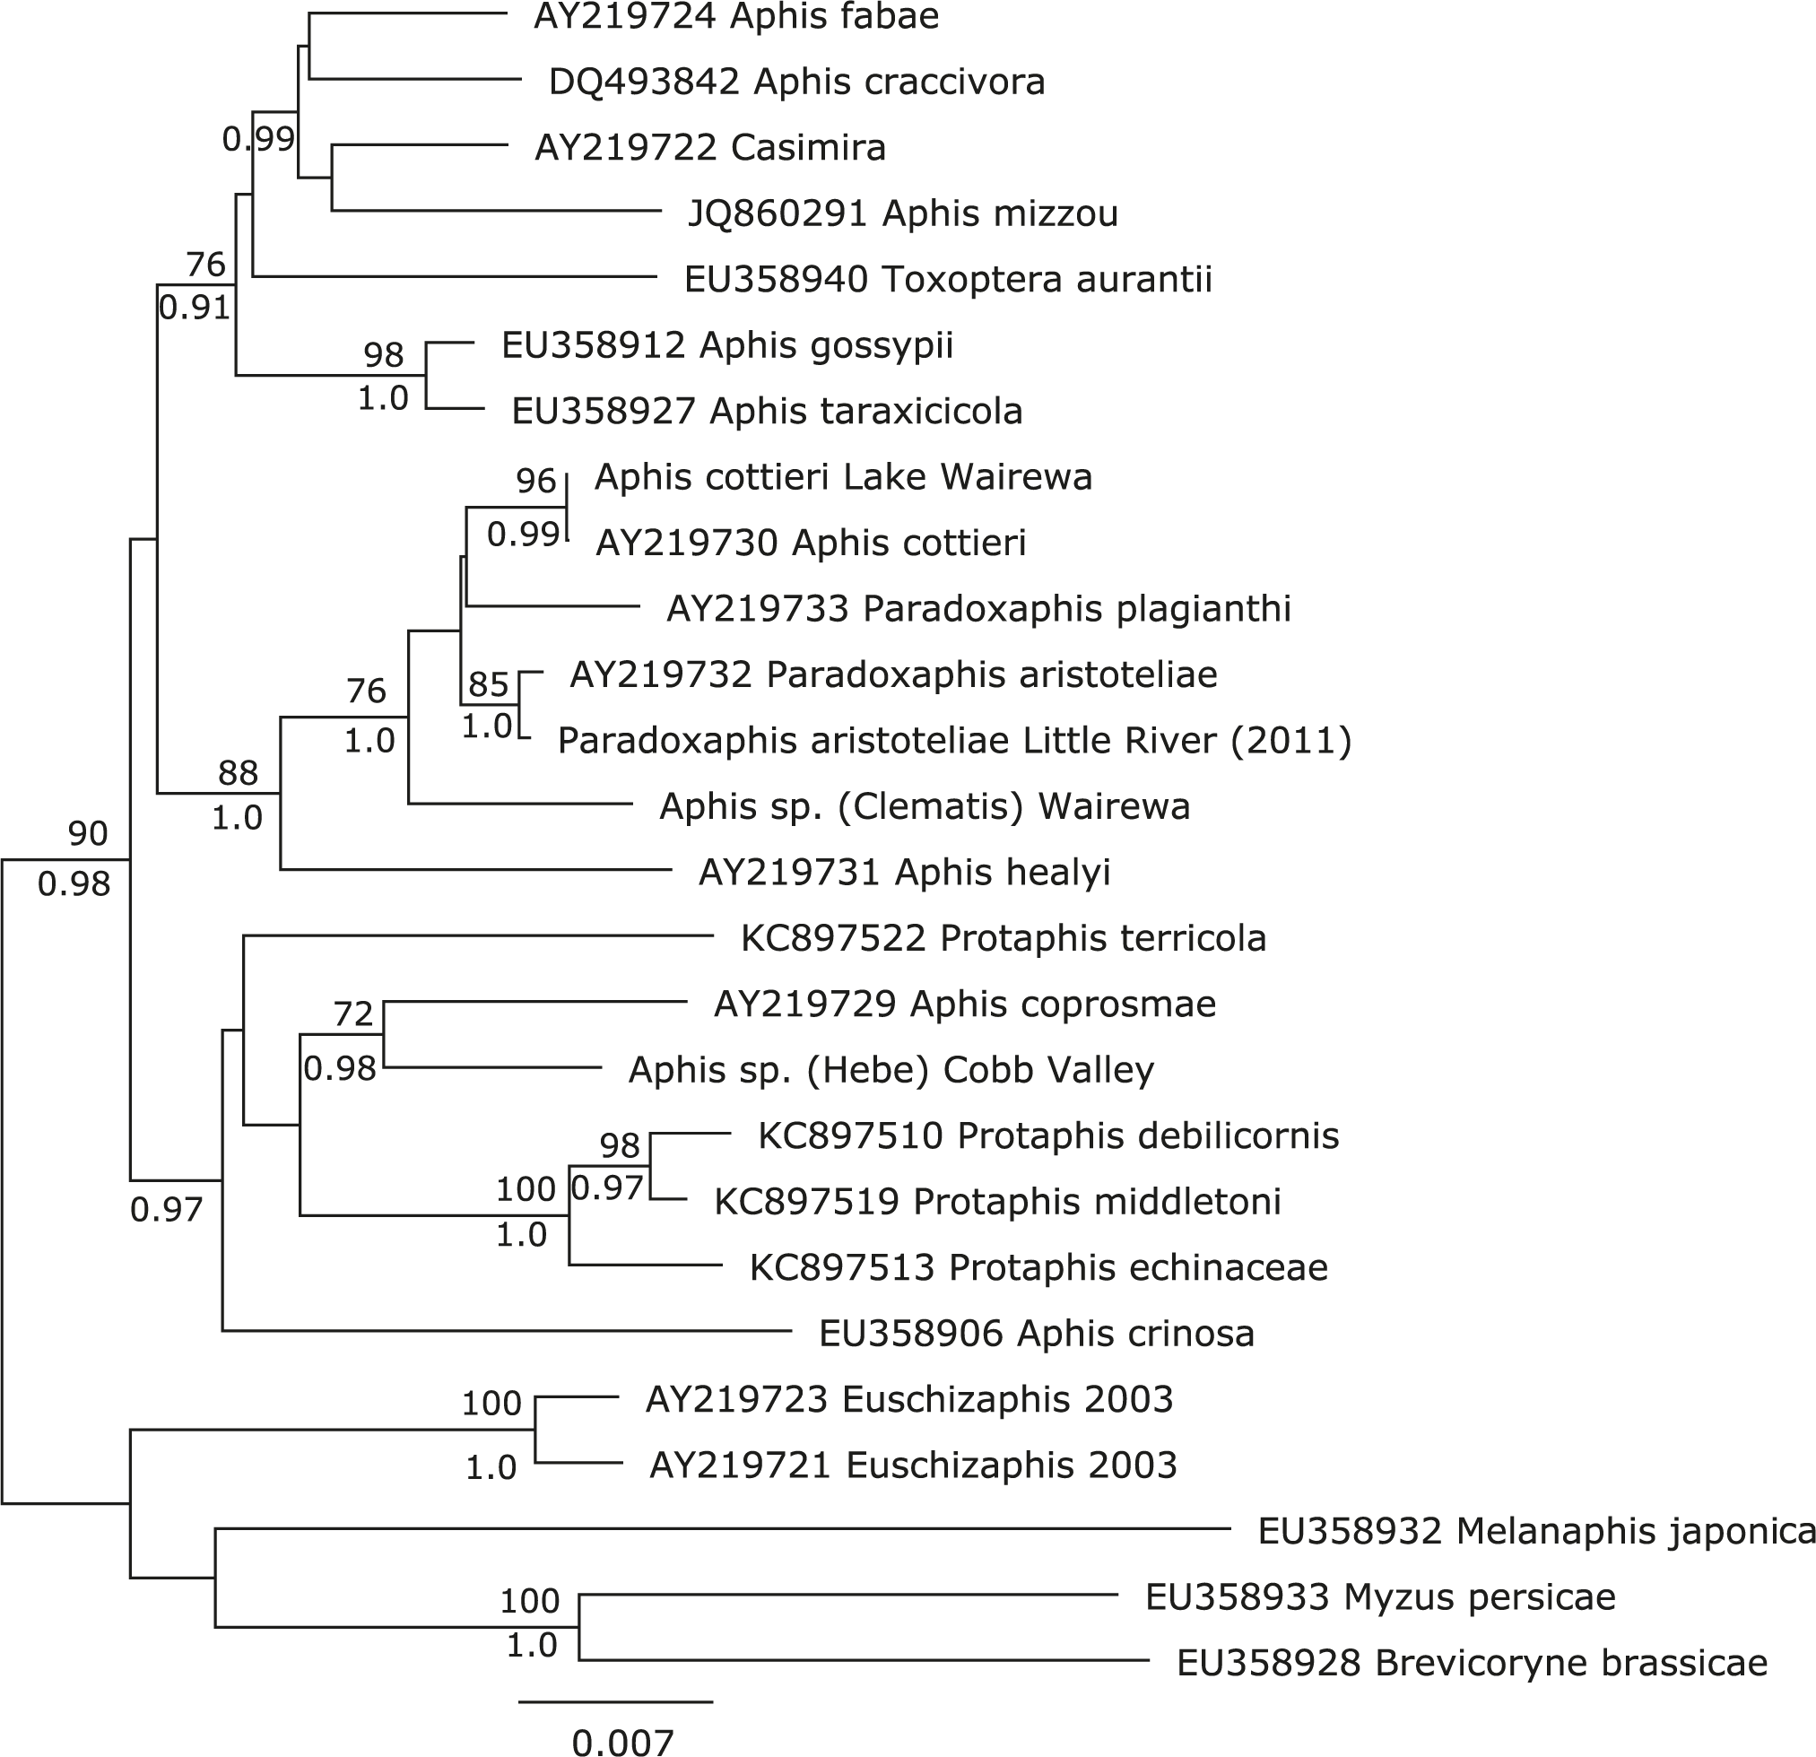

Supplementary Figure 1. Phylogenetic tree of New Zealand Aphidina aphids. Elongation factor 1α DNA sequences analysed by ML. Accession numbers are shown before sequences from Genbank. Numbers above branches indicate ML bootstrap values greater than 70%, numbers below branches indicate posterior probabilities from Mr Bayes analysis.

Acknowledgements. Angela Brandt provided highly useful discussions on the evolution of New Zealand plants. This study was partly funded by Plant and Food Research using core funding aligned to the Better Border Biosecurity programme (www.b3nz.org).

References

Blackman RL, Eastop VF 2006. Aphids on the World's Herbaceous Plants and Shrubs. Chichester, UK, John Wiley & Sons. 1460 p.
Bouckaert R, Heled J, Kuhnert D, Vaughan T, Wu CH, Xie D, Suchard MA, Rambaut A, Drummond AJ 2014. BEAST 2: a software platform for Bayesian evolutionary analysis. PLoS Comput Biol 10: e1003537.
Brower AVZ 1994. Rapid morphological radiation and convergence among races of the butterfly heliconius-erato inferred from patterns of mitochondrial-dna evolution. Proceedings of the National Academy of Sciences of the United States of America 91: 6491-6495.
Buckley TR, Simon C 2007. Evolutionary radiation of the cicada genus Maoricicada Dugdale (Hemiptera : Cicadoidea) and the origins of the New Zealand alpine biota. Biological Journal of the Linnean Society 91: 419-435.
Buckley TR, Krosch M, Leschen RAB 2015. Evolution of New Zealand insects: summary and prospectus for future research. Austral Entomology 54: 1-27.
Bunce M, Worthy TH, Phillips MJ, Holdaway RN, Willerslev E, Haile J, Shapiro B, Scofield RP, Drummond A, Kamp PJJ and others 2009. The evolutionary history of the extinct ratite moa and New Zealand Neogene paleogeography. Proceedings of the National Academy of Sciences of the United States of America 106: 20646-20651.
Chinn WG, Gemmell NJ 2004. Adaptive radiation within New Zealand endemic species of the cockroach genus Celatoblatta Johns (Blattidae): a response to Plio-Pleistocene mountain building and climate change. Molecular Ecology 13: 1507-1518.
Collins RA, Boykin LM, Cruickshank RH, Armstrong KF 2012. Barcoding's next top model: an evaluation of nucleotide substitution models for specimen identification. Methods in Ecology and Evolution 3: 457-465.
Edgar RC 2004. MUSCLE: a multiple sequence alignment method with reduced time and space complexity. Bmc Bioinformatics 5: 1-19.
Felsenstein J 1985. Confidence-limits on phylogenies - an approach using the bootstrap. Evolution 39: 783-791.
Folmer O, Black M, Hoeh W, Lutz R, Vrijenhoek R 1994. DNA primers for amplification of mitochondrial cytochrome c oxidase subunit I from diverse metazoan invertebrates. Molecular marine biology and biotechnology 3: 294-9.
Foottit RG, Maw HEL, Von Dohlen CD, Hebert PDN 2008. Species identification of aphids (Insecta: Hemiptera: Aphididae) through DNA barcodes. Molecular Ecology Resources 8: 1189-1201.
Fujisawa T, Barraclough TG 2013. Delimiting Species Using Single-Locus Data and the Generalized Mixed Yule Coalescent Approach: A Revised Method and Evaluation on Simulated Data Sets. Systematic Biology 62: 707-724.
Guindon S, Gascuel O 2003. A simple, fast, and accurate algorithm to estimate large phylogenies by maximum likelihood. Systematic Biology 52: 696-704.
Hasegawa M, Kishino H, Yano T-a 1985. Dating of the human-ape splitting by a molecular clock of mitochondrial DNA. Journal of Molecular Evolution 22: 160-174.
Heenan PB, McGlone MS 2013. Evolution of New Zealand alpine and open-habitat plant species during the late Cenozoic. New Zealand Journal of Ecology 37: 105-113.
Huelsenbeck JP, Ronquist F 2001. MRBAYES: Bayesian inference of phylogenetic trees. Bioinformatics 17: 754-5.
Irwin ME, Kampmeier GE, Weisser WW 2007. 7 Aphid Movement: Process and Consequences. In: van Emden H, Harrington R eds. Aphids as crop pests. UK, CAB International. Pp. 153-186.
Kean J, Stufkens M 2005. Phenology, population ecology, and rarity of the New Zealand ribbonwood aphid, Paradoxaphis plagianthi. New Zealand Journal of Zoology 32: 143-153.
Kearse M, Moir R, Wilson A, Stones-Havas S, Cheung M, Sturrock S, Buxton S, Cooper A, Markowitz S, Duran C and others 2012. Geneious Basic: An integrated and extendable desktop software platform for the organization and analysis of sequence data. Bioinformatics 28: 1647-1649.
Kim H, Lee S, Jang Y 2011. Macroevolutionary patterns in the Aphidini aphids (Hemiptera: Aphididae): diversification, host association, and biogeographic origins. PLoS One 6: e24749.
Lagos DM, Voegtlin DJ, Coeur d'acier A, Giordano R 2014. Aphis (Hemiptera: Aphididae) species groups found in the Midwestern United States and their contribution to the phylogenetic knowledge of the genus. Insect Sci 21: 374-91.
Marske KA, Leschen RAB, Buckley TR 2011. Reconciling phylogeography and ecological niche models for New Zealand beetles: Looking beyond glacial refugia. Molecular Phylogenetics and Evolution 59: 89-102.
Michonneau F 2017, August. Using GMYC for species delineation. Zenodo.
Munoz J, Felicisimo AM, Cabezas F, Burgaz AR, Martinez I 2004. Wind as a long-distance dispersal vehicle in the Southern Hemisphere. Science 304: 1144-1147.
Normark BB 1999. Evolution in a putatively ancient asexual aphid lineage: Recombination and rapid karyotype change. Evolution 53: 1458-1469.
O'Neill SB, Buckley TR, Jewell TR, Ritchie PA 2009. Phylogeographic history of the New Zealand stick insect Niveaphasma annulata (Phasmatodea) estimated from mitochondrial and nuclear loci. Mol Phylogenet Evol 53: 523-36.
Radford EA, Watson MF, Preston J 2001. Phylogenetic relationships of species of Aciphylla (Apiaceae, subfamily Apioideae) and related genera using molecular, morphological, and combined data sets. New Zealand Journal of Botany 39: 183-208.
Ratnasingham S, Hebert PDN 2013. A DNA-Based Registry for All Animal Species: The Barcode Index Number (BIN) System. PLoS ONE 8: e66213.
Russell J, Bulman S 2005. The liverwort Marchantia foliacea forms a specialized symbiosis with arbuscular mycorrhizal fungi in the genus Glomus. New Phytologist 165: 567-579.
Scott IAW, Teulon DAJ, Drayton GM, Bulman SR 2005. Towards a molecular inventory of the aphids of New Zealand. Aphids down under. 7th International Symposium on Aphids. Fremantle, Australia.
Simon C, Buckley TR, Frati F, Stewart JB, Beckenbach AT 2006. Incorporating molecular evolution into phylogenetic analysis, and a new compilation of conserved polymerase chain reaction primers for animal mitochondrial DNA. Annual Review of Ecology Evolution and Systematics. Pp. 545-579.
Spalik K, Piwczynski M, Danderson CA, Kurzyna-Mlynik R, Bone TS, Downie SR 2010. Amphitropic amphiantarctic disjunctions in Apiaceae subfamily Apioideae. Journal of Biogeography 37: 1977-1994.
Talavera G, Dincă V, Vila R 2013. Factors affecting species delimitations with the GMYC model: insights from a butterfly survey. Methods in Ecology and Evolution 4: 1101-1110.
Tanentzap AJ, Brandt AJ, Smissen RD, Heenan PB, Fukami T, Lee WG 2015. When do plant radiations influence community assembly? The importance of historical contingency in the race for niche space. New Phytologist 207: 468-479.
Teulon DAJ, Drayton GM, Scott IAW 2008. Exotic introductions of primary parasitoids of aphids in New Zealand: the good and the bad. In: Mason PG, Gillespie DR, Vincent C eds. Proceedings of the Third International Symposium on Biological Control of Arthropods. Pp. 421-430.
Teulon DAJ, Stufkens MAW, Drayton GM, Maw HEL, Scott IAW, Bulman SR, Carver M, Von Dohlen CD, Eastop VF, Foottit RG 2013. Native aphids of New Zealand-diversity and host associations. Zootaxa 3647: 501-517.
Trewick SA, Bland KJ 2012. Fire and slice: palaeogeography for biogeography at New Zealand's North Island/South Island juncture. Journal of the Royal Society of New Zealand 42: 153-183.
Von Dohlen CD, Teulon DAJ 2003. Phylogeny and historical biogeography of New Zealand indigenous aphidini aphids (Hemiptera, Aphididae): An hypothesis. Annals of the Entomological Society of America 96: 107-116.
Wagstaff SJ, Dawson MI, Venter S, Munzinger J, Crayn DM, Steane DA, Lemson KL 2010. Origin, diversification, and classification of the australasian genus dracophyllum (richeeae, ericaceae). Annals of the Missouri Botanical Garden 97: 235-258.
Withers TM 2001. Colonization of eucalypts in New Zealand by Australian insects. Austral Ecology 26: 467-476.

