Supplemental Material

Table 1. The comparison adult sample was obtained from The Consortium for Neuropsychiatric
Phenomics (CNP), a large study carried out at UCLA (Bilder et al., 2009; Poldrack et al., 2016) in which community participants were recruited from the larger Los Angeles area. All healthy participants were between the ages of 21-50 years of age, were of NIH racial/ethnic categories of either White, not Hispanic or Latino; or Hispanic or Latino, and were of any racial group. Participant’s primary language was either English or Spanish and all individuals had achieved at least 8 years of formal education. Participants were excluded for significant medical illness, inadequate cooperation, visual acuity of less than 20/60, and a urinalysis screen positive for drugs of abuse. Furthermore, healthy participants were excluded if they had lifetime diagnoses of Schizophrenia or Other Psychotic Disorders, Bipolar I or II Disorder, or Substance Abuse or Dependence (not counting caffeine or nicotine); or current Major Depressive Disorder; suicidality; Anxiety Disorder (Obsessive Compulsive Disorder, Panic Disorder, Generalized Anxiety Disorder, Post-Traumatic Stress Disorder), Attention Deficit Hyperactivity Disorder (ADHD) (see Bilder, 2009 for full screening details). Participants were recruited via advertisement, consented to participate through the UCLA IRB, and once enrolled underwent testing on an extensive neuropsychological battery.

Descriptive Statistics of BART Variable Within Age Brackets: Displayed as Mean (Standard Deviation)
Age Group/  BART Performance | Mean Adjusted Pumps | Total Adjusted Pumps | COV- All Balloons | COV – LR Balloons | COV- HR Balloons | Total Explosions | LR Balloon Pump Ratio | HR Balloon Pump Ratio
8-12 (N=12) | 9.97 (5.23) | 296.08 (149.42) | .63 (.31) | .81 (.62) | .61 (.28) | 10 (4.57) | 1.65 (1.14) | 1.80 (1.44)
13-17 (N=34) | 13.70 (7.10) | 412.44 (217.16) | .41 (.15) | .41 (.17) | .41 (.17) | 8.82 (4.93) | 1.11 (.67) | 1.15 (.51)
18-21 (N=50) | 14.74 (8.22) | 442.65 (249.02) | .44 (.19) | .41 (.20) | .46 (.22) | 9.20 (4.26) | 1.05 (.38) | 1.06 (.48)
22-25 (N=9) | 12.17 (5.63) | 347.11 (183.04) | .40 (.11) | .37 (.15) | .44 (.12) | 11.44 (5.9) | 1.03 (.48) | 1.11 (.24)
Adult Sample (N= 1102) | 15.61 (8.51) | 405.36 (160.07) | .50 (.22) | .41 (.20) | .41 (.18) | 11.52 (5.34) | NA | NA

Note. BART = Balloon Analogue Risk Task. COV = Coefficient of Variation of Adjusted Pumps. LR = Low-Risk. HR = High-Risk. NA = Not available. Adult sample data obtained from a publicly available dataset provided by the Consortium for Neuropsychiatric Phenomics (Poldrack, 2016; Bilder, 2009). Please note that age was not significantly correlated with MAI (r = .10, p =.33) in our full sample.

Descriptive Statistics of Neuropsychological Domains Within Age Brackets: Displayed as Mean (Standard Deviation)
Age Group/  NP Function | IQ | Processing Speed | Working Memory | Verbal Learning | Reasoning and Problem Solving | Inhibitory Control | Global Executive Control Function
8-12 (N=12) | 108.25 (10.61) | 30.50 (8.37) | 35.58 (6.43) | 44.50 (11.19) | 36.25 (10.83) | 48.57 (12.66) | 36.14 (6.50)
13-17 (N=34) | 103.21 (10.862) | 44.45 (9.67) | 42.94 (8.03) | 41.91 (8.45) | 41.82 (8.52) | 51.28 (9.99) | 44.95 (6.21)
18-21 (N=50) | 103.90 (11.11) | 46.80 (9.31) | 47.12 (8.45) | 40.86 (7.45) | 45.78 (8.64) | 56.80 (7.69) | 48.99 (6.07)
22-25 (N=9) | 105.11 (13.55) | 48 (14.08) | 50.44 (5.62) | 39.33 (7.43) | 41.89 (9.53) | 54.11 (8.94) | 48.61 (7.03)

Note. NP = Neuropsychological.

Supplemental Table 2.
Mediation analyses results in the opposite direction of original analyses to examine the role of
age in the relationship between executive control functions and Coefficient of Variation of
adjusted inflations (COV) during the BART are displayed below. All four criteria for a mediation
analysis were not met: 1) Working Memory related to COV (p=.002, beta=-.37, 2) Working
Memory related to Age related to Working Memory (p=.001, beta= .46) 3) Age related to COV
(p=.03, -.24, but 4) the relationship between Working Memory and COV was still significant
once Age was added to the model (p=.003, beta= -.29), indicating a mediation effect is not
present.

Model 1: Working Memory T-Score
Predictor Variable | Outcome Variable | P-Value | Beta
Working Memory | COV | .002 | -.37
Working Memory | Age | .001 | .46
Age | COV | .03 | -.24
Working Memory + Age* | COV | .003 | -.29

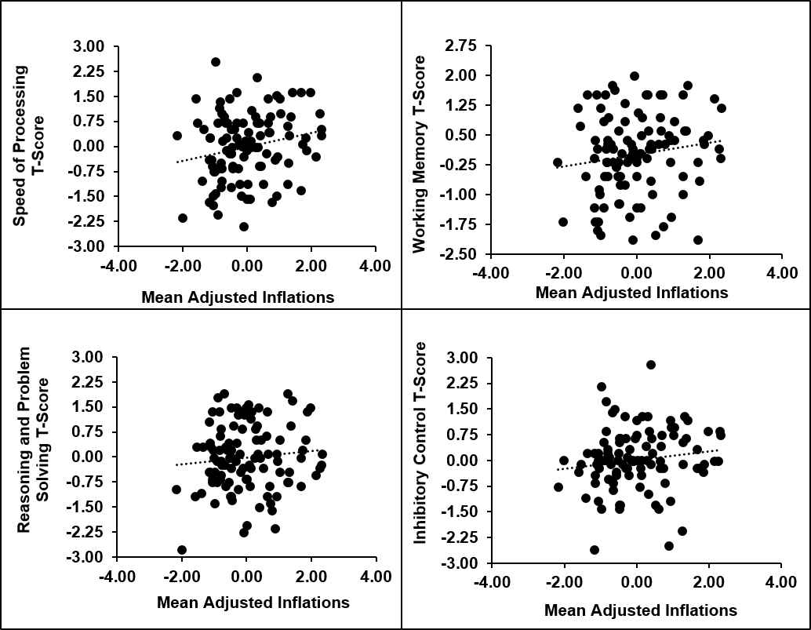

Supplemental Material Figure 1. These figures show the lack of significant relationship between relationship between the traditional Balloon Analogue Risk Task metric, Mean Adjusted Inflations and the four domains of executive control functions (ECF). These graphs demonstrate the distinct relationship ECF has to COV, a measure of adaptive risk-taking compared with Mean Adjusted Inflations, traditionally a measure of maladaptive risk-propensity. All graphs reflect z-scores of respective variables.

