SUPPLEMENTARY FIGURES

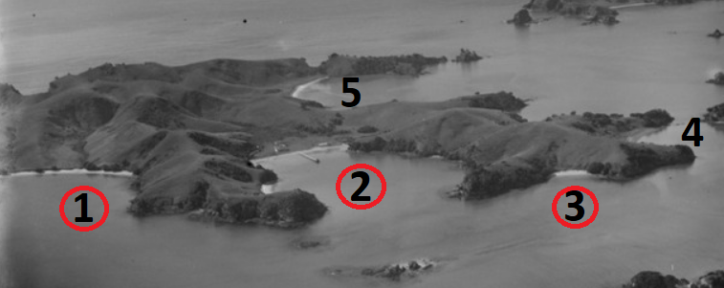

Figure S1. In 1939 (month unknown), Oneura (1), Otehei (2) and Sunset (3) bays appear to be without subtidal seagrass (red circles); Kapuharahurahu (4) is not well-enough in view; but – although the angle is very oblique - there could be seagrass present in Urupukapuka Bay (5) (National Library reference WA-03197-G & WA-03198-G).

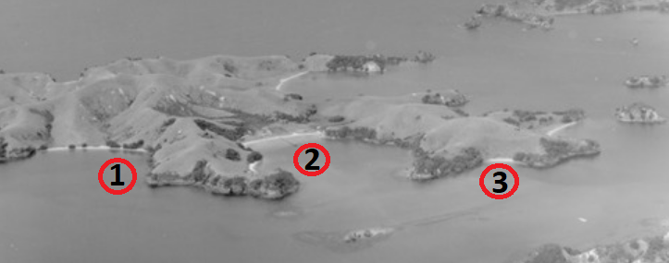

Figure S2. In 1947 (month unknown), no subtidal seagrass is unambiguously obvious in any of Urupukapuka’s western bays (red circles). (National Library reference WA-04655-F & WA-04659-F)

Figure S3. Extensive seagrass (arrows) between and within the Kaimarama (upper left) and Hauai (lower right) bays in spring 1959 (NZ Aerial Mapping Ltd SN1223 2791-2, with the boundary used in this study indicated by black line).
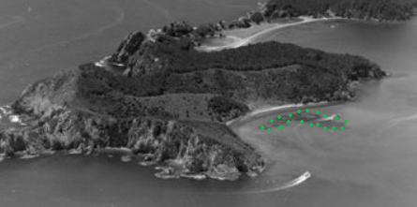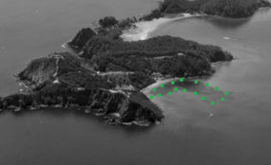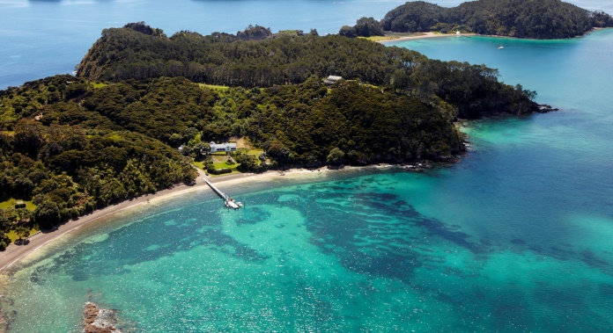

Figure S4. Some one-off oblique images were useful. On Motuarohia, Otarepo Bay apparently lacked seagrass in the late-1950s (upper left, the dark area on left of bay being kelp associated with reef; seagrass had clearly established by January 1973 (upper right; National Library reference WA-71219-G); it appears to have expanded by February 1987 (lower left; National Library reference 1434804); and to have covered much of the length of the bay by November 2011 (lower right; Salt Air Paihia 110, there no longer being subtidal kelp associated with the reef at left, and the bilobal-shape of the seagrass bed having been brought about by boat-manoeuvring near the end of the jetty).

A
B
C
D
E
F
G H
I
J
Figure S5. Graphs illustrating associations between the factors listed in Table 1.

