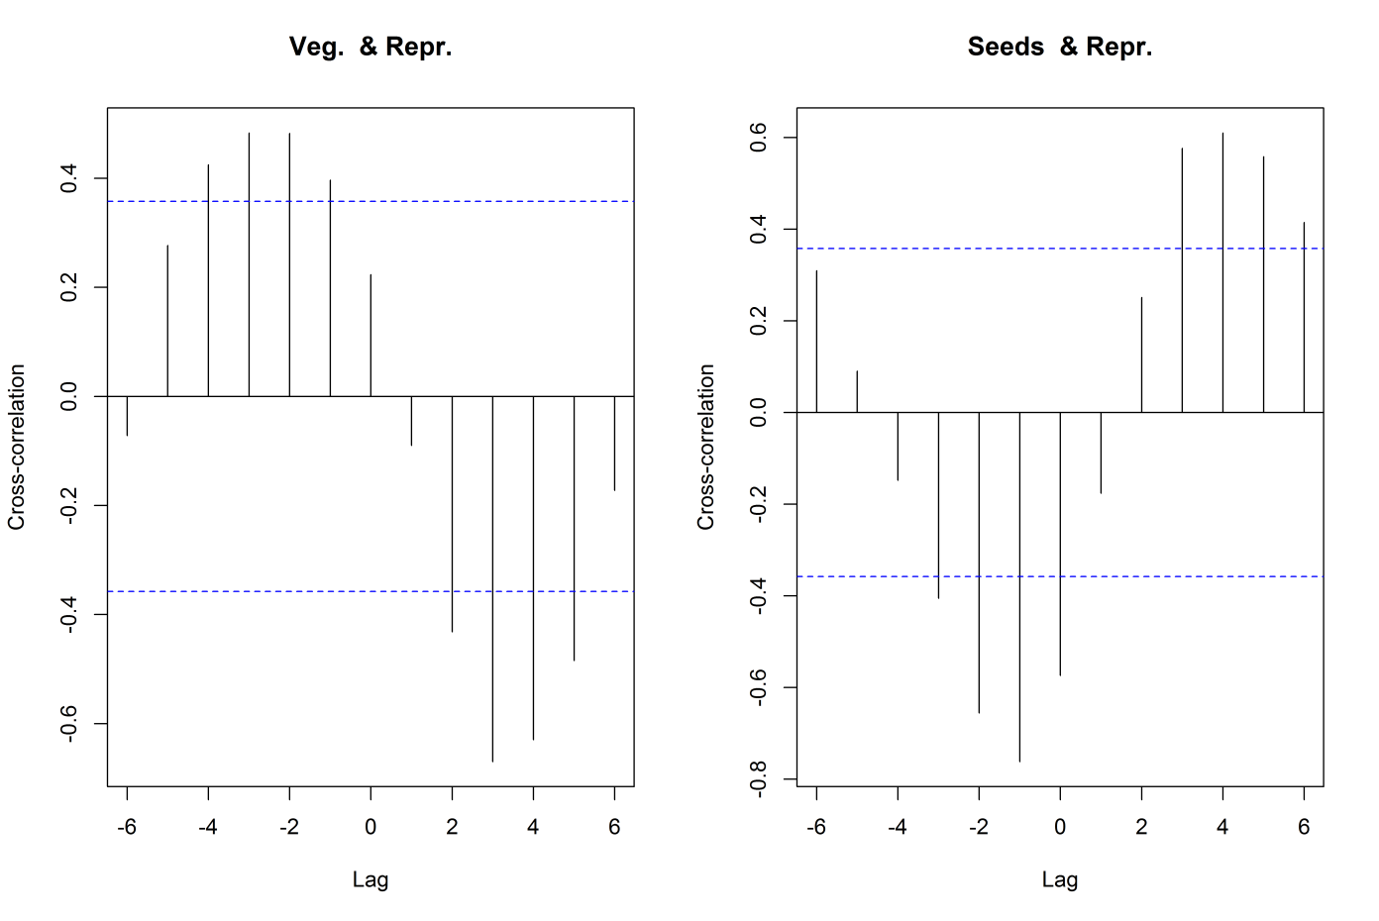
Figure 1: Cross correlation functions between the proportions of reproductively active animals and stomach content of M. natalensis at different time lags. Left: correlations between percentage vegetative material and reproductive activity. Right: correlations between percentage of seeds/grains and reproductive activity. The blue dotted lines represent the cut-off for correlations significant at that time-lag (months).

