Supplementary Material

Synthesis and characterization of a novel Mn(III)-(γ-diketone) complex with catalytic and antifungal activity

PRITI DUBEY and SUDHA YADAVA*

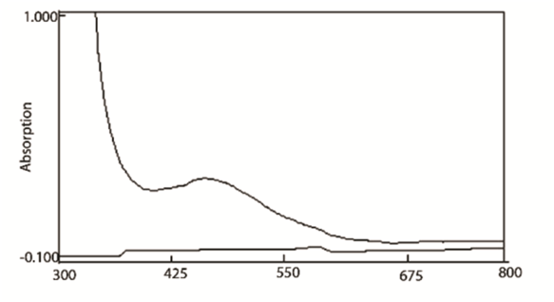
Figure S1. UV-Visible spectrum of [Mn(hdo)₃] complex.
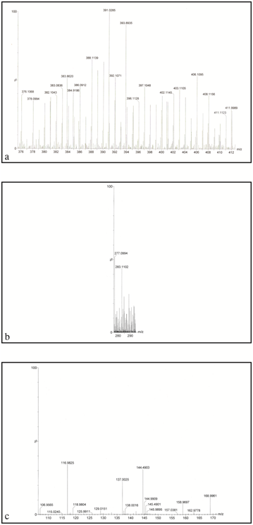
Figure S2. (a) ESI-mass spectrum of [Mn(C₁₈H₃₀O₆] complex; (b) ESI-mass spectrum of [Mn(C₁₂H₂₀O₄] complex; (c) ESI-mass spectrum of [Mn(C₆H₁₀O₂] complex.

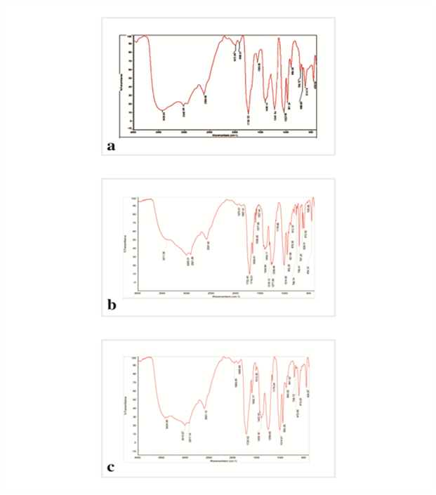
Figure S3. (a) FT-IR spectrum of methyl acetate, (b) phenyl benzoate and (c) 4-hydroxyphenyl acetate.

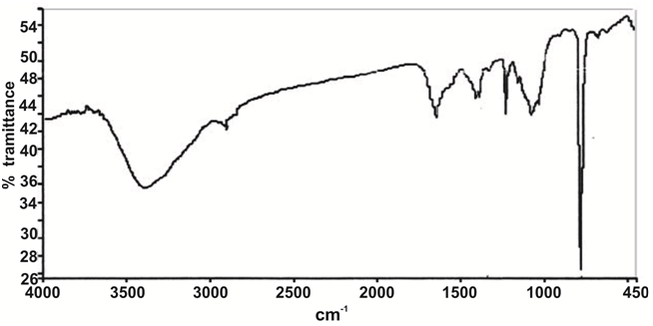
Figure S4. IR-spectra of catalyst after reaction.

