SUPPLEMENTAL MATERIALS
Supplemental Table 1. Summary of associations between the CpGs associated with prenatal arsenic exposure (EWAS) and birth gestational age: P-values and regression coefficients for unadjusted (reported) and cell-type adjusted models
 |  |  | Maternal drinking water arsenic, unadjusted for cell-type* |  |  |  | Maternal drinking water arsenic, adjusted for estimated cell-types** |  |  |  | Maternal drinking water arsenic, unadjusted for cell-type***
CpG ID | Gene |  | β Coeff. | P-value | FDR  P-value |  | β Coeff. | P-value | FDR  P-value |  | β Coeff. | P-value | FDR  P-value
cg01163597 | SLC22A23 |  | 0.11 | 5.21x10⁻⁸ | 5.44x10⁻⁴ |  | 0.08 | 8.05x10⁻⁶ | 0.03 |  | 0.08 | 1.75x10⁻² | 0.27
cg16081457 |  |  | 0.17 | 2.21x10⁻⁷ | 5.81x10⁻⁴ |  | 0.14 | 4.93x10⁻⁵ | 0.04 |  | 0.12 | 4.57x10⁻² | 0.35
cg06522054 | GNAL;GNAL;GNAL |  | 0.11 | 1.64x10⁻⁷ | 6.41x10⁻⁴ |  | 0.10 | 8.50x10⁻⁶ | 0.02 |  | 0.09 | 2.13x10⁻² | 0.28
cg20382695 | ATRNL1 |  | 0.10 | 1.03x10⁻⁷ | 5.76x10⁻⁴ |  | 0.09 | 1.39x10⁻⁵ | 0.03 |  | 0.07 | 8.24x10⁻² | 0.42
cg24937280 | MCC |  | 0.12 | 3.32x10⁻⁷ | 7.07x10⁻⁴ |  | 0.10 | 2.18x10⁻⁵ | 0.04 |  | 0.09 | 4.52x10⁻² | 0.35
cg01910639 | S100A6 |  | -0.15 | 4.71x10⁻⁷ | 7.70x10⁻⁴ |  | -0.09 | 6.21x10⁻⁴ | 0.06 |  | -0.09 | 1.09x10⁻¹ | 0.46
cg18115406 | LMX1B |  | 0.12 | 4.66x10⁻⁷ | 7.68x10⁻⁴ |  | 0.09 | 1.23x10⁻⁴ | 0.04 |  | 0.06 | 1.55x10⁻¹ | 0.52
cg04874129 | SLC6A2 |  | 0.14 | 9.00x10⁻⁷ | 8.67x10⁻⁴ |  | 0.10 | 1.22x10⁻⁴ | 0.04 |  | 0.10 | 6.45x10⁻² | 0.39
cg20277905 | miR124-3 |  | 0.12 | 3.72x10⁻⁷ | 7.27x10⁻⁴ |  | 0.09 | 7.91x10⁻⁵ | 0.04 |  | 0.12 | 7.32x10⁻³ | 0.23
cg00398764 |  |  | 0.13 | 9.84x10⁻⁷ | 8.82x10⁻⁴ |  | 0.08 | 1.26x10⁻⁵ | 0.03 |  | 0.12 | 7.82x10⁻³ | 0.23
*Model for log₂(maternal drinking water arsenic) adjusted for sex
**Model for log₂(maternal drinking water arsenic) adjusted for sex and estimated cell-type composition in cord blood (CD8T, CD4T, NK, B-cells, Monocytes, Granulocyte and nucleated red blood cells)
***Model for log₂(postpartum maternal toenail arsenic) adjusted for se

Supplemental Table 2. Relative contribution of each CpG to the 1st PC used in the discovery phase for mediation analyses.
CpG ID |  |  | Relative loading on 1st  Principal Component
cg01163597 | SLC22A23 |  | 0.10
cg16081457 |  |  | 0.08
cg06522054 | GNAL;GNAL;GNAL |  | 0.10
cg20382695 | ATRNL1 |  | 0.10
cg24937280 | MCC |  | 0.10
cg01910639 | S100A6 |  | 0.10
cg18115406 | LMX1B |  | 0.11
cg04874129 | SLC6A2 |  | 0.10
cg20277905 | miR124-3 |  | 0.10
cg00398764 |  |  | 0.11

Supplemental Table 3. CpG sites analyzed by bisulfite pyrosequencing.
Gene | CpG site | Genome coordinates | Mean methylation % (SD)
MIR124-3 | CpG 22 (cg20277905) | Chr20:63178364 | 2.24 (2.68)
 | CpG 21 | Chr20:63178372 | 3.80 (3.95)
 | CpG 20 | Chr20:63178377 | 1.31 (2.06)
 | CpG 19 | Chr20:63178383 | 3.93 (4.07)
 | CpG 18 | Chr20:63178392 | 2.67 (2.96)
 | CpG 17 | Chr20:63178397 | 0.69 (1.92)
 | CpG 16 | Chr20:63178399 | 1.99 (2.14)
 | CpG 15 | Chr20:63178402 | 5.76 (2.68)
 | CpG 14 | Chr20:63178408 | 0.63 (1.56)
 | CpG 13 | Chr20:63178416 | 1.24 (3.23)
 | CpG 12 | Chr20:63178420 | 3.41 (2.97)
 | CpG 11 | Chr20:63178422 | 1.06 (1.93)
 | CpG 10 | Chr20:63178429 | 1.67 (4.11)
 | CpG 9 | Chr20:63178433 | 2.88 (3.78)
GNAL | CpG 1000 | Chr18:11752462 | 1.05 (1.38)
 | CpG 1001 | Chr18:11752465 | 4.25 (2.24)
 | CpG 1002 | Chr18:11752478 | 2.14 (2.12)
 | CpG 1003 | Chr18:11752481 | 2.25 (2.13)
 | CpG 1004 | Chr18:11752494 | 2.37 (1.64)
 | CpG 1005 | Chr18:11752497 | 1.84 (1.41)
 | CpG 1006 | Chr18:11752499 | 1.27 (1.60)
 | CpG 1007 | Chr18:11752517 | 1.63 (1.80)
 | CpG 1008 (cg06522054) | Chr18:11752539 | 3.19 (2.31)
MCC | CpG 48 | Chr5:113488053 | 2.20 (2.67)
 | CpG 47 (cg24937280) | Chr5:113488060 | 1.73 (2.26)
 | CpG 46 | Chr5:113488078 | 0.26 (1.06)
 | CpG 45 | Chr5:113488085 | 1.21 (1.76)
 | CpG 44 | Chr5:113488091 | 0.35 (1.08)
 | CpG 43 | Chr5:113488096 | 0.67 (1.28)
 | CpG 42 | Chr5:113488102 | 2.63 (2.16)
 | CpG 41 | Chr5:113488104 | 2.72 (2.08)
 | CpG 40 | Chr5:113488110 | 2.51 (2.14)
 | CpG 39 | Chr5:113488116 | 2.55 (2.17)
 | CpG 38 | Chr5:113488118 | 0.69 (1.87)
 | CpG 37 | Chr5:113488132 | 0.75 (1.13)
 | CpG 36 | Chr5:113488134 | 0.92 (1.30)

Supplemental Table 4. Pearson correlations among CpG analyzed by bisulfite pyrosequencing located on MIR124-3.
 | CpG22 (cg20277905) | CpG21 | CpG20 | CpG19 | CpG18 | CpG17 | CpG16 | CpG15 | CpG14 | CpG13 | CpG12 | CpG11 | CpG10
CpG21 | 0.20*†
CpG20 | 0.34*† | 0.17*†
CpG19 | 0.10*† | 0.09*† | 0.14*†
CpG18 | 0.24*† | 0.17*† | 0.27*† | 0.20*†
CpG17 | 0.16*† | 0.07 | 0.26*† | 0.13*† | 0.12*†
CpG16 | 0.19*† | 0.18*† | 0.25*† | 0.19*† | 0.28*† | 0.19*†
CpG15 | 0.33*† | 0.30 | 0.28*† | 0.09*† | 0.19*† | 0.08 | 0.22*†
CpG14 | 0.22*† | 0.17*† | 0.14*† | 0.09*† | 0.12*† | 0.16*† | 0.23*† | 0.30*†
CpG13 | 0.08 | 0.05 | 0.10*† | 0.06 | 0.09*† | 0.16*† | 0.13*† | 0.01 | 0.14*†
CpG12 | 0.36*† | 0.25*† | 0.29*† | 0.24*† | 0.27*† | 0.22*† | 0.40*† | 0.42*† | 0.29*† | 0.13*†
CpG11 | 0.27*† | 0.13*† | 0.35*† | 0.17*† | 0.22*† | 0.27*† | 0.28*† | 0.26*† | 0.35*† | 0.20*† | 0.33*†
CpG10 | 0.12*† | 0.16*† | 0.21*† | 0.08 | 0.16*† | 0.16*† | 0.24*† | 0.21*† | 0.11*† | 0.14*† | 0.23*† | 0.29*†
CpG9 | 0.10*† | 0.14*† | 0.15*† | 0.16*† | 0.17*† | 0.16*† | 0.20*† | 0.11*† | 0.08 | 0.46*† | 0.26*† | 0.16*† | 0.12*†
*P <0.05, unadjusted; † P<0.05, FDR adjusted

Supplemental Table 5. Pearson correlations among CpG analyzed by bisulfite pyrosequencing located on GNAL.
 | CpG1000 | CpG1001 | CpG1002 | CpG1003 | CpG1004 | CpG1005 | CpG1006 | CpG1007
CpG1001 | 0.34*†
CpG1002 | 0.25*† | 0.41*†
CpG1003 | 0.33*† | 0.37*† | 0.49*†
CpG1004 | 0.34*† | 0.57*† | 0.67*† | 0.48*†
CpG1005 | 0.28*† | 0.34*† | 0.30*† | 0.41*† | 0.59*†
CpG1006 | 0.44*† | 0.44*† | 0.31*† | 0.50*† | 0.49*† | 0.54*†
CpG1007 | 0.21*† | 0.25*† | 0.26*† | 0.33*† | 0.52*† | 0.70*† | 0.45*†
CpG1008 (cg06522054) | 0.22*† | 0.34*† | 0.25*† | 0.36*† | 0.52*† | 0.67*† | 0.42*† | 0.68*†
*P <0.05, unadjusted; † P<0.05, FDR adjusted

Supplemental Table 6. Pearson correlations among CpG analyzed by bisulfite pyrosequencing located on MCC.
 | CpG36 | CpG37 | CpG38 | CpG39 | CpG40 | CpG41 | CpG42 | CpG43 | CpG44 | CpG45 | CpG46 | CpG47 (cg24937280)
CpG37 | 0.42*†
CpG38 | 0.31*† | 0.25*†
CpG39 | 0.53*† | 0.41*† | 0.27*†
CpG40 | 0.45*† | 0.39*† | 0.26*† | 0.71*†
CpG41 | 0.41*† | 0.36*† | 0.23*† | 0.49*† | 0.41*†
CpG42 | 0.44*† | 0.38*† | 0.26*† | 0.55*† | 0.46*† | 0.61*†
CpG43 | 0.49*† | 0.39*† | 0.30*† | 0.45*† | 0.46*† | 0.38*† | 0.46*†
CpG44 | 0.40*† | 0.33*† | 0.20*† | 0.29*† | 0.22*† | 0.27*† | 0.34*† | 0.31*†
CpG45 | 0.43*† | 0.52*† | 0.29*† | 0.37*† | 0.36*† | 0.44*† | 0.49*† | 0.47*† | 0.33*†
CpG46 | 0.27*† | 0.27*† | 0.18*† | 0.19*† | 0.28*† | 0.33*† | 0.37*† | 0.33*† | 0.32*† | 0.31*†
CpG47 (cg24937280) | 0.46*† | 0.28*† | 0.29*† | 0.43*† | 0.49*† | 0.47*† | 0.50*† | 0.42*† | 0.21*† | 0.38*† | 0.41*†
CpG48 | 0.40*† | 0.33*† | 0.22*† | 0.33*† | 0.35*† | 0.34*† | 0.42*† | 0.34*† | 0.25*† | 0.38*† | 0.36*† | 0.56*†
*P <0.05, unadjusted; † P<0.05, FDR adjusted

Supplemental Figure 1. Structural equation model for the mediated association of maternal drinking water arsenic concentration and birth gestational age by DNAm of miR124-3 in the validation phase.
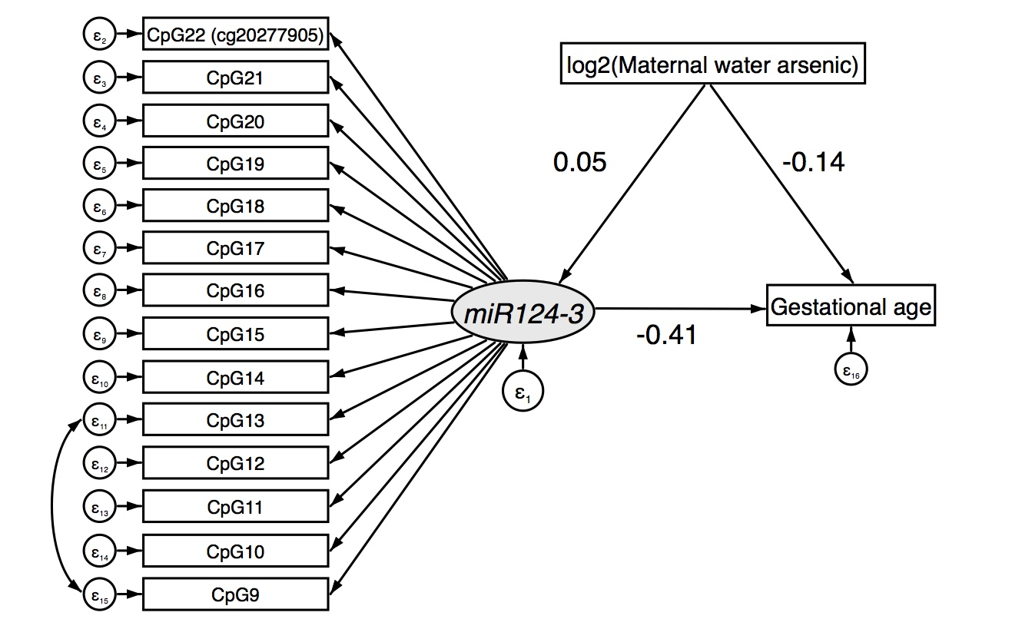

Supplemental Table 7. Parameter estimates from the structural equation model for the mediated effect of maternal drinking water arsenic concentration on birth gestational age through variation of DNAm of miR124-3 in the validation phase.
Pathway | Effect | β Coefficient | P
 |  | (95% CIs)
log₂(maternal water drinking arsenic) → miR124-3 | Direct | 0.05 (0.01, 0.10) | 0.03
log₂(maternal water drinking arsenic) → Gestational age | Direct | -0.14 (-0.20, -0.09) | <0.001
miR124-3 → Gestational age | Direct | -0.41 (-0.60, -0.22) | <0.001
log₂(maternal water drinking arsenic) → miR124-3 → Gestational age | Indirect | -0.02 (-0.04, 0.00) | 0.03
SEM fit measures (robust): χ2=140.908, p=0.006; CFI=0.943; RMSEA=0.032

Supplementary Figure 2. Structural equation model for the mediated association of maternal drinking water arsenic concentration and birth gestational age by DNAm of GNAL in the validation phase.
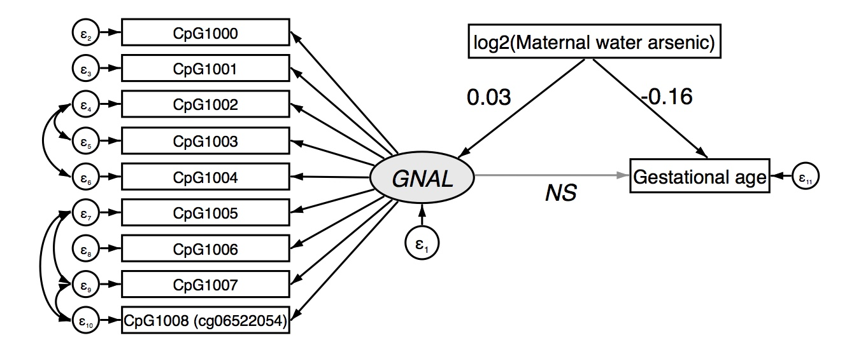
NS=non-significant

Supplementary Table 8. Parameter estimates from the structural equation model for the mediated effect of maternal drinking water arsenic concentration on birth gestational age through variation of DNAm of GNAL in the validation phase.
Pathway | Effect | β Coefficient | P
 |  | (95% CIs)
log₂(maternal drinking water arsenic) → GNAL | Direct | 0.03 (0.01, 0.05) | 0.02
log₂(maternal drinking water arsenic) → Gestational age | Direct | -0.16 (-0.21, -0.10) | <0.001
GNAL → Gestational age | Direct | -0.28 (-0.60, 0.02) | 0.07
log₂(maternal drinking water arsenic) → GNAL → Gestational age | Indirect | -0.01 (-0.02, 0.00) | 0.17
SEM fit measures (robust): χ2=80.483, P<0.001; CFI=0.953; RMSEA=0.069

Supplementary Figure 3. Structural equation model for the mediated association of maternal drinking water arsenic concentration and birth gestational age by DNAm of MCC in the validation phase.
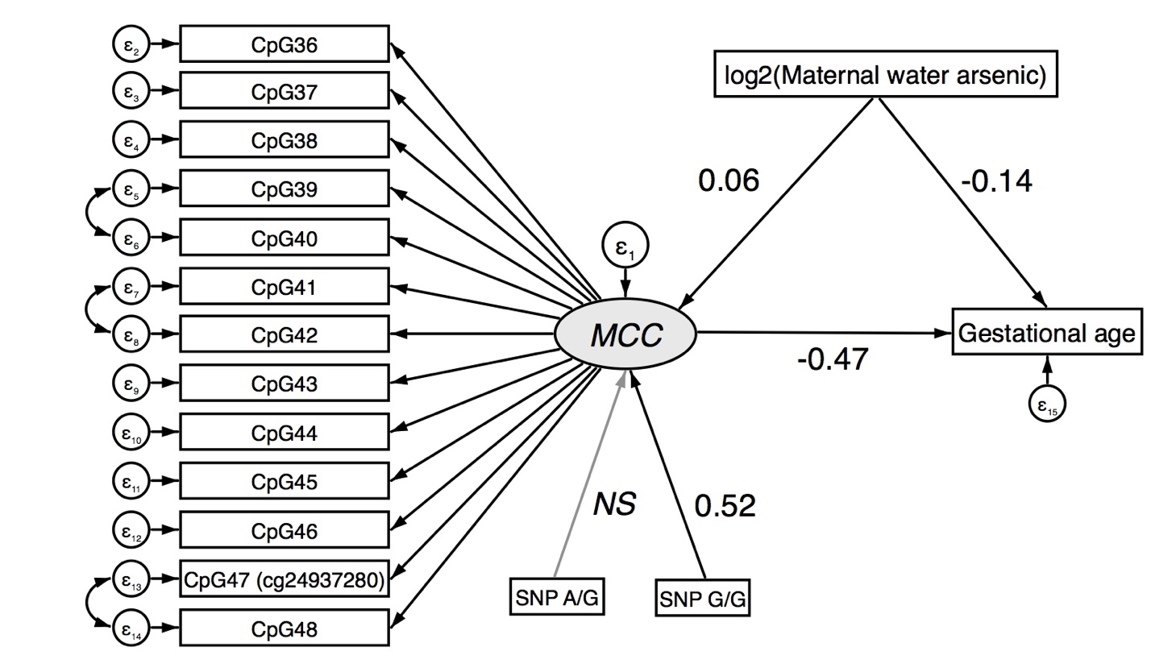
NS=non-significant
Supplementary Table 9. Parameter estimates from the structural equation model for the mediated effect of maternal drinking water arsenic concentration on birth gestational age through variation of DNAm of MCC in the validation phase.
Pathway | Effect | β Coefficient | P
 |  | (95% CIs)
log₂(maternal drinking water arsenic) → MCC | Direct | 0.06 (0.03, 0.09) | 0.001
SNP rs1057827 → MCC (reference: A/A)
G/G | Direct | 0.52 (0.07, 0.97) | 0.03
A/G | Direct | 0.13 (-0.05, 0.31) | 0.17
log₂(maternal drinking water arsenic) → Gestational age | Direct | -0.14 (-0.20, -0.08) | <0.001
MCC → Gestational age | Direct | -0.47 (-0.70, -0.24) | <0.001
log₂(maternal drinking water arsenic) → MCC → Gestational age | Indirect | -0.03 (-0.05, -0.01) | 0.004
SEM fit measures (robust): χ2=207.179, P<0.001; CFI=0.943; RMSEA=0.048

Supplementary Figure 4. Unadjusted structural equation model for the mediated effect of maternal drinking water arsenic concentration on birth gestational age through variation of DNAm of CpGs in miR124-3 and MCC in the validation phase.
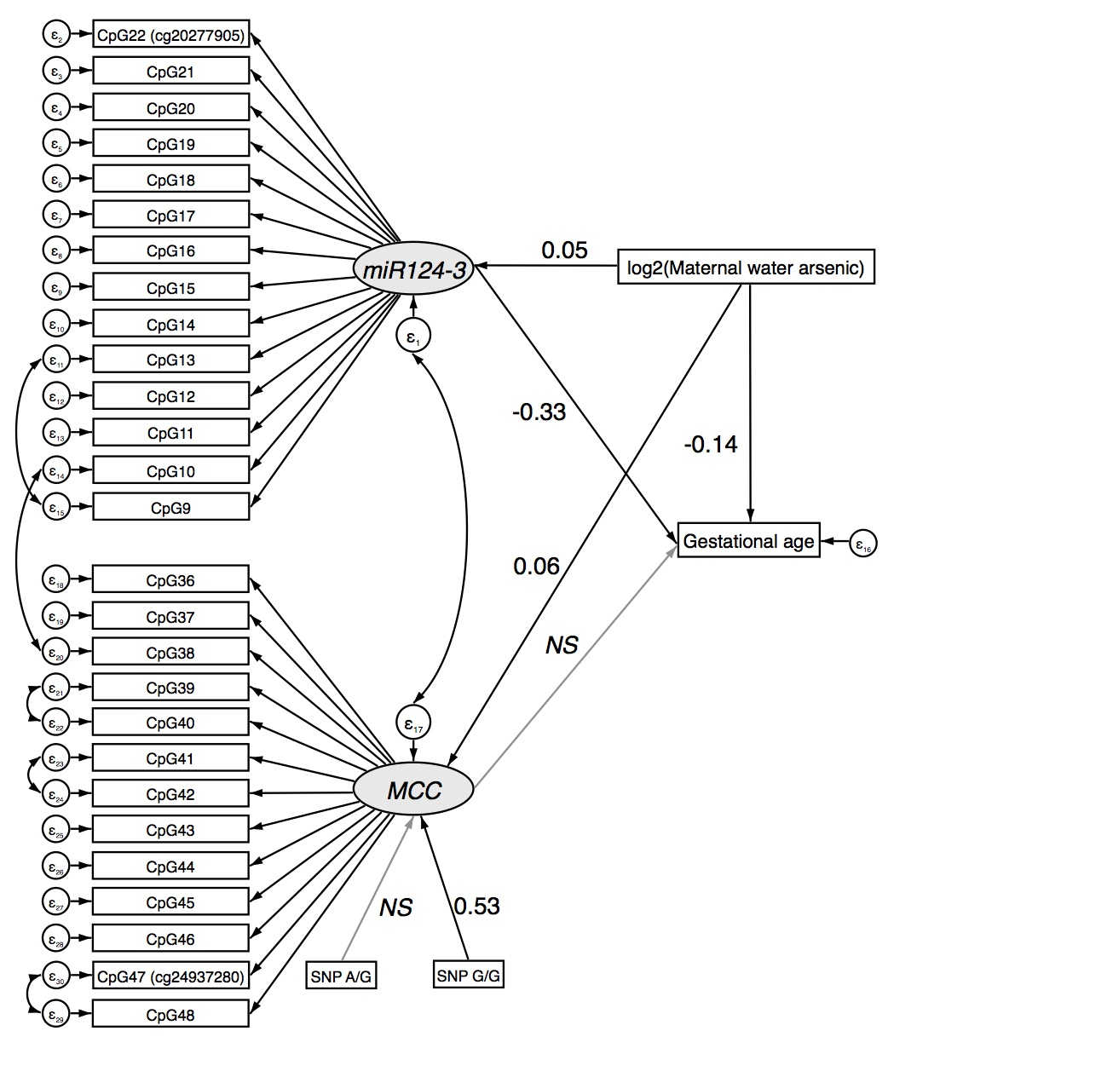

Supplemental Table 10. Unadjusted structural equation model for the mediated effect of maternal drinking water arsenic concentration on birth gestational age through variation of DNAm of CpGs in miR124-3 and MCC in the validation phase.
Pathway | Effect | β Coefficient | P
 |  | (95% CIs)
miR124-3
log₂(maternal water arsenic) → miR124-3 | Direct | 0.05 (0.01, 0.10) | 0.03
MCC
log₂(maternal water arsenic) → MCC | Direct | 0.06 (0.03, 0.09) | <0.001
SNP rs1057827 → MCC (reference: AA)
G/G | Direct | 0.53 (0.12, 0.94) | 0.01
A/G | Direct | 0.11 (-0.05, 0.27) | 0.19
Gestational age
log₂(maternal water arsenic) → Gestational age | Direct | -0.14 (-0.20, -0.08) | <0.001
miR124-3 → Gestational age | Direct | -0.33 (-0.53, -0.12) | 0.002
MCC → Gestational age | Direct | -0.18 (-0.47, 0.10) | 0.20
log₂(maternal water arsenic) → miR124-3 → Gestational age | Indirect | -0.02 (-0.03, 0.00) | 0.05
log₂(maternal water arsenic) → MCC → Gestational age | Indirect | -0.01 (-0.03, 0.01) | 0.22
SEM fit measures (robust): χ2=718.542, P<0.001; CFI=0.899; RMSEA=0.041

Supplementary Figure 5. Adjusted structural equation model for the mediated effect of postpartum maternal toenail arsenic concentration on birth gestational age through variation of DNAm of CpGs in miR124-3 and MCC in the validation phase.
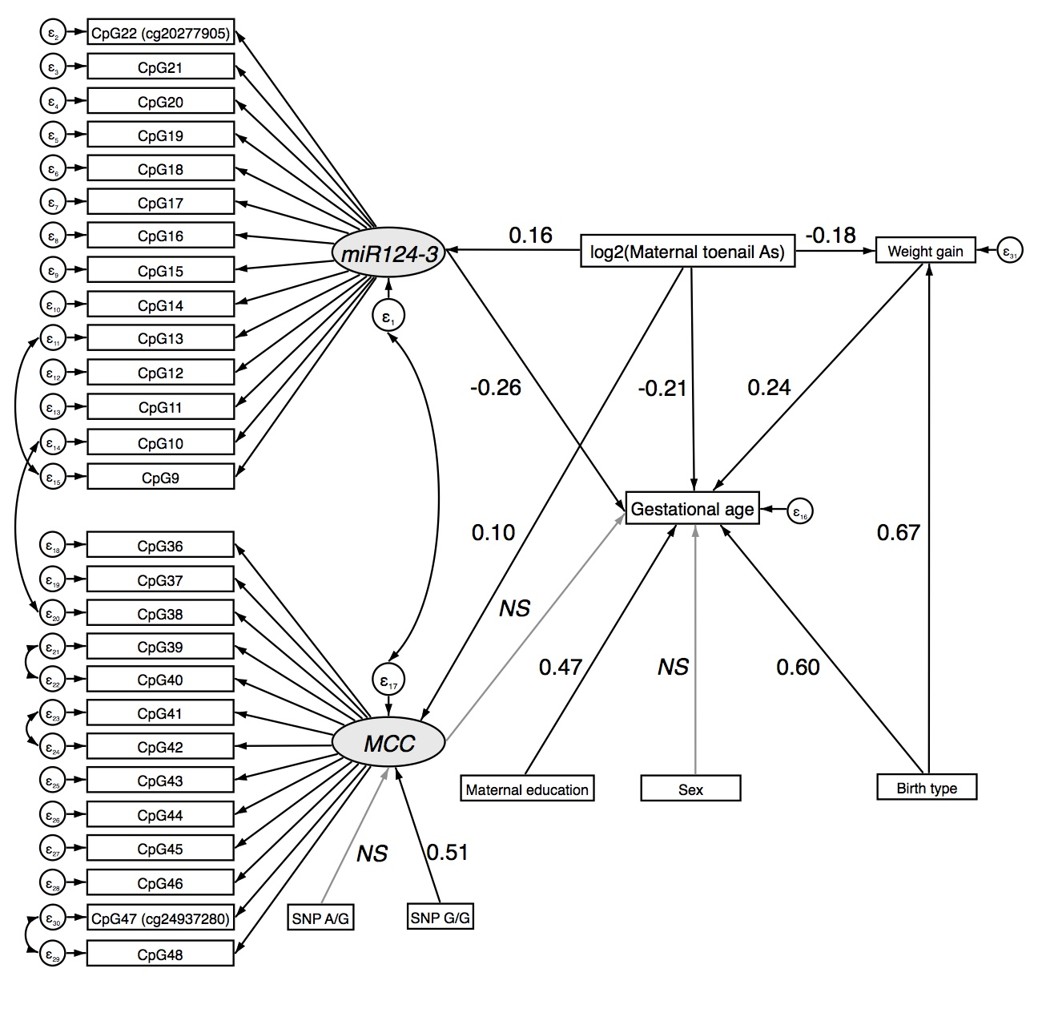
NS=non-significant

Supplemental Table 11. Structural equation model for the mediated effect of postpartum maternal toenail arsenic concentration on birth gestational age through variation of DNAm of CpGs in miR124-3 and MCC in the validation phase.
Pathway | Effect | β Coefficient | P
 |  | (95% CIs)
miR124-3
log₂(maternal toenail As) → miR124-3 | Direct | 0.16 (0.07, 0.25) | 0.001
MCC
log₂(maternal toenail As) → MCC | Direct | 0.10 (0.04, 0.15) | 0.001
SNP rs1057827 (reference: AA)
G/G | Direct | 0.51 (0.10, 0.92) | 0.01
A/G | Direct | 0.10 (-0.07, 0.25) | 0.26
Maternal weight gain
log₂(maternal toenail As) → Weight gain | Direct | -0.18 (-0.33, -0.03) | 0.02
Birth type (cesarean vs. vaginal) → Weight gain | Direct | 0.67 (0.15, 1.19) | 0.01
Gestational age
log₂(maternal toenail As) → Gestational age | Direct | -0.21 (-0.34, -0.08) | 0.002
miR124-3 → Gestational age | Direct | -0.26 (-0.46, -0.06) | 0.01
MCC → Gestational age | Direct | -0.18 (-0.45, 0.09) | 0.20
Sex (male vs. female) → Gestational age | Direct | 0.11 (-0.20, 0.42) | 0.48
Weight gain → Gestational age | Direct | 0.24 (0.18, 0.30) | <0.001
Birth type (cesarean section vs. vaginal) → Gestational age | Direct | 0.60 (0.30, 0.90) | <0.001
Maternal education (> primary vs. ≤ primary) → Gestational age | Direct | 0.47 (0.15, 0.79) | 0.004
log₂(maternal toenail As) → Weight gain → Gestational age | Indirect | -0.04 (-0.08, -0.01) | 0.03
log₂(maternal toenail As) →miR124-3 → Gestational age | Indirect | -0.04 (-0.08, -0.01) | 0.02
log₂(maternal toenail As) → MCC → Gestational age | Indirect | -0.02 (-0.04, 0.01) | 0.22
SEM fit measures (robust): χ2=886.434, P<0.001; CFI=0.893; RMSEA=0.038

Supplementary Figure 6. Adjusted structural equation model for the mediated effect of maternal toenail arsenic concentration at enrollment on birth gestational age through variation of DNAm of CpGs in miR124-3 and MCC in the validation phase.
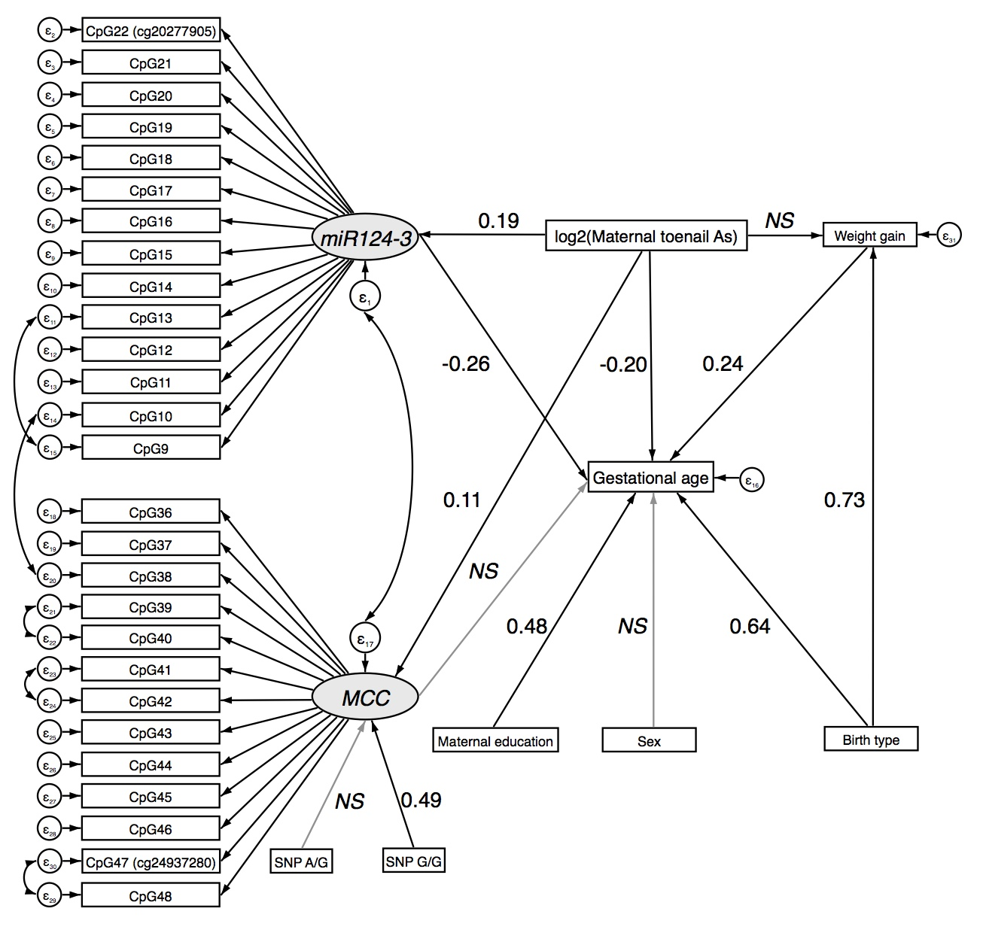
Supplemental Table 12. Structural equation model for the mediated effect of maternal toenail arsenic concentration at enrollment on birth gestational age through variation of DNAm of CpGs in miR124-3 and MCC in the validation phase.
Pathway | Effect | β Coefficient | P
 |  | (95% CIs)
miR124-3
log₂(maternal toenail arsenic) → miR124-3 | Direct | 0.19 (0.09, 0.29) | <0.001
MCC
log₂(maternal toenail arsenic) → MCC | Direct | 0.11 (0.05, 0.17) | <0.001
SNP rs1057827 → MCC (reference: AA)
G/G | Direct | 0.49 (0.08, 0.90) | 0.02
A/G | Direct | 0.10 (-0.07, 0.26) | 0.25
Maternal weight gain
log₂(maternal toenail arsenic) → Weight gain | Direct | -0.11 (-0.28, 0.05) | 0.18
Birth type (cesarean vs. vaginal) → Weight gain | Direct | 0.73 (0.22, 1.25) | 0.01
Gestational age
log₂(maternal toenail arsenic) → Gestational age | Direct | -0.20 (-0.34, -0.07) | 0.003
miR124-3 → Gestational age | Direct | -0.26 (-0.46, -0.06) | 0.01
MCC → Gestational age | Direct | -0.18 (-0.45, 0.10) | 0.20
Sex (male vs. female) → Gestational age | Direct | 0.09 (-0.22, 0.40) | 0.56
Weight gain → Gestational age | Direct | 0.24 (0.18, 0.30) | <0.001
Birth type (cesarean section vs. vaginal) → Gestational age | Direct | 0.64 (0.34, 0.94) | <0.001
Maternal education (> primary vs. ≤ primary) → Gestational age | Direct | 0.48 (0.16, 0.80) | 0.003
log₂(maternal toenail arsenic) → Weight gain → Gestational age | Indirect | -0.03 (-0.07, 0.01) | 0.18
log₂(maternal toenail arsenic) → miR124-3 → Gestational age | Indirect | -0.05 (-0.09, 0.01) | 0.02
log₂(maternal toenail arsenic) → MCC → Gestational age | Indirect | -0.02 (-0.05, 0.01) | 0.21
SEM fit measures (robust): χ2=884.114, P<0.001; CFI=0.894; RMSEA=0.038

